CHEM 4612 | Jonathan Riezman
Assignment 1 | 01/25/21

1a. The Cl⁻ ion can interact with the Na⁺ ion via ion – ion and London dispersion (induced dipole – induced dipole) forces.
b. Methane (CH₄) can interact with the Na⁺ ion via ion – induced dipole and London dispersion forces.
c. Chlorobenzene can interact with the Na⁺ ion via ion – dipole, dipole – induced dipole, London dispersion, and cation – π interaction forces.

2. A cation-π interaction occurs when a positively charged ion has a noncovalent interaction with an π electron system such as in the interaction of acetylcholine and tryptophan. A π-π interaction occurs when π electron systems interact with each other such as in graphite; these interactions are also known as stacking. The first interaction involves a positively charged species that is attracted to an electron-rich π electron cloud while molecules participating in π-π interactions often have neutral charge overall.

3. In aqueous solution, the charged Na and Cl ions attract the partial positive and negative charges of the polar (but overall neutral) water molecule. This causes the water molecules to form hydration shells around the dissolved ions. In this case the partially negative oxygen atoms are attracted to the positive Sodium ion and the partially positive hydrogen atoms are attracted to the negative Chloride ion. A graphical representation follows.

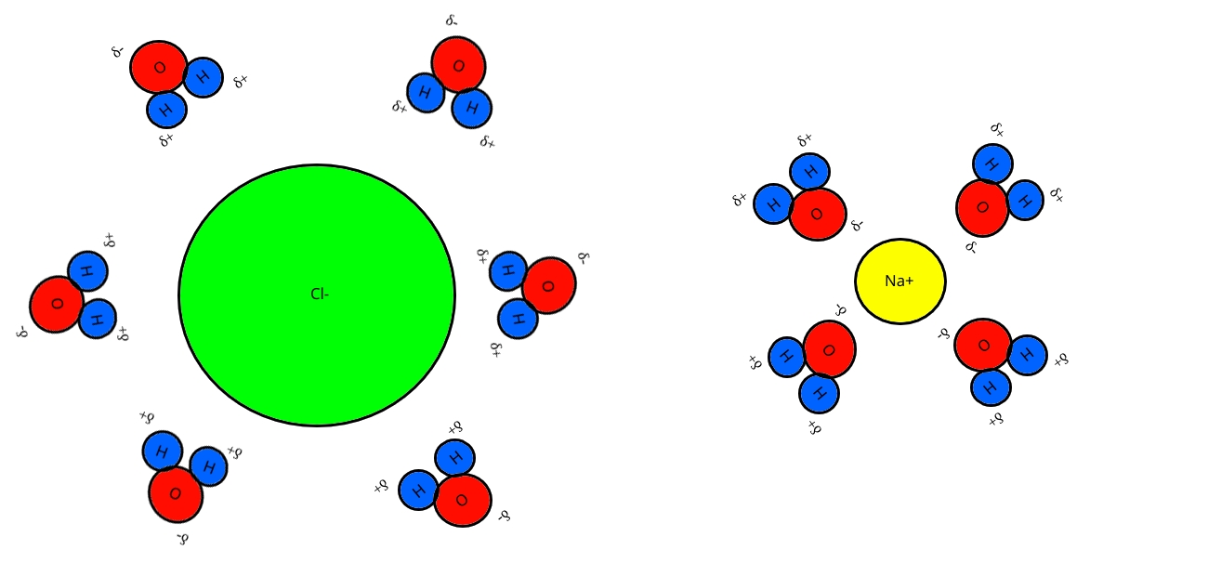

4. Guanine and cytosine have a stronger interaction because there are more hydrogen bonds involved. Adenine and Thymine only form two hydrogen bonds while guanine and cytosine form three.

5. Sodium dodecyl sulfate would have a greater hydrophobic effect than sodium octyl sulfate because the non-polar portion of the molecule, the part which causes the hydrophobic effect, is significantly larger. Below is a sketch of the structure of a micelle. The sketch is a 2D slice of a spherical construction generally containing 50-100 monomers. In addition to micelles, such molecules can form liposomes and bilayers which are ubiquitous throughout Biology.
