CHEM 3322: Physical Chemistry II | Jonathan Riezman
Meeting 2 Quick Problems | 01/25/21

1a) 6.646477 (323455986) x 10⁻²⁷ kg

b) 1351.6 (10181) m/s

c) 7.3758 (6650374016) x 10⁻¹¹ m

2a)

b) In order to make calculations we must convert wavelength to frequency and use the actual measurements of kinetic energy (i.e. multiply the given values by 10¹⁹). A graph of this data along with linear fit line follows.

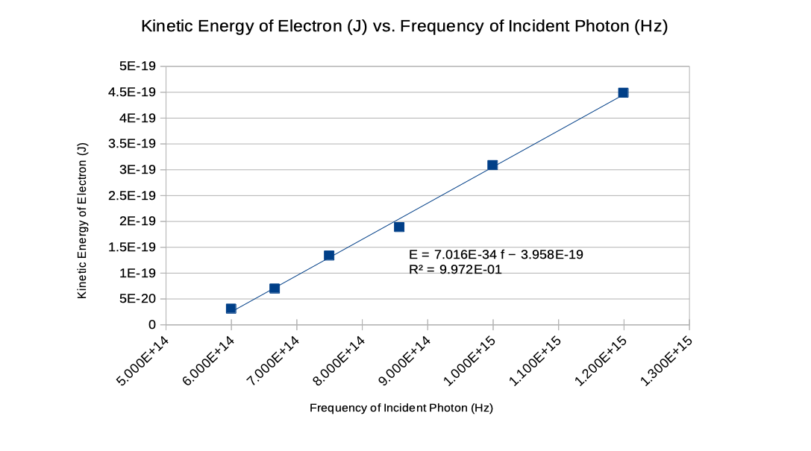

The linear fit line for this data can be compared to , the Photoelectric Effect equation. Thus the work function for potassium is given by the intercept of the linear fit line as 3.958 (31058413528) x 10⁻¹⁹ J = 2.470 (583142859059) eV.

c) Similarly an experimental value for Planck’s constant can determined from the slope of the linear fit line as 7.105 (53507954169) x 10⁻³⁴.

d) The literature value for the work function of potassium was found to be 2.29 eV¹ giving a deviation of 7.89% from the experimental value.

REFERENCES

1: Electron Work Function of the Elements, https://public.wsu.edu/~pchemlab/documents/Work-functionvalues.pdf (Accessed 1/25/2021)

