CHEM 3322: Physical Chemistry II | Jonathan Riezman
Assignment 1 Part B | 02/13/2021

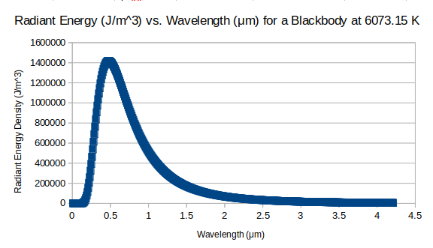
1a)

b) 99.033%

2a) 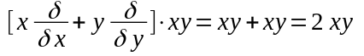 so xy is an eigenfunction of this operator with eigenvalue 2.

b) 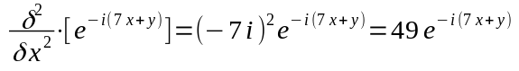 so 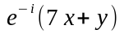 is an eigenfunction of this operator with eigenvalue 49.

c) 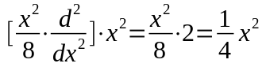 so x² is an eigenfunction of this operator with eigenvalue ¹/_{4 .}

3) Given the wave function 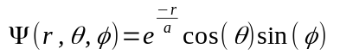. To normalize this wave function we need N such that 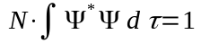, that is 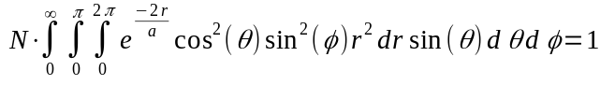. Because the variables are separable we can do each of the three integrals by itself then find the product of those results. First 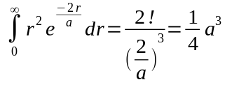, then we have 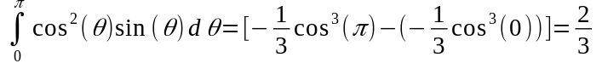and finally 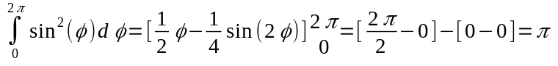. Finding the product of these terms gives us 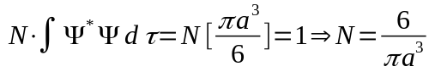.

4) In complex function space the condition for orthogonality for two functions ψ and ɸ is 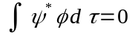 . For the given functions we calculate , but because 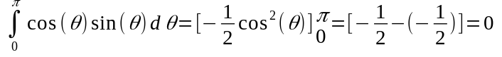 the entire integral is zero and therefore the functions are orthogonal in complex function space.

5) r = 5.1961, θ = 45.000° = ^{π}/₄ radians, ɸ = 54.736° = 0.95532 radians

6a) The commutator of two operators is defined as for an arbitrary function, f(x). It is equal to 0 if the operators commute. For position and linear momentum operators we have (primes are used instead of deltas for brevity since this is 1D) .

b) Since the commutator is not zero the operators do not commute for arbitrary functions. Trivially, these operators commute for the zero function, f(x)=0.

7a) Note that because the ɸ_{n} are orthonormal 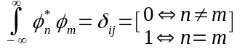. Note also that 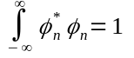. Given our function in terms of the orthonormal ɸ_{n} we have
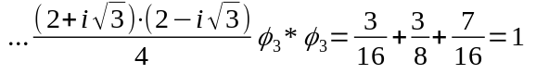. Therefore Ψ is normalized.

b) E₁, 2E₁, and 4E₁

c) ³/₈, ³/₁₆, and ⁷/₁₆ with respect to the order of the previous answer.

d) 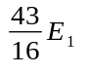

8a) The probability that a particle with wave function Ψ will be found in a given interval (0, a/4) is 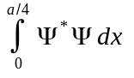. For our 1D particle in an infinite well . As a function of the quantum number, n.

b) As n approaches infinity 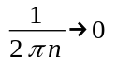 and so probability approaches ¼ as expected in classical physics, where the particle has an equal chance of being at any point in the well.

9a) 9.6394678 x 10⁻¹⁹ J at n=1
3.8557871 x 10⁻¹⁸ J at n=2
2.4098670 x 10⁻¹⁷ J at n=5

b) 68.6914081 nm

10a) 5.9885 x 10⁻³⁵ for n=1

1.7614 x 10⁻³⁴ for n=2

b) 1.7614 x 10⁻³⁴ > 5.9885 x 10⁻³⁵ > 5.27286 x 10⁻³⁵ = ^{h}/_{4π}

c) 4.5189 x 10⁻¹¹ for n=1
6.6459 x 10⁻¹¹ for n=2

