CHEM 3322: Physical Chemistry II | Jonathan Riezman
Meeting 6 Quick Problems | 02/08/21

1) Let Ψ be a wave function that is not an eigenfunction of the energy operator but can be written as a sum of eigenfunctions of the energy operator, ψ_{n}, and expansion coefficients, c_{n}, such that 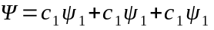 and therefore 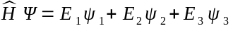 where the E_{n} are the eigenvalues of ψ_{n} with respect to the energy operator. We know from the 4th postulate of Quantum Mechanics that when a wave function is normalized the expectation (or average) value of an operator is given by 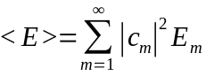 thus the probability of measuring any particular E_{m} is the square of its expansion coefficient. Specifically, in this case the probability of measuring E₁ for a large set of identically prepared systems is 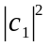.

2) Given that Ψ is normalized, 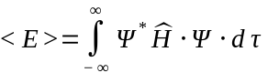. Using Ψ in terms of the expansion coefficients and eigenfunctions we have 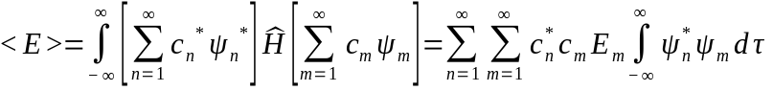, but since all the the eigenfunctions of Ψ form an orthonormal set, 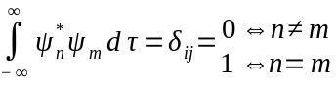 so the above expression simplifies to 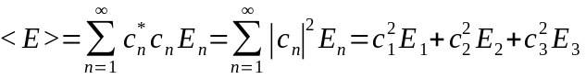 for the average energy of a QM system described by Ψ.

3) We now calculate 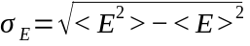or the standard deviation of the energy measurement for this system. From above we see 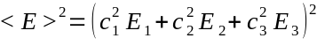. Because 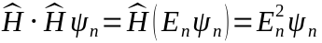, . Expanding this expression gives 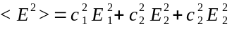. So finally we have .

