CHEM 3322: Physical Chemistry II | Jonathan Riezman
Meeting 7 Quick Problems | 2/11/21

1a) The energy is greater than that of the ground state where n=1.

b) 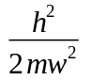

c) The position operator is 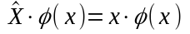. Thus 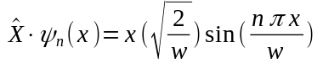 which is not a scalar multiple of 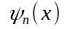 for any n, therefore no is an eigenfunction of 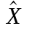.

d) The kinetic energy operator is 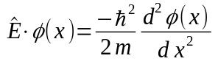. Therefore 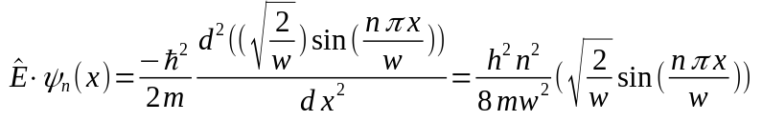. So for any n is an eigenfunction of the energy operator with eigenvalue 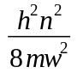. So when n=2 this eigenvalue is .

2a) 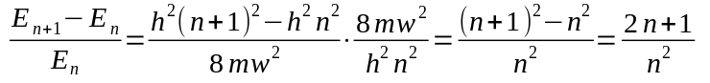

b) 3, 0.21, 0.0201, and 2 x 10⁻¹⁰

c) The Correspondence Principle states that when properties of quantum mechanical systems are measured at scales used in Classical Physics (specifically when the distances involved are much larger than the de Broglie wavelength of the particle in question) the results will be congruent with what we expect from classical physics. Specifically this means the results should appear continuous rather than quantized at classical scale. Because 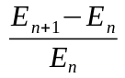 is the percent difference between successive energy levels, we see the Correspondence Principle is satisfied here because the difference between higher energy levels becomes very small as n increases thus the allowed energy levels will appear as a continuum and not quantized.

3) We know 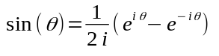 so then 

