Using div, a and img tags in the HTML

Tag a uses for permalinks to connect pages each other’s. Usually uses on navigation menus with tags ul, li.

* Simple using a tag in content:





* Using a tag on ul tag:

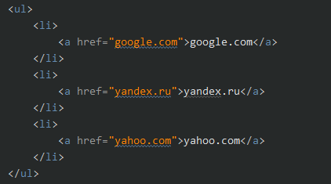



Tag img uses for showing photos, it has a lot of attributes. For example width, height, alt, src and e.t.c.





Tag div a one of the many using tags on HTML. It uses everywhere as container, can include multiple tags as group.

