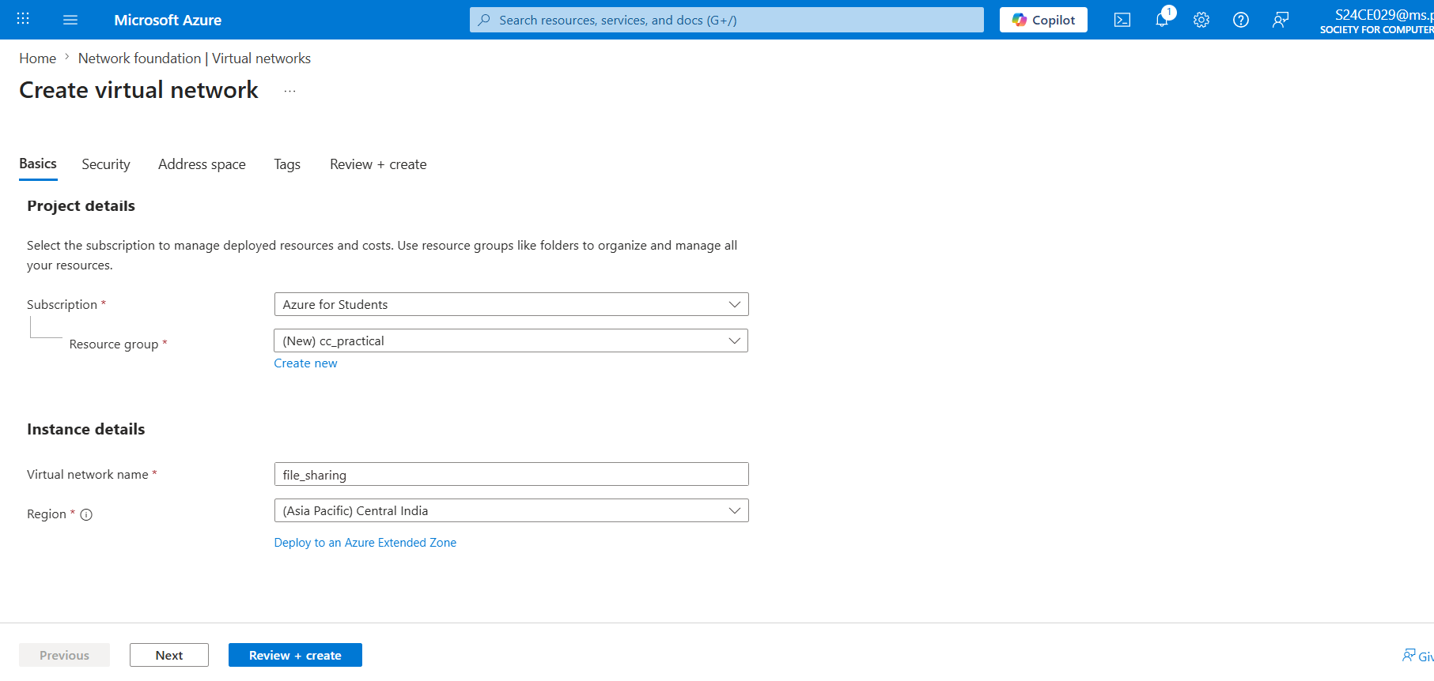
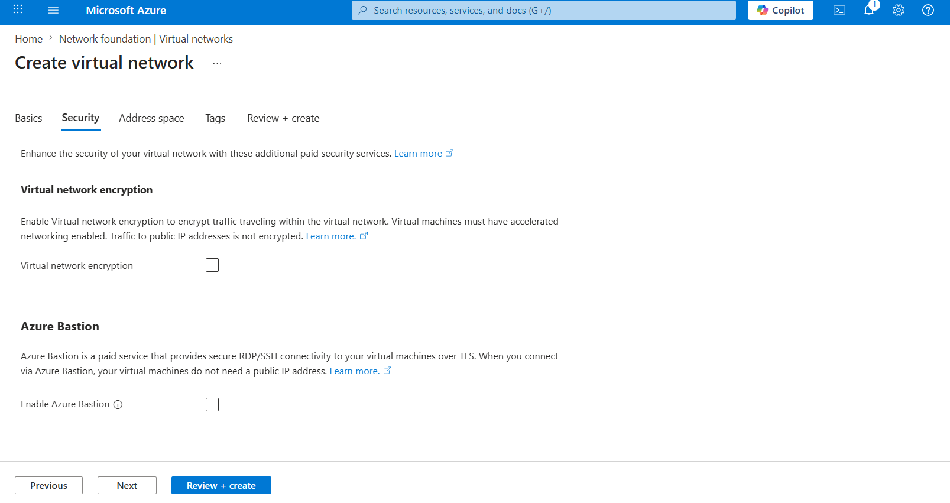
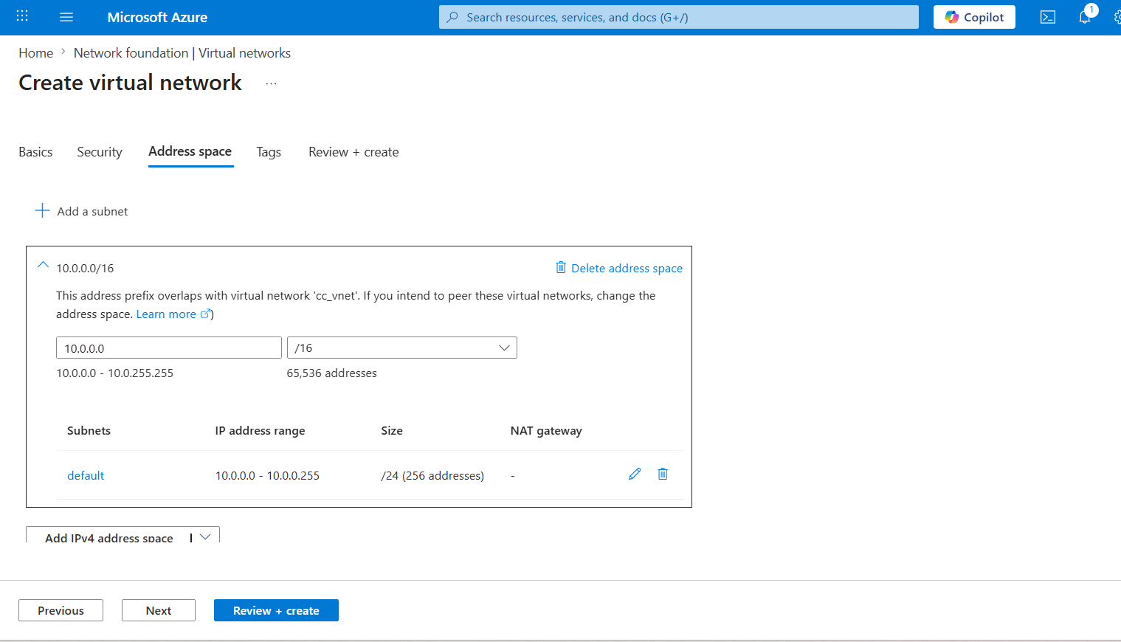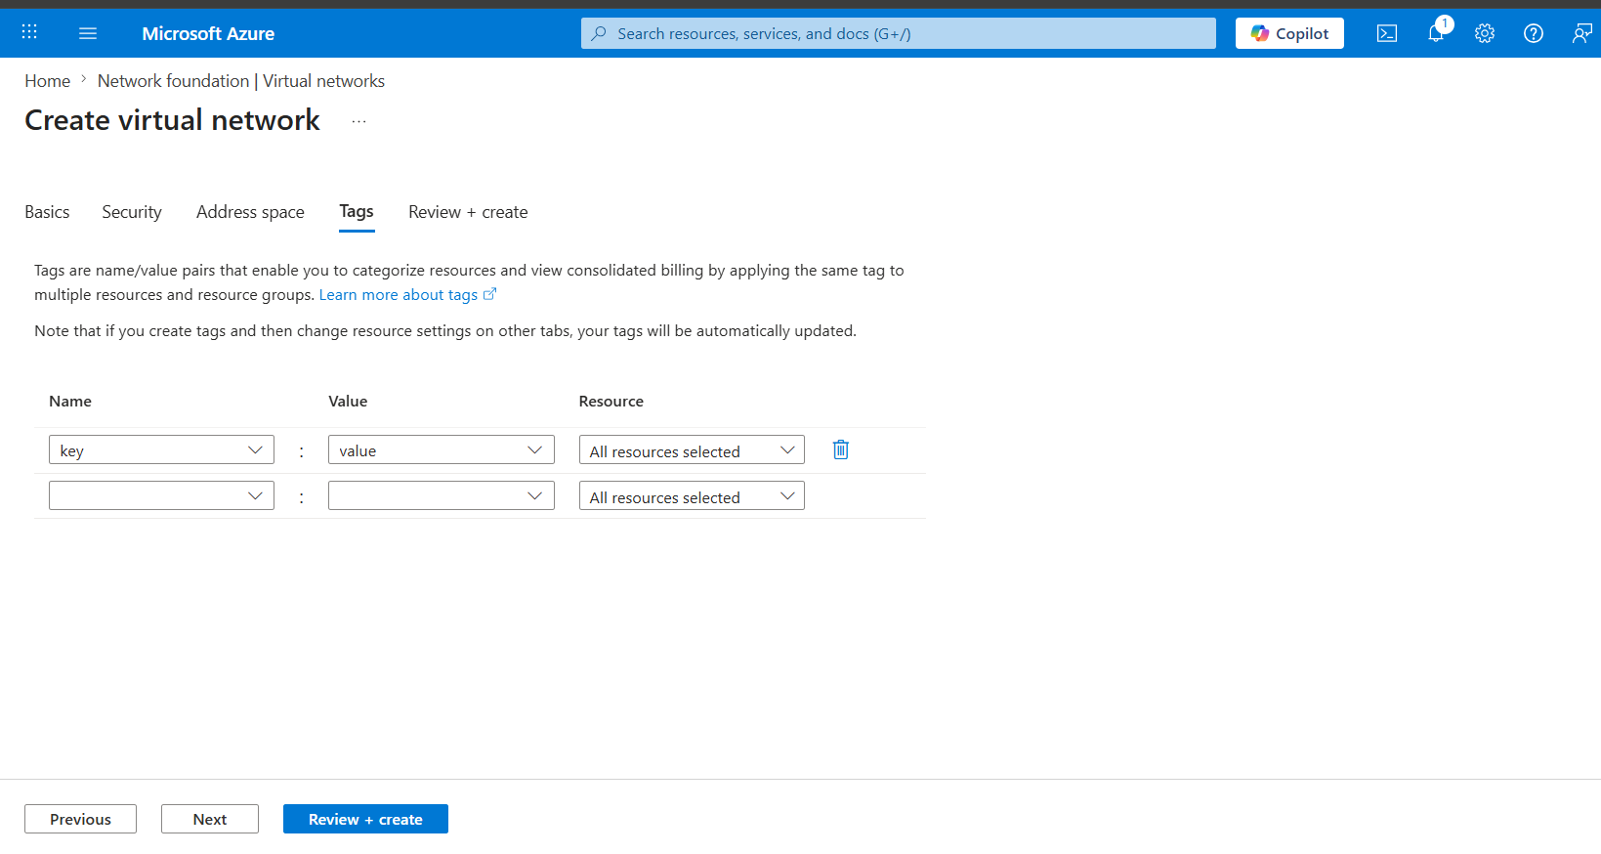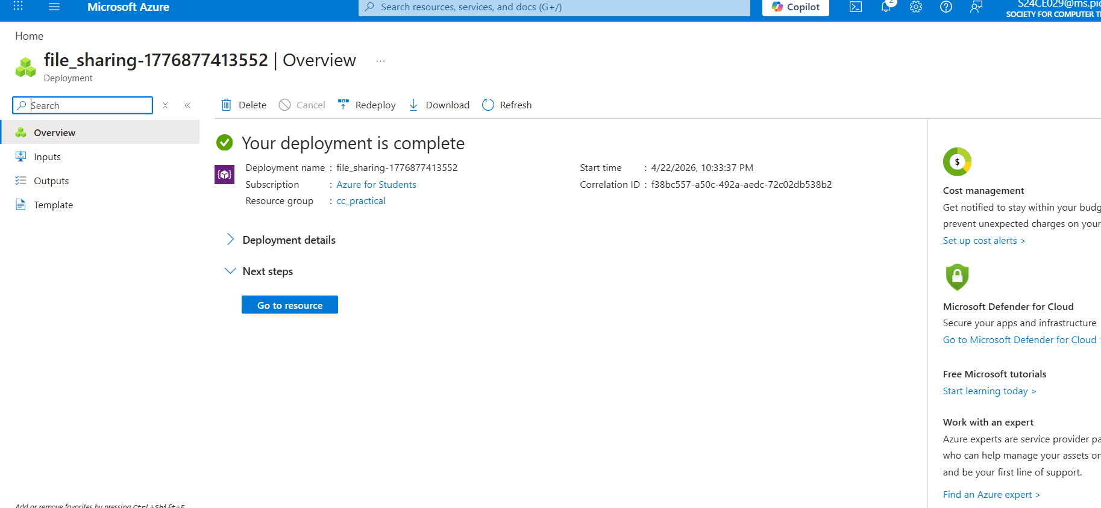
Now we have to create the virtual machine okay
go to virtual machine section
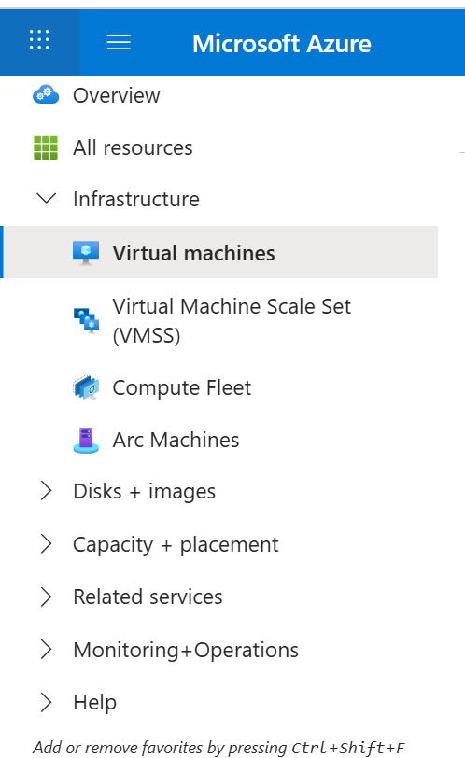
Click on create and create virtual machine
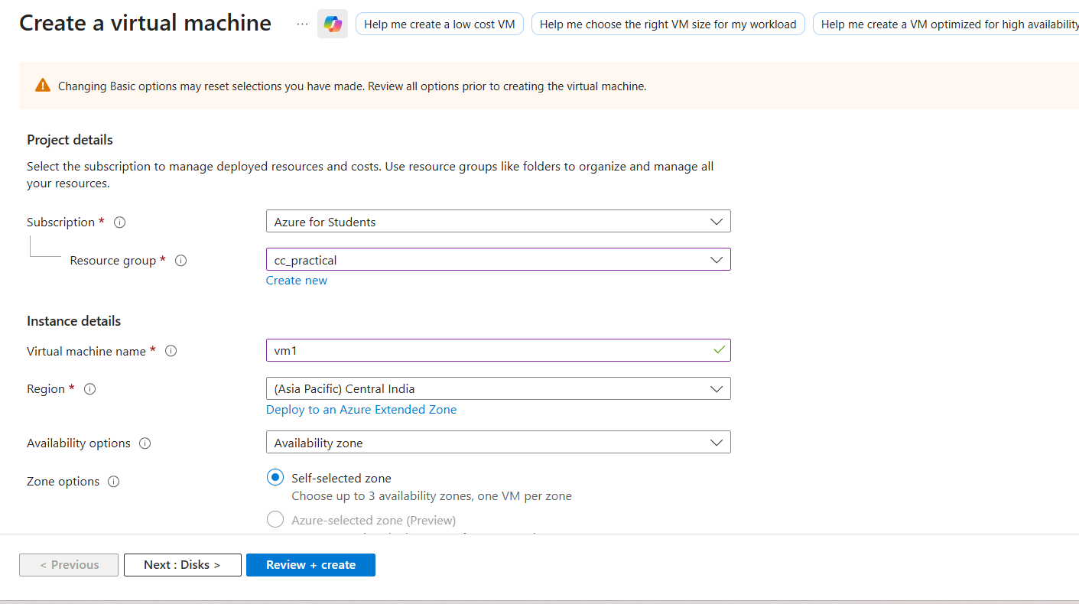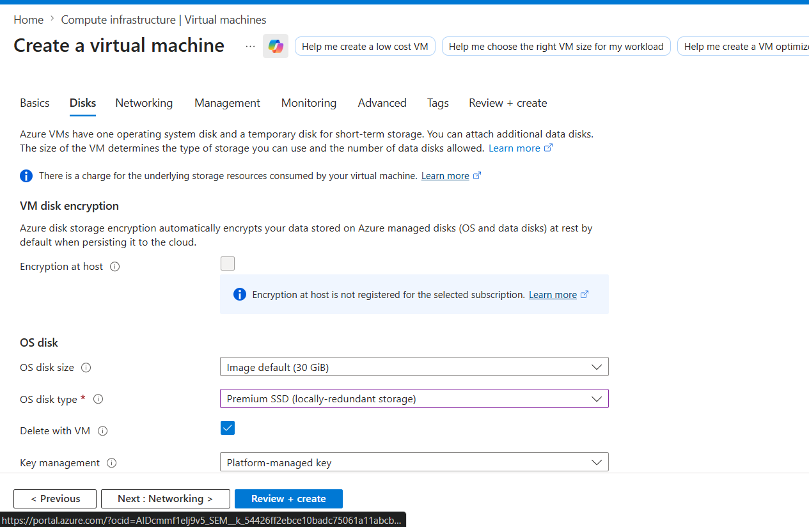
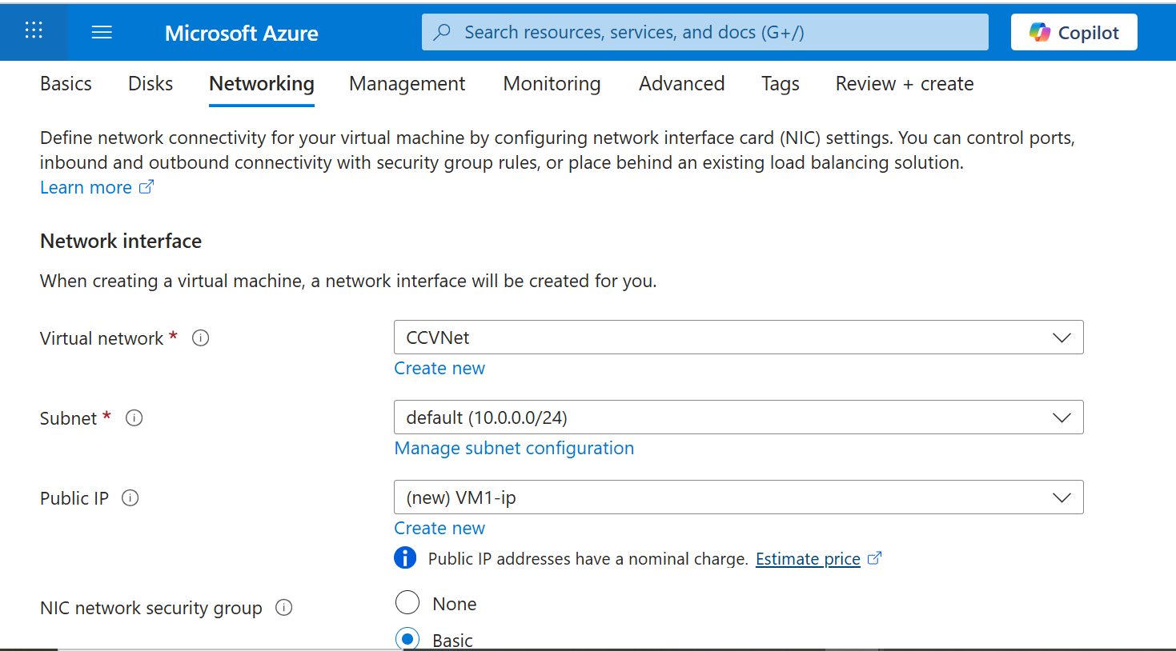
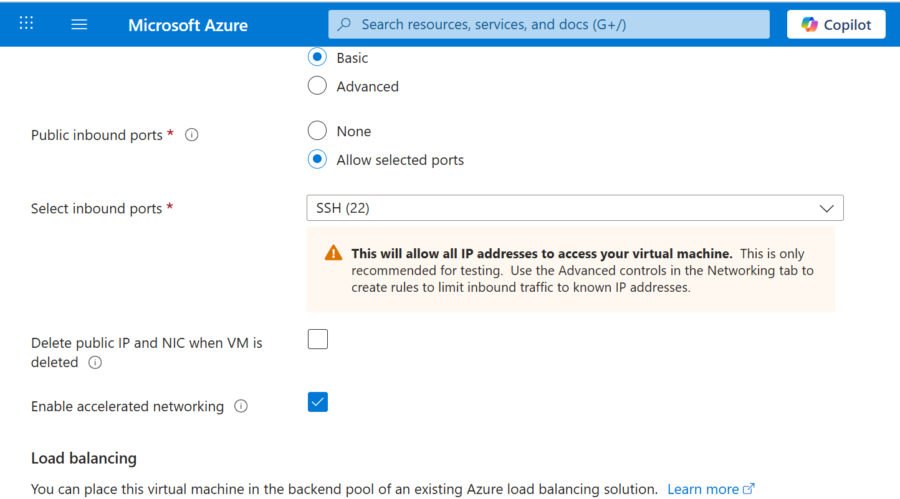
After Networking Click review+create

Download .pem file
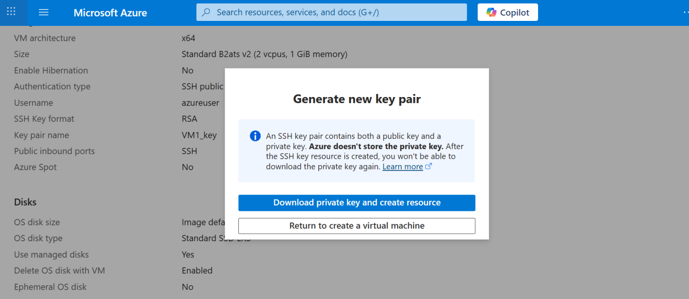
Create one more Virtual machine in same Way
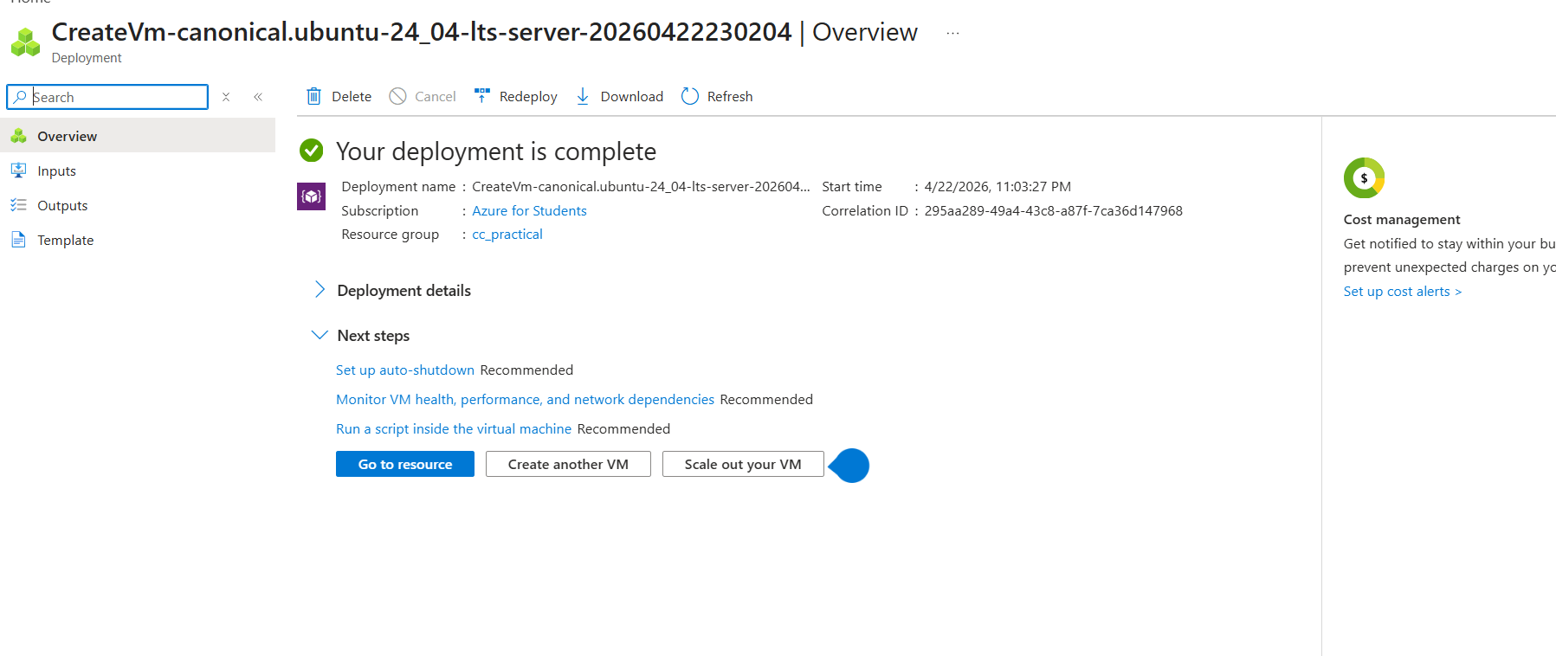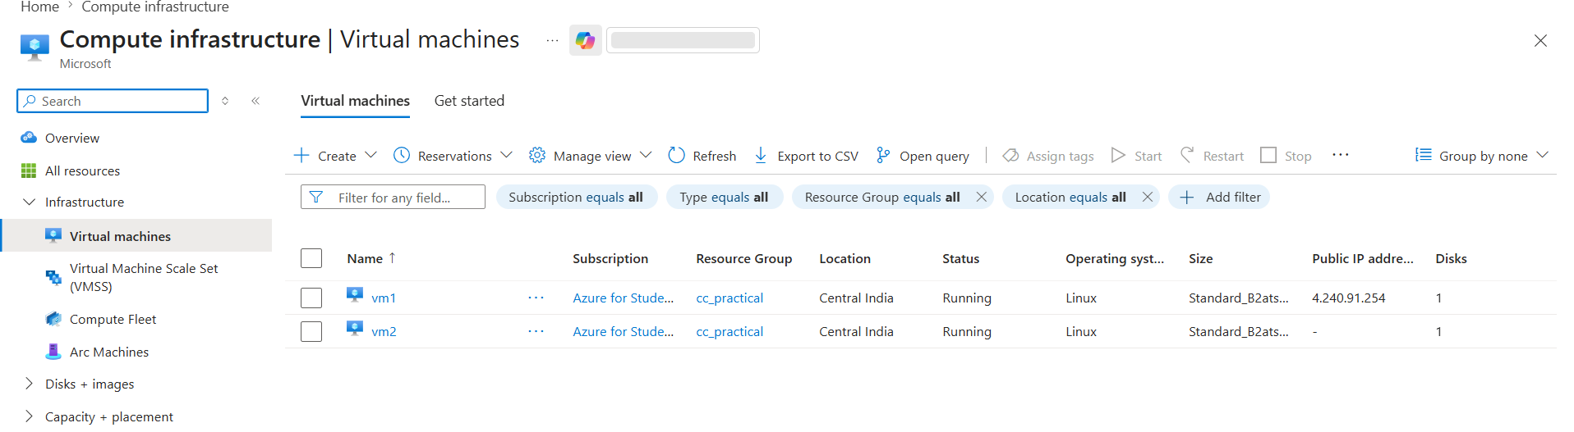

This is if SSH is Not Installed
Now open cmd where .pem files are saved usually in Downloads
Architecture:
Laptop → VM1 (Public IP) → VM2 (Private IP)
Steps Performed:
Step 1: Created Two Virtual Machines
- VM1 with public IP
- VM2 with private IP
- Both in same virtual network
Step 2: Connected to VM1
(Without SSH installed in CMD)
C:\Windows\System32\OpenSSH\ssh.exe -i vm1_key.pem azureuser@<VM1_PUBLIC_IP>
(If SSH installed)
ssh -i vm1_key.pem azureuser@<VM1_PUBLIC_IP>
C:\Users\Dell\Downloads>C:\Windows\System32\OpenSSH\ssh.exe -i vm1_key.pem azureuser@4.240.91.254
Welcome to Ubuntu 24.04.4 LTS (GNU/Linux 6.17.0-1011-azure x86_64)
* Documentation: https://help.ubuntu.com
* Management: https://landscape.canonical.com
* Support: https://ubuntu.com/pro
System information as of Wed Apr 22 17:51:31 UTC 2026

sSet permission on private key
This command restricts permissions of your private key file.
- 400 means:
  - Owner → read only ✅
  - No write ❌
  - No execute ❌
  - Others → no access ❌

azureuser@vm1:~$ chmod 400 vm2_key.pem
2. Create a file
azureuser@vm1:~$ echo "Hello from VM1" > test.txt
Copy file from VM1 → VM2
azureuser@vm1:~$ scp -i vm2_key.pem test.txt azureuser@10.0.0.5:/home/azureuser/
The authenticity of host '10.0.0.5 (10.0.0.5)' can't be established.
ED25519 key fingerprint is SHA256:FYHGX4oTAI5Ns2vh/I6AEpwhJICtYerUOxr+PZN5jcE.
This key is not known by any other names.
Are you sure you want to continue connecting (yes/no/[fingerprint])? yes
Warning: Permanently added '10.0.0.5' (ED25519) to the list of known hosts.
test.txt 100% 15 45.2KB/s 00:00
Connect to VM2 using SSH
azureuser@vm1:~$ ssh -i vm2_key.pem azureuser@10.0.0.5
Welcome to Ubuntu 24.04.4 LTS (GNU/Linux 6.17.0-1011-azure x86_64)
azureuser@vm2:~$ ls
test.txt
azureuser@vm2:~$ cat test.txt
Hello from VM1
azureuser@vm2:~$

If SSH is Installed
🔹 Terminal 1
cd Downloads
👉 Moves to the folder where your .pem key files are stored
scp -i VM1_key.pem VM2_key.pem azureuser@20.255.56.127:/home/azureuser/
👉 Copies VM2 key file from your local system to VM1
👉 Uses VM1 key to authenticate
👉 This allows VM1 to later connect to VM2 securely
ssh -i VM1_key.pem azureuser@20.255.56.127
👉 Connects (login) to VM1 using SSH key authentication
chmod 400 VM2_key.pem
👉 Sets secure permission on VM2 key
👉 Only owner can read the file (required for SSH security)
echo "Hello from VM1" > test.txt
👉 Creates a file named test.txt with sample content in VM1
scp -i VM2_key.pem test.txt azureuser@10.0.0.5:/home/azureuser/
👉 Transfers file from VM1 → VM2
👉 Uses VM2 key for authentication
👉 Uses private IP (secure internal network communication)
🔹 Terminal 2
cd Downloads
👉 Opens folder where VM2 key is stored
ssh -i VM2_key.pem azureuser@10.0.0.5
👉 Connects to VM2 using its SSH key
👉 Access is done via private IP
ls
👉 Lists files in VM2 directory
👉 Used to check if file transfer was successful
cat test.txt
👉 Displays contents of the transferred file
👉 Confirms successful and correct file transfer
🎯 One-Line Summary
👉 Secure file transfer is done using SCP over SSH, with authentication using private keys and communication through a private network.

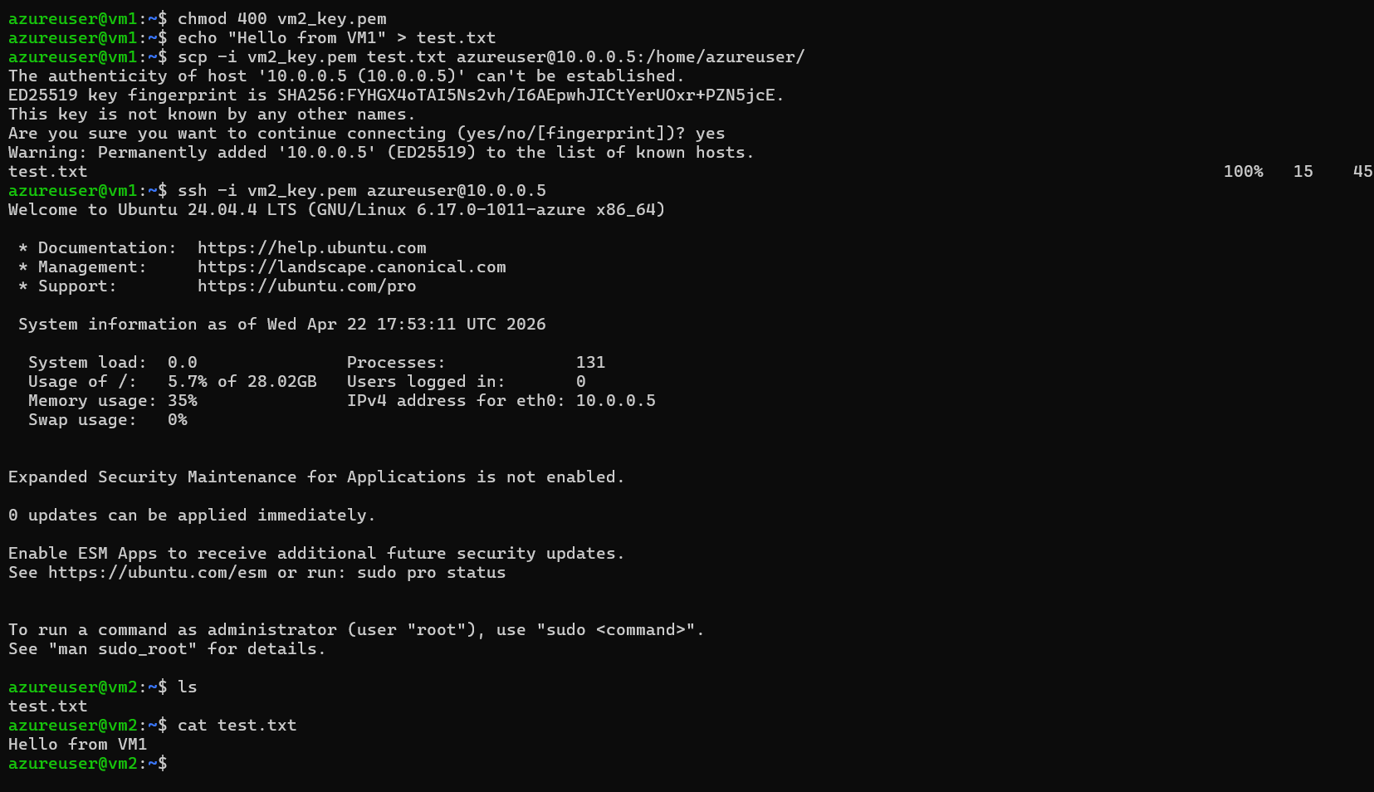
Perfect — here are the REVERSE STEPS (VM2 → VM1) with clear comments, same style as yours 👇
🔁 Reverse Transfer (VM2 → VM1) with Comments
🔹 Inside VM2 (after logging in)
echo "Hello from VM2" > reply.txt
👉 Creates a new file reply.txt in VM2 with sample content
scp vm1_key.pem azureuser@10.0.0.5:/home/azureuser/
👉 (Run this from VM1 earlier if not done)
👉 Copies VM1 key into VM2 so VM2 can authenticate while sending file back
chmod 400 vm1_key.pem
👉 Sets secure permission on VM1 key inside VM2
👉 Required for SSH to accept the key
scp -i vm1_key.pem reply.txt azureuser@10.0.0.4:/home/azureuser/
👉 Transfers file from VM2 → VM1
👉 Uses VM1 private IP (10.0.0.4)
👉 Uses VM1 key for authentication
🔹 Back to VM1 (verification)
ls
👉 Lists files in VM1
👉 Used to check if reply.txt is received
cat reply.txt
👉 Displays content of received file
👉 Confirms successful reverse file transfer
🎯 Key Understanding
Direction | Key Used | Source VM
VM1 → VM2 | VM2_key.pem | VM1
VM2 → VM1 | VM1_key.pem | VM2
💬 One-Line for Viva
“Bidirectional secure file transfer was achieved using SCP and SSH keys over a private network.”

