Assignment 4 : PL/SQL
Roll No:-31453

-> Roll_No INT PRIMARY KEY,
-> Name VARCHAR(50),
-> Date_of_Issue DATE,
-> Name_of_book VARCHAR(200),
-> Status CHAR(1) CHECK(Status IN ('I','R'))
-> );
Query OK, 0 rows affected (0.179 sec)

MariaDB [te31453_db]> CREATE TABLE fine (
-> Roll_No INT,
-> Fine_date DATE,
-> Amt DECIMAL(8,2),
-> CONSTRAINT fk_fine_borrower FOREIGN KEY (Roll_No) REFERENCES borrower (Roll_No)
-> );
Query OK, 0 rows affected (0.168 sec)

1) Create Procedure
MariaDB [te31453_db]> CREATE OR REPLACE PROCEDURE Issue_Book(
-> IN p_roll_no INT,
-> IN p_name VARCHAR(100),
-> IN p_issue_date DATE,
-> IN p_book_name VARCHAR(200)
-> )
-> BEGIN
-> DECLARE EXIT HANDLER FOR SQLEXCEPTION
-> BEGIN
-> ROLLBACK;
-> SELECT 'Error occurred, transaction rolled back!!' AS message;
-> END;
->
-> START TRANSACTION;
->
-> INSERT INTO borrower (Roll_No, Name, Date_of_Issue, Name_of_book, Status)
-> VALUES (p_roll_no, p_name, p_issue_date, p_book_name, 'I');
->
-> COMMIT;
->
-> SELECT 'Book issued successfully!!' AS message;
-> END$$
Query OK, 0 rows affected (0.098 sec)

MariaDB [te31453_db]>
MariaDB [te31453_db]> DELIMITER ;

MariaDB [te31453_db]> CALL issue_book(101,'John Doe','2025-07-01','Oracle Database Concepts');
+----------------------------+
| message |
+----------------------------+
| Book issued successfully!! |
+----------------------------+
1 row in set (0.026 sec)

Query OK, 1 row affected (0.026 sec)

MariaDB [te31453_db]> select * from borrower;
+---------+----------+---------------+--------------------------+--------+
| Roll_No | Name | Date_of_Issue | Name_of_book | Status |
+---------+----------+---------------+--------------------------+--------+
| 101 | John Doe | 2025-07-01 | Oracle Database Concepts | I |
+---------+----------+---------------+--------------------------+--------+
1 row in set (0.001 sec)

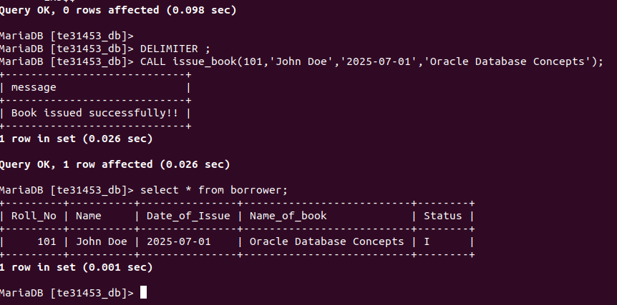
MariaDB [te31453_db]>

Exception Handler
CALL Issue_Book('205','Mayuri Sable','2025-03-13','The Pysology of Money');
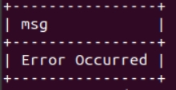

Display Records

SELECT * FROM borrow;
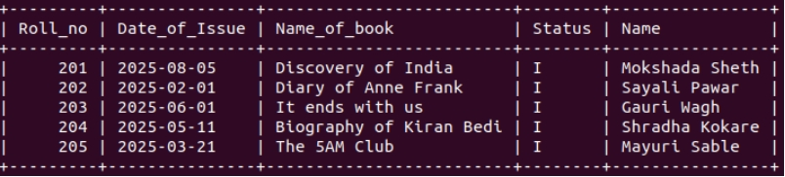
**Procedure to set fine if between 15 and 30 Rs 5/- per day. If >30 then Rs 50/- per day**
DELIMITER $$
MariaDB [te31448_db]> CREATE OR REPLACE PROCEDURE Return_Book(
-> IN p_roll_no INT,
-> IN p_return_date DATE)
-> BEGIN
-> DECLARE v_days INT;
-> DECLARE v_issue_date DATE;
-> DECLARE v_fine_amount DECIMAL(8,2);
-> SELECT Date_of_Issue INTO v_issue_date FROM borrow WHERE Roll_no = p_roll_no;
-> SET v_days = DATEDIFF(p_return_date,v_issue_date);
-> SET v_fine_amount = 0;
-> IF v_days BETWEEN 15 AND 30 THEN
-> SET v_fine_amount= (v_days-14)*5;
-> ELSEIF v_days>30 THEN
-> SET v_fine_amount= ((v_days-30)*50)+((v_days-14-(v_days-30))*5);
-> -- fiine=(days beyond 30×50)+(days between 15 and 30×5)
-> END IF;
-> UPDATE borrow SET Status='R' WHERE Roll_NO = p_roll_NO AND Status='I';
-> IF v_fine_amount>0 THEN
-> INSERT INTO fine(Roll_no,Fine_date,Amt) VALUES(p_roll_no,p_return_date,v_fine_amount);
-> END IF;
-> SELECT CONCAT('Return Processed.Fine amount: Rs ',v_fine_amount) AS msg;
-> END
-> $$ DELIMITER

Call Return Book
-- No fine
CALL Return_Book(203,'2025-06-12');

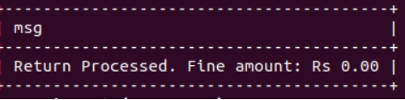

** days between 15-30

CALL Return_Book(204,'2025-05-30');

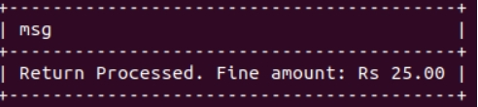

**days >30

CALL Return_Book(205,'2025-04-30');

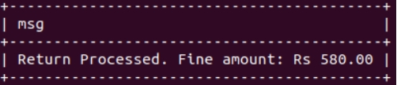

**Status updated

SELECT * FROM borrow;

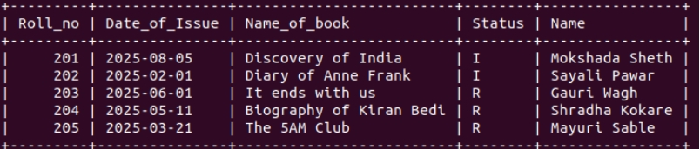

** Fine table

SELECT * FROM fine;

