Step-by-Step Procedure: Salesforce Calculator Project

Step 1: Login to Salesforce
- Open your browser
- Go to Salesforce login page
- Enter your username and password
- Click Login

Step 2: Open Developer Console
- After login, go to the top right corner
- Click on the Settings (⚙️ Gear icon)
- Click on Developer Console
- A new window (Developer Console) will open
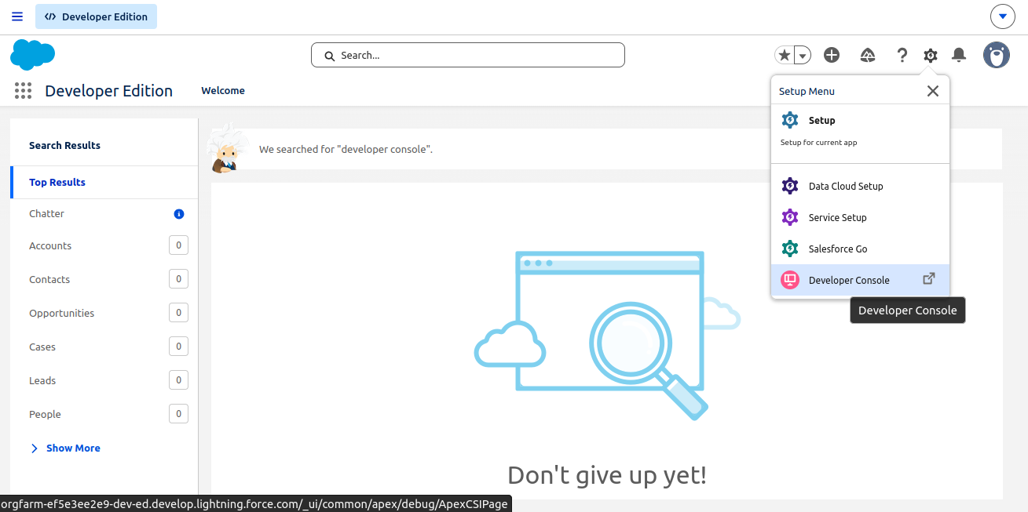

Step 3: Create Apex Controller Class
- Click on File
- Click New → Apex Class
- Enter class name: CalculatorVFController
- Click OK
- Paste controller code and click Save
public class CalculatorVFController {

public Decimal num1 {get; set;}
public Decimal num2 {get; set;}
public Decimal result {get; set;}

public void add() {
result = Calculator.addNumbers(num1, num2);
}

public void subtract() {
result = Calculator.subtractNumbers(num1, num2);
}

public void multiply() {
result = Calculator.multiplyNumbers(num1, num2);
}

public void divide() {
try {
result = Calculator.divideNumbers(num1, num2);
} catch (Exception e) {
ApexPages.addMessage(
new ApexPages.Message(ApexPages.Severity.ERROR, e.getMessage())
);
}
}
}

Step 4: Create Visualforce Page (UI)
- Click on File
- Click New → Visualforce Page
- Enter page name: CalculatorPage
- Click OK
- Paste Visualforce code and click Save
<apex:page controller="CalculatorVFController">
<apex:form>

<apex:pageBlock title="Simple Calculator">

<!-- Messages (for errors like divide by zero) -->
<apex:pageMessages />

<!-- Input Section -->
<apex:pageBlockSection title="Enter Numbers" columns="1">
<apex:inputText value="{!num1}" label="First Number" required="true"/>
<apex:inputText value="{!num2}" label="Second Number" required="true"/>
</apex:pageBlockSection>

<!-- Buttons Section -->
<apex:pageBlockButtons location="bottom">
<apex:commandButton value="Add" action="{!add}" rerender="resultPanel"/>
<apex:commandButton value="Subtract" action="{!subtract}" rerender="resultPanel"/>
<apex:commandButton value="Multiply" action="{!multiply}" rerender="resultPanel"/>
<apex:commandButton value="Divide" action="{!divide}" rerender="resultPanel"/>
</apex:pageBlockButtons>

<!-- Result Section -->
<apex:outputPanel id="resultPanel">
<apex:pageBlockSection title="Result">
<apex:outputText value="{!result}" style="font-size:18px; font-weight:bold;"/>
</apex:pageBlockSection>
</apex:outputPanel>

</apex:pageBlock>

</apex:form>
</apex:page>

Step 5: Preview the Application
- In Developer Console, open CalculatorPage
- Click on Preview (top right corner)
- A new browser tab will open
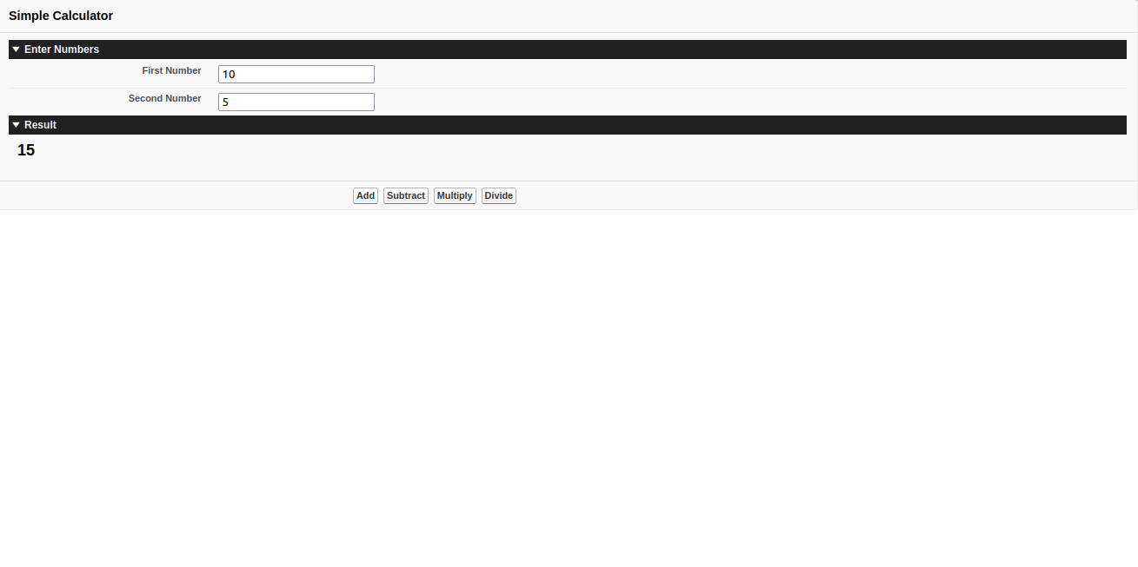

Step 6: Test the Calculator
- Enter value in First Number field
- Enter value in Second Number field
- Click any operation:
  - Add
  - Subtract
  - Multiply
  - Divide
- View the result displayed on screen.

Conclusion
The calculator application is successfully created using Apex and Visualforce. The system performs arithmetic operations and displays results dynamically.

