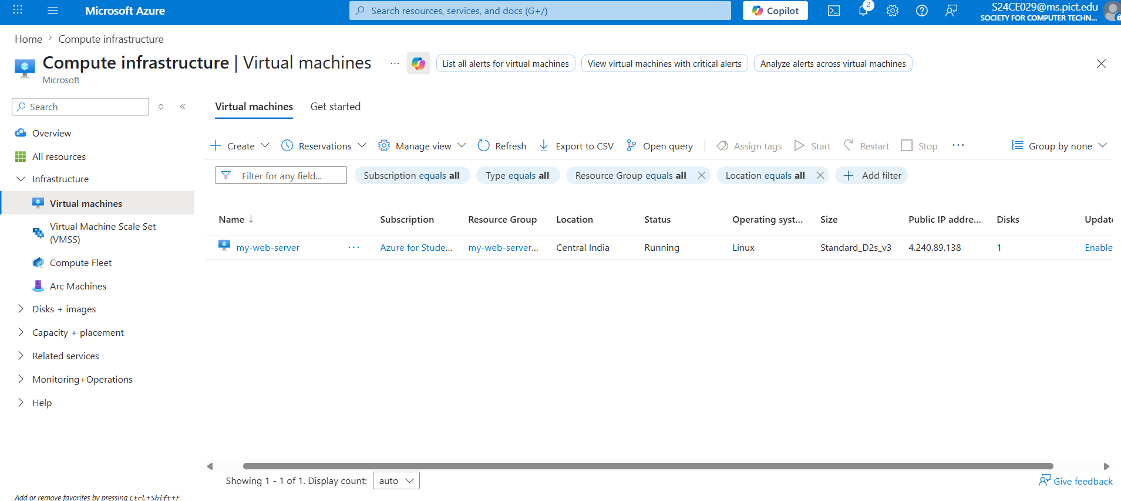

Click on that Virtual Machine
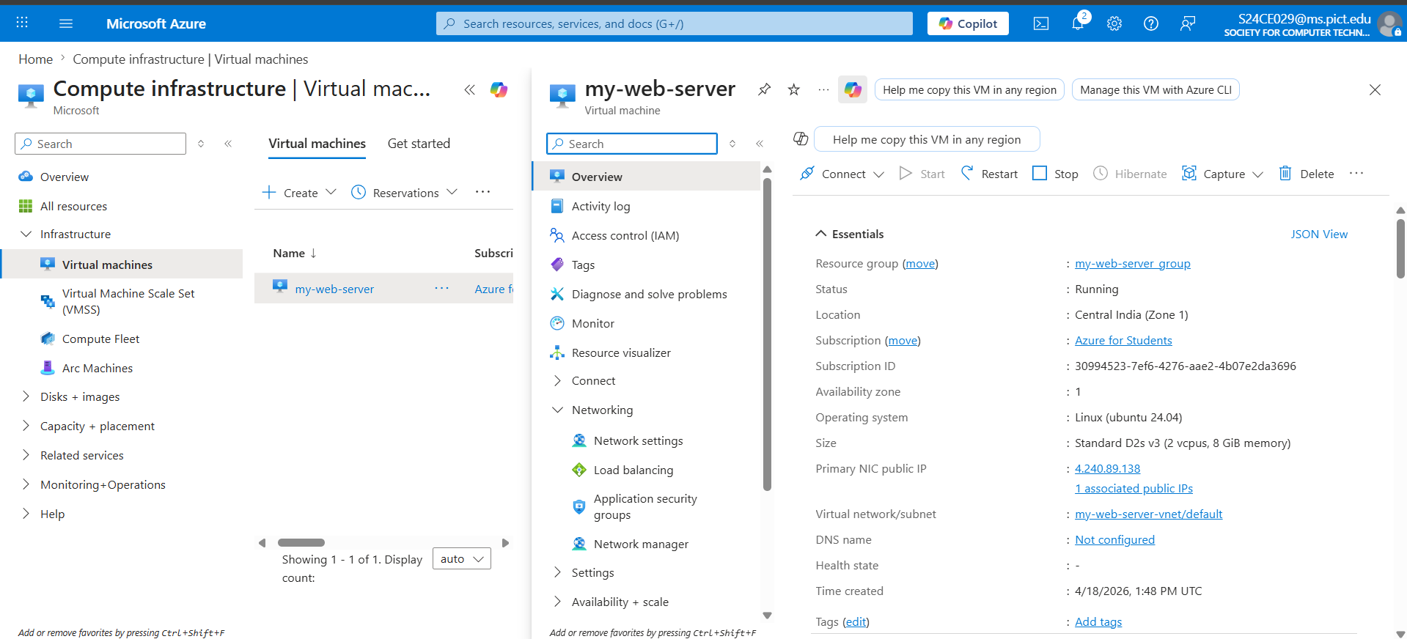

Now at Right Side Top Corner there is Connect Option
Click on it then it will show 2 more options
- Connect
- Connect via Bastion
Click on Connect
After clicking on it scroll down you will see More ways to connect
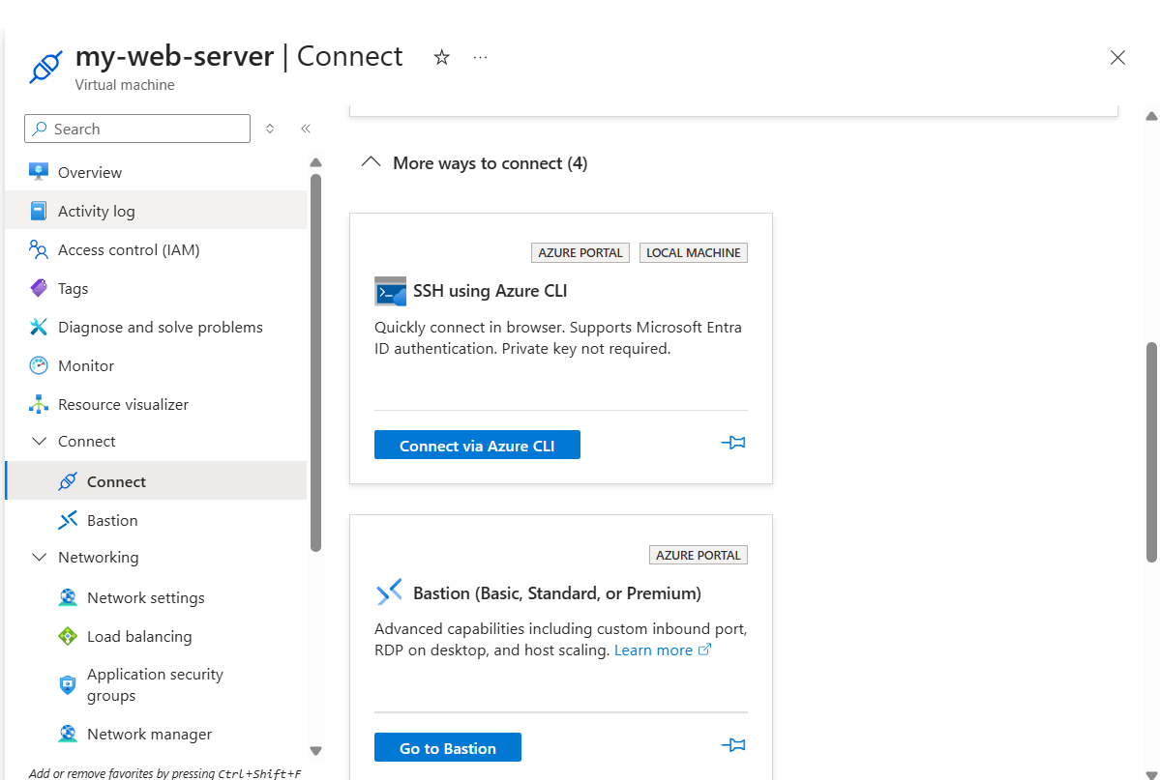

Click on SSH using Azure CLI
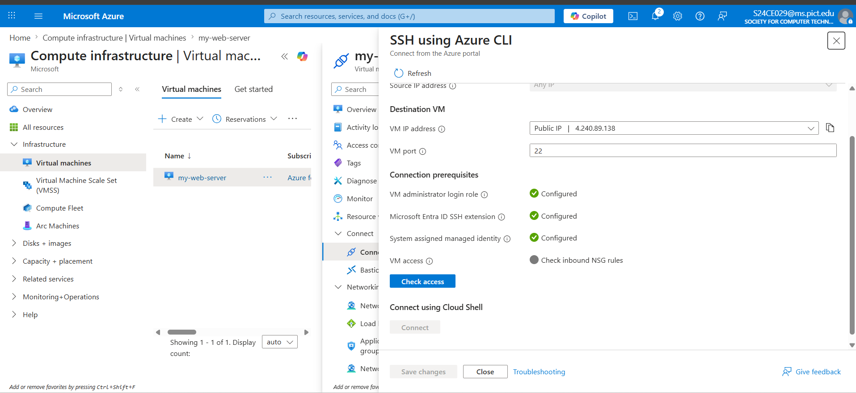
Click on Check Access and then click on Connect
Then a pop will come and ask about
BASH or POWERSHELL
Click on BASH then it will open SSH terminal

✅ Correct Final Flow (Clean + Perfect)
🔹 1. Connect to VM
az ssh vm --resource-group <your-group> --vm-name <your-vm>
az ssh vm --resource-group my-web-server_group --vm-name my-web-server

🔹 2. Install Apache
sudo apt update
sudo apt install apache2 -y

🔹 3. Start Apache
sudo systemctl start apache2
sudo systemctl enable apache2

🔹 4. Allow HTTP
sudo ufw allow 'Apache'

🔹 5. Go to Website Folder
cd /var/www/html

🔹 6. Remove Default Page
sudo rm index.html

🔹 7. Create Website
sudo nano index.html
👉 THEN paste HTML (inside nano, not in terminal directly ❗)
<!DOCTYPE html>
<html>
<head>
<title>My Azure Website</title>
</head>
<body>
<h1>Welcome to My Cloud Website 🚀</h1>
<p>Deployed using Azure VM</p>
</body>
</html>
👉 Save:
- CTRL + X
- Y
- Enter

🔹 8. Open Website
👉 In browser:
http://4.240.89.138
(Use your actual public IP)

❗ IMPORTANT CORRECTIONS
❌ Mistake 1:
You wrote HTML directly after command
👉 WRONG — must paste inside nano editor

❌ Mistake 2:

Don’t forget Azure Networking Rule
👉 Port 80 must be allowed
If not click on Networks
Network setting
scroll down
+create port rule
click on inbound port rule
Destination port ranges
80

To open file and update code
$ sudo nano /var/www/html/index.html

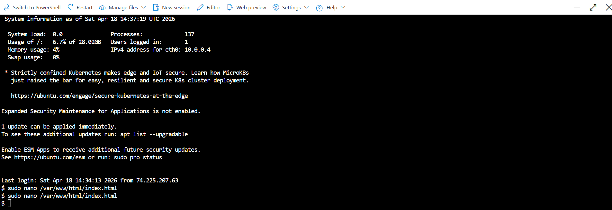
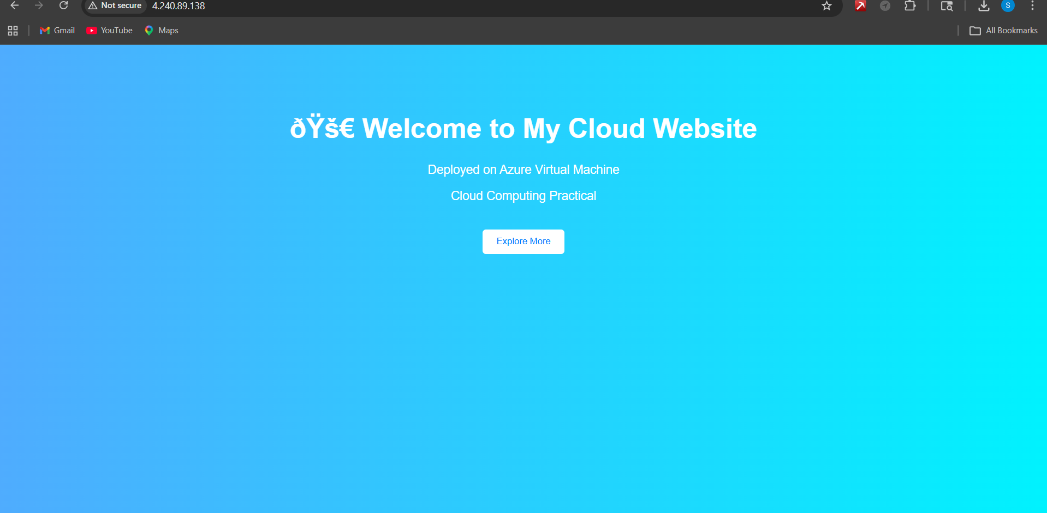
<!DOCTYPE html>
<html>
<head>
<title>My Azure Website</title>
<style>
body {
margin: 0;
font-family: Arial, sans-serif;
background: linear-gradient(to right, #4facfe, #00f2fe);
text-align: center;
color: white;
}
.container {
margin-top: 100px;
}
h1 {
font-size: 40px;
}
p {
font-size: 18px;
}
.btn {
margin-top: 20px;
padding: 10px 20px;
background-color: white;
color: #007BFF;
border: none;
border-radius: 5px;
cursor: pointer;
}
.btn:hover {
background-color: #ddd;
}
</style>
</head>
<body>
<div class="container">
<h1>🚀 Welcome to My Cloud Website</h1>
<p>Deployed on Azure Virtual Machine</p>
<p>Cloud Computing Practical</p>
<button class="btn">Explore More</button>
</div>
</body>
</html>

<!DOCTYPE html>
<html>
<head>
<title>My Azure Website</title>
</head>
<body>
<h1>Welcome to My Cloud Website 🚀</h1>
<p>Deployed using Azure VM</p>
</body>
</html>

