|  |
| --- |
| JAVALIFE |
| CS 1632 - DELIVERABLE 5: Performance Testing Conway's Game of Life  <https://github.com/MeSz/SlowLifeGUI> |

|  |
| --- |
| Joe Meszar (jwm54@pitt.edu)  4/5/2016 |

# SUMMARY

Using exploratory testing, coupled with the VisualVM profiler, it was actually quite simple to see exactly where the bottlenecks in the “Game Of Life” were to be found. The first step was to run the program with an input (15) and see how exactly it operated. Testing all of the possible operations of the GUI, I then profiled the program with VisualVM and ran the exact same tests. This plainly made aware what methods were causing the program to run sluggish (see screenshots of VisualVM below):

MainPanel.convertToInt()

MainPanel.runContinous()

MainPanel.toString() //found via Exploratory testing, not VisualVM

Cell.toString()

As part of the optimization process, I came across an error that I fixed. This issue was in the MainPanel.convertToInt() method, where a negative number would cause the program to error out. Now, any int value can properly be sent in and returned.

# VISUALVM (PRE-OPTIMIZED)

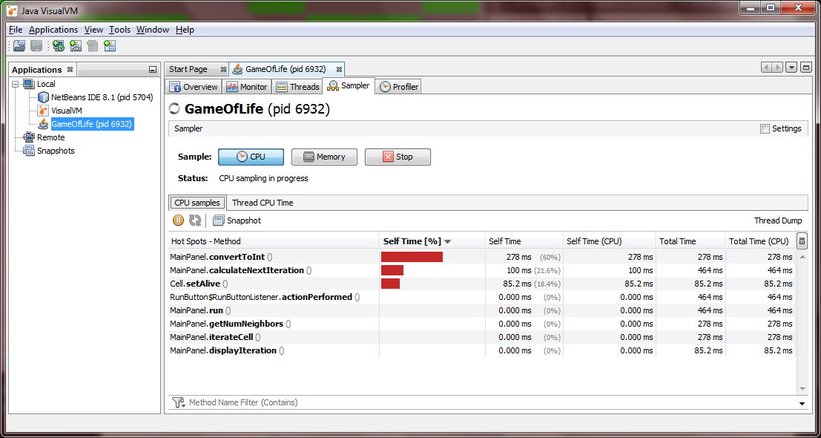

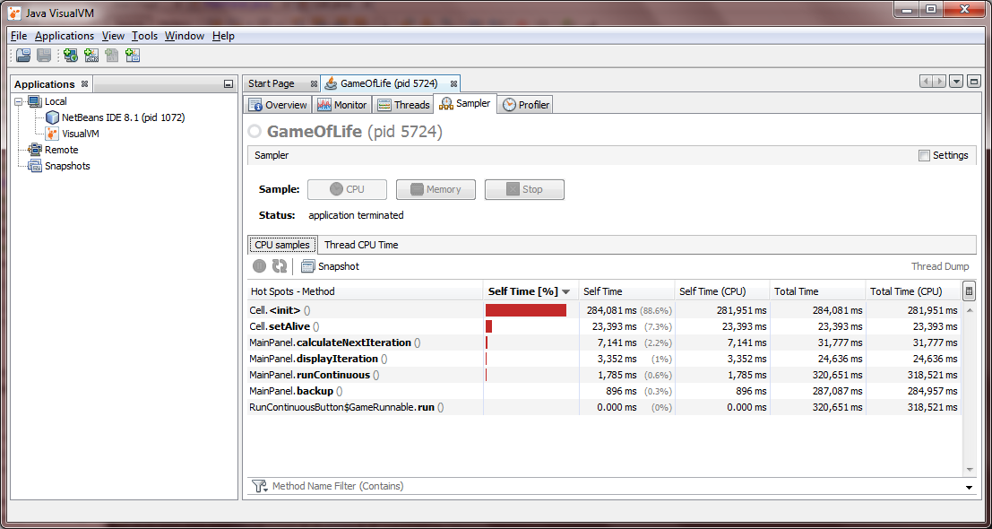

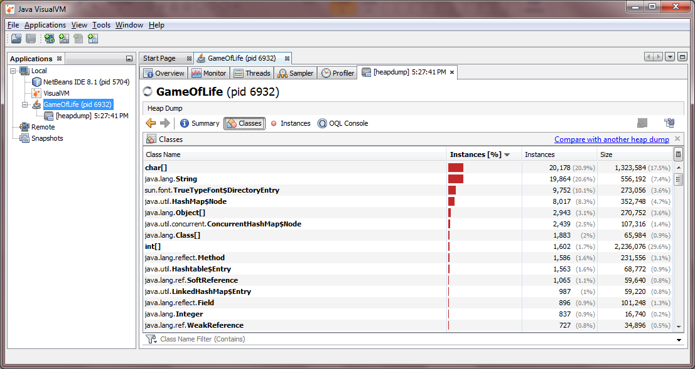

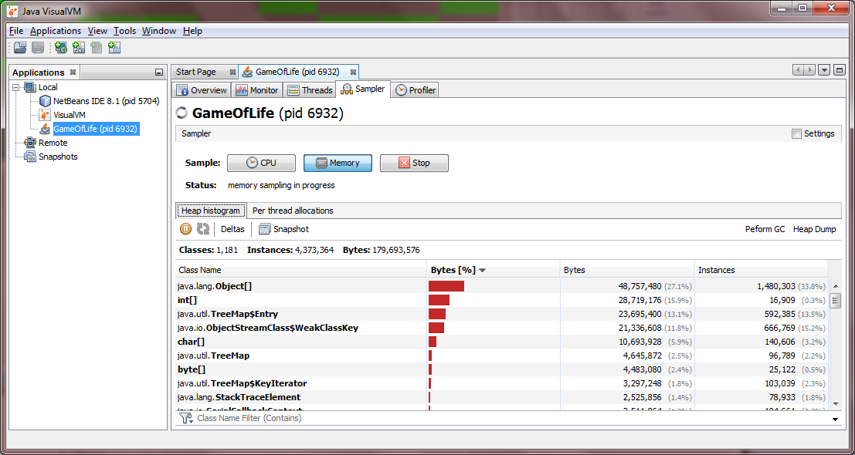

# VISUALVM (POST-OPTIMIZED)

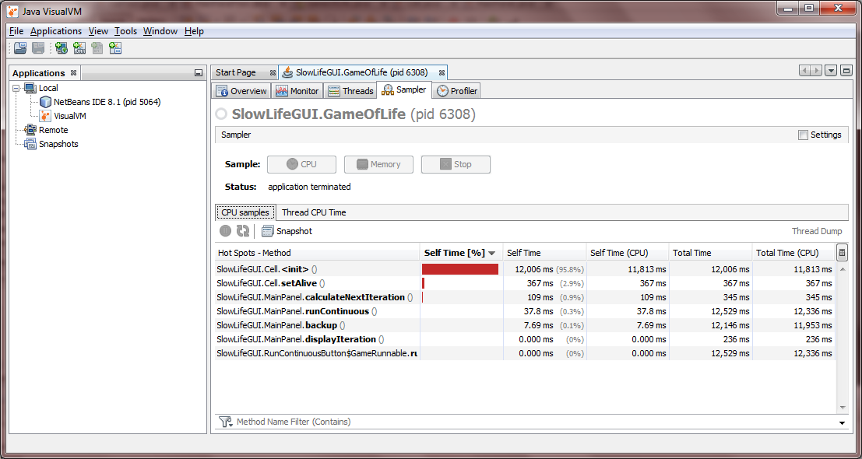

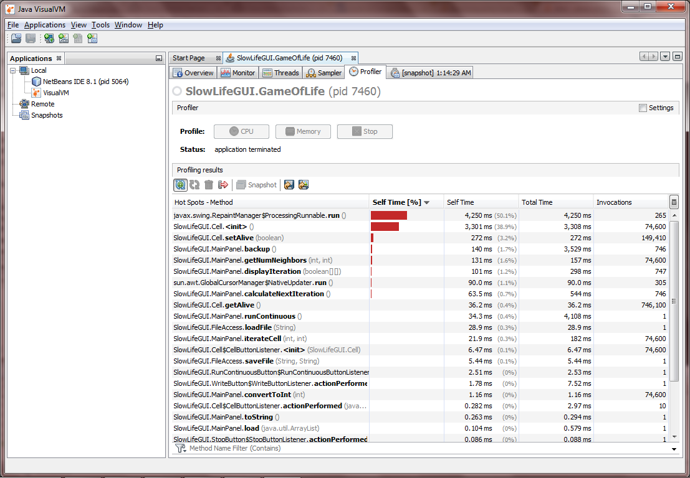

# JUNIT EXECUTION RESULTS

