**Documentation**

**Questions for Considering Potential Ideas for Your Portfolio Website**

**Mission Statement:**

Our mission is to create a compelling and professional online portfolio that effectively showcases our expertise in web development, UI design, and marketing. By highlighting our skills, projects, and achievements, we aim to attract potential clients, collaborators, and employers, demonstrating our commitment to delivering innovative digital solutions that drive business success.

**Who?**

**Who will benefit from your idea?**

* Potential clients seeking web development, UI design, and marketing services.
* Businesses looking for effective digital solutions and marketing strategies.
* Recruiters and collaborators interested in your skills and professional experience.

**What?**

**What made you decide that this would be a good idea?**

* The growing demand for skilled full-stack developers and marketing professionals.
* The need for a professional online presence to showcase your work and attract clients.
* Feedback from peers and mentors highlighting the importance of an online portfolio.

**Where?**

**Where has your idea been successfully implemented?**

* Many successful developers and marketing professionals have their own portfolio websites.
* Leading industry professionals use portfolios to demonstrate their skills and past projects.
* Online platforms and social media where personal branding and professional showcasing are essential.

**When?**

**When will the implementation of your idea show results?**

* The initial setup and design of the portfolio website can be completed within a few weeks.
* Results in terms of client inquiries and job opportunities may start showing within a few months of active promotion.
* Continuous updates and optimizations will enhance visibility and engagement over time.

**Why?**

**Why should you use this method over any other in existence?**

* A portfolio website provides a centralized platform to display your services, skills, and projects.
* It allows for greater control over your personal brand and online presence compared to social media alone.
* A website can be tailored to your specific needs and can include various interactive elements to engage visitors.

**How?**

**How should you implement your idea?**

* Start by planning the structure and content of your portfolio website.
* Use your web development skills to design and develop the site, ensuring it is responsive and user-friendly.
* Incorporate SEO strategies to enhance search engine visibility.
* Regularly update the website with new projects, blog posts, and testimonials to keep it current and relevant.

**Huh?**

**Does your idea make sense?**

* Yes, having a portfolio website is a standard practice for professionals in web development and marketing.
* It provides a professional and comprehensive way to showcase your skills and attract potential clients or employers.

## If there are any aspects that seem unclear or unfeasible, consider refining your idea or seeking feedback from trusted peers. **How DBS, DSA, OOP, and Software Construction Principles are Used in a Portfolio Website**

**1. Database Systems (DBS)**

**Role in Portfolio Website:**

* **Data Storage:** A database is used to store all the data related to the portfolio website, such as user information, project details, blog posts, contact form submissions, and more.
* **Data Retrieval:** Efficient querying mechanisms ensure that data can be retrieved quickly and accurately. For example, when a user searches for specific projects or blog posts, the database retrieves the relevant data.
* **Data Management:** Databases facilitate easy management of data, allowing for updates, deletions, and additions without affecting the website's overall performance.
* **Security:** Implementing security measures such as encryption and access control within the database helps protect sensitive information from unauthorized access.

**Examples:**

* Using MySQL or PostgreSQL to manage and store user profiles, project descriptions, images, and feedback.
* Implementing CRUD (Create, Read, Update, Delete) operations for managing content dynamically through an admin panel.

**3. Object-Oriented Programming (OOP)**

**Role in Portfolio Website:**

* **Modular Design:** OOP principles enable a modular approach to design, where different components of the website (e.g., user interface, data handling, and business logic) are encapsulated within classes and objects.
* **Reusability:** Classes and objects can be reused across the website, reducing code duplication and improving maintainability. For instance, a Project class can be used to create and manage different project entries.
* **Inheritance and Polymorphism:** These principles allow for creating a hierarchy of classes that share common functionality, promoting code reusability and extensibility. For example, a BlogPost class might inherit from a Content base class.
* **Encapsulation:** Encapsulation helps protect data by restricting access to certain components and exposing only necessary methods, ensuring data integrity and security.

**Examples:**

* Defining classes such as User, Project, BlogPost, and ContactForm to represent different entities in the website.
* Using inheritance to create specialized versions of base classes, such as an AdminUser class that extends the User class with additional permissions and functionalities.
* Implementing methods within these classes to handle specific actions like submitting a contact form or updating a project entry.

**4. Software Construction Principles**

**Role in Portfolio Website:**

* **Design Patterns:** Applying design patterns such as MVC (Model-View-Controller) to separate concerns and organize the codebase effectively. This enhances the readability and maintainability of the code.
* **SOLID Principles:** Ensuring that the code adheres to SOLID principles (Single Responsibility, Open/Closed, Liskov Substitution, Interface Segregation, Dependency Inversion) to create a robust and flexible architecture.
* **Testing:** Writing unit tests, integration tests, and end-to-end tests to ensure the reliability and correctness of the website's functionalities. Automated testing frameworks can be used to streamline this process.
* **Version Control:** Using version control systems like Git to track changes, collaborate with team members, and manage different versions of the codebase.

**Class diagram:**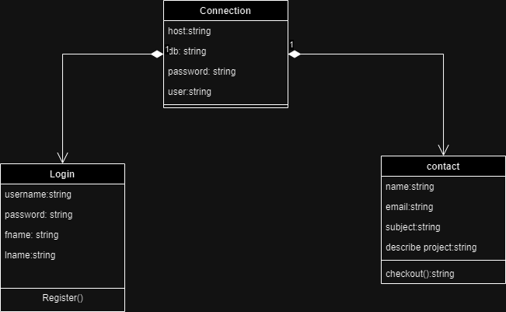

**Erd:**

