

King Saud University

**Summer training 2016**

LibArchive

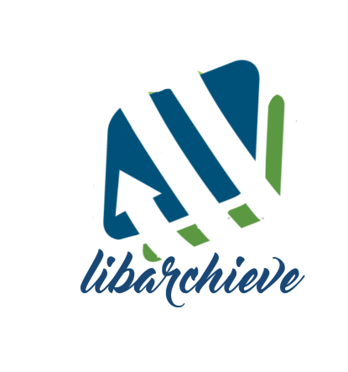

Prepared By:

Meaad AlRshoud

Sua’ad AlNosyaan

Haifa AlRashid

Supervised By:

Mrs.Khuloud MAlalllah

Table of Contents

CHAPTER ONE: INTRODUCTION 4

THE PROBLEM 4

PROJECT GOALS AND OBJECTIVES 4

THE SOLUTION 4

PROJECT SCOPE 4

HARDWARE AND SOFTWARE 5

COST 5

CHAPTER TWO: BACKGROUND 5

APPLYING TECHNOLOGY TO MANAGE THE FOLDER 5

2.1.1CLIENT/SERVER MODEL 5

2.1.2 CENTARLIZED DATABASE 5

2.1.3 FOLDERS AND FILE NAMING 5

TOOLS 5

GENERAL ADVANTAGES OF 5

DISADVANTAGES of 5

EXPANDING OPTIONS 5

GETTING STARTED 5

EVALUATION BETWEEN TRADITIONAL 5

CHAPTER THREE: LITERATURE REVIEW 5

SUPPORTIVE NETWORK OF 5

REAL-TIME MANAGING 5

MANAGEMENT ISSUES 6

REAL-TIME NETWORK 6

PERFORMANCES 6

SECURITY 6

HOW TO INCORPORATE THE TRADITIONAL WAY 6

CHAPTER FOUR: SYSTEM ANALYSIS USER CHARACTERISTICS 6

USER TYPES 6

SPECIFIC REQUIREMENTS 6

4.2.1 USER REQUIREMENTS AND SYSTEM REQUIREMENTS 6

ADMIN REQUIREMENT 7

ARCHIVIST REQUIREMENT 7

NON-FUNCTIONALREQUIREMENTS 7

USE CASE DIAGRAM 8

CHAPTER FIVE: SYSTEM DESIGN 8

ENTITY RELATIONAL DIAGRAM 8

DATABASE SCHEMA 9

INTERFACE DESIGN 10

USER NAVIGATION HIERARCHY 10

USER FUNCTION INTERFACES 10

5.3.3 ERROR MESSAGES 10

CHAPTER SIX: CONCLUSION 11

SMMARIZATION OF THE SOFTWARE DEVELOPMENT PROBLEMS OF THE SYSTEM 11

RECOMMENDATION 11

IMPLEMENTATION RECOMMENDATION 11

REFERENCES 11

# CHAPTER ONE: INTRODUCTION

Archiving documents is important for any faculty, It provides an easy and a quick access to data. Before the existence of this project the process for finding data is to fetch their paper files from the cellar, It lacks efficiency and more time consuming as the paper work documentation approach was used. Also keeping up to date information of employees is essential. Documents which were originally only available on paper can be digitized efficiently through scanners. The project provides these features. It is an application that uses a database to display the data to the user and allows him to add new data and he will also be able to change the data as well.

The project consists of three functions. First service is displaying the information of the employees. Secondly, scan old documents and save it in the program. Also it provides the ability to search for the old and the new documents it in the future. Finally , non due documents that needs evaluation periodically.

## THE PROBLEM

The database of the project consists of employees basic information, store data about the two kinds of transcripts: the old documents that were originally in paper, will now be scanned and stored in the database as pictures. The other kind of transcripts are the ones that are used currently and have more information than the older kinds of transcripts, they also use the new numbering system by the university “Madar”.

The project uses a very easy interface as it uses the GUI approach for interacting with the users of the system. For more reliability and robustness the system backs up the data storage after every update.

## PROJECT GOALS AND OBJECTIVES

The project aims to cover many features to facilitate finding data about different objects and employees working in the deanship of library affairs. It displays employees information to the admin and it gives the admin the permission to change and edit employee information if necessary. Quick access to the stored documents for the admin. That can only be obtained by archiving the paper documents electronically.

## THE SOLUTION

The System enables the users to view employee records of deanship of library affairs, Documents and evaluate employees only for the authorized users. Which reduces the time to to fetch one of these things in the old fashioned way. The system provides services and search feature to find what the user needs.

Also, it provide means for the employees affair to keep track of the employee status and evaluation degree.

## PROJECT SCOPE

This project consists of a PHP environment software system intended for KSU faculty members and Deanship of Library Affairs employees. It helps it employees to view employees record and keep track of them. And It helps them to get a quick access to the documents.

## HARDWARE AND SOFTWARE

Hardware: PC or Laptop.

Software: xampp.

## COST

The software program has no cost unless it’s uploaded to a host server.

## CHAPTER TWO: BACKGROUND APPLYING TECHNOLOGY TO MANAGE THE FOLDER

## 2.1.1CLIENT/SERVER MODEL

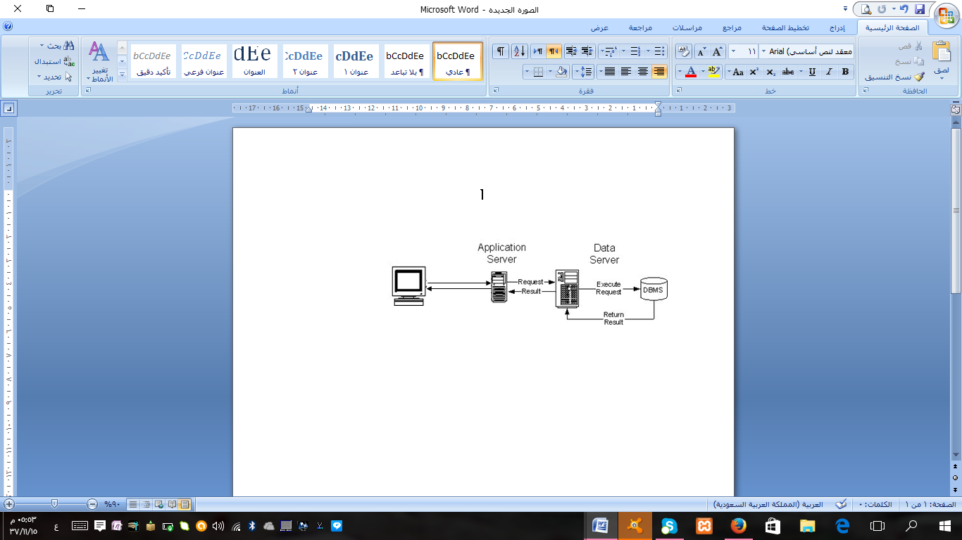

## 2.1.2 CENTARLIZED DATABASE

the software application database is physically placed in one location. Access due is to install Xampp.

## 2.1.3 FOLDERS AND FILE NAMING

## TOOLS

## We used search engines , lap tops, network , CD , Flash memory ,PHP , HTML and Javascript.

## The method to upload the files and share it among the team is google site and email.

WhatsApp mobile application was an alter way of communication between team members.

## GENERAL ADVANTAGES OF

## - Saves much time during document retrieval when compared to paper archives.

## - accuracy in the results .

- Compliant archiving.

## - set a password to keep files confidential.

- Convenient digitization of paper-bound documents.

## DISADVANTAGES of

1-It may occur data loss in the event of a sudden shut down for the computer work.

2- employees who find it not convenient to deal with electronic devices may have difficulty using the application .

3- Cannot use the application in the event of a power failure .

## EXPANDING OPTIONS

## GETTING STARTED

## EVALUATION BETWEEN TRADITIONAL

## In the past, we used paper and pen to jot down and write letters and are subject to loss or damage while now is used the most secure and protect the letters and the speed of the electronic application in the search for one of the speeches.

## CHAPTER THREE: LITERATURE REVIEW

## SUPPORTIVE NETWORK OF

## REAL-TIME MANAGING

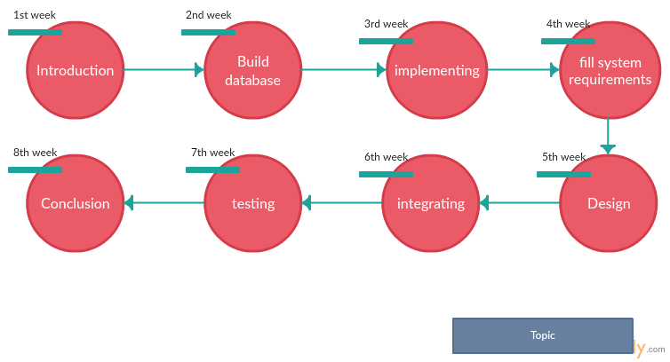

## MANAGEMENT ISSUES

1- Managing to meet new requirements after each meeting.

2-programming difficulties.

## REAL-TIME NETWORK

The software system doesn’t use any network to launch it.

## PERFORMANCES

The software system does not occupy much space in the hard-disk.

It’s a light program that uses local host and it has easy interface.

## SECURITY

The software system is secure in regards of it’s database and functionalities.

It authorizes each employee to use it in the scope of the employee permission.

## 

## HOW TO INCORPORATE THE TRADITIONAL WAY

## 1-use the local database base as repository for documents.

2- search the documents by specific information.

3-only authorized employees get access to certain services in software application and documents.

## CHAPTER FOUR: SYSTEM ANALYSIS USER CHARACTERISTICS

## USER TYPES

There are two types of users that interact with this system:

* Admin: manages all data in the database including viewing the data, adding new data and editing existing data.
* User: is able to view all data and is able to add new data.

## SPECIFIC REQUIREMENTS

## 4.2.1 USER REQUIREMENTS AND SYSTEM REQUIREMENTS

**USER REQUIREMENTS**

The system shall provide the following core requirements:

1. User shall be able to log into the system.
2. User shall be able to log out of the system.
3. The user shall be able to view employee records, old documents and the new documents.

**SYSTEM REQUIREMENTS :**

The system shall provide the following core requirements:

1. User shall be able to log into the system.

1.1. The system shall allow the user to log into the system using a username and password.

1.2. The system then checks for username and password validity.

1.3. If the checking was valid the system shall provide appropriate interface.

1.4. If not the system shall alert the user by a massage.

1.5. The system shall give the user user’s permissions after the login.

1. User shall be able to log out of the system.

2.1. The system shall provide a logout option to the user.

2.2. The system shall allow the user to click on logout button

2.3. The system shall display a confirmation message on the screen.

2.4. The system shall return to the main interface.

1. The user shall be able to view employee records, old documents and the new documents.

## **ADMIN REQUIREMENT**

1. The admin shall be able to log into the system.
2. The admin shall be able to log out of the system.
3. The admin shall be able to view employee records, old documents and the new documents.
4. The admin shall be able to add new employees to the database.
5. The admin shall be able to add new documents to the database.
6. The admin shall be able to edit employee's data.
7. The admin shall be able to edit document's data.
8. The admin shall be able to evaluate an employee’s degree.

## **USER REQUIREMENT**

1. The user shall be able to log into the system.
2. The user shall be able to log out of the system.
3. The user shall be able to view employee records, old documents and the new documents.
4. The user shall be able to add new employees to the database.
5. The user shall be able to add new documents to the database.

## NON-FUNCTIONALREQUIREMENTS

1. Backup

* The system backs up the data after every update.
* The system backs up the data on hardware storage.

1. All images should be saved as pdf.
2. The person who decides employee’s degree is his supervisor. But only the admin can fill these information.

## USE CASE DIAGRAM

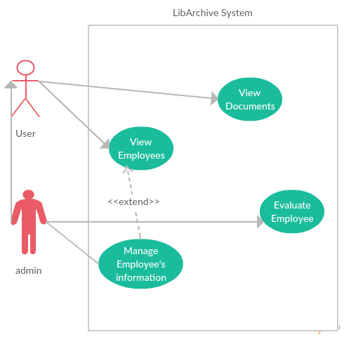

## CHAPTER FIVE: SYSTEM DESIGN

## ENTITY RELATIONAL DIAGRAM

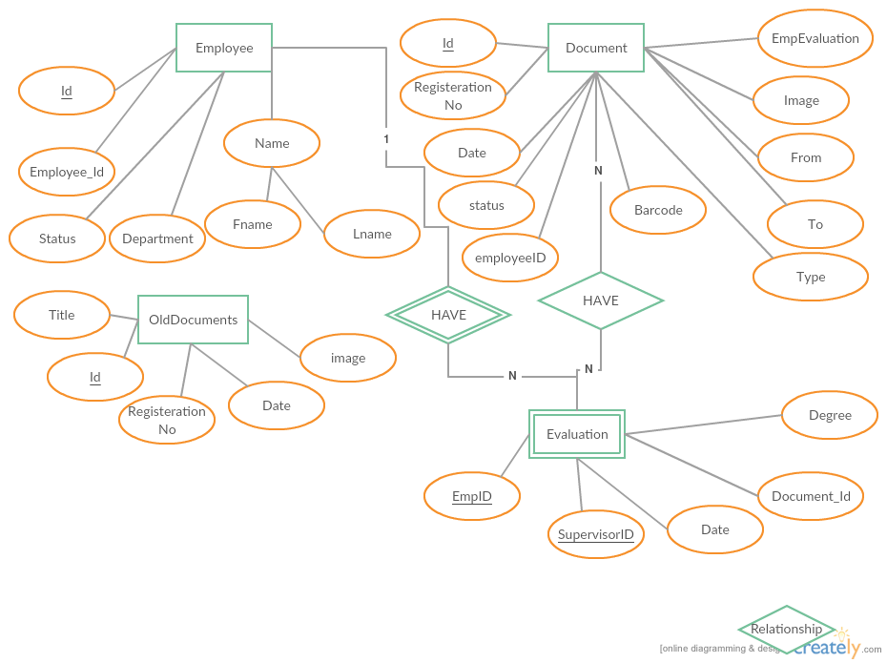

## DATABASE SCHEMA

EMPLOYEE

|  |  |  |  |  |  |
| --- | --- | --- | --- | --- | --- |
| Id | Employee_Id | Fname | LName | Department | Status |

|  |  |  |  |  |  |  |  |  |  |  |
| --- | --- | --- | --- | --- | --- | --- | --- | --- | --- | --- |
| Id | RegisterationNo | Date | BarCode | Image | Status | EmployeeID | EmpEvaluation | From | To | Type |

NEW_DOCUMENT

OLD_DOCUMENT

|  |  |  |  |  |
| --- | --- | --- | --- | --- |
| Id | RegisterationNo | Title | Date | Image |

Evaluation

|  |  |  |  |  |
| --- | --- | --- | --- | --- |
| EmpID | SupervisorID | Document_Id | Date | Degree |

## 

## INTERFACE DESIGN

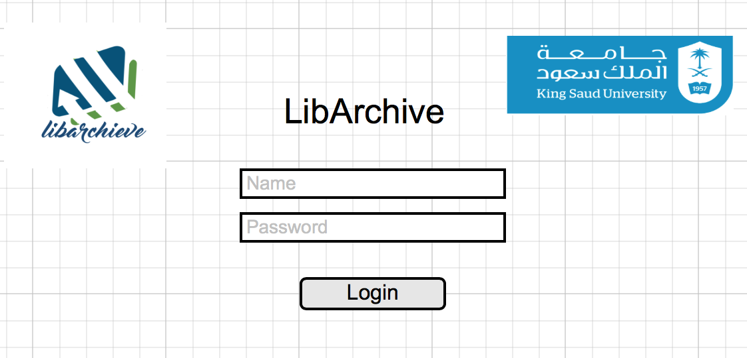

Employee control panel

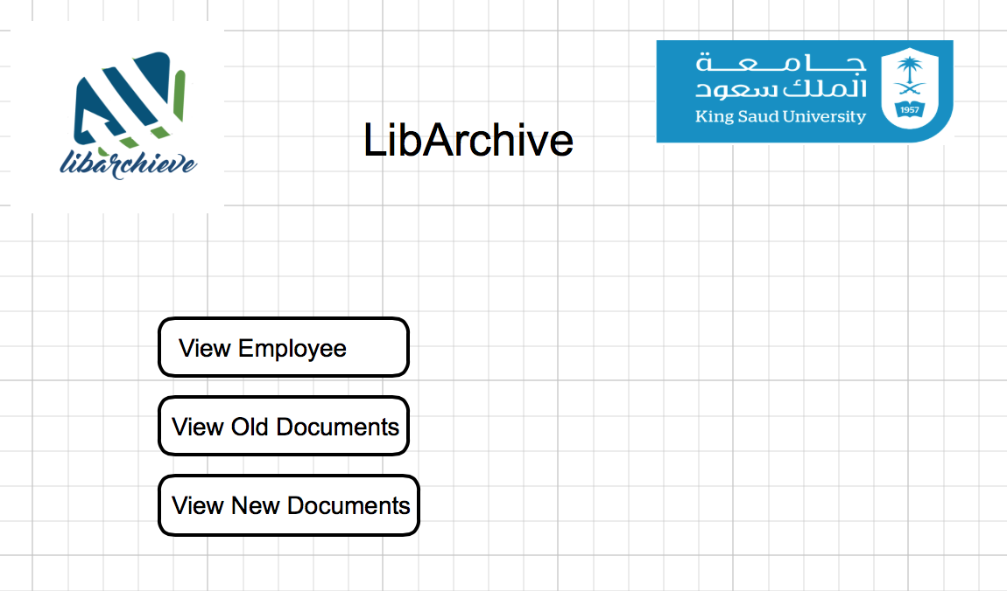

## 

## USER NAVIGATION HIERARCHY

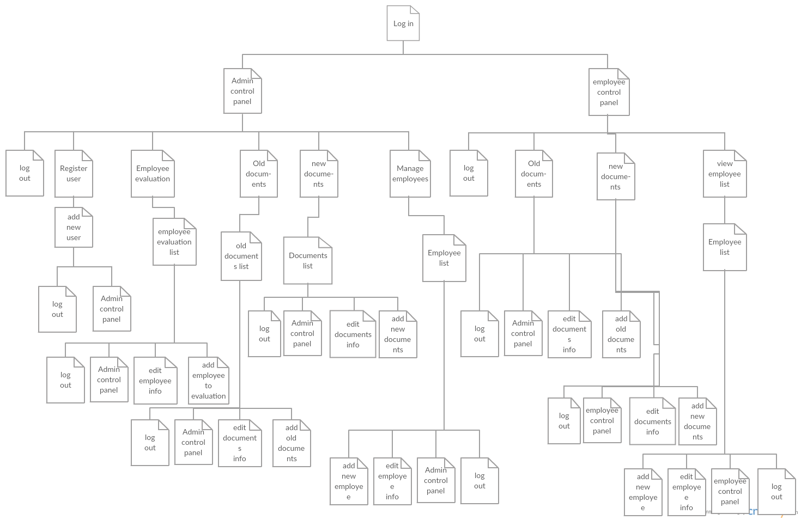

## USER FUNCTION INTERFACES

## Log in interface, for the Admin it directs him to his control panel. But for the employee it directs him to employee's control panel.

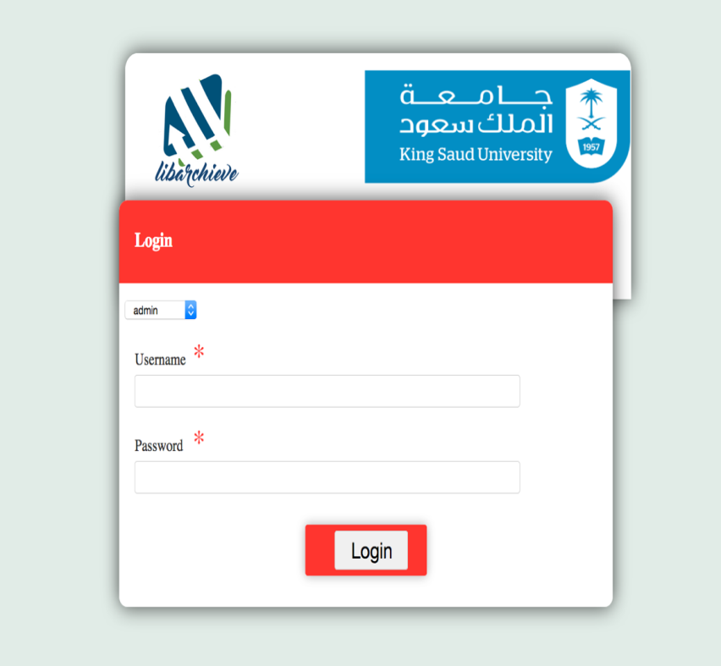

**Admin's control panel, it displays after login in as an admin.**

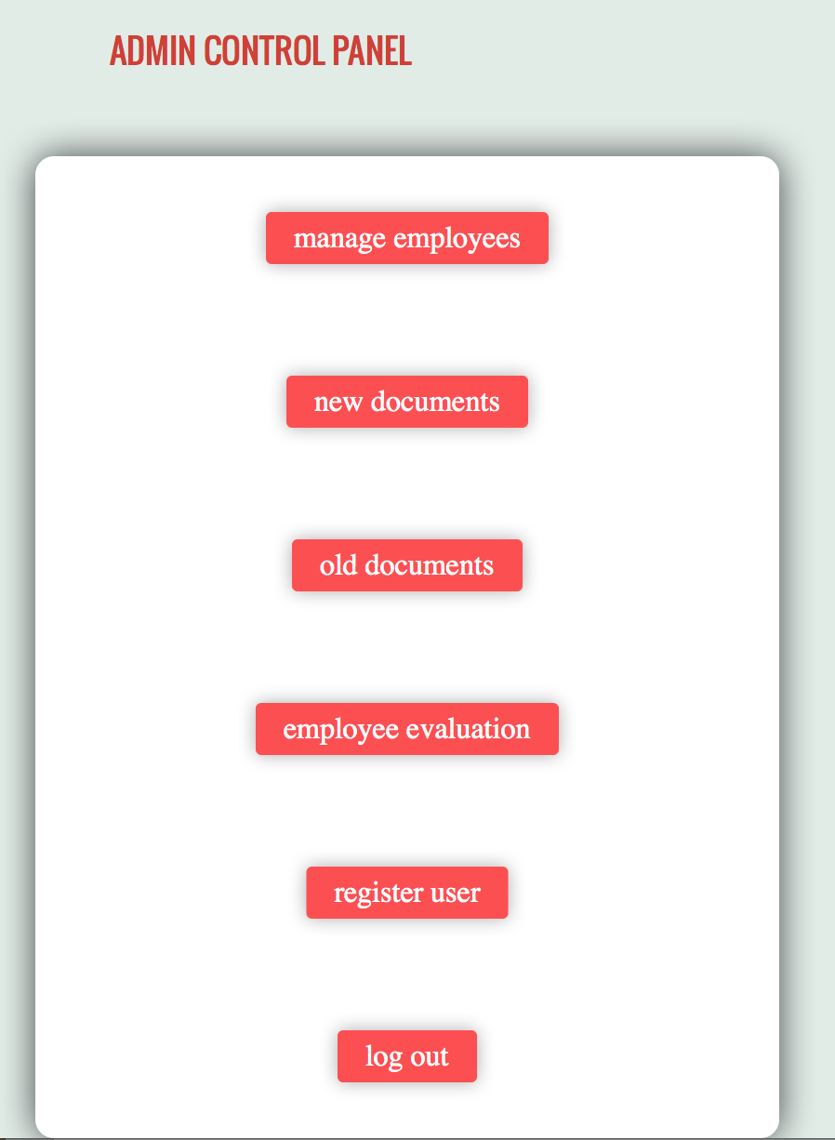

**After choosing New documents(2) the admin can add one. Also the employee can.**

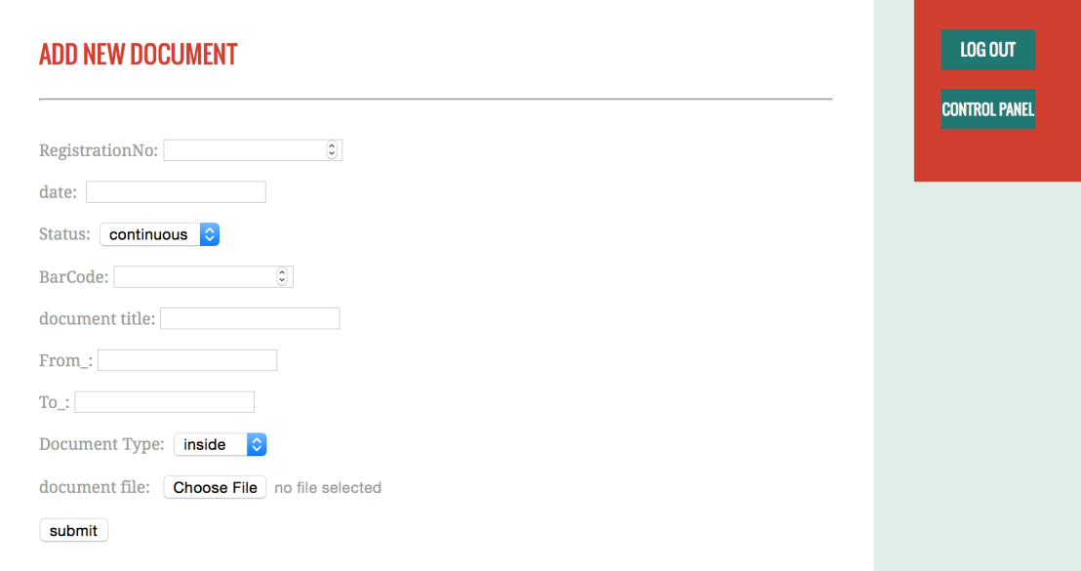

**After choosing manage employees(1), the admin can add a new one.**

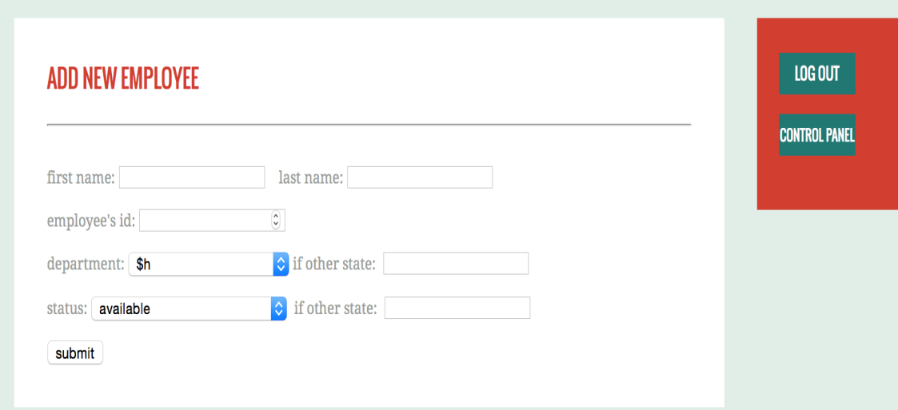

**Evaluating employees No.4 choice from control panel. The admin select the employee and his supervisor for the specific document then he can grade the employee.**

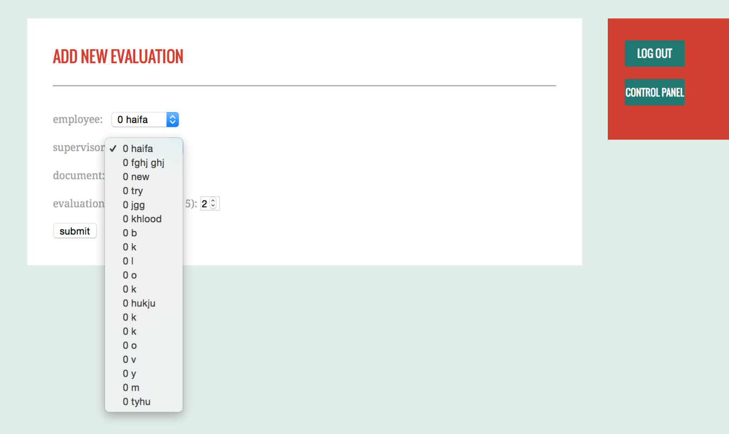

**No.5 Register user, the admin can register a user (employee) and save it into the database.**

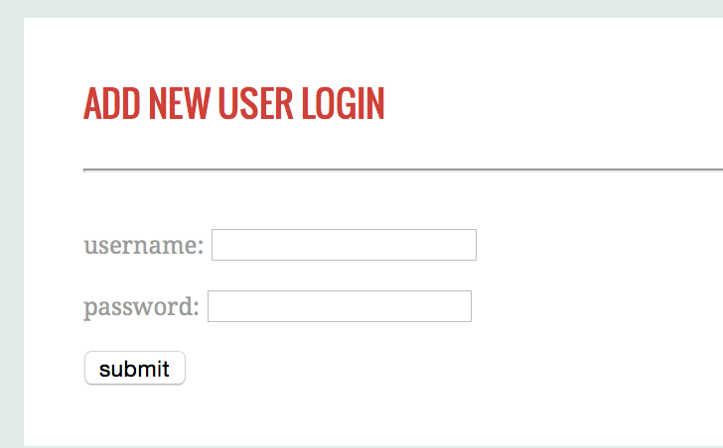

**Emplyee's control panel, shows after login in as an employee.**

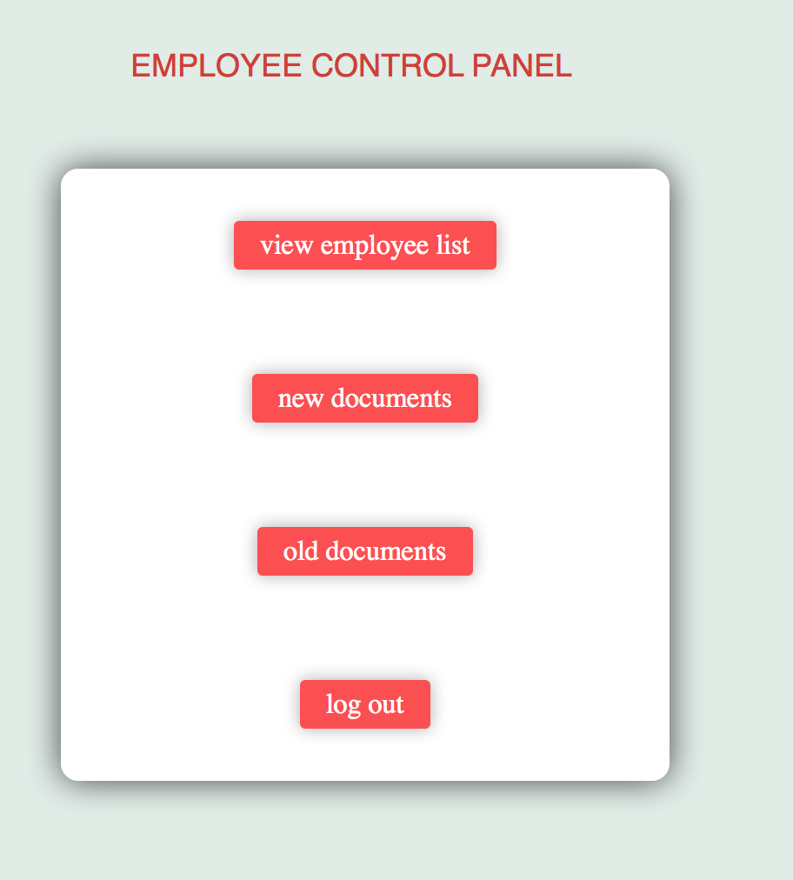

## The employee has the same operations for the admin but less. Employee can't register users to the application , can't evaluate employees.

## 5.3.3 ERROR MESSAGES

1. **Access denied**

**2. File not found**

**3. Low Disk Space**

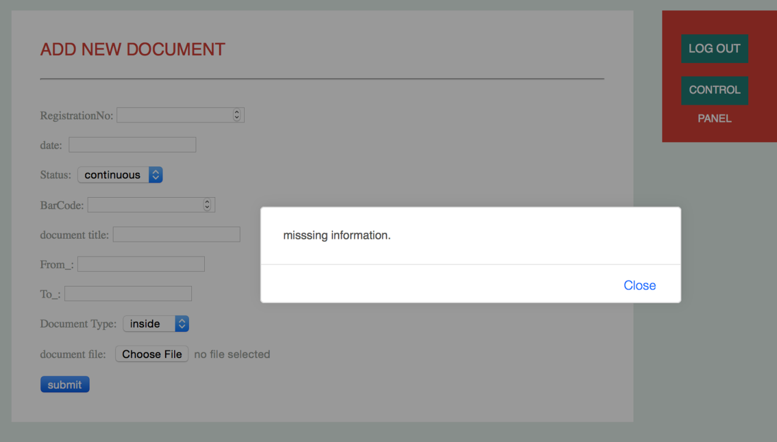

**Meeting Agenda and Summary**



|  |  |  |
| --- | --- | --- |
| **Meeting no** | **Agenda** | **Summary** |
| 1 - 3 | Divide the work | Dividing the work between all the group members. |
| 2 - 3 | Divide review  sections | Dividing the reviewing sections between all the group members. |

## CHAPTER SIX: CONCLUSION

## SMMARIZATION OF THE SOFTWARE DEVELOPMENT PROBLEMS OF THE SYSTEM

Developing a software application that provides simple and quick access to Library Affairs Deanship Documents and it’s employee’s statuses. The old fashioned way to search for documents and track employees is a waste of time and energy. Also keeping the permission of each process and documents to certain employees is hard to maintain in the traditional way. But it’s all solved in the software application. all the requirements will be completely fulfilled if documents are managed and archived electronically.

## RECOMMENDATION

- every faculty should build a software application as labArchive to benefit from it’s provided services.

- back up database data after a certain period automatically.

## IMPLEMENTATION RECOMMENDATION

## Implement the application using mobile application language for more simple and easier access for the employees.

## Raise application security by requiring more intense log in data for confidentiality.

## REFERENCES

* The Writing Center at UNC Chapel Hill.

* W3Schools