#Run <Mcflirt on the IHMT .nii file

Mcflirt -in IHMT.nii

#Calculate all the individual components of the maps (these don’t need to be done – this is just to know what volumes are part of each component)

subject_list=ids.txt #defining list of subjects to use for loop  
  
subjects=$( cat ${subject_list} )  
  
for id in $subjects  
  
do  
  
   
cd /Users/jess/Documents/IHMT/${id}

3dcalc -a ${id}_mcf.nii.gz[0] -expr 'a*1' -prefix MTR_Ref.nii

3dcalc -a ${id}_mcf.nii.gz[1] -expr 'a*1' -prefix MT_Ref.nii

3dcalc -a ${id}_mcf.nii.gz[2,6,10] -expr 'a*1' -prefix Positive.nii

3dcalc -a ${id}_mcf.nii.gz[3,5,7,9,11,13] -expr 'a*1' -prefix Dual.nii

3dcalc -a ${id}_mcf.nii.gz[4,8,12] -expr 'a*1' -prefix Negative.nii

cd /Users/jess/Documents/IHMT/

done

#Formula for calc qihMT maps

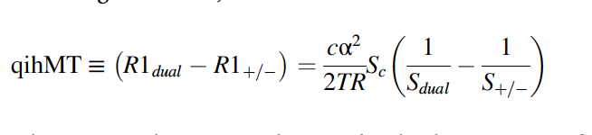

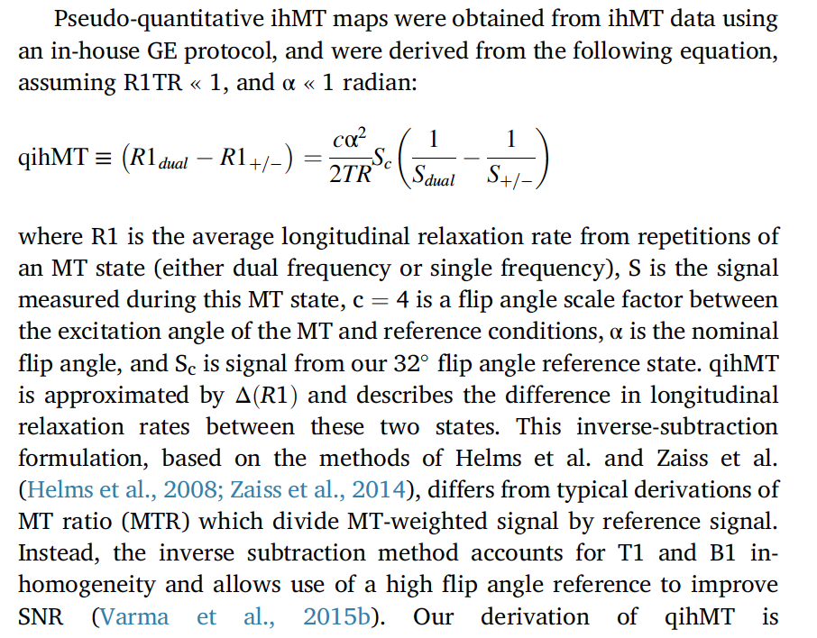

α = 8 (needs to then be converted to radians)

c = 4



Sc = Reference Image

TR = 10.572ms

Sdual = average of all dual images

S+/- = average of all positive and negative – as uneven in some cases, average each separately and then average?

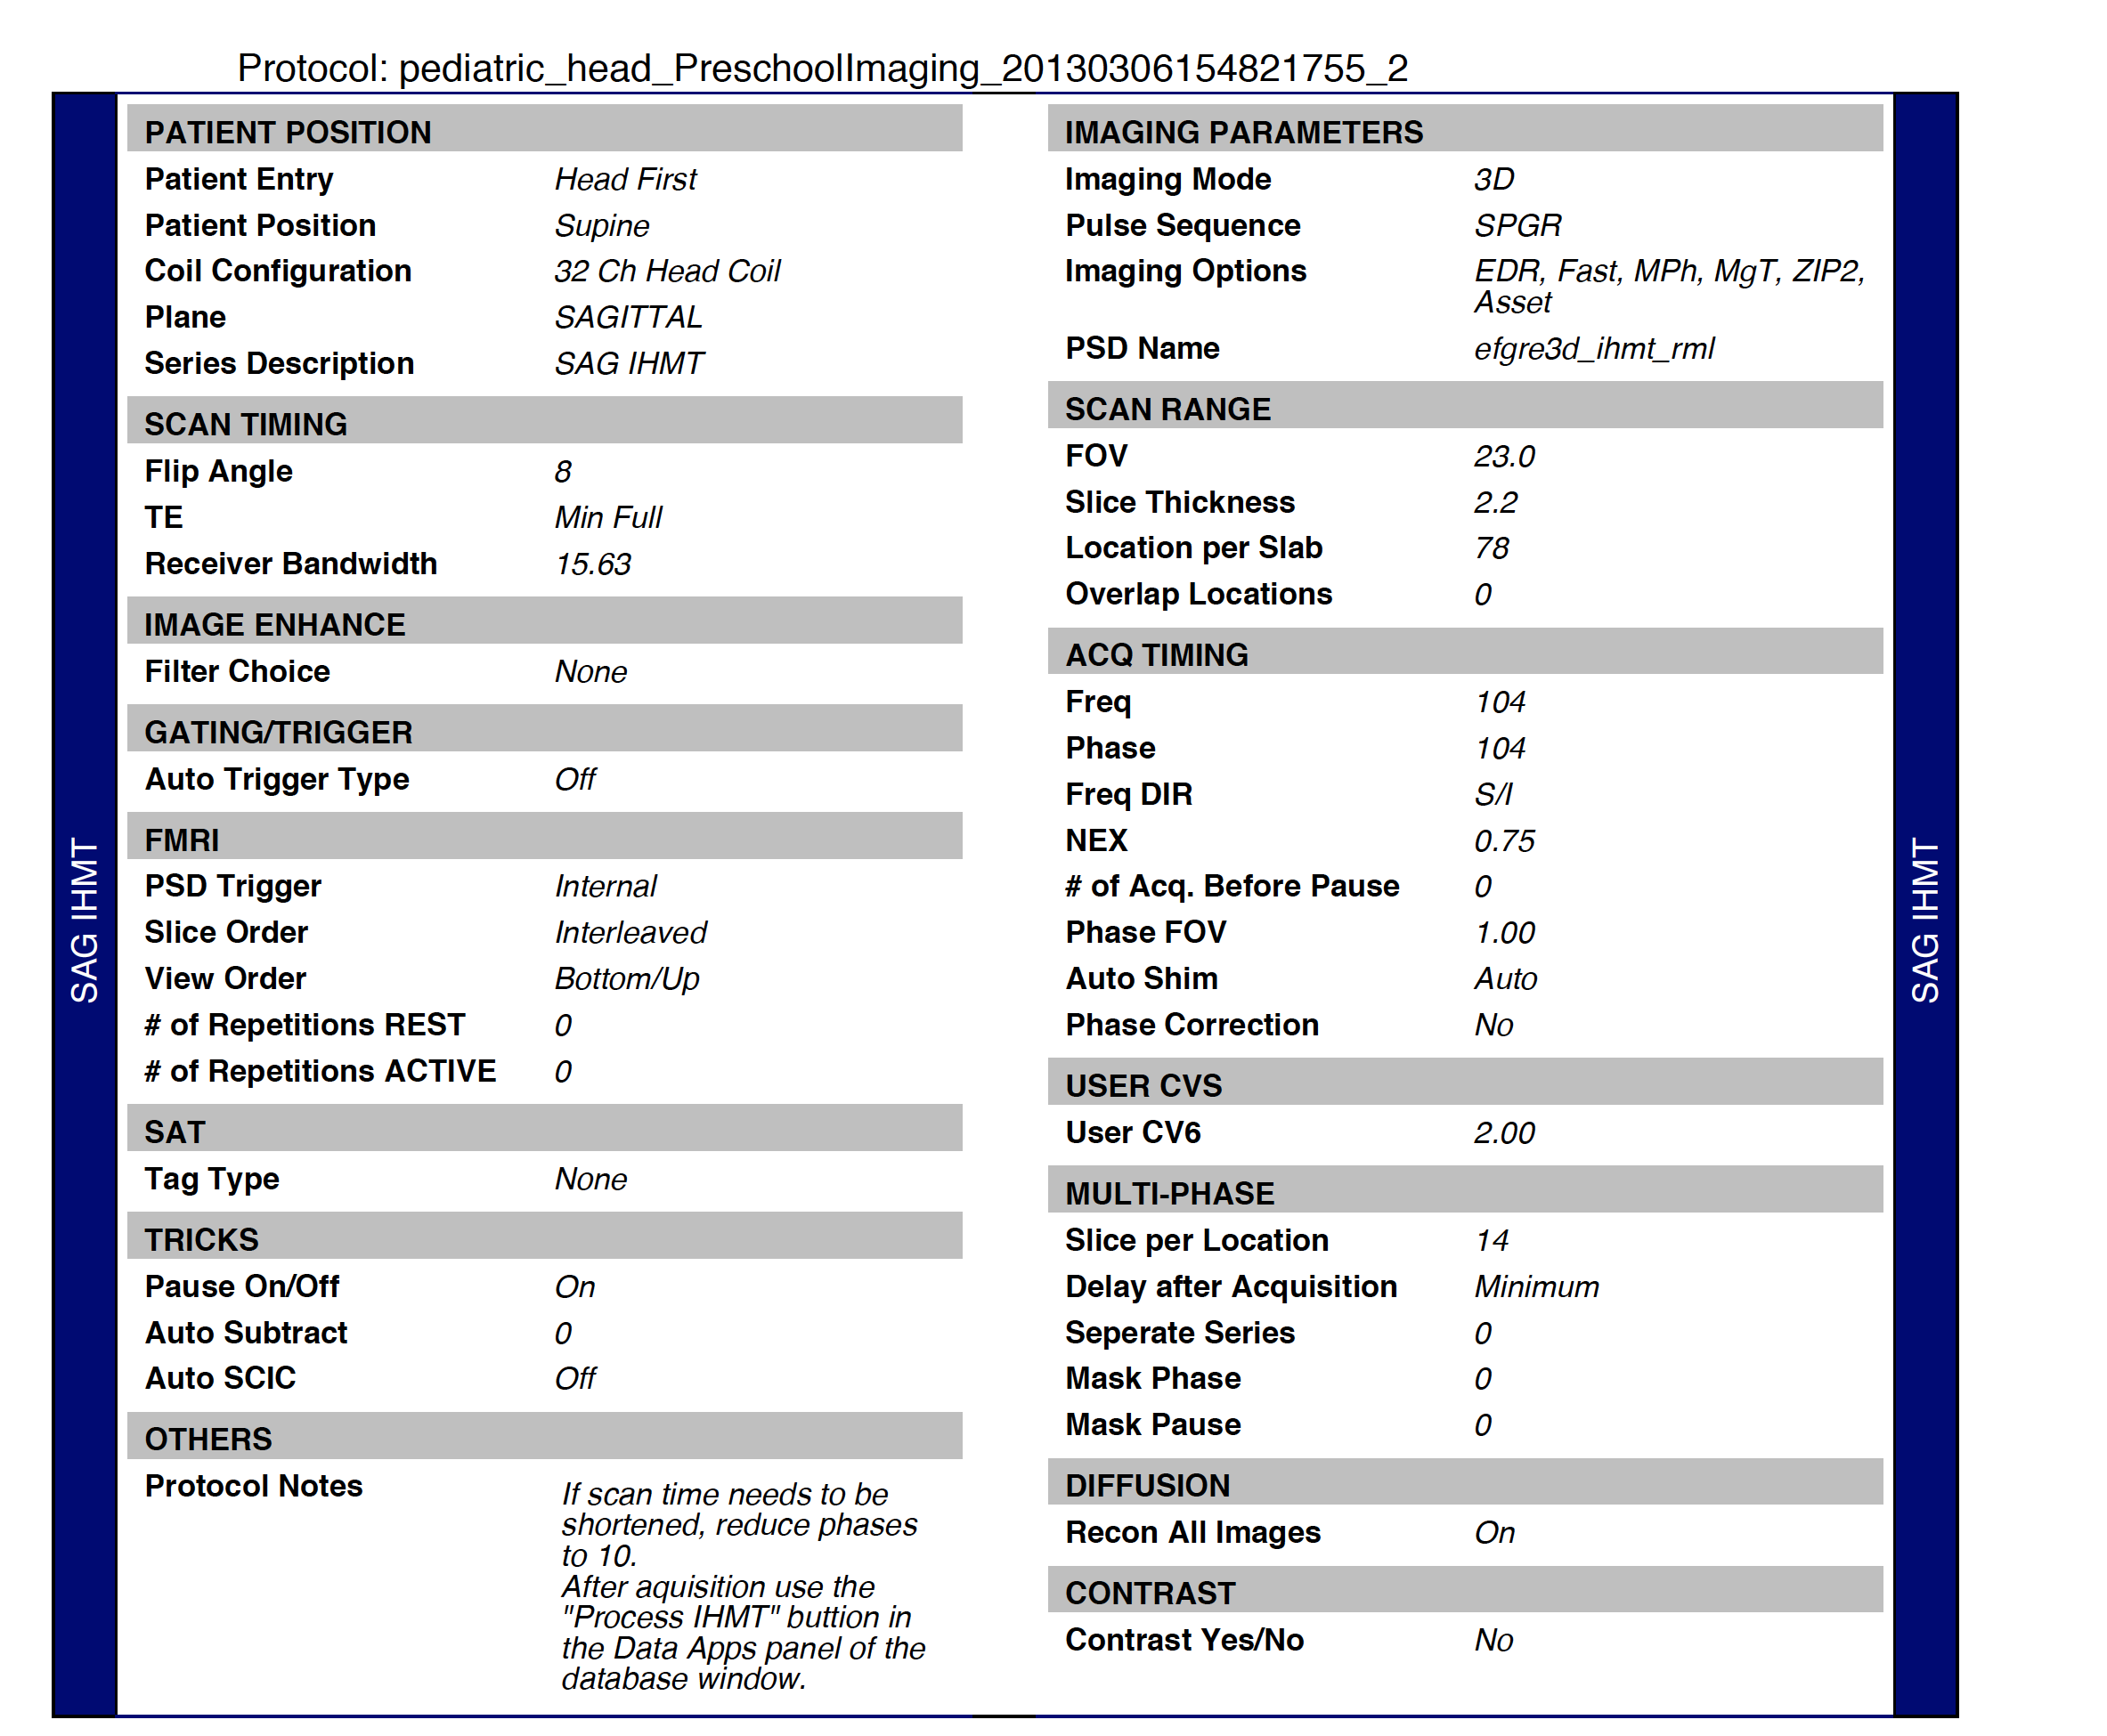



qihMT



3dcalc -datum float -a Positive.nii[0] -b Positive.nii[1] -c Positive.nii[2] -expr '(a+b+c)/3' -prefix Positive_Avg.nii

#average of positive

3dcalc -datum float -a Negative.nii[0] -b Negative.nii[1] -c Negative.nii[2] -expr '(a+b+c)/3' -prefix Negative_Avg.nii

#average of negative

3dcalc -datum float -a Positive_Avg.nii -b Negative_Avg.nii -expr '(a+b)/2' -prefix S_PosNeg.nii

#average of negative and positive

3dcalc -datum float -a Dual.nii[0] -b Dual.nii[1] -c Dual.nii[2] -d Dual.nii[3] -e Dual.nii[4] -f Dual.nii[5] -expr '(a+b+c+d+e+f)/6' -prefix S_Dual.nii

#average of dual

3dcalc -datum float -a S_Dual.nii -expr '1/a' -prefix 1_S_Dual.nii

#1/Sdual image

3dcalc -datum float -a S_PosNeg.nii -expr '1/a' -prefix 1_S_PosNeg.nii

#1/S+/- image

3dcalc -datum float -a 1_S_Dual.nii -b 1_S_PosNeg.nii -expr 'a-b' -prefix S_Star.nii

#S* image = 1/Sdual image minus 1/S+/- image

Final Equation

3dcalc -datum float -a MT_Ref.nii -b S_Star.nii -expr '((((4*(8*PI/180)* (8*PI/180))/0.021144)*a*b)*1000)' -prefix qihMT_Manual.nii

**MTR**

“MTR = (Mo - Msat)/Mo”

3dcalc -datum float -a Positive.nii[0] -b Positive.nii[1] -c Positive.nii[2] -expr '(a+b+c)/3' -prefix Positive_Avg.nii

#average of positive

3dcalc -datum float -a Negative.nii[0] -b Negative.nii[1] -c Negative.nii[2] -expr '(a+b+c)/3' -prefix Negative_Avg.nii

#average of negative

3dcalc -datum float -a Positive_Avg.nii -b Negative_Avg.nii -expr '(a+b)/2' -prefix S_PosNeg.nii

#average of negative and positive

Final Equation

3dcalc -datum float -a S_PosNeg.nii -b MTR_Ref.nii -expr '((b-a)/b)*10000' -prefix MTR_Manual.nii

Further processing:

Swap dimensions

subject_list=ids_good.txt #defining list of subjects to use for loop  
subjects=$( cat ${subject_list} )  
for id in $subjects  
do  
cd /Users/jess/Documents/IHMT/${id}

fslswapdim MTR_Manual.nii RL PA IS ${id}_MTR_Manual_swap.nii

cd /Users/jess/Documents/IHMT/

done

Create brain masks using MTR maps

#create brain masks based on MTR and apply these to the qihMT images

Step3.a

subject_list=ids_good.txt #defining list of subjects to use for loop  
subjects=$( cat ${subject_list} )  
for id in $subjects  
do

cd /Users/jess/Documents/IHMT/${id}

bet2 ${id}_MTR_Manual_swap.nii ${id}_MTRBrain.nii -f 0.8

cd /Users/jess/Documents/IHMT/

done

Step3.b

subject_list=ids_good.txt #defining list of subjects to use for loop  
subjects=$( cat ${subject_list} )  
for id in $subjects  
do  
cd /Users/jess/Documents/IHMT/${id}

bet ${id}_MTRBrain.nii ${id}_MTRBrainR2.nii -R -m

cd /Users/jess/Documents/IHMT/

done

Swap dimensions of qihMT and then apply brain mask (created from MTR bet) to qihMT

subject_list=ids_missing.txt #defining list of subjects to use for loop  
subjects=$( cat ${subject_list} )  
for id in $subjects  
do  
cd /Users/jess/Documents/IHMT/${id}

fslswapdim qihMT_Manual.nii RL PA IS ${id}_qihMT_swap.nii

fslmaths ${id}_qihMT_swap.nii.gz -mas ${id}_MTRBrainR2_mask.nii.gz ${id}_qihMTMasked.nii

cd /Users/jess/Documents/IHMT/

done

subject_list=ids_missing.txt #defining list of subjects to use for loop  
subjects=$( cat ${subject_list} )  
for id in $subjects  
do  
cd /Users/jess/Documents/IHMT/${id}

fslmaths ${id}_qihMT_swap.nii.gz -mas ${id}_MTRBrainR2_mask.nii.gz ${id}_qihMTMasked.nii

cd /Users/jess/Documents/IHMT/

done

#subject_list=ids.txt #defining list of subjects to use for loop  
  
subjects=$( cat ${subject_list} )  
  
for id in $subjects  
  
do  
  
#threshold the image maps so they don’t have any negative values  
cd /Users/jess/Documents/IHMT/ProcessedData/${id}/autoReg/qihMT

mv qihMTBrain.nii qihMTBrain_orig.nii

fslmaths qihMTBrain_orig.nii -thr 0 qihMTBrain.nii

gunzip qihMTBrain.nii  
cd /Users/jess/Documents/IHMT/

done

#theshold it to only have 0 and no neg values