Visual QC must be done at several points throughout the MRTrix processing pipeline.

(See @a214_CSD_pipeline.txt for work flow and points at which this should be done)

After running dwifslpreproc, check outputs of denoising and degibbs steps:

cd /Volumes/PSYCH_Landi/Projects/A214_MRI/a214_data/derivatives/mrtrix/sub-214XXX

mrview res.mif dwi_degibbs.mif

Use page up / page down keys to switch between images

For res.mif, scroll through the slices in axial view. You should not see any obvious anatomy (manifests as solid gray outline of the skull and/or ventricles, etc.) make note of obvious anatomy. For dwi_degibbs.mif, look at the areas around the ventricles in axial view, you may see some ringing but it should be somewhat blurred. Make note of quality in data tracking spreadsheet. Subjects with excessive anatomy evident in the res.mif image should be excluded from further analysis.

After running step 4 with bet mask creation, inspect the mask output:

cd /Volumes/PSYCH_Landi/Projects/A214_MRI/a214_data/derivatives/mrtrix/sub-214XXX

mrview dwi_preproc_upsampled.nii.gz

mrview will open with the preprocessed, upsampled brain image.

Open the mask over this image by clicking the “Tool” icon in the upper right corner, select ROI editor, then use the open icon and select dwi_preproc_upsampled_bet_mask.nii.gz. The mask will show up in translucent yellow over the brain image.

Change to Sagittal view by clicking View in the top toolbar and selecting Sagittal from the drop-down menu.

Scroll through each slice to check that the boundaries of the mask align with the boundaries of the brain. At this stage, it is better to have a more conservative mask (excluding some brain voxels) rather than an over-extending mask. It is ok if a little bit of the frontal lobe gets excluded from the mask, but if there are large areas covering non-brain tissue (see image below), these need to be edited.

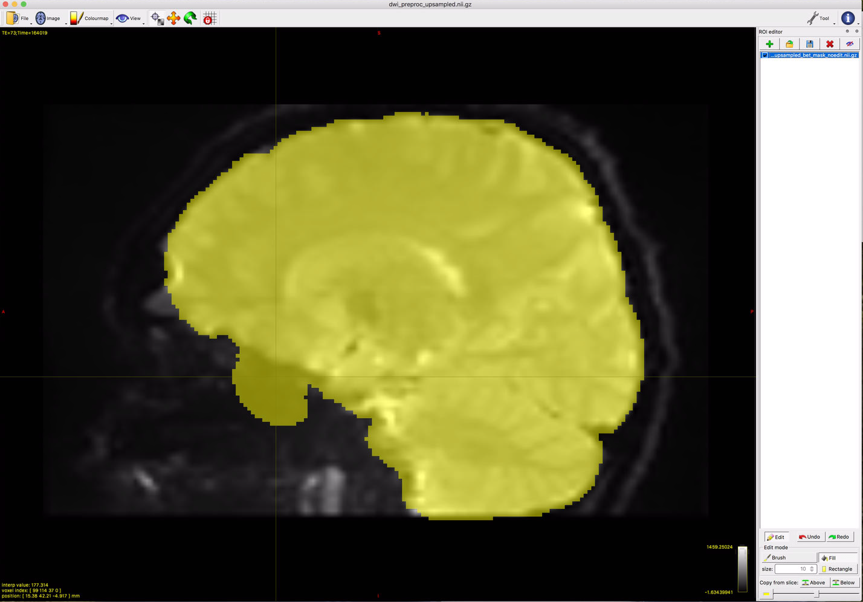

First, click the save icon at the top of the ROI editor panel and save the mask as “dwi_preproc_upsampled_bet_mask_**noedit**.nii.gz” To remove excess voxels from mask, use edit mode by clicking the “edit” button in the bottom of the ROI editor side panel. Use the brush tool holding down the right mouse button to erase voxels. For an issue like this, you can use the brush tool to erase a line of voxels along the edge of the brain, then use the fill tool (right click) to erase the dis-connected blob. Be certain that the voxels you are erasing are non-brain tissue, and not part of the temporal lobes. Make sure to edit slice-by-slice to completely remove all excess voxels. Once you begin editing, click the save icon again and save the mask as “dwi_preproc_upsampled_bet_mask.nii.gz” (replace the existing file). After you’ve completed the edits, look through the slices again to make sure you haven’t missed any. Make sure to save when finished editing (replace the existing file) before closing mrview.

If a mask excludes a large chunk of brain tissue, those voxels will need to be filled in. This is done the same way as for removing voxels, just use the left mouse button to fill in voxels instead of the right to erase. Make sure to rename and save the old mask with the _noedit ending, and save the edited mask with the original file name.

Remember, it is OK if a little frontal or superior parietal brain tissue is excluded from the mask. Edits are only needed if white matter is substantially affected, see example below.

