Lab 9: Authentication (Step by step)
- Authentication with Phone number
Go to this link to create project in Firebase
https://console.firebase.google.com/u/0/?pli=1
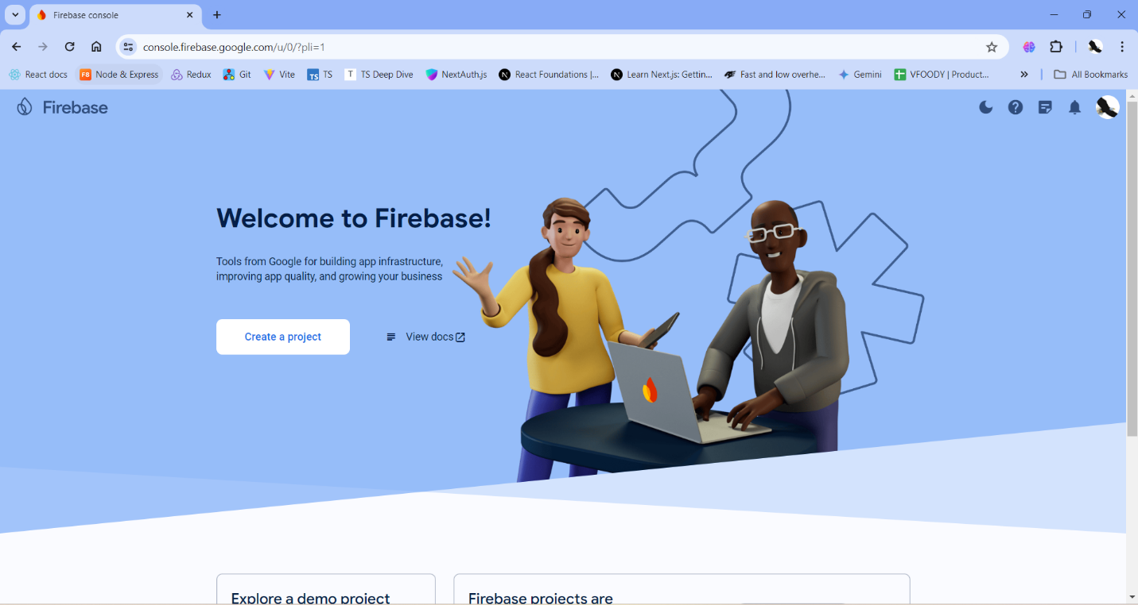
Create a project name, then accept all checkboxes and continue in the next steps
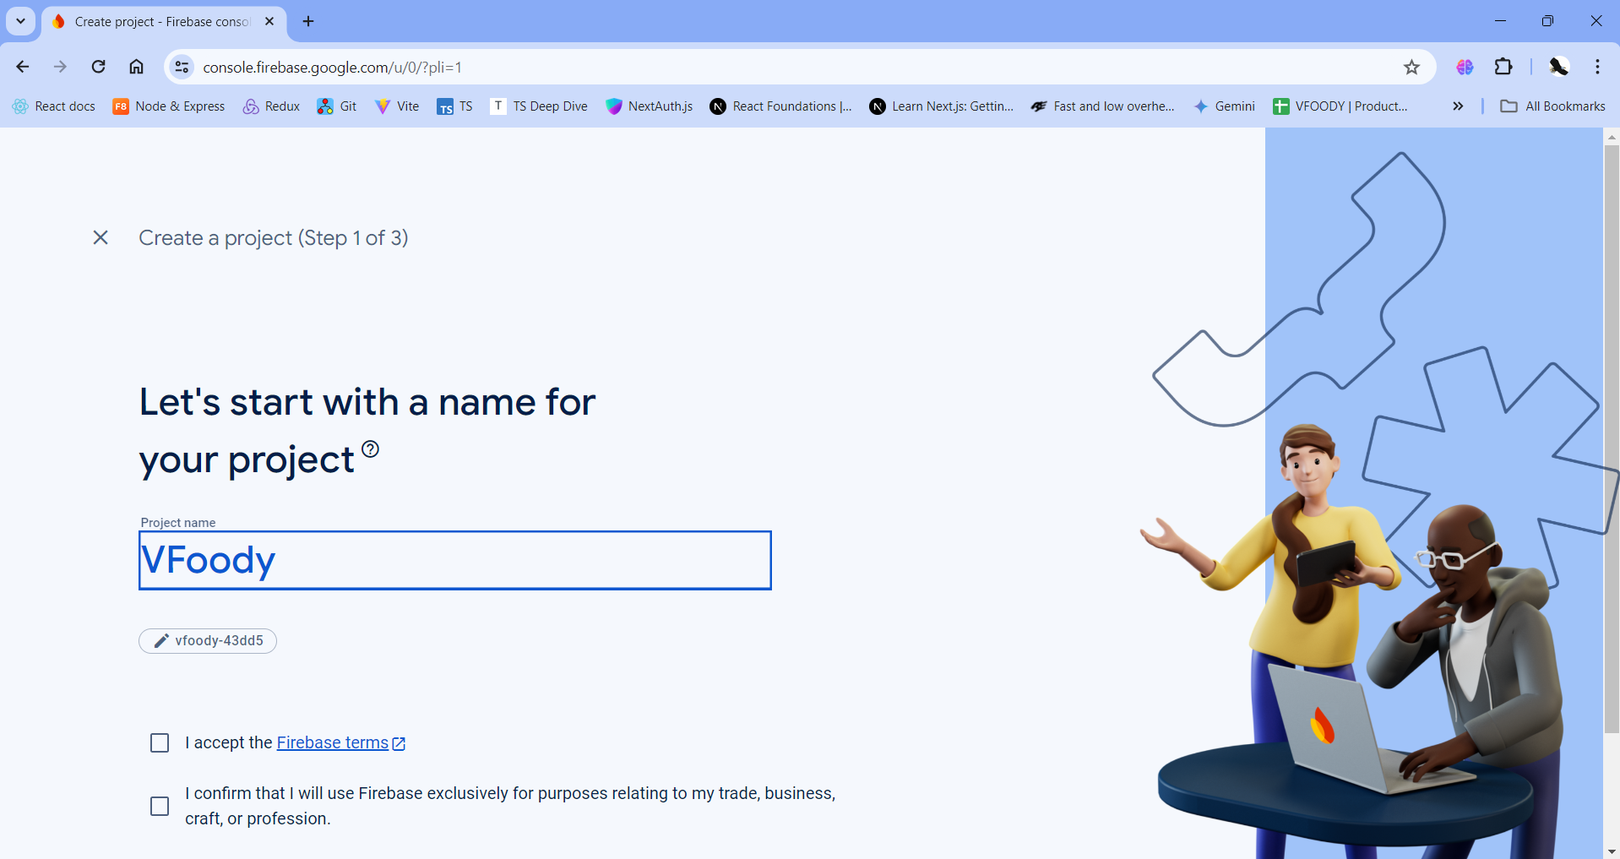
Click Project Overview to go to your project you created
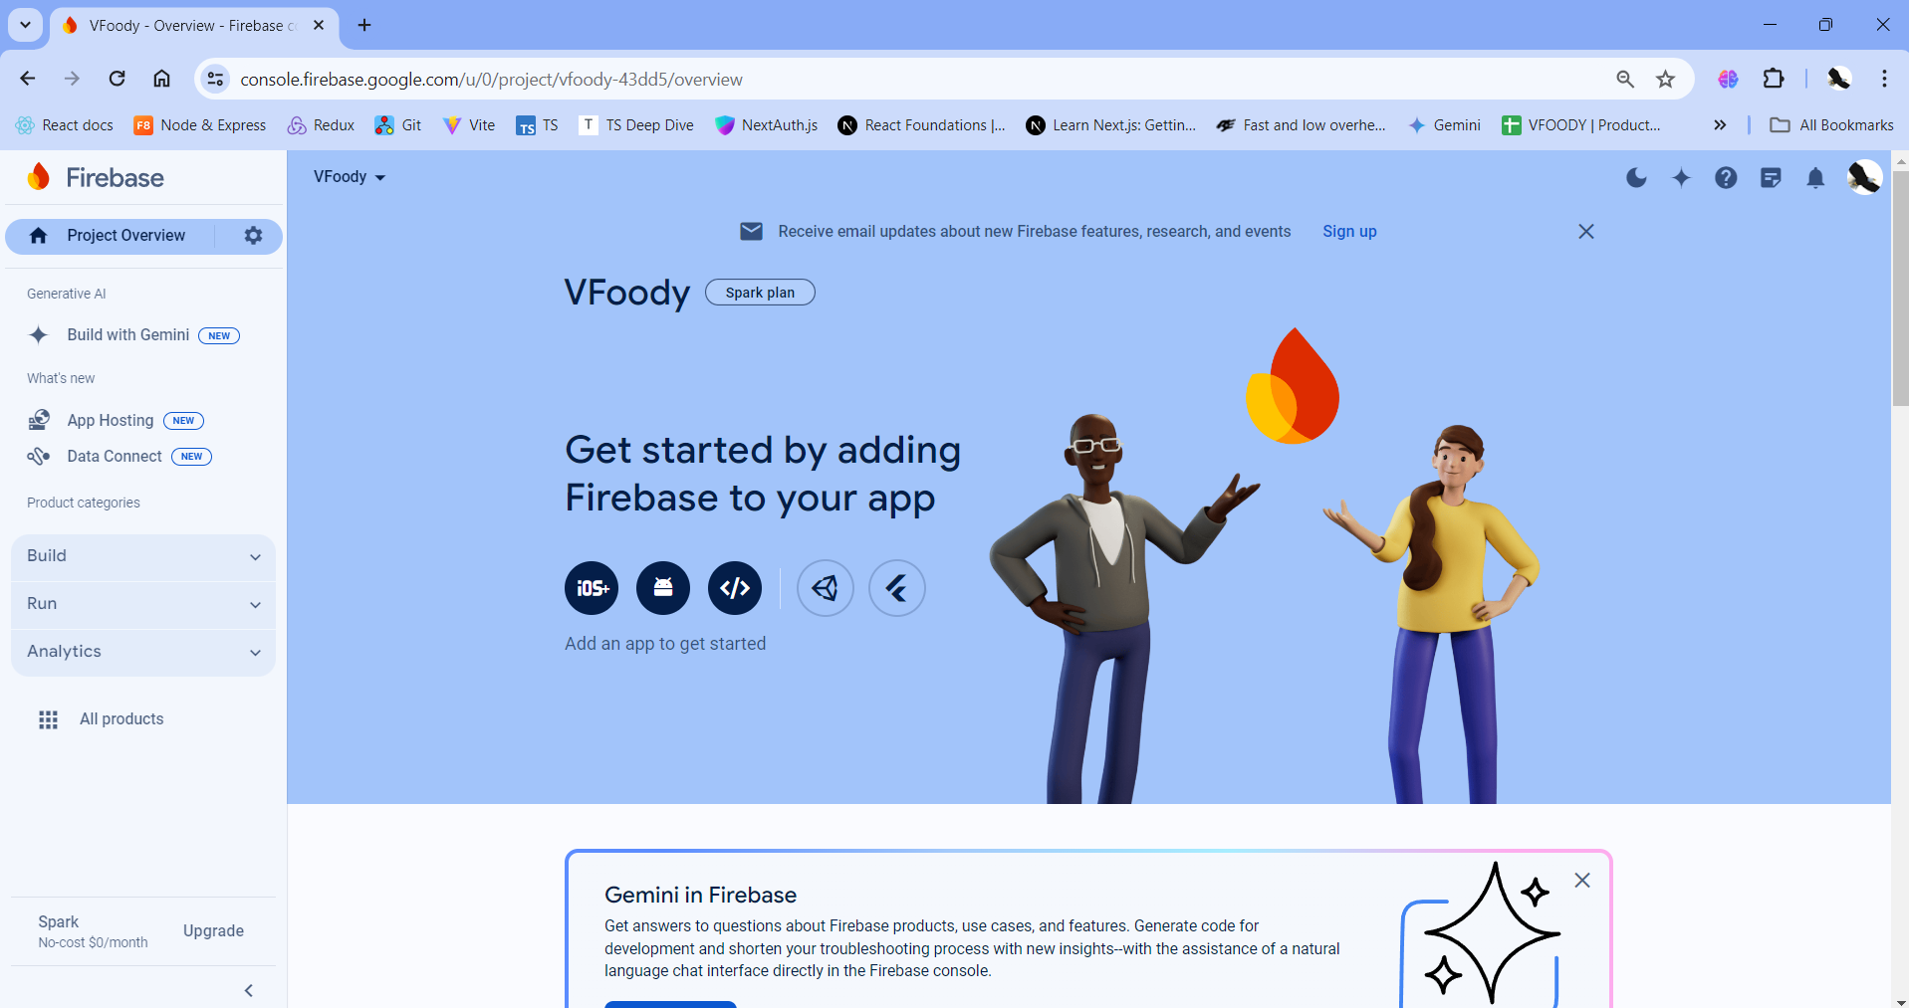
Scroll down and click Authentication
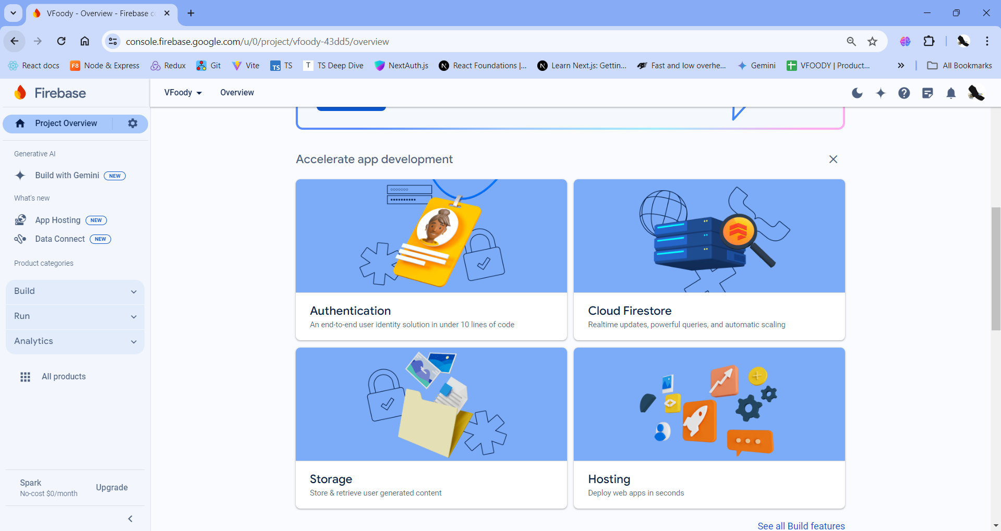
Click button Get Started
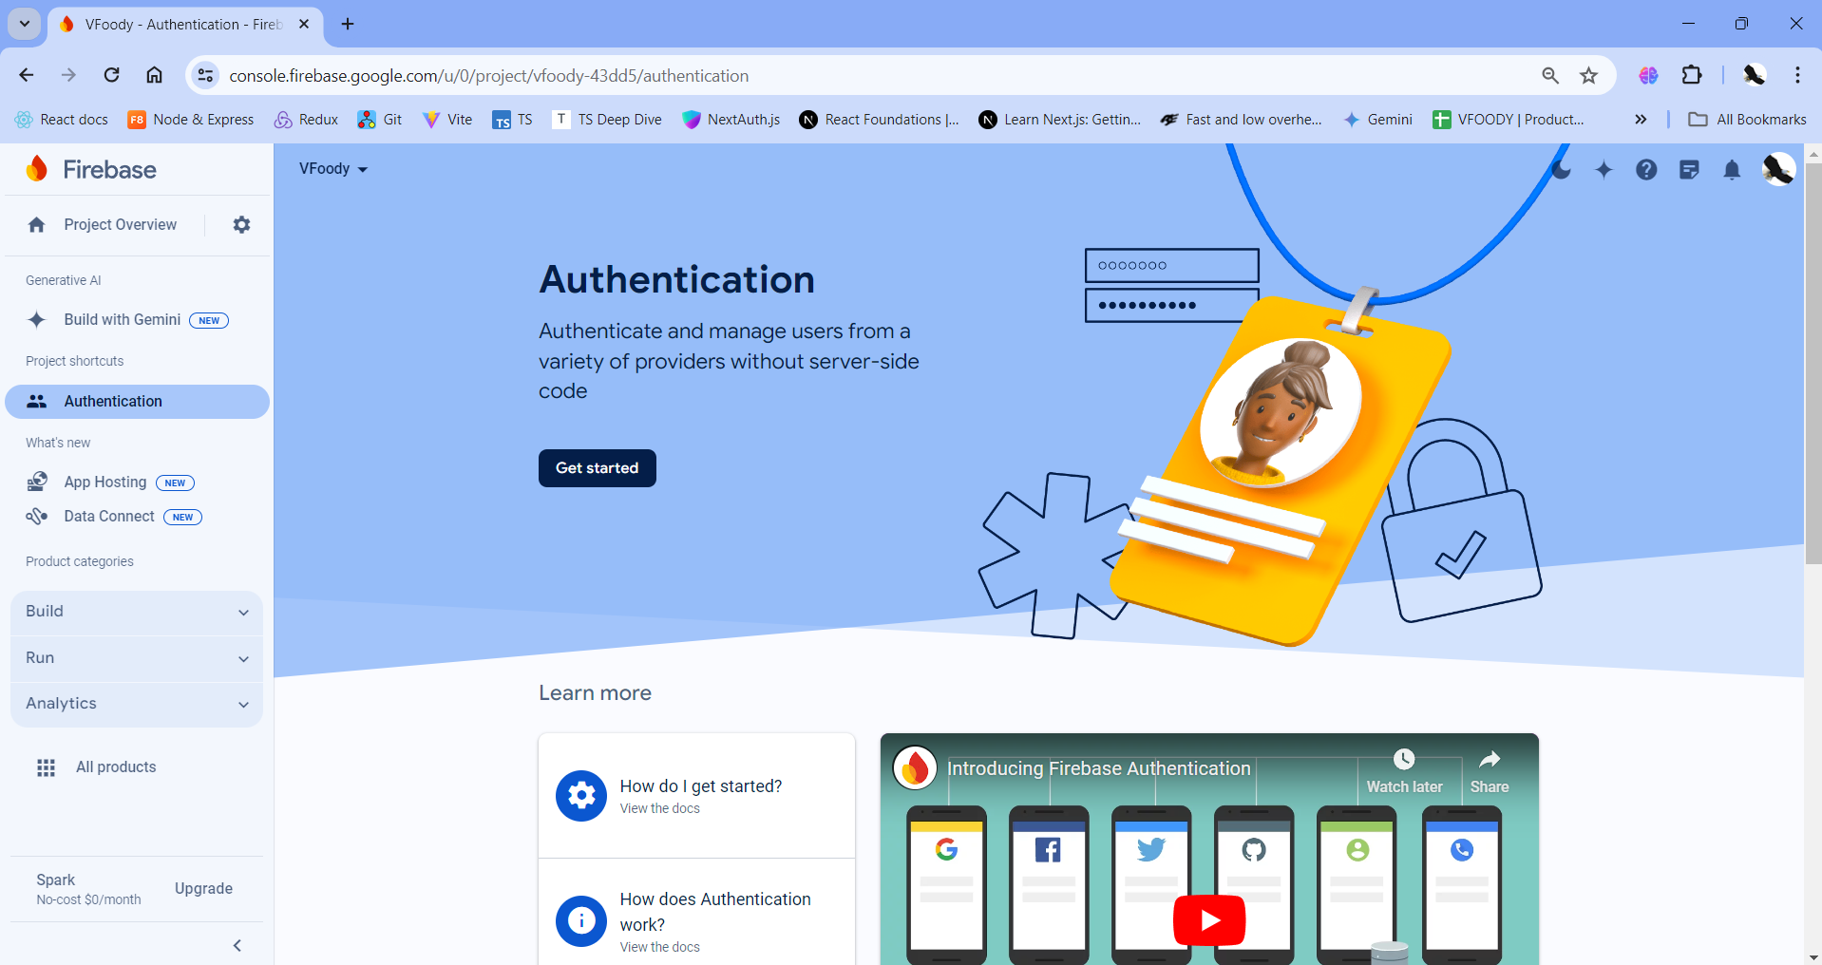
Choose sign-in method Phone in Native providers
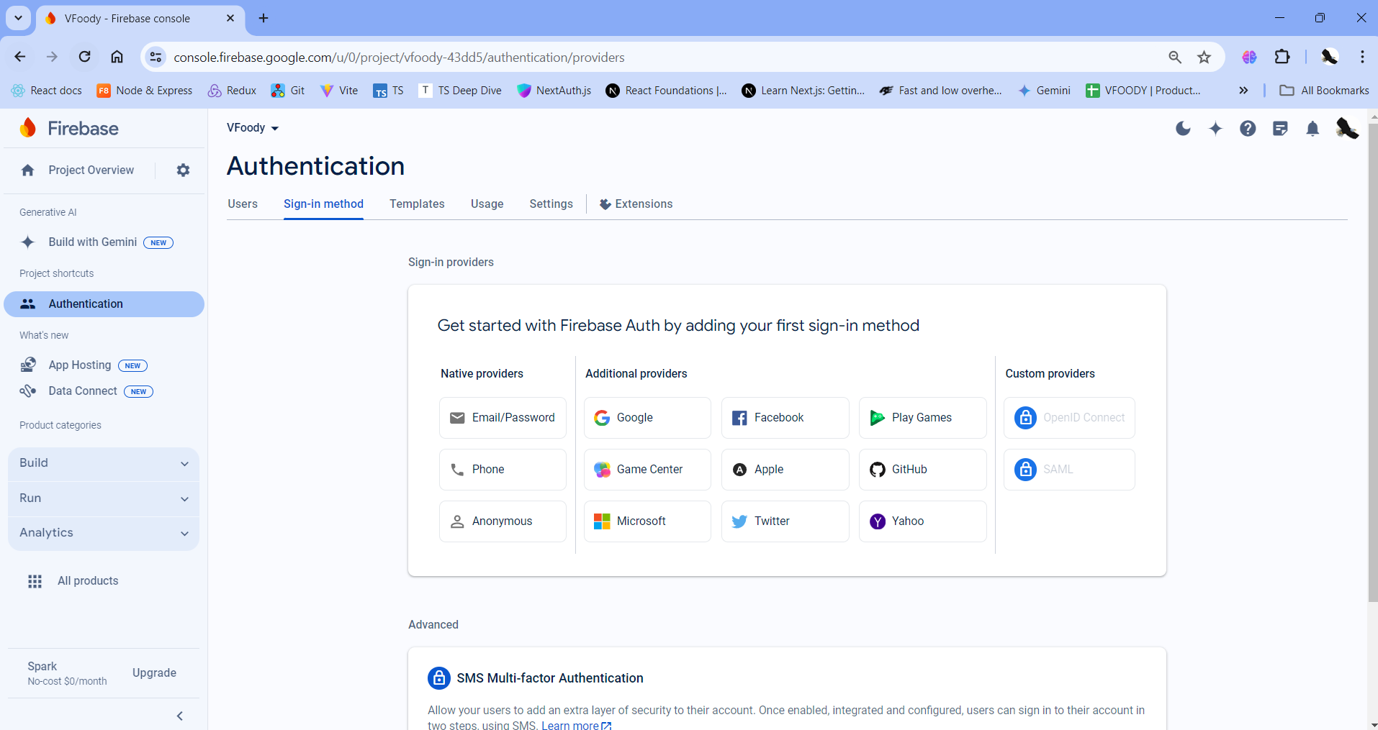

Enable phone sign-in method
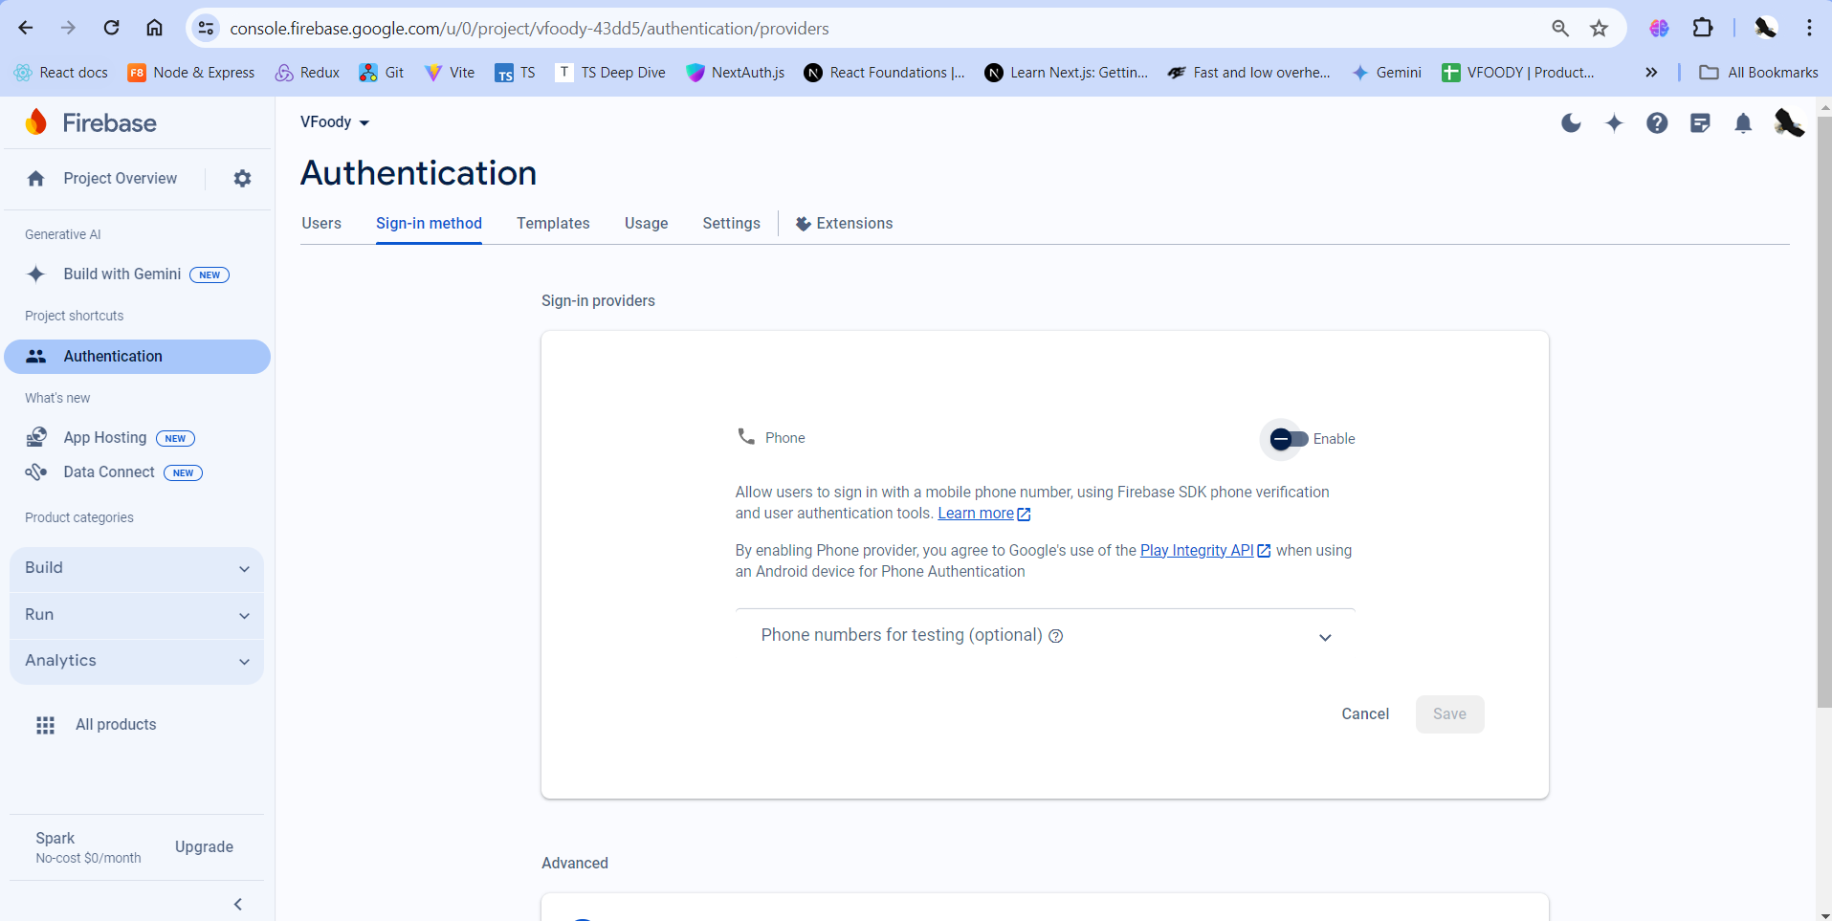
Click on optional in the bottom when you want to test (input fake phone number and fake validation code you want to use when you test). If your Firebase’s account is free, sometime it will not smooth or have some troubles, so that you can think about this solution.
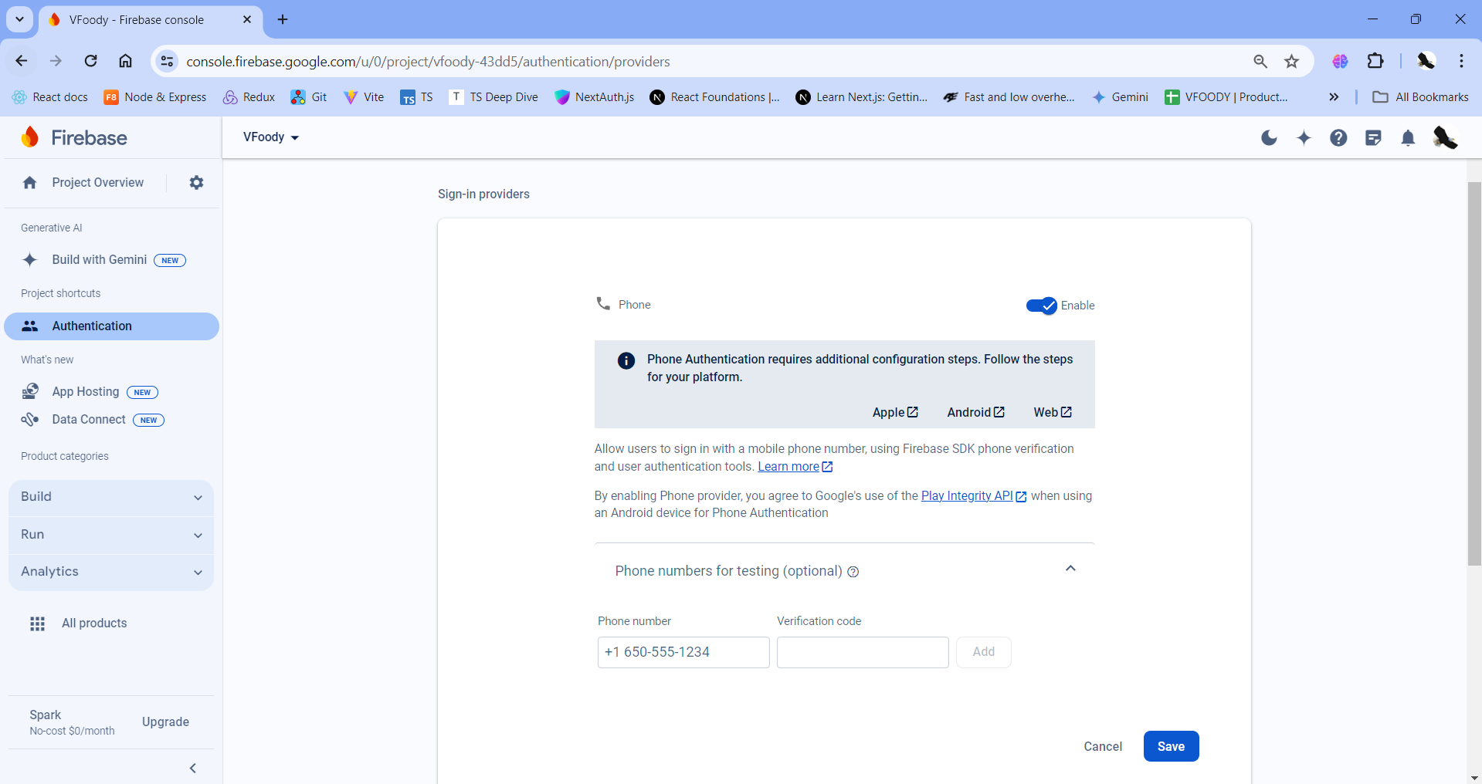

After that, the screen will be like this.
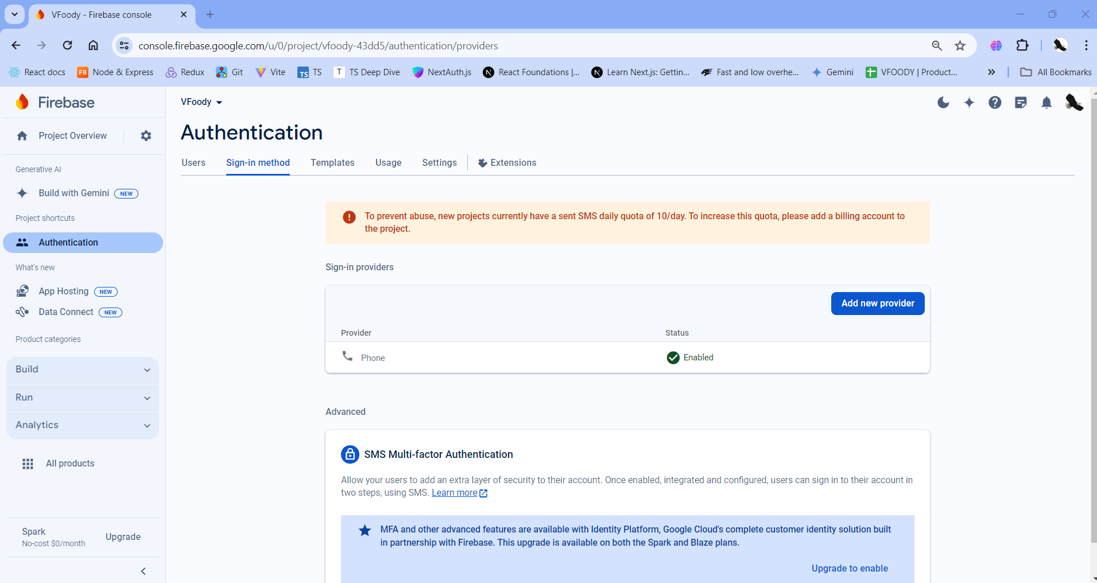
Back to the Project Overview. Then click into the Android button to go to next steps
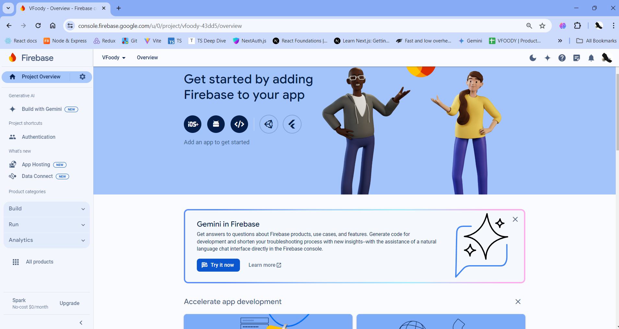

Input the Android package name based on the namespace in your project (you can skip 2 options below).
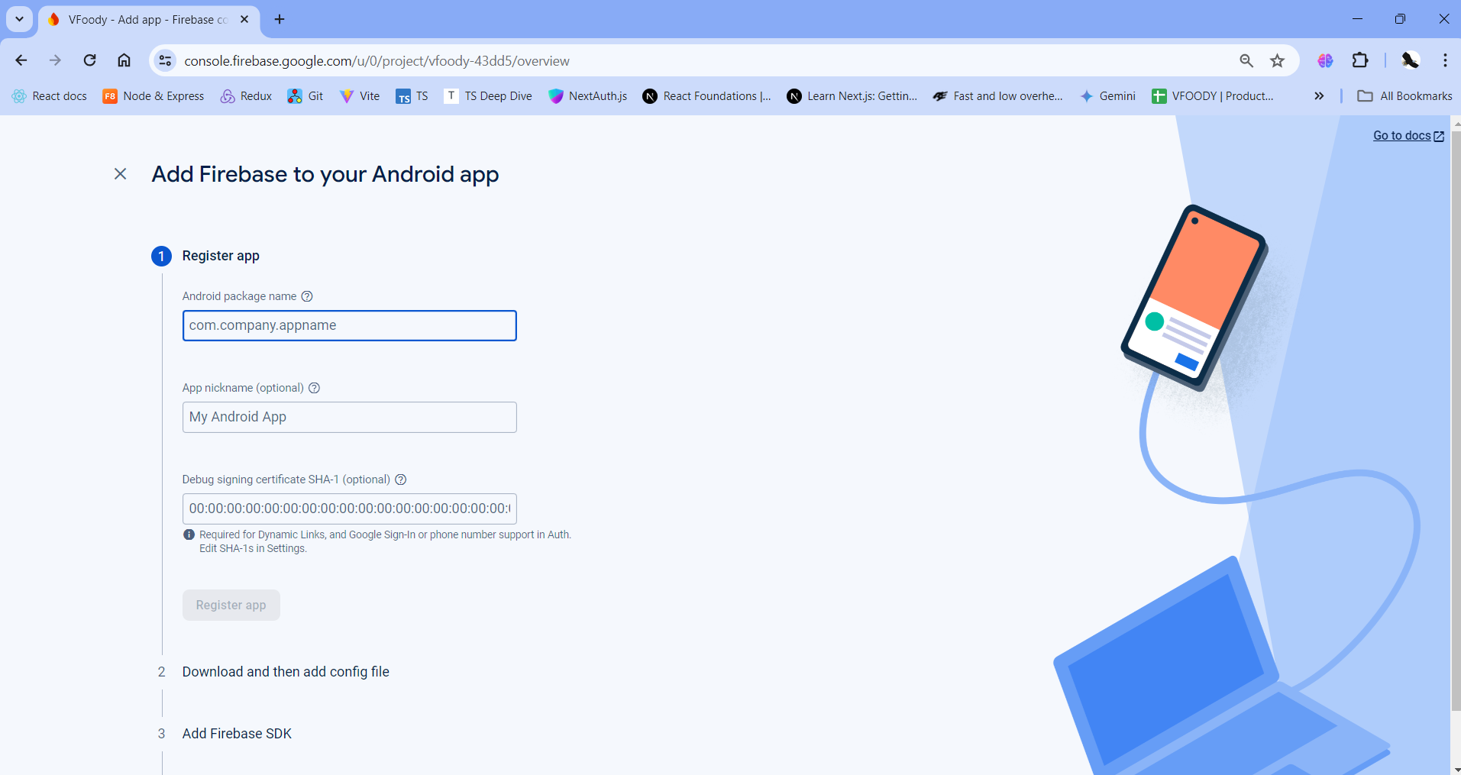
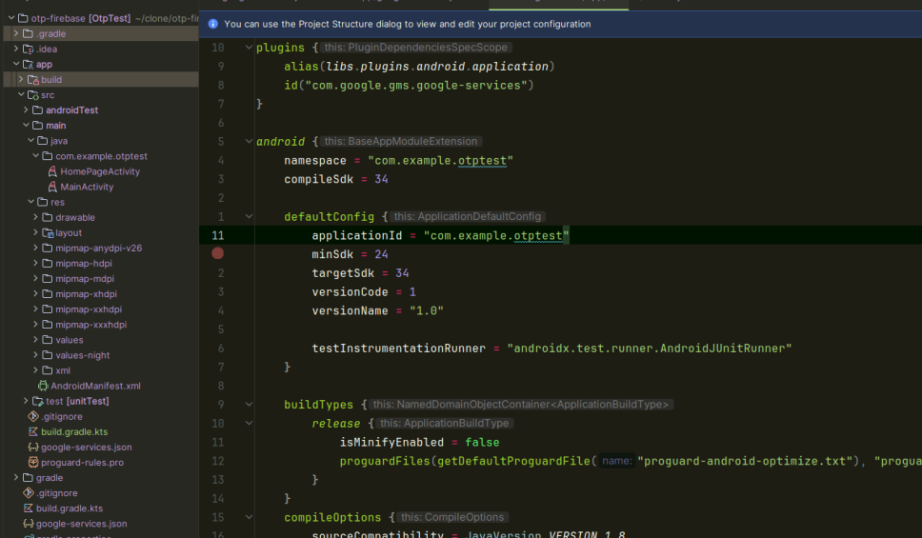

Download google-services.json and go to next step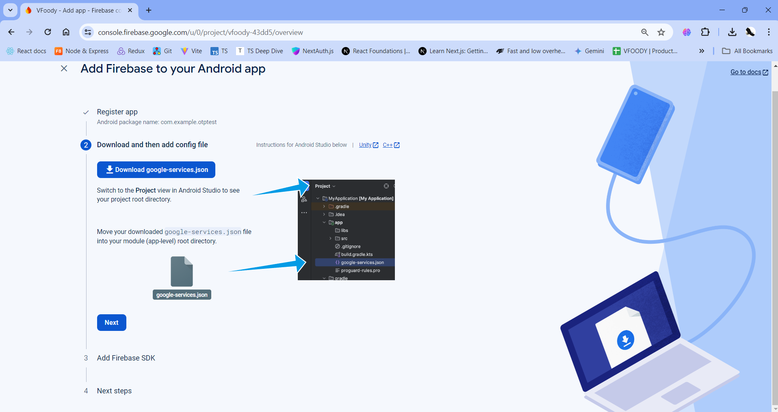
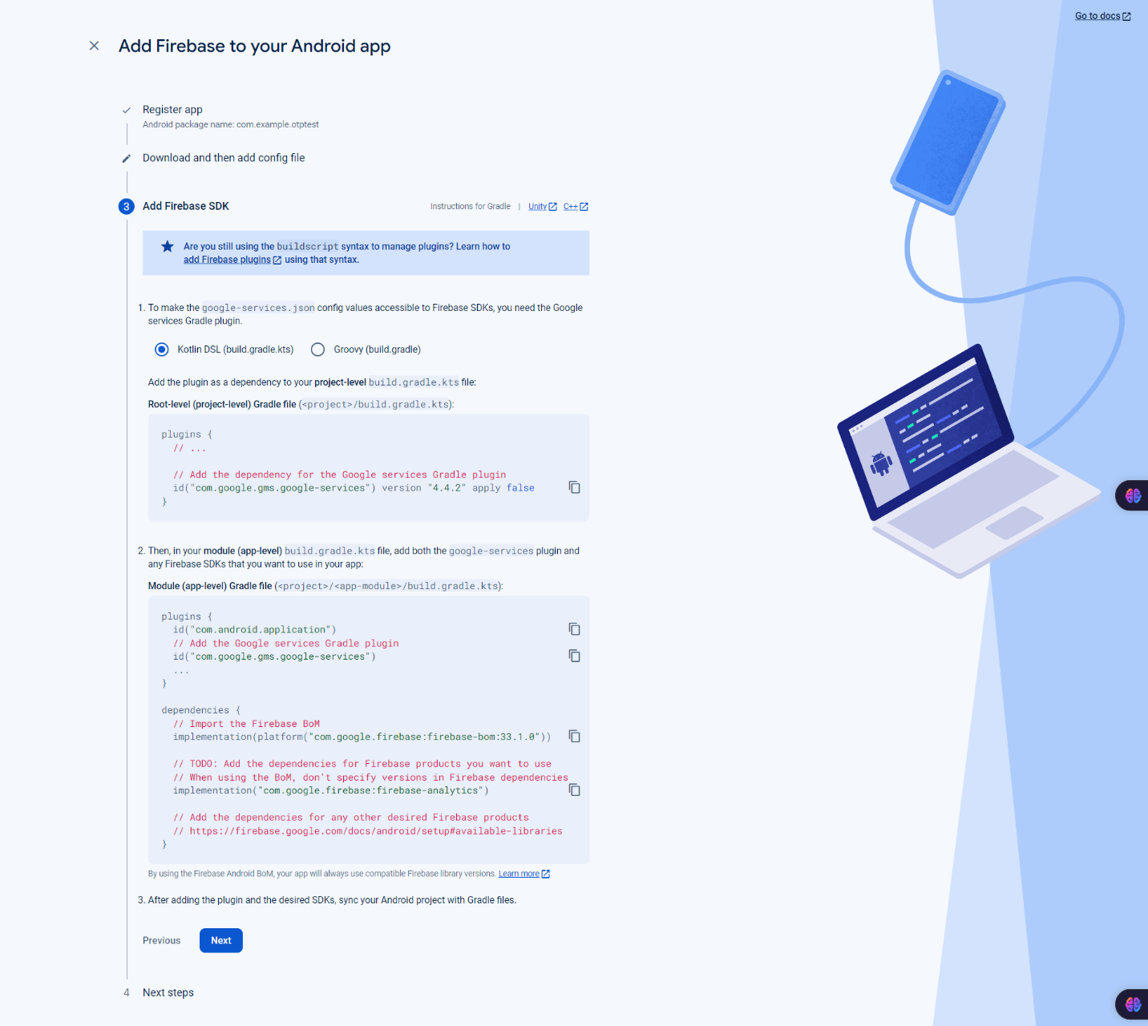
Follow all the instructions in steps 3 and 4
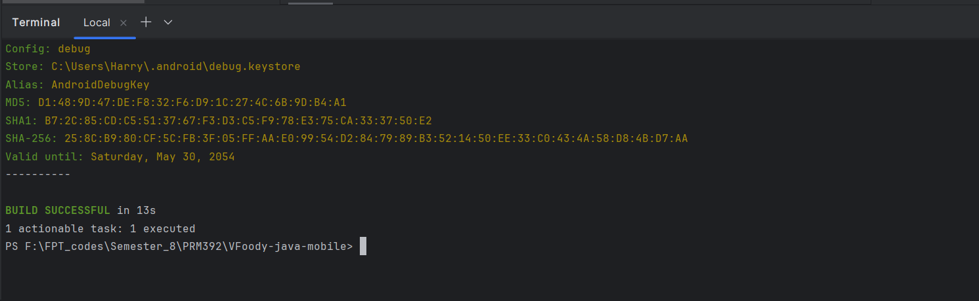
Go to your project and open terminal. Then type ./gradlew signingReport

Back to your console.firebase, click into Add fingerprint and paste values of SHA1 and SHA-256
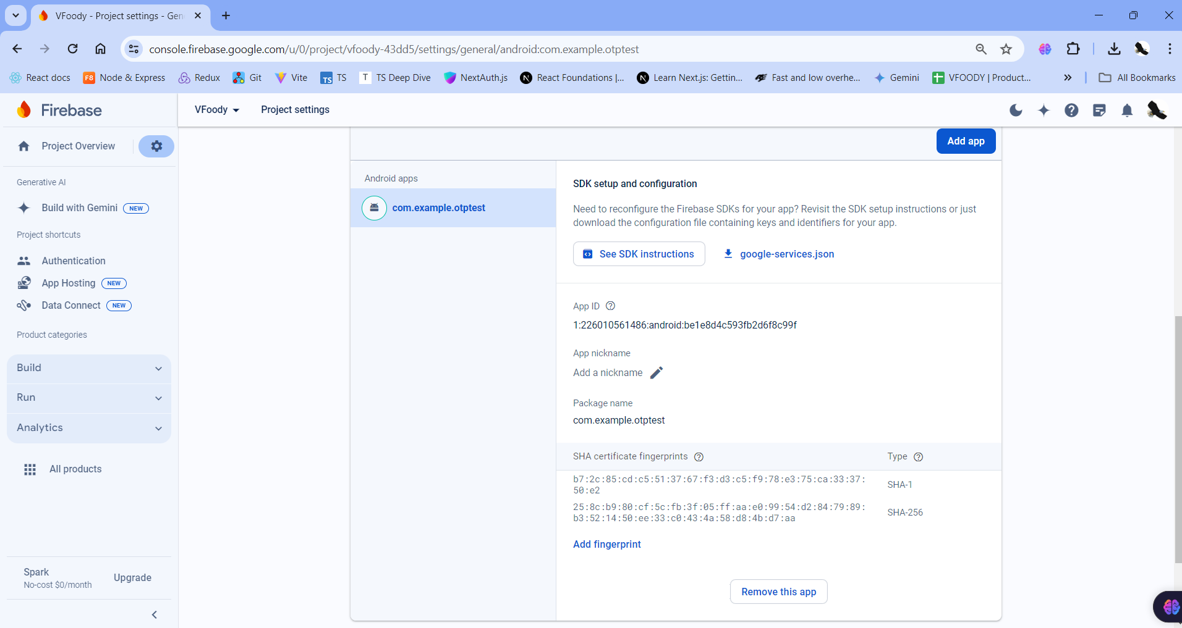
Go to the activity_main.xml file and refer to the following code. Below is the code for the activity_main.xml file.
<?xml version="1.0" encoding="utf-8"?>
<RelativeLayout
xmlns:android="http://schemas.android.com/apk/res/android"
xmlns:tools="http://schemas.android.com/tools"
android:layout_width="match_parent"
android:layout_height="match_parent"
tools:context=".MainActivity">

<!--Edittext for getting users phone number-->
<EditText
android:id="@+id/idEdtPhoneNumber"
android:layout_width="match_parent"
android:layout_height="wrap_content"
android:layout_centerHorizontal="true"
android:layout_margin="10dp"
android:hint="Enter your phone"
android:importantForAutofill="no"
android:inputType="phone" />

<!--Button for getting OTP-->
<Button
android:id="@+id/idBtnGetOtp"
android:layout_width="match_parent"
android:layout_height="wrap_content"
android:layout_below="@id/idEdtPhoneNumber"
android:layout_margin="10dp"
android:text="Get OTP"
android:textAllCaps="false" />

<!--Edittext for getting otp from user-->
<EditText
android:id="@+id/idEdtOtp"
android:layout_width="match_parent"
android:layout_height="wrap_content"
android:layout_below="@id/idBtnGetOtp"
android:layout_margin="10dp"
android:hint="Enter OTP"
android:importantForAutofill="no"
android:inputType="phone" />

<!--button for verifying user OTP-->
<Button
android:id="@+id/idBtnVerify"
android:layout_width="match_parent"
android:layout_height="wrap_content"
android:layout_below="@id/idEdtOtp"
android:layout_margin="10dp"
android:text="Verify OTP"
android:textAllCaps="false" />
</RelativeLayout>

Navigate to the app > AndroidManifest.xml file and add the below permissions to it.
<uses-permission android:name="android.permission.INTERNET" />
<uses-permission android:name="android.permission.ACCESS_NETWORK_STATE" />

Navigate to the app > java > your app’s package name > Right-click on your app’s package name and click on New > Activity > Empty Activity and name your activity. Here we have given it a name as HomeActivity.

Go to the MainActivity.java file and refer to the following code. Below is the code for the MainActivity.java file. Comments are added inside the code to understand the code in more detail.
import android.content.Intent;
import android.os.Bundle;
import android.text.TextUtils;
import android.view.View;
import android.widget.Button;
import android.widget.EditText;
import android.widget.Toast;

import androidx.annotation.NonNull;
import androidx.appcompat.app.AppCompatActivity;

import com.google.android.gms.tasks.OnCompleteListener;
import com.google.android.gms.tasks.Task;
import com.google.android.gms.tasks.TaskExecutors;
import com.google.firebase.FirebaseException;
import com.google.firebase.auth.AuthResult;
import com.google.firebase.auth.FirebaseAuth;
import com.google.firebase.auth.PhoneAuthCredential;
import com.google.firebase.auth.PhoneAuthProvider;

import java.util.concurrent.TimeUnit;

public class MainActivity extends AppCompatActivity {

// variable for FirebaseAuth class
private FirebaseAuth mAuth;

// variable for our text input
// field for phone and OTP.
private EditText edtPhone, edtOTP;

// buttons for generating OTP and verifying OTP
private Button verifyOTPBtn, generateOTPBtn;

// string for storing our verification ID
private String verificationId;

@Override
protected void onCreate(Bundle savedInstanceState) {
super.onCreate(savedInstanceState);
setContentView(R.layout.activity_main);

// below line is for getting instance
// of our FirebaseAuth.
mAuth = FirebaseAuth.getInstance();

// initializing variables for button and Edittext.
edtPhone = findViewById(R.id.idEdtPhoneNumber);
edtOTP = findViewById(R.id.idEdtOtp);
verifyOTPBtn = findViewById(R.id.idBtnVerify);
generateOTPBtn = findViewById(R.id.idBtnGetOtp);

// setting onclick listener for generate OTP button.
generateOTPBtn.setOnClickListener(new View.OnClickListener() {
@Override
public void onClick(View v) {
// below line is for checking whether the user
// has entered his mobile number or not.
if (TextUtils.isEmpty(edtPhone.getText().toString())) {
// when mobile number text field is empty
// displaying a toast message.
Toast.makeText(MainActivity.this, "Please enter a valid phone number.", Toast.LENGTH_SHORT).show();
} else {
// if the text field is not empty we are calling our
// send OTP method for getting OTP from Firebase.
String phone = "+91" + edtPhone.getText().toString();
sendVerificationCode(phone);
}
}
});

// initializing on click listener
// for verify otp button
verifyOTPBtn.setOnClickListener(new View.OnClickListener() {
@Override
public void onClick(View v) {
// validating if the OTP text field is empty or not.
if (TextUtils.isEmpty(edtOTP.getText().toString())) {
// if the OTP text field is empty display
// a message to user to enter OTP
Toast.makeText(MainActivity.this, "Please enter OTP", Toast.LENGTH_SHORT).show();
} else {
// if OTP field is not empty calling
// method to verify the OTP.
verifyCode(edtOTP.getText().toString());
}
}
});
}

private void signInWithCredential(PhoneAuthCredential credential) {
// inside this method we are checking if
// the code entered is correct or not.
mAuth.signInWithCredential(credential)
.addOnCompleteListener(new OnCompleteListener<AuthResult>() {
@Override
public void onComplete(@NonNull Task<AuthResult> task) {
if (task.isSuccessful()) {
// if the code is correct and the task is successful
// we are sending our user to new activity.
Intent i = new Intent(MainActivity.this, HomeActivity.class);
startActivity(i);
finish();
} else {
// if the code is not correct then we are
// displaying an error message to the user.
Toast.makeText(MainActivity.this, task.getException().getMessage(), Toast.LENGTH_LONG).show();
}
}
});
}

private void sendVerificationCode(String number) {
// this method is used for getting
// OTP on user phone number.
PhoneAuthOptions options =
PhoneAuthOptions.newBuilder(mAuth)
.setPhoneNumber(number) // Phone number to verify
.setTimeout(60L, TimeUnit.SECONDS) // Timeout and unit
.setActivity(this) // Activity (for callback binding)
.setCallbacks(mCallBack) // OnVerificationStateChangedCallbacks
.build();
PhoneAuthProvider.verifyPhoneNumber(options);
}

// callback method is called on Phone auth provider.
private PhoneAuthProvider.OnVerificationStateChangedCallbacks

// initializing our callbacks for on
// verification callback method.
mCallBack = new PhoneAuthProvider.OnVerificationStateChangedCallbacks() {

// below method is used when
// OTP is sent from Firebase
@Override
public void onCodeSent(String s, PhoneAuthProvider.ForceResendingToken forceResendingToken) {
super.onCodeSent(s, forceResendingToken);
// when we receive the OTP it
// contains a unique id which
// we are storing in our string
// which we have already created.
verificationId = s;
}

// this method is called when user
// receive OTP from Firebase.
@Override
public void onVerificationCompleted(PhoneAuthCredential phoneAuthCredential) {
// below line is used for getting OTP code
// which is sent in phone auth credentials.
final String code = phoneAuthCredential.getSmsCode();

// checking if the code
// is null or not.
if (code != null) {
// if the code is not null then
// we are setting that code to
// our OTP edittext field.
edtOTP.setText(code);

// after setting this code
// to OTP edittext field we
// are calling our verifycode method.
verifyCode(code);
}
}

// this method is called when firebase doesn't
// sends our OTP code due to any error or issue.
@Override
public void onVerificationFailed(FirebaseException e) {
// displaying error message with firebase exception.
Toast.makeText(MainActivity.this, e.getMessage(), Toast.LENGTH_LONG).show();
}
};

// below method is use to verify code from Firebase.
private void verifyCode(String code) {
// below line is used for getting
// credentials from our verification id and code.
PhoneAuthCredential credential = PhoneAuthProvider.getCredential(verificationId, code);

// after getting credential we are
// calling sign in method.
signInWithCredential(credential);
}
}

Now we have authenticated our user and move towards our Home Activity. Now we will display a welcome message to our user on successful authentication. For this Navigate to the app > res > layout > activity_home.xml and add the below code to it.
<?xml version="1.0" encoding="utf-8"?>
<RelativeLayout
xmlns:android="http://schemas.android.com/apk/res/android"
xmlns:tools="http://schemas.android.com/tools"
android:layout_width="match_parent"
android:layout_height="match_parent"
tools:context=".HomeActivity">
<TextView
android:layout_width="match_parent"
android:layout_height="wrap_content"
android:layout_centerInParent="true"
android:padding="10dp"
android:text="Geeks for Geeks \n Welcome to Home Screen"
android:textAlignment="center"
android:textColor="@color/purple_500"
android:textSize="20sp" />
</RelativeLayout>
For enabling Phone authentication in the Firebase console go to the Firebase Console. Now click on Go to Console option and navigate to your project. After that click on your project. You can get to see the below screen.
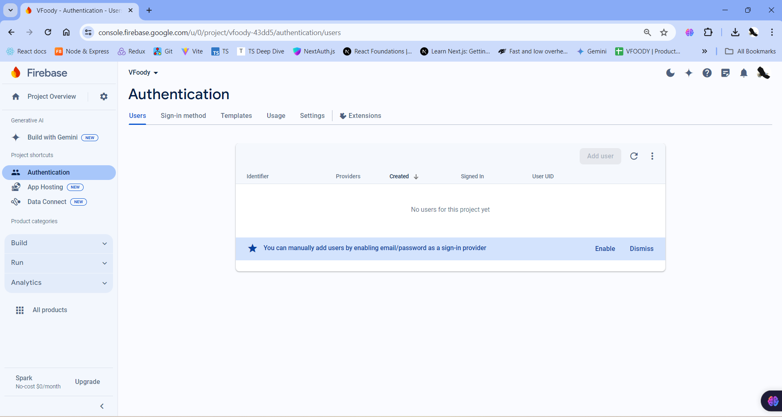
Go to Authentication 🡪 Sign-In method 🡪 Click on Phone in Provider
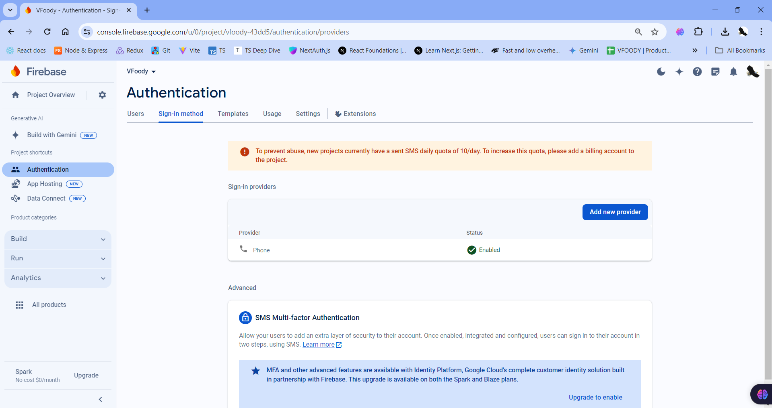
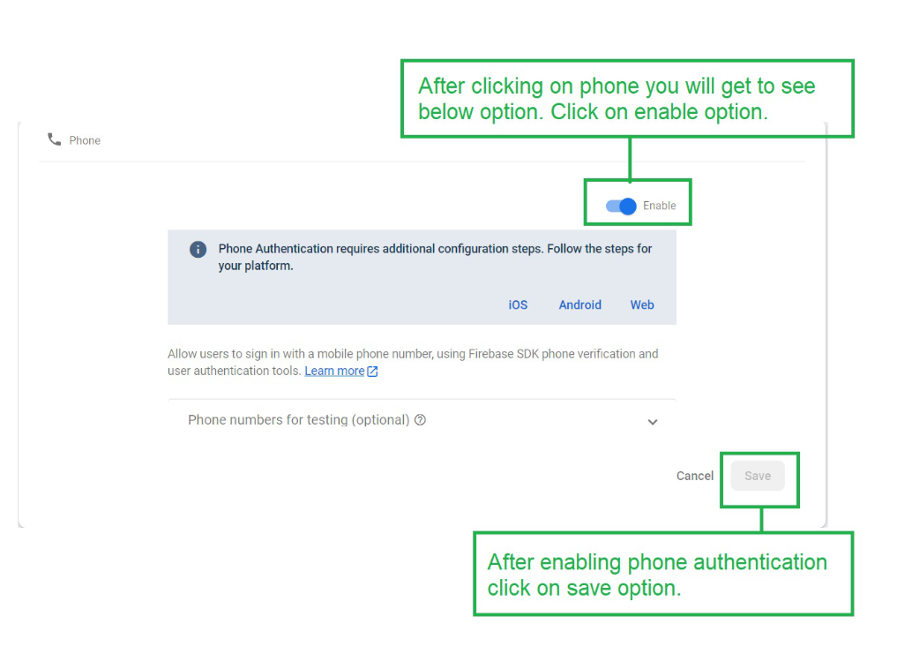
Click to Enable button and then Save

- Authentication with Email
Go to this link to create project in Firebase
https://console.firebase.google.com/u/0/?pli=1

Create a project name, then accept all checkboxes and continue in the next steps



Click Project Overview to go to your project you created

Scroll down and click Authentication


Click button Get Started



Choose sign-in method Email/Password in Native providers


Enable Email/Password sign-in method
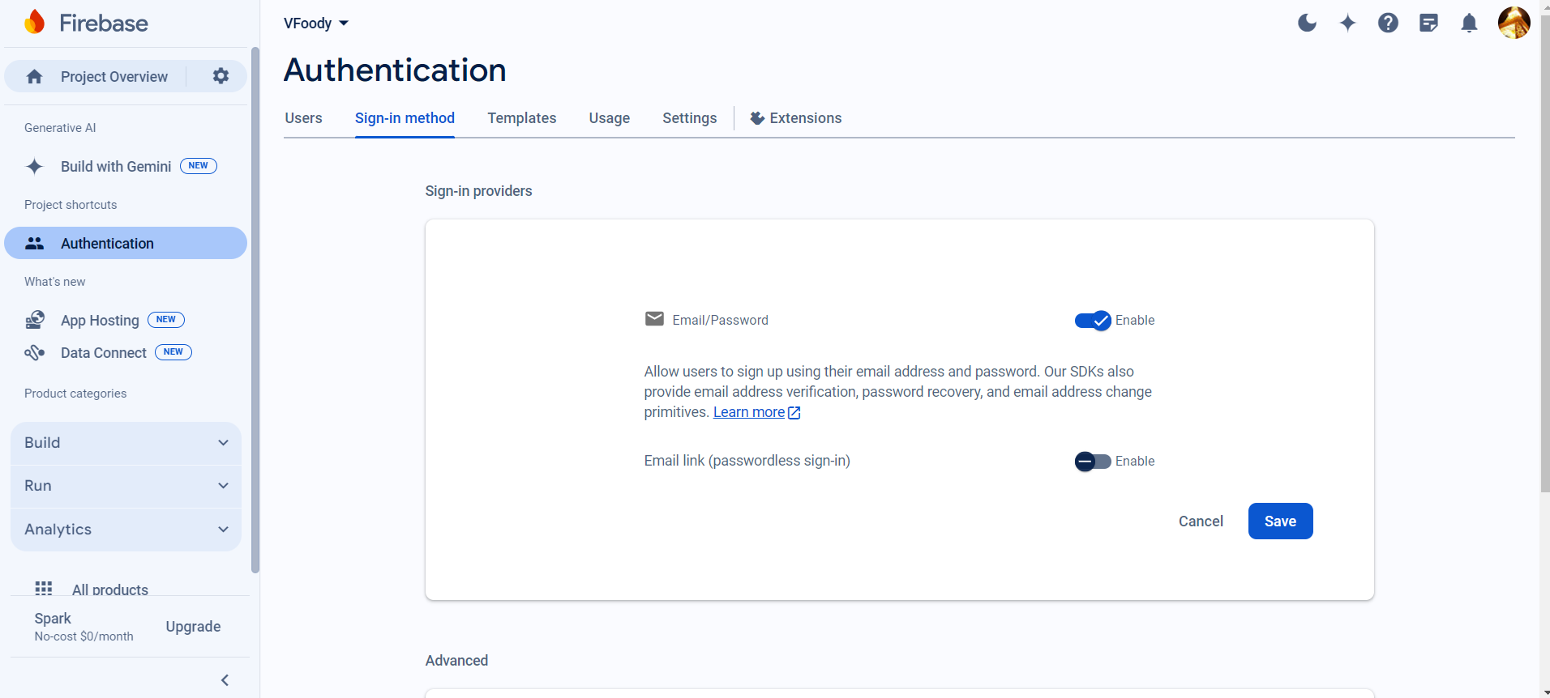

After that, the screen will be like this.
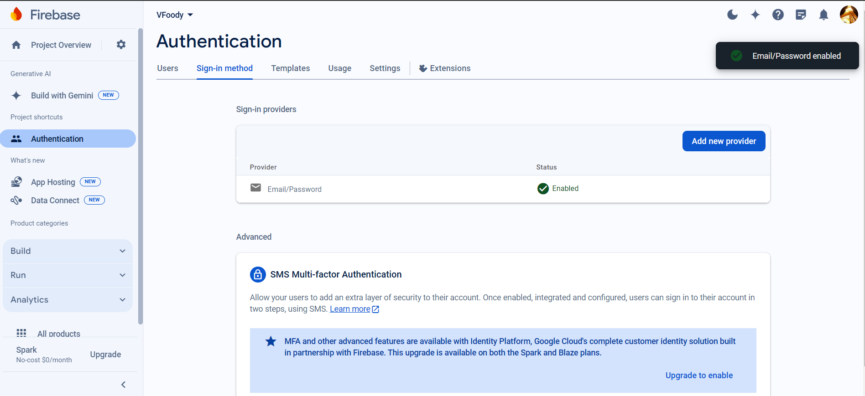

Back to the Project Overview. Then click into the Android button to go to next steps
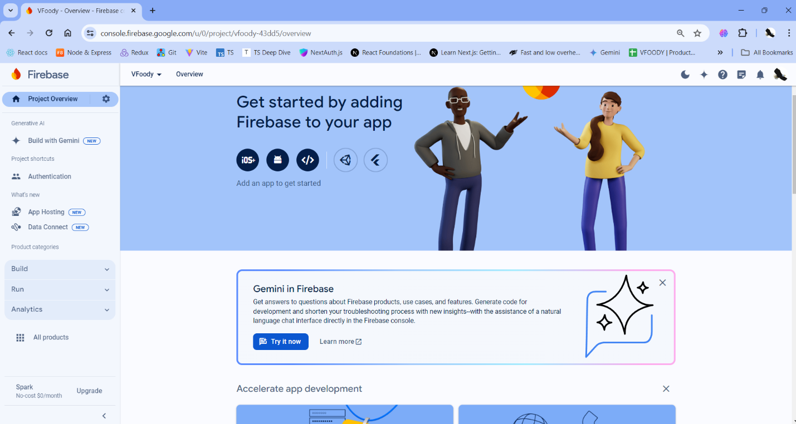

Input the Android package name based on the namespace in your project (you can skip 2 options below).

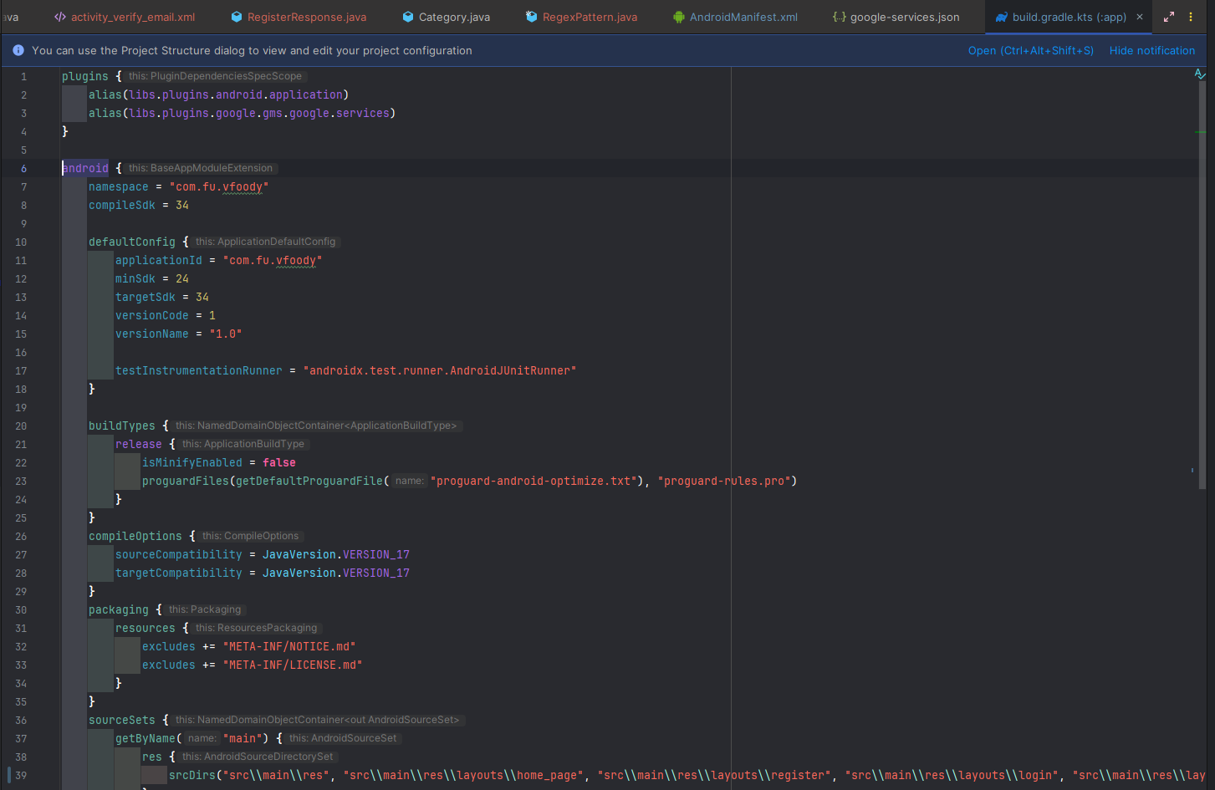

Download google-services.json and go to next step
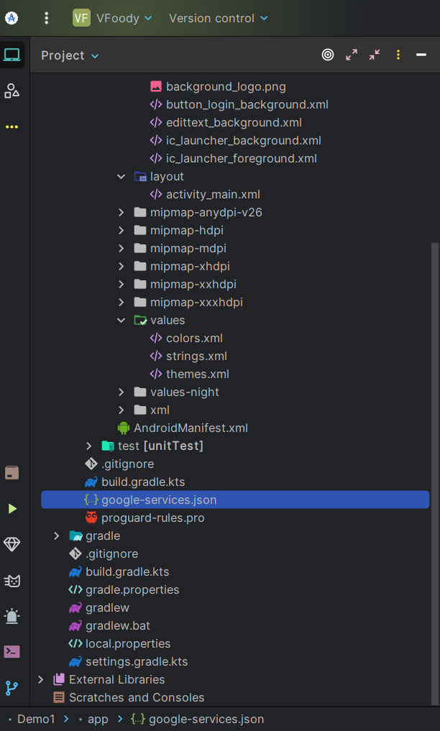



Follow all the instructions in steps 3 and 4

Go to your project and open terminal. Then type ./gradlew signingReport
Back to your console.firebase, click into Add fingerprint and paste values of SHA1 and SHA-256

Add libraries:
Add this in build.gradle.kts(Picture below)
id("com.google.gms.google-services") version "4.4.2" apply false

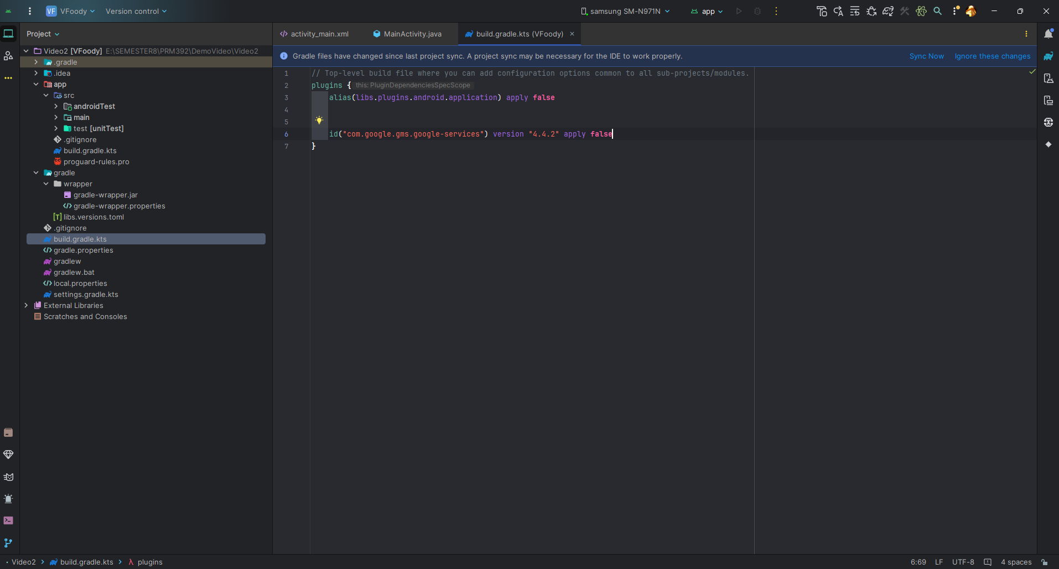

Add this dependencies in build.gradle.kts(Picture below)
id("com.google.gms.google-services")

implementation(platform("com.google.firebase:firebase-bom:33.1.0"))
implementation("com.google.firebase:firebase-auth")
implementation("com.google.android.gms:play-services-auth:21.2.0")

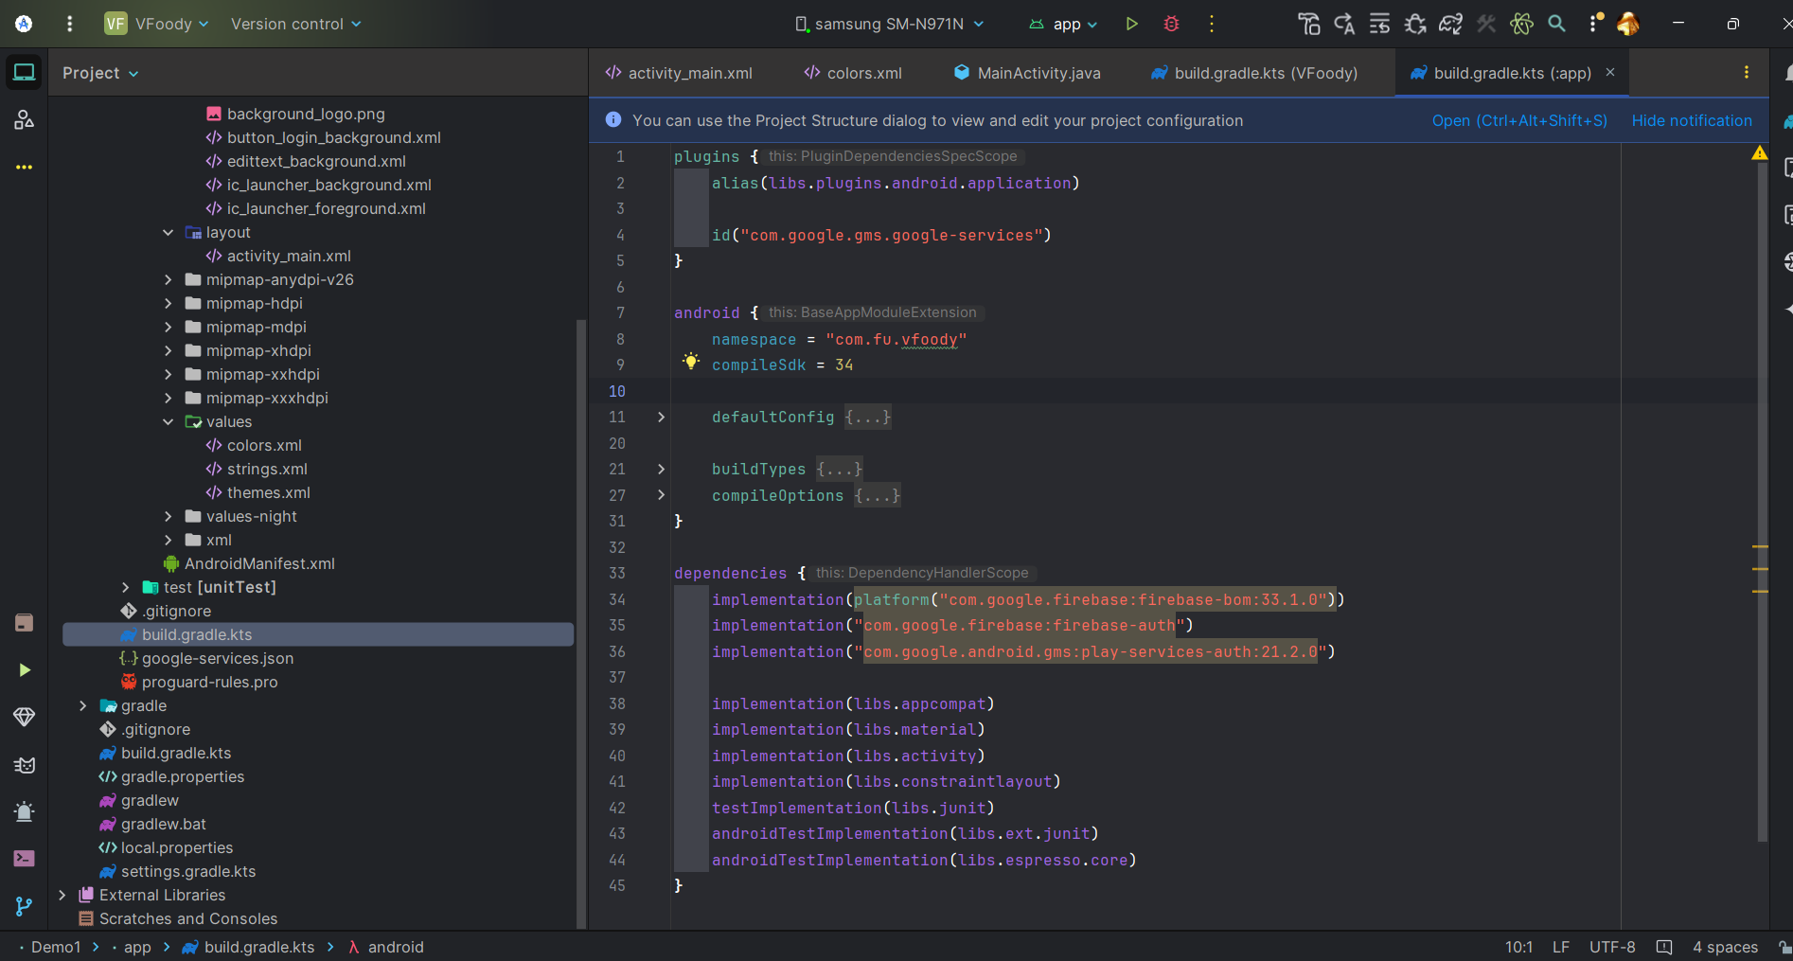

Add resource to drawable from source code provide.
Go to the activity_main.xml file and refer to the following code. Below is the code for the activity_main.xml file.
<?xml version="1.0" encoding="utf-8"?>
<androidx.constraintlayout.widget.ConstraintLayout xmlns:android="http://schemas.android.com/apk/res/android"
xmlns:app="http://schemas.android.com/apk/res-auto"
xmlns:tools="http://schemas.android.com/tools"
android:id="@+id/main"
android:background="@drawable/background_logo"
android:layout_width="match_parent"
android:layout_height="match_parent"
tools:context=".MainActivity">
<EditText
android:id="@+id/editTextTextEmailAddress"
android:layout_width="250dp"
android:layout_height="45dp"
android:layout_weight="4"
android:background="@drawable/edittext_background"
android:drawablePadding="10dp"
android:ems="10"
android:hint="Email"
android:inputType="text"
android:padding="10dp"
android:textColor="#FF000000"
android:textColorHint="#9AA0B4"
android:textSize="15sp"
app:layout_constraintEnd_toEndOf="parent"
app:layout_constraintStart_toStartOf="parent"
app:layout_constraintTop_toTopOf="@+id/guideline30" />
<EditText
android:id="@+id/editTextPassword"
android:layout_width="250dp"
android:layout_height="45dp"
android:layout_weight="4"
android:background="@drawable/edittext_background"
android:drawablePadding="10dp"
android:ems="10"
android:layout_marginTop="30dp"
android:hint="Password"
android:inputType="textPassword"
android:padding="10dp"
android:textColor="#FF000000"
android:textColorHint="#9AA0B4"
android:textSize="15sp"
app:layout_constraintEnd_toEndOf="parent"
app:layout_constraintStart_toStartOf="parent"
app:layout_constraintTop_toBottomOf="@+id/editTextTextEmailAddress" />
<androidx.appcompat.widget.AppCompatButton
android:id="@+id/btnRegister"
android:layout_width="wrap_content"
android:layout_height="wrap_content"
android:layout_gravity="center_horizontal"
android:background="@drawable/button_login_background"
android:paddingStart="80dp"
android:paddingEnd="80dp"
android:layout_marginTop="30dp"
android:text="Xác nhận"
android:textAllCaps="false"
android:textColor="#FFFFFF"
android:textSize="20sp"
app:layout_constraintEnd_toEndOf="parent"
app:layout_constraintStart_toStartOf="parent"
app:layout_constraintTop_toBottomOf="@+id/editTextPassword" />
<androidx.constraintlayout.widget.Guideline
android:id="@+id/guideline30"
android:layout_width="wrap_content"
android:layout_height="wrap_content"
android:orientation="horizontal"
app:layout_constraintGuide_percent="0.35" />
</androidx.constraintlayout.widget.ConstraintLayout>

Navigate to the app > AndroidManifest.xml file and add the below permissions to it.
<uses-permission android:name="android.permission.INTERNET" />
<uses-permission android:name="android.permission.ACCESS_NETWORK_STATE" />

Go to the MainActivity.java file and refer to the following code. Below is the code for the MainActivity.java file. Comments are added inside the code to understand the code in more detail.

package com.fu.vfoody;
import android.content.Intent;
import android.os.Bundle;
import android.widget.EditText;
import android.widget.Toast;
import androidx.activity.EdgeToEdge;
import androidx.appcompat.app.AppCompatActivity;
import androidx.appcompat.widget.AppCompatButton;
import androidx.core.graphics.Insets;
import androidx.core.view.ViewCompat;
import androidx.core.view.WindowInsetsCompat;
import com.google.firebase.auth.FirebaseAuth;
import com.google.firebase.auth.FirebaseUser;
import java.util.concurrent.ThreadLocalRandom;
public class MainActivity extends AppCompatActivity {
private AppCompatButton btnRegister;
private EditText editTextTextEmailAddress, editTextPassword;
private FirebaseAuth mAuth;
@Override
protected void onCreate(Bundle savedInstanceState) {
super.onCreate(savedInstanceState);
EdgeToEdge.enable(this);
setContentView(R.layout.activity_main);
init();
btnRegister.setOnClickListener(v -> {
signUpUser(editTextTextEmailAddress.getText().toString(), editTextPassword.getText().toString());
});
}
private void signUpUser(String email, String password) {
mAuth.createUserWithEmailAndPassword(email, password)
.addOnCompleteListener(this, task -> {
if (task.isSuccessful()) {
FirebaseUser user = mAuth.getCurrentUser();
if (user != null) {
user.sendEmailVerification()
.addOnCompleteListener(emailTask -> {
if (emailTask.isSuccessful()) {
//Process with backend
Toast.makeText(MainActivity.this, "Successfully to send verification email.", Toast.LENGTH_SHORT).show();
} else {
Toast.makeText(MainActivity.this, "Failed to send verification email.", Toast.LENGTH_SHORT).show();
}
});
}
} else {
Toast.makeText(MainActivity.this, "Authentication failed.", Toast.LENGTH_SHORT).show();
}
});
}
private void init() {
mAuth = FirebaseAuth.getInstance();
editTextTextEmailAddress = findViewById(R.id.editTextTextEmailAddress);
editTextPassword = findViewById(R.id.editTextPassword);
btnRegister = findViewById(R.id.btnRegister);
}
}

