Investigating the Truth Behind a Demographic Assumption:
The Assumption being, that the Outer Suburban Areas are Popular Destinations for Young Families to Live.

Hypothesis 1: Population data will show that younger families exist in greater proportion closer to the city centre, whilst families of teens, and older demographics persist greatly in the outer suburban areas.

My hypothesis dictates that population data will show that younger families will persist in greater proportion closer to the city centre (demographic ages 20-24, 25-34, and 0-4). Whilst families of teens or older (15 and above) persist within the suburban areas. Such data reflects a change in lifestyle within younger generations and families, as well as a change in working lifestyle in modern society.

Australian Postal Code Mapping Pretence and Pretence of all Data Analysed:
The postcode map used is the standard postcode map as of 17/05/2018 – the latitude and longitude approximation coordinates of this postal map are taken by interfacing Google’s Google Map navigation system on the same date. This data is employed to evaluate vector distances from the Central Point of the Perth metropolitan area: in our data, this is defined as the postcode 6000.
Software Notes:
The software designed for the analysis of this data employs the Python3 programming language, specifically drawing function from the modules: Matplotlib.pyplot, pandas, math, and re (regular expressions). To view the code itself, please refer to the files provided with this document. Please view the appendix to obtain greater understanding of the choices made.

Data Processing:
Below is a recording of the data processing, raw data, and an in-depth analysis of data choices made.

Population Distribution Across Perth Postcodes

Population distribution across Perth postcodes is first gauged in the most simple manner possible, as a categorisation of post-code residency (POA) to population. Although not a completely representative quantifier of population density or population as a function of urban density, it is the first obvious method of analysing urban population. Under this examination, POA (postcode address) – as defined by the Australian Bureau of Statistics (ABS) – is taken as the categoriser, and the population is plotted over uniform intervals that are independent of vector distances from the city centre.
The data plotted is as follows.
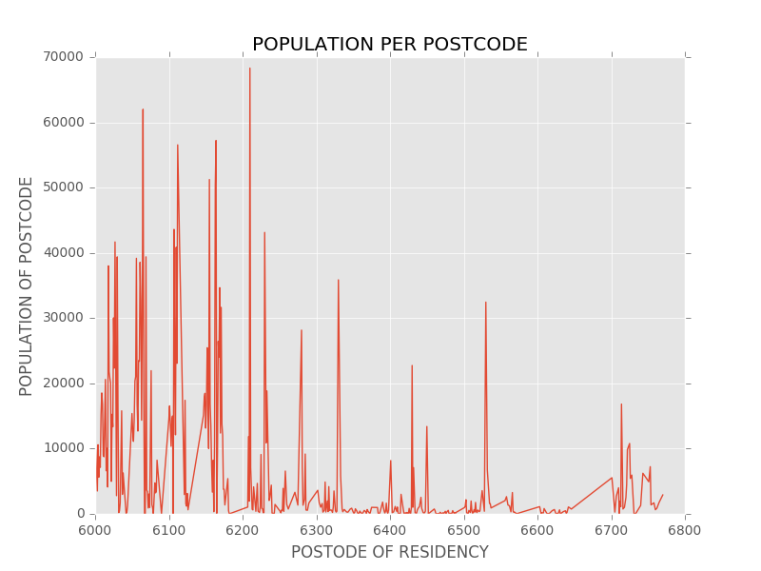
Although not being completely representative of population data, this data does demonstrate the potential for 3 main population clusters: the first centred in close proximity to postcode area 6000, a secondary, smaller cluster at medium distance, and a third, larger cluster at great distance. Considerations must be made about the representation of this data; the data does not take into account the density of the population in each of these areas. This, in conjunction with the trend for postal areas to become larger as population density decreases, produces data that is not accurate to a large degree. To improve accuracy, the density of the population data must be ascertained.

Population Distribution as a consideration of Distance Vectors from Postcode 6000

This data may also be plotted as urban density, taking the density as a function of distance from the city centre as represented by POA6000.

This distance is defined via the retrieval of the latitude and longitude from google’s services, this is then compared to the same variables under the postcode 6000. Using Pythagoras theorem, the distance is plotted as the square-root of the summed square of both values.
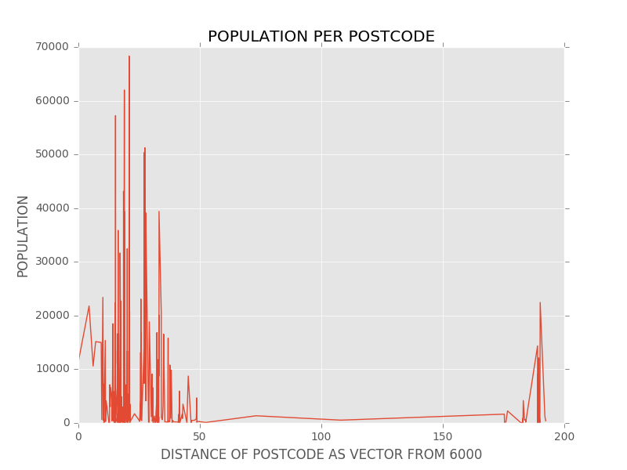
This is then stored in a .csv file which is later accessed from another module to graph the data. The data stored includes the coordinated (dictionary format) of each postcode, alongside the distances (float values) of each postcode.
Under this consideration, the data may be graphed in the same manner to produce the following results:

Observing the graphed data from these results it becomes evident that there are two large clusters of population, the first being within highly close proximity to the city centre, and the second being at large distance from the city centre. Population between these points is relatively small. The first population cluster spans from 0 to 50 kilometres distance from postcode 6000, and the second spanning roughly 175 to 200 kilometres from the city centre.
For clarity, the graph should be restricted to the 100 kilometre mark – as any population beyond this point is, for arguments sake, roughly outside of the area of the extra-metropolitan suburbs that we are concerned with.
The following graph is constructed from this data:
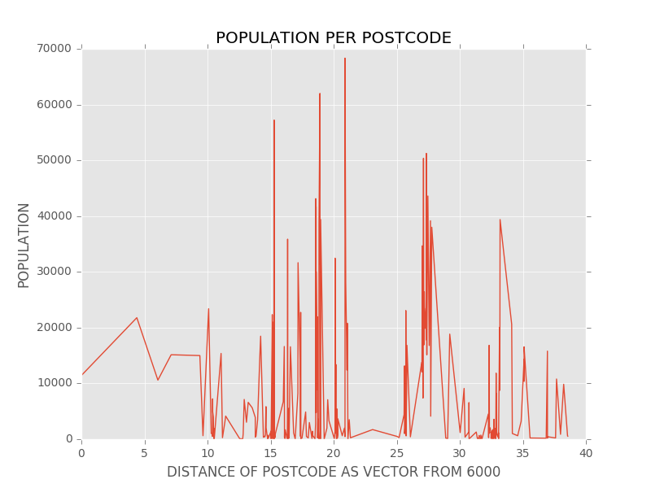
This restricted data may now be allotted into 5km “rings” of land that propagate out from postcode 6000. This sectioning is shown below. This makes the data easier to understand and process. Under no conditions of age, the following data is produced.
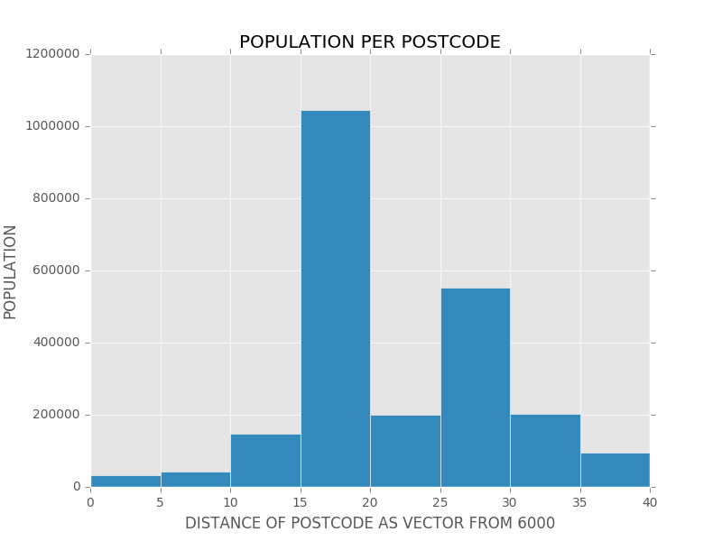

Population Distribution as a consideration of Distance and Comparing Age.
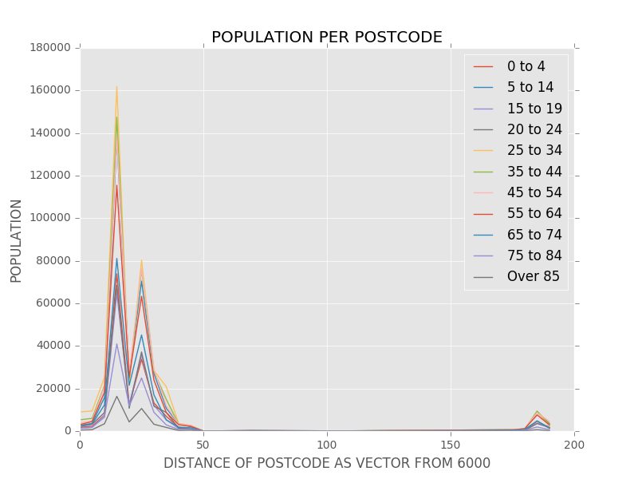
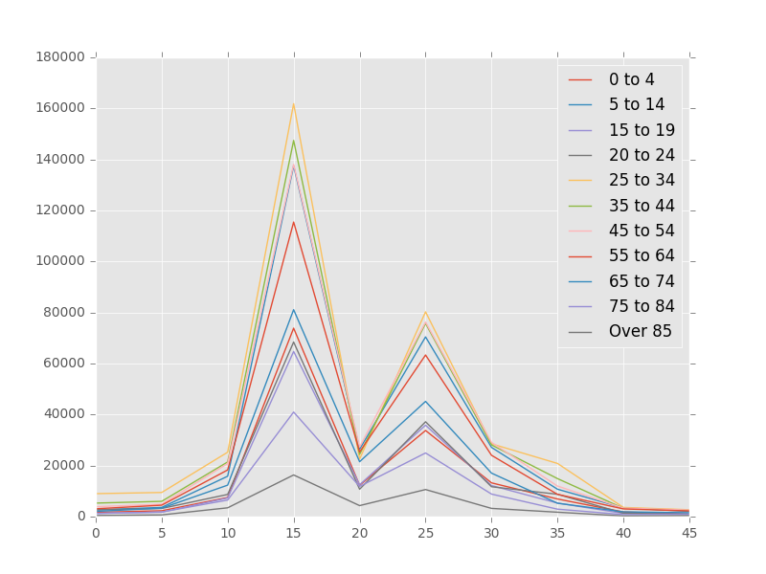
Plotting this data against age we obtain the following data on the left. This data is represented below. Similarly, restricting this data to the first 45 kilometres from the city centre, the following data is portrayed on the right.

Area Approximation across Irregular Polygons

To approximate the area of an irregular polygon, two main approaches are pertinent to the accuracy required in this population density analysis – the first employing Gauss’s area formula, and the second employing a “Bubble-area” approximation of postcode area.
Bubble area:
The simplest and most easily obtained solution is to approximate area using overlapping, approximated circles around the coordinates of the postcode, with a radius that is dependent on distance from POA6000 (central postcode). The area is then gauged from simply observing the area within the circle:
Several assumptions are made in this methodology that determine it’s accuracy under varying conditions.
- The centre of the postcode as advertised by Google’s services is approximately the geometric centre of the postcode area.
- The postcode area is regular enough to be approximated by a circle – assumption is not applicable to postcodes that are highly elongated, or have any other highly irregular geometry.
- The Border of a postcode area is halfway between the subject postcode, and the closest postcode to it.

An equation for the area of a postcode is given below, this formula is implemented into the Python code for this processing.

Under this approximation of urban area, and hence the urban density of the postcode area, the following data can be plotted In a more representative manner.
Under this correction, our initial postcode to population data:
Transforms into this plotting of population density as a function of distance from postcode address 6000.
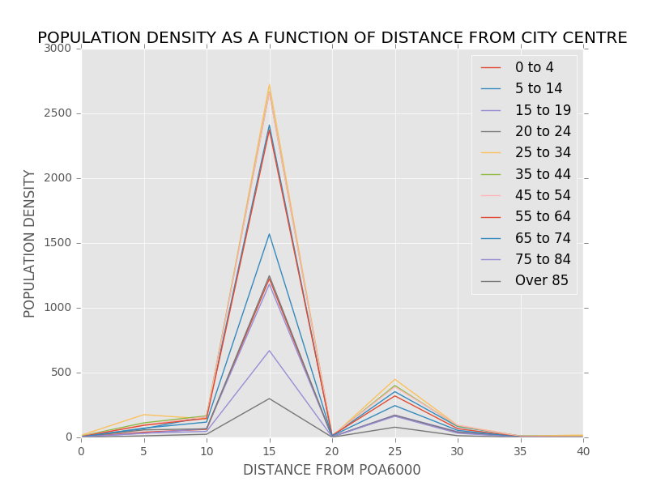

From this data, it may be observed that there is a small difference in population age proportion between the two main clusters of dense population (one centring around 15 kilometres from the city centre, and the other centring 25 kilometres from the city centre).
Note that these clusters of population most likely represent a) Bentley and the surrounding areas on the left, and b) Joondalup and the surrounding suburbs on the right.
It may be observed that there is a proportionately greater population of those 25-34 years of age and 20-24 years of age in population cluster a – there is, however, a very substantial increase in those of the ages 0 to 4 In the central city areas. This increase is expected, in an absolute sense, due to the increased population. But it is still an increase – proportionately – to the portion of that demographic in the outer suburban areas.

Conclusion
The data obtained from the 2016 Census from the Australian Bureau of Statistics demonstrates a developing difference In the lifestyles of young families and people within the metropolitan and surrounding suburbs of Perth, Western Australia. The relative population proportions of both regions demonstrating an older population (on average) in the suburban areas than the central metropolitan areas. The same data demonstrates a greater proportion of young adults (20-34) and small children (0-4) in these areas compared to suburban spaces. Suburban spaces, similarly, saw a greater proportion of teen (15-19) individuals and older (45-45) adults.

To see processing of data please refer to _____.py.

