Change in Religious Belief and Religious Education:
An investigation into the religious beliefs of Australians from 2011 to 2016, and an investigation into the prevalence of religion in education.

Hypothesis 2: Population data will show a small but insubstantial change in religious beliefs of Australians over 2011 to 2016, with a significant portion of high-school education (years 7 to 12) being religious.

Under the consideration of an age bracket of 4 to 19 years of age (schooling age). Reasons for this correlation will be explored in depth, and any discordance in this hypotheses will be explored. Population data will hence imply, that a greater proportion of religious schools in a geographic area will result in a greater proportion of religious individuals.

Australian Postal Code Mapping Pretence and Pretence of all Data Analysed:
The postcode map used is the standard postcode map as of 17/05/2018 – the latitude and longitude approximation coordinates of this postal map are taken by interfacing Google’s Google Map navigation system on the same date. This data is employed to evaluate vector distances from the Central Point of the Perth metropolitan area: in our data, this is defined as the postcode 6000.
Software Notes:
The software designed for the analysis of this data employs the Python3 programming language, specifically drawing function from the modules: Matplotlib.pyplot, pandas, math, and re (regular expressions). To view the code itself, please refer to the files provided with this document. Please view the appendix to obtain greater understanding of the choices made.

Data Processing:
Below is a recording of the data processing, raw data, and an in-depth analysis of data choices made.

Age Across Postcode (Schooling Years)
Looking at religion of regions in relation to the religious beliefs of schooling systems, we must first ascertain the population of school-age students across postcode areas.
This data is shown below for the 2016 Census data, and the 2006 Census Data.
2016 Data Portrayed:
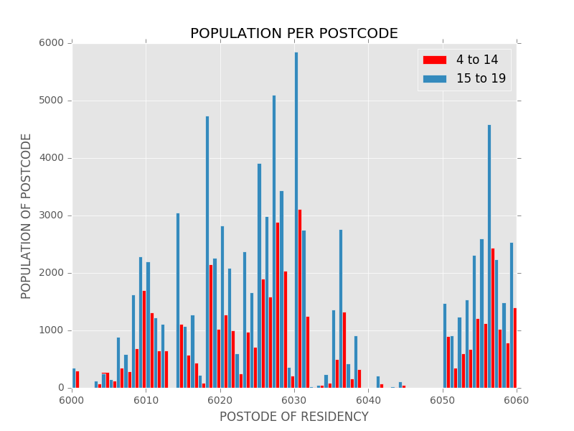
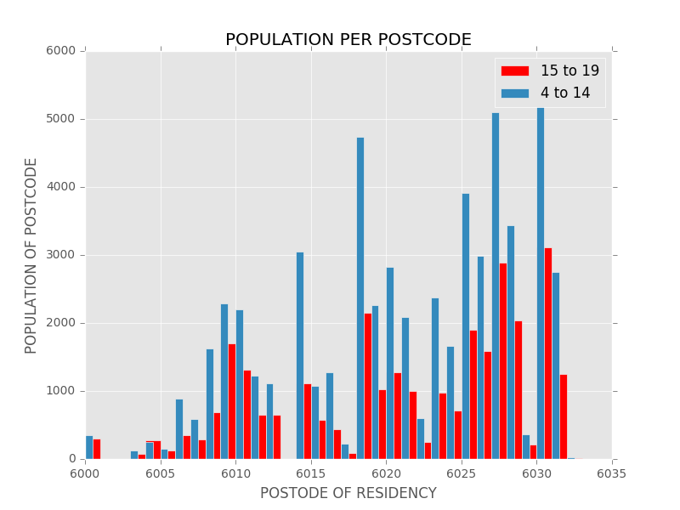

Analysing this data, the average proportion of the population at 4-15 years old across the postal codes of Perth Western Australia is 84’440 individuals. The population of individuals 15-19 years of age is 42’099 individuals. Combined, the schooling age of individuals across Perth is 126’539 individuals. According to census data for the number of residents across ass postal addresses, that is 18.82% of the total population.
2016 and 2011 Data Compared:
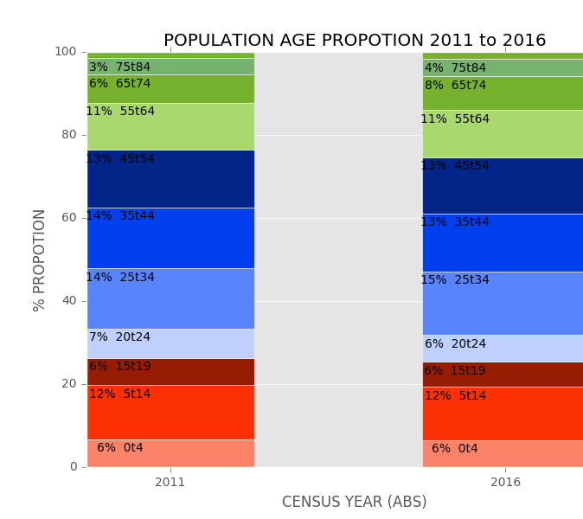
As the graphed data above shows. Very similarly, in 2011, the proportion of school-age population was 18%. Observably, population proportions have not substantially changed over this period.

c

Religious Affiliation Per Postcode

Religious Affiliation Across the Perth Area
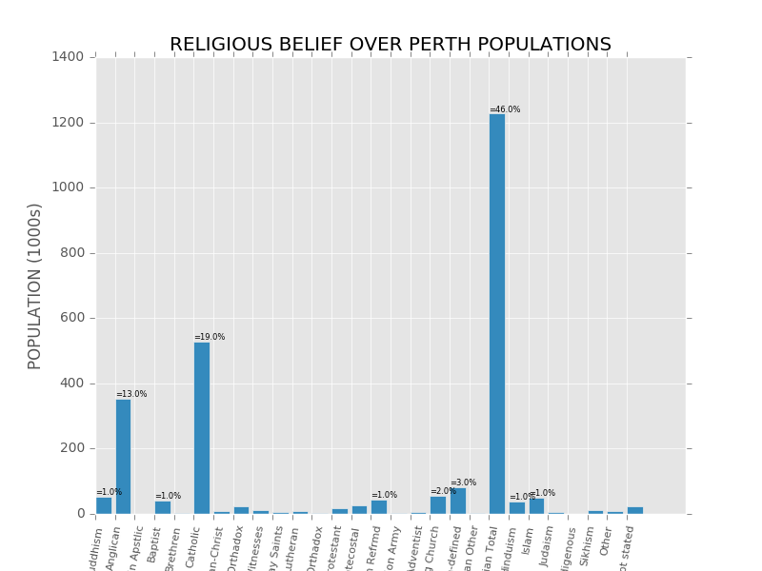
Observably, Christian derived religions make up the vast majority of the population (46%) whilst catholic populations make up the remaining 10%, Judaism composing of 1%, Anglican 13%, and Islam/ Buddhism 1%.

Bellow are graphs of religious belief per postcode
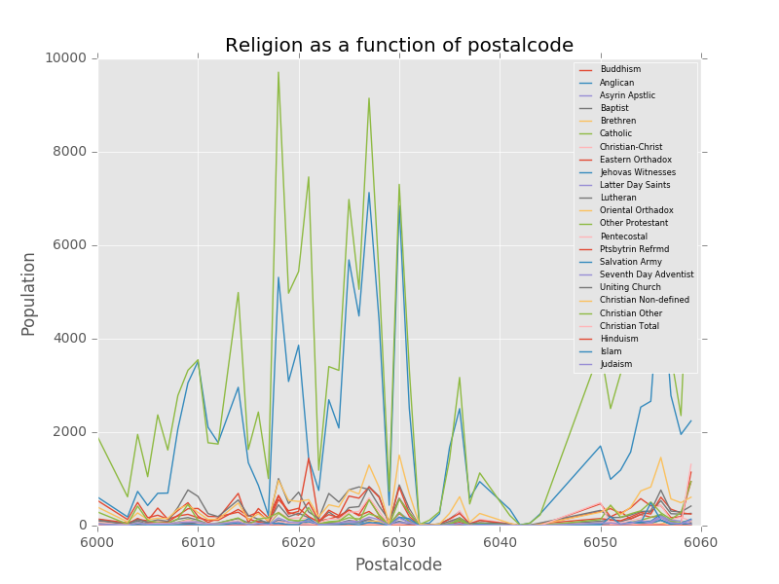

It is clear from this data that the majority of Perth population claims to hold some theistic, religious belief on some level. This Compassion between stating no religious affiliation, and stating a religious affiliation on some level is depicted below.

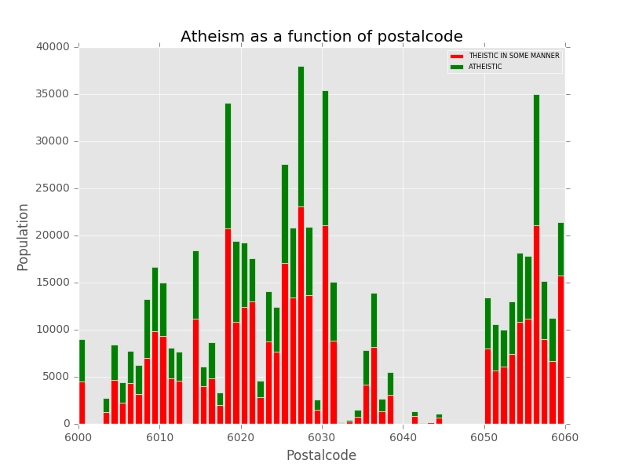
The same graphs for the year 2011 are depicted below.
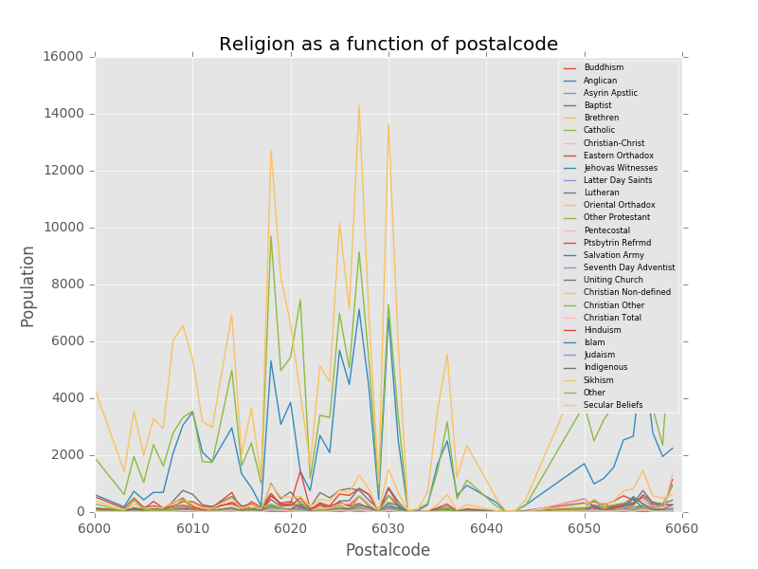

Observably, these beliefs are relatively stable in Australian society, showing no measurable change from the year 2011 to 2016.
A more comparable time-frame to analyse the changing religious beliefs of Australians may be from the year 2006 to 2016.

Proportion of Population Attending Religious or Public Schools
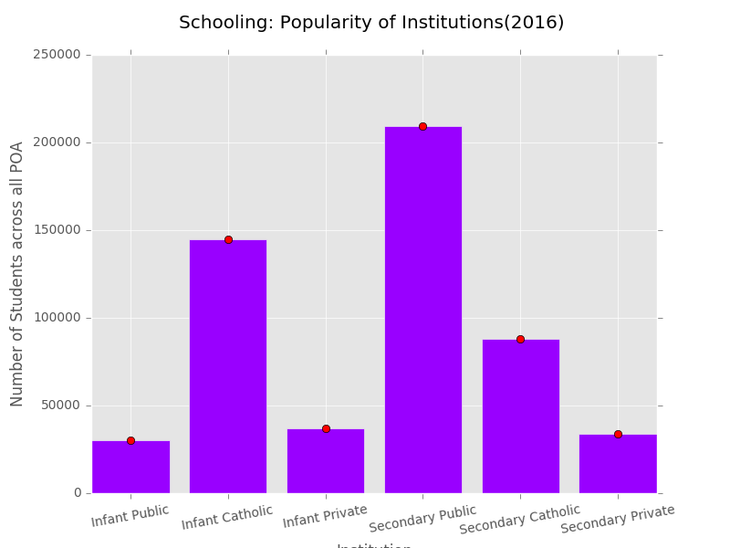
Conclusion
From this data, it may be observed that there is a small increase in the proportion of non-religious individuals residing in Western Australia that shows no substantiated correlation to postal code of residency. This increase of non-religious individuals may be measured over a span of 10 years – from 2006 to 2016, but shows negligible change over a 5 year interval. This lack of change over the five year interval from 2011 to 2016 compared to the considerable change from 2006 to 2011 (of the same interval) may be indicative of a change in the survey methodology of the ABS. Notably, far less people identified as being “non-religious” in 2011 compared to 2006. Instead, this population appears to have identified themselves as “Secular” in belief. To identify this shift as a change in questionnaire formatting, or a cultural change, more statistical analysis over a longer time period must be completed.

