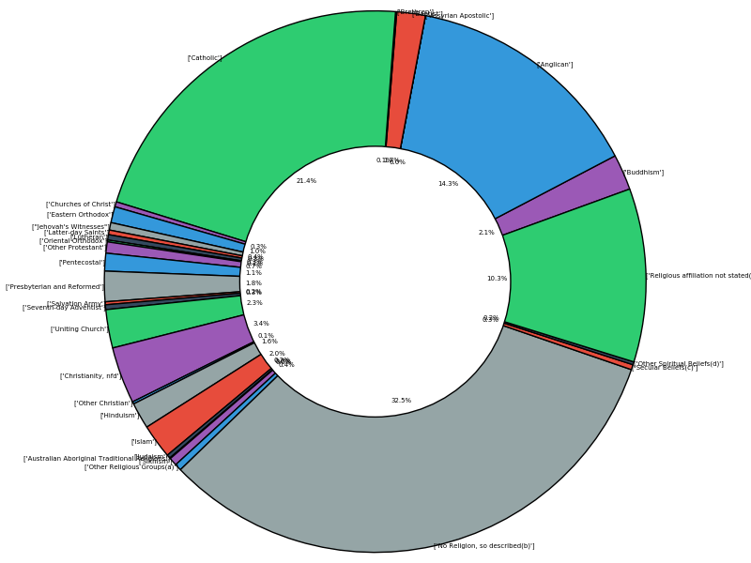
Above: 2006 Religion Distribution. With a 32.5 % secular share (additional 30.3% not stating religion) a 21.4% Catholic share, and a Majority share to Christian Beliefs; under specific dominions.

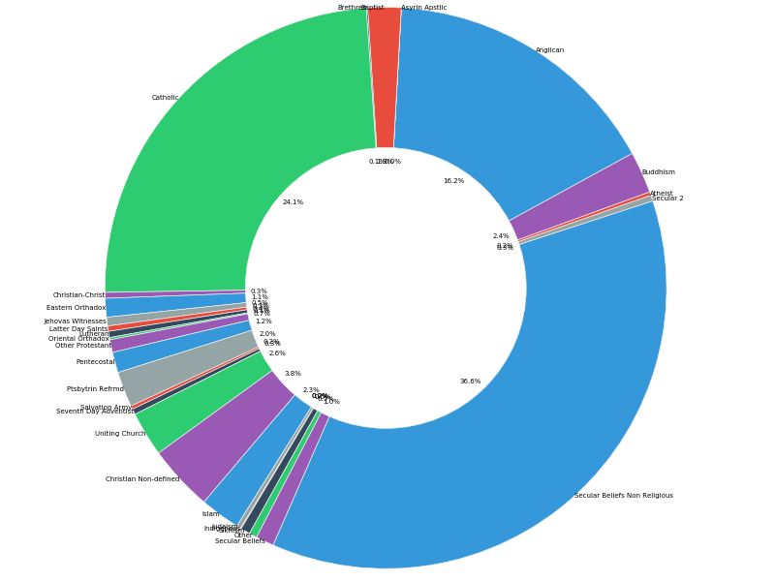

Above: 2011 Religious Distribution from this data is may be observed that 36.6% of people identify under secular beliefs, an increase from 5 years ago. Similarly, Less people identified under no religion (“religious affiliation not stated”) it is unclear if this is due to a cultural shift – potentially around the stigma of secular beliefs in some communities – or if its a change in the surveying method of the ABS.

Above: 2016 Religious Distribution (Negligible Observable Change Since 2011)

