Does extra amino acid supplement in YPD medium boost santalol production?

When santalol biosynthesis is optimised, the uptake fluxes of six amino acids (Asp, Asn, Glu, Gln, Ser and Thr) from YPD medium are at maximum, indicating that the uptake of those amino acids could be rate-limiting. Assuming that amino acid uptake is not saturated, santalol production fluxes in yeasts were estimated under different levels of squalene flux and amino acid flux; amino acid uptake flux varied in 10 selected values between 0.5 and 5, inclusive. Since the responses of santalol to Asp, Glu and Ser supplement are almost identical to those to Asn, Gln and Thr supplement, we are only showing and discussing Asp, Glu and Ser supplement response.

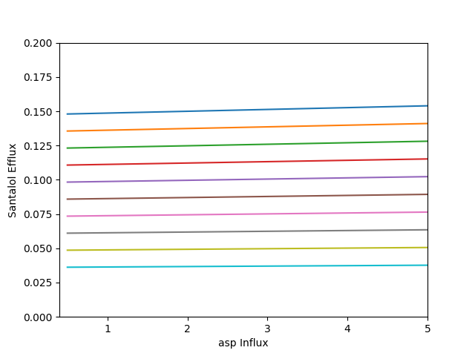

Figure 1 Asp (Top: squalene flux min, Bot: squalene flux = 90% of FPP efflux)

Asp supplement could lead to an increase in santalol production (Figure 2). The effect of Asp supplement on bisabolene production is more apparent when squalene production is minimised (slope: 0.00133, compared to 0.00033 when squalene flux = 90% of FPP flux). However, the boost in santalol by increase in Asp influx is relatively inefficient. When squalene production is at minimum, 10-fold Asp influx could only boost santalol flux by 1.04041 times.

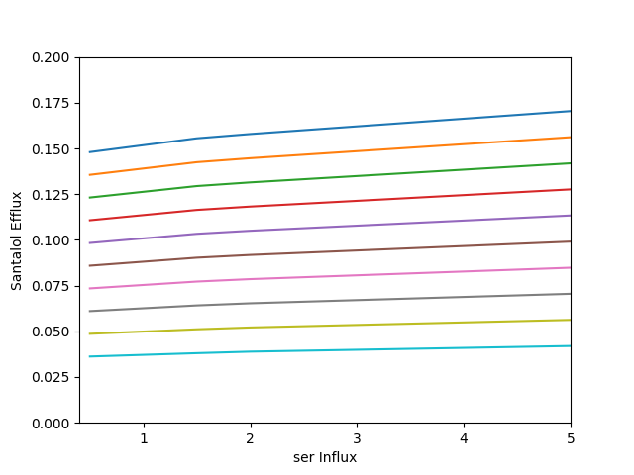

Figure 2 Ser

Similarly, Ser supplement could lead to an increase in santalol production, which is more apparent when squalene production is minimised (slope: 0.00476, compared to 0.00123 when squalene flux = 90% of FPP flux). Compared to Asp, Ser is much more efficient in boosting santalol production. When santalol production is at minimum, 10-fold more Ser influx could boost santalol flux up to 1.15158 times.

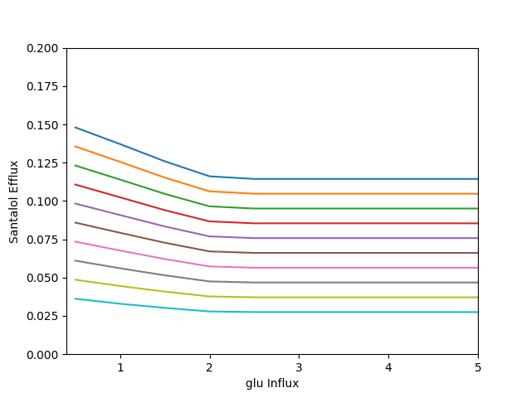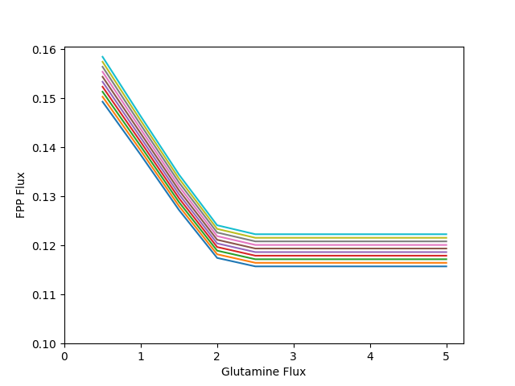

Figure 3 Glu (A) Santalol vs influx (B) FPP vs influx

Conversely, more glutamate influx leads to a reduction to santalol flux and the effect is more apparent with lower squalene flux. Since the reduction in FPP is observed, increased glutamate uptake favours diversion of cellular carbon to reactions other than santalol production, such as growth.

In general, rate-limiting amino acid supplement could theoretically improve santalol flux and yield yet at a rather low efficiency or reduce santalol flux. The effect of amino acid supplement is more apparent when squalene flux is minimised.

Reducing squalene flux is more important than supplementing amino acids in improving yield.