# ABS Butler

ABS Butler downloads spreadsheets from the Australian Bureau of Statistics.

# Setting up ABS Butler

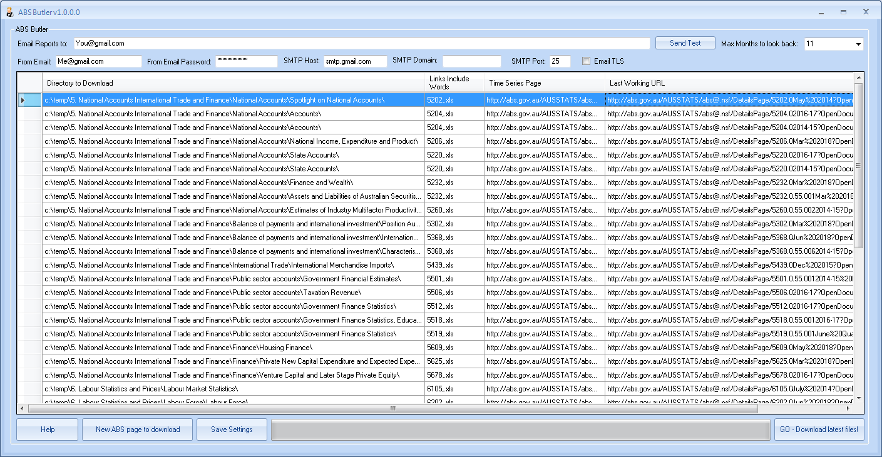

1. The ABS Butler application comes with a RunSheet.TSV file. Open the tsv file in Notepad or Excel and do a Find/Replace of “C:\temp\” with a directory you would like to store the ABS files.

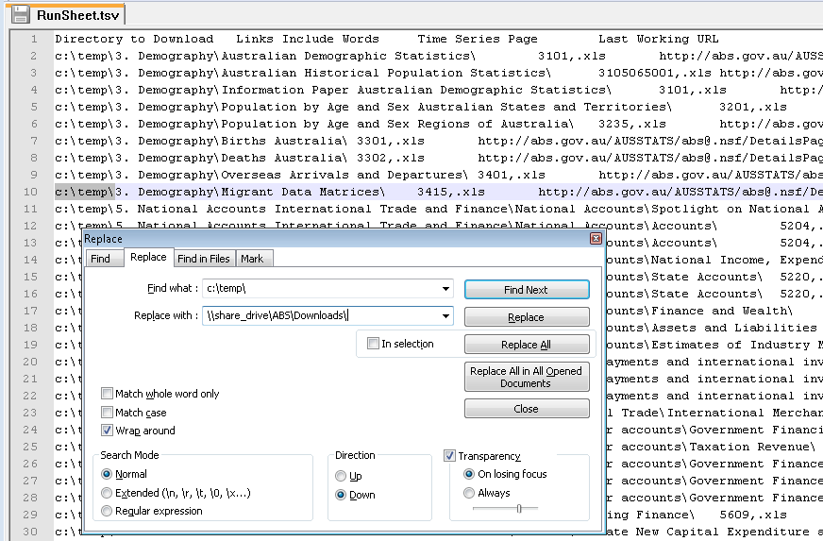

Optionally skip this step and test it out using your C:\Temp\ directory.

1. Click the “GO” button to run ABS Butler. The very first time it will create all the directories and download an initial baseline of ABS files from Jun 2017. Subsequently clicking the Go button will confirm the baseline is in place and retrieve the latest files compared to what versions you already have.

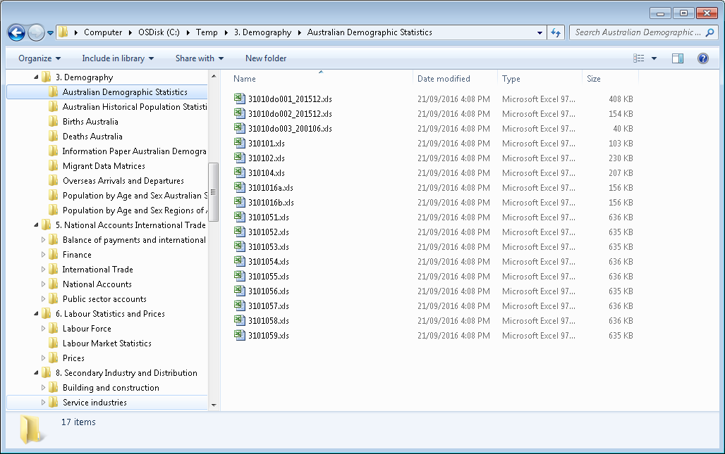

1. Setup ABS Butler to run daily on a Scheduled Task

a) Click Start > Control Panel > Administrative Tools > Task Scheduler > Action > Create New Task

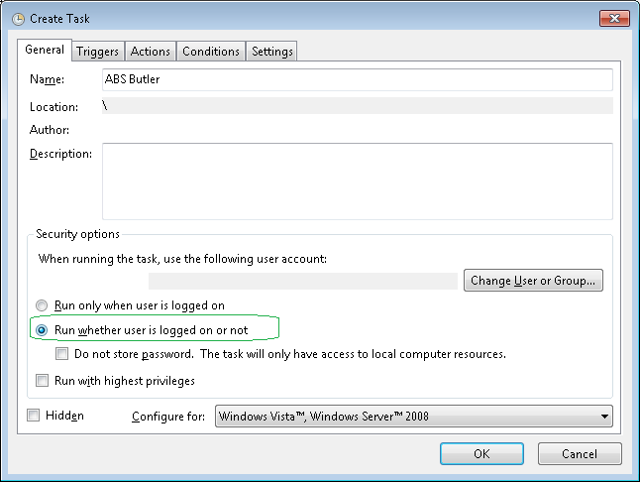

b) Triggers Tab > New and enter a daily schedule:

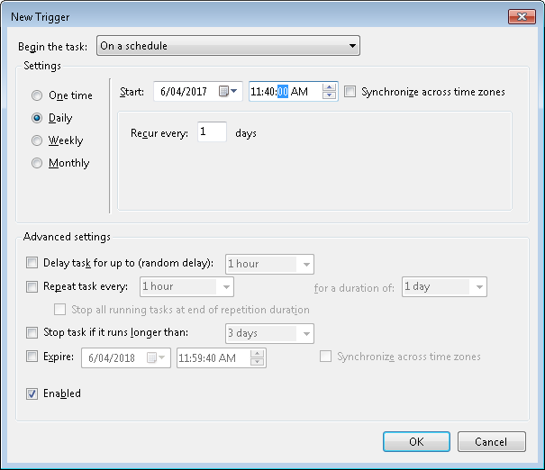

c) Actions Tab > New and specify the path to the EXE followed by a **–Auto** so it runs unattended:

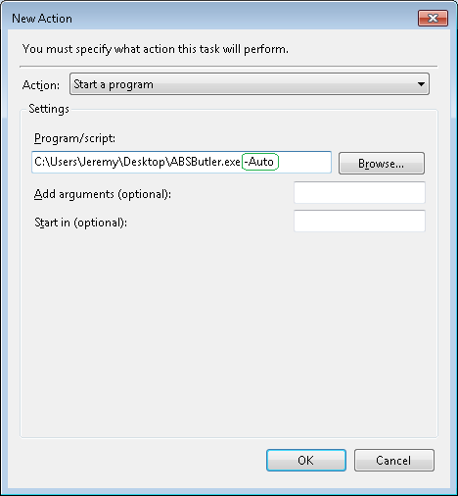

d) Settings Tab > tick “Run Task as soon as possible after a scheduled start is missed”:

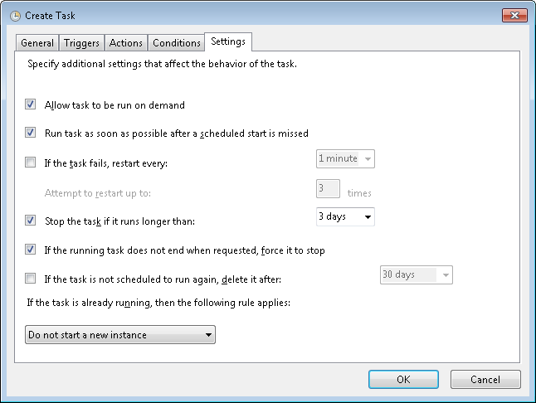

e) Click Ok.

# How ABS Butler works?

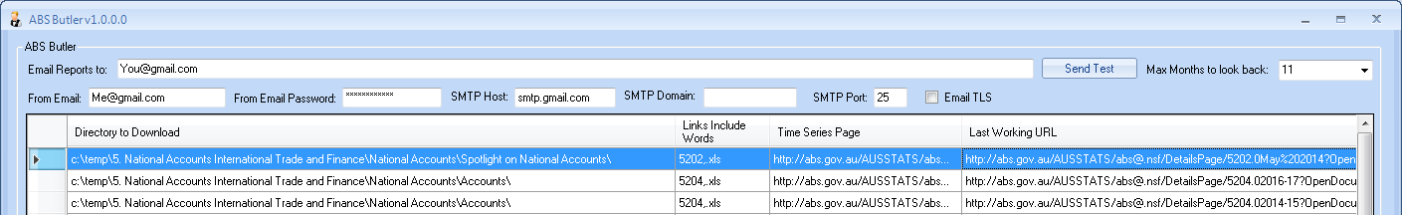

The ABS Butler searches updated pages using **tokens** in ABS website URL’s:

http://abs.gov.au/AUSSTATS/abs@.nsf/DetailsPage/3101.0**[MMM]**%20**[yyyy]**?OpenDocument

Substituting the [MMM] and [yyyy] with Months and Years it searches backwards until it finds a page, eg: <http://abs.gov.au/AUSSTATS/abs@.nsf/DetailsPage/3101.0Dec%202015?OpenDocument>

If the search result is the “Last Working URL” we know we have the latest and move on.

When a page is found that is newer than our “Last Working URL” ABS Butler proceeds to checks all the “Link Include Words” (containing comma delimited keywords such as 3101 and .xls) and downloads URLs with the included words to applicable directories.

We can see this highlighted by the green circles in both the top URL and the bottom download link:

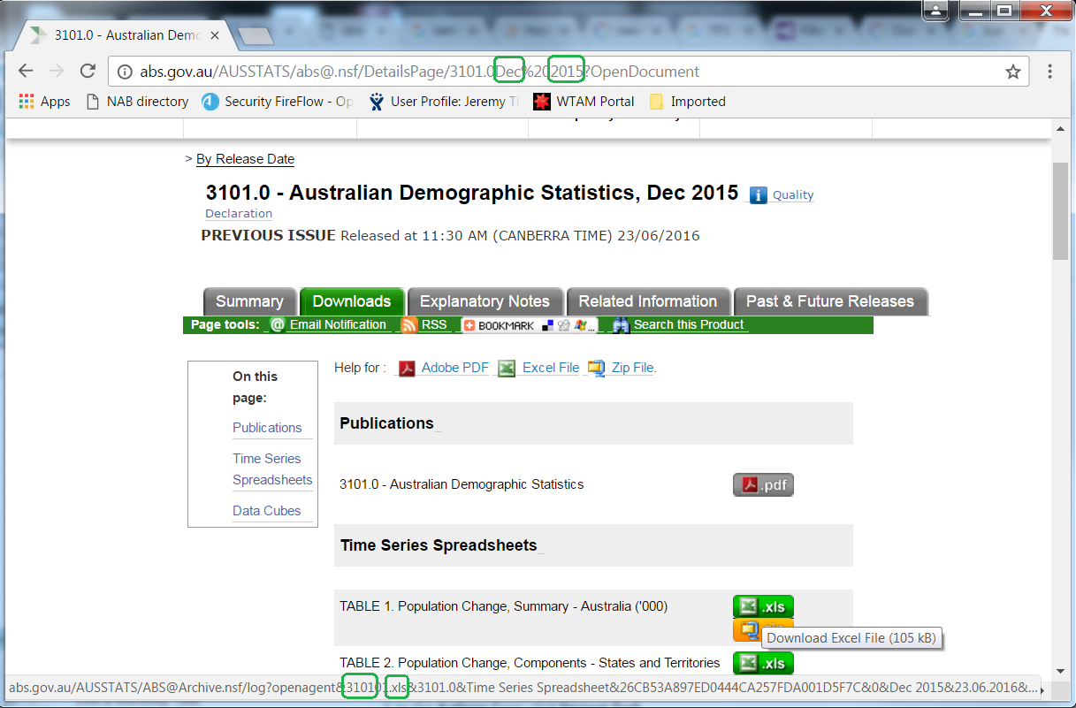

# Configuring ABS Butler

Click the “Add new ABS page to download” button, or right click the grid to edit existing ones.

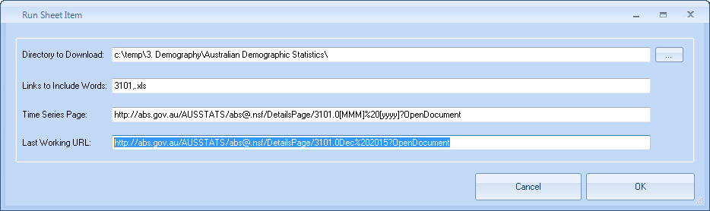

Tip: Do large edits using the RunSheet.TSV file; just take a backup of it before manually editing it.

There’s a small amount of functionality provided for tokens in URLs. There are 3 formats for months:

|  |  |  |
| --- | --- | --- |
| [MMM] | [MM] | [M] |

2 formats for years:

|  |  |
| --- | --- |
| [yyyy] | [yy] |

Plus the ability to deduct years (up to 5 years ago)

|  |  |
| --- | --- |
| [yyyy-1] | [yy-1] |

To configure the “Max Months to look back” set the drop down list:

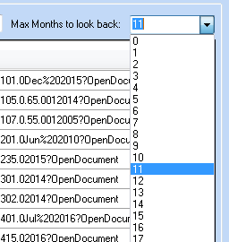

To configure Emails Reports enter email addresses separated by comma or semicolon:

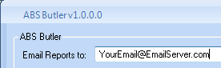

Click “Save Settings” button after changing the settings.

# Reporting

When new pages are found the latest files will be downloaded and users notified by email.