# Setting up RBA Downloader

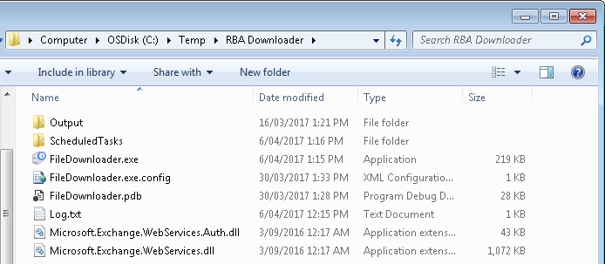

1. The RBADownloader application comes with a folder of ScheduledTasks. Open the xml files in Notepad++ and do a Find/Replace of “c:\temp\” with a directory you would like to run RBADownloader, eg:

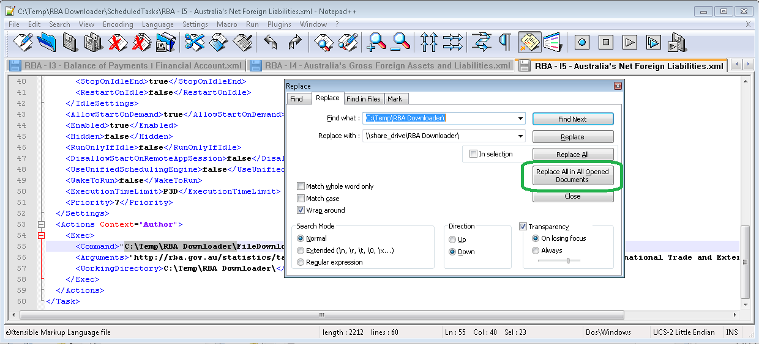

Optionally skip this step and test it out first using your C:\Temp directory.

1. Unfortunately the many companies’ security teams monitor programmatically adding scheduled tasks so you may need to manually import the Scheduled Tasks.

Click Start > Control Panel > Administrative Tools > Task Scheduler > Action > Import New Task

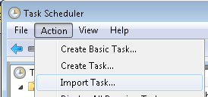

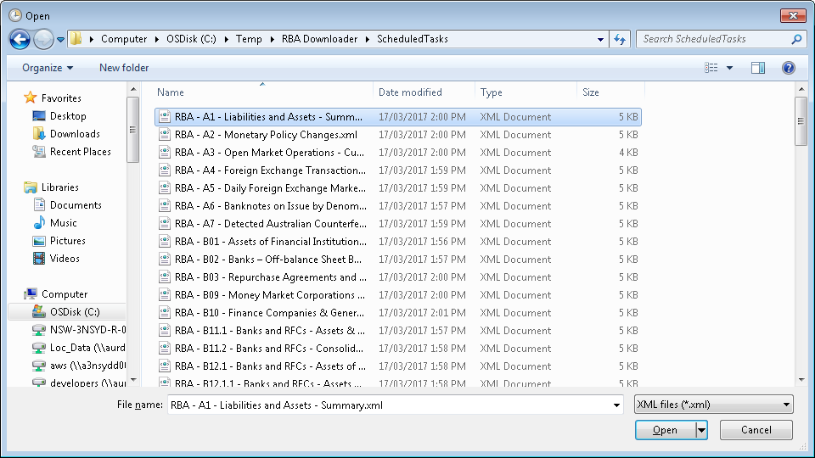

1. Repeat for all 85 Scheduled Tasks

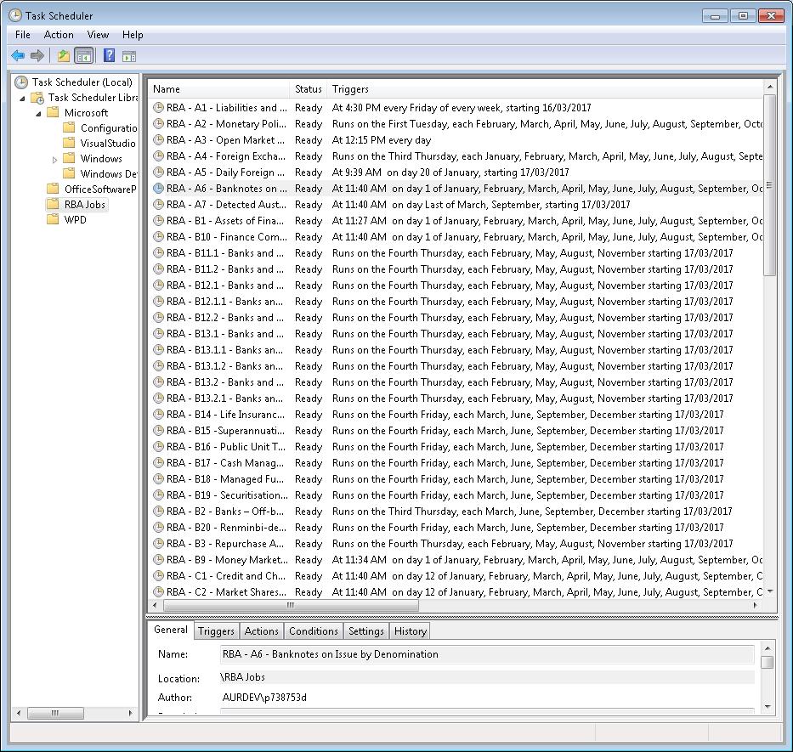

# How RBA Downloader works?

The RBA Downloader works based on the Reserve Bank of Australia’s frequency of publication and update schedule: <http://www.rba.gov.au/statistics/tables/frequency-statistical-releases.html>

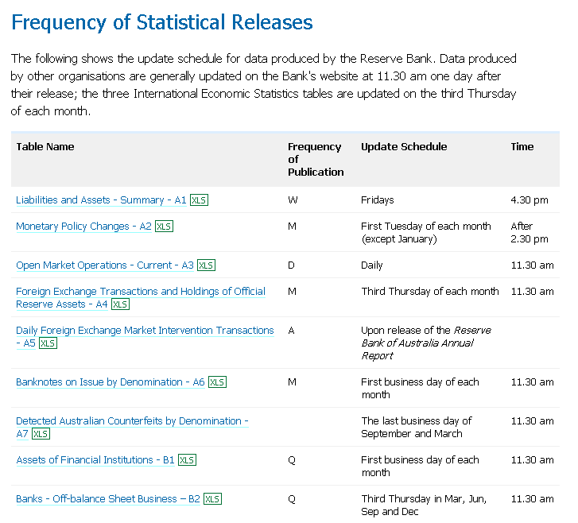

Scheduled Tasks are setup on publication release dates triggering an exe to download files:

Command: "C:\Temp\RBA Downloader\FileDownloader.exe"

Arguments: "http://rba.gov.au/statistics/tables/xls/b09hist.xls" "C:\Temp\RBA Downloader\Output\Statistics\Assets and Liabilities"

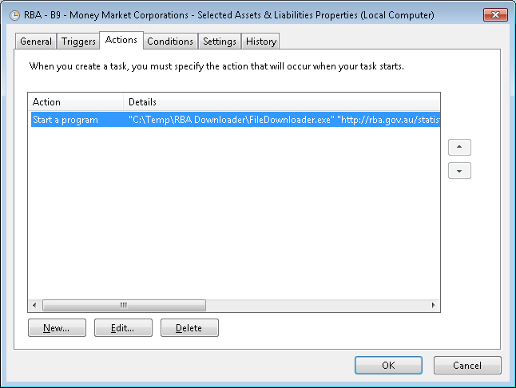

The File Downloader exe runs unattended when started with command line arguments; otherwise it starts up with a GUI:

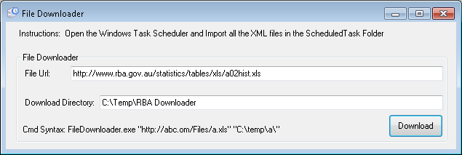

# Configuring RBA Downloader

|  |  |
| --- | --- |
| 1. Create Scheduled Tasks according to the publication release date: | 2. Specify the command to the FileDownload.exe and the arguments of the file URL and download directory: |

3. Tick “Run Task as soon as possible after a scheduled start is missed”:

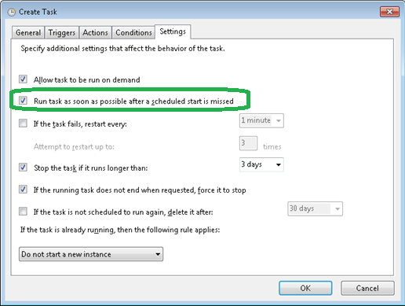

# Reporting

When files are downloaded users get notified by email:

