**BOLANO, MICHAEL RYAN**

**S**ampaloc Site, Lovely Homes,

Almanza 1, Las Pinas City, Metro Manila

Cell # 09469371477

[michaelryanbolano@gmail.com](mailto:michaelryanbolano@gmail.com)

**PERSONAL DATA**

Date of Birth : July 16, 2002

Age : 20

Place of Birth : Las Pinas District

Height : 5’8”

Father : Michael B. Baldoza

Contact # : 09690137214

Mother : Fe O. Bolano

Contact #. : 09079573670

Parent’s Address : Sampaloc Site, Almanza 1, Las Pinas City, Metro Manila

Religion : Roman Catholic

Sex : Male

Civil Status : Single

Language : Tagalog, English

**PERSONAL SKILLS**

* Communication
* Analytical Skill
* Problem Solving
* Attention to Detail
* Time Management
* Software Testing

**EDUCATIONAL ATTAINMENT**

* Almanza Elementary School

Las Pinas City

Batch 2014 - 2015

* Almanza – Las Pinas National High School

Las Pinas City

Batch 2018 – 2019

* Informatics Northgate Alabang – (ICT – Programming)

Muntinlupa City

Batch 2019 – 2021

**MOTOL, MARY ANN**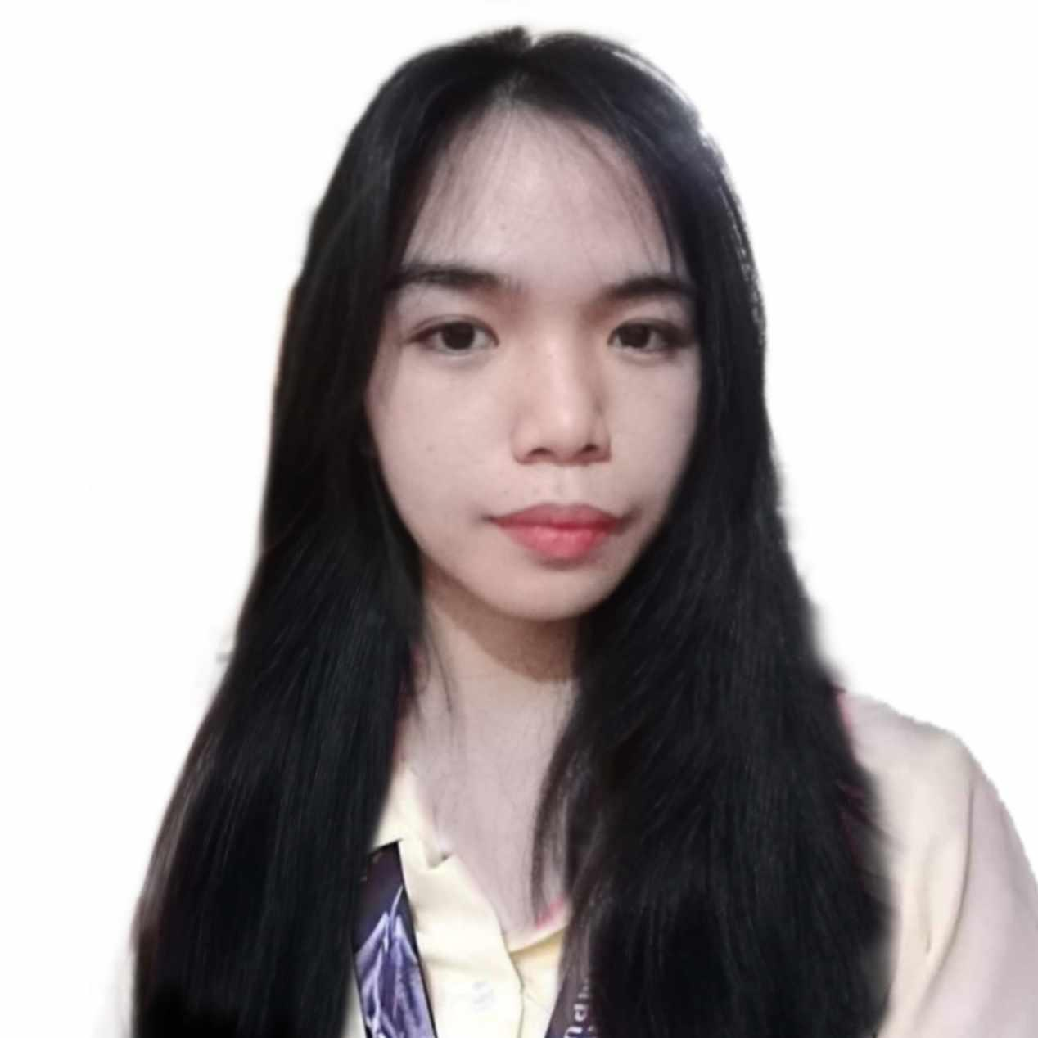

Talon Dos, Las Pinas

Cell #094569662458

maryannmotol@gmail.com

**PERSONAL DATA**

Date of Birth : November 23, 2003

Age : 19

Place of Birth : Las Pinas District

Height : 5’3”

Religion : Born Again

Sex : Female

Civil Status : Single

Language : Tagalog, English

**PERSONAL SKILLS**

* Web Developer
* Mobile Developer
* Game Developer
* Backend Programmer
* Frontend Programmer

**EDUCATIONAL ATTAINMENT**

* Cavite State University

Bacoor, Caviter

Batch 2021 - Present

* Las Pinas National High School

Las Pinas City

Batch 2014– 2015

* Don Carlo Cavina – (STEM)

Las Pinas City

Batch 2019 – 2021

**ORTIZ, MICHAEL**

Zapote 5, Bacoor Cavite

Cell #0965438974

michaelortiz@gmail.com

**PERSONAL DATA**

Date of Birth : August 12, 2001

Age : 22

Place of Birth : Las Pinas District

Height : 5’5”

Religion : Roman Cat

Sex : Male

Civil Status : Single

Language : Tagalog, English

**PERSONAL SKILLS**

* Web Developer
* Mobile Developer
* Game Developer
* Backend Programmer
* Frontend Programmer

**EDUCATIONAL ATTAINMENT**

* Cavite State University

Bacoor, Cavite

Batch 2021 - Present

* Las Pinas National High School

Las Pinas City

Batch 2014– 2015

* Olivares College – (STEM)

Paranaque City

Batch 2019 – 2021

**GATIL, DAVES VAL**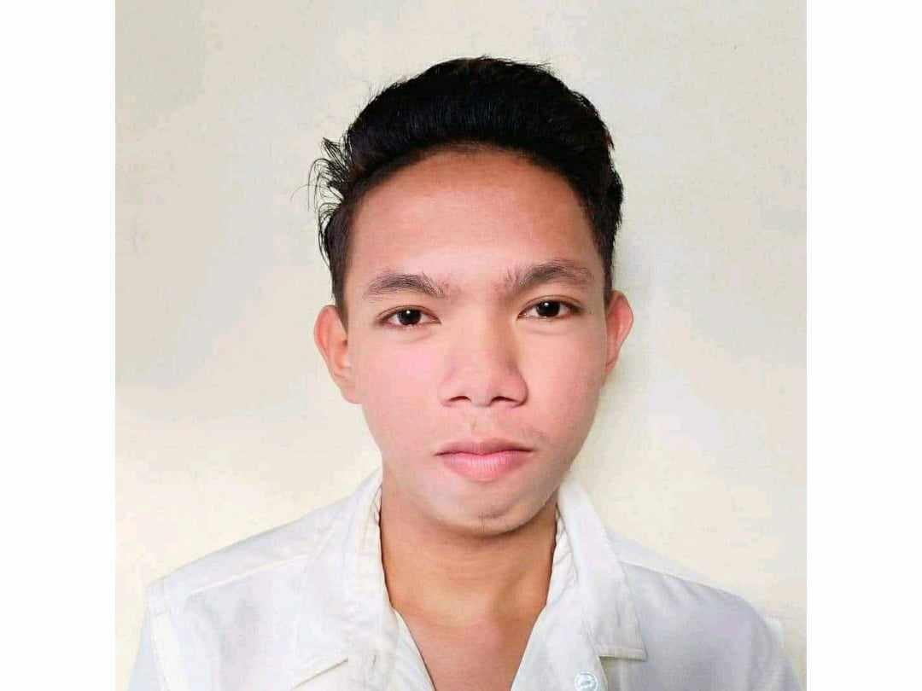

Zapote 5, Bacoor, Cavite

Cell #09324698464

davesvalgatil@gmail.com

**PERSONAL DATA**

Date of Birth : August 13, 2001

Age : 22

Place of Birth : Las Pinas District

Height : 5’7”

Religion : Roman Catholic

Sex : Male

Civil Status : Single

Language : Tagalog, English

**PERSONAL SKILLS**

* Web Developer
* Mobile Developer
* Game Developer
* Backend Programmer
* Frontend Programmer

**EDUCATIONAL ATTAINMENT**

* Cavite State University

Bacoor, Cavite

Batch 2021 - Present

* Las Pinas National High School

Las Pinas City

Batch 2014– 2015

* Olivares College – (STEM)

Paranaque City

Batch 2019 – 2021

**ESPERIDA, RAMER**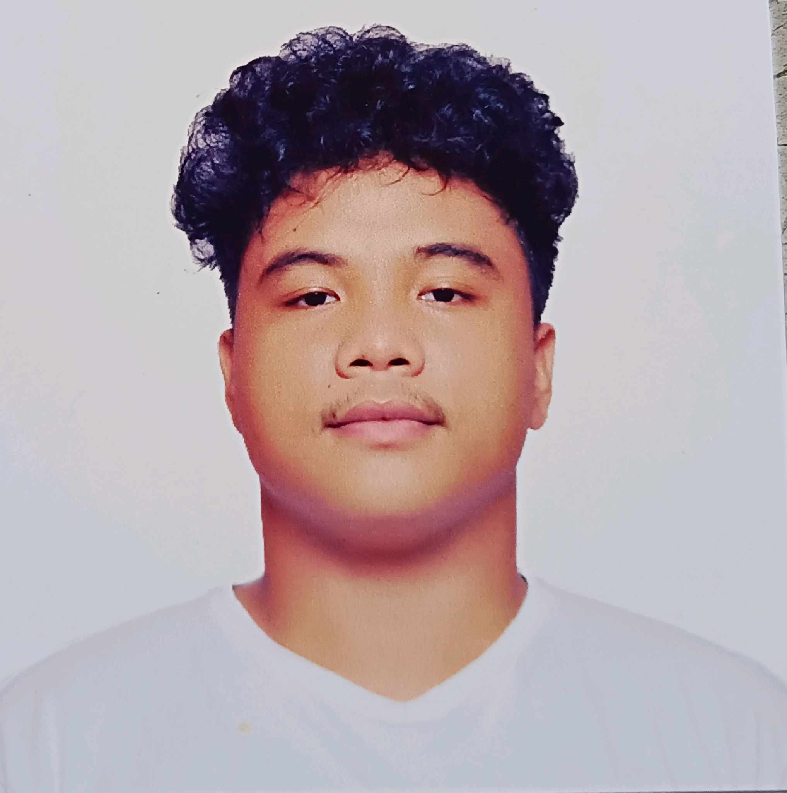

Moonwalk Talon 5, Las Pinas City

Cell #09568931475

rameresperida@gmail.com

**PERSONAL DATA**

Date of Birth : March 25, 2000

Age : 23

Place of Birth : Las Pinas District

Height : 5’4”

Religion : Roman Catholic

Sex : Male

Civil Status : Single

Language : Tagalog, English

**PERSONAL SKILLS**

* Web Developer
* Mobile Developer
* Game Developer
* Backend Programmer
* Frontend Programmer

**EDUCATIONAL ATTAINMENT**

* Cavite State University

Bacoor, Cavite

Batch 2021 - Present

* Las Pinas National High School

Las Pinas City

Batch 2014– 2015

* Olivares College – (STEM)

Paranaque City

Batch 2019 – 2021