Daniel Kamil Kosatka

Network Infrastructure Report

Contents
AD – Single domain controller created. DNS configured to relay to 8.8.8.8 5
AD - PDC and BDC created and connected together 7
AD - DHCP configured. All servers are 'hardcoded' within the DHCP server. 8
AD - User groups for pupils, teachers, administrative staff and system administrators. Appropriate limits applied to each group. 9
AD - Roaming profiles setup. Home directory stored on network drive. 11
AD - Import users script created in Python. 12
Internet - Full access to the Internet via something like NAT. 15
Internet - Internet access allowed only via a web proxy. Exchange server setup for all staff. 16
Internet - Web filtering enabled for all users. Content limited so that it is safe from pupils of the primary school. 18
Internet - Web filtering individual for each user class. For pupils’ content is filtered via a whitelist. For all other users the web access is filtered via a blacklist. 20
Internet - Web filtering software authenticates the users to ensure the they cannot get around the content filtering. 20
Internet - Deep packet inspection using an ICAP server to limit access based on keywords. 22
Internet - All pupil machines are deployable via PXE. Machine should join the Domain automatically. 22
Internet - All machines are deployable via PXE. 22
Internet - Machine images are only deployable to the appropriate physical machine. 22
Deployment – SCCM installed but not functional 22
Deployment – Application deployment via Active Directory 22
Deployment – Applications that can be deployed depends on the user group. 25
Deployment - All pupil machines are deployable via PXE. Machine should join the Domain automatically. 25
Deployment — PXE Boot (WDS) 25
Deployment — Images Only Deploy to Correct Physical Machine 26
Monitoring - Nagios XI deployed but not usable. 26
Monitoring - All servers monitoring to ensure they are alive. Disk space monitored on servers. If 80 percent full the system should issue a warning. If 90 percent full the system should issue an alert 26
Monitoring - Test to ensure that the PDC and BDC services are running. Test that the DNS and DHCP are running. 29
Monitoring - Log on to all machines are logged. Username, machine and timestamp saved. 33
Monitoring - Only Administrator can log onto the Network Monitoring system 34
Monitoring - Web access URLs are logged and timestamped available in the network monitor. 35
Extras - Daily backup of servers configured to a machine within the network. 36
Extras - VPN configured to an external source. Daily backup is over the VPN. 38
Extras - RDP configured for all desktop computers for administration within the network. Only usable by the system administrator. 38
Extras - Per teacher VPN enabled. to allow teachers access to network drives and resources from outside of the school. 39
Extras - RDP on the teacher computers which allows the teachers to access and run applications from their desktop at home. Pupil accounts should not work via RDP. 39

Important Information:
PDC IP: 10.0.1.2
BDC IP: 10.0.1.10
Subnet: 255.255.255.0
DNS:
Root domain name:
PDC Forward lookup zone: assignment2.local
Full PDC FQDN: assignment2.assignment2.local
Full BDC FQDN: assignment2-bdc.assignment2.local
NetBIOS domain name: ASSIGNMENT20
Credentials:
Name of PDC computer: assignment2
Name of BDC computer: assignment2-bdc
Admin:
Username: Administrator
Password: Pa55word

Test user information:
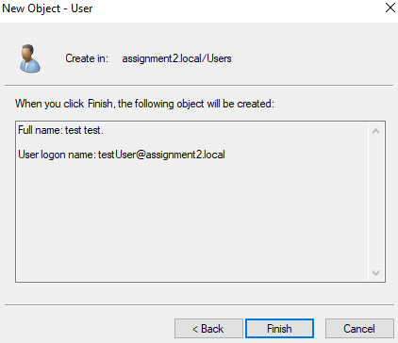

AD – Single domain controller created. DNS configured to relay to 8.8.8.8

Created a Forward lookup zone
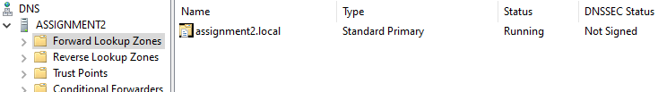
Created Reverse lookup zone
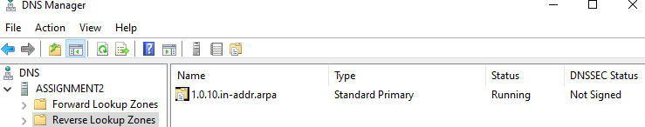
Successfully created and promoted the domain
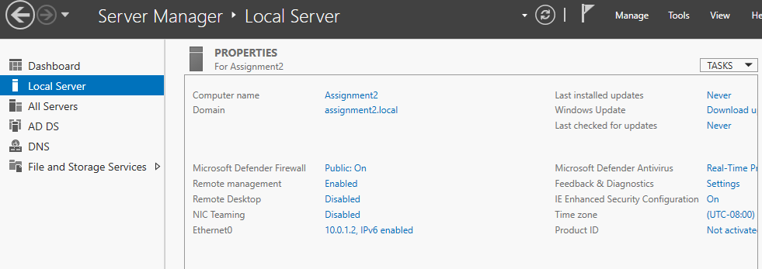
Only a single domain controller
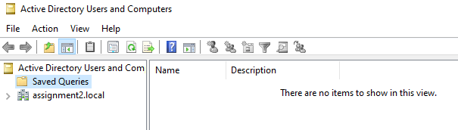
DNS configuration to relay 8.8.8.8 (no internet configured at this time so can’t resolve)
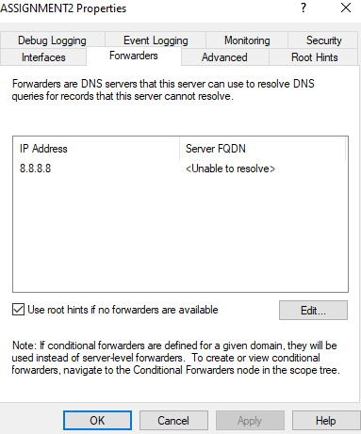

AD - PDC and BDC created and connected together
Both domain controllers listed
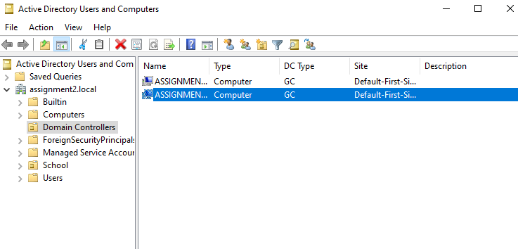
This shows that BDC is being seen as a backup/replication of PDC
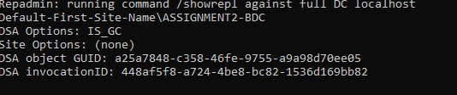

Shows both the domain controllers listed

AD - DHCP configured. All servers are 'hardcoded' within the DHCP server.
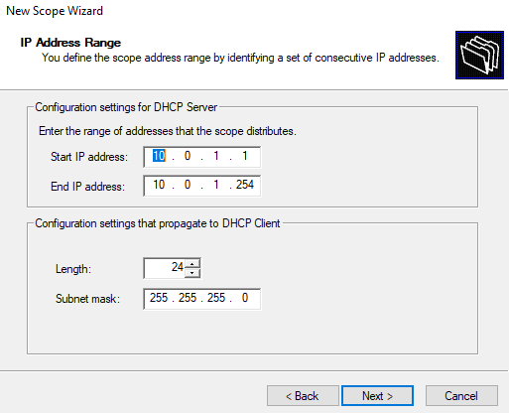
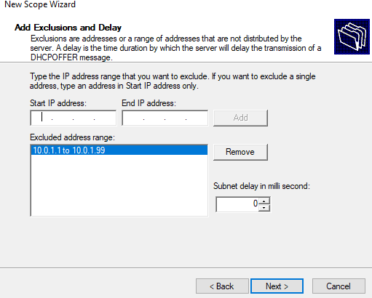
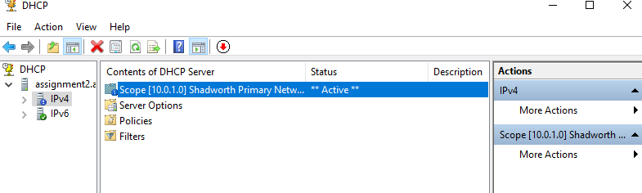
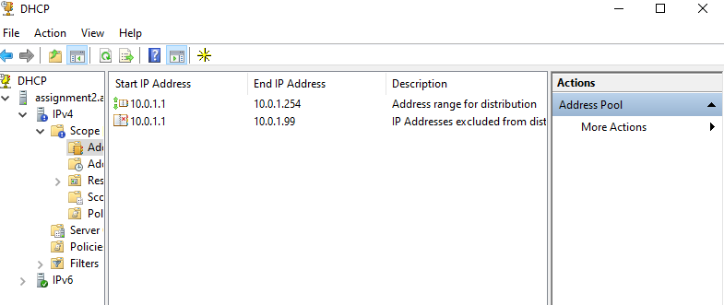

AD - User groups for pupils, teachers, administrative staff and system administrators. Appropriate limits applied to each group.
Shows all the User groups
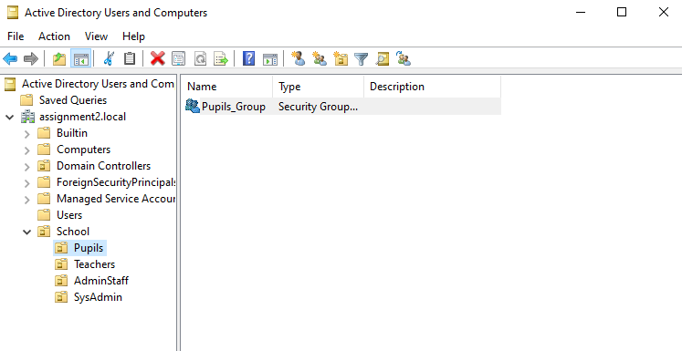
Shows all the created policies
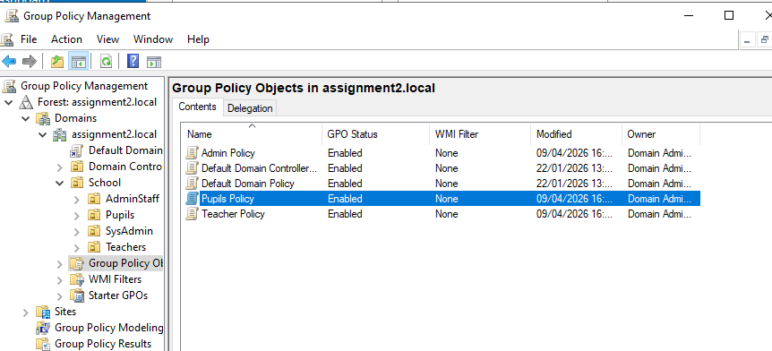
Shows the policy to be disabled ( blocks msi downloads)
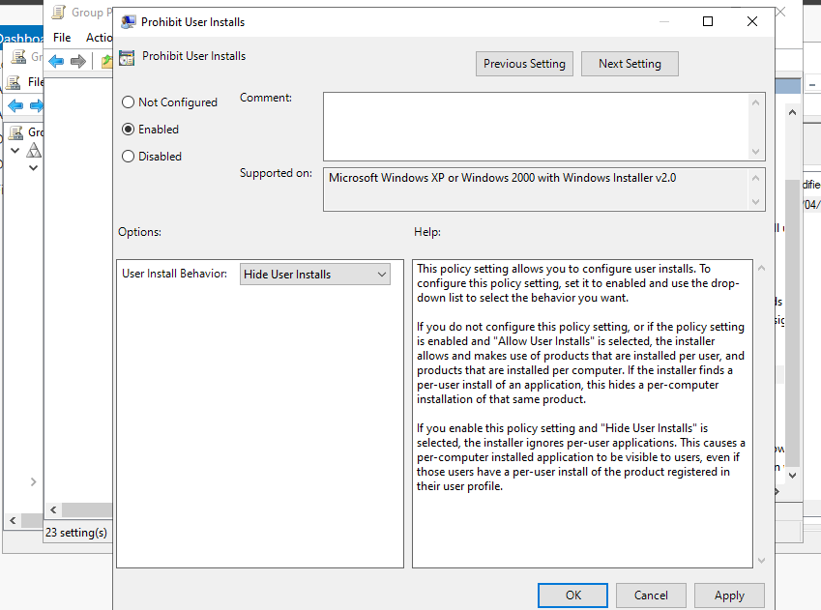
Shows policies created to block writing to those paths so .exe installers can’t run
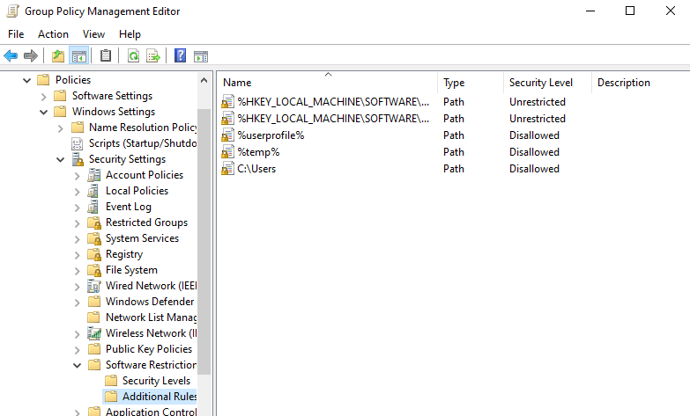


AD - Roaming profiles setup. Home directory stored on network drive.

Profile and home path set up for a test profile
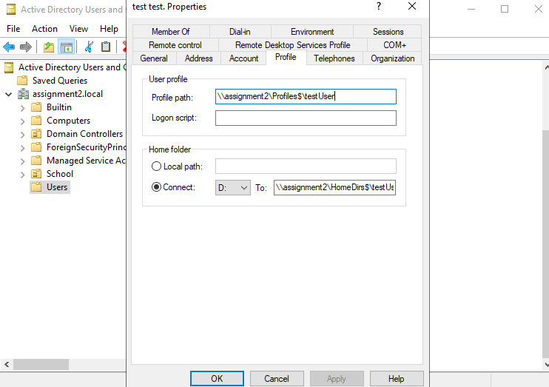
Directory showing the existence of the profiles file and HomeDir file
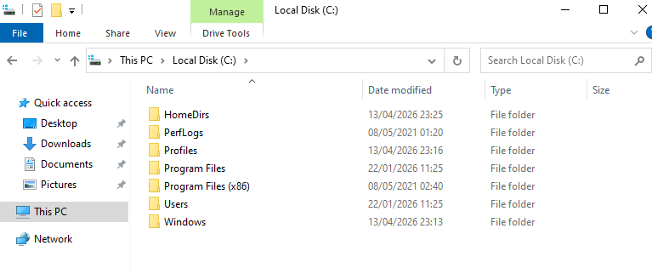

AD - Import users script created in Python.
Csv file:
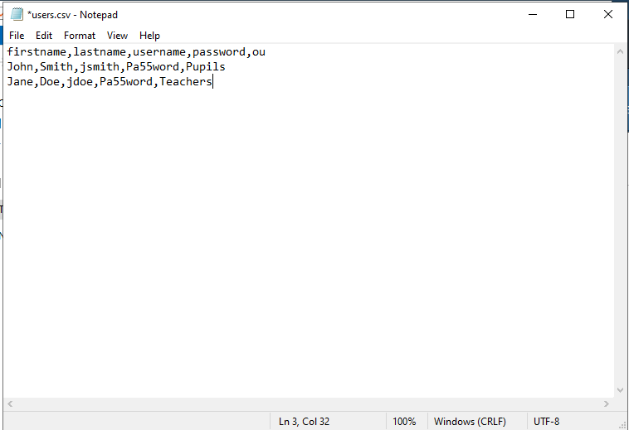
Evidence of creation:
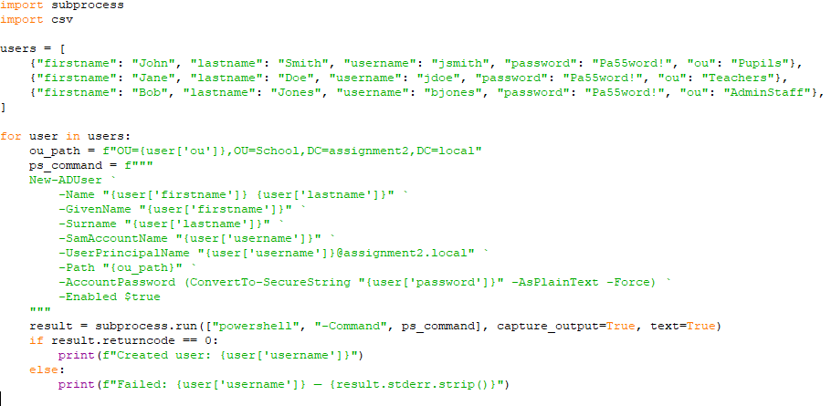
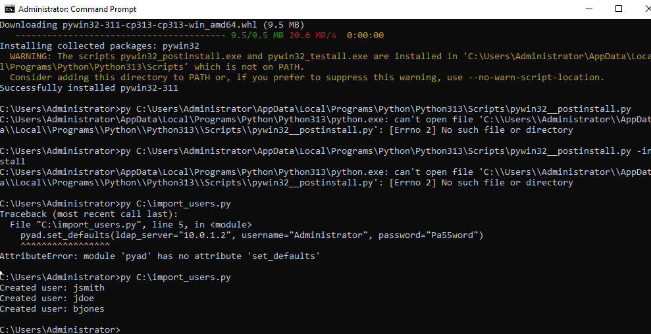
Created people:
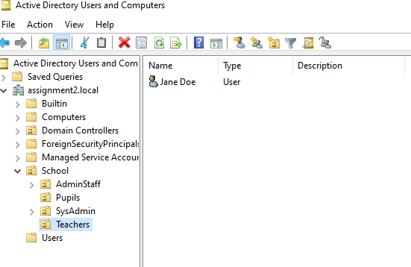
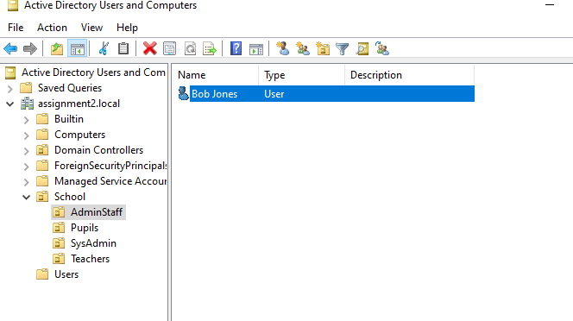
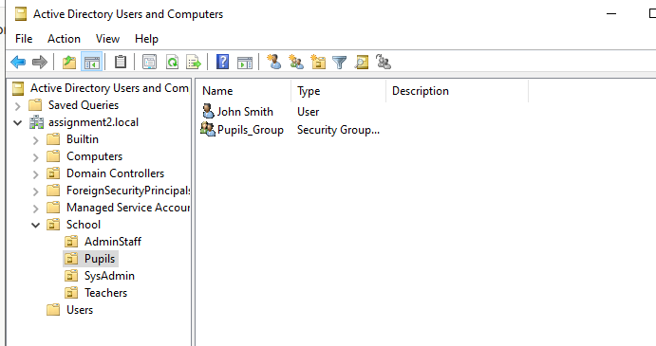

Internet - Full access to the Internet via something like NAT.
Displays the connected network adapters and ping to 8.8.8.8 which is the internet.
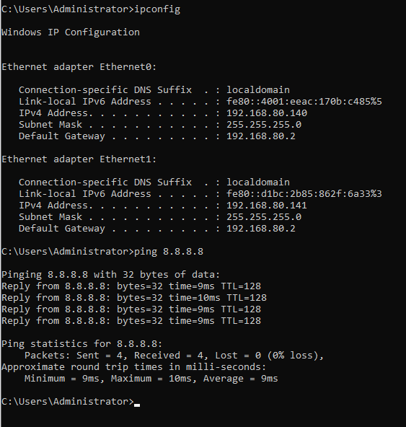

Internet - Internet access allowed only via a web proxy. Exchange server setup for all staff.
Proxy set up and connecting to the client IP.
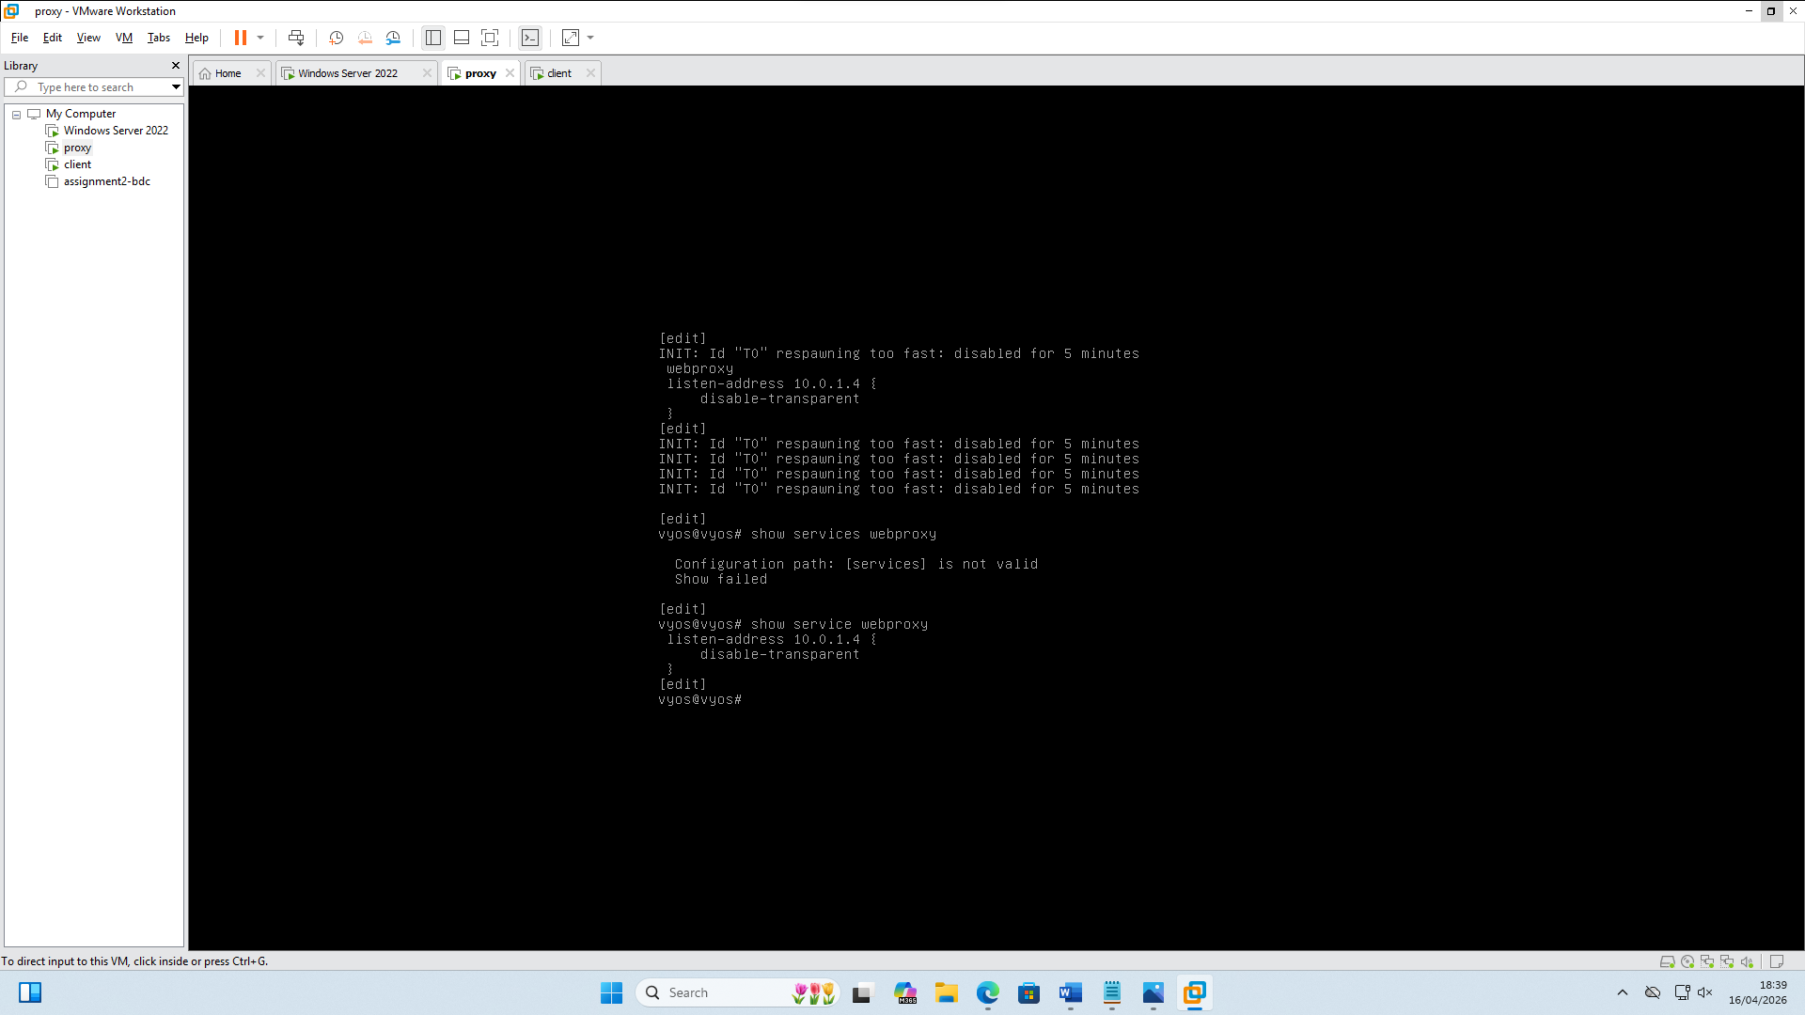

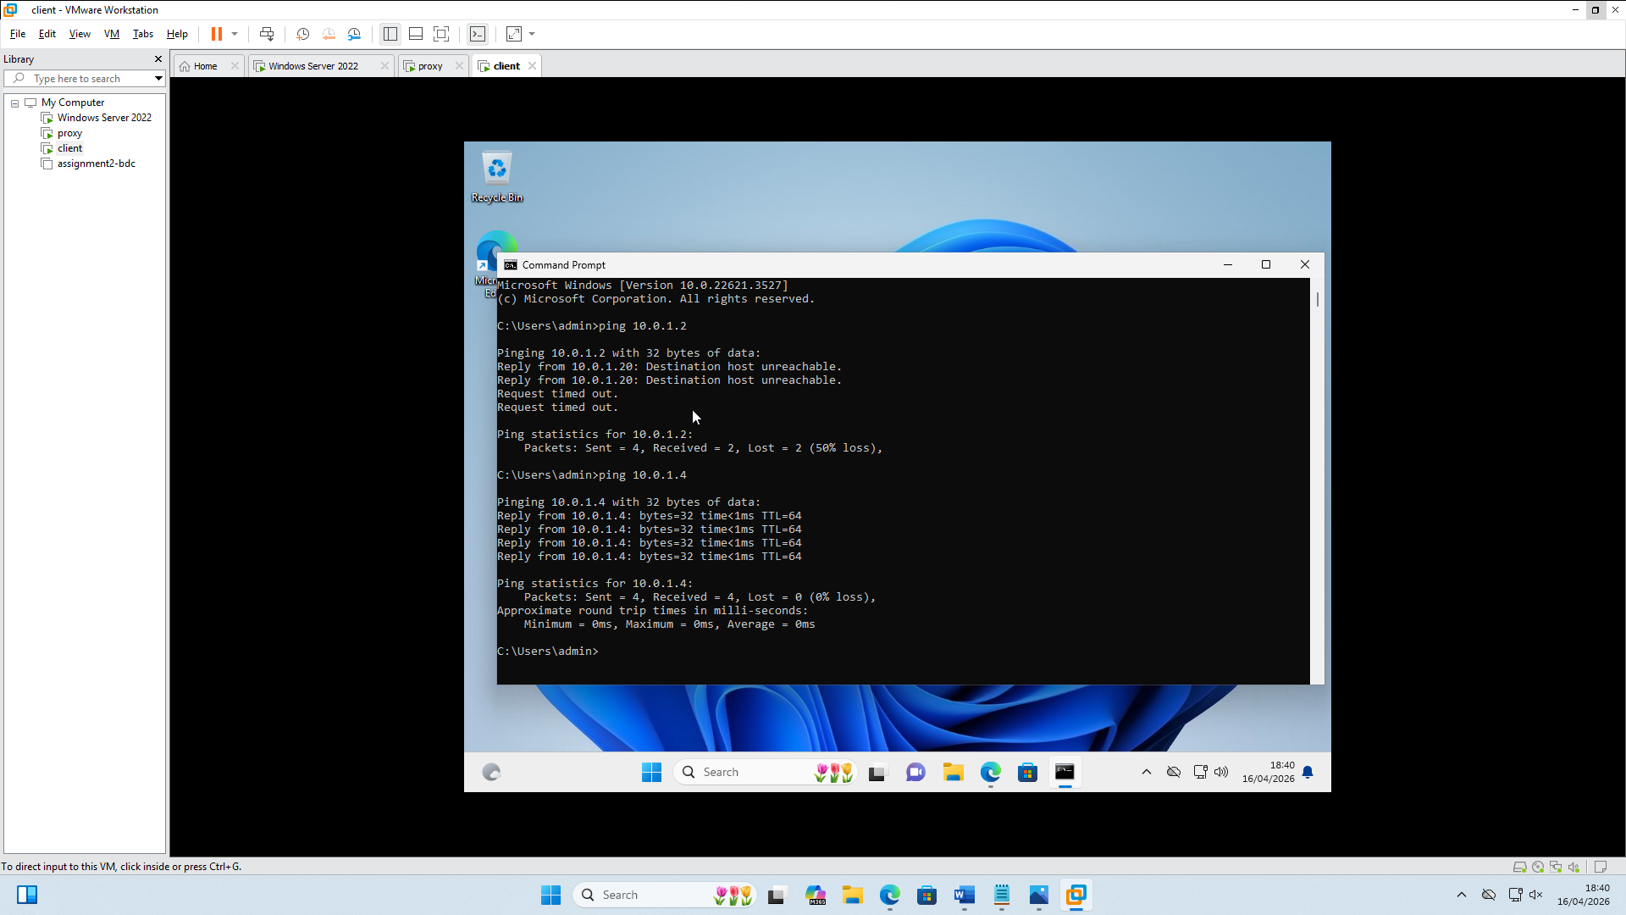

Connected giving the client internet access
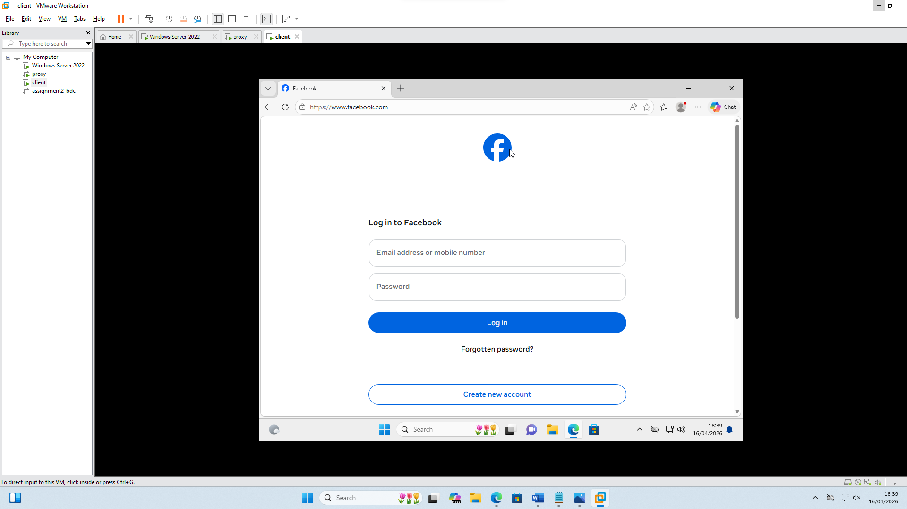

Internet - Web filtering enabled for all users. Content limited so that it is safe from pupils of the primary school.
Result of show services webproxy showing connection some authentication as well as filters put in place
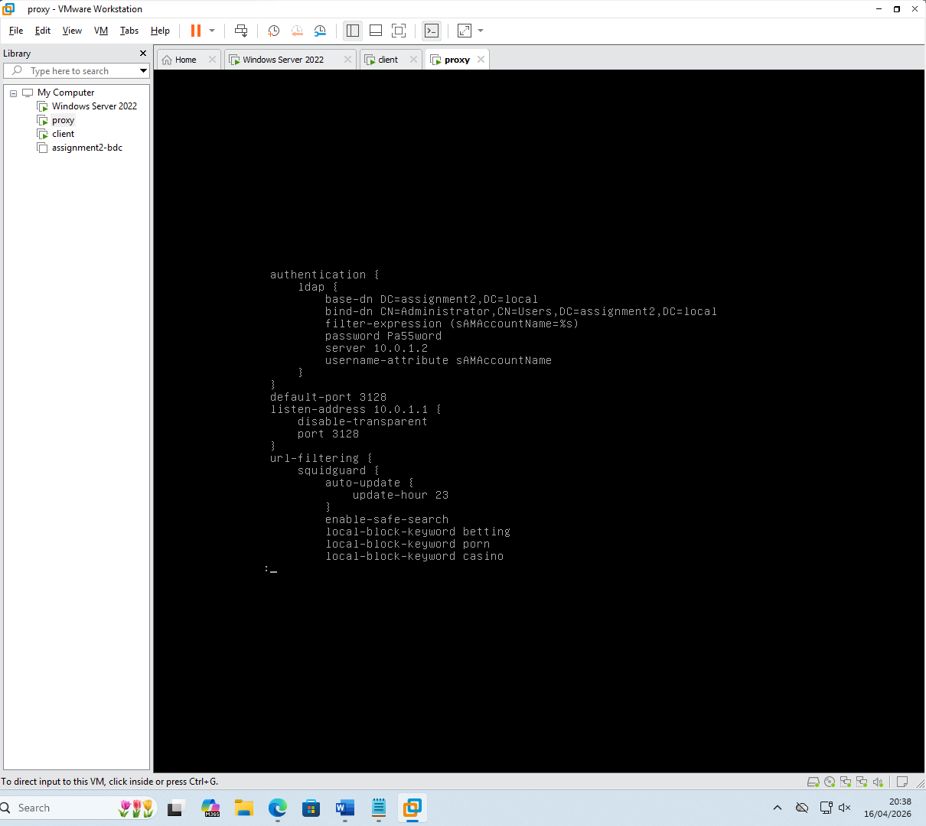
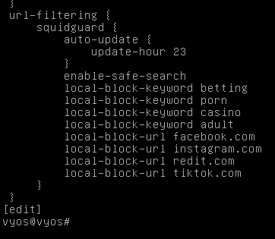
Further filters

Internet - Web filtering software authenticates the users to ensure the
they cannot get around the content filtering.
Role , groups and user
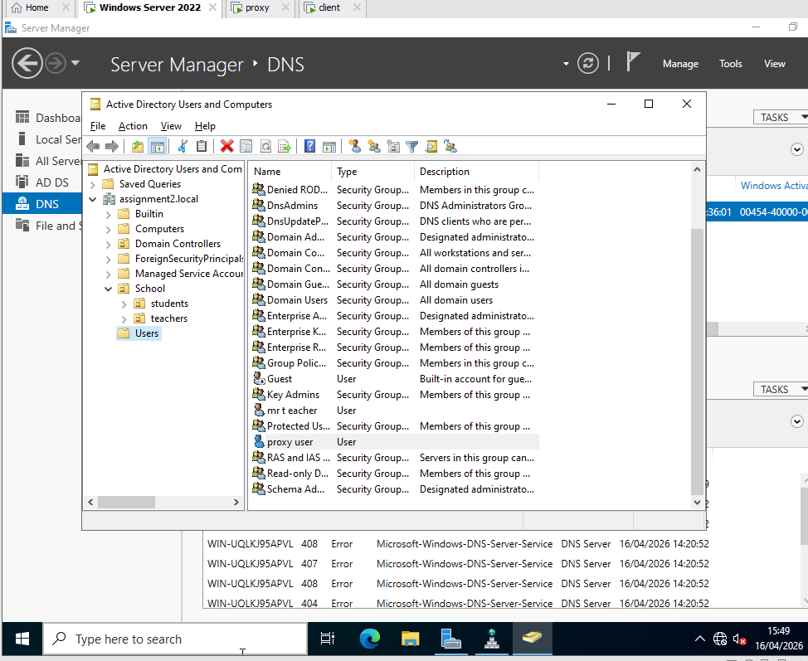
Showing updated webproxy with binding to roles through ldap and further authentication.
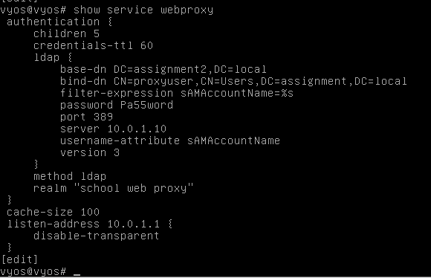
Evidence on a teacher account of restriction in place
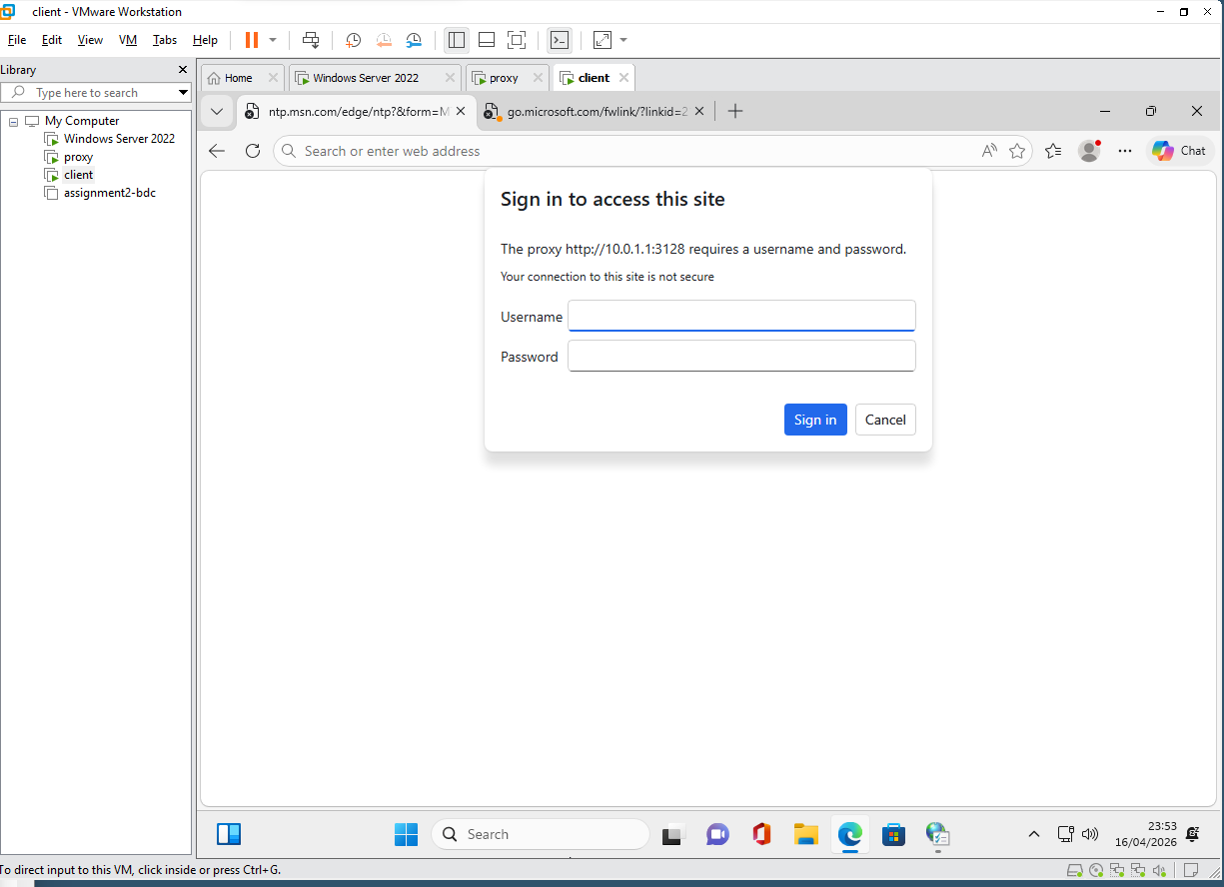

Deployment – Application deployment via Active Directory
Chrome installation within the group manager and software deployment. – previously added to all installation to a folder in c and shared between domain computers same for NFTS.
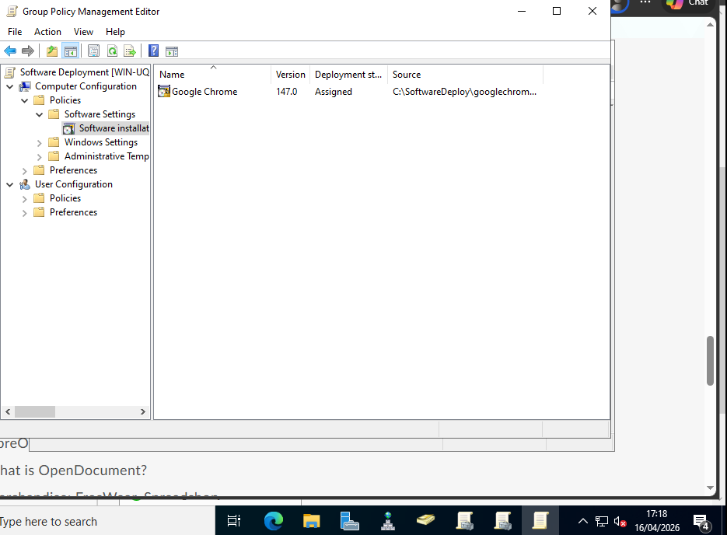
Script for installs of other application – libre wouldn’t upload to software deployment due to incompatibility issues.
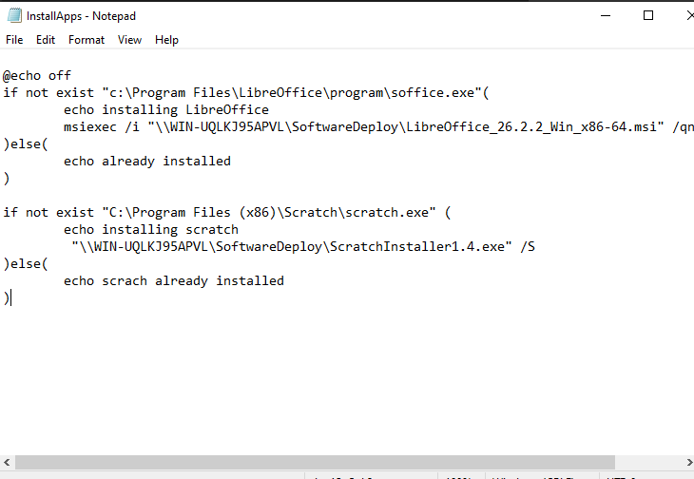
Script being stored in the executable script storage.

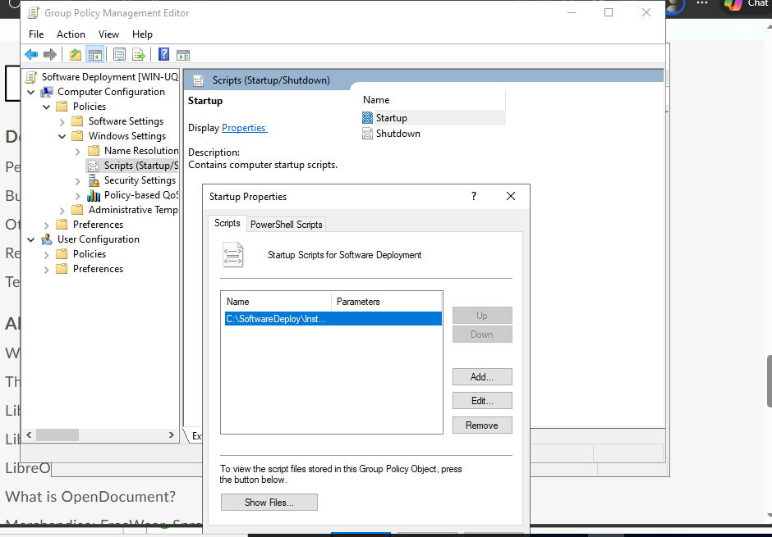
Command to install all
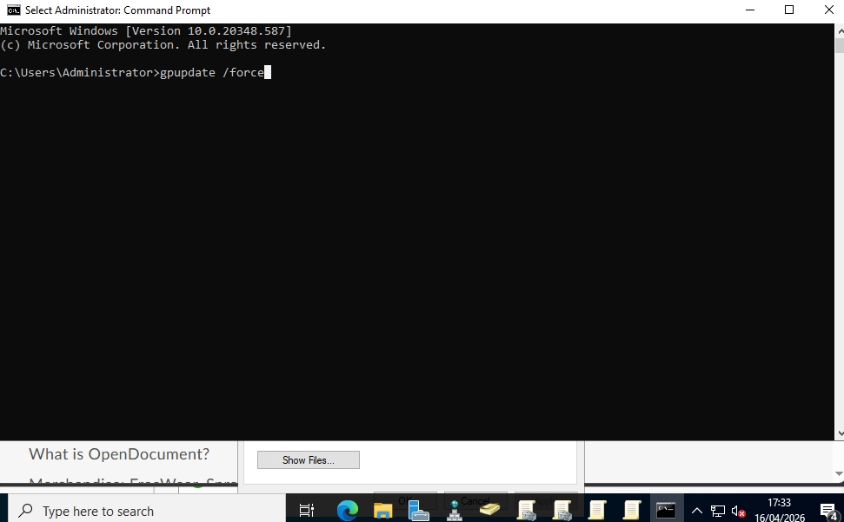
Final all applications installed when rebooted.
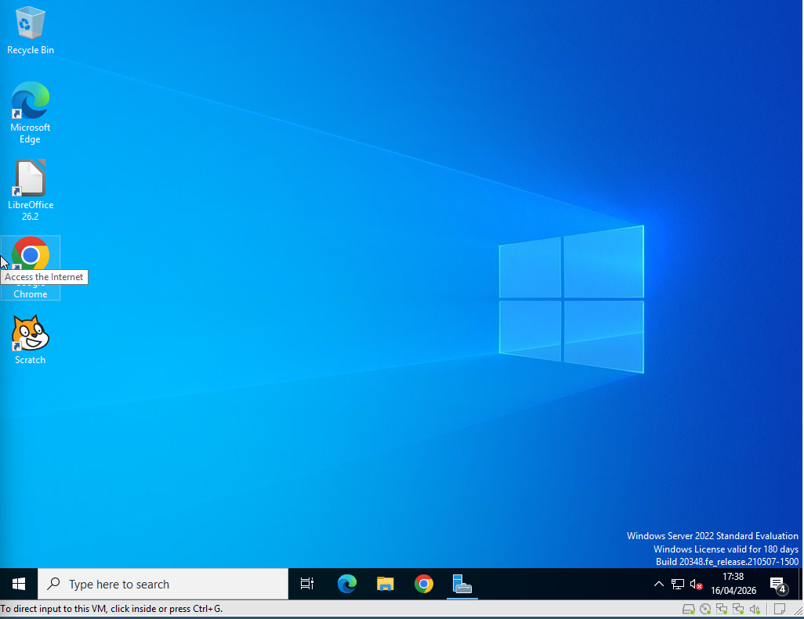

Monitoring - Nagios XI deployed but not usable.
Screenshot of the dashboard: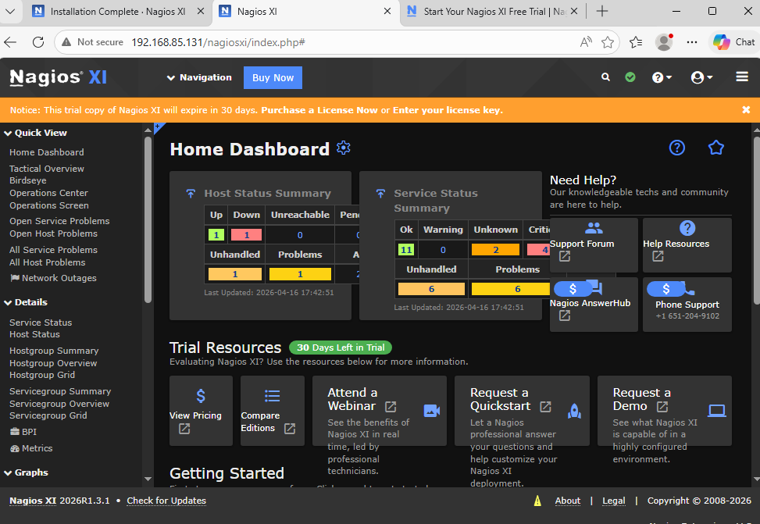

Service is up and running:
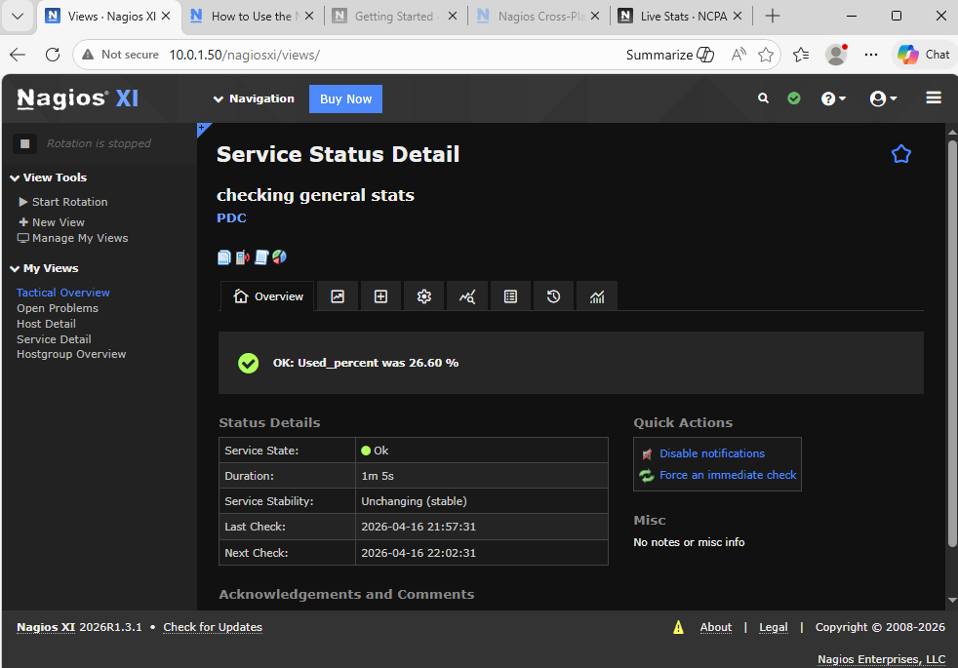
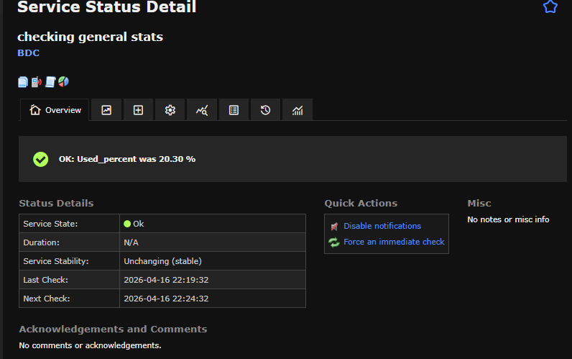
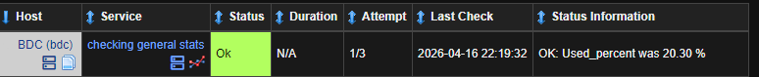
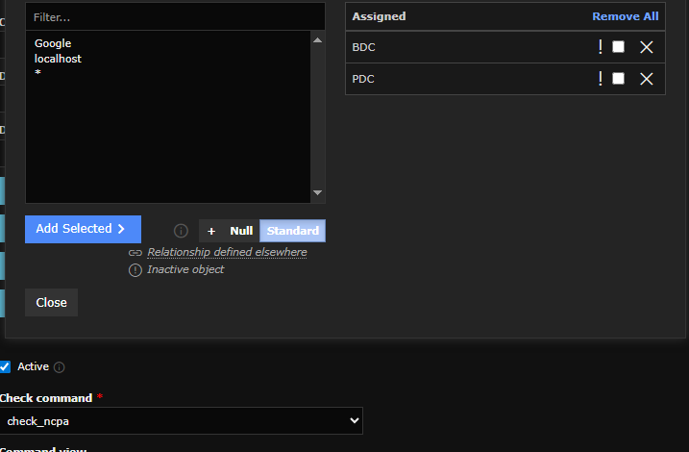
Showing command where if it crosses 80 it warns, 90 it goes critical
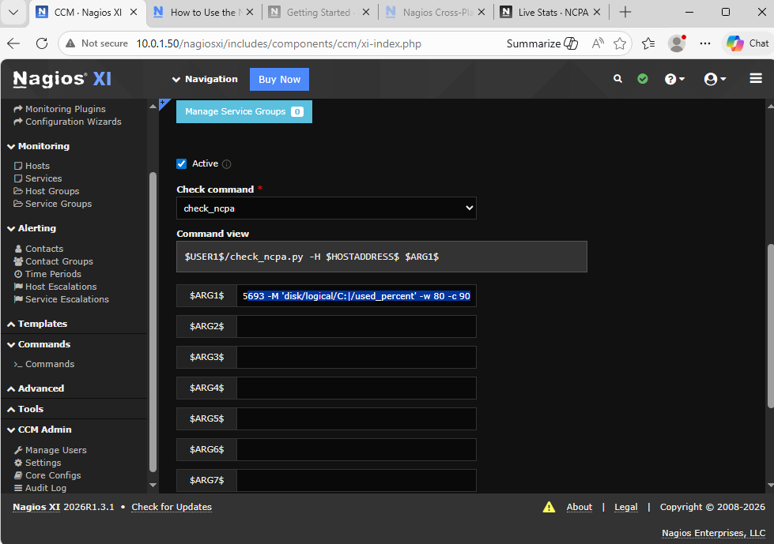

Monitoring - Test to ensure that the PDC and BDC services are running.
Test that the DNS and DHCP are running.

DHCP:
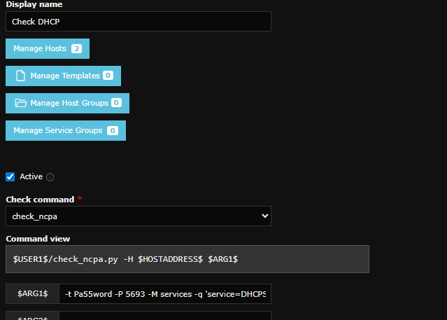
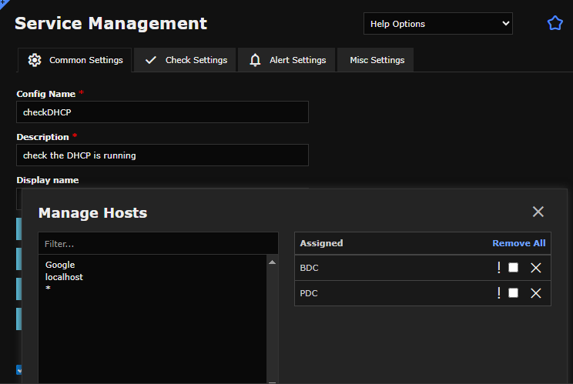
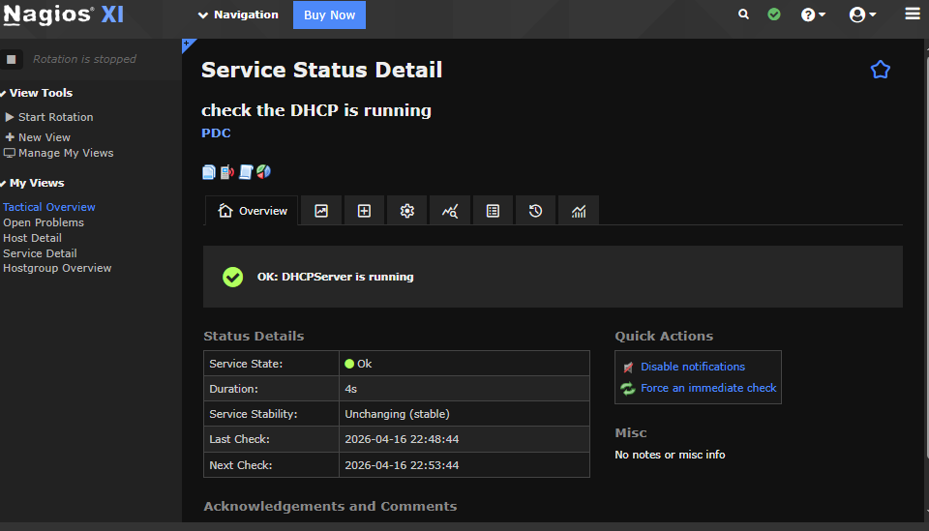
DNS:
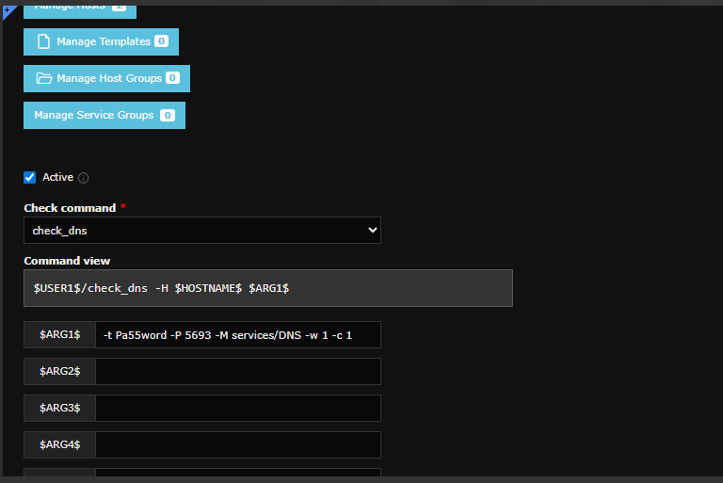
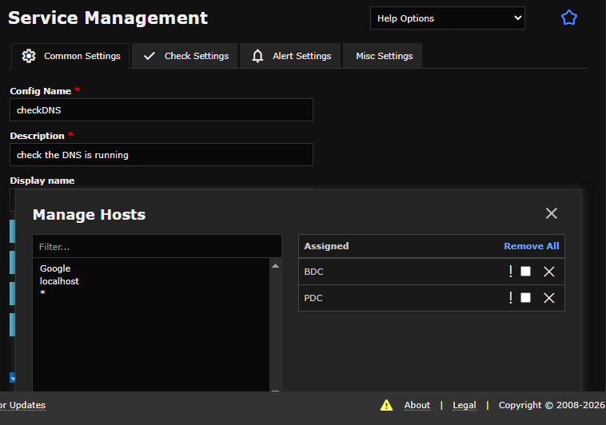
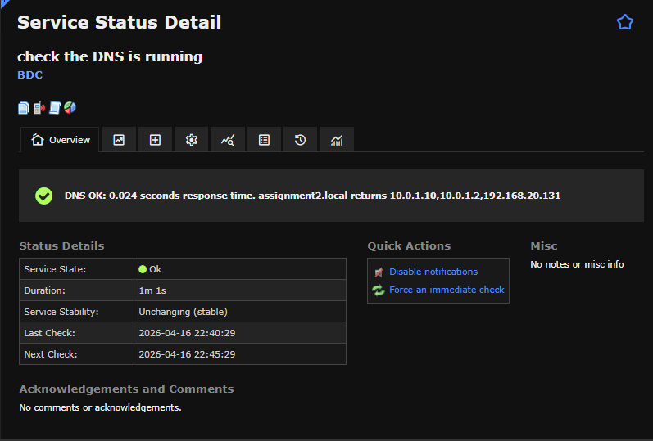
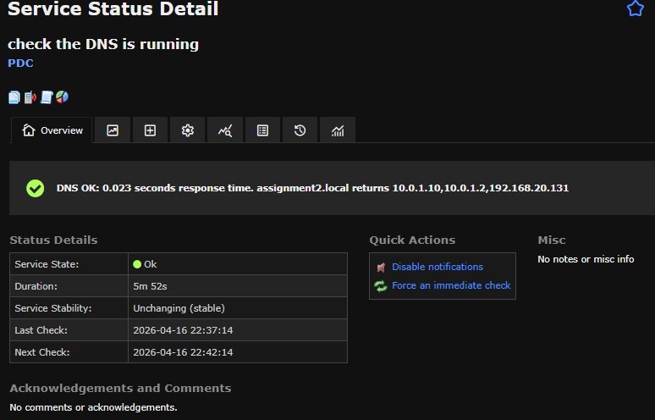

Monitoring - Log on to all machines are logged. Username, machine
and timestamp saved.
GPO editor with the policy changed to log it.
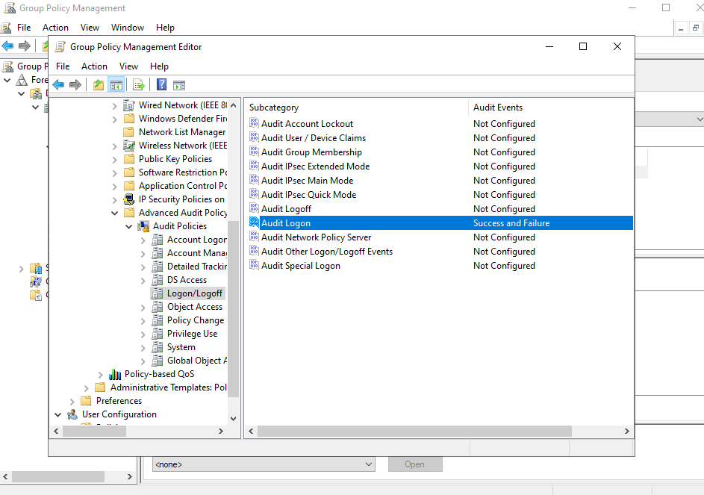
Showing logs of it being logged:
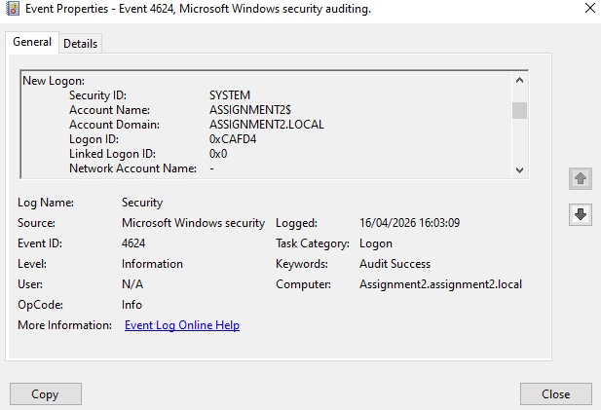

Monitoring - Only Administrator can log onto the Network Monitoring
system
Showing all accounts on the server
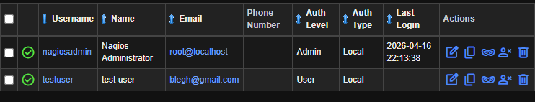
Test user hasn’t been given access to any monitored objects so it’s an empty dashboard
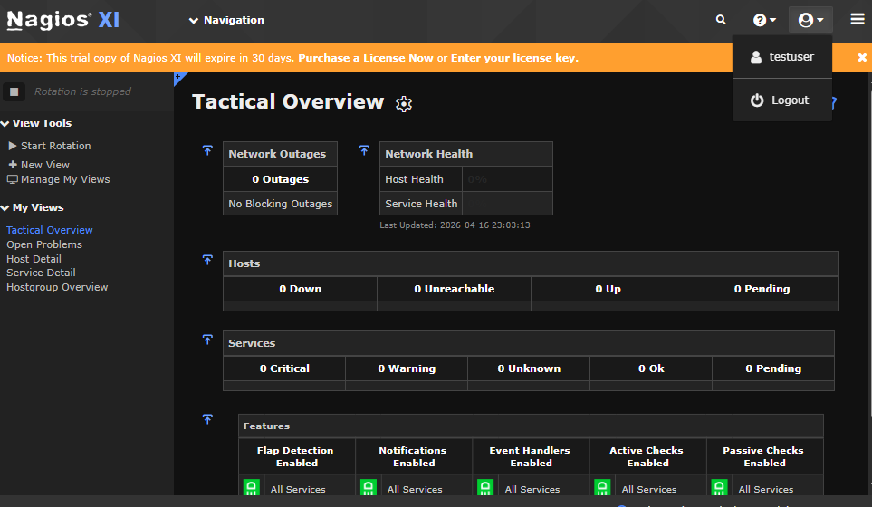

Monitoring - Web access URLs are logged and timestamped available
in the network monitor.
In the Nagios it shows all the logged in accounts in the audit log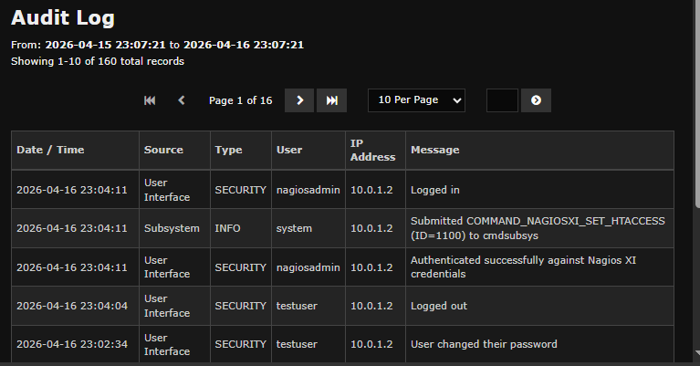

Extras - Daily backup of servers configured to a machine within the
network.
Permissions and configs: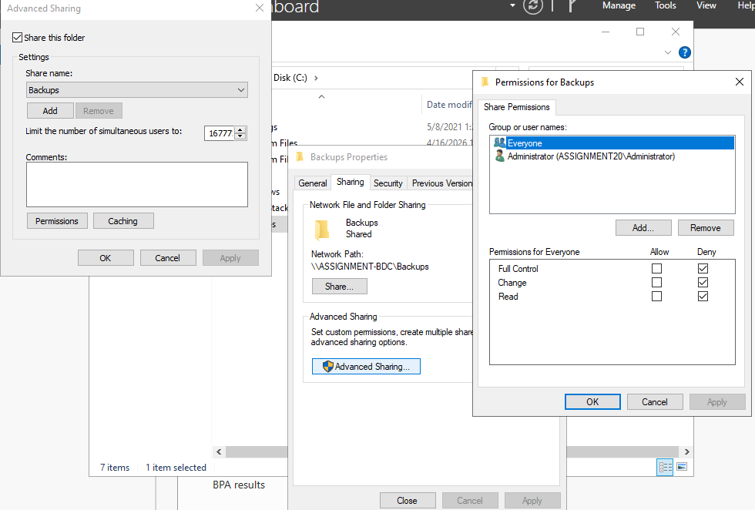
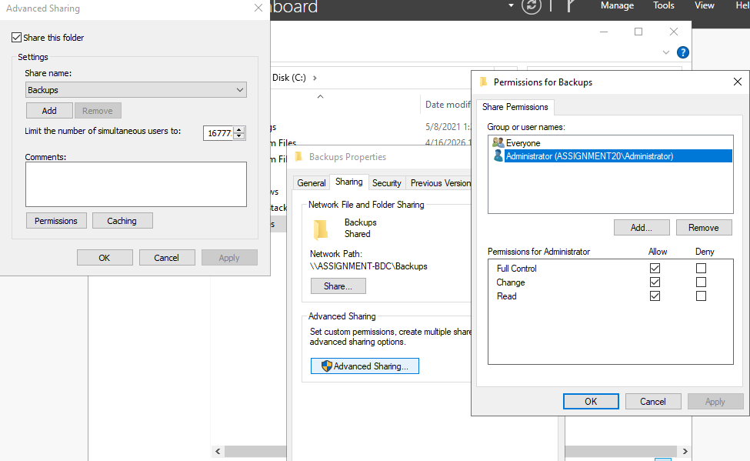
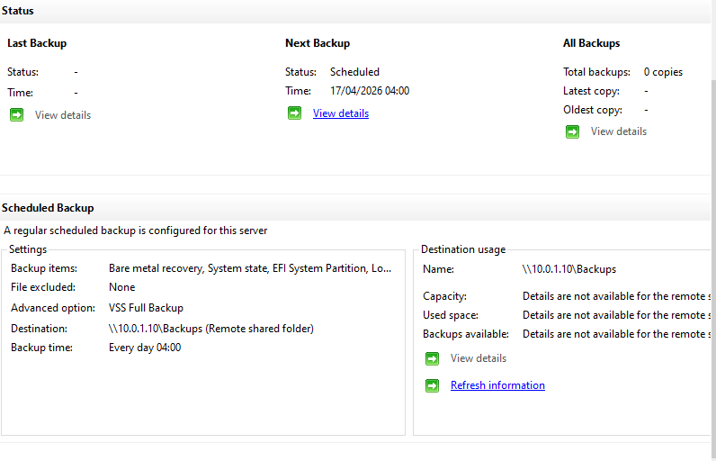

Extras - RDP configured for all desktop computers for administration
within the network. Only usable by the system administrator.

