TO: Chuck Welter

From: Ray Nelson

CC: Leann Arend, Geoffrey Lawrence, Dave Claar, Mountaineer Account

Subject: Meany Power Line Replacement Report

Date: June 25, 2015

On approximately April 24, 2015 the Mountaineers contracted with L-Boz Construction from Ellensburg, Jack Sandsaver supervising, to replace the aging Meany power line from the PSE power line on the BPA Right-of-Way to the Lodge with feeds to the Tow Hut and Maintenance Shed (known as the Zoo) as well as the Lodge.

That work involved the replacement of 6 power poles and the addition of 3 new ones (there were actually 4 new ones because of a clearance problem) plus considerable tree trimming and some new anchors. The power line now has all new poles and no longer runs on some trees. The bid was for $22,400 plus tax with a $2500 deposit.

That work is now complete as of this date and from my review completely satisfactory.

- The poles were replaced with poles as specified plus the addition of one extra (for clearance problems) at no additional cost to the Mountaineers. The old poles were taken down and left for us to dispose of as per agreement.
- The power line was constructed to PSE standards as well as I know them using surplus PSE hardware.
- The trees were trimmed per expectation. The limbs were left for us to dispose as per agreement.

Below are some pictures of the new Power Line:

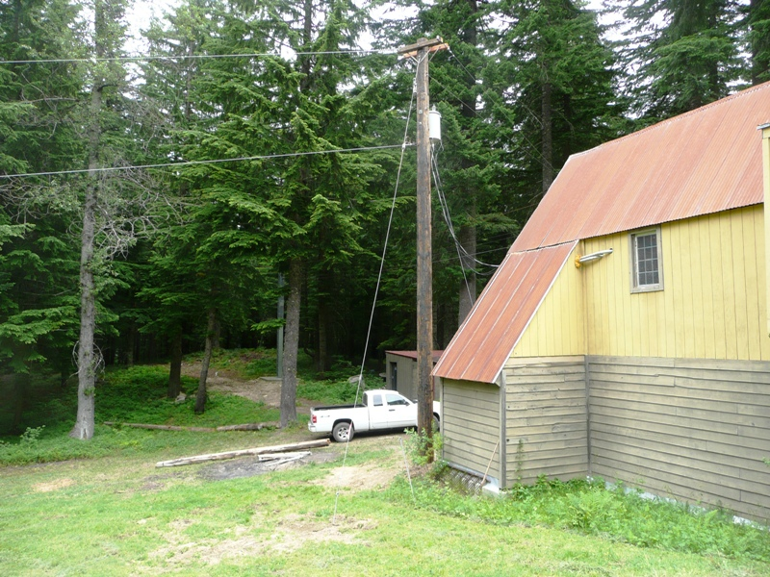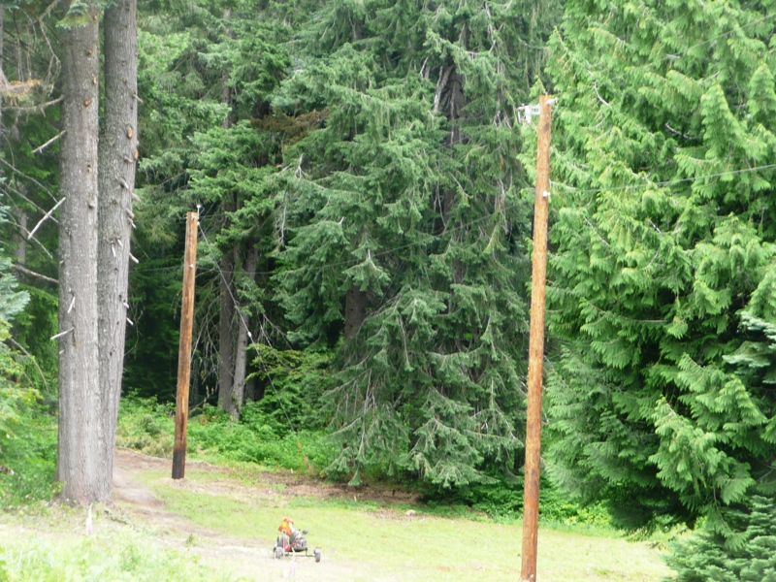
Sectionalizing fuse pole 25 amp
New pole
New pole at Tow Hut Poles between the Tow Hut and the Lodge

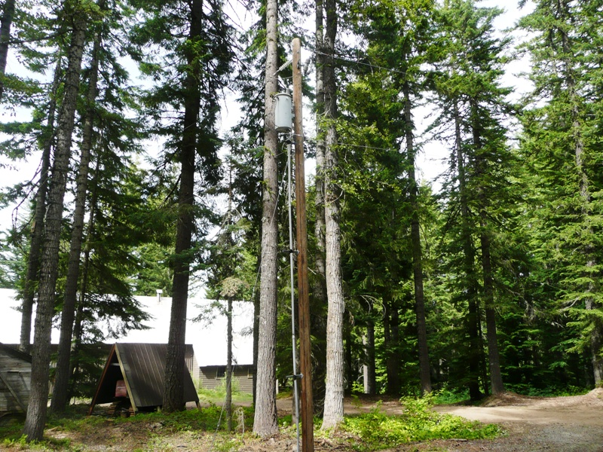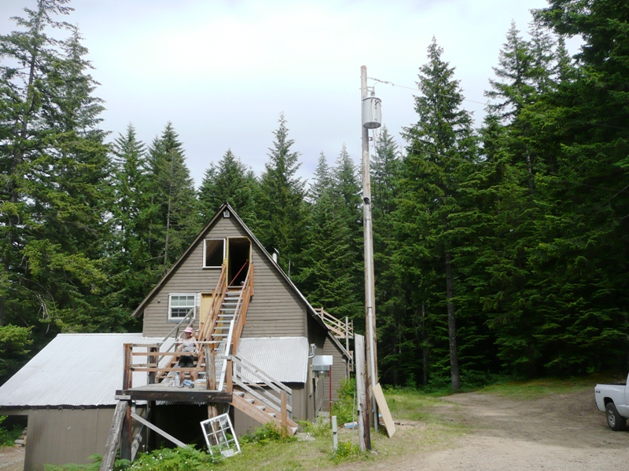
New Pole
New Pole
New pole at the maintenance shed (also known as the Zoo) New pole at the Lodge

PS. The power line looks very good to me and should last for many years. The only issue is - by necessity the power line runs near the trees and is exposed to tree and limb fall which may take out the power line. It was constructed with this in mind and we should lose only one span (the line between poles) and should be easy to repair when and if this should occur.

In conclusion, I am recommending making the final payment.

/tmp/lo/0000.doc

