

Track F1

Project Report

DT228/DT282

Web Dev 1

**Daniel Krasovski**

School of Computing

Dublin Institute of Technology

**13/12/2018**



Declaration

I hereby declare that the work described in this dissertation is, except where otherwise stated, entirely my own work and has not been submitted as an exercise for a degree at this or any other university.

Signed:

_________________________

<Daniel Krasovski>

<13/12/2018>

Table of Contents

*1.* Problem Description 4

*2.* Research 4

*3.* Technology Selection and Site Architecture 4-5

*4.* Low Fidelity Prototype 5

*5.* Development Plan 5

*6.* Testing Plan 6

*7.* Site Evaluation 6

*8.* Deployment 6

Appendices 6-7

# Problem Description

The websites I called Track F1 and the purpose of this website is the website to go to keep up to date on F1. You can find Video’s on the website from the official F1 YouTube channel. Check the current standings. Post comments and see what other people have commented. See the countdown for the next 3 upcoming races.

The users of this website would be people that are not too good with technology, with an easy to use website with simple design and aesthetics.

# Research

I looked at these 3 websites while doing my research:

* [www.f1.com](http://www.f1.com)
* [www.planetf1.com](http://www.planetf1.com)
* [www.statsf1.com/en/default.aspx](http://www.statsf1.com/en/default.aspx)

All three of these websites are extremely complex and have a lot of information that the average fan of F1 does not need. These websites are also a lot more difficult to navigate and thus not as technologically adapt users will most likely get confused by the website and have an un-satisfactory experience. This is where my website will come into play, being a lot more simple and easy to get around. It will hopefully attract the people that find these other websites hard to use. Since my website is also a lot more simpler, it will take less time to navigate and thus save some time for the user.

# Technology Selection and Site Architecture

HTML5 is used for this website and the latest version of CSS.

The website has a responsive design and changes depending on the resolution of your screen.

The videos are displayed using <iframe> and are embedded youtube videos.

I used an open source google script, that gets data that is filled into a static website host that’s is then forwarded to email and a google sheets database for storage, I used this tutorial here: <https://github.com/dwyl/learn-to-send-email-via-google-script-html-no-server#how>

After setting up the form and making sure the script works, I embedded the google sheets to show all the responses. This is used as a simple commenting system for the website and for people to post their reactions.

I used some more JavaScript on the next race page to create a countdown for the next upcoming 3 races. I used the example from: <https://www.w3schools.com/howto/howto_js_countdown.asp> and adapted the code to make it work for my website.

The website can be viewed on all devices ranging from an iPhone, to desktop pcs, to a 4k tv without too much difference in experience. The website works on most web browsers however some functionality will be lost on less popular websites. For example, being able to change the size on the form is only available, on Google Chrome and Firefox, from my testing.

# Low Fidelity Prototype

I created the website prototype using a website called draw.io which made it extremely simple to make one, due to there already being temples already made and having lots shapes and options which make customising the prototype easy. 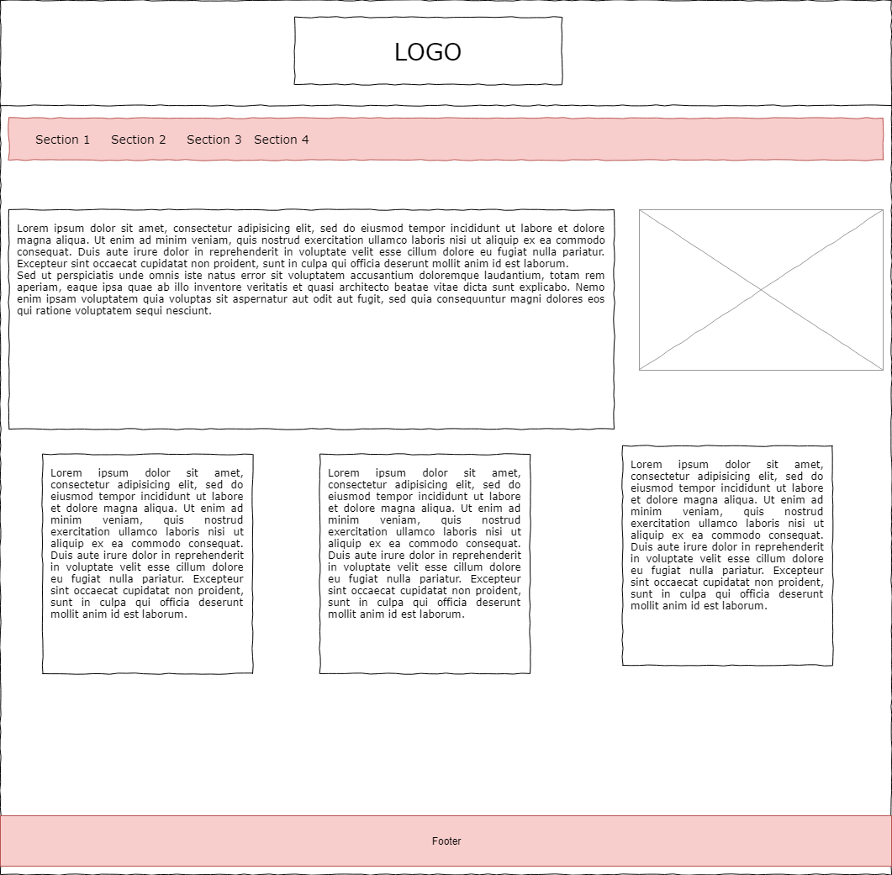

# Development Plan

The website will be made using notepad++ for editing the HTML, CSS and JavaScript. For any images that need to be created or edited, I will use photoshop. To make the development easier when switching from laptop to desktop pc, I will be using GitHub to push and pull the most recent version of the website when switching between computers

.

# Testing Plan

To test the website, I will be trying the website on all my devices and different web browsers. Firstly, I used my iphone, and loaded the website onto safari and tested all the different pages. Afterwards I used my desktop and laptop to try the website on multiple browsers such as Edge, Google Chrome, Firefox and Opera. After making sure that the website responds as intended, I connected my computer to a 4k tv to check how the website would react to a resolution that isn’t as mainstream currently but that would be soon in the future. The website worked as intended and I came across no bugs or glitches

# Site Evaluation

For my site evaluation I used <https://validator.w3.org/> . any errors that came up I fixed and fixed most of the warnings that came up. Currently only 1 error comes up for the website which is the character encoding type. Other than that error, the rest are warnings for not using <h2-6> in my section tags which are container that are used to store, text, videos, images and JavaScript countdowns.

# Deployment

The website will be deployed using Amazon Web services and the domain name was bought from GoDaddy.com, I have control of the domain name for 1 year and have the option to extend it after the time expires. I used Amazon’s S3 service to host my website since it is perfect for static websites and does not require any monthly or yearly fee. All it requires that you have a domain name which I already have. Updating the website for AWS is also simple due to the Drag and Drop mechanic they have. Compared to the 000Webhosting the lecturer suggested, I chose AWS due to it being a lot more faster, not needing to have .000webhostapp in the domain name and the overall satisfaction of being able to connect to a full domain name that you own.

The site is currently deployed at [www.track-f1.com](http://www.track-f1.com)

# Appendices

Weekly Logs

Week 8:

As soon as the lecturer gave the project, I already I had an idea on what I was going to do the website on. It was Formula 1 or more commonly known as F1. The first thing I will have to make is the home page and then come up with ideas on the other 4 pages.

Week 9:

This week I have purchased a domain name from GoDaddy.com, Afterwards I created an account on AWS in order to host my website. I also created a GitHub repository, so I could work on the website on my laptop while I am in school or on my computer when I am at home. I also used JavaScript to create a countdown timer for the upcoming racing. I have also removed some of the place-holder text and added some content about F1.

I have also looked at some websites that would be quite similar to mine. I also came up with the colour scheme of my website, Red and White. I also came up with the 4 additional headings for my website which are: Next race, Standings, Reactions and Updates.

Week 10:

This week for the web dev project, I have added more images to the website and its different pages. I have added some more comment to replace the filler lorem lipsum. I am planning on adding a comment section to the reactions page. The final race of the season is also coming up and I am planning on writing a paragraph on it and writing some on the upcoming season.

Week 11:

The last race of the season has finished. I have updated information on driver swaps and the end of the season report. I have changed some of the styling to make the website more simple and appealing. This week I have added the forum with javascript to my website. I am getting close to finishing my website and only have some touch ups to do and add some more content about f1.

Week 12:

For the last week of the logs, I am getting close to finish my website and only have to do a few touch ups and check the site for errors using validation. I also added a Logo and icon to my website which I created using photoshop. I added the standing tables for the 2018 season, for both the drivers and constructors. I also added videos to the website which are taken from the official F1 youtube channel.