LAB FINAL
E-Commerce & Digital Marketing

Premier Tech Store
premiercomputers.store

Submitted By
Syed Muhammad Measum Naqi
Reg No: BCS-FA23-209

Ahmad Ibrahim
Reg No: BCS-FA23-220

COD Available Nationwide | premiercomputers.store

SecsStore Summary:tion 1: Website Overview
URL: https://premiercomputers.store/
Store Name: Premier Tech Store
Purpose: Online retail store for computers, laptops, and tech accessories
Payment: Cash on Delivery (COD) — only payment option at checkout

Logo:


Website Pages
Page | Features & Description
Home Page | Main landing page, top categories, banners, and store highlights.  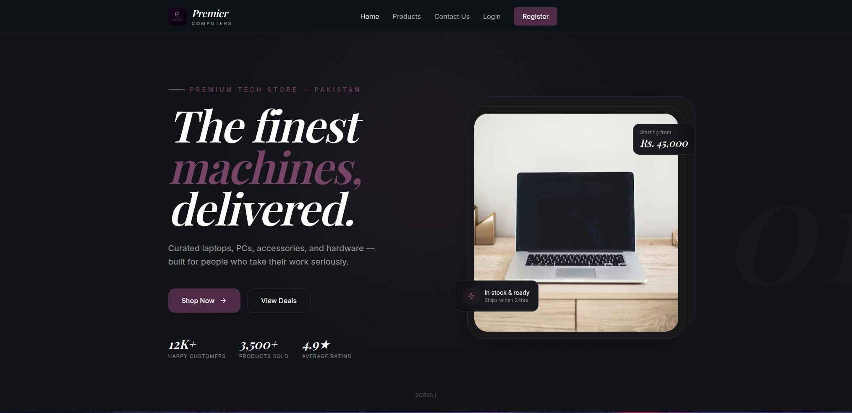  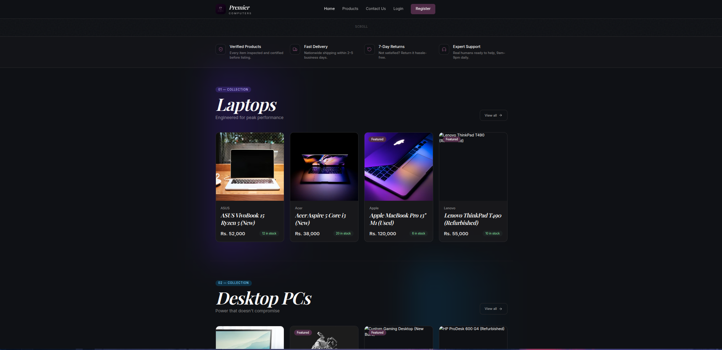
Category Page | Organizes products into categories. Customers can browse and filter items within each category.  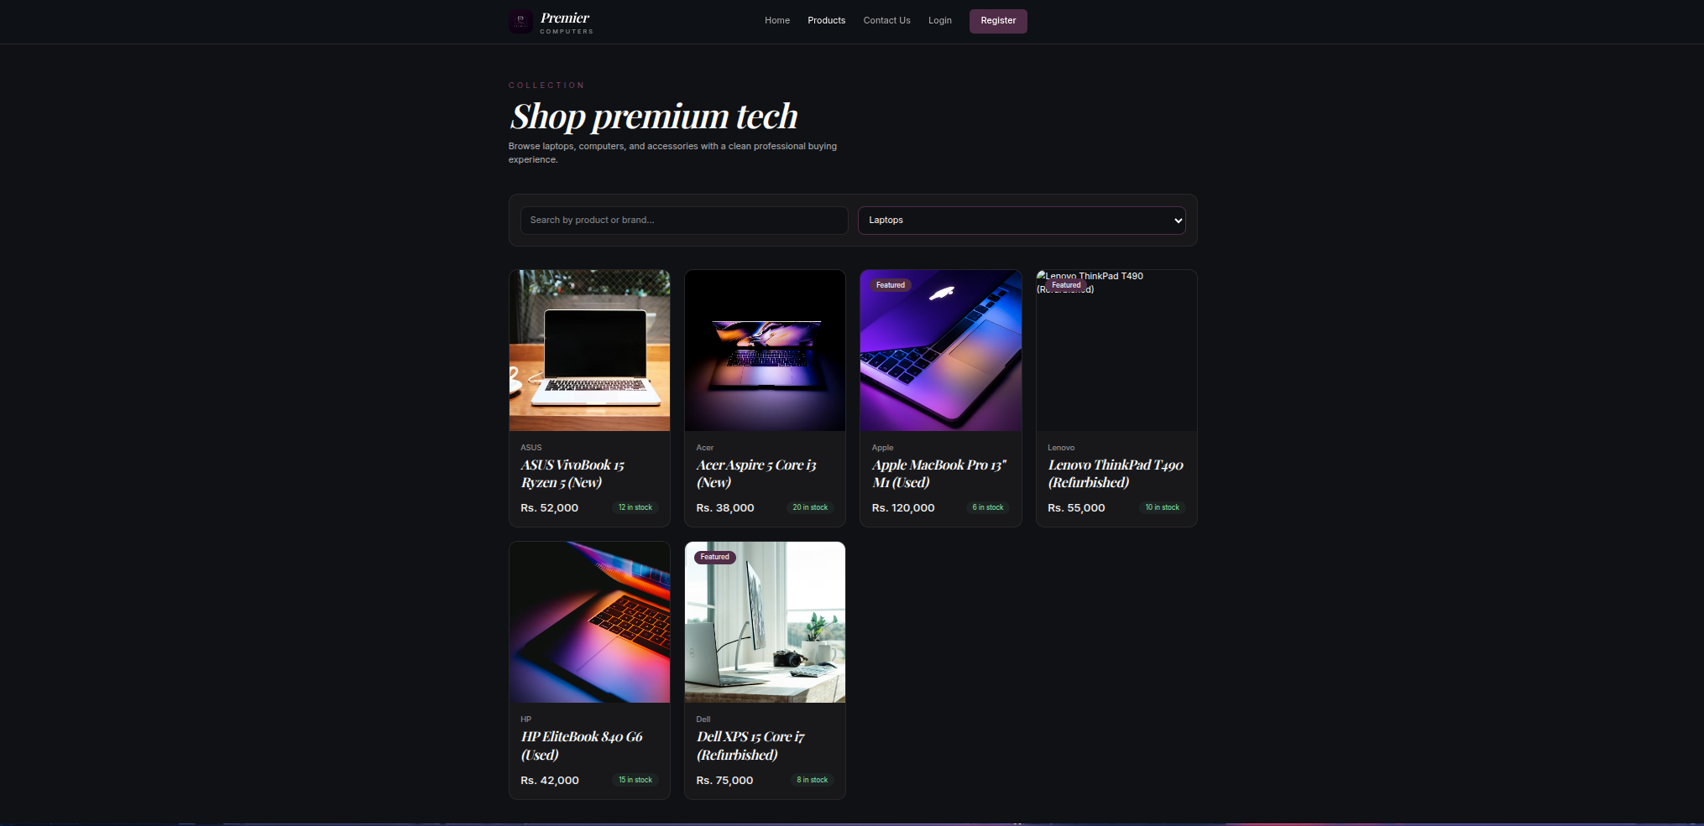
Product Page | Dedicated page per product showing images, description, price, specs, and Add to Cart button.  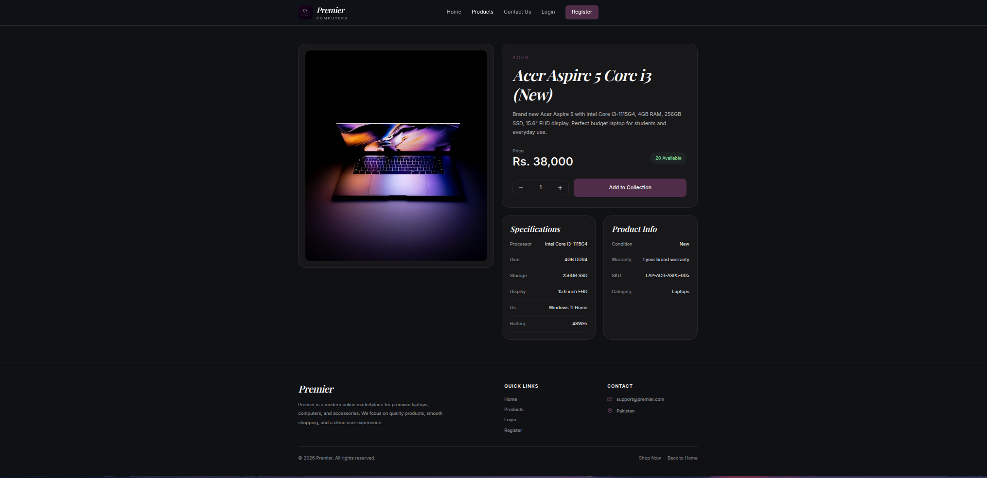
Contact Page | Displays store contact info and includes a customer inquiry form for direct messages.  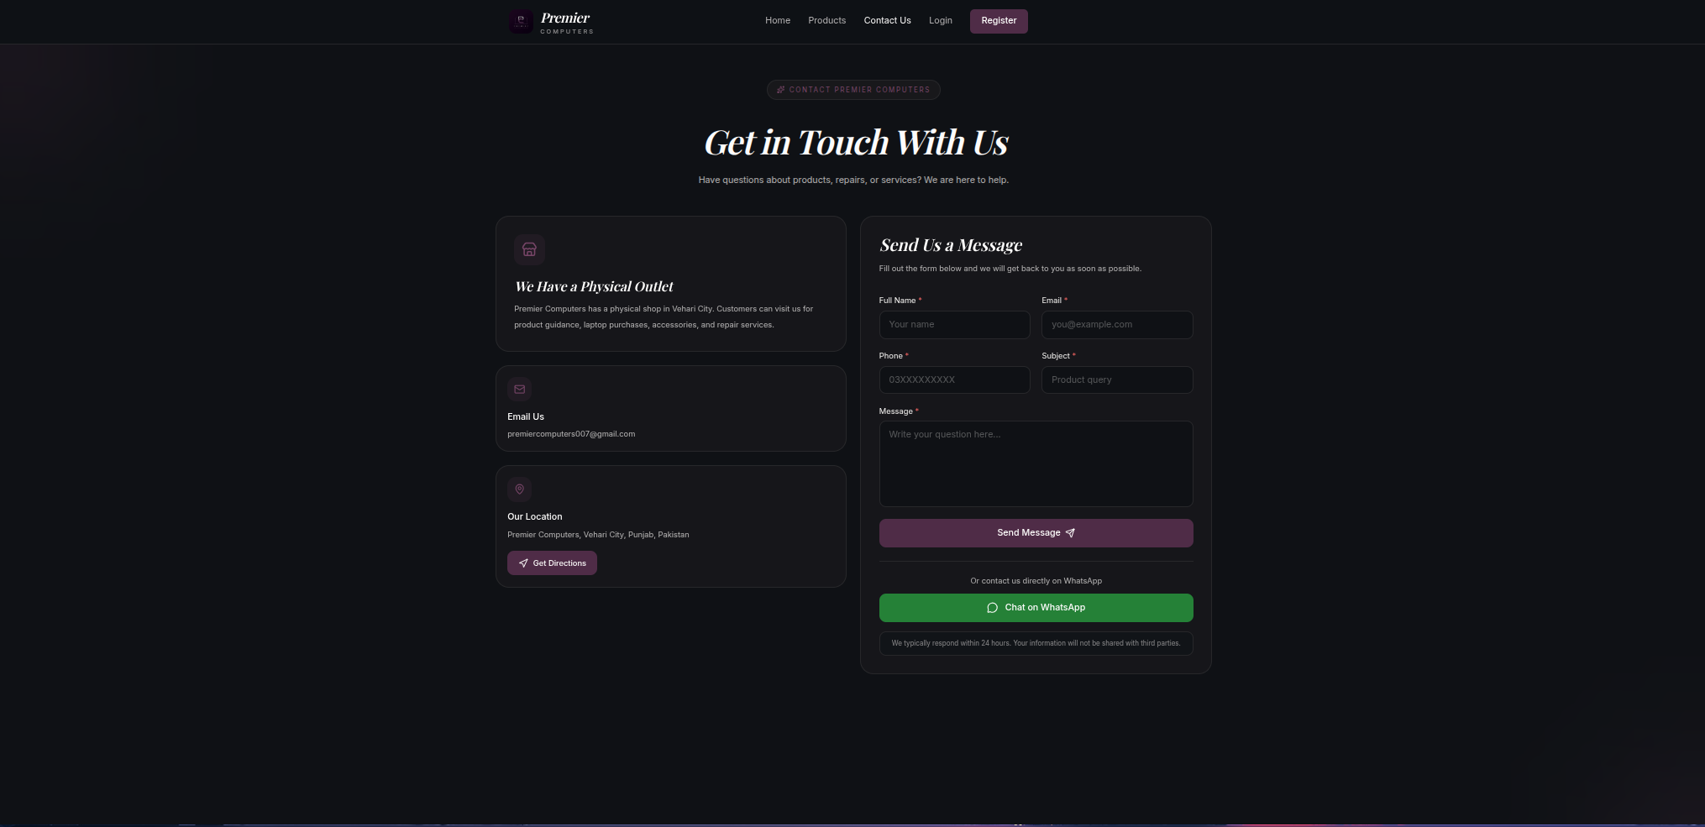

Customer Shopping Flow
Step 1 | Step 2 | Step 3 | Step 4
Browse Categories / Products | Add Items to Cart | Proceed to Checkout | Place Order via COD

Cart & Checkout
Feature | Details
Shopping Cart | Add multiple products, review items, update quantities, and remove products before checkout.  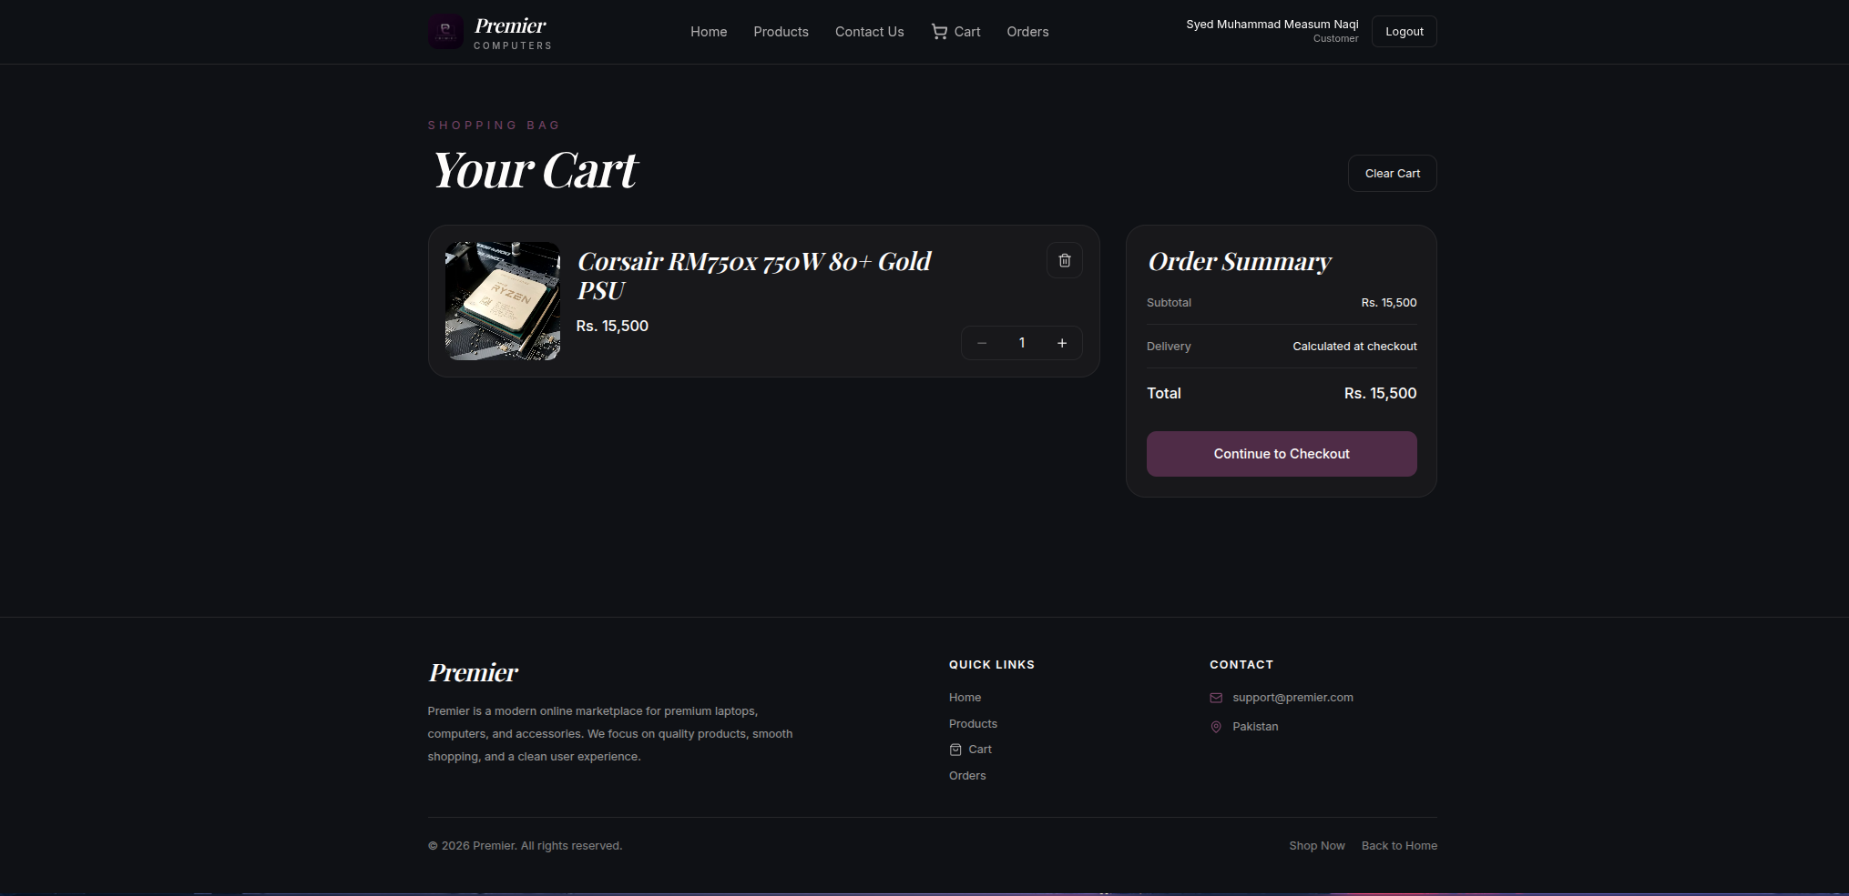
Checkout | Streamlined checkout — enter delivery details and confirm. Only COD available.  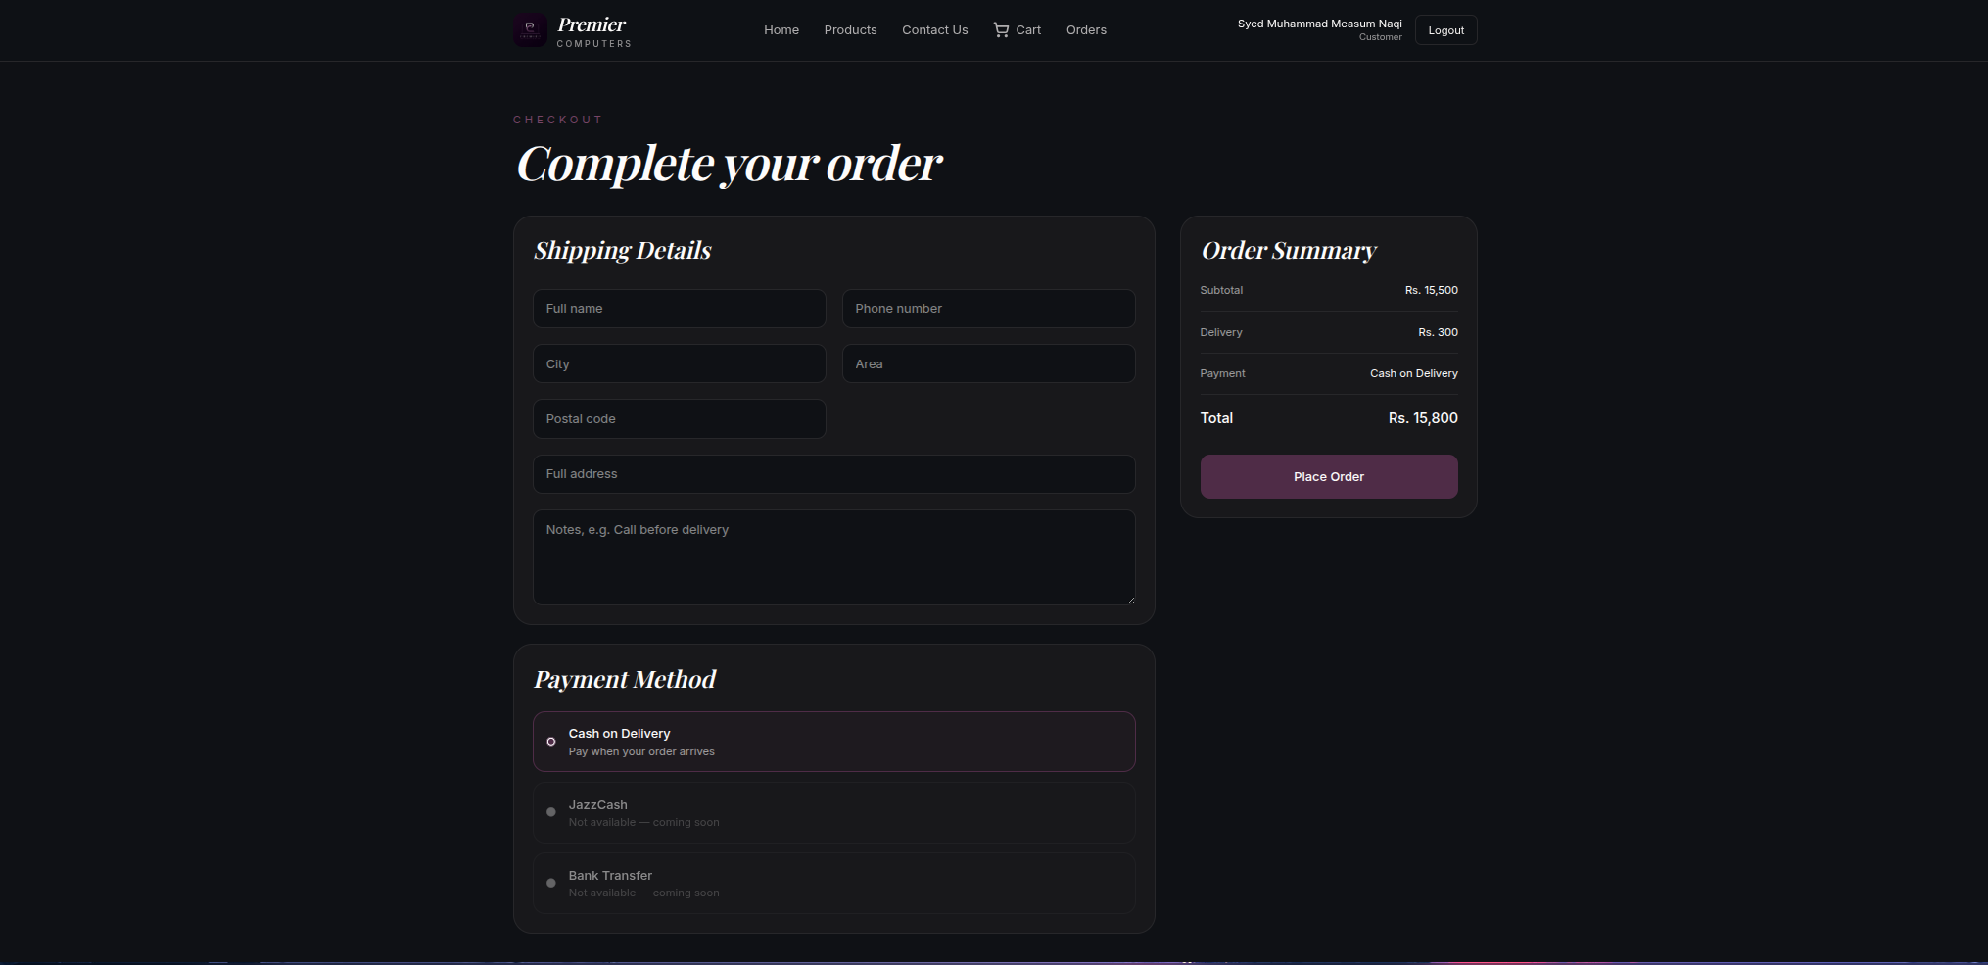
COD Payment | Payment collected at delivery. No online payment gateway required.

Admin Panel
Feature | Details
product Management | Monitor and manage products.  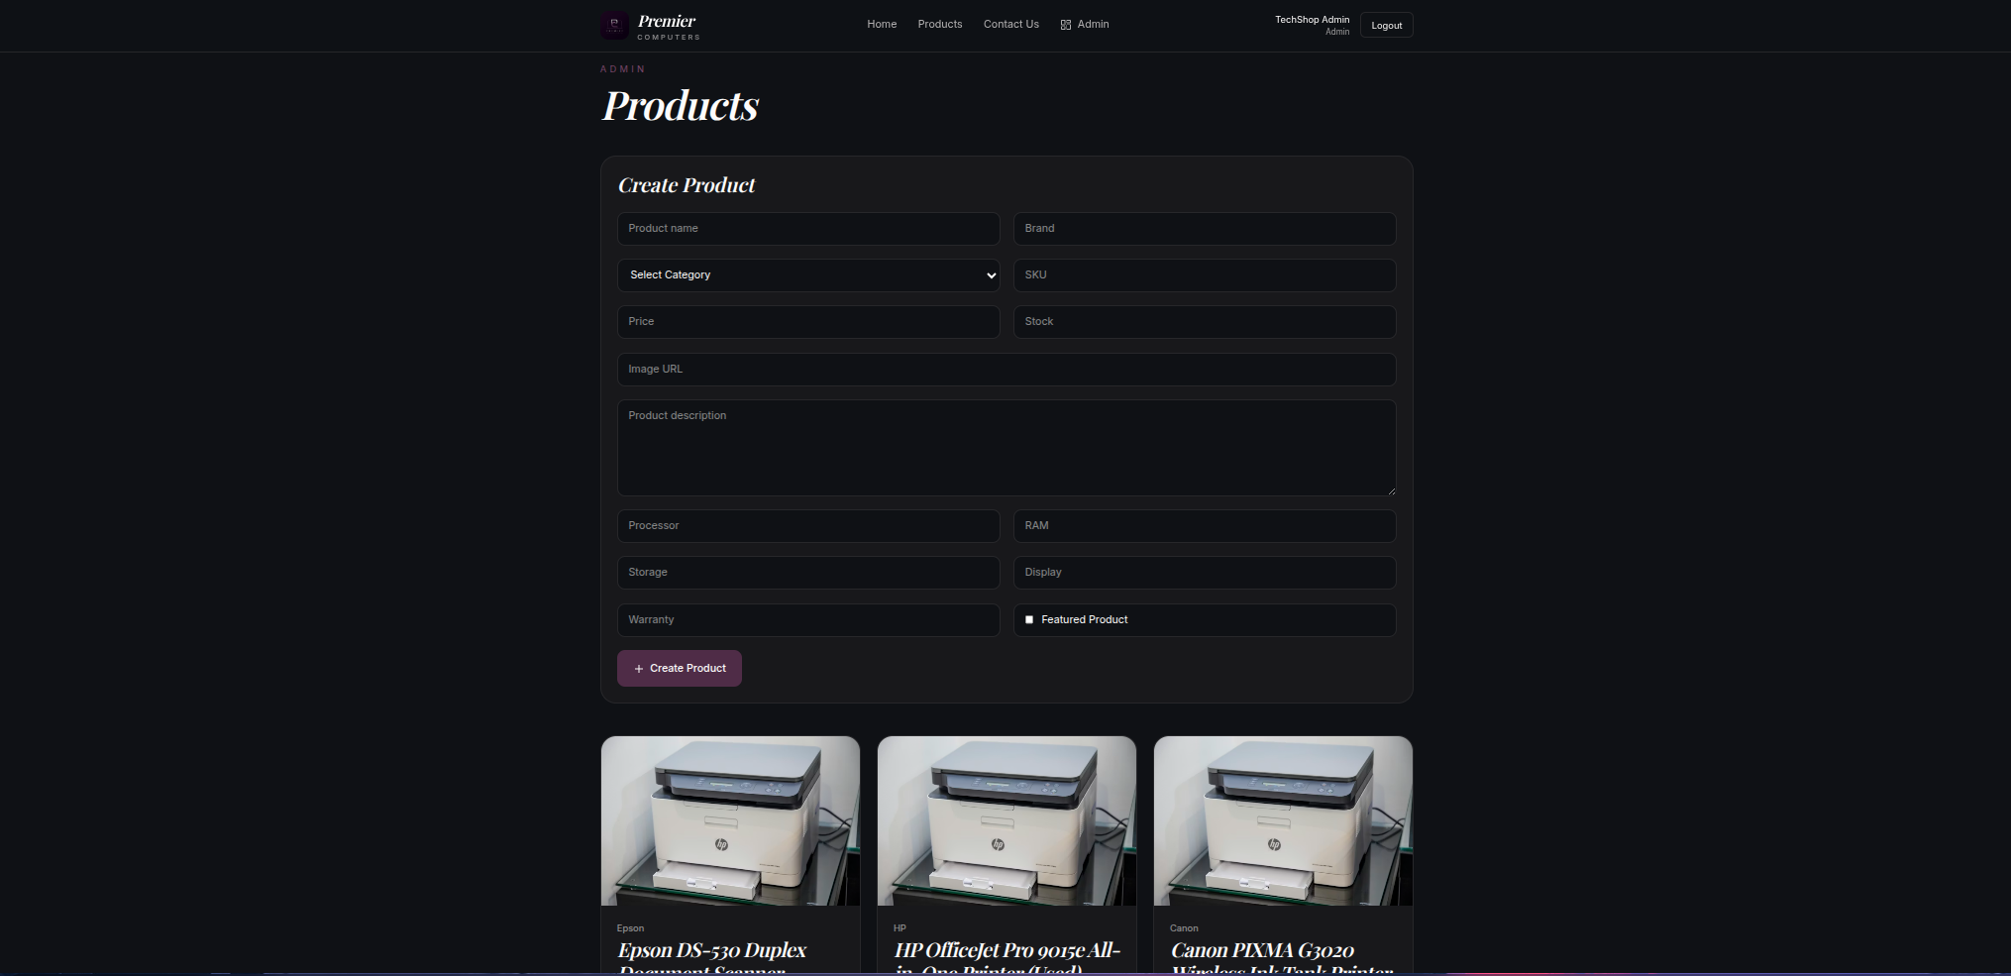
Contact Management | Visibility over customer contact request..  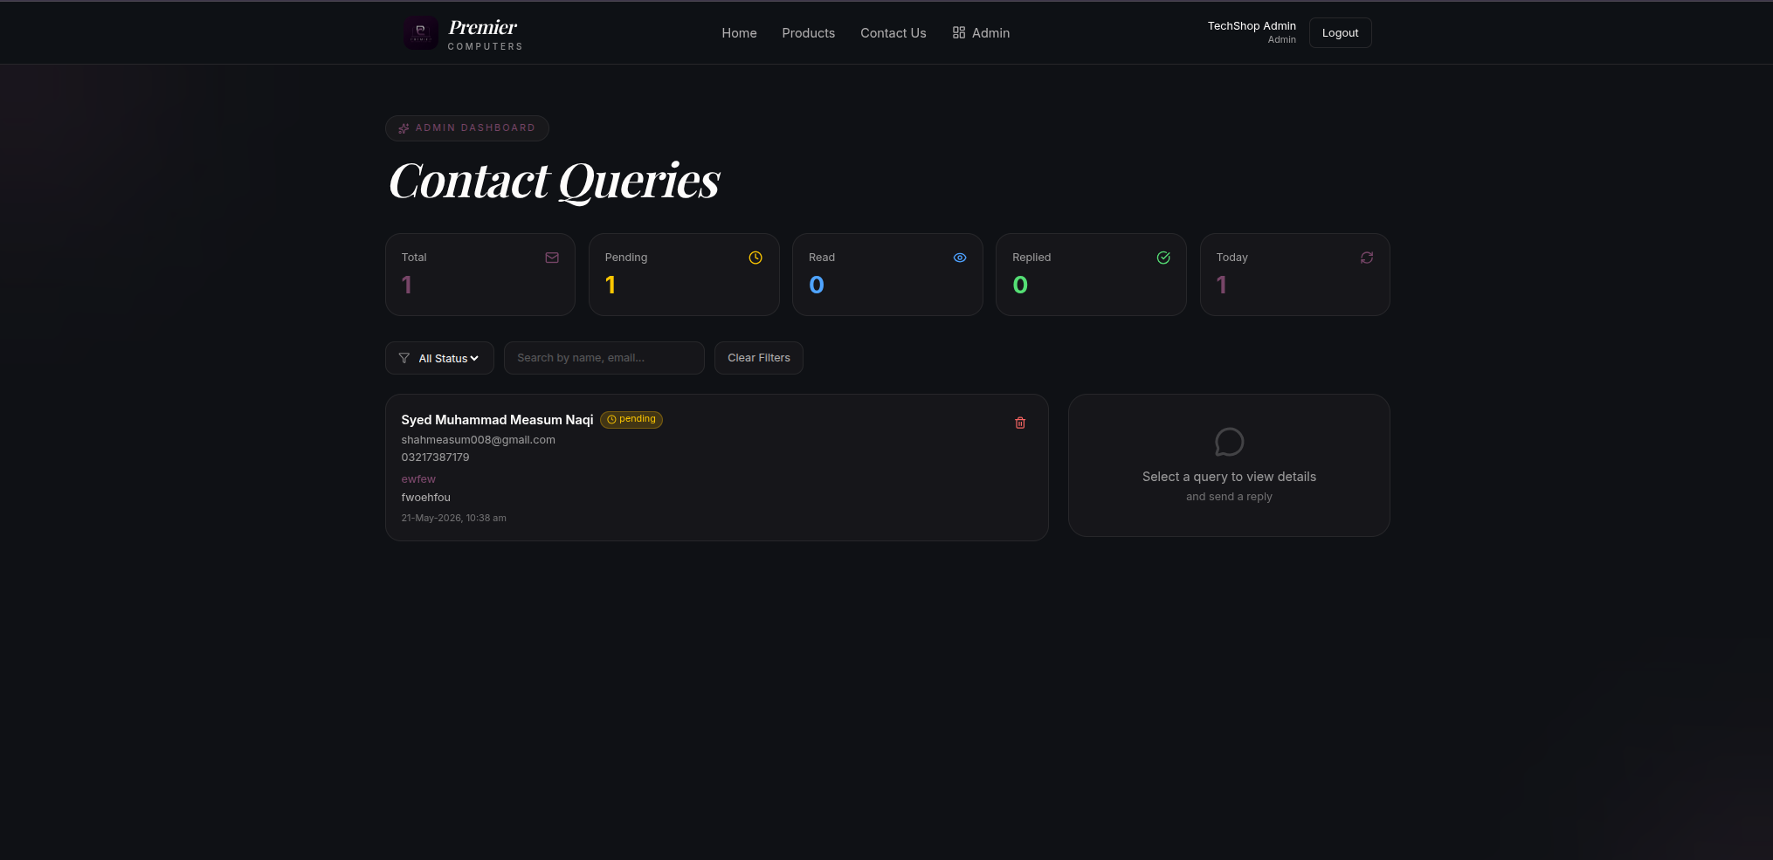
Order Management | Full control — view order details, update order status (pending, processing, delivered.  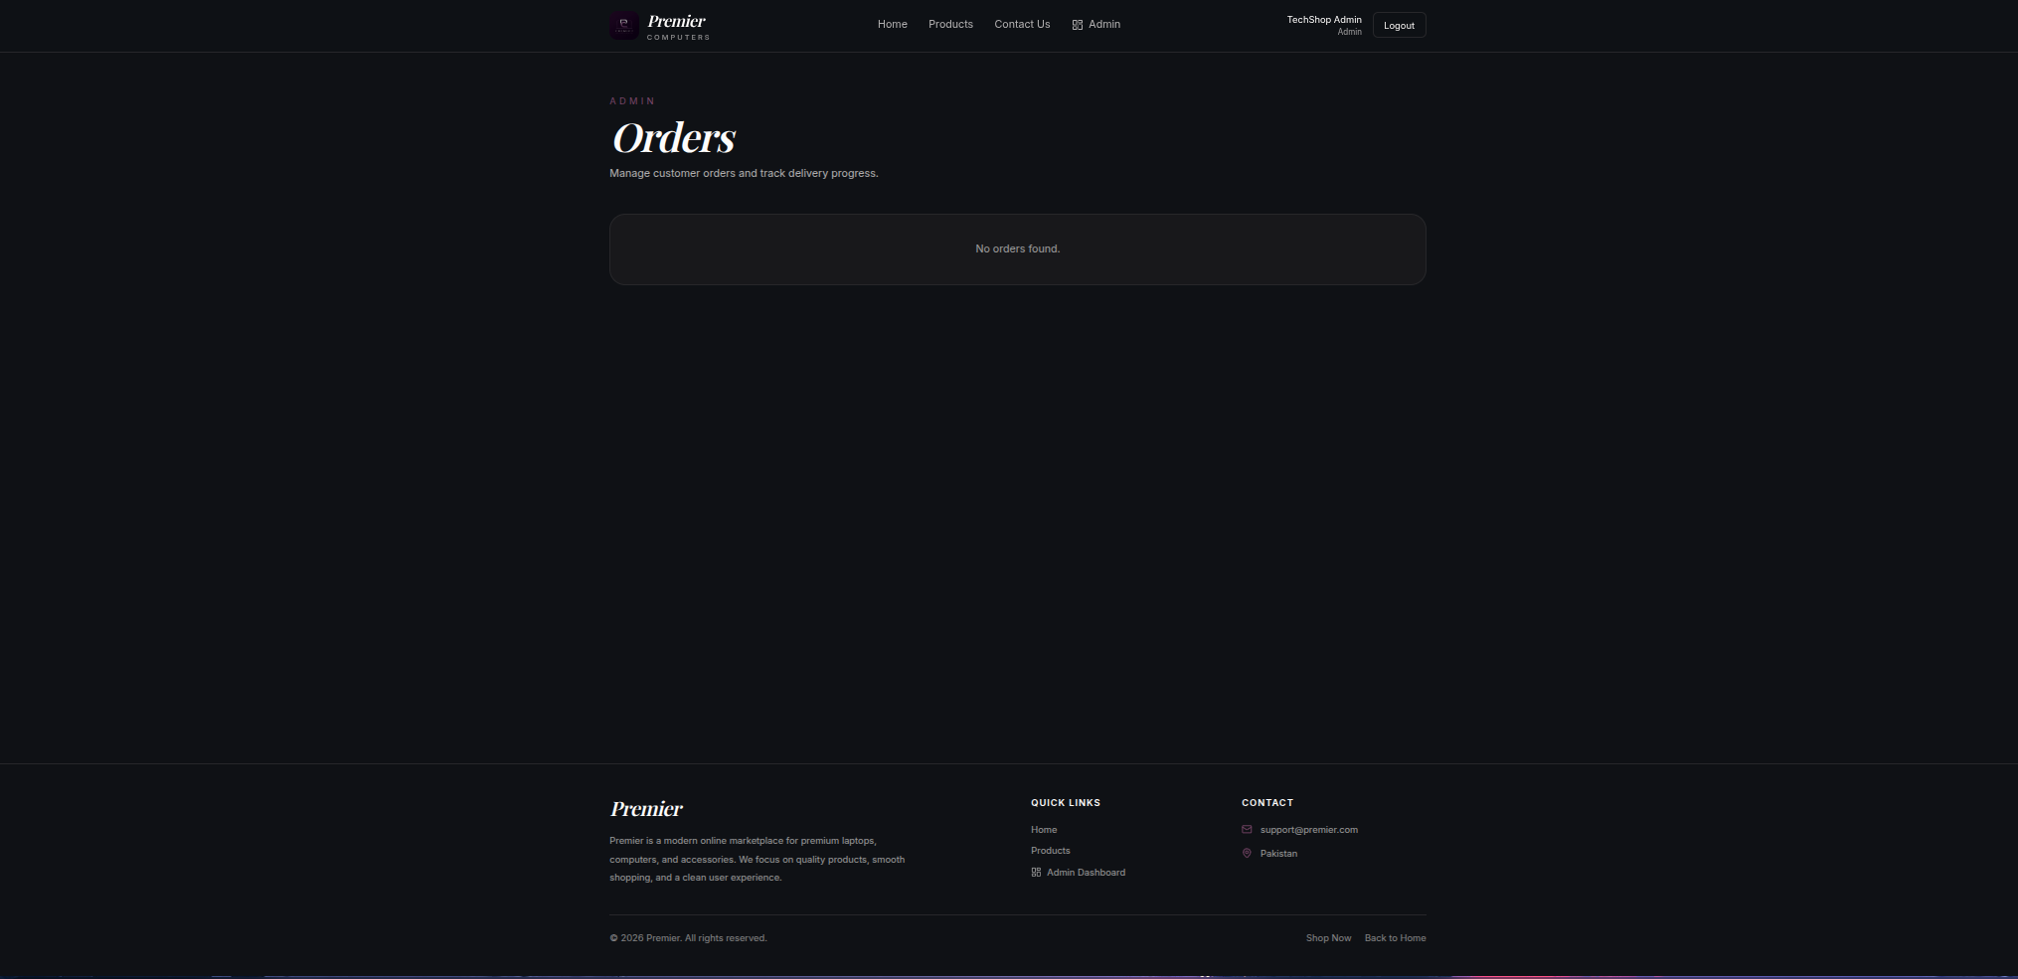

Product Catalogue
Category | Products
Laptops | HP, Dell, Lenovo, Acer — IdeaPad, ThinkPad, Legion, EliteBook, XPS, Pavilion, Aspire, Nitro, Predator & more
Desktop PCs | HP Pavilion, EliteDesk, ProDesk, Dell OptiPlex, Inspiron Desktop, Alienware, Custom/Assembled PCs
Accessories | Keyboards, Mice, Monitors, Webcams, External HDDs, SSDs, USB Drives, Routers, UPS, Cables, Hubs
Hardware Components | CPUs (Intel/AMD), GPUs (NVIDIA/AMD), RAM (DDR4/DDR5), SSDs, Motherboards, PSUs, Cases, Cooling

Three Day Posts:

Post 01 — Awareness Post
Field | Content
Headline | Your next laptop is one click away — meet Premier Tech Store.
Platform | Instagram | Facebook | LinkedIn
Caption | Pakistan's go-to online computer store. Browse hundreds of laptops, desktops & accessories — competitive prices, delivered to your door. No card needed. Pay cash on delivery.
Hashtags | #PremierTechStore #OnlineShopping #LaptopsPakistan #TechDeals #COD
CTA | Shop Now at premiercomputers.store
Image | 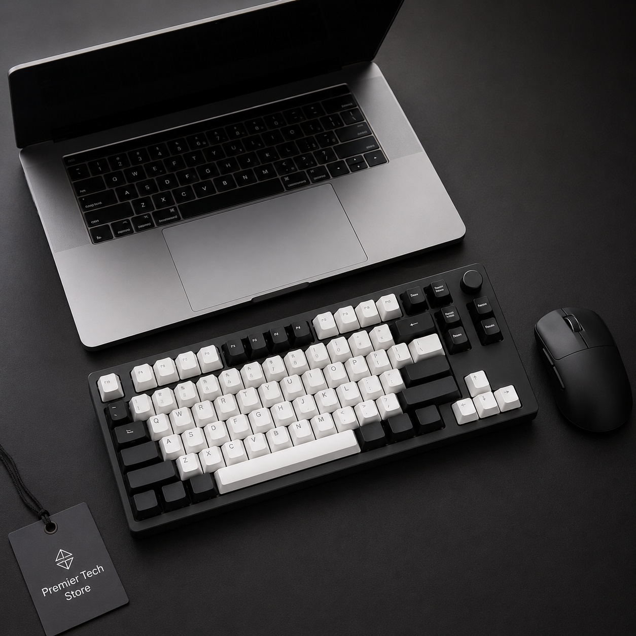

Post 02 — Customer Review / Testimonial Post
Field | Content
Headline | Real customers. Real results. Real reviews.
Platform | Instagram | Facebook | Google Business
Reviewer | Ahmed Khan — Lahore | ★★★★★ Verified Buyer
Review | "Ordered my HP laptop and it arrived the very next day. Paid cash on delivery — no stress, no card required. The packaging was perfect and the price was unbeatable. Highly recommend Premier Tech Store!"
Caption | Join thousands of happy customers across Pakistan. Your dream laptop is just an order away — and you pay only when it arrives at your door.
Hashtags | #CustomerLove #5StarReview #PremierTechStore #TrustedStore #HappyCustomer
CTA | Read More Reviews — Visit premiercomputers.store
Image | 

Post 03 — Limited-Time Discount / Flash Sale Post
Field | Content
Headline | Flash Sale — Up to 30% OFF. Ends in 48 hours. Don't miss it.
Platform | Instagram | Facebook | WhatsApp Status
Offer | Up to 30% OFF Laptops | Free Delivery | COD Only
Promo Code | PREMIER30 — Use at checkout
Caption | This weekend only — our biggest sale of the month. Grab your favourite laptop or desktop before stock runs out. Cash on delivery available nationwide. Hurry, offer ends in 48 hours!
Hashtags | #FlashSale #TechSale #LaptopSale #PremierTechStore #LimitedOffer #CODPakistan
CTA | Grab the Deal — Shop Now at premiercomputers.store
Image | 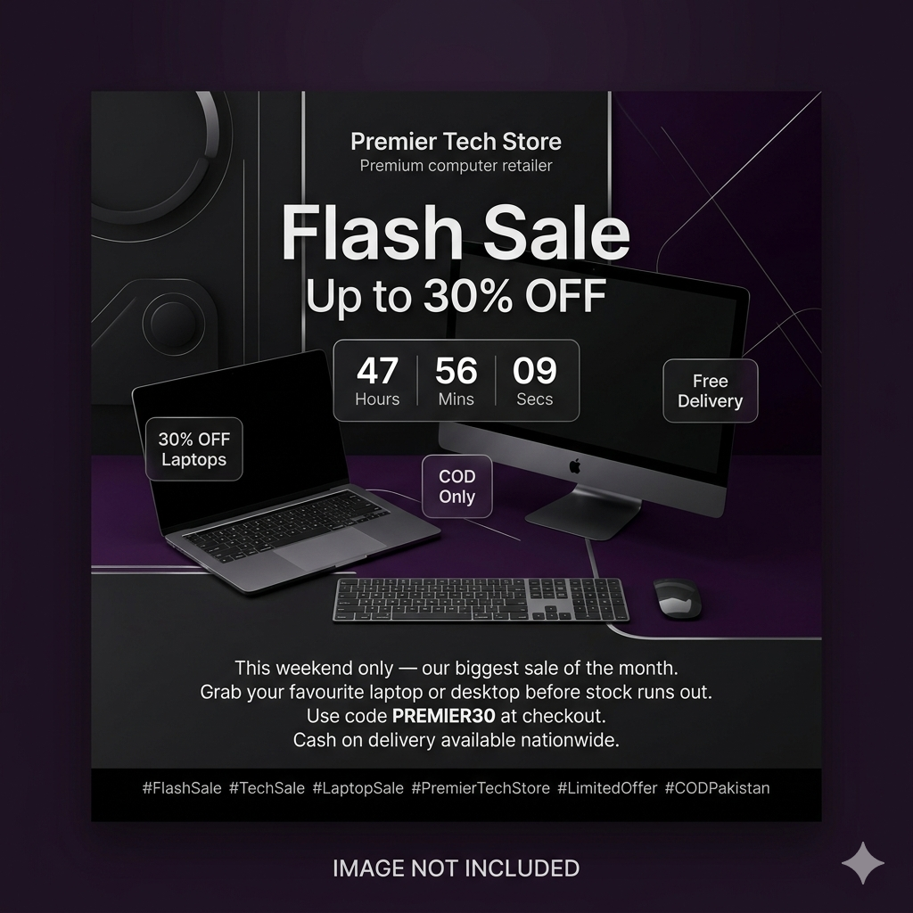

Section 3: 3-Day Social Media Calendar
Premier Tech Store — Campaign Calendar

Platform | Date | Time | Post Type | Topic | Caption/Copy | CTA | Account Link
Instagram | Day 1 | 10:00 AM | Image Post  (Awareness) | Introduce Premier Tech Store | Pakistan's go-to online computer store. Browse laptops, desktops & accessories. Pay cash on delivery. | Shop Now →  premiercomputers.store | instagram.com/premiercomputers.store
Facebook | Day 1 | 12:00 PM | Image Post  (Awareness) | Store Launch / Brand Intro | No card needed. Browse hundreds of tech products & get it delivered to your door. COD available nationwide. | Visit Store →  premiercomputers.store | facebook.com/premiercomputers
Instagram | Day 2 | 11:00 AM | Testimonial  (Social Proof) | Customer Review — Ahmed Khan | Join thousands of happy customers. Real reviews. Real delivery. Pay only when your order arrives. | Read Reviews →  premiercomputers.store | instagram.com/premiercomputers.store
Facebook | Day 2 | 02:00 PM | Testimonial  (Social Proof) | 5-Star Verified Buyer Story | Ahmed from Lahore got his HP laptop next day — paid cash on delivery. Your turn! 🛒 | Order Now →  premiercomputers.store | facebook.com/premiercomputers
WhatsApp  Status | Day 2 | 07:00 PM | Story  (Engagement) | Customer Satisfaction | ⭐⭐⭐⭐⭐ 'Best tech store in Pakistan!' — Verified Buyer. Shop & pay on delivery. | Tap to Shop →  premiercomputers.store | WhatsApp Business
Instagram | Day 3 | 10:00 AM | Sale Post  (Conversion) | Flash Sale — 30% OFF Laptops | Flash Sale ends in 48 hrs! Grab your favourite laptop before it's gone. Use code PREMIER30. COD only. | Grab Deal →  premiercomputers.store | instagram.com/premiercomputers.store
Facebook | Day 3 | 01:00 PM | Paid Ad  (Conversion) | Flash Sale Promotion | This weekend only — UP TO 30% OFF! Free delivery. Cash on delivery. Limited stock — order NOW! | Shop Flash Sale →  premiercomputers.store | facebook.com/premiercomputers
WhatsApp  Status | Day 3 | 06:00 PM | Story  (Urgency) | Last Hours — Flash Sale | ⏰ Hurry! 30% OFF ends tonight. Use PREMIER30 at checkout. COD available. Don't miss it! | Order Now →  premiercomputers.store | WhatsApp Business

AddADs Part:Section 4: SEM Ad Copy
Google / Search Ad — Premier Tech Store

Ad Component | Content
Headline 1 | Buy Laptops & PCs Online — COD
Headline 2 | HP, Dell, Lenovo | Best Prices in PK
Description | Shop premium laptops, desktop PCs & accessories at Premier Tech Store. Cash on delivery available nationwide. Browse HP, Dell, Lenovo, Acer & more. Order now — fast delivery guaranteed!
Keywords | buy laptop online Pakistan, laptop COD Pakistan, HP laptop price Pakistan, Dell laptop online, Premier Tech Store, desktop PC Pakistan, cheap laptop Lahore, gaming laptop Pakistan
Landing Page URL | https://premiercomputers.store/

Ad Preview
 | Ad Preview
Headline | Buy Laptops & PCs Online — COD | HP, Dell, Lenovo | Best Prices in PK
Display URL | premiercomputers.store/laptops
Description | Shop premium laptops, desktop PCs & accessories at Premier Tech Store. Cash on delivery available nationwide. Browse HP, Dell, Lenovo, Acer & more. Order now — fast delivery guaranteed!

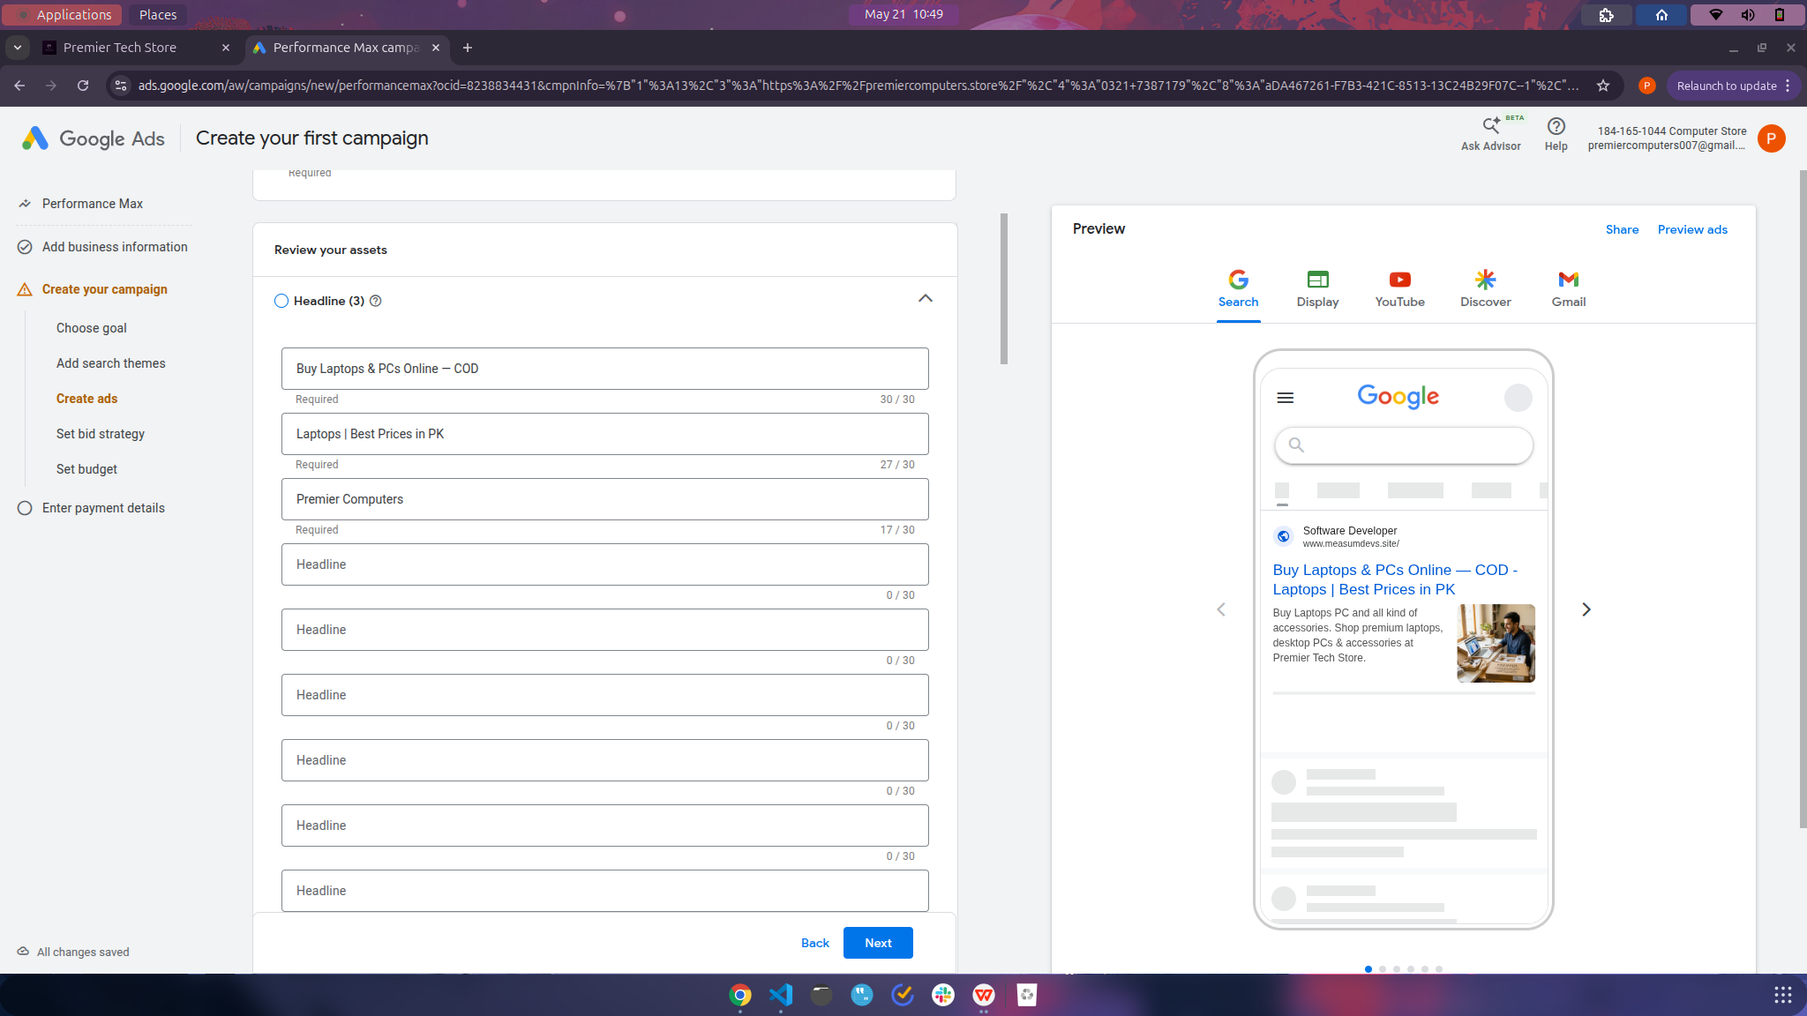
What is Runtime Engagement?
Runtime engagement is the process of automatically or manually performing social interactions (likes, comments, follows, story views) on a live social media platform at a scheduled or triggered time. It simulates or assists human interaction at scale.

Runtime engagement means interacting with real social media posts in real time using automated tools or APIs. Below is a step-by-step guide with a live runtime example using the Instagram profile: instagram.com/premierstore/

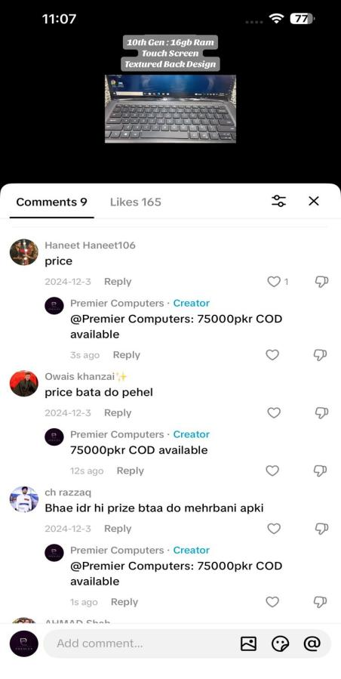
Method: Instagram Graph API + Meta Developer App
Step | Action | Details
1 | Create Meta Developer Account | Go to developers.facebook.com → Create App → Select 'Business' type
2 | Connect Instagram Business Account | Link your Instagram Business/Creator account to the Meta App
3 | Get Access Token | Generate a long-lived User Access Token with instagram_basic and instagram_manage_comments permissions
4 | Get Target Post ID | Call: GET https://graph.instagram.com/me/media?fields=id,caption&access_token={TOKEN}
5 | Post a Comment (Runtime) | Call: POST https://graph.instagram.com/{media-id}/comments?message=Your+Comment&access_token={TOKEN}
6 | Like a Post | Call: POST https://graph.instagram.com/{media-id}/likes?access_token={TOKEN}
7 | Verify Engagement | Call: GET https://graph.instagram.com/{media-id}?fields=like_count,comments_count&access_token={TOKEN}

Python Code — Runtime Comment Example
import requests

MEDIA_ID = '17858893269000001' # Target post ID from @premerstore
ACCESS_TOKEN = 'YOUR_LONG_LIVED_TOKEN'
COMMENT = 'Amazing products! Loving the quality'

url = f'https://graph.instagram.com/{MEDIA_ID}/comments'
params = { 'message': COMMENT, 'access_token': ACCESS_TOKEN }
response = requests.post(url, params=params)
print('Comment Posted:', response.json())

Runtime Output Example
Output Field | Value
API Response | { "id": "17858893269000001" }
Status | 200 OK — Comment successfully posted
Comment Text | Amazing products! Loving the quality
Posted On | @zolary.pk — Latest Post
Time | Runtime — executes immediately upon API call
Visible On | instagram.com/zolary.pk/ — comment section of target post

Other Engagement Actions Possible at Runtime
Action | API Endpoint | Method
Like a Post | graph.instagram.com/{media-id}/likes | POST
Reply to Comment | graph.instagram.com/{comment-id}/replies | POST
Get Comment Count | graph.instagram.com/{media-id}?fields=comments_count | GET
Get Likes Count | graph.instagram.com/{media-id}?fields=like_count | GET
Delete a Comment | graph.instagram.com/{comment-id} | DELETE

All sections above (3-Day Social Calendar, SEM Ad Copy, and Runtime Engagement) have been created specifically for Premier Tech Store at premiercomputers.store. The runtime engagement example demonstrates how to interact with a live Instagram account (@zolary.pk) using the Instagram Graph API — the same method applies to Premier Tech Store's own Instagram account.

Campaign Summary
Section | Deliverable | Platform / Tool
Website Summary | Full website features, pages, shopping flow, admin panel, product catalogue | premiercomputers.store
Social Media Posts | 3 ready-to-publish posts (Awareness, Testimonial, Flash Sale) | Instagram, Facebook, WhatsApp
3-Day Calendar | 9 scheduled posts across 3 days with timings, copy, CTA, and account links | Instagram, Facebook, LinkedIn, WhatsApp
SEM Ad Copy | Google Search Ad with 2 headlines, description, keywords, and landing page | Google Ads
Runtime Engagement | Live API-based comment/like system with Python code and response example | Instagram Graph API (@zolary.pk)

Premier Tech Store | premiercomputers.store | COD Available Nationwide
Lab Final — E-Commerce & Digital Marketing

