PREMIER TECH STORE
Social Media Post Campaign
premiercomputers.store

POST 01 — Awareness Post — Introduce the Product/Service

Your next laptop is one click away — meet Premier Tech Store.
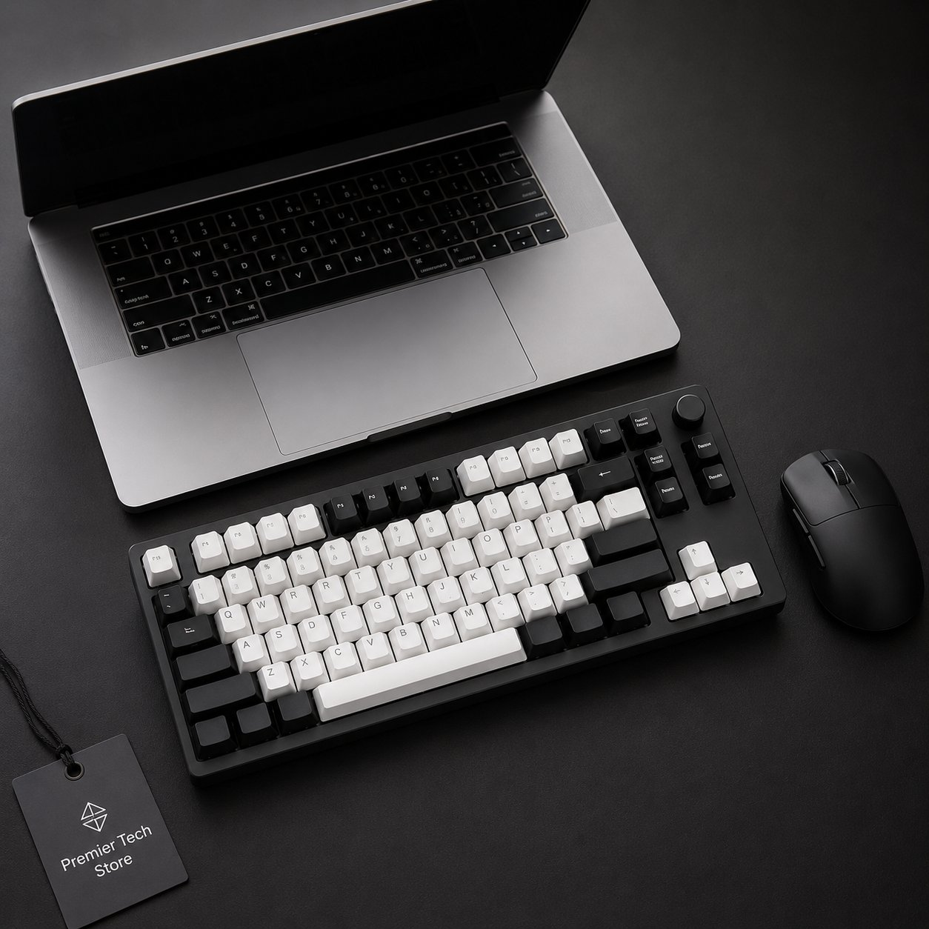

Platform | Instagram | Facebook | LinkedIn
Caption | Pakistan's go-to online computer store. Browse hundreds of laptops, desktops & accessories — competitive prices, delivered to your door. No card needed. Pay cash on delivery.
Hashtags | #PremierTechStore #OnlineShopping #LaptopsPakistan #TechDeals #COD
Shop Now at premiercomputers.store →

IMAGE GENERATION PROMPT
A sleek, modern flat-lay of a high-end laptop, mechanical keyboard, and wireless mouse on a clean matte black desk. Soft studio lighting. Minimal white and black aesthetic. A small tag reads 'Premier Tech Store' in the corner. Sharp product photography style. Ultra-high resolution, no text overlay, square crop.

POST 02 — Customer Review / Testimonial Post

Real customers. Real results. Real reviews.
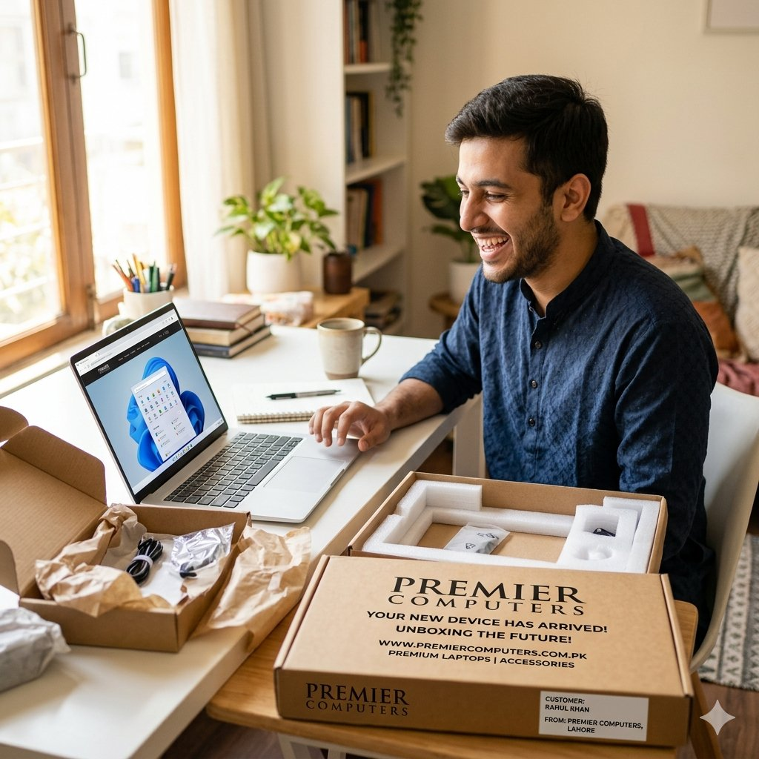

Platform | Instagram | Facebook | Google Business
Reviewer | Ahmed Khan — Lahore | ★★★★★ Verified Buyer
Review | "Ordered my HP laptop and it arrived the very next day. Paid cash on delivery — no stress, no card required. The packaging was perfect and the price was unbeatable. Highly recommend Premier Tech Store!"
Caption | Join thousands of happy customers across Pakistan. Your dream laptop is just an order away — and you pay only when it arrives at your door.
Hashtags | #CustomerLove #5StarReview #PremierTechStore #TrustedStore #HappyCustomer
Read More Reviews — Visit premiercomputers.store →

IMAGE GENERATION PROMPT
A happy young Pakistani man sitting at a clean white desk, smiling at a brand-new open laptop. Unboxing scene with kraft paper packaging visible. Warm natural window light. Casual home setting. Candid, authentic lifestyle photography feel. Shallow depth of field. Square format, no text overlay.

POST 03 — Limited-Time Discount Post — Flash Sale

Flash Sale — Up to 30% OFF. Ends in 48 hours. Don't miss it.
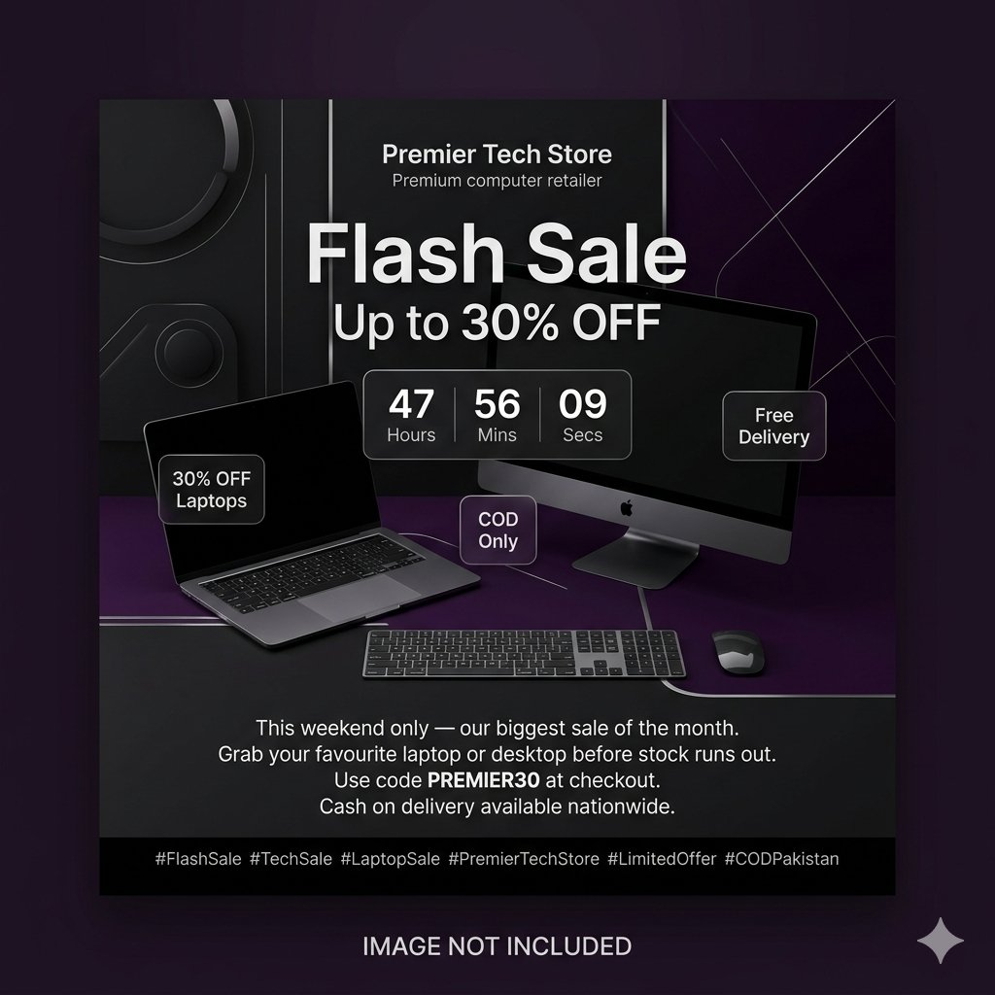

Platform | Instagram | Facebook | WhatsApp Status
Offer | Up to 30% OFF Laptops | Free Delivery | COD Only
Promo Code | PREMIER30 — Use at checkout
Caption | This weekend only — our biggest sale of the month. Grab your favourite laptop or desktop before stock runs out. Cash on delivery available nationwide. Hurry, offer ends in 48 hours!
Hashtags | #FlashSale #TechSale #LaptopSale #PremierTechStore #LimitedOffer #CODPakistan
Grab the Deal — Shop Now at premiercomputers.store →

IMAGE GENERATION PROMPT
A dramatic overhead shot of multiple laptops and tech accessories arranged in a bold geometric pattern on a pure white background. Bold '30% OFF' tag floating above one product. High-contrast black and white product photography. Dynamic, energetic composition. Studio lighting with sharp shadows. Square crop, no extra text.

Premier Tech Store | premiercomputers.store | COD Available Nationwide

