**Prepared for:**

**Centers for Medicare & Medicaid Services and Office of the National Coordinator for Health Information Technology**

**CMS Alliance to Modernize Healthcare  
Federally Funded Research and Development Center**

Technical Authority for the Unified Clinical Quality Improvement Framework

Bonnie User Guide

Version 2.0

November 9, 2017

The views, opinions, and/or findings contained in this report are those of The MITRE Corporation and should not be construed as official government position, policy, or decision unless so designated by other documentation.

© 2017, The MITRE Corporation. All Rights Reserved. Approved for Public Release. Distribution Unlimited 13-4297.

Record of Changes

| Version | Date | Author / Owner | Description of Change |
| --- | --- | --- | --- |
| 0.1 | April 15, 2014 | Andre Quina / MITRE | Initial draft |
| 0.1.1 | July 18, 2014 | Cristen Jones / MITRE | Update for Bonnie v 1.1 |
| 0.2 | April 13, 2015 | Cristen Jones / MITRE | Update for Bonnie v 1.3 |
| 1.4 | January 13, 2016 | Pace Ricciardelli / MITRE | Update for Bonnie v 1.4 |
| 1.5 | November 18, 2016 | David Connolly and Lizzie DeYoung / MITRE | Update for Bonnie v 1.5 |
| 1.6 | January 4, 2017 | Kristian Mulcahy and Chris Tohline / MITRE | Update for Bonnie v 1.6 |
| 1.6.5 | June 8, 2017 | Chris Tohline / MITRE | Update for Bonnie v 1.6.5 |
| 2.0 | November 9, 2017 | Rose Almonte, Lizzie Charbonneau, Chris Tohline, Jenn Reed / MITRE | Update in preparation for Bonnie v 2.0 |
|  |  |  |  |
|  |  |  |  |

Table of Contents

1. Introduction 1

1.1 Background 1

1.2 Purpose 1

1.3 Application Description 1

2. User Account Creation 3

2.1 Login Page 3

2.2 Creating a New User 3

2.3 Resetting a Password 4

2.4 Account Management 5

3. Measure Dashboard 6

3.1 Overview 6

3.2 Loading a New Measure 7

3.3 Updating a Measure 9

3.4 Creating Synthetic Test Records 9

4. Measure Results View 11

4.1 Overview 11

4.2 Measure Logic 13

4.3 Creating a New Test Record 14

4.4 Calculation Results 14

4.5 Editing a Test Record 16

4.6 Cloning a Test Record 16

4.7 Deleting a Test Record 16

4.8 Updating a Measure 16

4.9 Deleting a Measure 17

5. Building a Patient Test Record 18

5.1 Overview 18

5.2 Building a Synthetic Patient 19

5.3 Building the Patient History 20

5.3.1 Patient History Items that are Related to Past Items 22

5.4 Incremental Calculation 22

6. Feedback and Support 23

7. Frequently Asked Questions 24

Acronyms 26

List of Figures

Figure 1. Bonnie Login Page 3

Figure 2. Account Registration Page 4

Figure 3. Password Reset Page 4

Figure 4. Account Management Page 5

Figure 5. Measure Dashboard View 6

Figure 6. New Measure Dialog 8

Figure 7. Finalize Measure Dialog 8

Figure 8. Updating Measure Dialog 9

Figure 9. Measure View 12

Figure 10. Measure Terminology and Overlapping Value Sets 13

Figure 11. Expanded Results View 15

Figure 12. Logic Calculation Highlight – Passing Results 15

Figure 13. Logic Calculation Highlight – Failing Results 16

Figure 14. Patient Builder View 18

Figure 15. Continuous Variable Measures Expected Populations 20

Figure 16. Building Patient History, including Edit Clinical Element View 21

Figure 17. References Section of the Patient History Builder 22

Figure 18. User Group Link on Bonnie Splash Page 23

Figure 19. User Group Link in the Application Header 23

# Introduction

## Background

Bonnie is a software tool that allows electronic Clinical Quality Measure (eCQM) developers to test and verify the behavior of their CQM logic. The main goal of the Bonnie application is to reduce the number of defects in eCQMs by providing a robust and automated testing framework. The Bonnie application allows measure developers to independently load measures that they have constructed using the Measure Authoring Tool (MAT). Developers can then use the measure metadata to build a synthetic patient test deck for the measure from the clinical elements defined during the measure construction process. By using measure metadata as a basis for building synthetic patients, developers can quickly and efficiently create a test deck for a measure. The Bonnie application helps measure developers execute the measure logic against the constructed patient test deck and evaluate whether the logic aligns with the intent of the measure.

Bonnie has been designed to integrate with the nationally recognized data standards the Centers for Medicare & Medicaid Services (CMS) Quality Reporting programs use for expressing CQM logic for machine-to-machine interoperability. This integration provides enormous value to the eCQM program and federal policy leaders and stakeholders. The Bonnie tool verifies that the new and evolving standards for eCQMs used in the CMS Quality Reporting programs are flexible and can be implemented in software.

Bonnie was also designed to provide an intuitive and easy-to-use interface based on feedback from the broader measure developer community. A key goal of the Bonnie application is to deliver a user experience that provides an efficient and intuitive method for constructing synthetic patient records for testing and validating eCQMs.

Finally, the Bonnie software is freely available via an Apache 2.0 open source license. The CMS EHR Incentive Program makes all or parts of the Bonnie software available for inspection, verification, and even reuse by other government programs or federal contractors.

## Purpose

The purpose of this document is to describe the functionality of the Bonnie web application that allows measure developers to test and verify the behavior of their CQM logic. This document provides Bonnie users with step-by-step instructions for testing eCQMs by building synthetic patient records.

## Application Description

The Bonnie application provides the capability to import measures defined in Health Quality Measure Format (HQMF) XML and Clinical Quality Language (CQL). The HQMF specification provides the metadata and the CQL libraries provide the logic for calculating a CQM. The Bonnie application can load an eCQM containing the HQMF and CQL describing a measure and programmatically convert both into an executable format that allows calculation of the measure directly from the specification.

The Centers for Medicare & Medicaid Services (CMS) Measure Authoring Tool is the primary source for eCQMs used by the Bonnie application. Measure developers use the MAT to build eCQMs and export those measures as measure bundles containing HQMF and one or more CQL libraries. These measure bundles can be downloaded from the MAT and loaded into the Bonnie user interface for measure testing.

Once an eCQM has been loaded into the Bonnie application, a user can inspect the measure logic and then build synthetic test records and set expectations on how those test records will calculate against a measure. This capability to build synthetic test patient records, set expectations against those records, and calculate the measures using those patient records provides an automated and efficient testing framework for eCQMs. Through the Bonnie-supported eCQM testing framework, measure developers can more clearly understand the behavior of the measure logic and validate that the measure logic encodes their intent, as well as validate multiple iterations of measure updates against a test deck.

In addition, the development of a test deck as part of measure development provides benefits after the measures are finalized. For example, the test deck can demonstrate the intent of the measure through the patient examples in the deck. The systems in the test deck implement those measures with a means to validate their development through a base set of synthetic patient records with known expectations for calculating against the implemented measures. Finally, the test deck can provide input for the Office of the National Coordinator (ONC) Health IT Certification Program. If the synthetic patients are clinically valid, Cypress[1] users can use them in addition to or instead of their own patients.

# User Account Creation

## Login Page

Users require a valid account to access the Bonnie application. All measures loaded into the Bonnie application and all synthetic test patients are isolated by account. Therefore, users can only view, access, and modify data that they have loaded under their own account. Figure 1 shows the login screen for the Bonnie application. To log in, a user must provide the email address and password for a valid account.

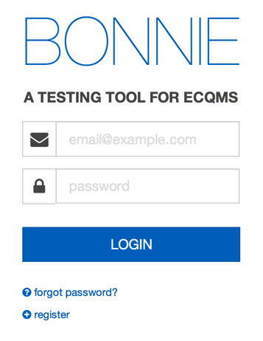

Figure 1. Bonnie Login Page

## Creating a New User

A user can create a new account by clicking the “register” link on the login page. The register link brings the user to account creation page shown in Figure 2. A user can create a new account by filling out the fields in the registration form and clicking the “REGISTER” button. Once an account has been created, the user can log in to the Bonnie application with the email address and password specified as part of account creation.

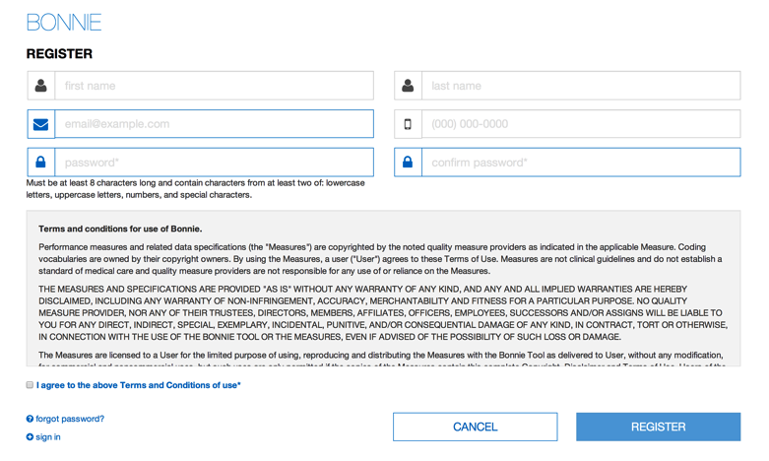

Figure 2. Account Registration Page

## Resetting a Password

If a user forgets a password or an account is locked, the user can reset the password using the password reset page shown in Figure 3. This page is accessed from the “forgot password?” link on the login page (Figure 1). On the password reset page, the user provides the email address associated with the account and then presses the “Send” button. This action sends an email to the registered email address for the account to facilitate resetting the user’s account password.

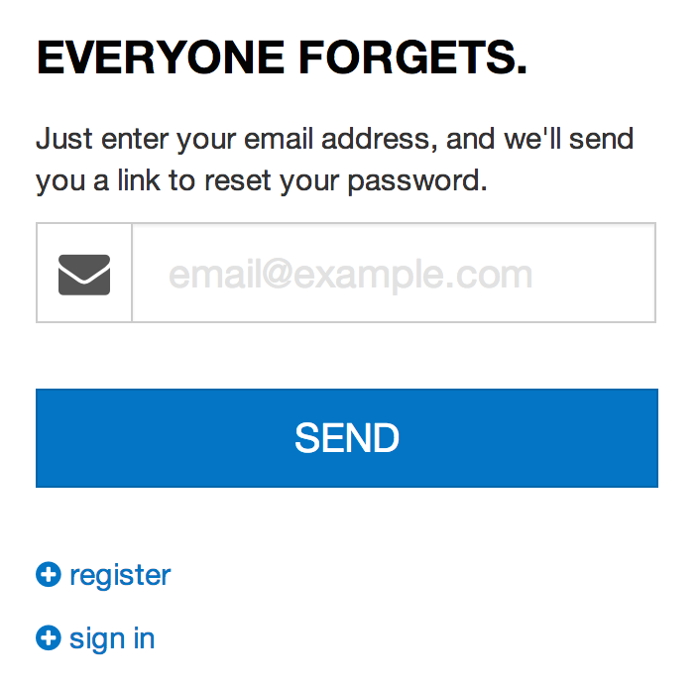

Figure 3. Password Reset Page

## Account Management

After logging into the application, the user can change the information associated with the account by accessing the account management page shown in Figure 4. The account management page can be opened by clicking the “Account” link in the application header shown at the top of Figure 4. From this page, users can change the information provided during the registration process and select a new password for their account.

The header of the Account Management page has three links for Dashboard, Help, and Logout. The page presents fields for Account Information, including entering first and last name, email address, phone number, and password.  At the bottom right are two buttons, "cancel" and "save", as well as a link that to "Delete your account."


Figure 4. Account Management Page

# Measure Dashboard

## Overview

The Measure Dashboard page, as shown in Figure 5, is the initial page presented to users when they log into the application. The Measure Dashboard shows the calculation status of each measure loaded into the system. The calculation status shows how many patient records have been built for the measure, whether the measure is currently passing or failing, and how many patients are passing or failing for each measure.

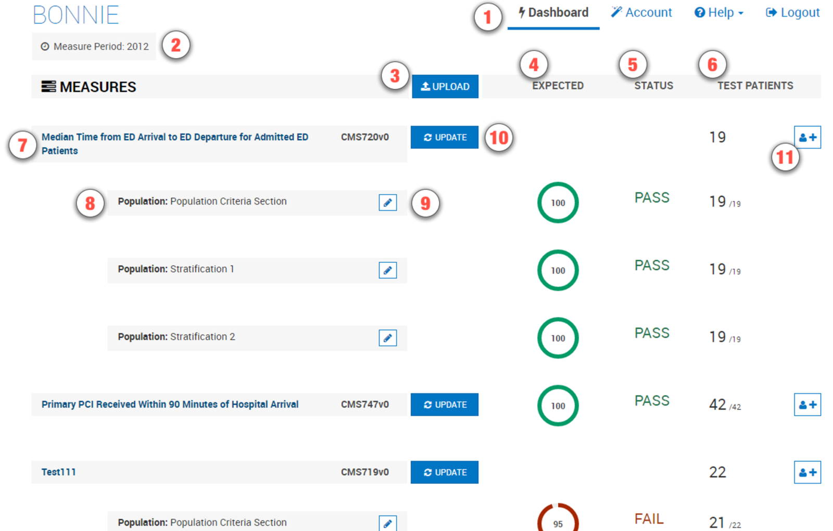Figure 5. Measure Dashboard View

The Measure Dashboard View employs the following user interface (UI) elements (indicated by their item numbers in Figure 5):

1. Header – Allows the user to navigate to different parts of the application, access account information, send a support email (Contact), and log out of the application.
2. Measure Period Date – Displays the measurement period used for calculating measures.
3. Upload Button – Allows the user to upload a new measure.
4. Expected Column – Displays the percentage of passing patients for the measure.
5. Status Column – Displays the status of the measure (New, Pass, Fail).
6. Test Patient Column – Displays the number of patients passing out of the total number of patients.
7. Measure Title – Displays the title for the measure and allows navigation to the measure view.
8. Subpopulation and stratification titles – Displays the titles for subpopulations or stratifications of a measure.
9. Edit Title Button – Allows the user to rename a subpopulation or stratification.
10. Update Button – Allows the user to update a previously loaded measure.
11. Add Patient Button – Allows the user to start building a new patient for a measure.

## Loading a New Measure

When users log into the system for the first time, no measures will be associated with the account. The user’s first step is to load a measure into the account to begin testing the measure with the Bonnie application. The New Measure dialog, as shown in Figure 6, prompts the user to upload a measure.

The user may either upload a measure now or close this display and upload a measure later. After one or more measures have been uploaded, this page displays the current set of measures loaded into the system along with the subpopulations and stratifications associated with the measures. The Measure Dashboard allows users to navigate to the details of individual measures, upload a new measure, or update the definition of an existing measure.

The steps for loading a new measure into Bonnie are as follows:

1. Click the “Upload” button (item #4 in Figure 5) on the Measure Dashboard, which opens the New Measure Dialog shown in Figure 6.
2. On the New Measure Dialog:
   1. Choose a MAT export zip file.
   2. Bonnie requires your Value Set Authority Center (VSAC) credentials when you upload a new measure.

(1) If you do not already have VSAC credentials, click the link that says, “Register for VSAC”, which will take you to the Unified Medical Language System (UMLS) Terminology Services page to register for a UMLS License. The credentials entered here will serve as your VSAC credentials.

* 1. Specify if the value sets are Draft or Measure Defined. Draft will always get you the latest version of the value sets regardless of what is in the measure.
  2. Specify if the measure is eligible professional (EP) or eligible hospital (EH).
  3. Specify if the measure is Patient-based or Episode of Care.
  4. Click the “Load” button.

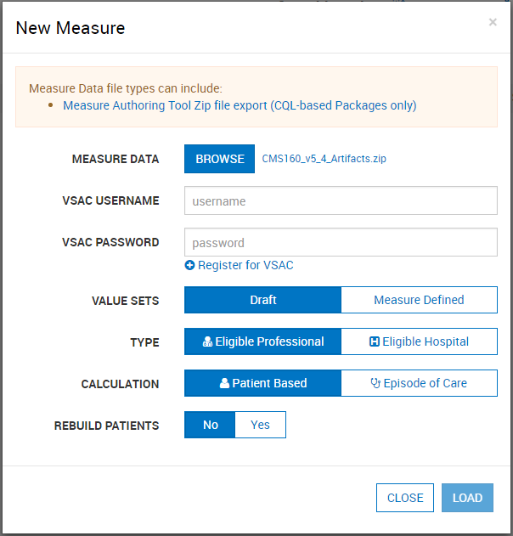

Figure 6. New Measure Dialog

The action of clicking the “Load” button in the New Measure Dialog uploads the measure to the application for processing. If the measure loaded is Episode of Care or has multiple populations, the user is presented with the Finalize Measure Dialog shown in Figure 7. This dialog allows the user to specify the episode(s) of care for the measure and provide titles for subpopulations. After filling out the Finalize Measure fields, the user clicks the “Done” button to finish loading the measure. Once measure loading is complete, the application directs the user to the Measure Dashboard (Figure 5) with the new measure available. If the measure is not Episode of Care or does not have subpopulations, the Finalize Measure Dialog is not presented because no additional information is required to load the measure.

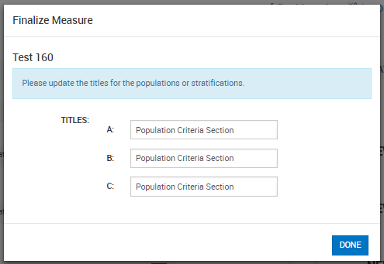

Figure 7. Finalize Measure Dialog

## Updating a Measure

Once the measure has been loaded, the testing process may identify issues with the measure. When issues are identified, the logic must be updated in the MAT to resolve these issues. Alternatively, the measure could be updated in the MAT as part of an annual update. After a measure has been updated in the MAT, it may be necessary to update that measure in Bonnie for testing. To update a measure, follow these steps:

1. Click the “Update” button (item #11 in Figure 5) on the Measure Dashboard, which displays the “Update Measure” dialog as shown in Figure 8.
2. Select a new MAT export zip with the updated measure definition.
3. Click the “Load” button to load the new version of the measure.

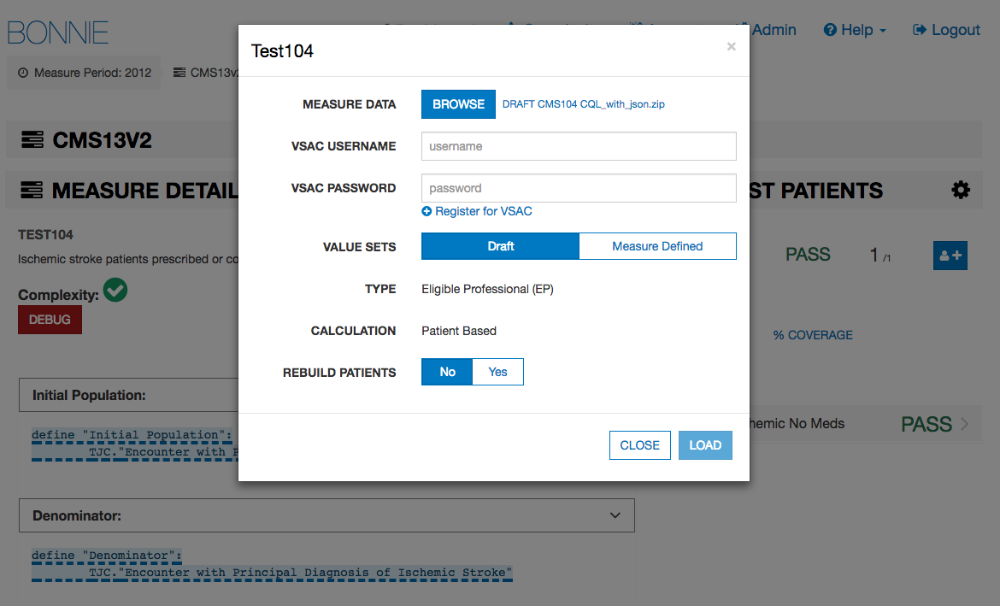

Figure 8. Updating Measure Dialog

## Creating Synthetic Test Records

Once a set of measures has been loaded into the Bonnie application, users can start building test patients for the measures. To build a test patient from the Measure Dashboard (Figure 5), click the “Add Patient” button (item #12). This action opens the patient builder screen as shown in Figure 14. For more information, please refer to Section 5, *Building a Patient Test Record.*

After the user creates synthetic test patients for measures, the Measure Dashboard displays summary calculation results of the patients associated with each measure loaded by the user (Figure 5). As shown in Figure 5, UI elements #s 5, 6, and 7 on the Measure Dashboard provide the summary results for each measure. In the “Expected” column (item #5), the UI displays the percentage of patients associated with the measure whose calculated values meet the expectations set for the patient. The “Status” column (item #6) indicates the current state of the measure—whether it is passing, failing, or new. A measure is in the passing state if all associated patients are meeting expectations. If one or more patients are not meeting expectations, then the measure is in a failing state. Any measure is in the new state when there are no patients associated with it. Finally, the “Test Patients” column (#7) displays the number of passing patients over the total number of patients as a fraction. The measure view, as represented in Figure 9 in Section 4, shows more detailed results for a measure.

# Measure Results View

## Overview

As shown in Figure 9, the Measure View page displays the detailed information, associated patients, and calculation results for a single measure. In this view, users can add new patients to a measure, update a measure, and delete a measure. To access the Measure View, click on the “Measure Title” link (item #8) on the Measure Dashboard, as shown in Figure 5.

The Measure View page presents the title and description of the measure, the logic for the measure, and a measure complexity indicator. The page lists the current set of test patients associated with the measure in the column on the right-hand side of the page. This column displays the summary calculation results for the patient test deck associated with the measure along with the list of patients and the individual calculation results for each. This page also shows the results of calculation for a single patient along with an overlay of the calculation results on the measure logic.

The following UI elements appear at the top of the Measure View page (indicated by their item numbers in Figure 9):

1. Measure Title – Displays the title and description of the measure.
2. Measure Actions – Allows the user to delete or update a measure definition.
3. Measure Complexity – Indicates the measure’s degree of complexity.
4. Measure Subpopulations or Stratifications – Allows access to different subpopulations or stratifications in the measure.
5. Measure Logic – Displays a representation of the logic for the measure.
6. Logic Highlighted With Coverage – Displays the logic for the measure, highlighting which lines of the measure are covered by the test patients.
7. Patient Actions – Allows the user to export patient records as QRDA or Excel.
8. Percent Successful – Displays the percent of patients currently meeting expectations for the measure.
9. Patients Passing Count – Displays the current number of patients meeting expectations over the total number of patients in the test deck for the measure.
10. Test Coverage – Displays the percentage of the measure logic that has evaluated to true for the patient test deck. This measure provides a method for determining how much of the logic has been tested.
11. Add Patient – Allows the addition of a new patient to the test deck for this measure.
12. Failing Patient – Displays an example of a patient that is not currently meeting expectations for the measure.
13. Passing Patient – Displays an example of a patient that is meeting expectations.
14. Patient Name – Displays the name given to the patient.
15. Patient Status – Displays PASS or FAIL to indicate if the patient is meeting expectations.

Expand Patient Results Button – Displays the calculation details of a patient. This display will show the expected and actual values for the patient against the measure.

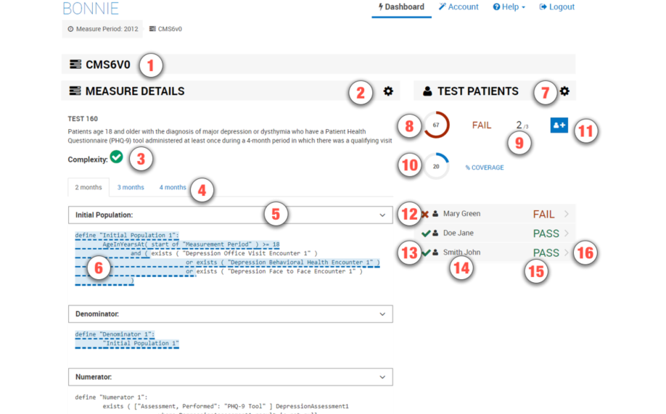

Figure 9. Measure View

The following UI elements (indicated by their item numbers in Figure 10) appear at the bottom of the Measure View Page:

1. Terminology – Displays the value sets from the measure and referenced libraries. Clicking on any one of these value sets will show the list of codes associated with that value set.

Overlapping Value Sets – Displays value sets in the measure and referenced libraries that have shared codes.

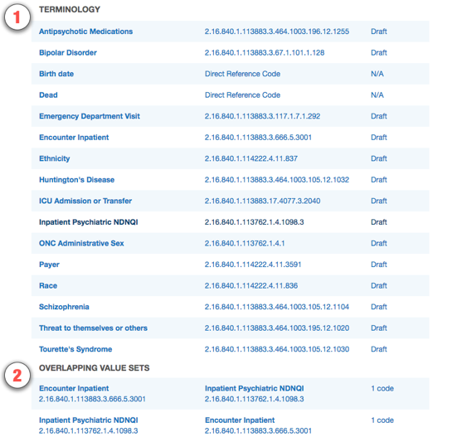

Figure 10. Measure Terminology and Overlapping Value Sets

## Measure Logic

The left-hand side of the Measure View contains the measure title, description, and a representation of the logic. The representation of the measure logic is similar to the human-readable display for the measure provided in the MAT measure exports.

The measure logic section can be used to verify that the measure logic was properly loaded from the HQMF without the loss of any logical conditions. The logic can also be used to evaluate the nature of the calculation of a test patient against the logic (please refer to subsection 4.4, *Calculation Results*) and to visualize the test coverage of the measure logic.

## Creating a New Test Record

To create a new test record, begin by clicking the “Add Patient” button (item #9) in the Measure View (Figure 9). This action opens the Patient Builder (shown in Figure 14). After creating the test patient record, the application returns the user to the Measure View where the user can evaluate the results of calculating the patient against the measure.

## Calculation Results

The user can calculate the test patient against the logic of the measure in the Measure View (Figure 9). High-level results are calculated automatically when the Measure View is loaded. These high-level results appear under the test patients section on the right-hand side of the Measure View. These results include the percent of patients passing (item #6), the test coverage (item #8), individual statuses for each patient (items #10–13), and the passing patient count (item #7).

In addition to these high-level results, detailed results can be displayed for an individual patient by clicking the “Expand Patient Results” button (#16). This displays a table of expected and actual results for the patient covering each population listed in the measure and shows whether that population currently meets or fails expectations.

The Expanded Results View employs the following UI elements (as indicated by their item numbers in Figure 11):

1. Failing Population – A population for which the patient fails.
2. Passing Population – A population for which the patient passes.
3. Population Column – A list of the population types.
4. Expected Value – The user-defined expected value for the population.
5. Actual Value – The calculated value for that population.
6. Edit Patient Button – Allows editing of the selected patient.
7. Clone Patient Button – Allows cloning of the selected patient.

Delete Patient Button – Allows deleting of the selected patient.

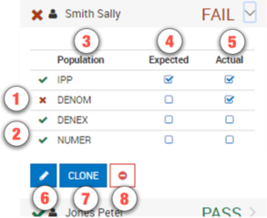

Figure 11. Expanded Results View

Clicking the “Expand Patient Results” button also displays the patient results calculated against each line of logic. This information is displayed in the measure logic section of the view by highlighting each logic clause. As shown in Figure 12 and Figure 13, a green highlight (accompanied by a solid underline) indicates a passing result for the logic calculation, while a red highlight (accompanied by a double-underline) indicates a failing result over the applicable lines of text.

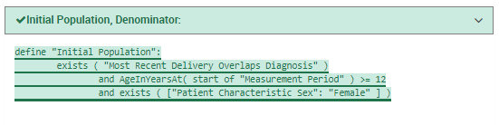

Figure 12. Logic Calculation Highlight – Passing Results

Figure 12 shows the results of a single patient calculated against the measure logic. The highlighting of the measure logic text for calculation is intended to provide a clearer understanding of why a patient is calculating to a specific population, and uses the following indications of status:

* Logic evaluated to TRUE – Green highlighting along with a solid underline
* Logic evaluated to FALSE – Red highlighting along with a double underline

The results of the calculation in Figure 12 are that the patient aligns with the logic of the initial patient population (IPP). The highlighting of the logic in Figure 12 indicates that every AND condition evaluated to true and at least one condition from each OR evaluated to true. Based on this calculation, the IPP and the Denominator evaluate to true for the patient.

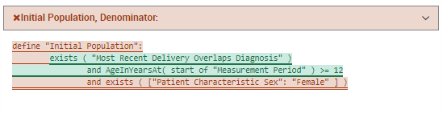

Figure 13. Logic Calculation Highlight – Failing Results

In Figure 13, the population is highlighted in red, indicating that the logical statements evaluate to false. Some clauses in this figure are green, indicating they are true; however, the false female statement causes the AND logic to be false, and therefore, the results calculated in Figure 13 indicate that the patient is neither included in the IPP nor the Denominator.

## Editing a Test Record

The user can edit a test patient from the Measure View (Figure 9) by clicking the “Edit” button. The user accesses the “Edit” button for a patient (item #6 in Figure 11), accessible after expanding the patient result. Clicking the “Edit” button opens the Patient Builder (as shown in Figure 14) with the data populated for that patient. Once a patient record has been edited and saved, the application returns the user to the Measure View.

## Cloning a Test Record

The user can clone a test patient from the Measure View (Figure 9) by clicking the “Clone” button (item #7 in Figure 11) to the immediate right of the “Edit” button, accessible after expanding the patient result. This action opens the Patient Builder (Figure 14) with the data populated for the patient being cloned. The difference between editing and cloning a patient is that the clone process creates a new patient based on an existing patient, while the edit process updates the data for an existing patient. Once a patient record has been cloned, edited, and saved, the application returns the user to the Measure View.

## Deleting a Test Record

The user can delete a test patient from the Measure View (Figure 9) by clicking the “Delete” icon (item #8 in Figure 11) to the immediate right of the “Clone” button, accessible after expanding the patient result. Deleting a patient requires a two-step process for confirmation. Once a user deletes a patient record, the action cannot be undone. To delete a patient record, the user initially clicks the “Delete” button. A second “Delete” button is then displayed. The user must click the second “Delete” button to confirm the deletion of the patient.

## Updating a Measure

The user can update a measure by clicking the “Update Measure” button, which is accessed by clicking the “Measure Actions” icon (item #2 in Figure 9). The “Update Measures” button displays the Update Measure Dialog (shown in Figure 8), which allows the user to specify a new zip package for a measure exported from the MAT. Once the new measure package has been entered, the user clicks the “Load” button, which updates the measure definition and returns the user to the Measure View with the updated measure definition.

## Deleting a Measure

The user can delete a measure from the Measure View (Figure 9) by clicking the “Delete” icon for a measure. To access the “Delete” icon, the user clicks the “Measure Actions” icon (item #2 in Figure 9). A user cannot undo the deletion of a measure. To delete a measure, the user initially clicks the “Delete” icon. A second “Delete” icon is then displayed. The user must click the second “Delete” icon to confirm the deletion of the measure. Deleted measures are no longer displayed on the Measure Dashboard.

# Building a Patient Test Record

## Overview

The Patient Builder view, as shown in Figure 14, allows the addition and editing of clinical data for a synthetic test patient record. The user accesses the Patient Builder view by clicking the “Add Patient” button (item #12) on the Measure Dashboard (Figure 5), or by clicking the “Add Patient,” ‘Edit,” or “Clone” buttons from the Measure View (Figure 9).

The Patient Builder View employs the following UI elements (as indicated by their item numbers in Figure 14):

1. Patient Name – Allows the entry of a first and last name for the patient record.
2. Patient Characteristics – Allows the definition of characteristics data for the patient.
3. Measure Information – Shows the description for the patient’s associated measure.
4. Expectations – Allows users to set the calculation expectation for each population of the measure.

Actions – Allows users to save or cancel a patient record.

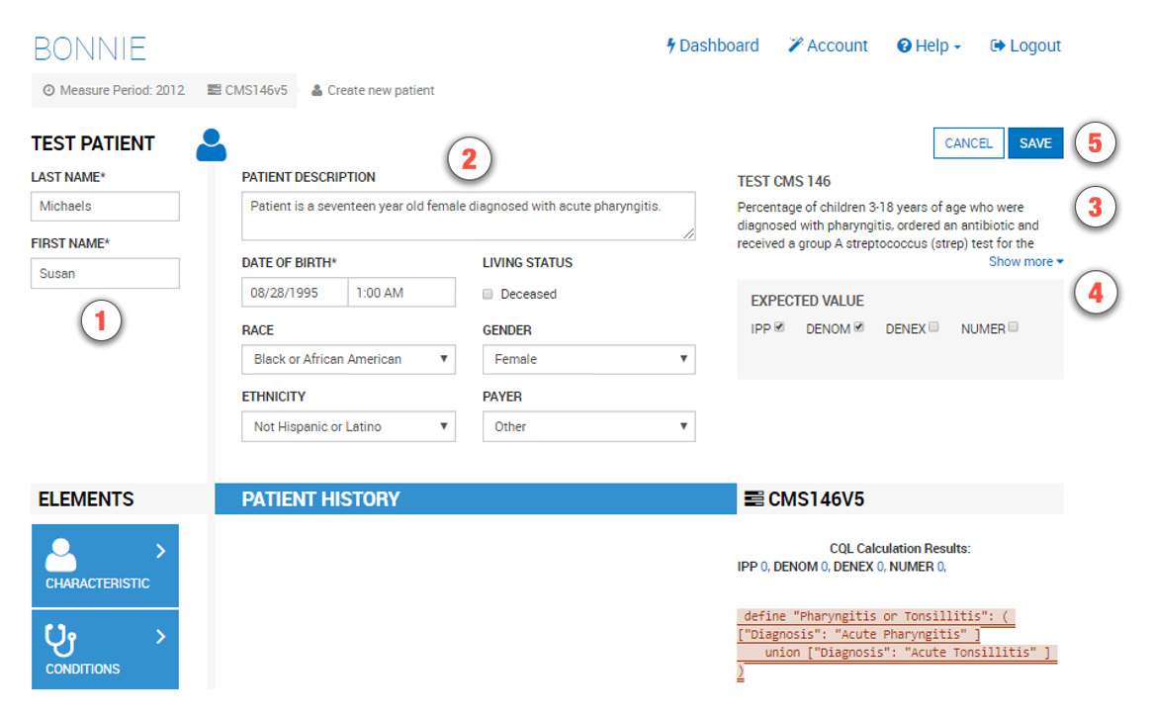

Figure 14. Patient Builder View

The Patient Builder view also provides fields to either add new data or edit existing data for a patient. The patient’s first and last names can be defined using the associated edit fields. Characteristics such as gender, birthdate, race, and ethnicity can be set in the characteristics section. Quality Data Model (QDM) elements can be added to the patient history section by dragging and dropping an individual element onto the patient history section.

In addition to defining the patient data, the Patient Builder view allows the user to set expectations on the patient using the “Expectations” section. Expectations represent how the user expects the patient to calculate against the measure. The “Expectations” section will be different based on the type of measure used to build the patient record. The “Expectations” section for patient-based measures provides a check box for users to select the appropriate expected populations (e.g., numerator, denominator) within which the patient will be included. The “Expectations” section for episode of care-based measures allows users to select the number of episodes of care that are expected to be included in each population using a number picker. Continuous variable measures allow users to define the expected value(s) the measure is expected to calculate for the patient.

The Patient Builder’s logic section displays the logic of the measure against which the patient test record is constructed. As data is entered, the application continuously calculates the patient against the measure logic, and the results are displayed against the measure using the logic highlighting. Subsection 4.4 provides additional information about the descriptions of the logic highlighting technique based on calculation results shown in Figure 12 and Figure 13.

## Building a Synthetic Patient

The first step in building a synthetic patient record is defining the patient name. The patient’s first and last name can be set in the “Patient Name” section (item #1 in Figure 14). The user can then add patient notes and define patient characteristics in the “Patient Characteristics” section (item #2). Characteristics for the patient include data such as birthdate, race, ethnicity, gender, payer, and living status.

After defining the patient’s name, the user defines the expectations for how the patient will behave and be calculated against the measure. The user sets the expectations for the patient in the “Expectations” section (item #4). If the user expects the patient to align with the initial patient population logic, then the user should set that expectation in item #4. Expectations are used throughout the Bonnie application to determine if a patient is passing or failing against the measure.

If the expected results for the patient align with the actual results from calculating the patient against the measure logic, the patient passes. If the expected results do not match the actual calculated results, the patient fails. This system provides the capability to build patients and set expectations for those patients based on the intent of the measure. Once the measure is calculated, the passing state indicates that the measure logic aligns with the intent, while the failing state indicates that either the measure logic does not align with the intent or the synthetic patient was constructed improperly.

Note that in Figure 15, the depicted measure has a discrete expected value. Accordingly, the NUMER, DENOM, and DENEX options are shown. For continuous variable measures that rely on an aggregate calculation (e.g., a median time between ED arrival and ED departure), the OBSERV, MSRPOPL, and (optionally) MSRPOPLEX options are shown, as in Figure 15.

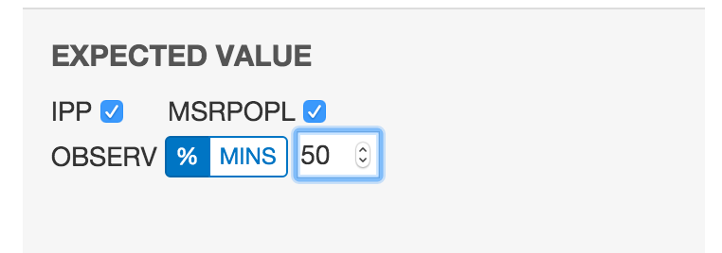

Figure 15. Continuous Variable Measures Expected Populations

Although discrete measures offer only a checkbox for including patients in the NUMER population, continuous variable measures offer the ability to set a certain percentage or minute value for a given patient calculation. This value is only available if the patient is in the MSRPOPL population.

## Building the Patient History

Figure 16 depicts four events in the patient’s history—an encounter, a diagnosis, and two medications—based on data elements from the measure. When a QDM element is added to the patient history, it becomes an event in the patient’s history, which warrants a duration and associated fields. When an event is first created, it is given default start and end date/times and is associated with a code from each value set associated with the source QDM element. These defaults as well as additional data can be edited by expanding the event. Figure 16 shows an example of an expanded event from the patient history that can be edited. By clicking the expand/collapse details icon (item #3), the user can edit the details of the element.

The following UI elements are shown in Figure 16:

1. Elements Section – Contains QDM elements that the user can add to the patient history.
2. QDM Element – Shows a condensed summary of a QDM element.
3. Expand/Collapse Details – Allows hiding or expanding the details of an element.
4. Start Date/Time – Allows setting the start date/time for an element.
5. End Date/Time – Allows setting the end date/time for an element. The checkbox allows specifying that the end date/time is undefined (ongoing event).
6. Codes Section – Allows adding codes to the element. Note that Bonnie will automatically find an appropriate code and add it.
7. Medication or Value Section – Allows adding values to the element (i.e., laboratory result values). This element shows details for adding a medication, allowing the user to specify amount prescribed, regimen, amount filled, and the times the prescription was filled.
8. Fields Section – Allows adding fields to the element (i.e., ordinality).
9. Negation Section – Allows indicating that the element is not done with a reason.
10. Delete Button – Allows deleting an element from the patient history.

CQL Calculation Results – Shows the results for each of the populations.

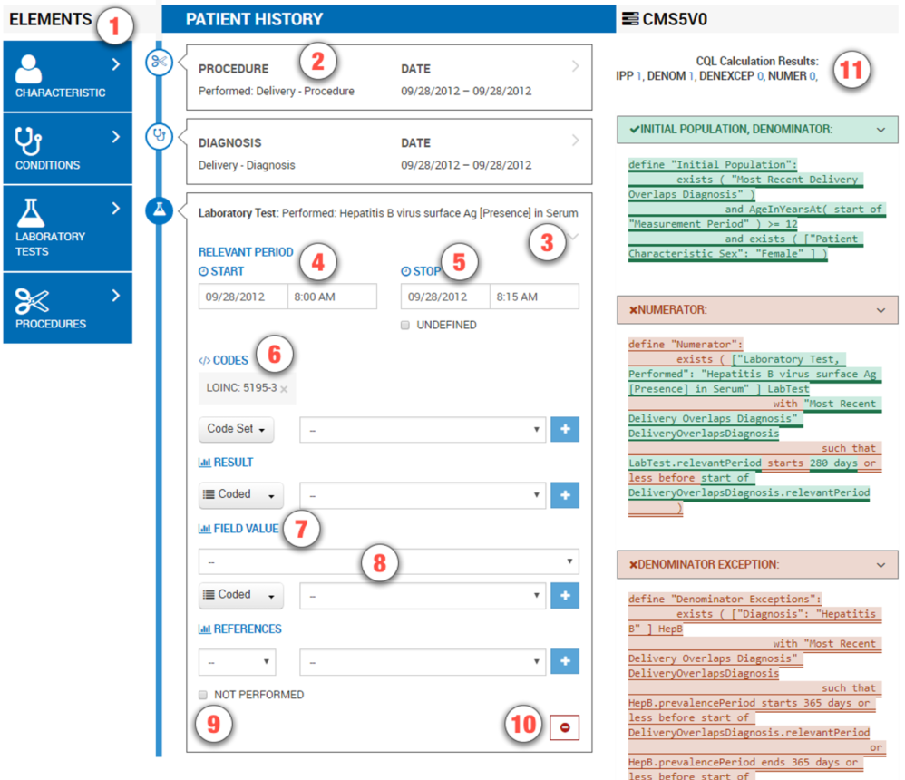

Figure 16. Building Patient History, including Edit Clinical Element View

After the user defines the patient characteristics, the user builds a patient history from QDM elements extracted from the measure. The available elements from the measure are organized by category and listed in the “Elements” section (item #1). The user can click a category to expand the list of available elements. Expanding this list allows the user to click and drag an individual element onto the patient history (item #2).

Several fields in the Edit Clinical Element View can be edited for an event in the patient history using the controls shown in Figure 16. These fields include the start date/time of the event (items #4 and #5), codes (item #6), values (item #7), various fields (item #8), and negation rationale (item #9). The start and end date times can be set for an event by either typing into the text fields directly or by using the date/time pickers that are displayed when the field is selected. An undefined end time can be set for the event (used for active or ongoing events) by selecting the “Undefined” checkbox. Selecting the “Undefined” check box clears the end date/times, indicating that the event has not ended.

Values, fields, and negation rationale also can be set for an event. Values can be set by electing the type of the value (scalar or coded) and entering a scalar value or selecting a coded value from a drop-down listing of all the value sets associated with the measure. Fields such as ordinal, severity, discharge date/time, etc. can be added using the “Fields” section. Fields are added by selecting the type of the field (scalar, coded, or time) and entering a scalar value, selecting a value set, or entering a date.

Negation rationale can be defined for the event to indicate that the event was not done for a specific reason. Negation rationale is added by clicking the “Not Performed” checkbox in the negation section and selecting a value set representing the reason the event was not done.

Finally, events can be removed from the patient history by clicking the “Delete” icon (item #10). Deletion requires a two-step process. After initially pressing the “Delete” icon, the user is prompted to depress the “Delete” icon a second time to confirm the deletion.

### Patient History Items that are Related to Past Items

In creating the patient timeline, some items may change related to other items that occurred in the past. For example, a note or report may relate to a specific order or referral. Users can relate these two items using the “References” section, as depicted in Figure 17.

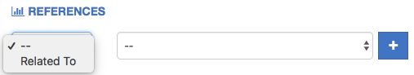

Figure 17. References Section of the Patient History Builder

## Incremental Calculation

The final section of the Patient Builder View is the logic section. This section displays a representation of the logic for the measure against which the patient is constructed. The logic can be a reference to help describe the details of the data that should be added in building the synthetic patient.

The logic section continuously displays the results of calculating the patient against the measure by means of the logic highlighting described in Figure 12 and Figure 13. Any modification made to a patient triggers a recalculation of the patient against the measure, which updates the results of the calculation displayed by the logic highlighting. Therefore, while the user constructs the patient record, the user can inspect the behavior of the logic relative to the patient.

When the user has completed constructing a synthetic patient, the user clicks the “Save” button in the Patient Builder View. This action adds the patient to the test deck for the measure and returns the user to the Measure View. After the user creates the first patient, additional patients can be created from scratch or cloned from existing patients to extend the coverage of the test deck against the measure.

# Feedback and Support

An issue tracker and feedback email list are available to support the resolution of issues and to answer questions related to the Bonnie application. The Bonnie issue tracker is available on the ONC Jira system at: <http://jira.oncprojectracking.org/browse/BONNIE>

When users encounter bugs in the Bonnie application, they should use the issue tracker to report bugs, ask questions, or to request new features. To add an issue, users must create a login account in the Jira system. Once an issue has been entered, the Bonnie team will review and prioritize it. Alternatively, questions can also be addressed to the Bonnie feedback list at [bonnie-feedback-list@lists.mitre.org](mailto:bonnie-feedback-list@lists.mitre.org). The Bonnie feedback list email can be accessed using the “Contact” link in the main Bonnie navigation menu at the top of every page.

In addition to feedback provided through the issue tracker, users may join the Bonnie user group for community support. This group offers the opportunity for Bonnie users to ask and respond to questions about Bonnie and receive feedback from other community members. Bonnie developers will monitor and periodically provide input as well. To join the Bonnie user group, users may click on the “User Group” link on the splash page shown in Figure 18 or the User Group option in the Help menu in the application header shown in Figure 19.

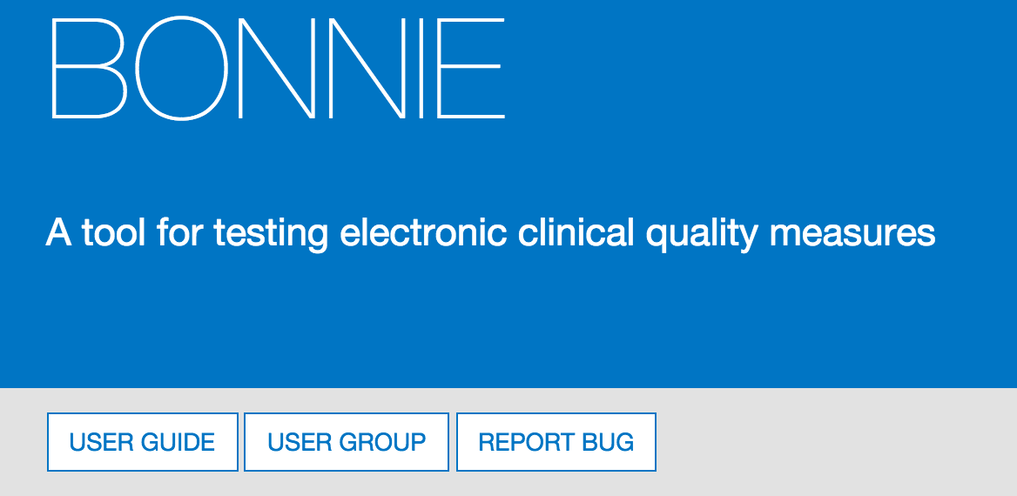

Figure 18. User Group Link on Bonnie Splash Page

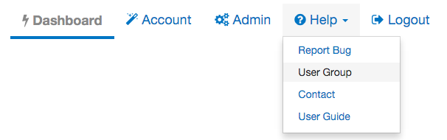

Figure 19. User Group Link in the Application Header

# Frequently Asked Questions

Does Bonnie replace Cypress or is it an alternative to Cypress for certification?

No. Bonnie is a testing tool for measure developers to test measures as they are being authored, while Cypress is the Meaningful Use certification tool. Bonnie cannot be used for Meaningful Use certification for vendors.

Bonnie provides insight into the details of how measure logic behaves. This makes it useful to vendors, measure developers, and others in the clinical quality measure space who would like to better understand the behavior of clinical quality measures. The Bonnie testing tool uses the same measure calculation engine as the Cypress tool. Therefore, Bonnie can be used to better understand the behavior of the measures when implementing a measure prior to certification.

Can I export patient records from Bonnie?

Users can export test patients constructed using Bonnie in a human-readable (HTML) format and in the QRDA Category 1 format.

Can I load patient records into Bonnie?

Currently, Bonnie does not support loading patient records into the tool. If you would like to calculate clinical quality measures using existing patients, the popHealth tool may be a better solution.

Does Bonnie automatically generate patient records?

Currently, Bonnie does not offer the capability to automatically generate patient records based on the measure logic. The goal of Bonnie is to allow the construction of carefully considered patient scenarios. These synthetic patient records are intended to have an expected result based on the intent of the measure. Automatically generating patient records would generate patients that align with the measure logic as written, but if there were issues in the measure logic, these patients might not align with the intent of the measure.

My patient does not match the logic of the Initial Population. Why is the patient passing?

A test in Bonnie is based on assigning an expected outcome to a synthetic patient record based on the intent of the measure. A patient can be constructed with the expectation that the patient calculated is to be included in the Initial Patient Population. If the patient actually calculates to the Initial Patient Population, then the test passes. If the patient does not calculate to the Initial Patient Population, then the test fails.

There must be an exact match between the patient’s alignment and the expectation’s needs. For instance, if the expectation is set for only the Initial Patient Population, and the patient calculates to the Initial Patient Population and the Denominator, the test fails. Similarly, a patient can be constructed with the expectation that the patient does not align with any of the measure populations. In this case, if the patient does not calculate into the Initial Patient Population, the test will pass. If a patient is constructed with the expectation set of not aligning with any of the measure populations and that patient calculates into the Initial Patient Population, that test will fail.

Where can I get help with Bonnie?

The Bonnie application has a Help menu in the header. Once you log into the application, you can use the help menu to send an email to the Bonnie feedback list to (a) ask a question directly; (b) access the Bonnie issue tracker to enter a bug, ask a question, or request a feature; and (c) access the user guide that provides step-by-step instructions on using the Bonnie tool.

What measure formats can I load into the Bonnie tool?

The Bonnie application can load CQL measure packages from the Measure Authoring tool using the QDM 5.3 model. Note that when loading, you will need a National Library of Medicine (NLM) Value Set Authority Center (VSAC) account to download the value sets associated with the measure.

Do I have to be a measure developer to use the Bonnie tool?

No. Anyone can sign up for a Bonnie account using the register link on the login page.

Do I need to be a Measure Authoring Tool user to use the Bonnie tool?

No. Measures can be loaded into the Bonnie tool either by using a Measure Authoring Tool zip file export or by loading measures released to the CMS website. Loading measures using a MAT zip file export will require a MAT account to download the export zip; however, if you do not have a MAT account, you can the released versions of the measures from the electronic Clinical Quality Measures (eCQM) Library page on the CMS website once they are published.

Can Bonnie be used to calculate the results for a large number of patient records?

Bonnie is not designed to handle calculations for more than a few hundred patient records per measure. If you are interested in calculating clinical quality measures against a larger number of patient records, the popHealth tool may be a better solution.

Acronyms

| Term | Definition |
| --- | --- |
| CMS | Centers for Medicare & Medicaid Services |
| CQL | Clinical Quality Language |
| CQM | Clinical Quality Measure |
| eCQM | electronic Clinical Quality Measure |
| ED | Emergency Department |
| EH | Eligible Hospital |
| EP | Eligible Professional |
| HHS | Department of Health and Human Services |
| HQMF | Health Quality Measure Format |
| HTML | Hypertext Markup Language |
| MAT | Measure Authoring Tool |
| NLM | National Library of Medicine |
| ONC | Office of National Coordinator for Health Information Technology |
| QDM | Quality Data Model |
| QRDA | Quality Reporting Document Architecture |
| UI | User Interface |
| UMLS | Unified Medical Language System |
| VSAC | Value Set Authority Center |
| XML | Extensible Markup Language |
|  |  |
|  |  |

1. Cypress is the rigorous and repeatable testing tool of Electronic Health Records (EHR) and EHR modules used in calculating Meaningful Use Stage 2 Clinical Quality Measures.