## *Mini Project Report*

***On***

**Simulating DNS & FTP server**

***Submitted to***

**Shri Ramdeobaba College of Engineering & Management, Nagpur**

**(**An Autonomous College of Rashtrasant Tukadoji Maharaj Nagpur University**)**

***for partial fulfillment of the degree in***

**Master in Computer Application**

**Second Semester, Shift I**

***Developed by***

**Vaibhav sanjay shewale**

**Shashank Banduji Moundekar**

***Under the Guidance of***

**Prof. Mohini Upasani**

**Assistant Prof., MCA, RCOEM**



**Department of Computer Application**

**Shri Ramdeobaba College of Engineering & Management**

**2018-2019**



**CERTIFICATE**

*This is to certify that the Project Report on*

**“Simulating DNS & FTP server”**

*is a bonafide work and it is submitted to*

**Shri Ramdeobaba College of Engineering & Management, Nagpur**

**(**An Autonomous College of Rashtrasant Tukadoji Maharaj Nagpur University**)** by

**Name of Projectee**

Vaibhav Sanjay Shewale

Shashank Banduji Moundekar

*For partial fulfilment of the degree in*

**Master in Computer Application**,

Second Semester, Shift I

*during the academic year 2018-2019*

*under the guidance* *of Prof.Mohini Upasani*

Name & Signature of Internal Examiners Name & Signature of External Examiner

**Prof. Mohini Upasani Dr. P. S. Voditel**

Head, Department of Computer Application

**Project documentation**

Title of Project

Simulation of Domain Name Server (D.N.S) and File Transfer Protocol (F.T.P)

1. Abstract

The objective of this project is of using the Cisco packet.

Cisco packet is a software which helps the user to understand the networking of the different systems and connections.

In this project we have created a DNS Server where the website’s domain is saved so that they can be located, whenever a user search for it with the help of internet.

And we also performed a FTP process where we have taken an FTP server and then sending the file to the server with the help of the computer.

## Requirement analysis

## Minimum System Requirement

## The following configuration is the ****minimum system requirements**** recommended by Cisco to successfully install and run Packet Tracer :

* CPU: Intel Pentium 4, 2.53 GHz or equivalent
* OS: Microsoft Windows 7, 8.1, 10, Ubuntu Linux 16.04 LTS (Ubuntu 12.04 or 14.04 LTS not supported anymore)
* RAM: 2 GB
* Storage: 1.4 GB of free disk space
* Display resolution: 1024 x 768
* Language fonts supporting Unicode encoding (if viewing in languages other than English)
* Latest video card drivers and operating system updates

For **optimal performance** when running Packet Tracer, the following capabilities are recommended:

* CPU: Intel Pentium 4, 3.0 GHz or better
* RAM: 4 GB or more
* Storage: 1.6 GB of free disk space
* Display resolution: 1920 x 1080 (HD)
* Sound card and speakers
* Internet connectivity (if using the Multiuser feature)

3.Technical Description:

**Packet Tracer** is a cross-platform visual simulation tool designed by Cisco Systems that allows users to create network topologies and imitate modern computer networks. The software allows users to simulate the configuration of Cisco routers and switches using a simulated command line interface. Packet Tracer makes use of a drag and drop user interface, allowing users to add and remove simulated network devices as they see fit. The software is mainly focused towards Certified Cisco Network Associate Academy students as an educational tool for helping them learn fundamental CCNA concepts.

5.Implementation:

1. Open Cisco Packet Tracer
2. Select PC-PT, Router-PT, Switch-PT and Server-PT from Tool Bar.
3. Connect Different connection by using connector option.
4. Wait for green light to get light up (green shows the connection is successful, red shows the connection is not successful)
5. Give proper IP address to every connector.
6. Open the computer and write the command in the command prompt of that computer.
7. For FTP check server for the file is there or not.

4.Screen shots

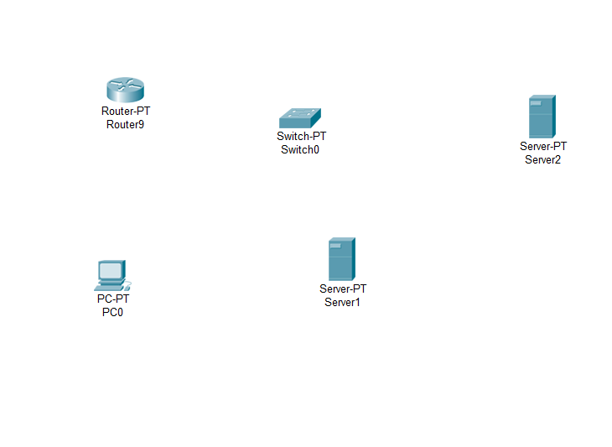

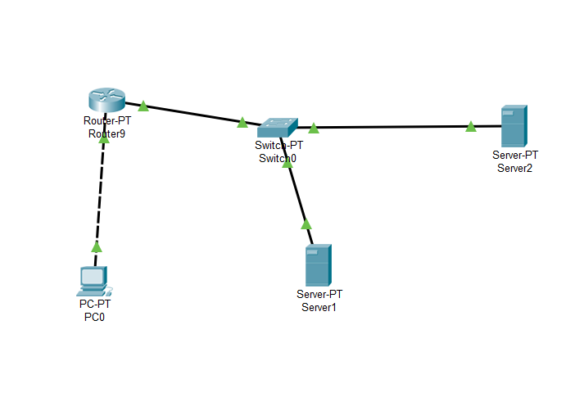

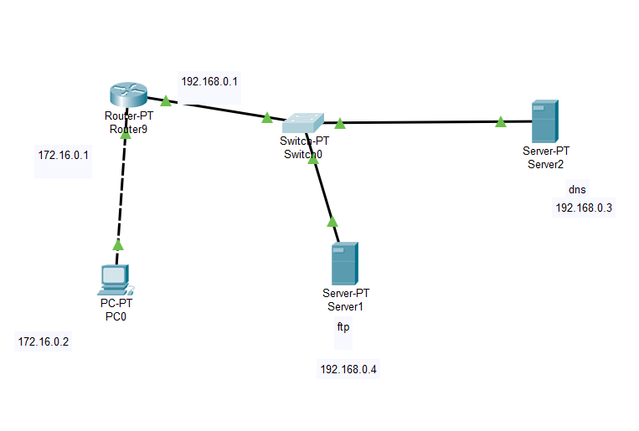

FTP Server:

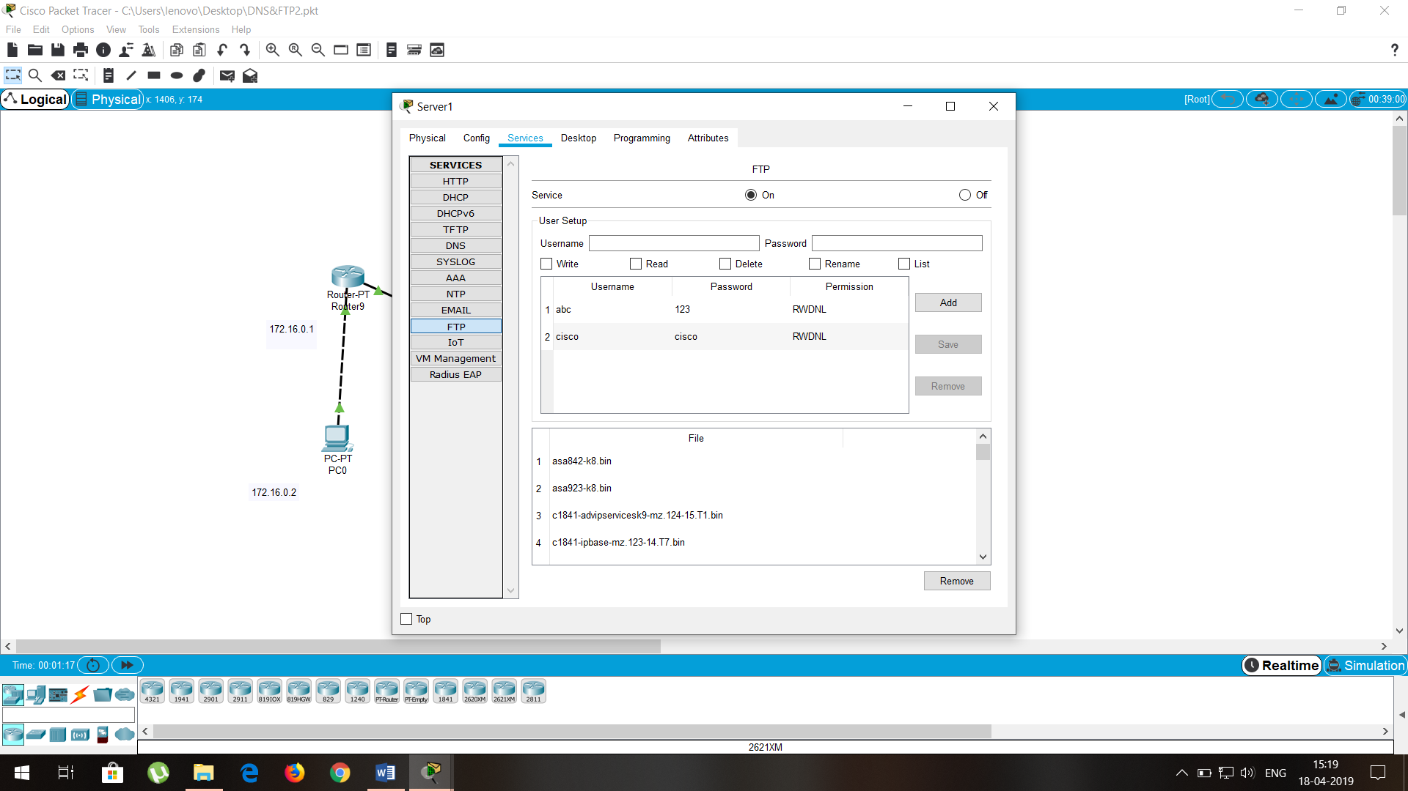

DNS server:

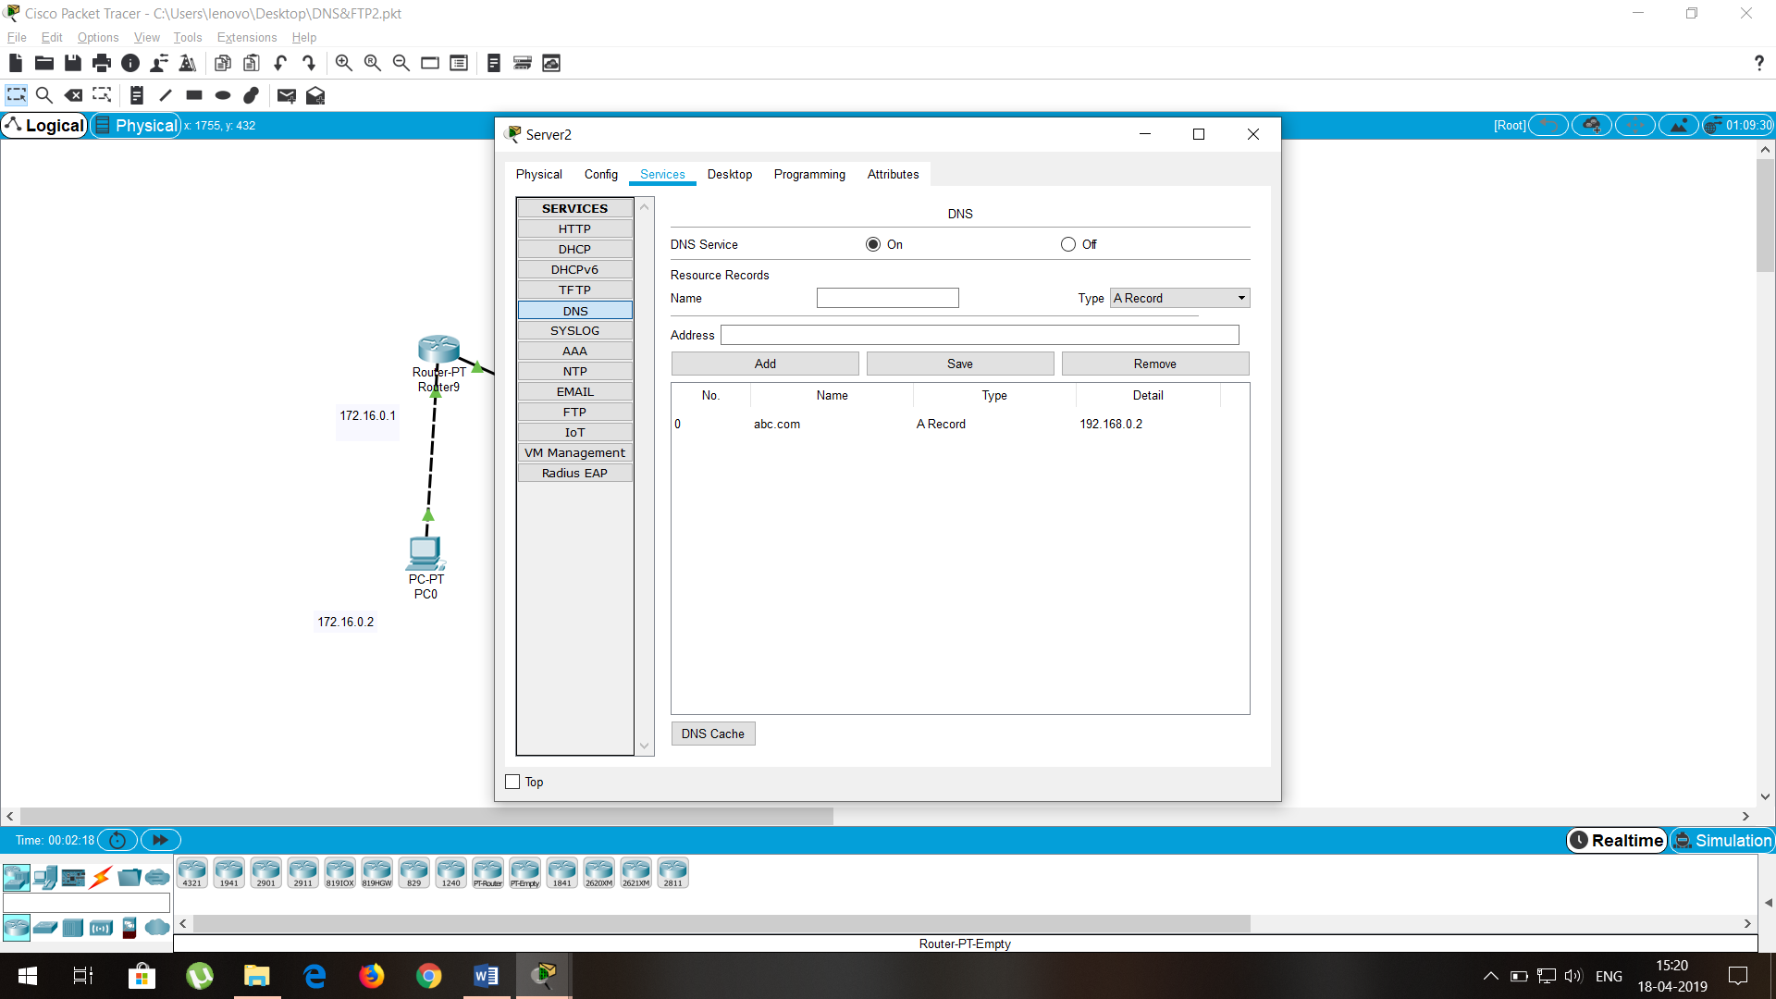

Checking Connection with DNS server

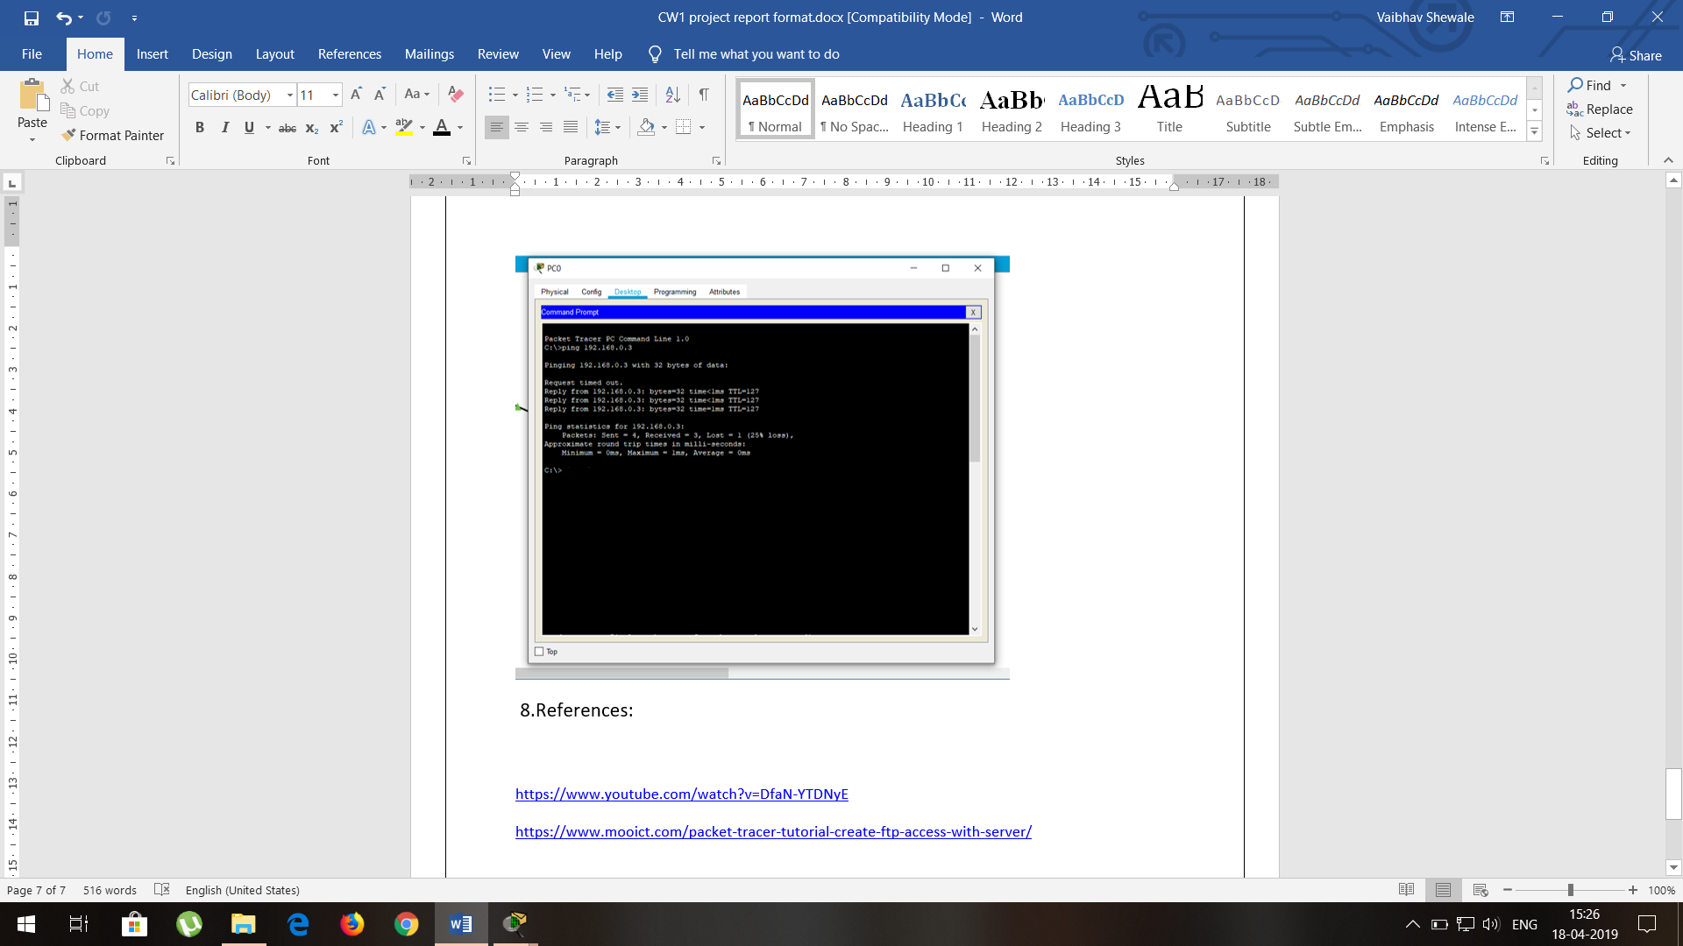

Connection with FTP server

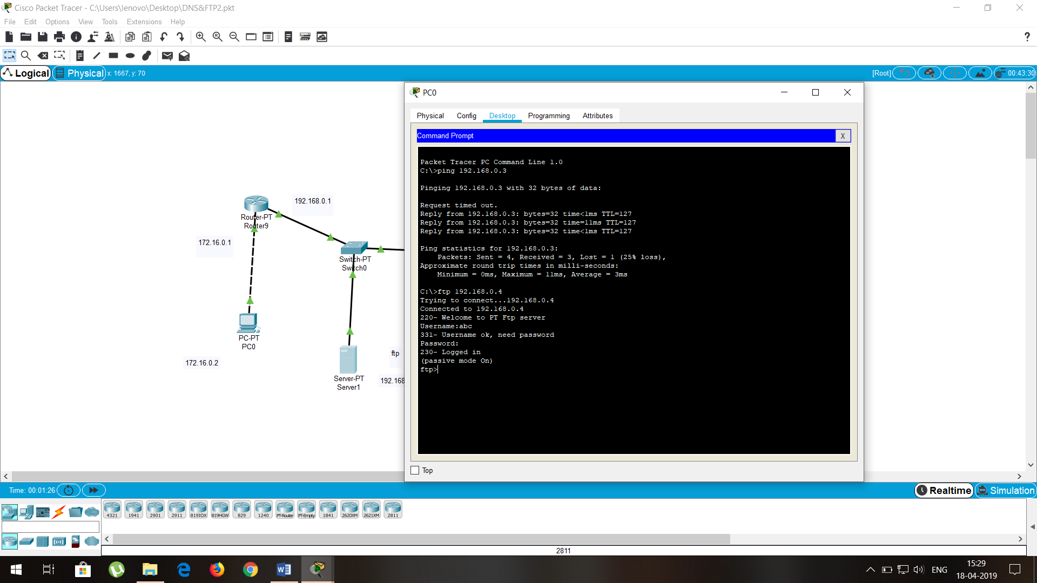

Putting file in FTP server

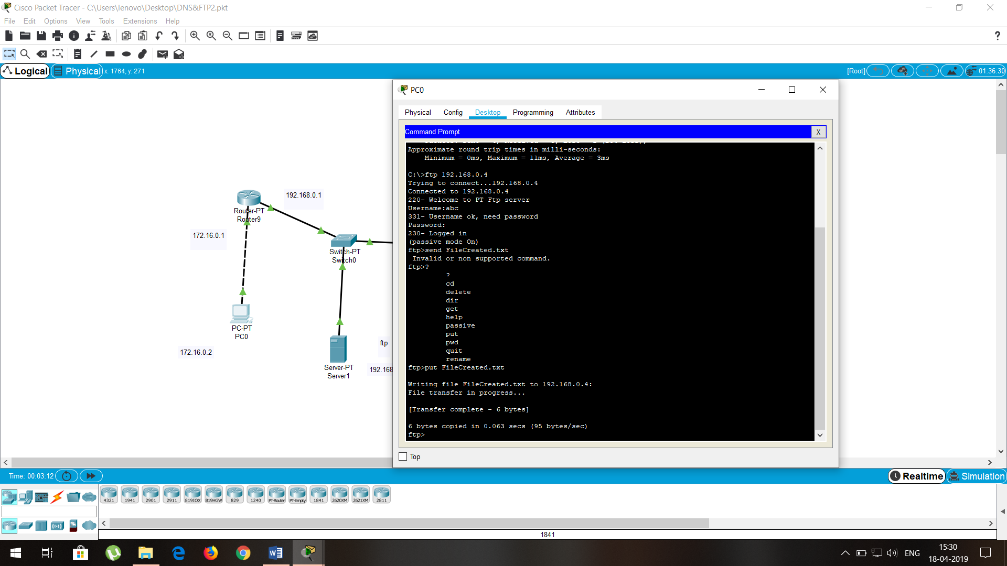

File Uploaded Successfully in FTP server (FileCreated.txt)

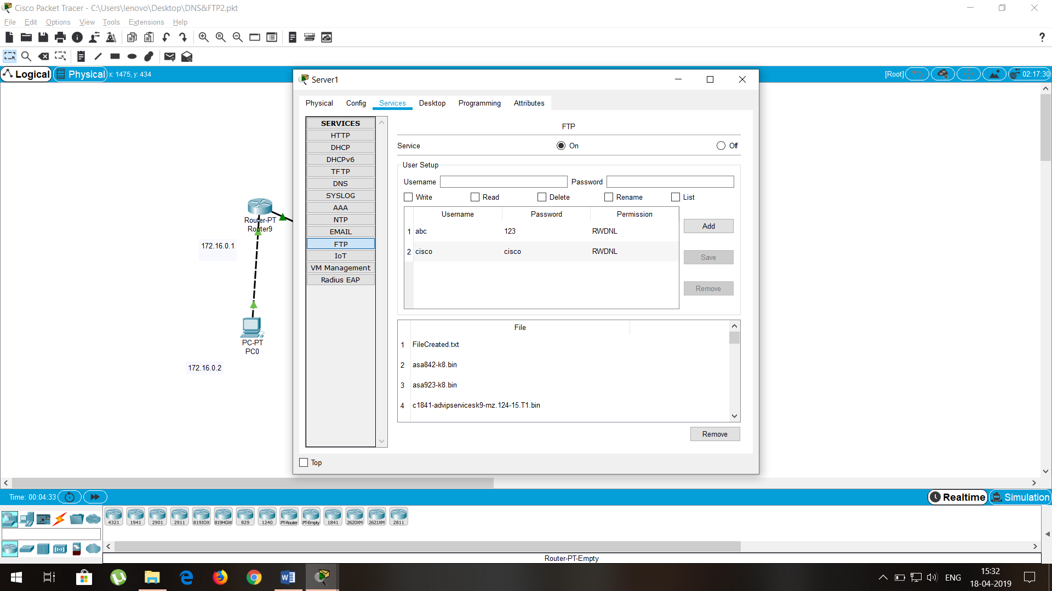

5.References:

<https://en.wikipedia.org/wiki/Packet_Tracer>

<http://w7cloud.com/packet-tracer-cisco-commands-list-cli-basic/>

<https://www.youtube.com/watch?v=DfaN-YTDNyE>

<https://www.mooict.com/packet-tracer-tutorial-create-ftp-access-with-server/>

**Project Developed By:**

**Vaibhav Sanjay Shewale (Roll No: 48)**

**Shashank Banduji Moundekar (Roll No: 44)**