Network Security and Forensics – EECS 4482
DNS Rebinding Attack
Prepare by: Dr. Ruba Al Omari
Fall 2024

Instructions:
- Uploading of course material, assignments, labs, sample solutions, or tests to online sites is prohibited. No reuse of this assignment is allowed in part or in full without my written permission.
- Providing more than what is required will result in a penalty of:
  - -5 Marks per extra screenshot.
  - -5 Marks per extra command/answer/comment.
  - -5 Mark per screenshot with error messages.
- Do not delete the text in this answer file including the highlighted text.
- Low-quality screenshots will receive zero marks.
- Negative marking: if you see a negative sign next to a mark, it means you don’t receive marks for answering the question, but you lose marks for not answering.

Answers:
Place Screenshot#1 Below (-5 Marks)
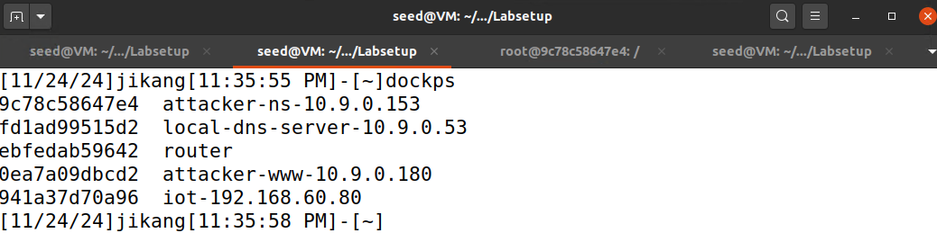

Place Screenshot#2 Below (5 Marks)

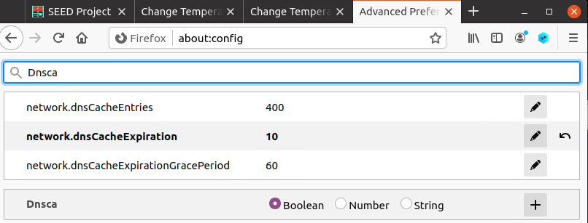

Place Screenshot#3 Below (5 Marks)
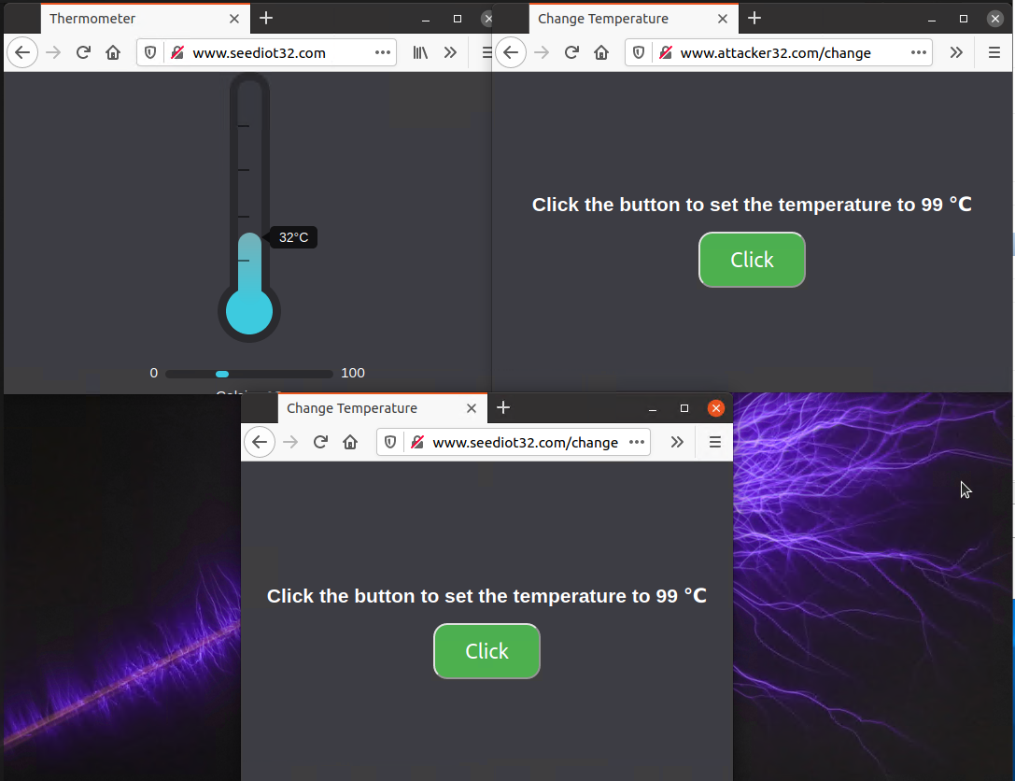

Question#1 (5 Marks): Try changing the temperature from URL2, were you successful?
Yes, it was successful because URL2 is from the same domain as the IoT server, complying with the Same-Origin Policy.

Question#2 (10 Marks): Try changing the temperature from URL3, were you successful? Why?
No, it was not successful because URL3 is from a different domain, and the Same-Origin Policy blocked the request.
Question#3 (5 Marks): What did you set TTL to?
I set the TTL to 10 seconds to minimize caching and enable quick DNS rebinding.

Question#4 (10 Marks): Where did you get the www entry to point to?
The www entry was initially pointed to the attacker's web server and then remapped to the IoT server's IP address (192.168.60.80) during the DNS rebinding.

Upload Video1-YourFirstName on eClass. (30 Marks)

Upload Video2-YourFirstName on eClass. (30 Marks)

