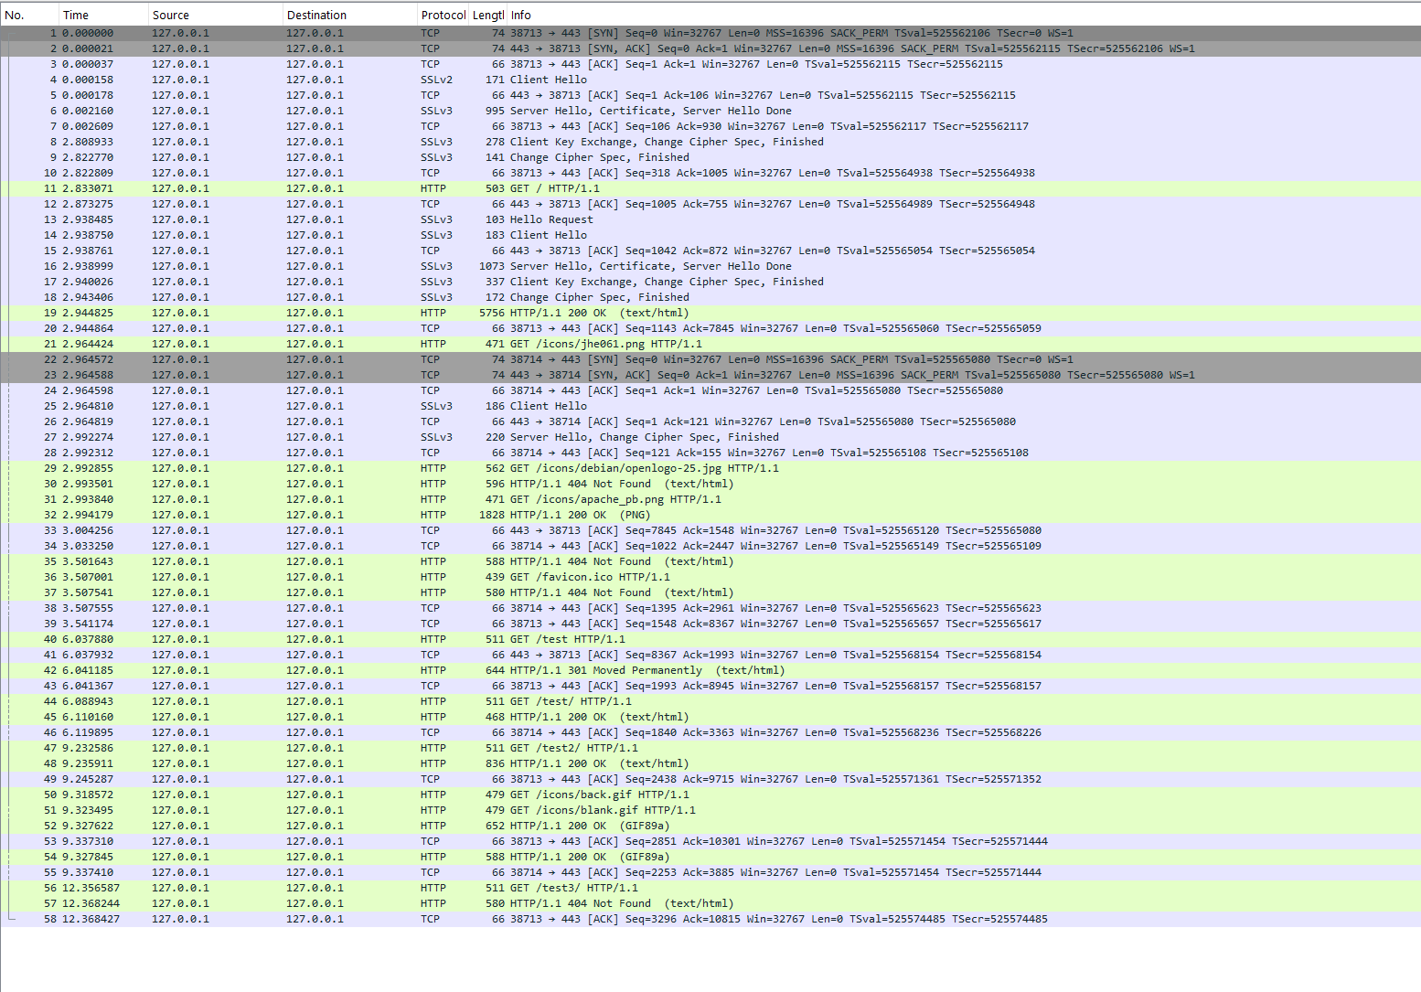EECS 4482 – Network Security and Forensics
Lab – Sniffing and Spoofing
Prepare by: Dr. Ruba Al Omari
Fall 2024

Instructions:
- Uploading of course material, assignments, labs, sample solutions, or tests to online sites is prohibited. No reuse of this assignment is allowed in part or in full without my written permission.
- Providing more than what is required will result in a penalty of:
  - -5 Marks per extra screenshot.
  - -5 Marks per extra command/answer/comment.
  - -5 Mark per screenshot with error messages.
- Do not delete the text in this answer file including the highlighted text.
- Low-quality screenshots will receive zero marks.
- Negative marking: if you see a negative sign next to a mark, it means you don’t receive marks for answering the question, but you lose marks for not answering.

Answers:
Part 1
Question#1 (-1 Mark): In the docker-compose.yml file, why was the network_mode set to host for the seed-attacker container?
ANSWER: because the attacker container needs full access to the network so it can capture packets.

Question#2 (-1 Mark): What is the name of the network interface with the 10.9.0.1 IP address?
ANSWER: It is br-341bf90f0d45

Question#3 (-1 Mark): What is the network id for the net-10.9.0.0 network?
ANSWER: the netmask is 255.255.255.0 in /ifconfig so the id is 10.9.0.0/24 where it ranging from 10.9.0.1 to 10.9.0.255

Place Screenshot#1 Below (5 Marks)
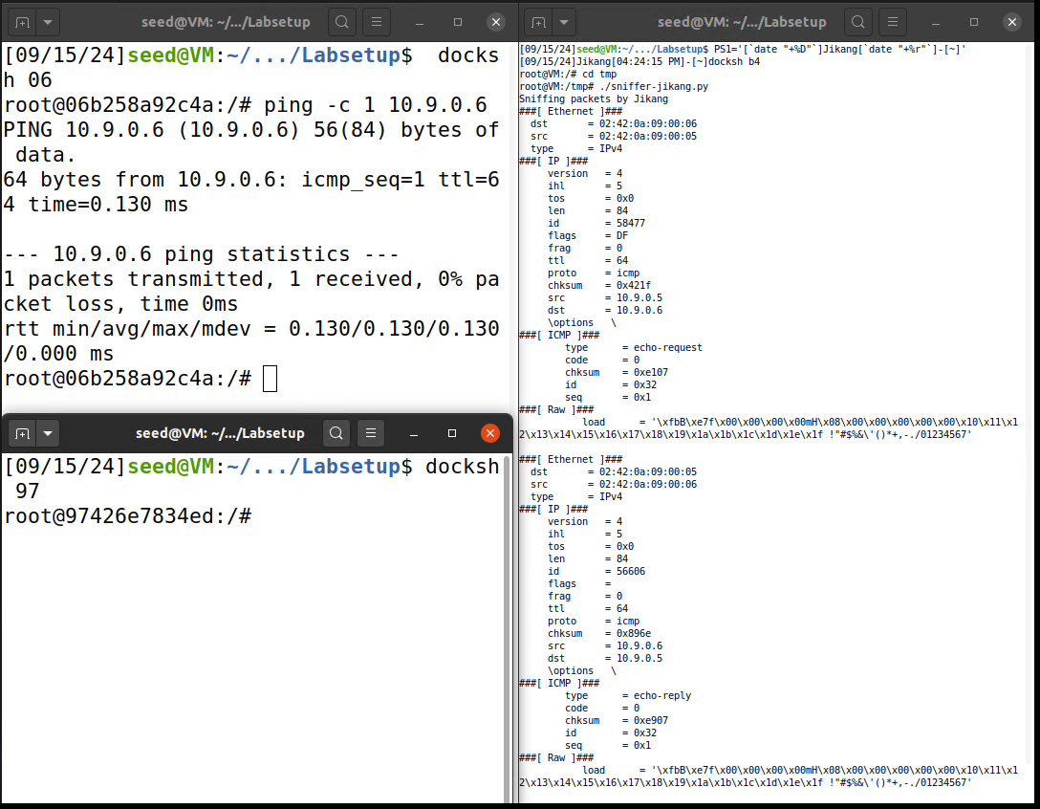

Place Screenshot#2 Below (5 Marks) 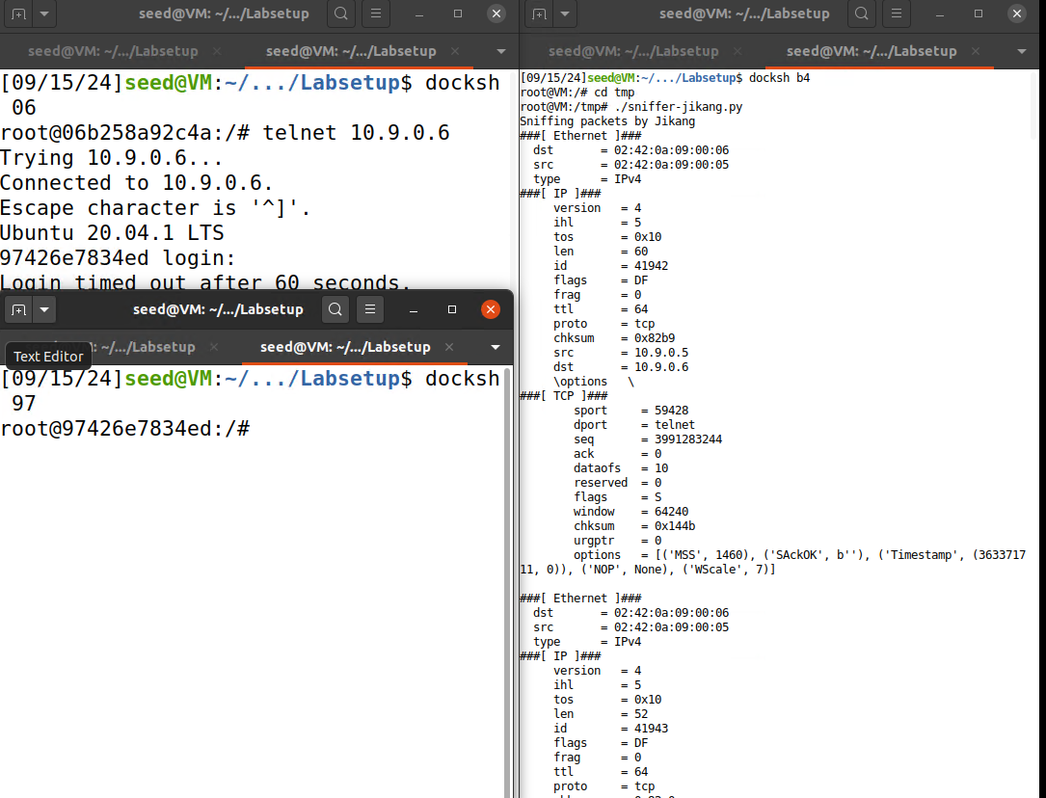

Question#4 (5 Marks): Copy the packet filter you used in your sniffer.py program below:
pkt = sniff(iface='br-c93733e9f913',filter='tcp and src host 10.9.0.5 and dst port 23', prn=print_pkt)
Place Screenshot#3 Below (10 Marks)

Question#5 (5 Marks): Copy the packet filter you used in your sniffer.py program below: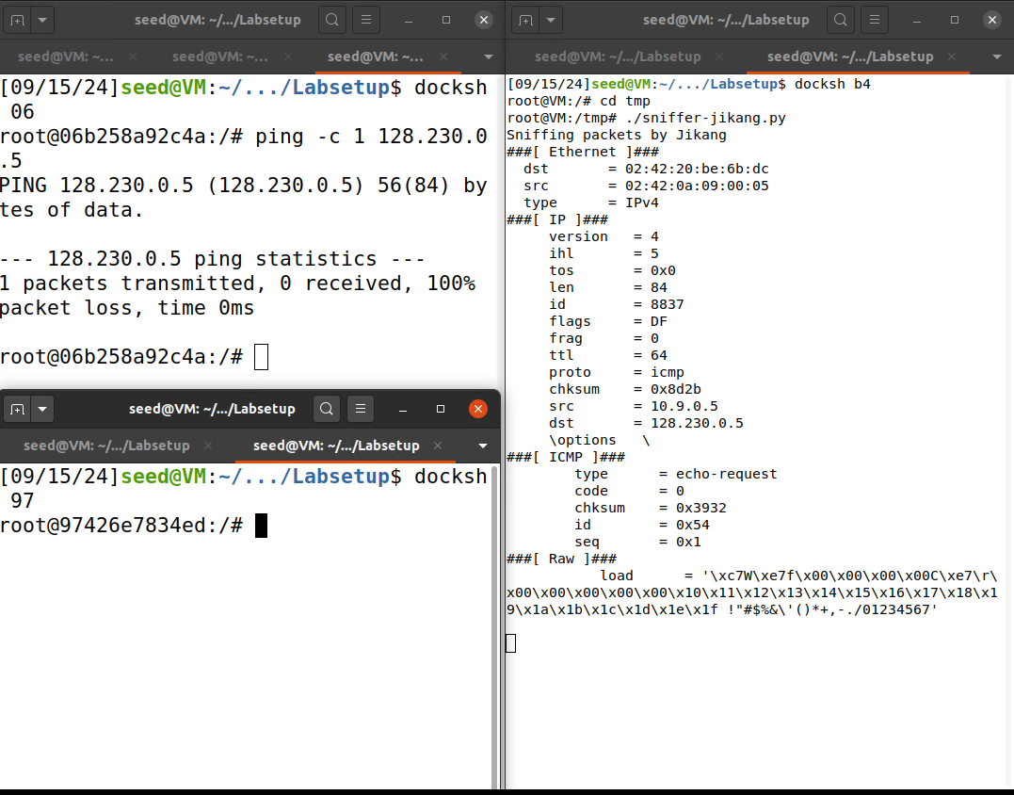
pkt = sniff(iface='br-c93733e9f913',filter= ‘net 128.230.0.0/16‘, prn=print_pkt)

Place Screenshot#4 Below (10 Marks)
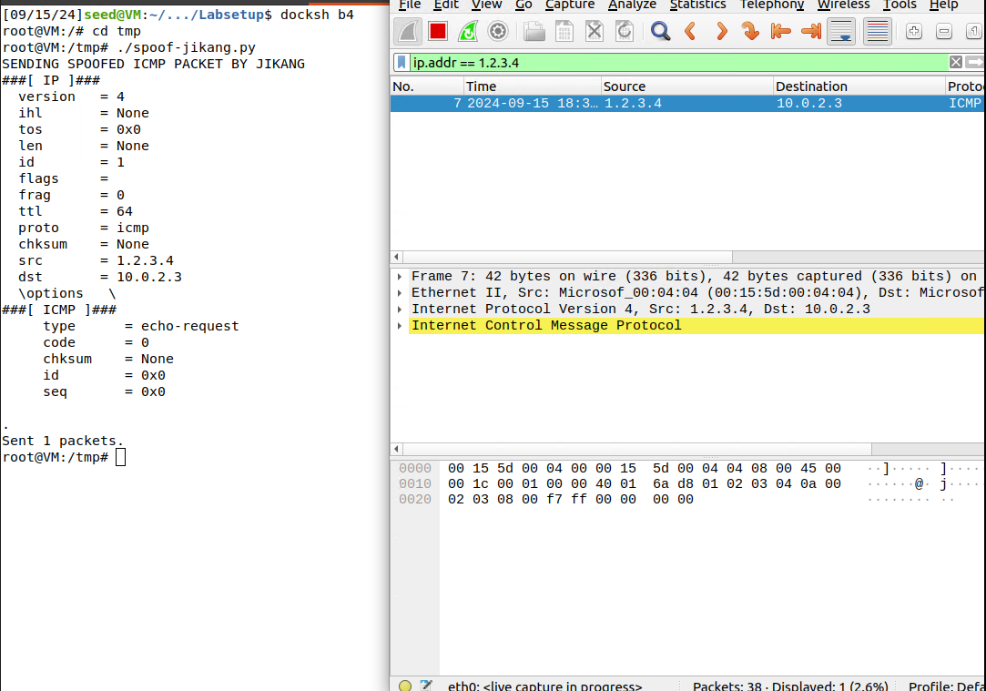

Question#6 (10 Marks): Copy the code you used in your spoof.py program below:
#!/bin/env python3
from scapy.all import *
print(“SENDING SPOOFED ICMP PACKET BY JIKANG”)
ip = IP(SRC = “1.2.3.4”, dst=”10.0.2.3”)
icmp ICMP()
packet = ip/icmp
packet.show()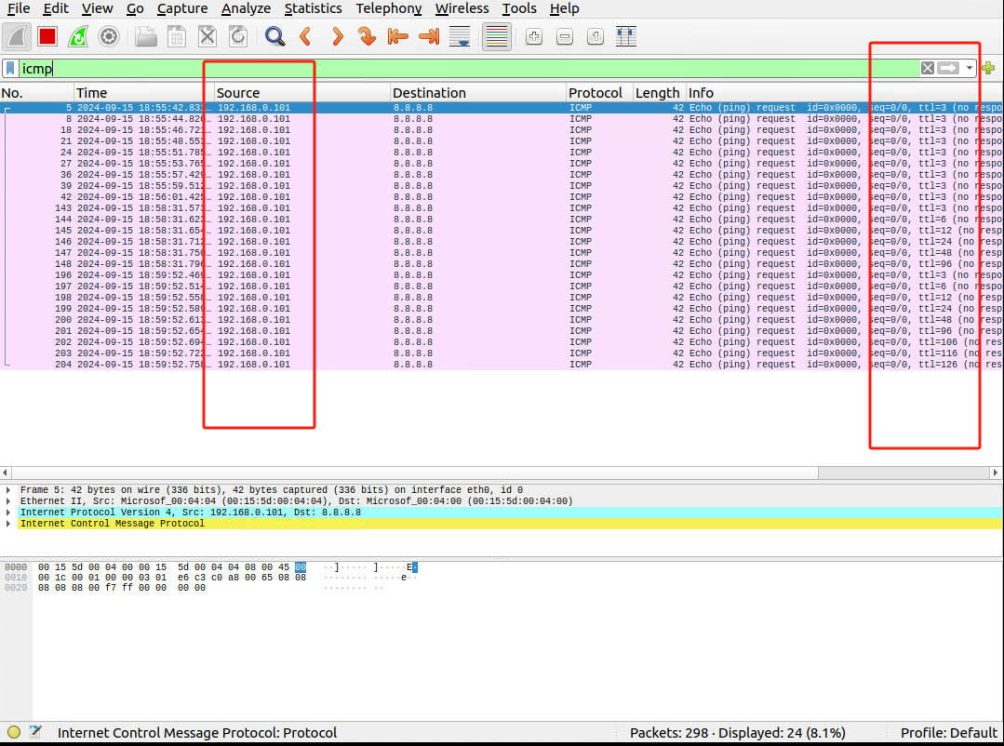
send(packet)
Place Screenshot#5 Below (10 Marks)

Question#7 (3 Mark): Why are you getting duplicate replies when pinging 8.8.8.8? Limit your answer to one line.
ANSWER: because both spoofed and actual source is getting reply

Question#8 (3 Mark): Why are you getting replies when pinging 1.2.3.4 when the host doesn’t exist? limit your answer to one line.

ANSWER: it is generated by spoof.py

Question#9 (4 Mark): Why is your sniffer not displaying any traffic when pinging a non-existing local host? Limit your answer to two lines.
ANSWER: The sniffer does not display traffic because the ARP request sent to resolve the non-existing host’s IP address does not receive a response, so no ICMP packet is sent.

End of Part 1

Part 2

Question#10 (10 Marks): Fill in the network diagram shown below.
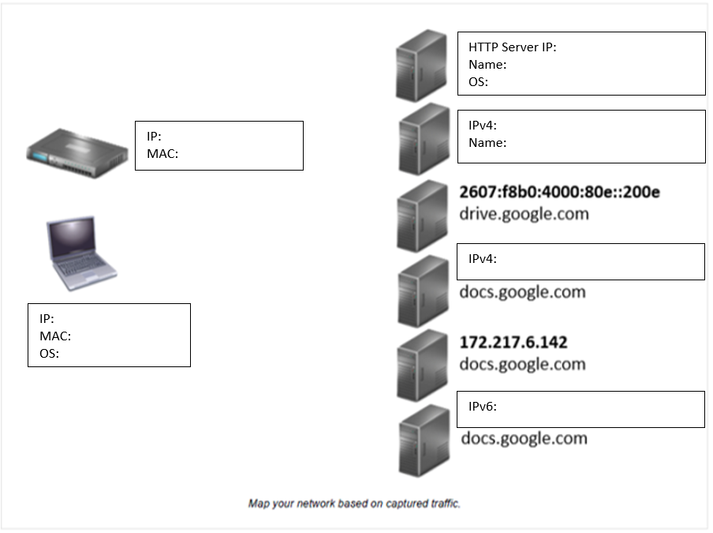
• Laptop:
- IP: 192.168.0.101
- MAC: d4:3d:7e:a6:41:fd
- OS: Windows
• Router:
- IP: 192.168.0.1
- MAC: d4:3d:7e:a6:41:fd
• HTTP Server:
- IP: 23.48.32.43
- MAC: 0c:80:63:d1:7e:f8
- OS: TPlink
• drive.google.com:
- IPv4: 216.58.194.46
- IPv6: 2607:f8b0:4000:80e::200e
• docs.google.com:
- IPv4: 172.217.6.142
- IPv6: 2607:f8b0:4000:80e::200e

Question#11 (-1 Mark): List 1 password you were able to read in plain text. Remember that listing more than what is required will result in negative marking.
ANSWER: merlin

Question#12 (-1 Mark): What protocol is this?
ANSWER: IRC (Internet Relay Chat)

Place Screenshot#6 Below (10 Marks)

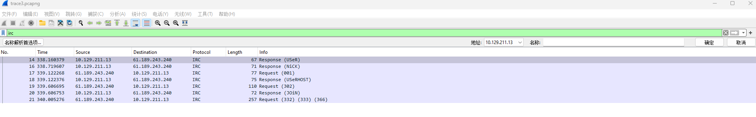
Question#13 (-1 Mark): If you reassemble a malicious file downloaded by a host, can you infect your own system if you execute that file?
ANSWER: Yes, if you reassemble a malicious file downloaded by a host and execute it, your system can become infected. When executed, the file can run harmful code that may install malware

Place Screenshot#7 Below (10 Marks)

End of Part 2

