Network Security and Forensics – EECS 4482
TCP Attacks
Prepare by: Dr. Ruba Al Omari
Fall 2024

Instructions:
- Uploading of course material, assignments, labs, sample solutions, or tests to online sites is prohibited. No reuse of this assignment is allowed in part or in full without my written permission.
- Providing more than what is required will result in a penalty of:
  - -5 Marks per extra screenshot.
  - -5 Marks per extra command/answer/comment.
  - -5 Mark per screenshot with error messages.
- Do not delete the text in this answer file including the highlighted text.
- Low-quality screenshots will receive zero marks.
- Negative marking: if you see a negative sign next to a mark, it means you don’t receive marks for answering the question, but you lose marks for not answering.

Answers:
Place Screenshot#1 Below (-5 Marks)
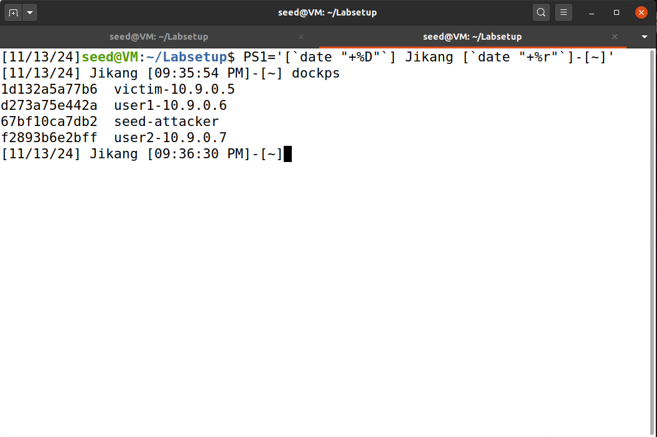
Place Screenshot#2 Below (20 Marks)

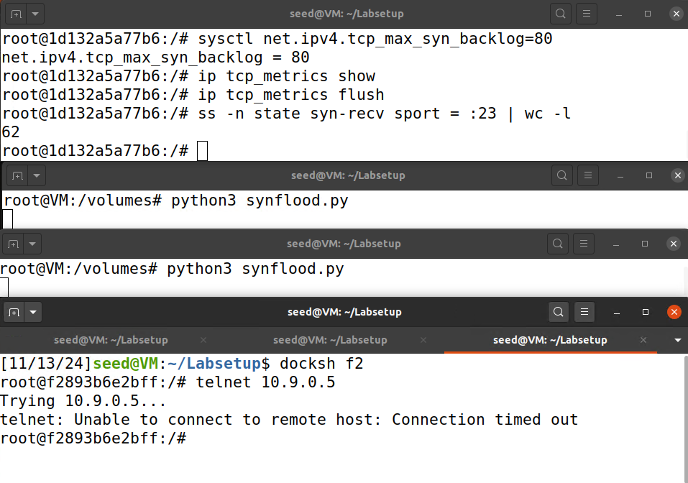

Question#1 (10 Marks):
Flushing the cache clears half-open connections, freeing up space in the connection queue for accurate testing.
Question#2 (10 Marks):
With SYN cookies enabled, the attack is likely unsuccessful because the victim can handle SYN requests without filling the connection queue.

Place Screenshot#3 Below (20 Marks)

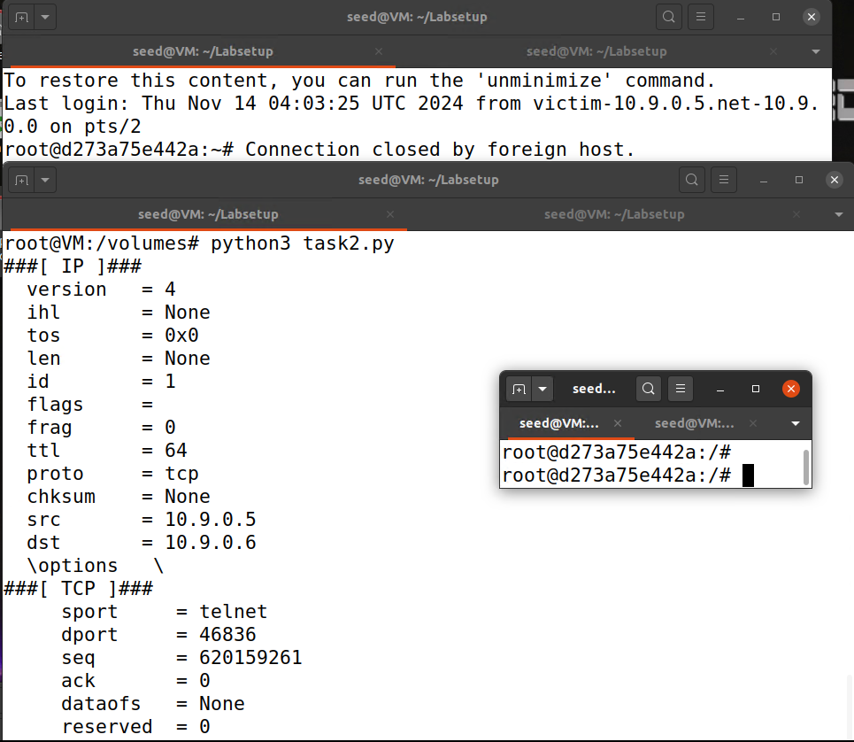

Place Screenshot#4 Below (20 Marks)

Place Screenshot#5 Below (20 Marks)

