ARTIFICIAL INTELLIGENCE COURSE PROJECT

MULTI-DISEASE
MACHINE LEARNING SYSTEM
Final Technical Report
Mechatronics Engineering - Supervised Machine Learning
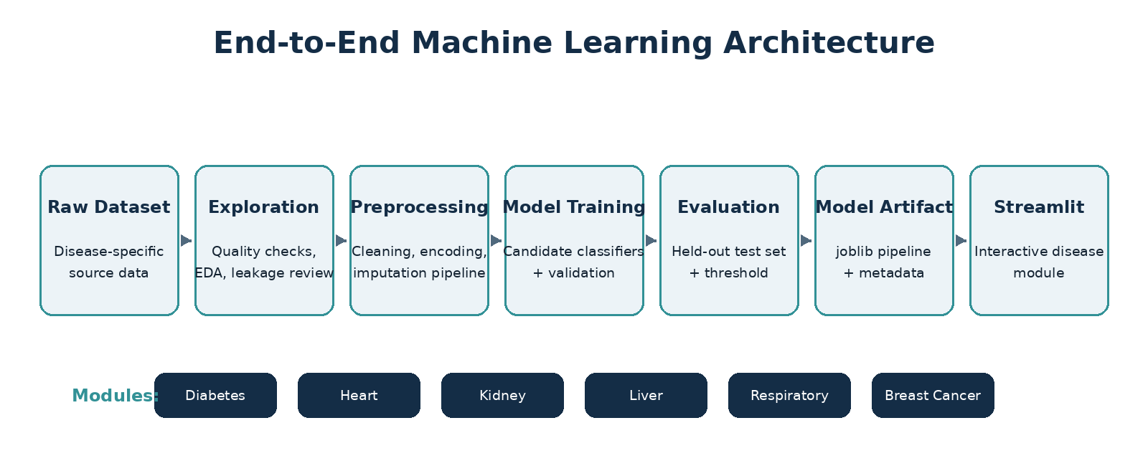

Prepared by | Abdullah Mohammed Nasser Al-Dhahab  202474228  Abdullah Khalid Alkorbaty  202274065
Supervised By | Asma Al-Ariqi
Academic Year | 2026

September 2026

Abstract
This project presents a multi-disease machine-learning system that integrates six independent supervised-classification models into a unified Streamlit application. The system covers diabetes, heart disease, chronic kidney disease, liver disease, respiratory disease/asthma, and breast cancer. Each disease is treated as a separate machine-learning problem with its own dataset, exploratory analysis, preprocessing strategy, model-training workflow, evaluation process, decision threshold, and saved model artifact. The final held-out results show particularly strong performance for chronic kidney disease and breast cancer, while the respiratory module demonstrates the importance of preventing target leakage even when that decision lowers apparent performance. The project is an academic demonstration of end-to-end machine-learning development and is not intended for clinical diagnosis.
Key contribution: A single academic application demonstrates six complete ML pipelines while preserving disease-specific preprocessing, evaluation, and model artifacts.

Table of Contents
Abstract 1
1. Introduction 2
2. System Architecture and Methodology 2
3. Dataset and Preprocessing Overview 3
4. Diabetes Module 4
5. Heart Disease Module 5
6. Chronic Kidney Disease Module 6
7. Liver Disease Module 7
8. Respiratory Disease / Asthma Module 8
9. Breast Cancer Module 9
10. Comparative Results and Discussion 11
11. Streamlit Application and Deployment 13
12. Final Quality Assurance 14
13. Limitations and Ethical Use 15
14. Conclusion 16
15. References 17
Appendix A. Supplementary Exploration Figures 18

1. Introduction
Machine learning can be used to identify patterns in structured healthcare data, but a credible academic implementation requires more than obtaining high accuracy. The workflow must address data quality, class imbalance, missing values, categorical encoding, leakage prevention, reproducibility, threshold selection, and transparent interpretation of evaluation metrics.
The purpose of this project is to build six independent disease-classification pipelines and integrate the resulting trained models into one Streamlit interface. Keeping the models independent prevents incompatible feature spaces from being mixed and makes the implementation easier to audit, reproduce, and explain.

1.1 Problem Statement
Healthcare datasets differ widely in scale, feature type, class distribution, and clinical meaning. A single monolithic model is therefore inappropriate for the six selected conditions. The engineering problem is to develop a consistent framework in which each disease is modeled separately while sharing a common application architecture and quality-assurance process.

1.2 Objectives
- Develop six independent supervised-classification pipelines.
- Perform exploratory data analysis and cleaning for every dataset.
- Remove identifiers and leakage-prone features before training.
- Compare multiple candidate algorithms and select models using validation performance.
- Evaluate selected models on held-out test data.
- Save complete model pipelines and metadata using joblib.
- Deploy the six models in a unified Streamlit application.
- Document limitations and avoid presenting model output as medical diagnosis.

2. System Architecture and Methodology
The project follows the same high-level engineering workflow for every disease while allowing dataset-specific preprocessing and feature handling. The final application is therefore modular: each Streamlit page loads only the trained artifact and features required by its disease model.

Figure 1. End-to-end architecture used across the six disease-classification modules.

2.1 Experimental Workflow
- Acquire and document the raw dataset.
- Inspect target distribution, feature quality, missing values, duplicates, and suspicious values.
- Clean the dataset without leaking information from the target.
- Split data into training, validation, and held-out test subsets where applicable.
- Build preprocessing and classifier pipelines.
- Compare candidate models on validation data.
- Select a decision threshold using validation data when threshold tuning is used.
- Evaluate once on the untouched test set.
- Serialize the fitted model pipeline and metadata using joblib.
- Integrate the artifact into the corresponding Streamlit disease page.

2.2 Evaluation Metrics
Accuracy is reported together with balanced accuracy, precision, recall, F1 score, and ROC-AUC because class imbalance makes accuracy alone insufficient. PR-AUC is also used where it was stored by the training artifact. Recall is especially important when the project objective favors capturing a larger proportion of positive cases, while precision reflects the cost of false-positive predictions.
Interpretation rule: The six disease scores are results from different datasets and should not be treated as a direct ranking of clinical diagnostic difficulty.

3. Dataset and Preprocessing Overview
Module | Dataset family | Data profile | Key preprocessing decision
Diabetes | BRFSS-derived health indicators | Large tabular health-indicator dataset | Binary target; class imbalance; health indicators
Heart Disease | UCI-derived heart disease data | Cardiovascular measurements and patient variables | Mixed clinical features; class-balanced evaluation
Chronic Kidney Disease | UCI Chronic Kidney Disease | 400 records; 24 model predictors | Mixed numerical/categorical data; substantial missingness
Liver Disease | Indian Liver Patient Dataset (ILPD) | Demographics and liver-function laboratory measurements | Four missing A/G-ratio values preserved for pipeline imputation
Respiratory Disease | Asthma patient dataset | 300 records; 4 valid model predictors | Medication removed because it leaked the target
Breast Cancer | Wisconsin Diagnostic Breast Cancer | 569 records; 30 numerical predictors | Identifier and empty source column removed

4. Diabetes Module
The diabetes module uses structured health indicators to estimate the positive diabetes/prediabetes class. The dataset is strongly imbalanced, so evaluation focuses on discrimination and recall in addition to overall accuracy.

4.1 Exploration and Feature Behavior
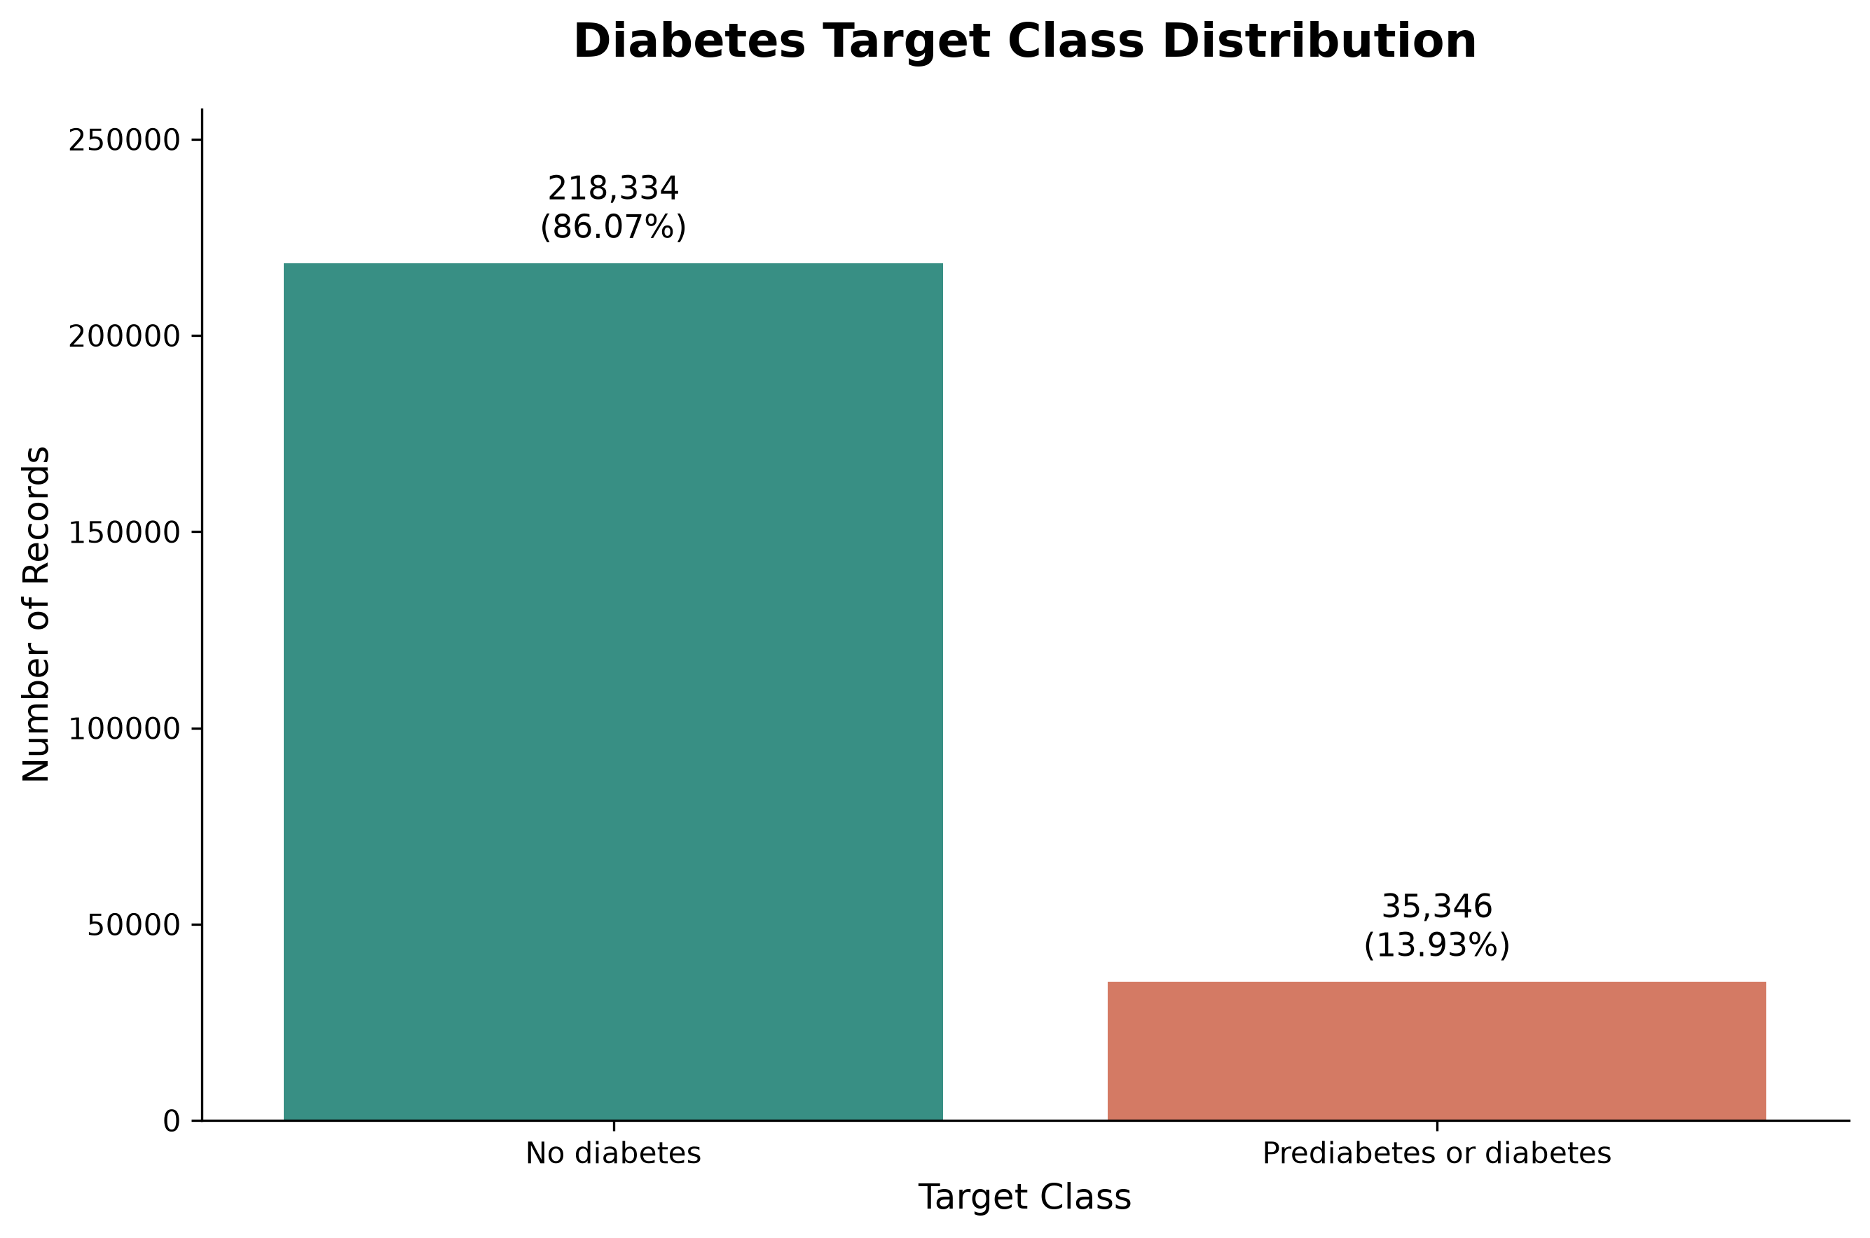 | 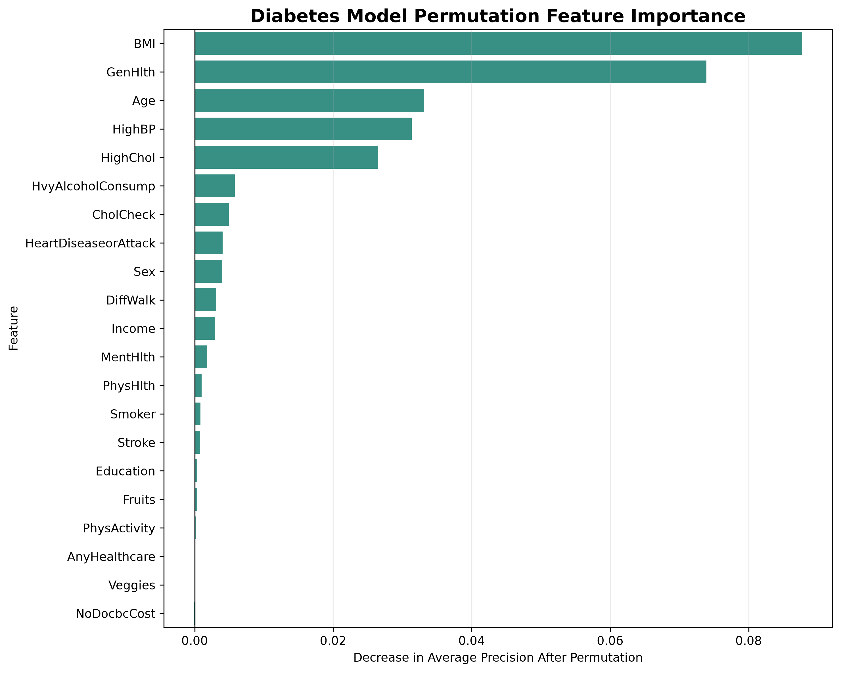
Figure 2. Diabetes target distribution showing a dominant negative class. | Figure 3. Permutation feature importance for the selected diabetes model.

The target-distribution figure confirms substantial class imbalance. General-health indicators, BMI, blood-pressure-related variables, and age-related information contribute meaningful predictive signal, but the imbalance makes precision a critical metric.

4.2 Final Model and Test Performance
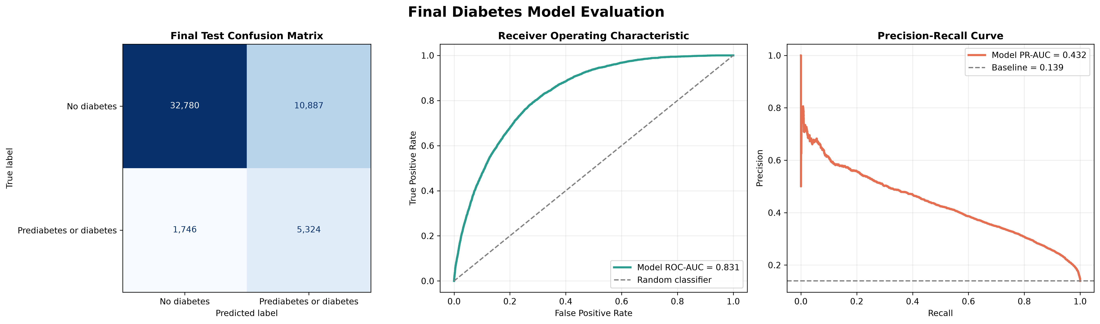
Figure 4. Final diabetes model evaluation: confusion matrix, ROC curve, and precision-recall curve.
HistGradientBoostingClassifier was selected with a decision threshold of 0.547. The final test accuracy was 0.7510, recall 0.7530, F1 score 0.4574, and ROC-AUC 0.8313. Precision was lower at 0.3284, indicating that the model identifies many positive cases but also produces a meaningful number of false positives.

5. Heart Disease Module
The heart-disease module uses cardiovascular measurements and patient characteristics. Logistic Regression was selected as the final model and produced a comparatively balanced held-out result.

5.1 Feature Contribution
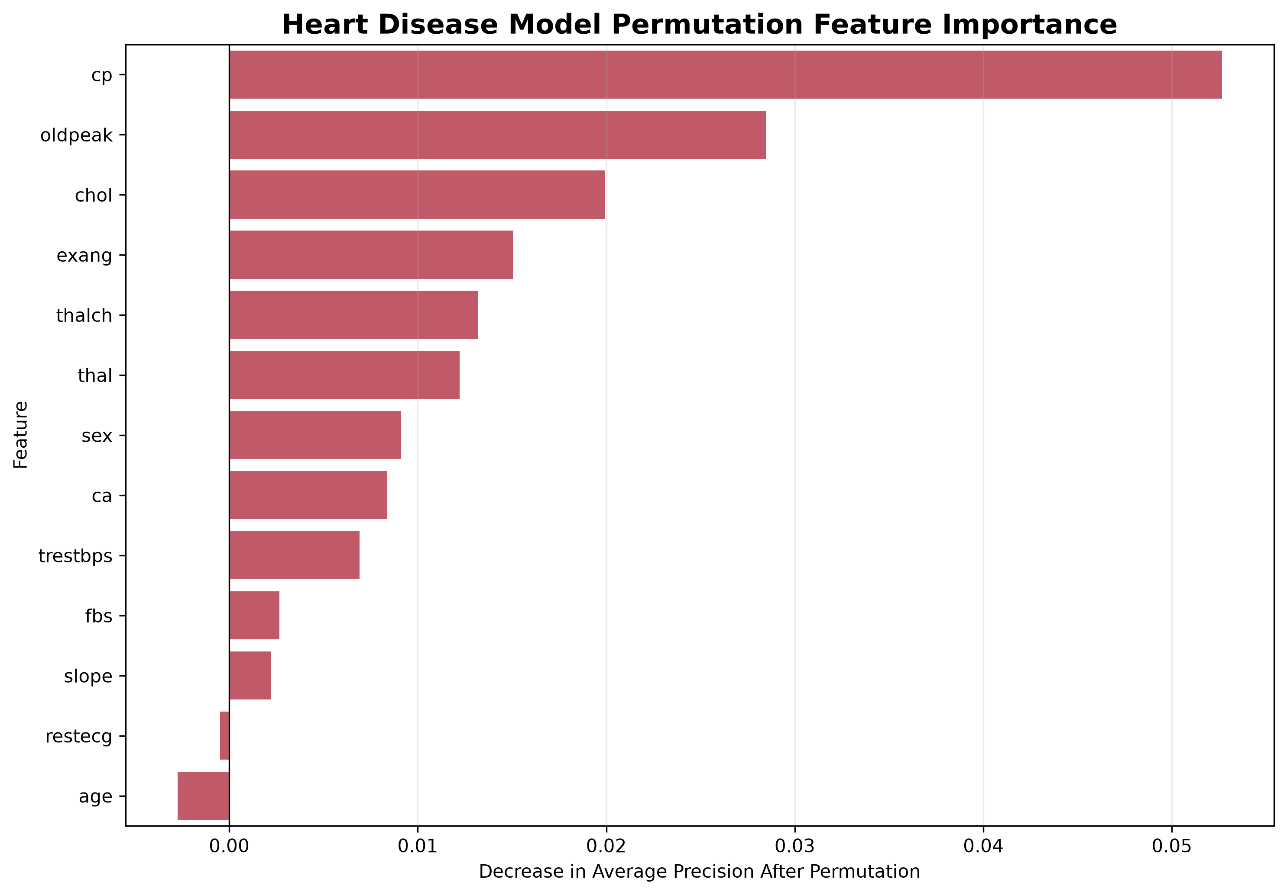
Figure 5. Permutation feature importance for the heart-disease classifier.
Chest-pain-related information, ST-segment behavior, exercise-response variables, and other cardiovascular indicators contribute strongly to the heart-disease decision boundary.

5.2 Final Evaluation
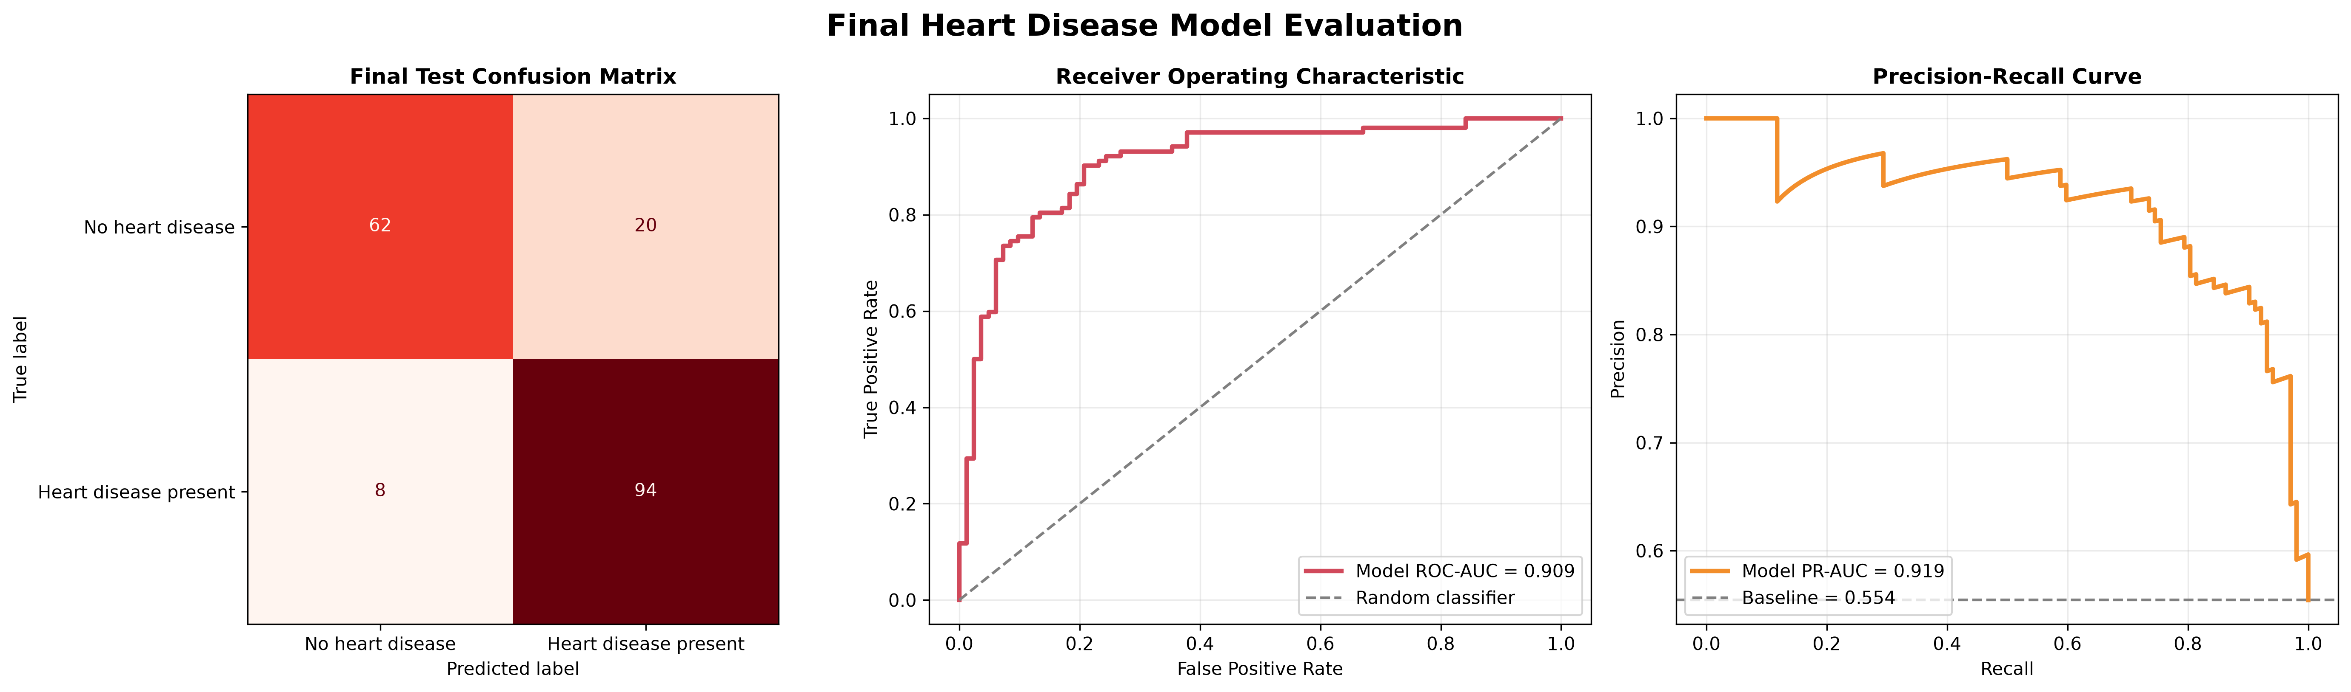
Figure 6. Final heart-disease evaluation with confusion matrix, ROC curve, and precision-recall curve.
The selected Logistic Regression model used a threshold of 0.313 and achieved accuracy 0.8478, precision 0.8246, recall 0.9216, F1 score 0.8704, and ROC-AUC 0.9085. The high recall shows that most positive heart-disease cases in the held-out test set were identified.

6. Chronic Kidney Disease Module
The chronic kidney disease dataset contains 400 records and a mixture of numerical and categorical predictors with extensive missing values. Missing values are intentionally retained during exploration and handled inside the model pipeline to avoid leakage.

6.1 Exploration and Feature Importance
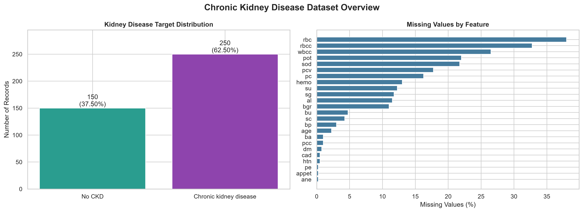 | 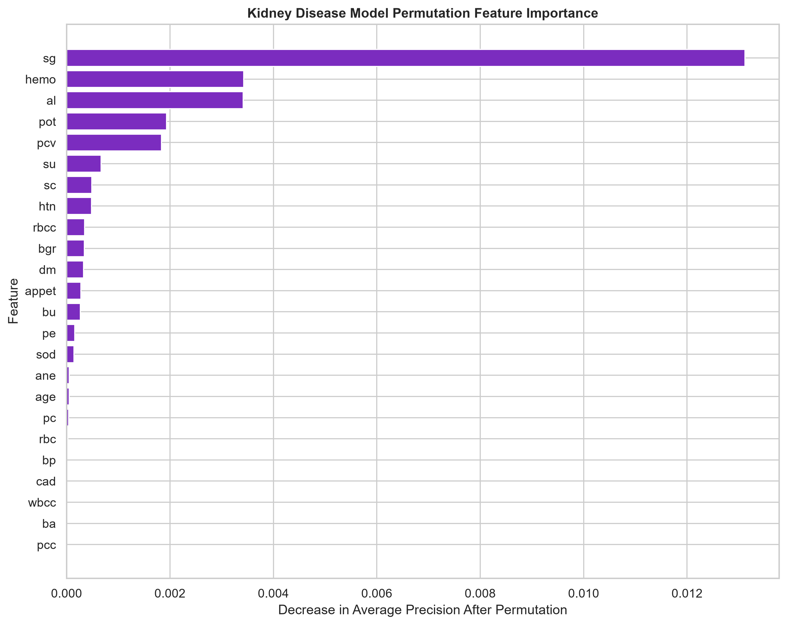
Figure 7. CKD target distribution and feature-level missingness overview. | Figure 8. Permutation feature importance for the CKD classifier.

Specific gravity, hemoglobin, serum creatinine, packed-cell volume, hypertension status, and related kidney indicators provide strong predictive information. The dataset also demonstrates why pipeline-based imputation is necessary: several clinically relevant variables contain missing observations.

6.2 Final Evaluation
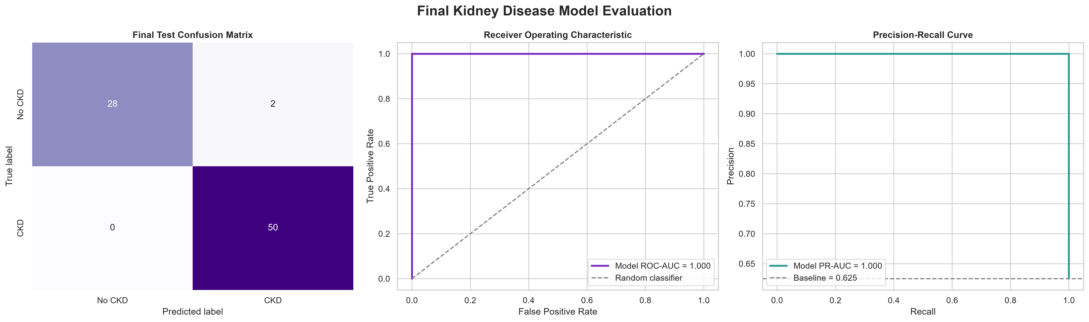
Figure 9. Final CKD evaluation with confusion matrix, ROC curve, and precision-recall curve.
Logistic Regression was selected at a threshold of 0.091. The held-out test accuracy was 0.9750, recall 1.0000, F1 score 0.9804, and ROC-AUC 1.0000. This was the strongest numerical test performance among the six independent experiments. It should still be interpreted as dataset-specific model performance rather than perfect clinical diagnosis.

7. Liver Disease Module
The liver module uses age, gender, bilirubin values, liver enzymes, total proteins, albumin, and albumin/globulin ratio. Exact duplicate records are removed, while plausible extreme laboratory values are preserved because high values can represent genuine disease cases.

7.1 Dataset Profile and Feature Importance
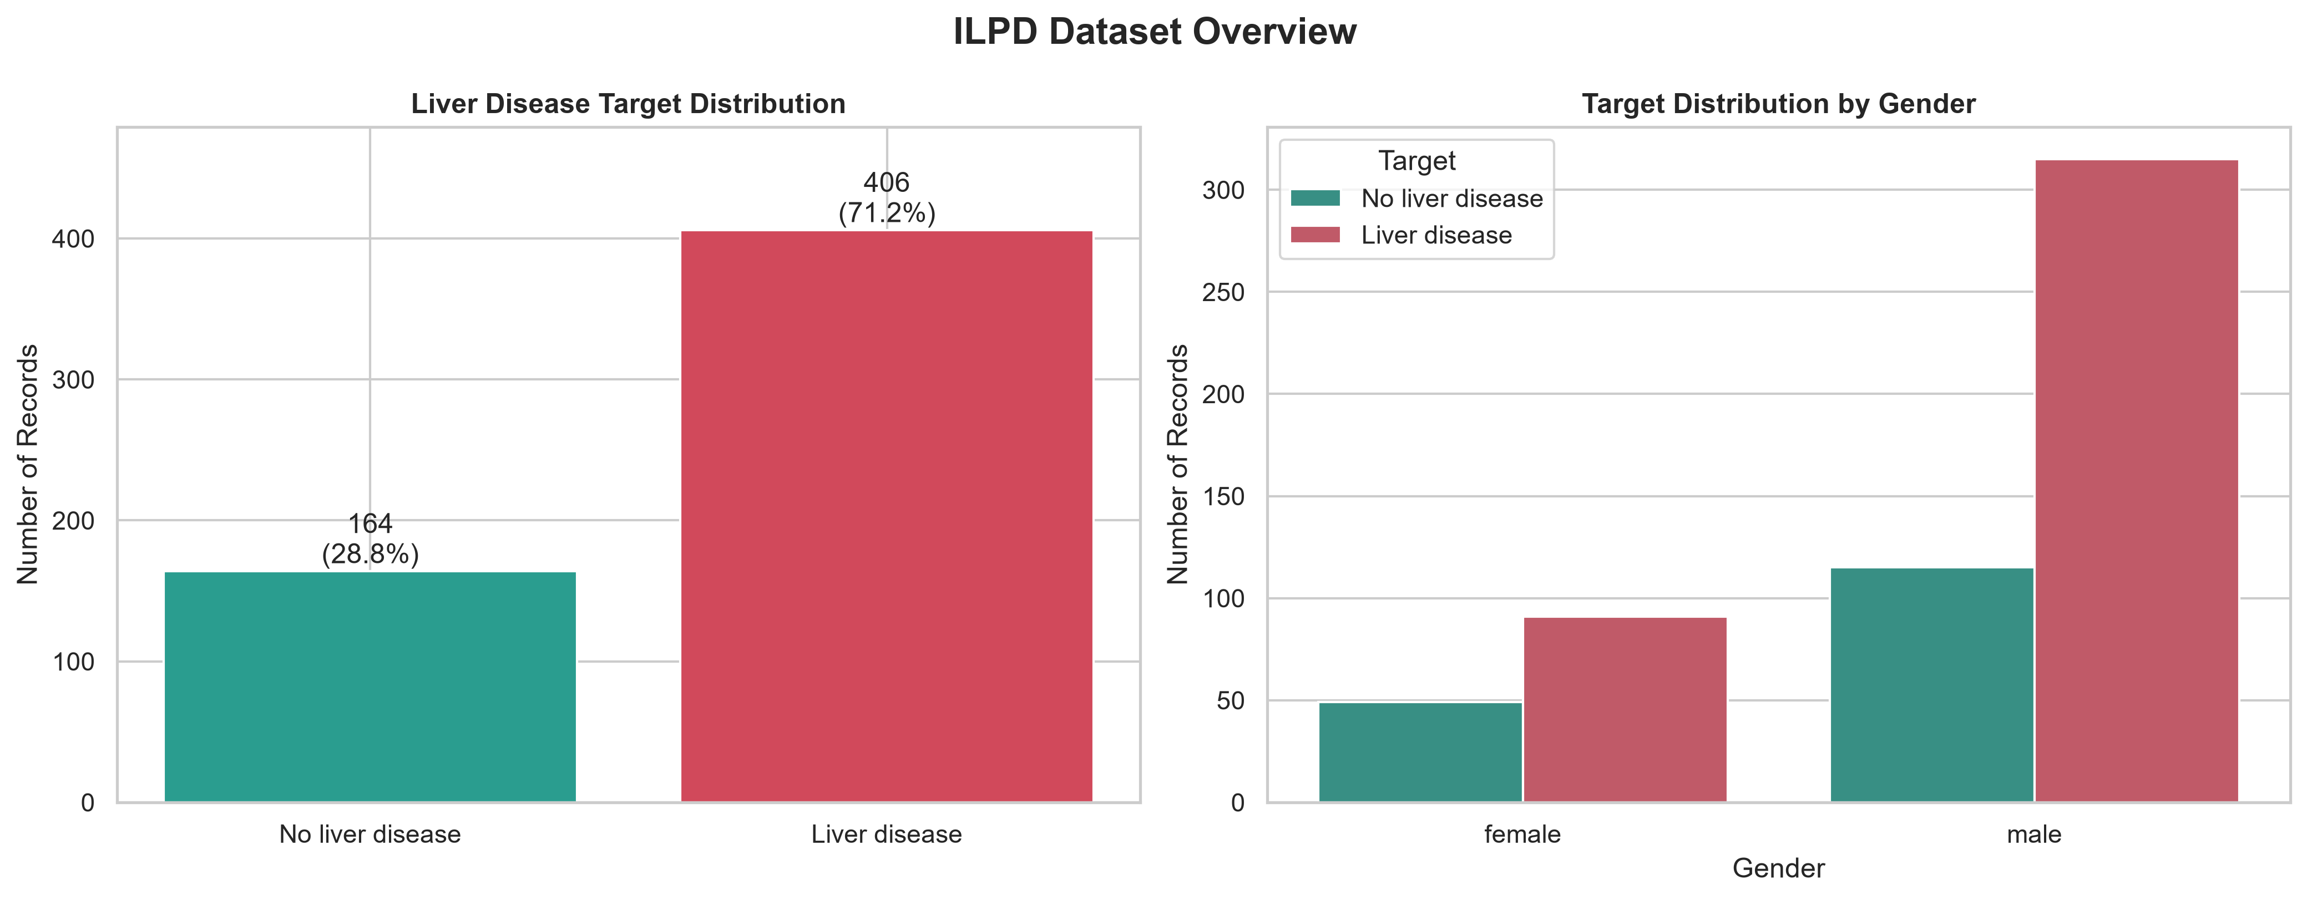 | 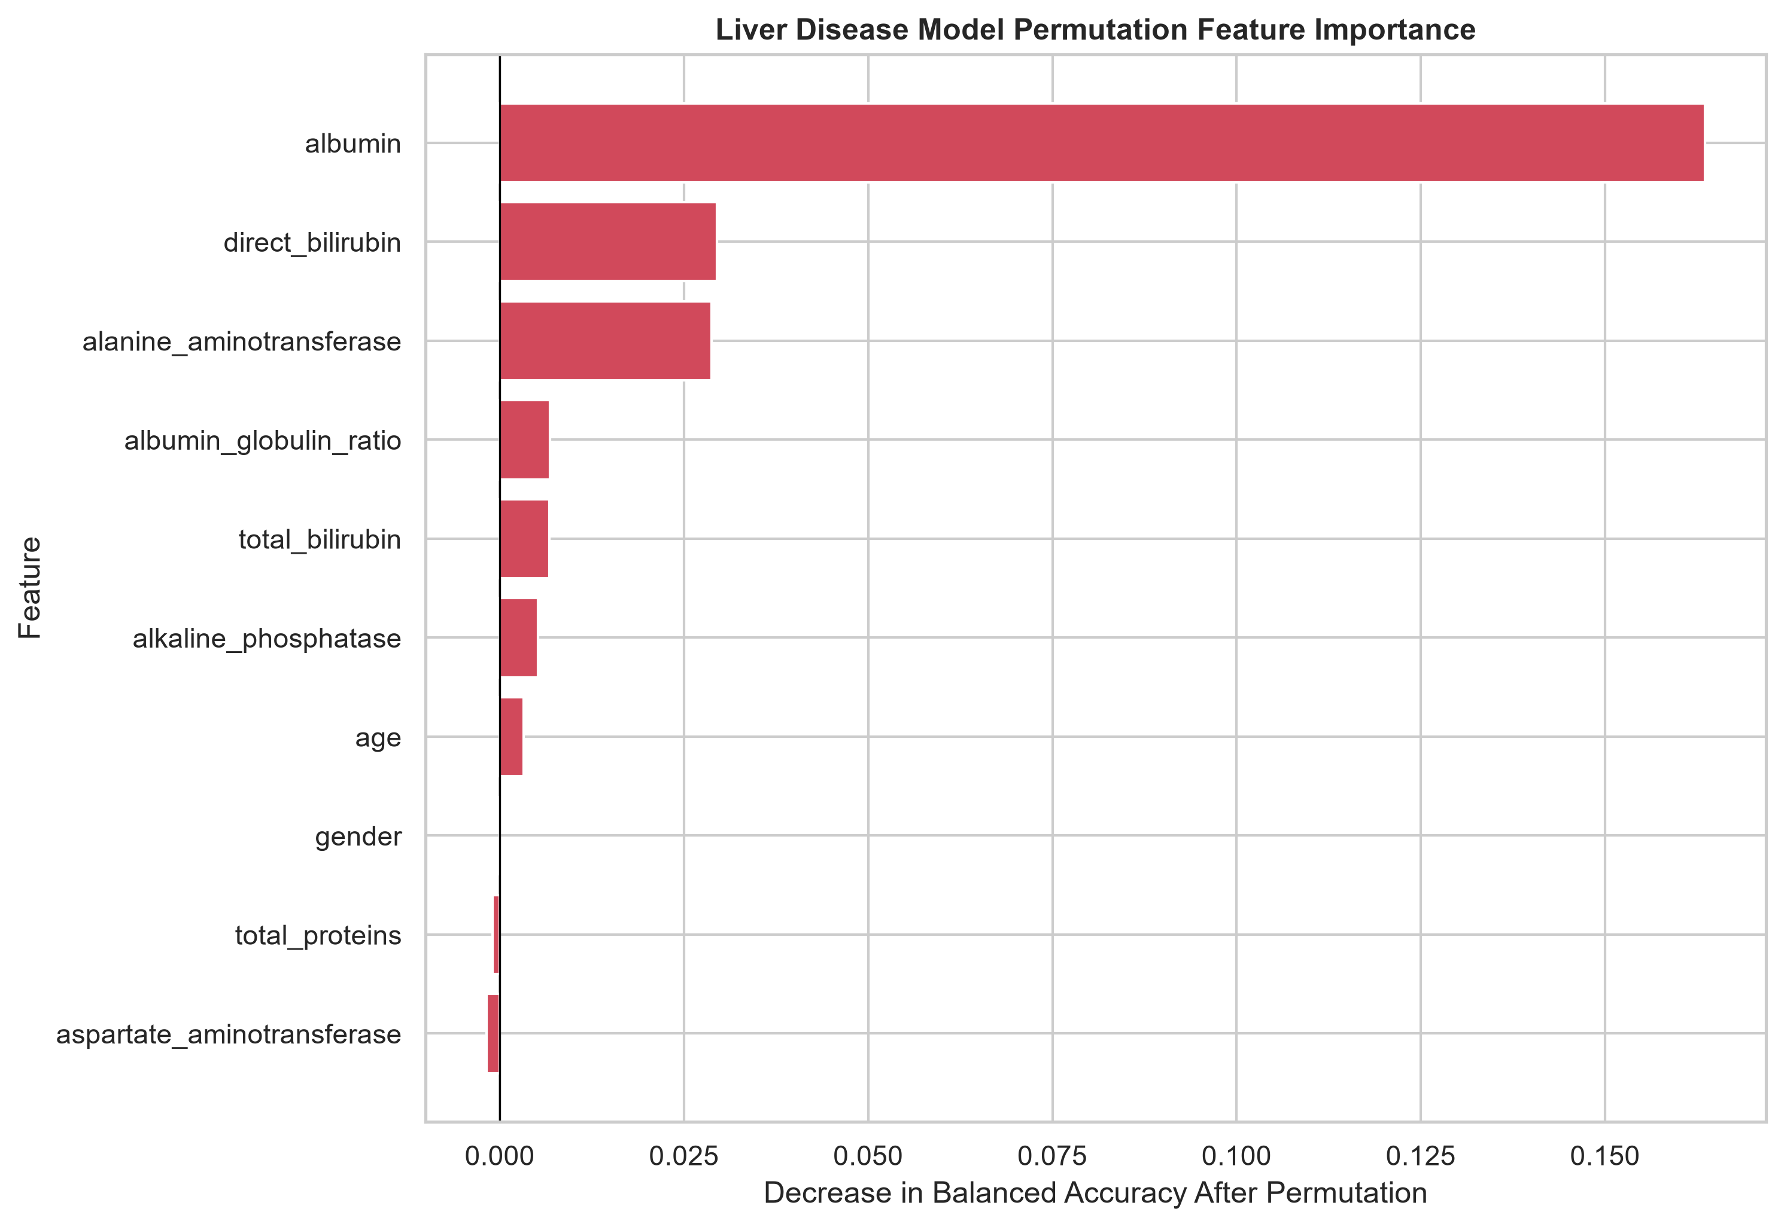
Figure 10. Liver-disease target, gender, and target-by-gender overview. | Figure 11. Permutation feature importance for the liver-disease model.

The dataset contains more positive liver-disease records than negative records and shows a male-dominant sample profile. Albumin, bilirubin-related measurements, and liver-enzyme variables contribute materially to the model.

7.2 Final Evaluation
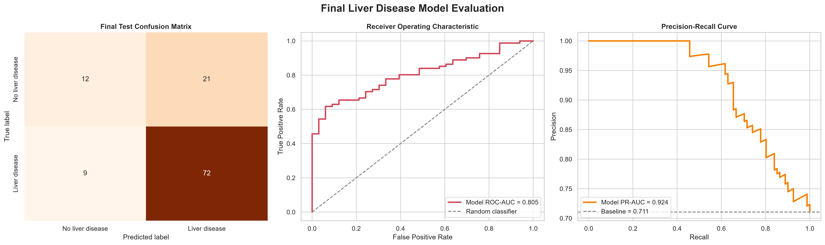
Figure 12. Final liver-disease evaluation with confusion matrix, ROC curve, and precision-recall curve.
Logistic Regression was selected with threshold 0.295. Test accuracy was 0.7368, precision 0.7742, recall 0.8889, F1 score 0.8276, and ROC-AUC 0.8047. Balanced accuracy was lower at 0.6263, indicating better positive-class sensitivity than balanced discrimination across both classes.

8. Respiratory Disease / Asthma Module
The respiratory module uses age, gender, smoking status, and peak flow. Patient_ID was removed as an identifier. Medication was deliberately excluded because it strongly encoded whether asthma had already been diagnosed, which would create target leakage and artificially inflate performance.

8.1 Exploration and Leakage-Aware Feature Set
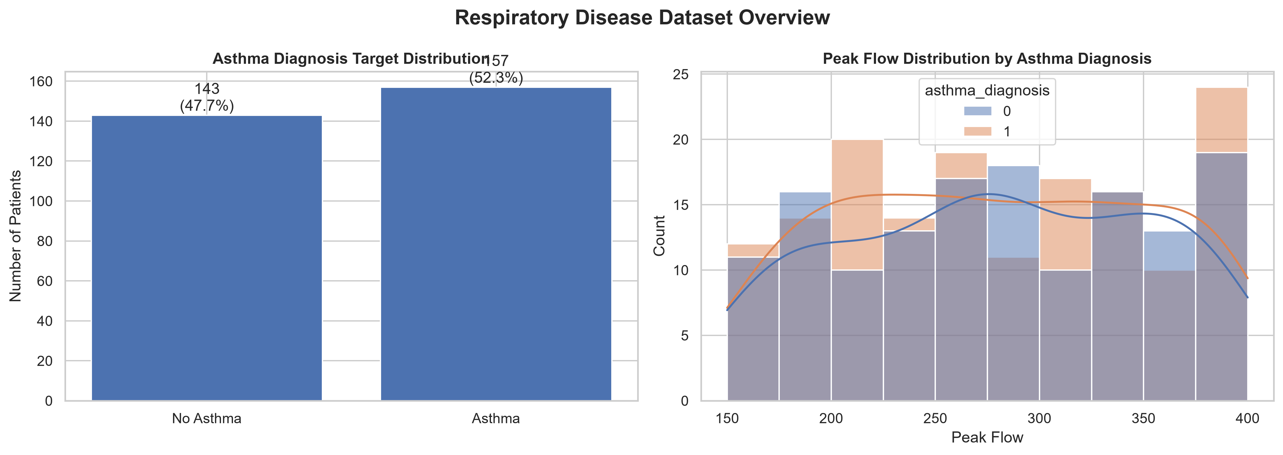 | 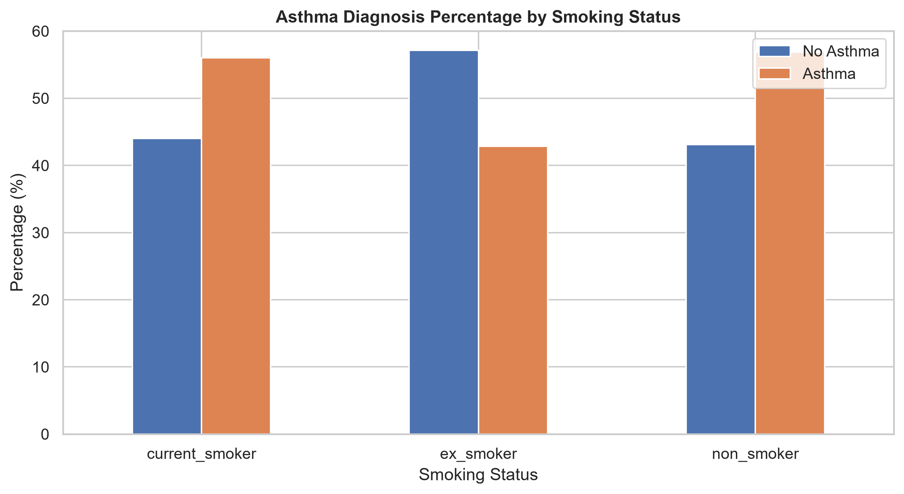
Figure 13. Asthma target distribution and peak-flow distribution by class. | Figure 14. Asthma diagnosis percentage across smoking-status categories.

The target classes are relatively balanced, but peak-flow distributions overlap substantially. Smoking status changes class proportions but does not create a clean separation. These figures help explain why the leakage-free feature set has limited discrimination.

8.2 Final Evaluation
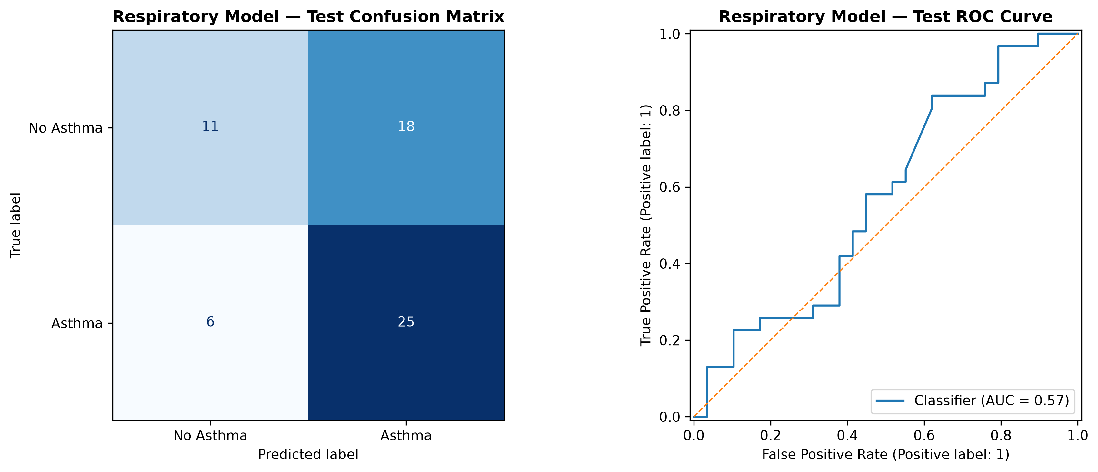
Figure 15. Final respiratory model evaluation with confusion matrix and ROC curve.
Support Vector Machine was selected with threshold 0.495. The held-out accuracy was 0.6000, recall 0.8065, F1 score 0.6757, and ROC-AUC 0.5717. Although this is the weakest discrimination result in the project, it is methodologically more defensible than a high score obtained by allowing Medication to leak the target into the model inputs.
Academic significance: Preventing leakage is more important than maximizing apparent accuracy. The respiratory result demonstrates this principle directly.

9. Breast Cancer Module
The breast-cancer module uses the Wisconsin Diagnostic Breast Cancer dataset. The raw sample identifier and an empty source column are removed. All 30 numerical diagnostic measurements are retained for model training.

9.1 Target and Feature Behavior
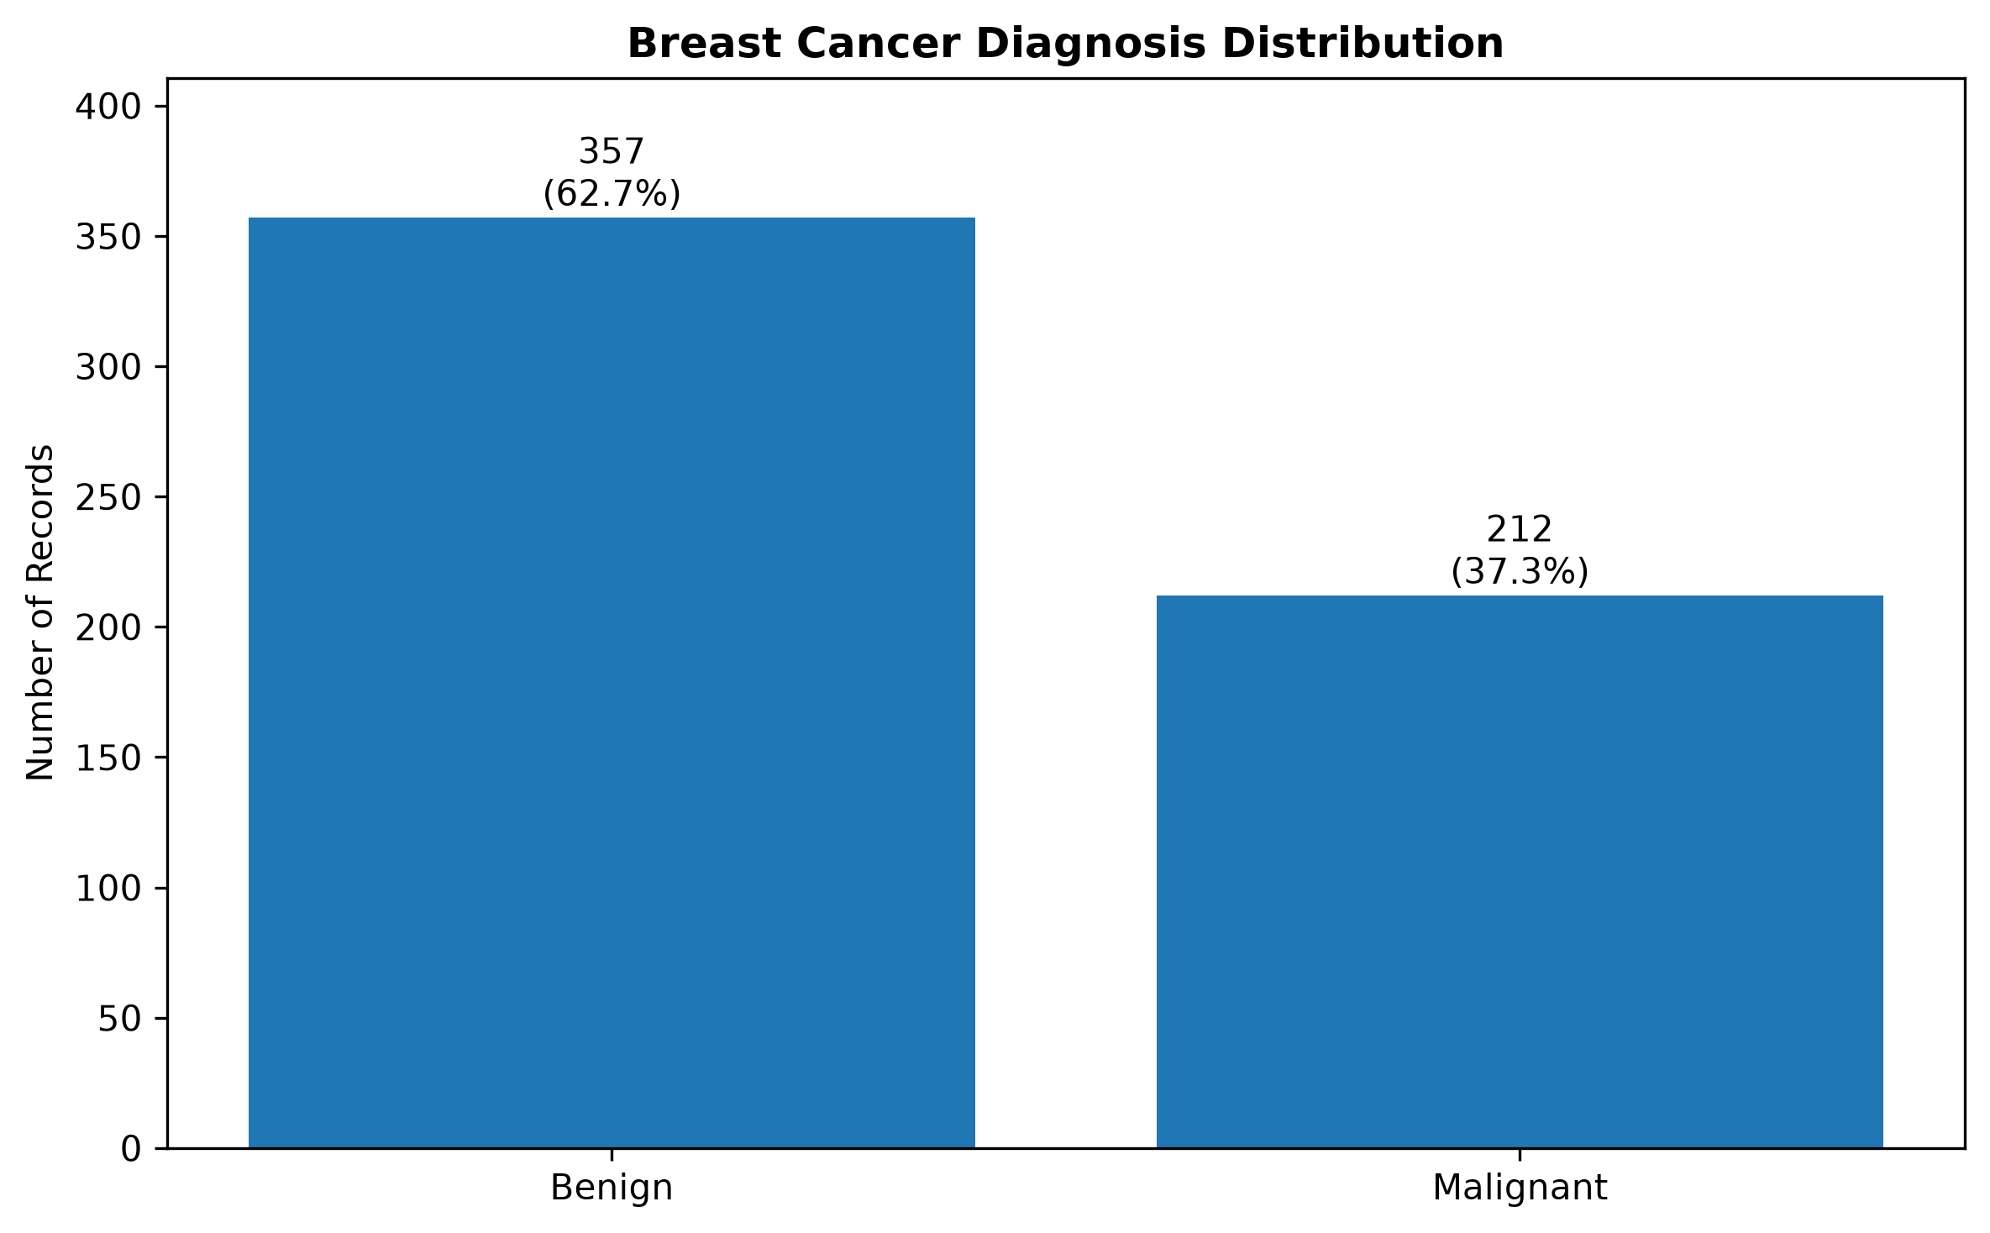 | 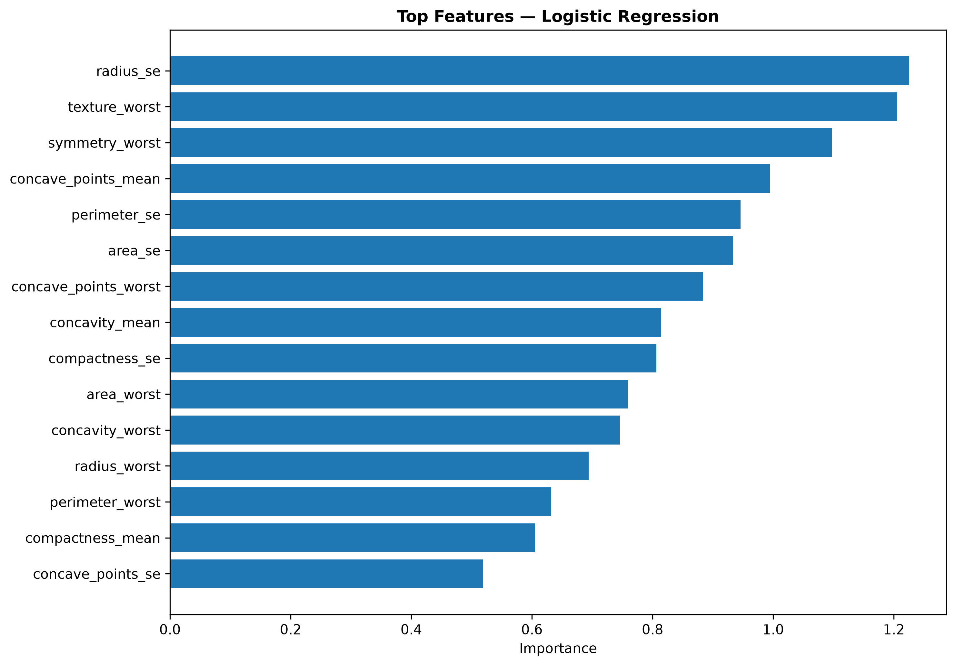
Figure 16. Breast-cancer diagnosis distribution: benign versus malignant. | Figure 17. Top feature contributions for the selected breast-cancer model.

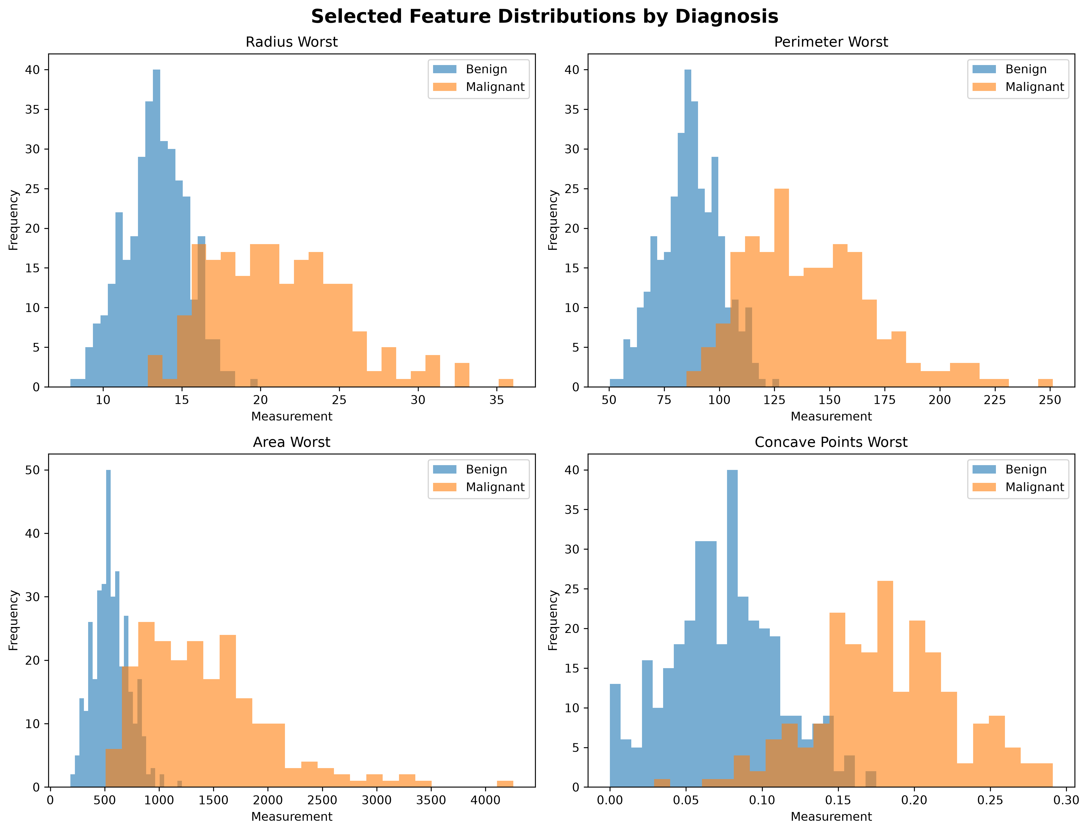
Figure 18. Selected diagnostic feature distributions for benign and malignant classes.
Malignant samples tend to occupy higher ranges for several geometric and boundary-irregularity measurements. Worst-case radius, perimeter, area, and concave-point measurements provide strong discriminative information.

9.2 Final Evaluation
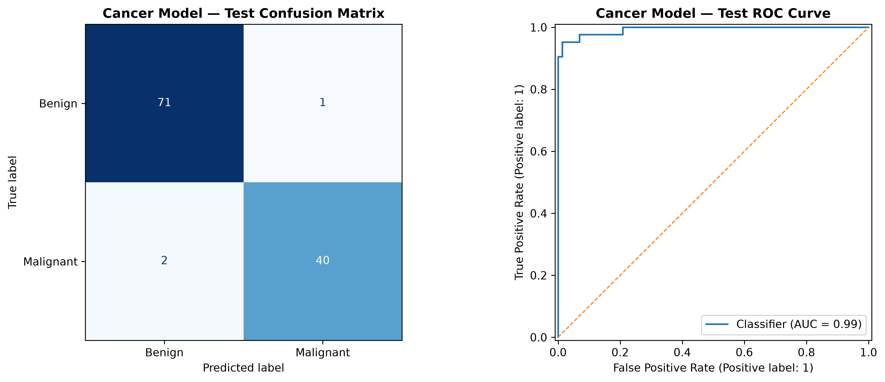
Figure 19. Final breast-cancer evaluation with confusion matrix and ROC curve.
Logistic Regression was selected with threshold 0.330. Test accuracy was 0.9737, precision 0.9756, recall 0.9524, F1 score 0.9639, and ROC-AUC 0.9927. The model therefore achieved strong discrimination between benign and malignant classes in the held-out test subset.

10. Comparative Results and Discussion
The following table summarizes the held-out test results extracted from the saved model artifacts. These values are the official final metrics for the report. The datasets are independent, so the numbers should be interpreted within each experiment rather than as a direct comparison of clinical disease difficulty.
Disease | Selected Model | Accuracy | Precision | Recall | F1 | ROC-AUC
Diabetes | HistGradientBoostingClassifier | 0.7510 | 0.3284 | 0.7530 | 0.4574 | 0.8313
Heart Disease | Logistic Regression | 0.8478 | 0.8246 | 0.9216 | 0.8704 | 0.9085
Chronic Kidney Disease | Logistic Regression | 0.9750 | 0.9615 | 1.0000 | 0.9804 | 1.0000
Liver Disease | Logistic Regression | 0.7368 | 0.7742 | 0.8889 | 0.8276 | 0.8047
Respiratory Disease | Support Vector Machine | 0.6000 | 0.5814 | 0.8065 | 0.6757 | 0.5717
Breast Cancer | Logistic Regression | 0.9737 | 0.9756 | 0.9524 | 0.9639 | 0.9927
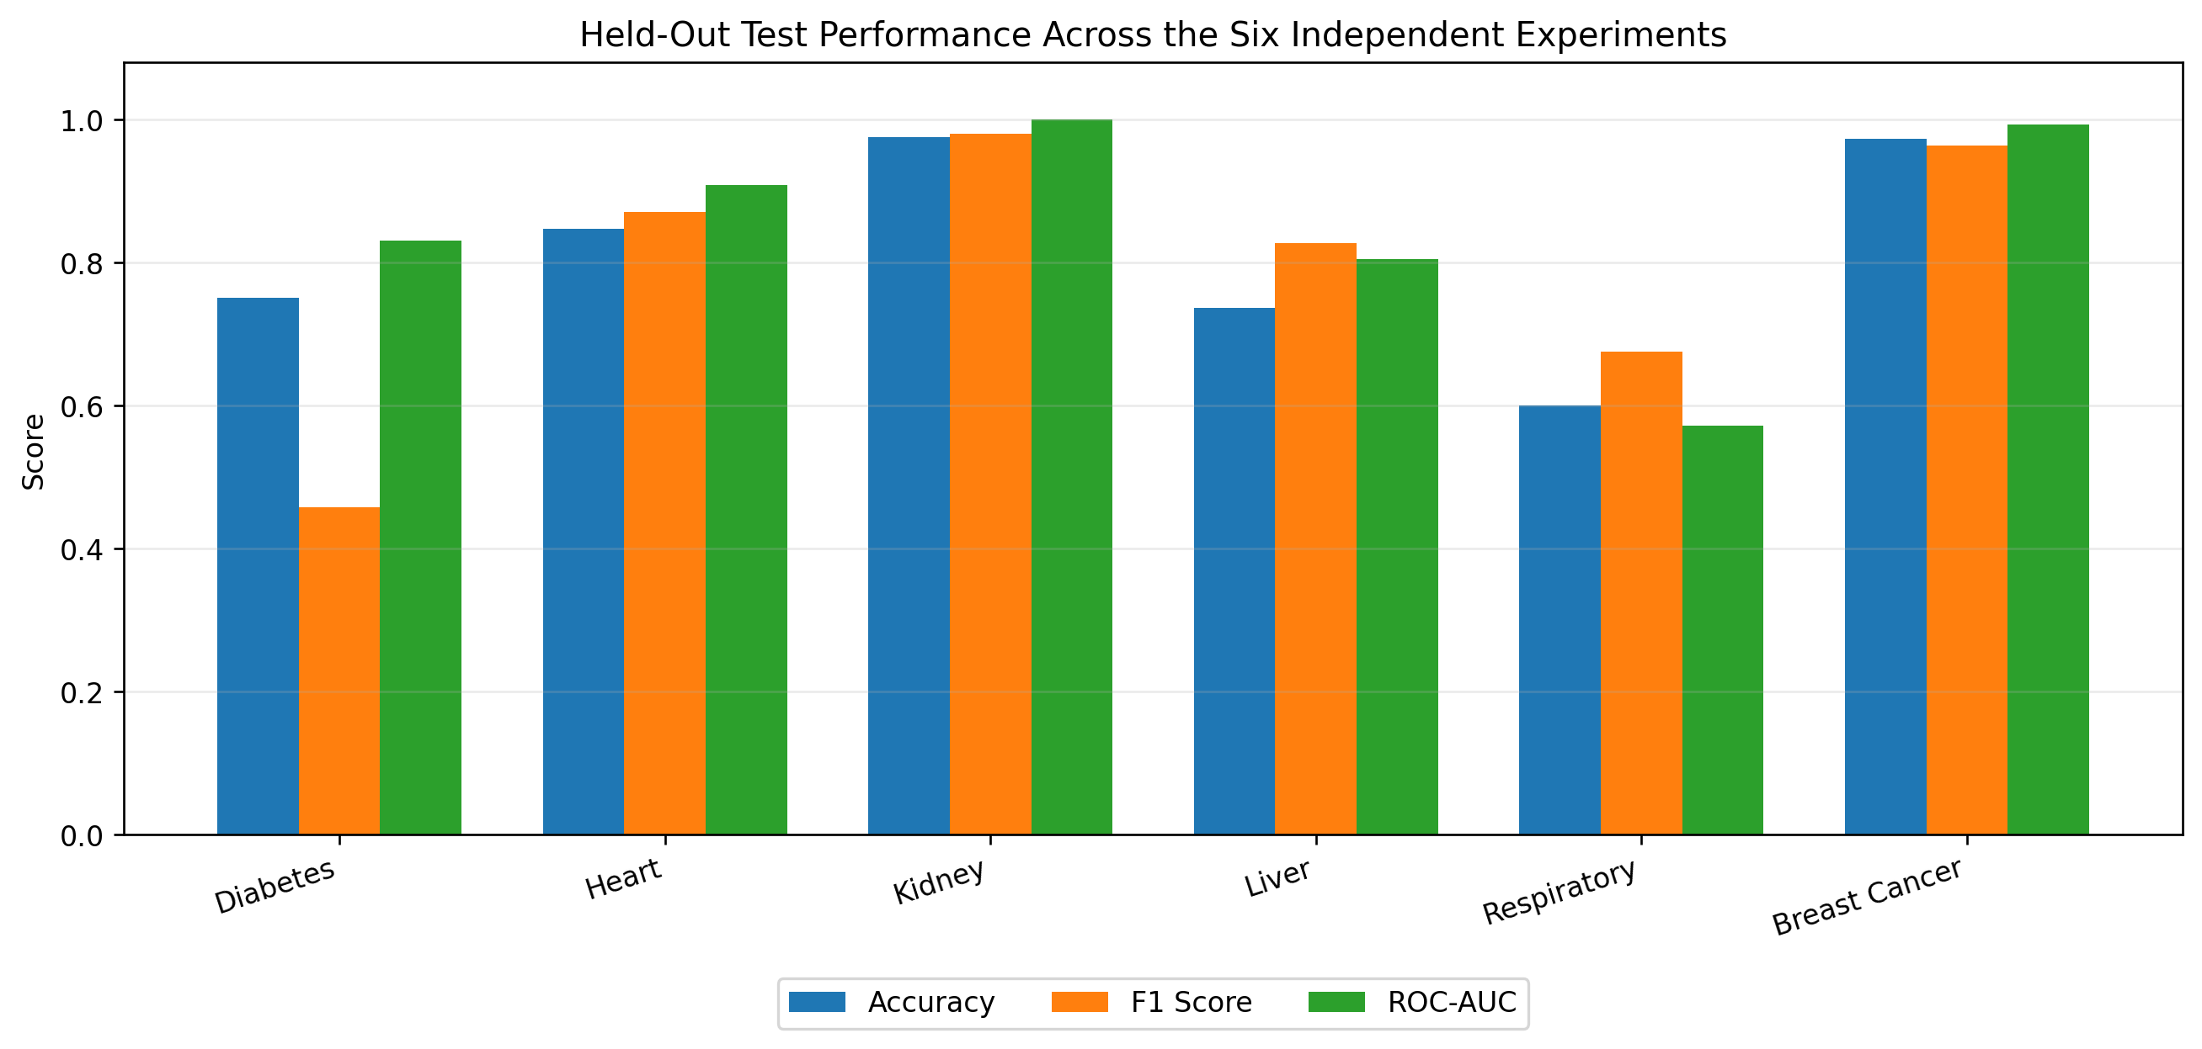
Figure 20. Accuracy, F1 score, and ROC-AUC across the six independent held-out experiments.

10.1 Decision Thresholds
Disease | Threshold | Rationale
Diabetes | 0.547 | Validation-based operating point stored with the model artifact.
Heart Disease | 0.313 | Validation-based operating point stored with the model artifact.
Chronic Kidney Disease | 0.091 | Validation-based operating point stored with the model artifact.
Liver Disease | 0.295 | Validation-based operating point stored with the model artifact.
Respiratory Disease | 0.495 | Validation-based operating point stored with the model artifact.
Breast Cancer | 0.330 | Validation-based operating point stored with the model artifact.

10.2 Main Findings
- Chronic Kidney Disease achieved the strongest held-out test performance (accuracy 0.9750; ROC-AUC 1.0000).
- Breast Cancer also achieved strong discrimination (accuracy 0.9737; ROC-AUC 0.9927).
- Heart Disease produced a balanced result with recall above 0.92 and ROC-AUC above 0.90.
- Liver Disease achieved high recall but lower balanced accuracy, indicating asymmetric class performance.
- Diabetes achieved useful ROC-AUC and recall, but low precision indicates a higher false-positive burden.
- Respiratory Disease had limited ROC-AUC after leakage-prone Medication was excluded; this is a methodological strength rather than a reason to reintroduce leakage.

11. Streamlit Application and Deployment
The deployment layer is implemented in Streamlit. The main page acts as an academic dashboard and links to six disease-specific modules. Every page loads its corresponding joblib artifact, reconstructs the feature order expected by the trained pipeline, collects user inputs, computes a model score, applies the stored decision threshold, and presents an educational result.
- Six disease pages are available from one main navigation interface.
- Each module loads its own model artifact and required features.
- Model score and decision threshold are displayed where applicable.
- Input validation prevents obvious impossible relationships in selected modules.
- Result wording explicitly states that the system is educational and not a medical diagnosis.
- A Windows batch launcher starts the application using the project virtual environment.
Deployment principle: The conversation between preprocessing metadata, trained pipeline, and Streamlit inputs is preserved by storing feature order and threshold information with the model artifact.

12. Final Quality Assurance
A final quality-check workflow was added before submission. The automated script verifies the core application files, Python syntax, required dependencies, model artifact loading, and release-folder hygiene. The six Streamlit modules were then tested end-to-end manually.
- All six Streamlit page files present.
- All six model artifacts load successfully.
- Core Python files pass syntax validation.
- Required runtime libraries are available in the project virtual environment.
- No duplicate release main file is used.
- All six pages open and generate a model result without missing-feature errors.

13. Limitations and Ethical Use
- The six datasets differ in size, feature type, data-collection process, and class distribution.
- Some datasets are small and may produce optimistic or unstable estimates.
- Some modules use screening-style indicators, while cancer uses diagnostic measurements from a breast mass.
- Model scores are not calibrated clinical probabilities unless calibration is explicitly performed.
- The respiratory dataset contains limited predictive information after leakage prevention.
- The system has not undergone prospective clinical validation.
- The software is an academic AI demonstration and must not replace professional medical evaluation.
Required wording: Predictions should be described as machine-learning classifications, risk indicators, or educational screening outputs - not medical diagnoses.

14. Conclusion
The Multi-Disease Machine Learning System successfully demonstrates an end-to-end supervised-learning workflow across six independent healthcare classification tasks. The project includes data exploration, preprocessing, leakage prevention, model comparison, validation-based model and threshold selection, held-out evaluation, artifact serialization, Streamlit integration, and final quality assurance.
The strongest held-out results were observed for chronic kidney disease and breast cancer. The respiratory module provided an equally important academic lesson: preserving methodological integrity by removing target leakage is more valuable than reporting artificially high accuracy. Overall, the project meets its objective of showing how multiple machine-learning models can be engineered, evaluated, and deployed within a unified academic AI application.

15. References
[1] Centers for Disease Control and Prevention (CDC). Behavioral Risk Factor Surveillance System (BRFSS), 2015. Diabetes Health Indicators data derived from BRFSS records.
[2] Janosi, A., Steinbrunn, W., Pfisterer, M., and Detrano, R. Heart Disease. UCI Machine Learning Repository. UCI-derived heart-disease data used in the project.
[3] Rubini, L., Soundarapandian, P., and Eswaran, P. (2015). Chronic Kidney Disease. UCI Machine Learning Repository. DOI: 10.24432/C5G020.
[4] Indian Liver Patient Dataset (ILPD). UCI Machine Learning Repository / BUPA Medical Research-derived dataset used for the liver module.
[5] COPD (Asthma) Patient Dataset. Kaggle dataset used for the respiratory/asthma module; project file: asthma_dataset.csv.
[6] Wolberg, W. H., Street, W. N., and Mangasarian, O. L. Breast Cancer Wisconsin (Diagnostic). UCI Machine Learning Repository.
[7] Pedregosa, F. et al. (2011). Scikit-learn: Machine Learning in Python. Journal of Machine Learning Research, 12, 2825-2830.
[8] Streamlit documentation. Streamlit: an open-source Python framework for data applications.

Appendix A. Supplementary Exploration Figures
The following supplementary figures were generated during the exploration notebooks and retained as supporting evidence for the final report.
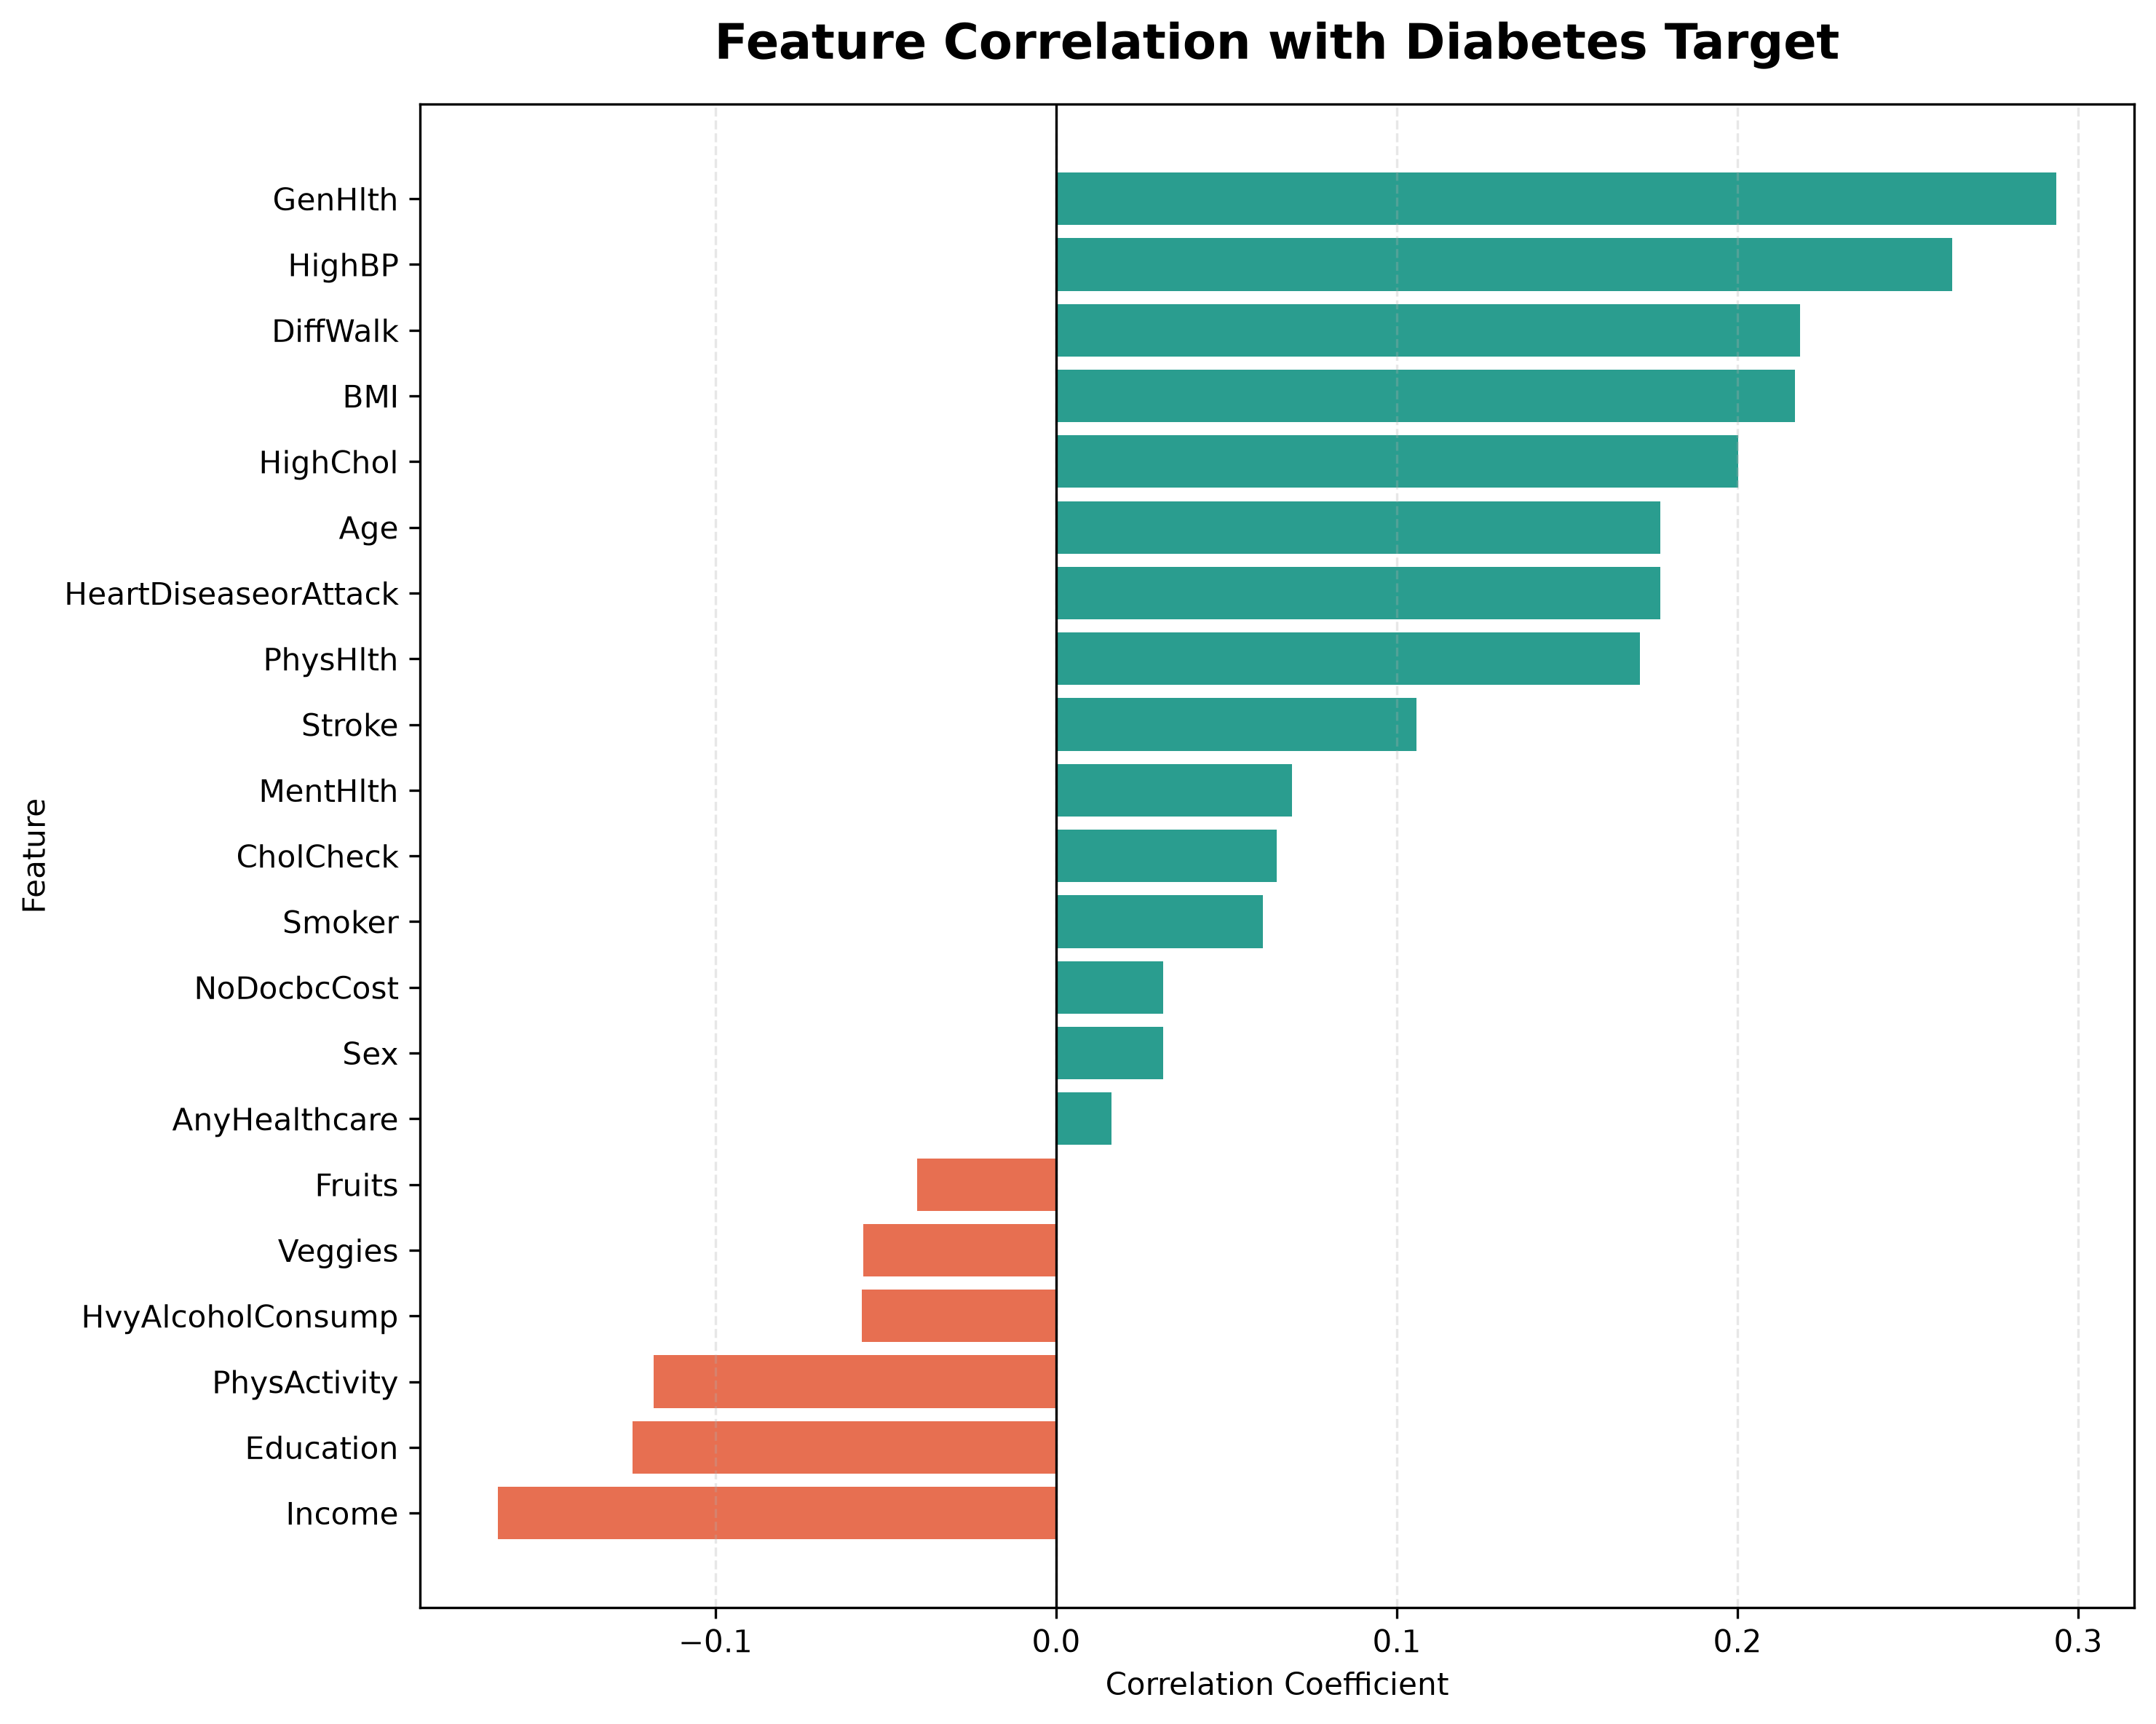 | 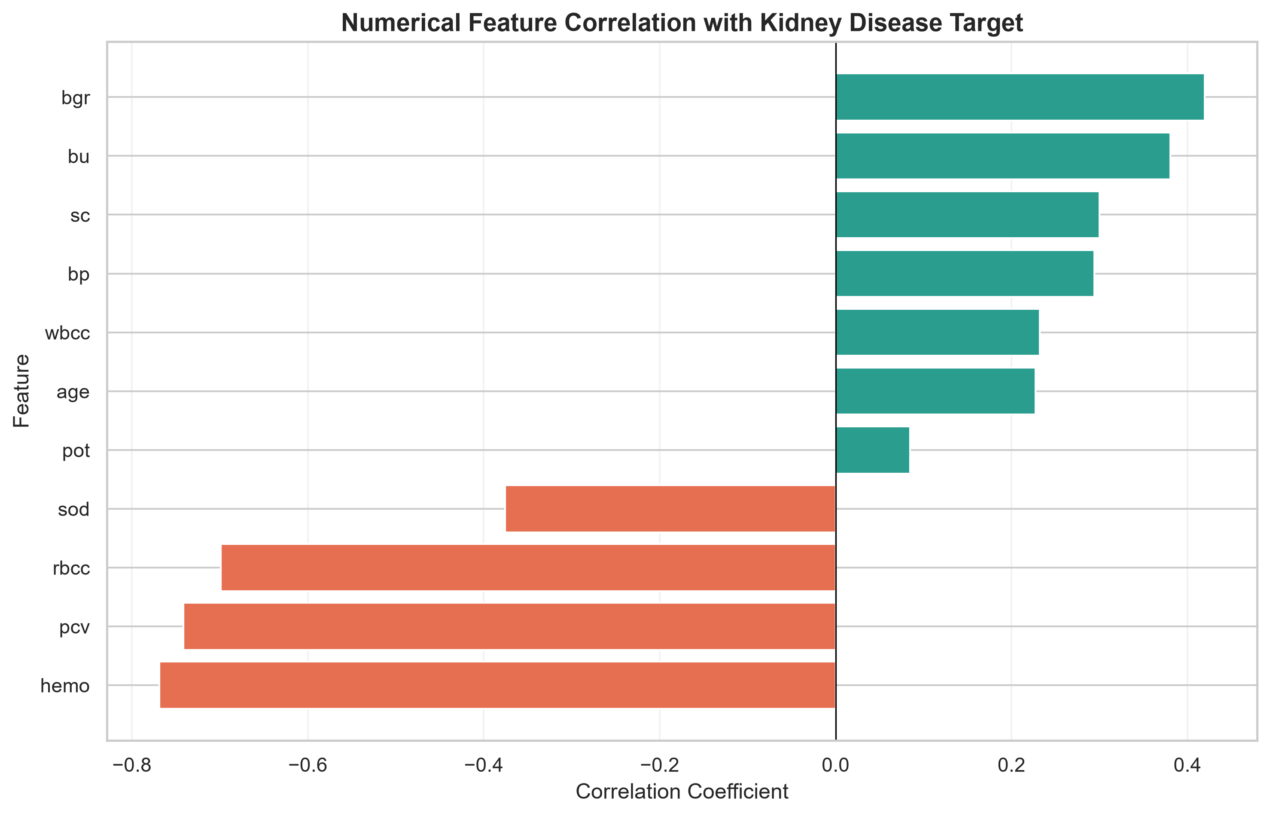
Figure A1. Correlation of health indicators with the diabetes target. | Figure A2. Numerical feature correlation with the CKD target.

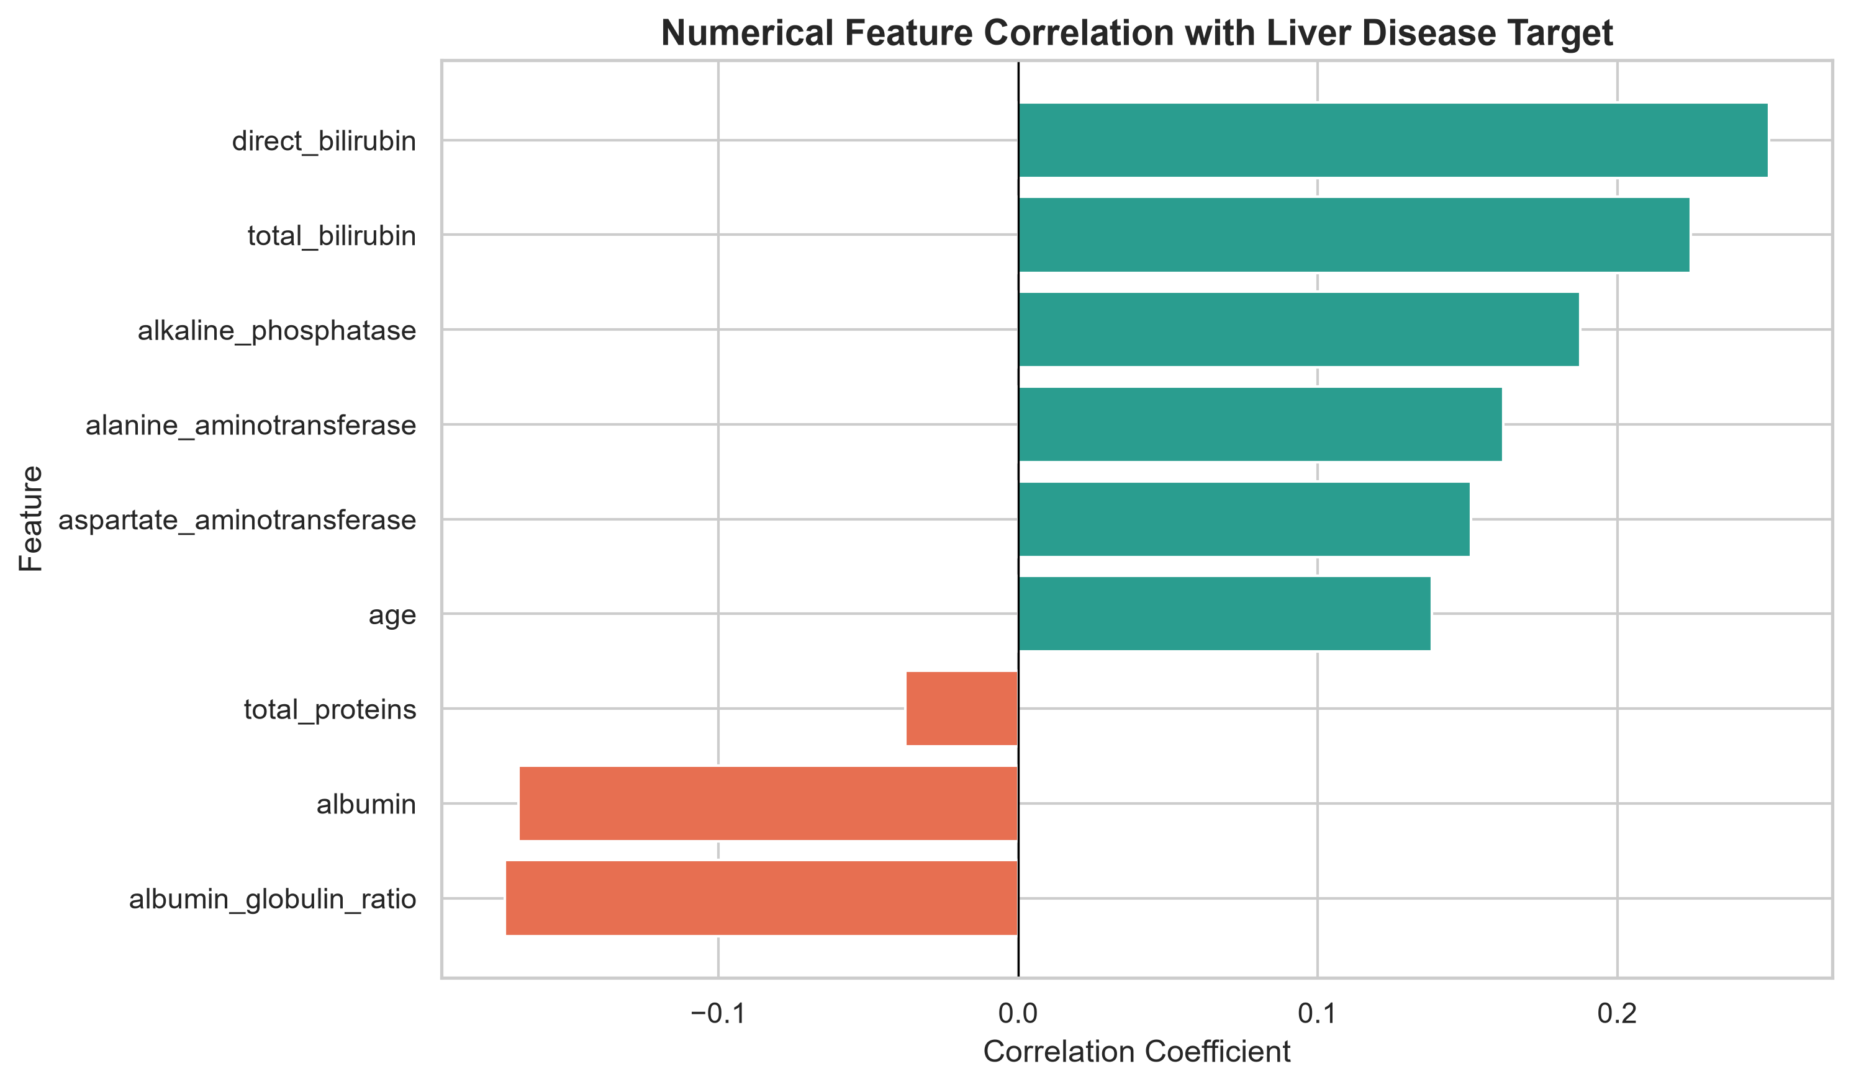 | 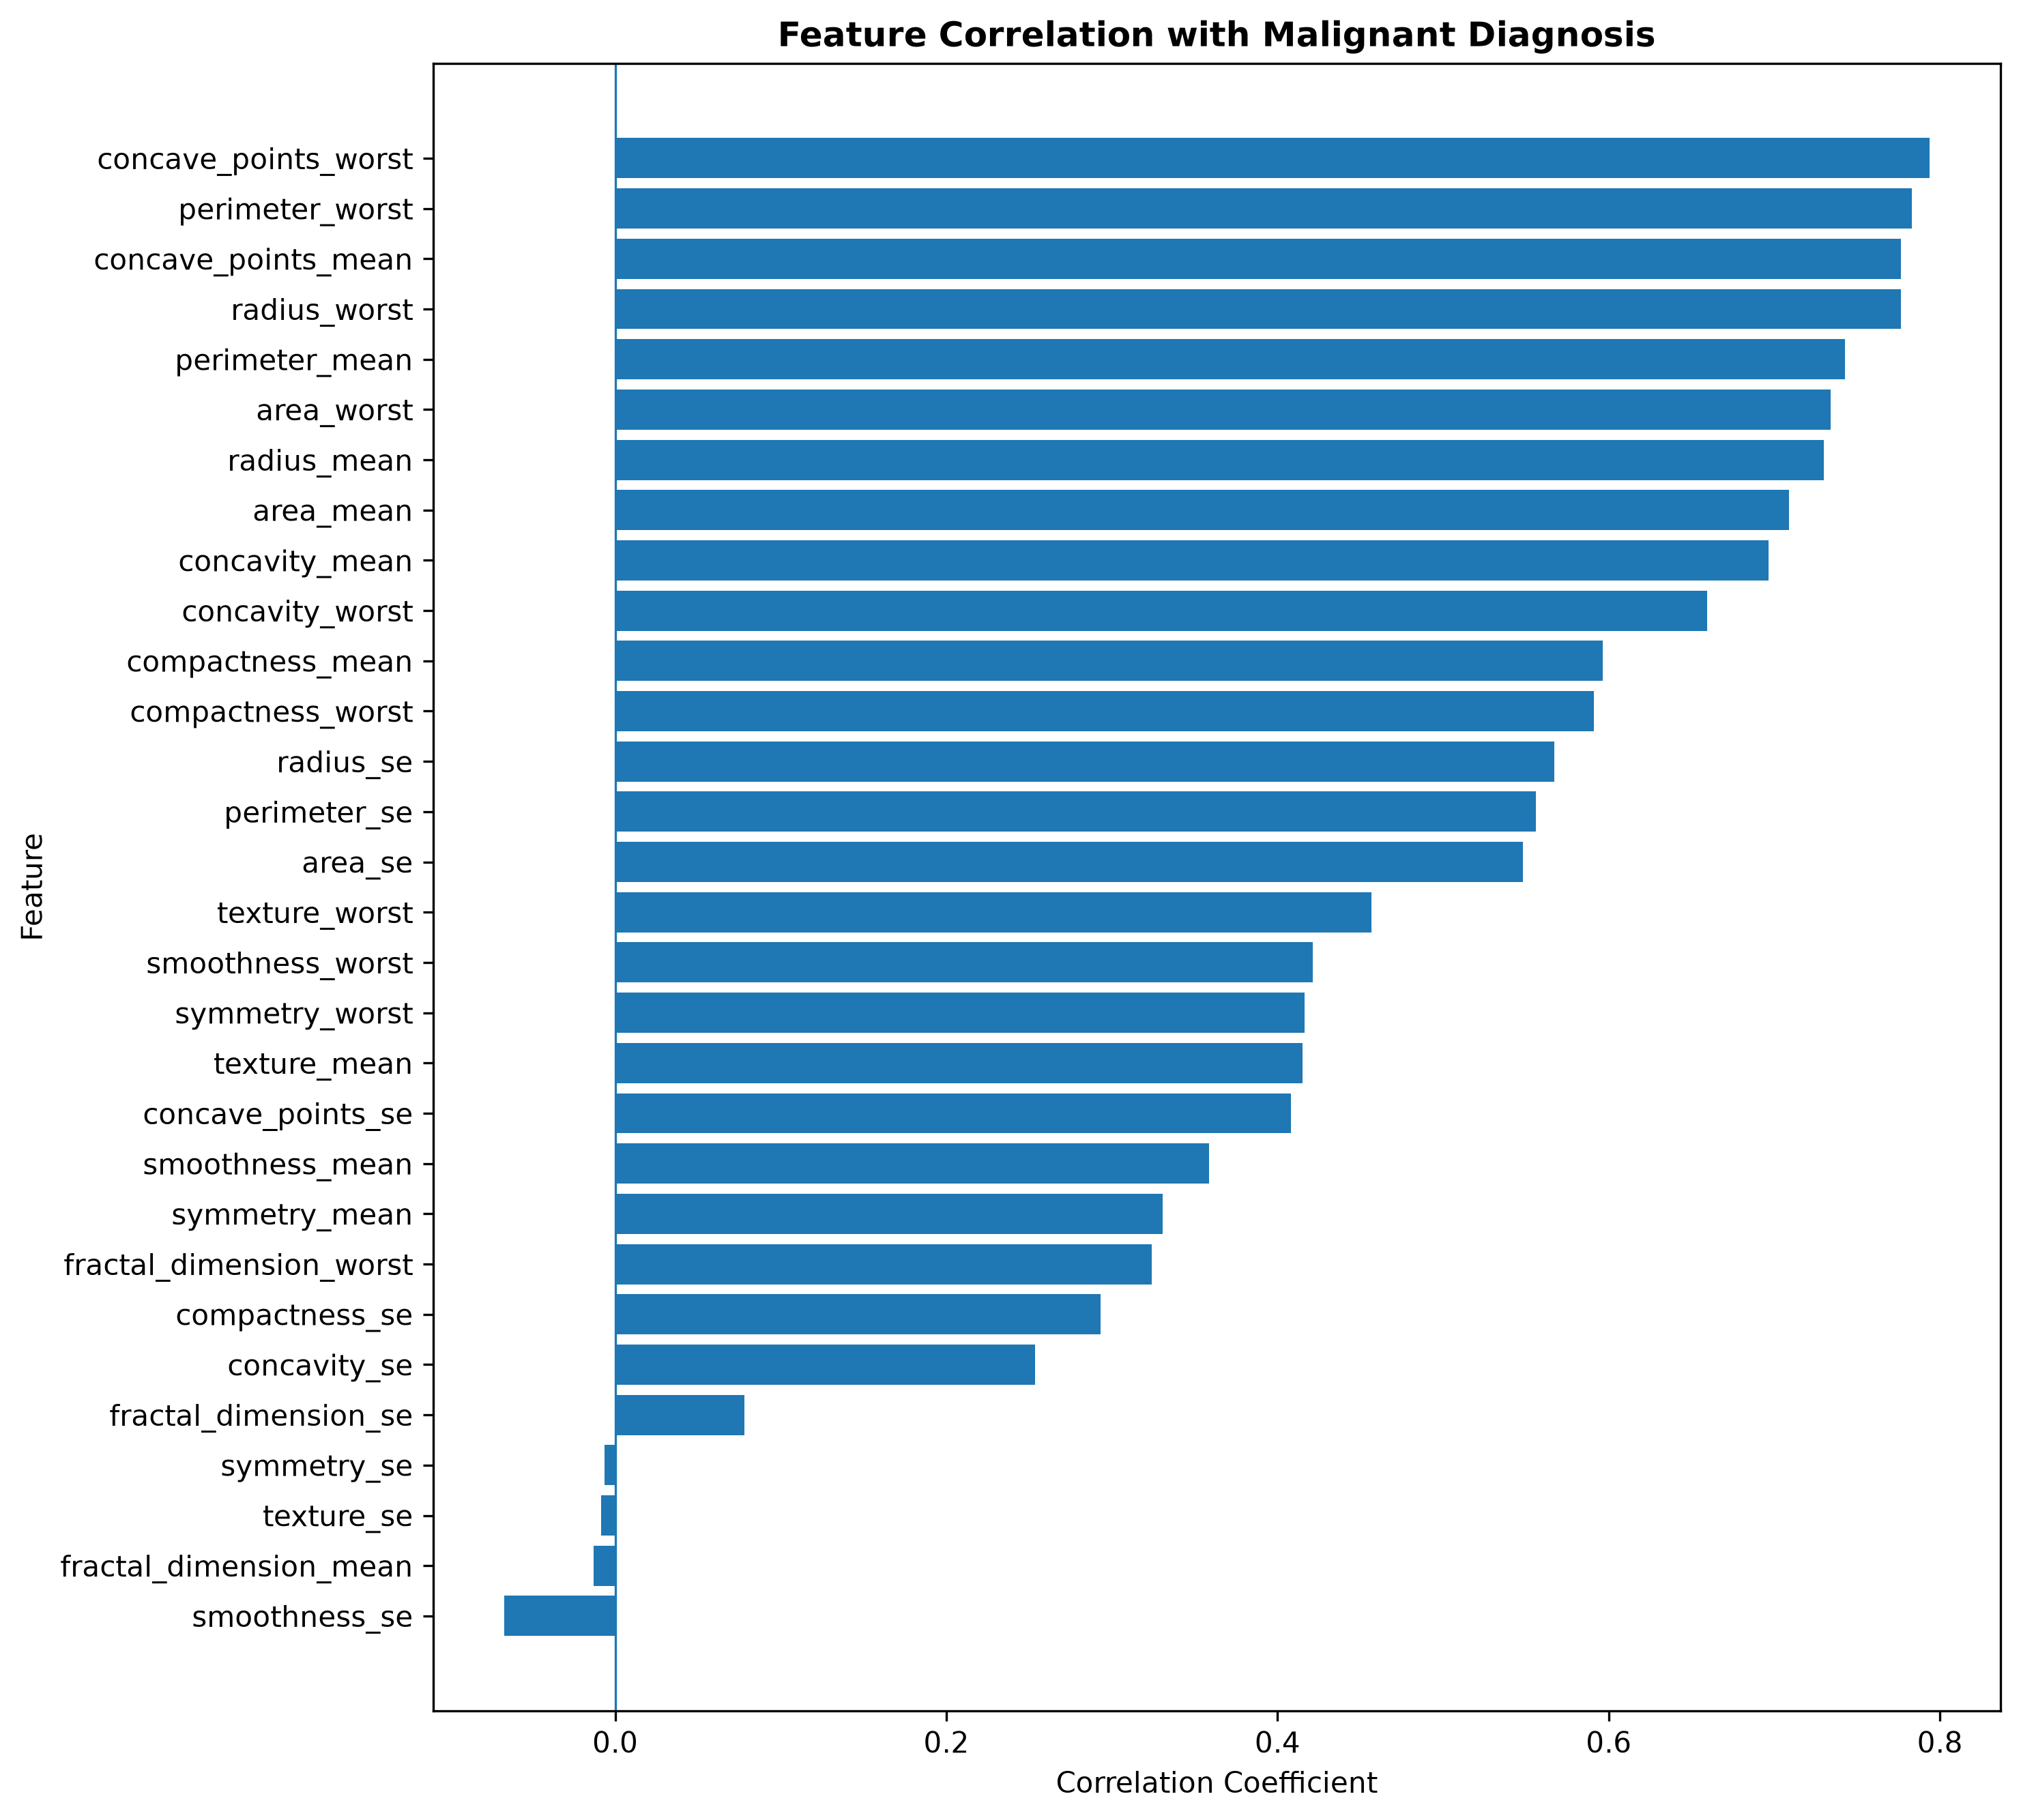
Figure A3. Numerical feature correlation with the liver-disease target. | Figure A4. Correlation of the 30 diagnostic measurements with malignant diagnosis.

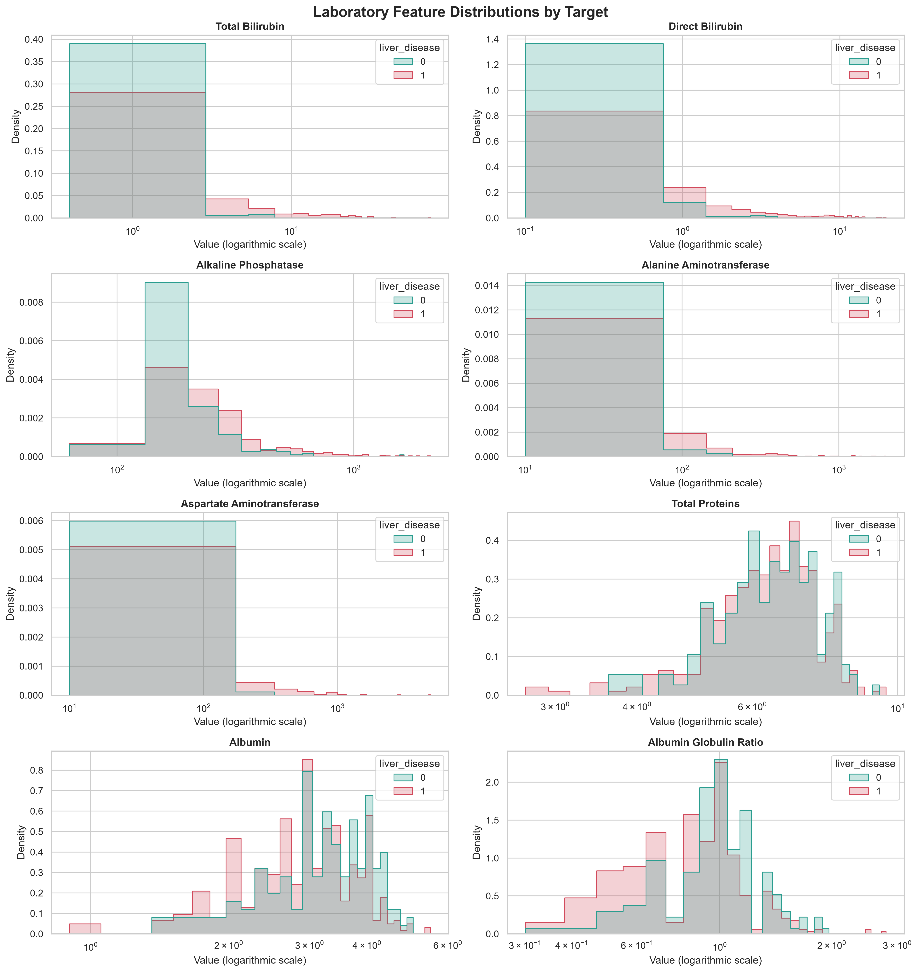
Figure A5. Distribution of liver laboratory measurements by target class.

