Document
Date: 2026-10-18 | Version: 1.0

Table of Contents
1. Executive Summary
2. Architecture Overview
3. Processing Pipeline
4. Core Components
5. API Contracts and Message Schemas
6. Infrastructure and Deployment
7. Extension Patterns
8. Rules and Anti-Patterns
9. Dependencies
10. Code Structure
Verification Notes

1. Executive Summary
Credit Application Encoder is a Dockerized FastAPI application that turns semi-structured credit application text into a completed copy of an Excel template. It parses borrower and co-maker sections, maps label variants to a stable schema, normalizes common formats, reports warnings and validation issues, and writes recognized values into the supplied workbook. It preserves merged-cell destinations and template OOXML drawing parts that openpyxl may not round-trip.

2. Architecture Overview
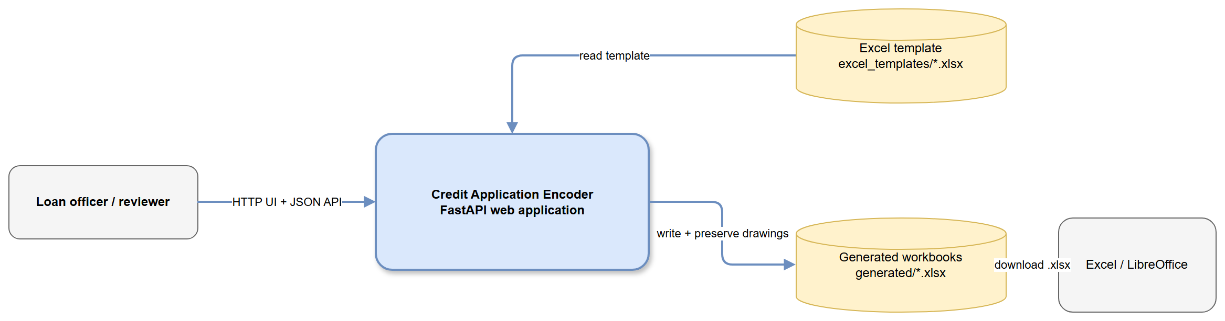
High-Level Architecture
app/main.py registers the FastAPI app, static assets, and routes. The browser submits raw text to /api/parse, reviews normalized ApplicationData, then submits /api/generate. Generated workbooks are stored under generated/ and downloaded through /api/download/{filename}. /health reports template existence and workbook structure.

3. Processing Pipeline
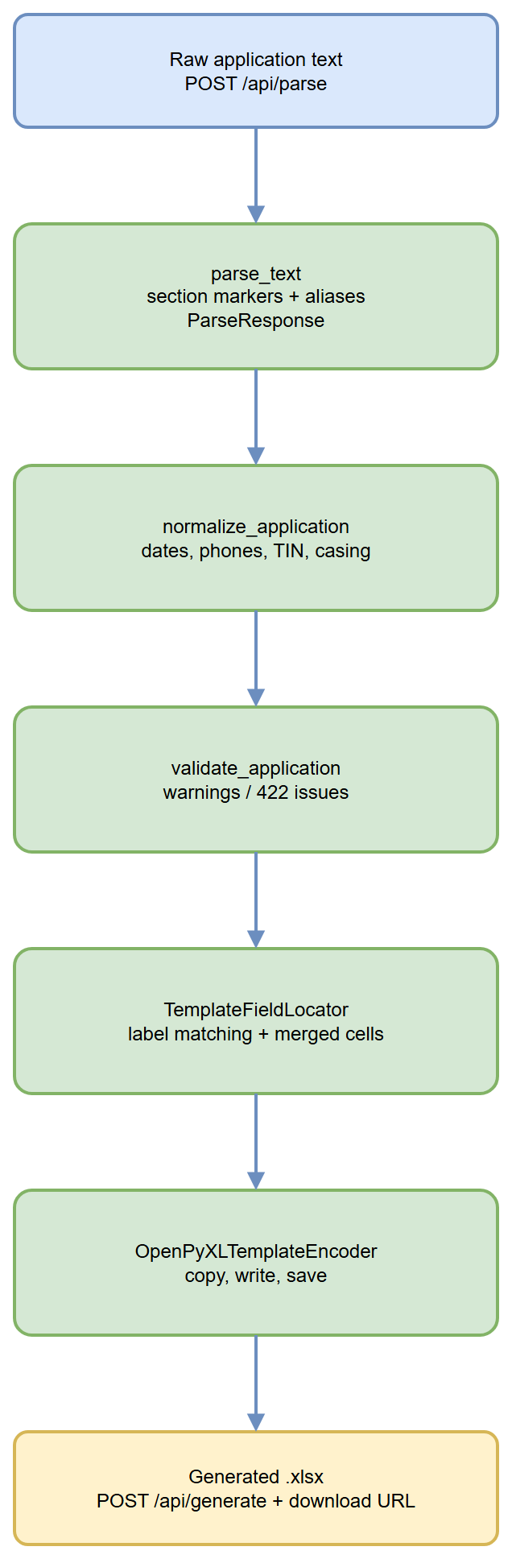
Processing Pipeline
1. ParseRequest accepts non-empty raw_text.
2. parse_text recognizes borrower and co-maker section markers, parses LABEL: value and LABEL#value lines, supports continuation lines, and records warnings, conflicts, and source values.
3. normalize_application formats dates as MM/DD/YYYY, groups phone numbers and nine-digit TINs, lowercases email addresses, and uppercases most text fields.
4. validate_application checks real date formatting and recognized housing statuses. Generation returns HTTP 422 for issues unless accept_errors is true.
5. TemplateFieldLocator resolves labels through FIELD_ALIASES, section boundaries, explicit age destinations, merged-cell rules, and occupied-adjacent-label fallback behavior.
6. OpenPyXLTemplateEncoder writes a timestamped workbook copy, refuses to generate when no recognized labels were written, and invokes FloatingObjectPreserver after saving.

4. Core Components
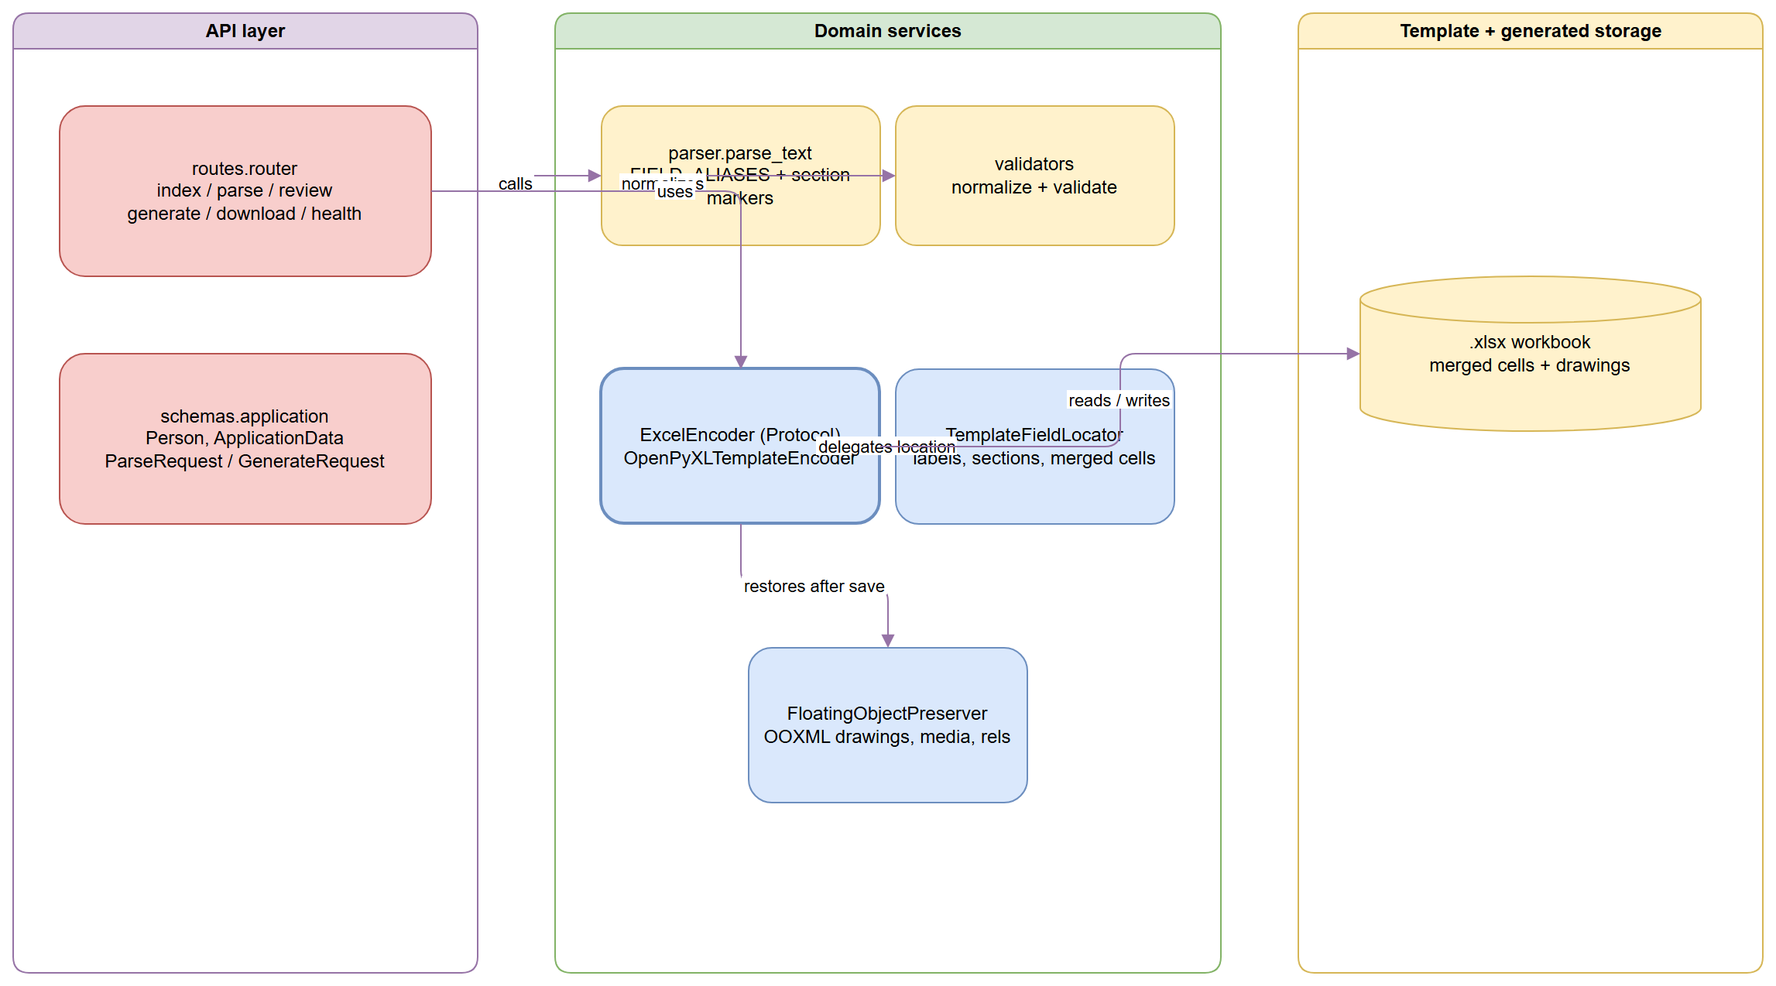
Component Relationships
Component | Responsibility | Location
FastAPI application | Static files, templates, and route registration | app/main.py
Route layer | Browser pages and parse/generate/download/health endpoints | app/api/routes.py
Domain schema | Pydantic request, response, and application models | app/schemas/application.py
Parser | Section-aware text extraction and alias resolution | app/services/parser.py
Field map | Canonical fields and accepted labels | app/services/field_map.py
Validators | Normalization and validation rules | app/services/validators.py
Encoder port | Replaceable workbook-writing contract | app/services/excel_encoder.py
Template locator | Label matching and writable-cell resolution | app/services/excel_encoder.py
OOXML preservation | Restores drawings, media, relationships, and worksheet object references | app/services/floating_objects.py

The ExcelEncoder protocol is the primary extension point. New label variants belong in FIELD_ALIASES; normalization rules belong in correct_value_format; workbook placement rules belong in TemplateFieldLocator.

5. API Contracts and Message Schemas
Method | Path | Input | Output / behavior
GET | / | Browser request | HTML entry page and template availability flag
POST | /api/parse | { "raw_text": string } | ParseResponse with data, warnings, conflicts, and source values
GET | /review | Browser request | HTML review page
POST | /api/generate | ApplicationData plus accept_errors | Filename and download URL; 422 for validation issues unless accepted
GET | /api/download/{filename} | Generated filename | Excel file; 404 if missing or outside generated storage
GET | /health | None | Status and inspected workbook metadata

ApplicationData contains unit, two preferred colors, and applicant and spouse Person objects. Person stores identity, contact, residence, employment, banking, and TIN fields. Both models allow extra fields for forward compatibility.

6. Infrastructure and Deployment
The Dockerfile uses python:3.12-slim, installs requirements.txt, copies the application, creates generated/, and starts Uvicorn on port 8000. compose.yaml publishes port 8000, mounts ./generated as writable output, mounts ./excel_templates read-only, and supplies GENERATED_DIR and TEMPLATE_PATH.
docker compose up --build

There is no external database or message broker. Durable inputs and outputs are filesystem volumes. Production deployment should protect generated-file access and ensure the template volume contains the expected workbook.

7. Extension Patterns
To support a new customer label, add it to the relevant canonical entry in app/services/field_map.py, then add parser and Excel output tests. To add normalization, update correct_value_format and cover the normalized value and validation behavior. To support another workbook format, implement ExcelEncoder.encode(template_path, output_dir, data). To support a new drawing or embedded-object type, extend the package prefixes and worksheet object restoration logic in FloatingObjectPreserver.

8. Rules and Anti-Patterns
The writer must not silently produce an unmapped workbook; it raises when no recognized labels were written. Prefer alias-based label matching over fixed coordinates, except for documented explicit destinations such as age fields. Always write to a generated copy. Keep download candidates inside GENERATED_DIR. Treat new template object types as a compatibility change and visually verify them in Excel or LibreOffice.

9. Dependencies
Category | Packages
Web API | fastapi==0.115.6, uvicorn==0.34.0
Templates / forms | jinja2==3.1.5, python-multipart==0.0.20
Workbook processing | openpyxl==3.1.5, Pillow==11.1.0
Testing | pytest==8.3.4, httpx==0.28.1

10. Code Structure
Path | Purpose
app/main.py | FastAPI application setup
app/api/routes.py | HTTP and HTML endpoints
app/core/config.py | Environment-backed paths
app/schemas/application.py | Pydantic contracts
app/services/ | Parser, validators, field map, Excel writer, encoder, and OOXML preservation
app/web/ | Templates and static browser assets
tests/ | Parser, validator, and Excel output tests
excel_templates/ | Source workbook mount
generated/ | Generated workbook output

Verification Notes
This summary was generated from the repository code graph and spot-checked against the route, schema, parser, validator, encoder, preservation, deployment, and test files. No credentials or connection strings are included.

