User Guide

Accessing PLO Database

1. Navigate to the following website *remotemysql.com* and left-click log in. This is our remote database where the slo-scraper dumps all the information it collects.

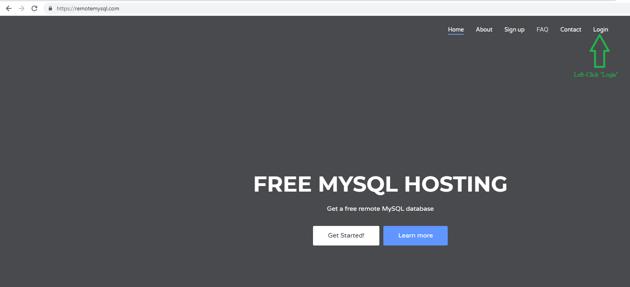

1. Enter the username *WlH9s7G8vy* and password *uH0YWN3msY* then click “go”. Administration of the database is handled through phpMyAdmin. 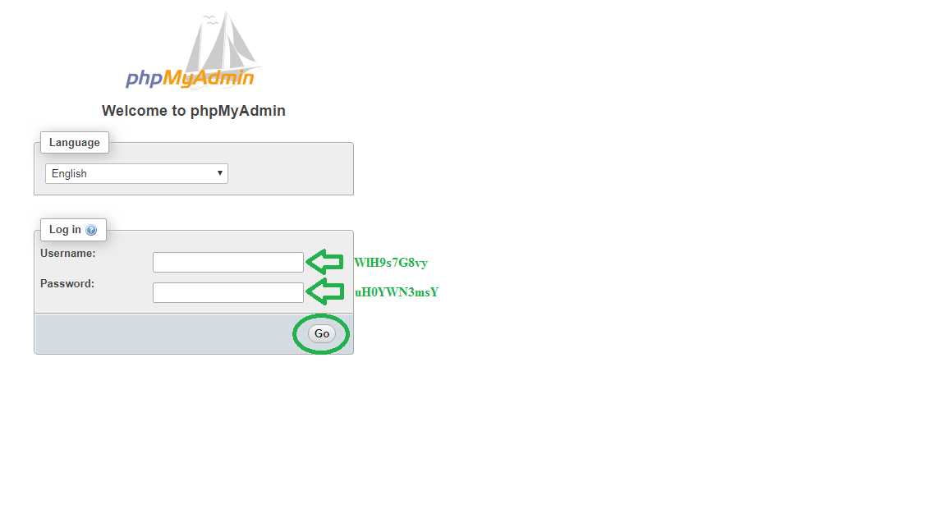
2. Left-click *WlH9s7G8vy* located on the left sidebar. This is the name of our database. It holds various, specific tables generated by slo-scraper.

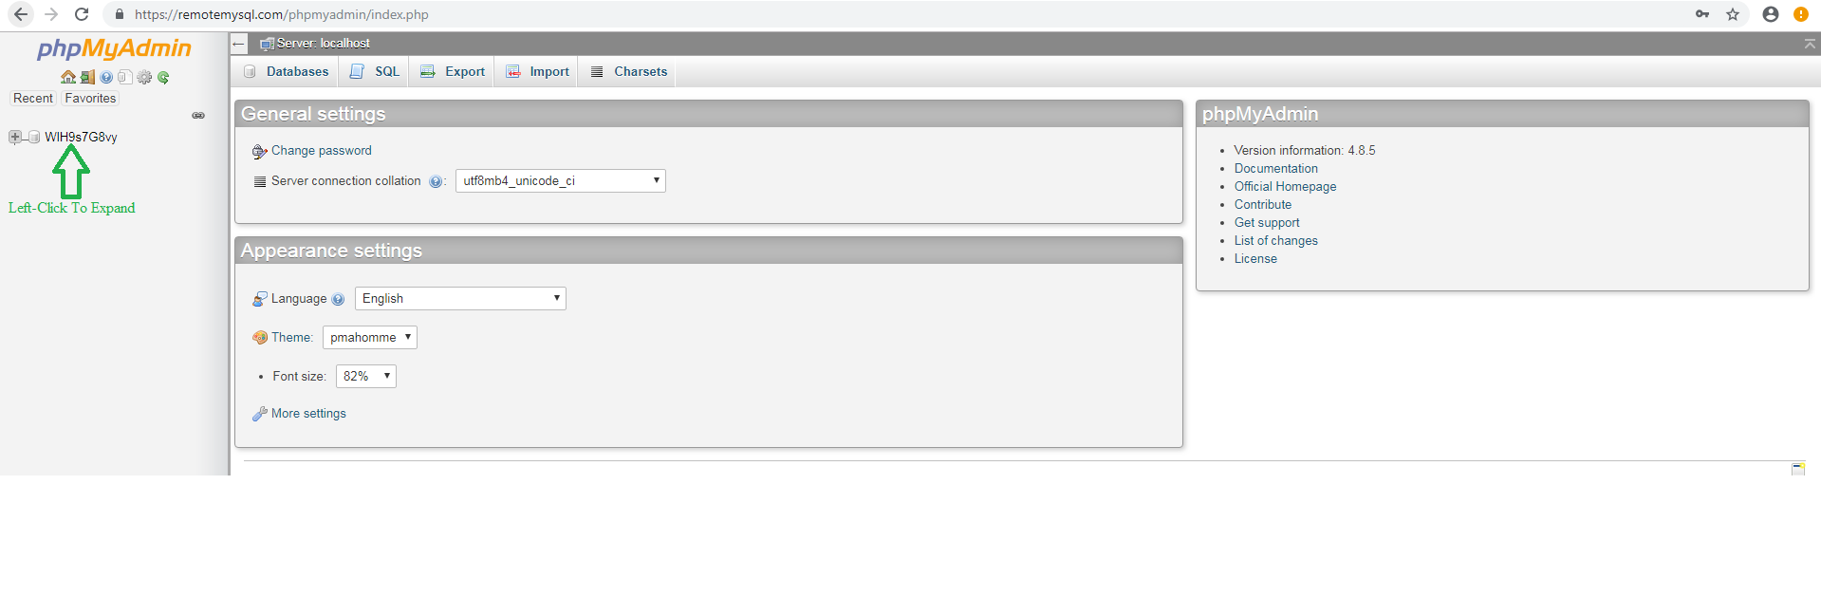

1. Left-Click “programs”. This is the table that holds information regarding the description of learning outcomes in all scraped programs.

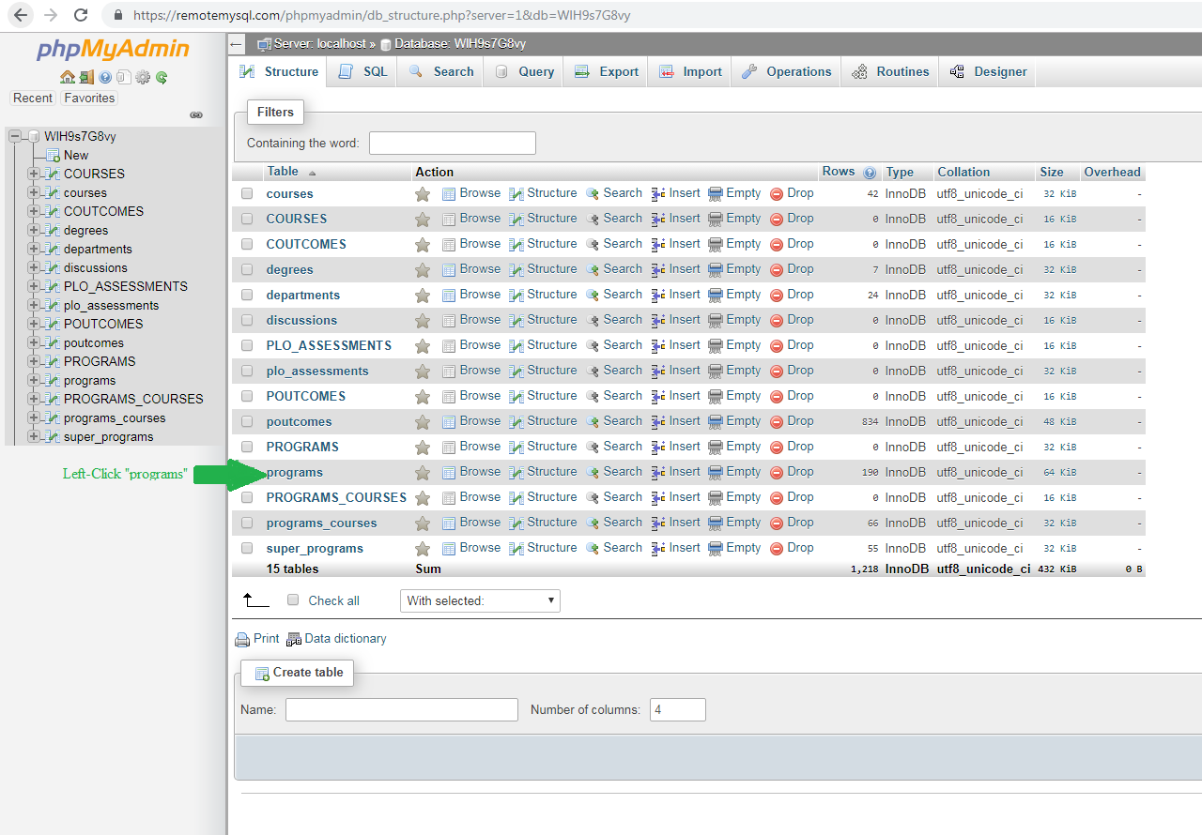

1. Completed. Items may be edited or deleted as desired.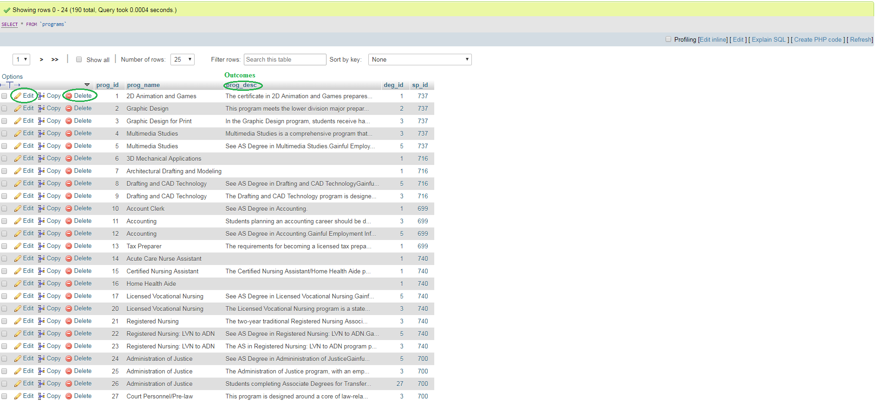

Edit

Add

Delete