Hi there,

For running these scripts, you have to followed these steps:

* Download Anaconda

Here is the link:

<https://www.anaconda.com/products/individual>

After installing you will get this interference:

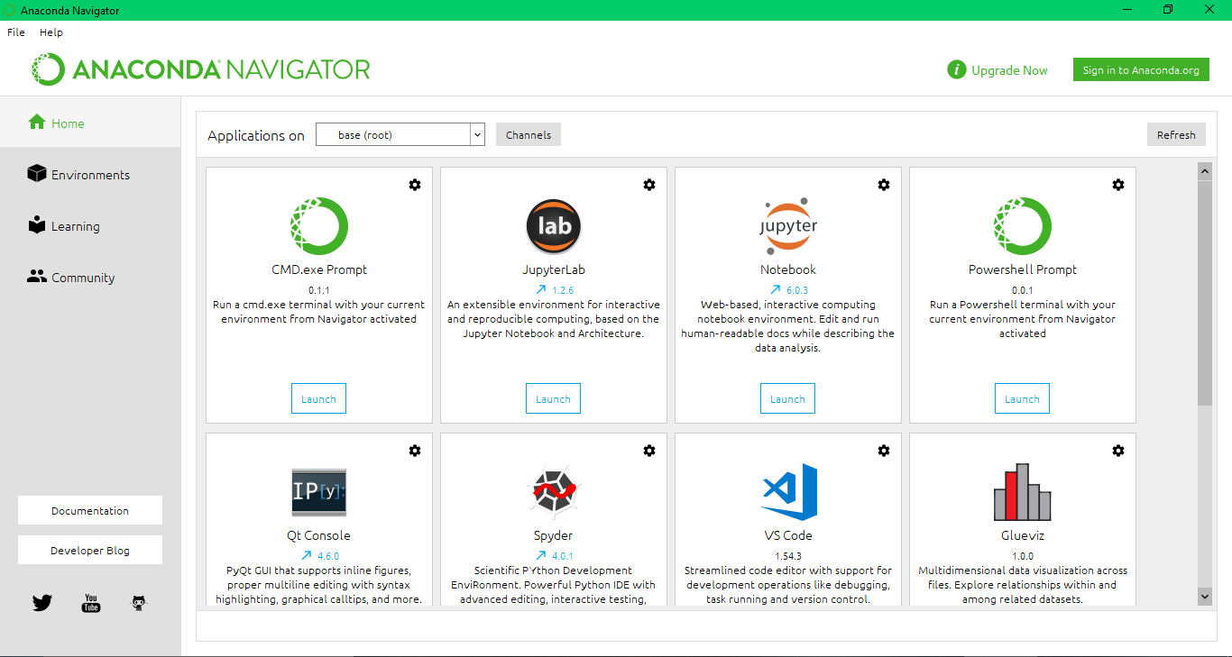

Now click on environment:

You will get this interference:

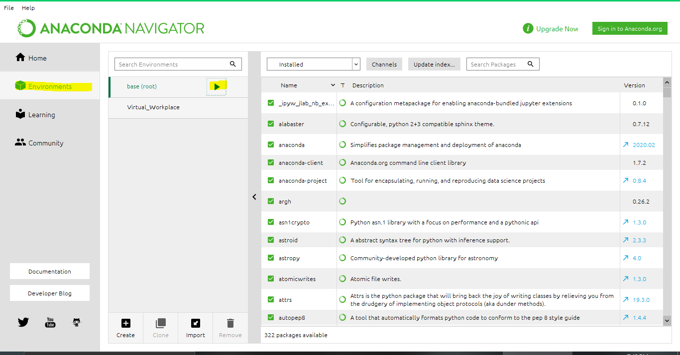

Now click the play button and you will get a drop-down menu from here

* Click on Open Terminal

Now open the path in the terminal where you extract these scripts:

Now you have run these commands to install these libraries:

* pip install scrapy
* pip install selenium
* pip install fake_useragent

Open path in cmd where you extracted these files.

**Now you need to download chrome driver of your chrome relative version.**

**Here is link:**

**https://chromedriver.chromium.org/**

**Note place chrome driver next to python file:**

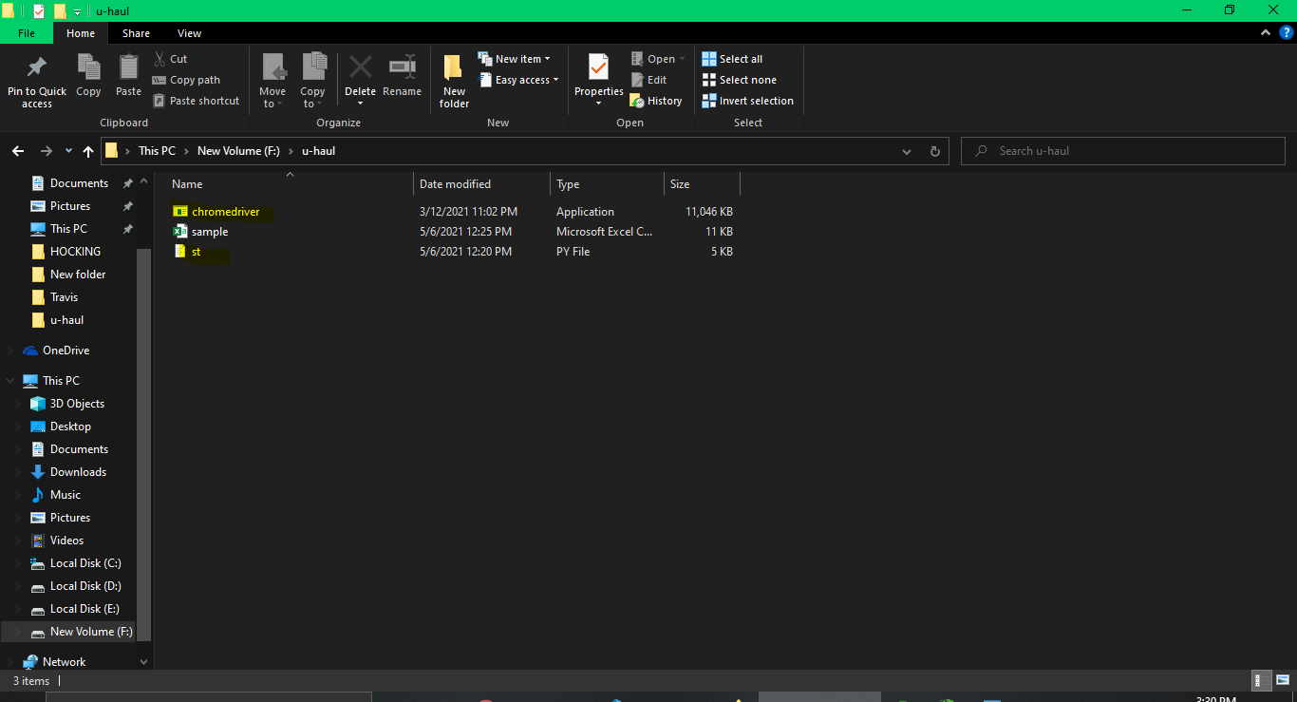

**Usage:**

* **st.py**

For running these scripts

You have to use:

**running:**

python st.py

IT will always save data in sample.csv you can rename it later on.

**Working:**

**While Script is underway It will ask you enter input state or zip code or name where you want to scrap data.**

PS: If you have any confusion feel free to ping me. It was pleasure working with you.