Hi there,

For running these scripts, you have to followed these steps:

* Make sure you have python installed if not here is the python link:

https://www.python.org/downloads/release/python-370/

* Download Anaconda

Here is the link:

<https://www.anaconda.com/products/individual>

After installing you will get this interference:

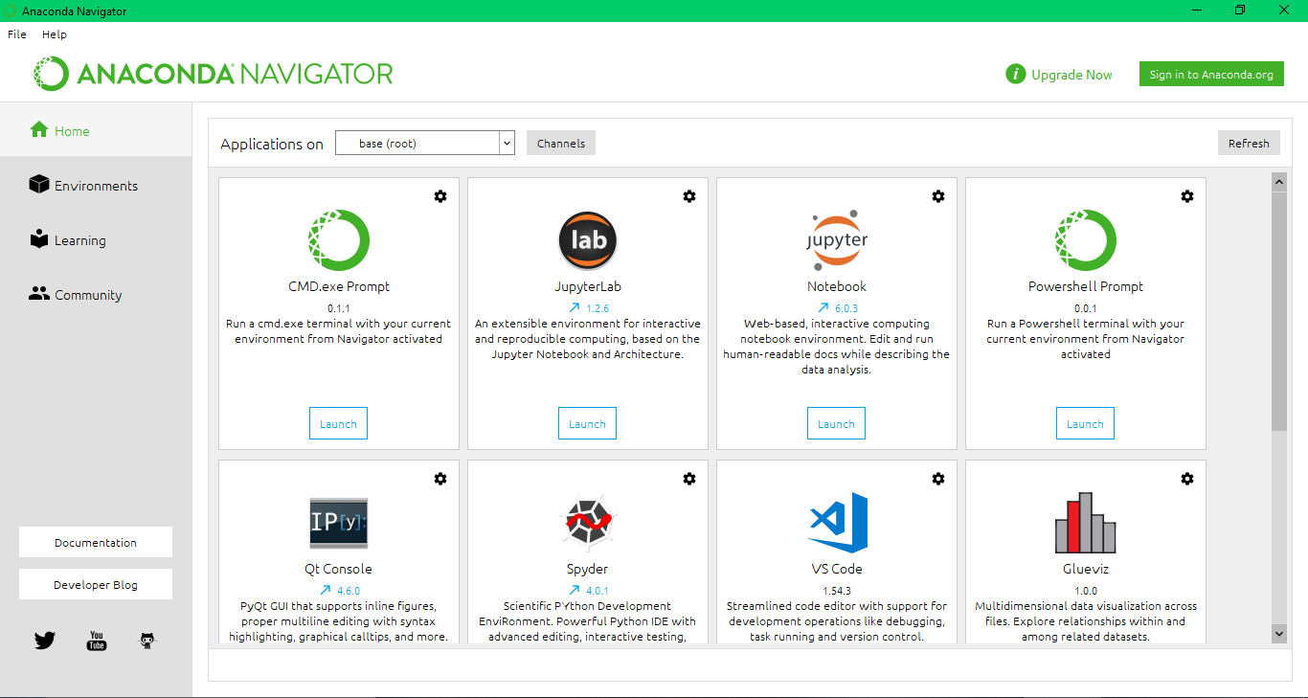

Now click on environment:

You will get this interference:

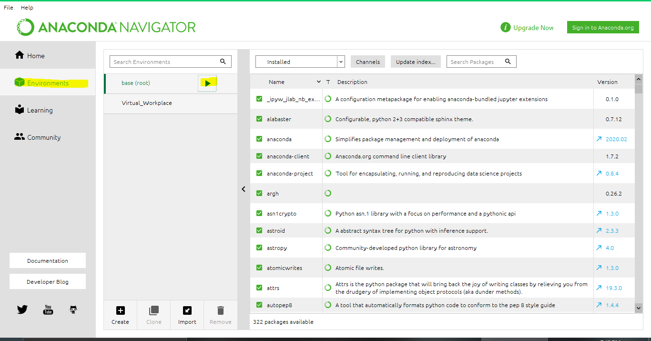

Now click the play button and you will get a drop-down menu from here

* Click on Open Terminal

Now open the path in the terminal where you extract these scripts:

Now you have run these commands to install these libraries:

* pip install selenium
* pip install time
* pip install UserAgent
* pip install fake_useragent
* pip install wget

Now you have to check what’s your chrome version and you have to download their relative driver if your chrome driver is same as mine then there is no need if not you can download chrome driver of your relative version from this site:

<https://chromedriver.chromium.org/>

S.s of chrome Driver version:

After installing replace that driver in the existing script folder

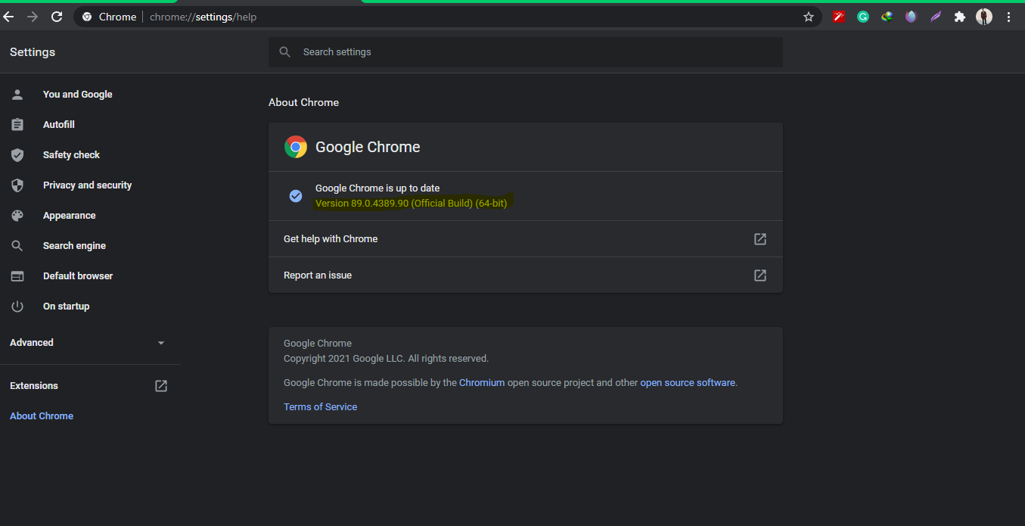

**Changes: (important)**

You need to change the output path where you need to download your images.

Here you need to change.

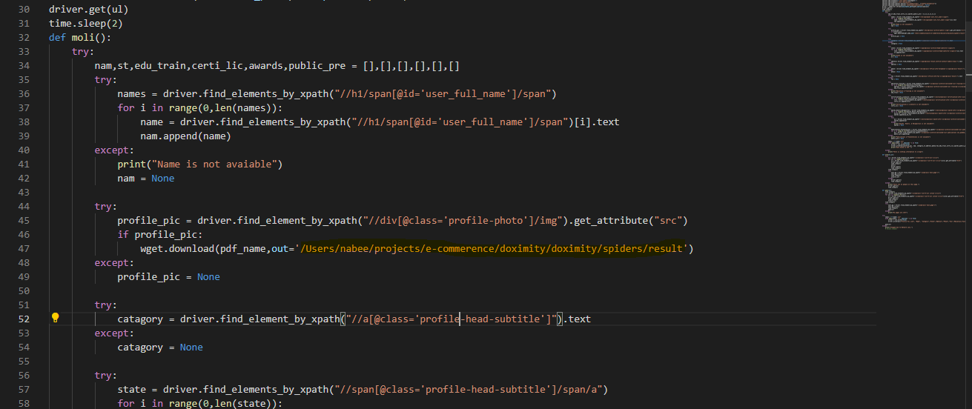

**Usage:**

You need to open path in anaconda terminal and then just run

* Python pra.py

Script will ask you to enter state name then it will start scraping results.

PS: If you have any confusion feel free to ping me. It was pleasure working with you.

**Note: If you want a video how to do changes and working, I can make them for you.**