Hi there,

For running these scripts, you have to followed these steps:

* Make sure you have python installed if not here is the python link:

https://www.python.org/downloads/release/python-370/

* Download Anaconda

Here is the link:

<https://www.anaconda.com/products/individual>

After installing you will get this interference:

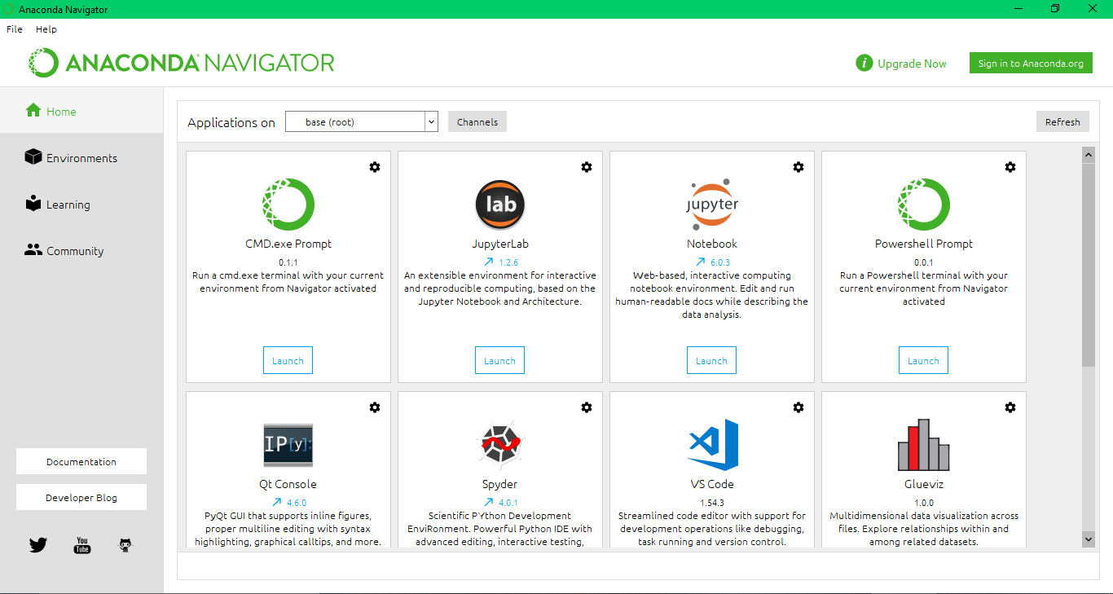

Now click on environment:

You will get this interference:

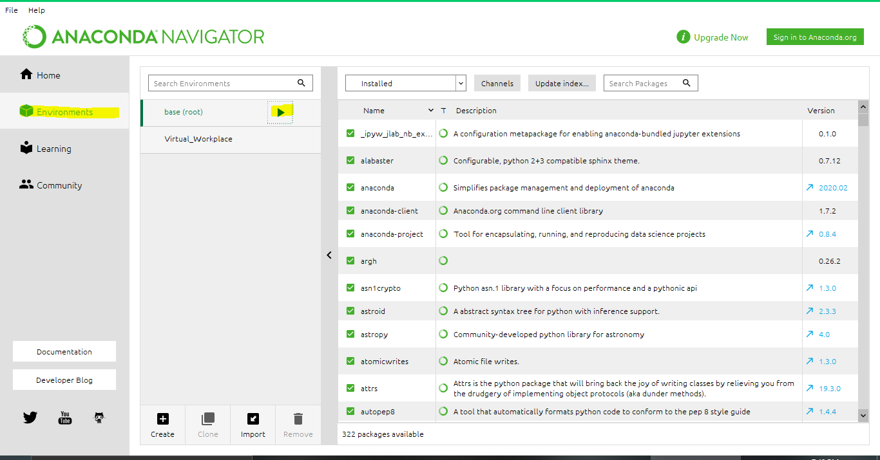

Now click the play button and you will get a drop-down menu from here

* Click on Open Terminal

Now open the path in the terminal where you extract these scripts:

Now you have run these commands to install these libraries:

* pip install scrapy
* pip install selenium
* pip install selenium-requests
* pip install time
* pip install UserAgent
* pip install fake_useragent
* pip install scrapy_selenium
* pip install Pillow

Now you have to check what’s your chrome version and you have to download their relative driver if your chrome driver is same as mine then there is no need if not you can download chrome driver of your relative version from this site:

<https://chromedriver.chromium.org/>

S.s of chrome Driver version:

After installing replace that driver in the existing script folder

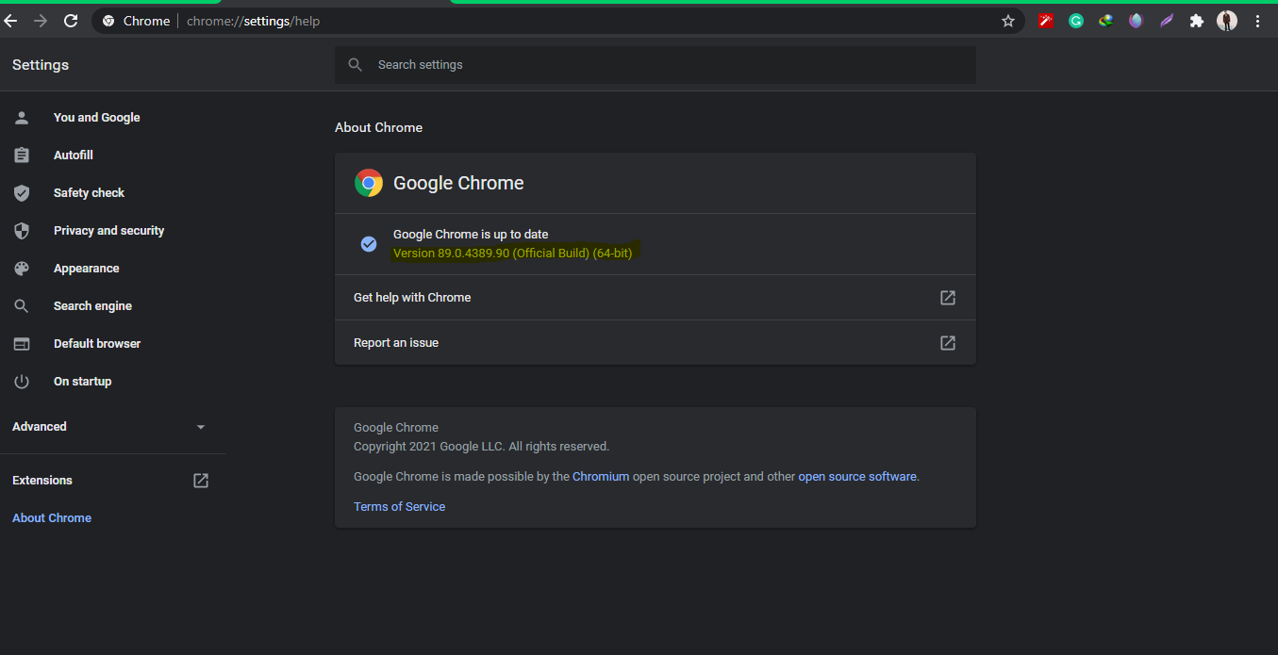

**Changes: important**

**You need to set path before running them in the scripts:**

You need to change image store path that means you have to give your path where you need to store images.

**Open setting.py:**

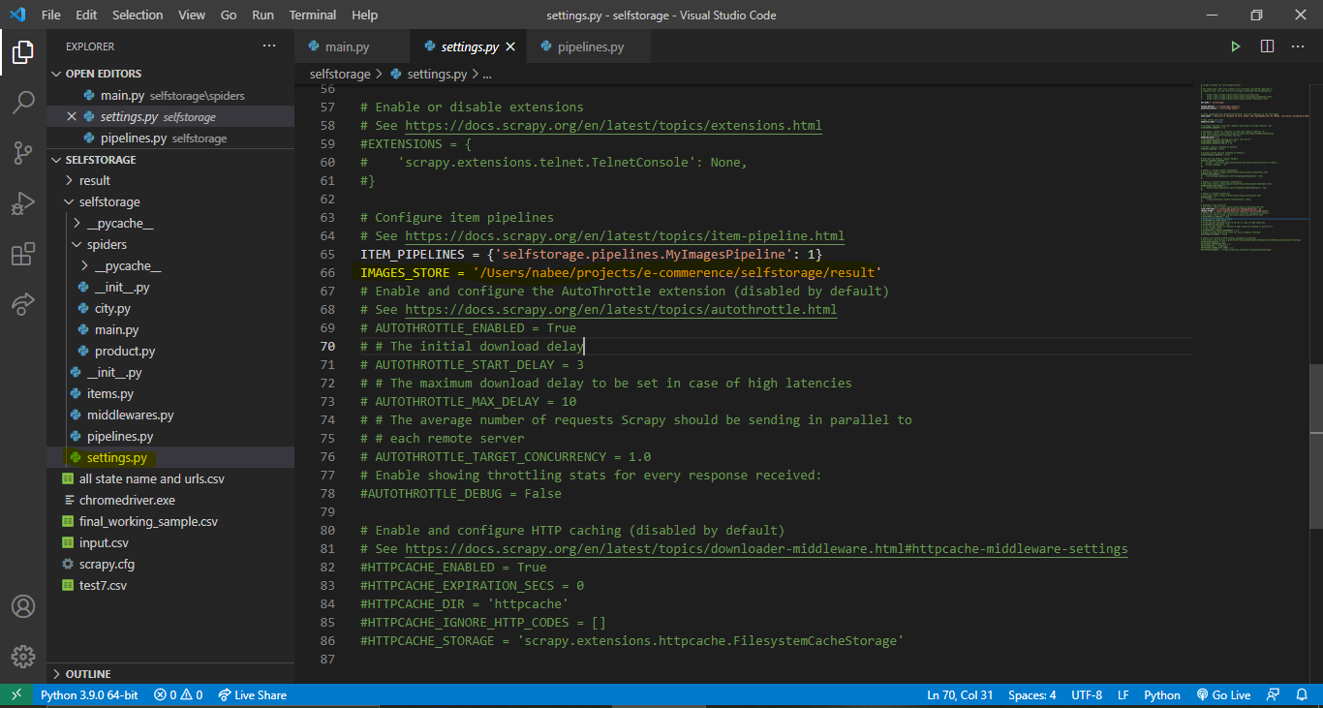

**Change the path of input file:**

You need to change the input file path to where you extract this script. In oder to do that open main.py file line no 27 change it.

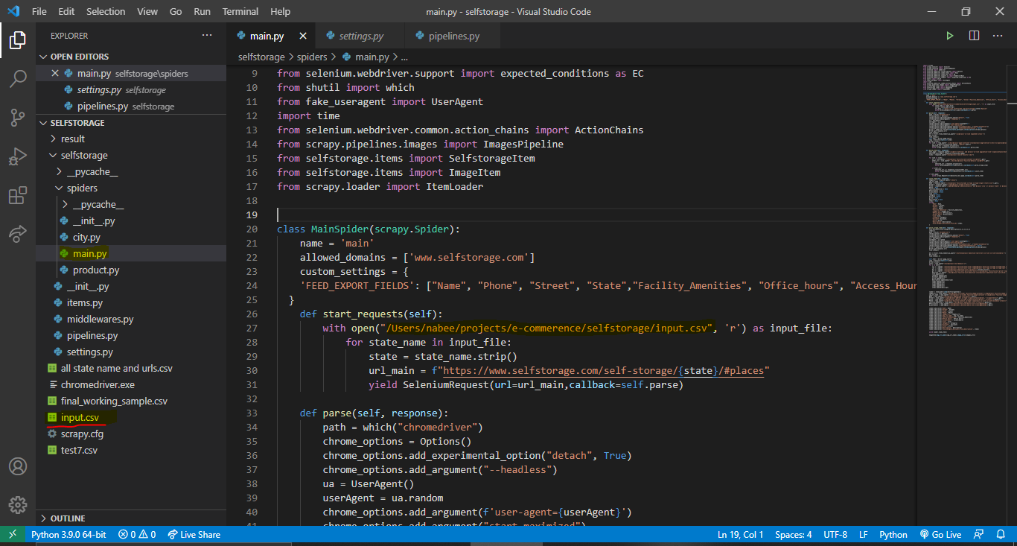

**Usage:**

**There are two files in spider folder:**

* **main**
* **city**

: main.py scrape whole website and city.py scrape single city from website

After opening these scripts in terminal as mentioned in above

For running these scripts

You have to use:

**running:**

Scrapy crawl main -o name.csv

:name = any name you want to give your csv

PS: If you have any confusion feel free to ping me. It was pleasure working with you.

**Note: If you want a video how to do changes and working, I can make them for you.**