Hi there,

For running these scripts, you have to followed these steps:

* Download Anaconda

Here is the link:

<https://www.anaconda.com/products/individual>

After installing you will get this interference:

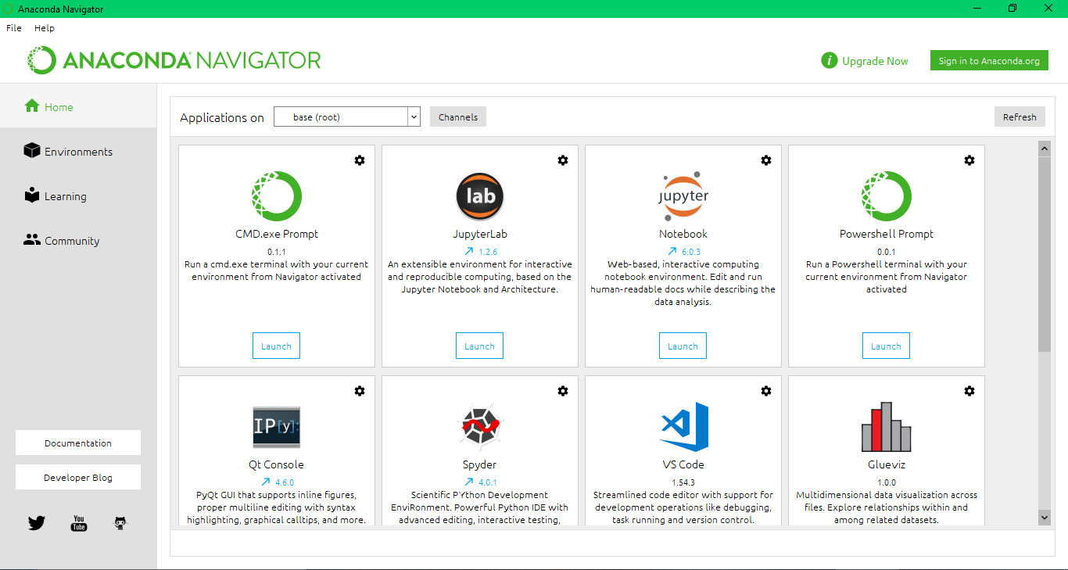

Now click on environment:

You will get this interference:

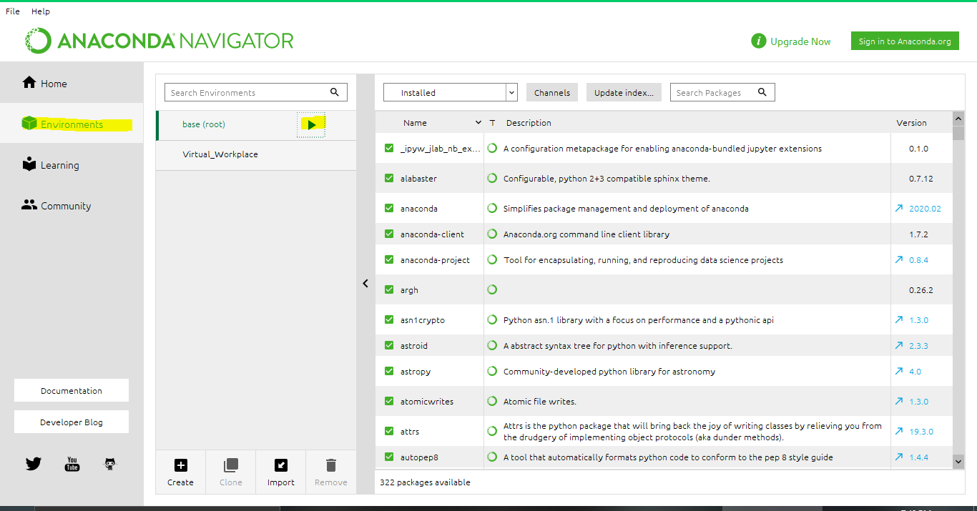

Now click the play button and you will get a drop-down menu from here

* Click on Open Terminal

You will get this:

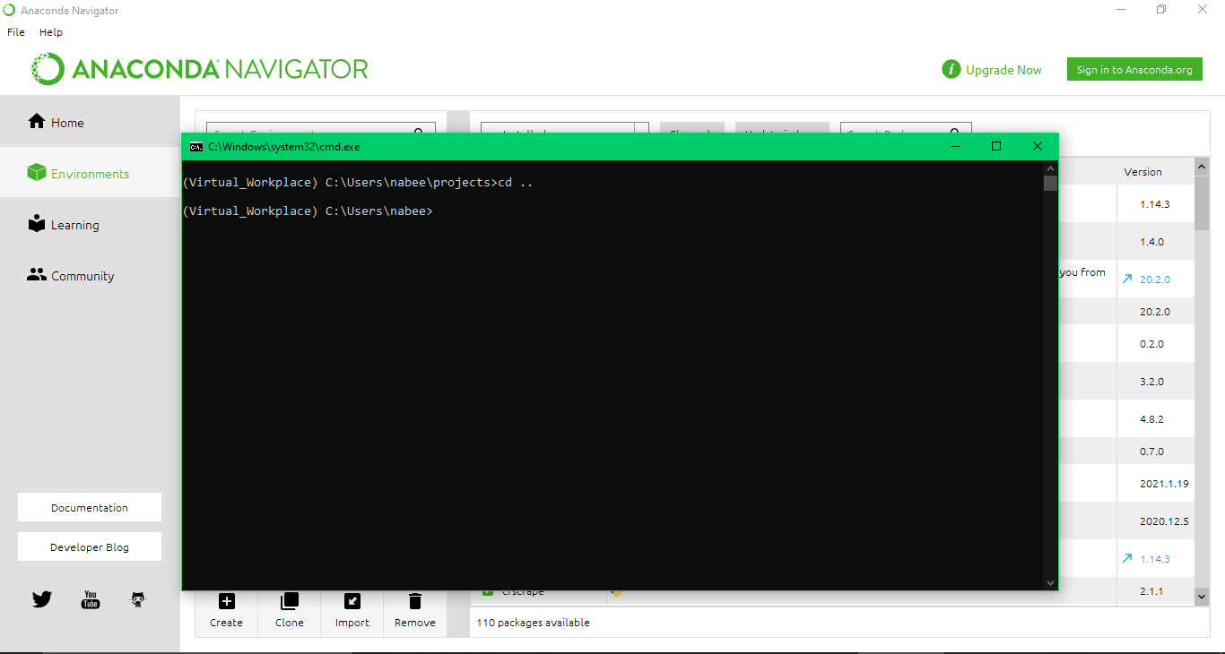

Now you have run these commands to install these libraries:

* pip install selenium
* pip install time
* pip install UserAgent
* pip install fake_useragent

Now you have to check what’s your chrome version and you have to download their relative driver if your chrome driver is same as mine then there is no need if not you can download chrome driver of your relative version from this site:

<https://chromedriver.chromium.org/>

S.s of chrome Driver version:

After installing replace that driver in the existing script folder

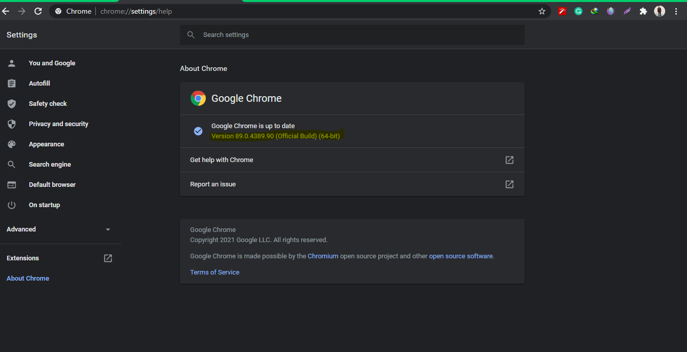

**Usage:**

**For Running this script you just need to open Terminal from Anaconda and here it is representation**

**Representation:**

Opening folder where python file is:

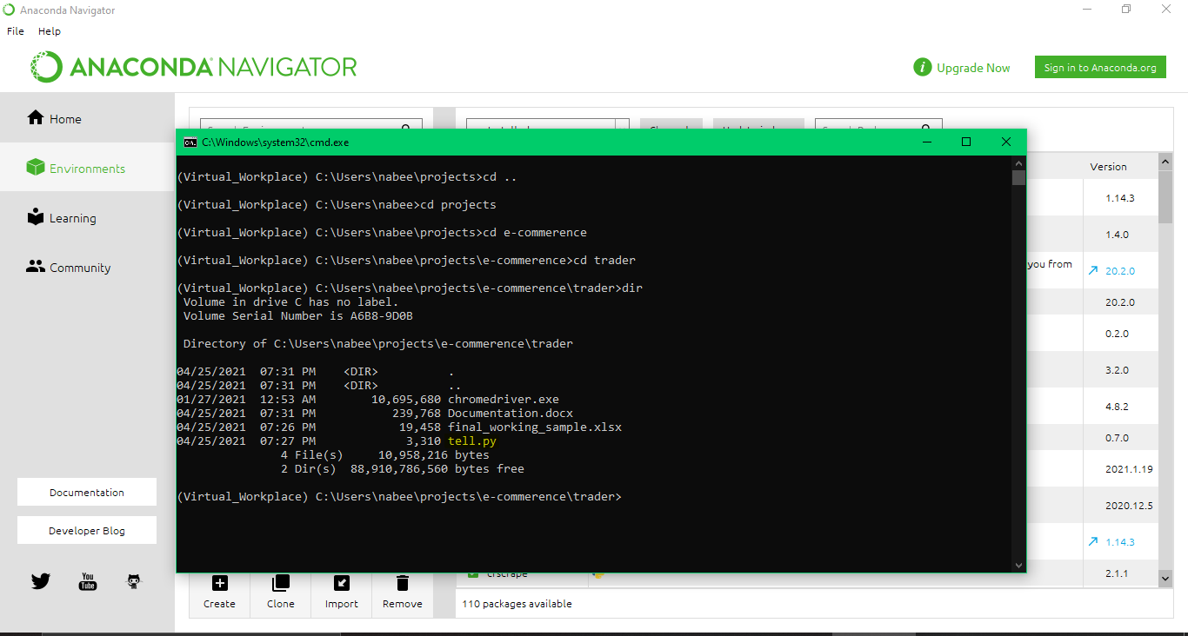

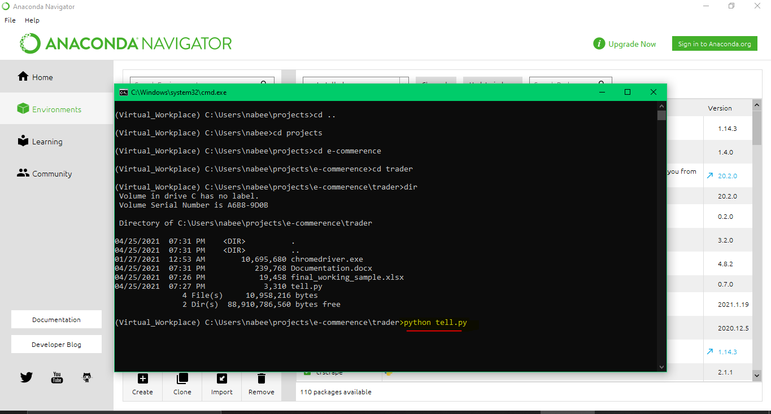

**Command:**

**Python tell.py**

PS: If you have any confusion feel free to ping me. It was pleasure working with you.

**Note: If you want a video how to do changes and working, I can make them for you.**