Emmanuel Ogunyemi I9988587

**TM252 EMA**

**Part 1 Project Plan and Risk Assessment**

**A:**

|  |  |  |  |  |  |  |
| --- | --- | --- | --- | --- | --- | --- |
| **Task** | **Subtasks** | **Duration Scheduled** | **Start Date** | **Finish Date** | **Notes** | **Complete (Y/N)** |
| **Design Report** | Create Site map.  Create Wireframe  Write report explaining how design is appropriate for their requirements  Prepare viable acceptance tests  Look through report structure once more and check for requirements | 4 Hours | 10/09/2025 | 10/09/2025 | Admin View Wireframes. For landscape orientation | Complete |
| **Form Implementation of design** | Create version control repository (Git)  Create web page  Show version control screenshots (3) | 4 Hours | 11/09/2025 | 11/09/2025 | Web page must be named “form.html”  Must be made identical to wireframe design.  The form must include a hidden field named ‘itemID’ with value | Complete |
| **Discussion** | Re-read scenario  Come up with questions relevant with their requirements  Note down questions  and advice | 3 Hours | 12/09/2025 | 12/09/2025 |  | Complete |
| **Discussion Again** | Come up with answers for possible questions about their website.  Give advice for the sustainability of their website | 4 Hours | 13/09/2025 | 13/09/2025 |  | Complete |
| **Reflect** | Answer the given questions | 2 Hours | 14/09/2025 | 14/09/2025 |  | Complete |
| **Review** | Review the relevant parts and make sure they are in order | 1 Hour | 15/09/2025 | 15/09/2025 |  | Complete |

**Part 1 B:**

|  |  |  |  |  |
| --- | --- | --- | --- | --- |
| **Event** | **Likelihood** | **Impact** | **Risk** | **Mitigation** |
| Medical checkup | High | High | Medium | Work a bit later in the night to offset missed schedule period. |

**Part 2:**

**Part 2B:**

Proposal of the Layout for the Admin View Page

## Introduction

This is a proposal for suggestion of the layout for the Edumax Teams Admin view Page. It was made using Balsamiq Wireframes (the popular app for frameworks), with the mentioned specifications in mind. It shows how the admin side of the site is organized, what exactly is on each page, how it corresponds to the given requests, and the sites navigation scheme.

### Organization

The admin view page is organized to support efficiency, clarity, and usability. By grouping related features and options inti a catalogue-like menu, navigation is made more intuitive.

### Navigation

For the desktop/laptop/landscape view, a top bar navigation menu will be used. This will help keep all major sections accessible with a click and make navigation through the site more convenient for the user. In a catalogue-like format, each top-level section will expand into its relevant sub-sections (e.g security into User Permissions, Policies, and Login History). The top navigation bar also provides easy access to the user’s profile settings and the logout option in a position expected in modern web applications.

In the mobile view, navigation will be shown in a hamburger menu form. This makes it consistent with modern mobile applications, while also keeping its functionality and reducing clutter on a smaller mobile screen.

### Pages:

All the sections and their subsections are noted below:

Home (Admin)

- Manage Users

-- View All Users

-- Add New User

-- Edit User

- Manage Modules

-- Catalogue

-- Add New Module

-- Assign Teachers

-- Reviews

- Learning Events

-- View Events

-- Add New Event

-- Reports

- Content

-- Module Text Content

-- Module Video Content

- Memberships

-- Sign-Up Requests

-- Registered Members

-- Payments and Approvals

- Forums

-- Manage Posts

-- Manage Categories

- News & Announcements

-- Post News

-- Post Announcement

-- Archive

- Reports

-- User Activity

-- Course Progress

-- Export Reports

- Security

-- User Permissions

-- Policies

-- Login History

- Settings

-- Profile Settings

-- System Settings

-- Logout

Their grouping reduces duplication and supports the admin user’s mental models. This structure not only makes it easier and more intuitive for admins to navigate, but it also allows room for expansion if new features need to be introduced. They can then be depicted using wireframes to solidify this mental image as indicated by Balsamiq: *“The wireframes were created using Balsamiq Wireframes, which is a low-fidelity design tool widely used for rapid prototyping (Balsamiq, 2025).”*

Some alternatives were considered during the design but rejected. For example, Tabbed navigation which was discarded because they would not accommodate deeper sub-sections and are prone to overload. This would make the site difficult to expand. Identical layouts for desktop and mobile devices were also considered. Only rejected because the site was a bit too complex and hefty to be identically realized in a smaller mobile screen. Forcing it would reduce usability and accessibility.

## Conclusion

This plan displays a balance between functionality and usability for the Edumax Admin Platform. There are clear grouping structures and divides, and Navigation is steadily maintained. There is even the option to backtrack if necessary. The editing tools are located on each page, and they are simple and intuitive to use. All these ensure this site to display the astounding functionality and responsiveness that is critical for Admin users.

**(551 Words)**

**Reference List:**

Balsamiq, 2025. ‘*Balsamiq wireframes: the rapid, effective and fun wireframing tool’*.

Available at: https://balsamiq.com/wireframes/ (Accessed: 15 September 2025).

**Part 2C Acceptance Tests:**

**Test 1: Successful (Good Input Data)**

|  |  |
| --- | --- |
| **Parameters** | **Values** |
| Requirements: | The Admin tester must be logged in to the Edumax Admin site. Registration required |
| Purpose: | Making sure that the edit button functions and interacts with the page as expected. |
| Instructions: | 1. Navigate to the Learning Events section. 2. Select any existing event in the “Upcoming events” catalogue 3. Select the edit button 4. Change the title of the event and save |
| Expected Outcome: | 1. The Edit function changes the selected title properly 2. The save function updates the catalogue with the new title |

**Test 2: Unsuccessful (Bad Input Data)**

|  |  |
| --- | --- |
| **Parameters** | **Values** |
| Requirements: | The Admin tester must be logged in to the Edumax Admin site. Registration required |
| Purpose: | Making sure that the system prevents deletion of data if the actions are incomplete. |
| Instructions: | 1. Navigate to the Learning Events section. 2. Select any existing event in the “Auxiliary events” catalogue 3. Select the delete event button 4. When the confirmation button pops up, select cancel |
| Expected Outcome: | 1. The event is not deleted 2. The catalogue does not change |

**Test 3: Successful (Good Input Data)**

|  |  |
| --- | --- |
| **Parameters** | **Values** |
| Requirements: | The Admin tester must be logged in to the Edumax Admin site. Registration required. |
| Purpose: | To verify that the “Add News Item” function allows new entries to be saved and displayed. |
| Instructions: | 1. Navigate to the “News and Announcements” section and go to the “Post News” Subsection. 2. Select the “Add news Item” button. 3. Enter details of the news 4. Click save. |
| Expected Outcome: | 1. The system will accept the new data 2. The new post appears at the top of the News and Announcements section. |

**Test 4: Unsuccessful (Bad Input Data)**

|  |  |
| --- | --- |
| **Parameters** | **Values** |
| Requirements: | The Admin tester must be logged in to the Edumax Admin site. Registration required. |
| Purpose: | To verify that invalid or incomplete news entries cannot be added. |
| Instructions: | 1. Navigate to the “News and Announcements” section and go to the “Post News” subsection. 2. Select the “Add News Item” button. 3. Leave the Title field blank (or enter an invalid date such as 32/15/2025). 4. Enter some body text. 5. Click Save. |
| Expected Outcome: | 1. The system rejects the input. 2. The news item is not added to the catalogue. |

**Part 3A: W3C Validation evidence**

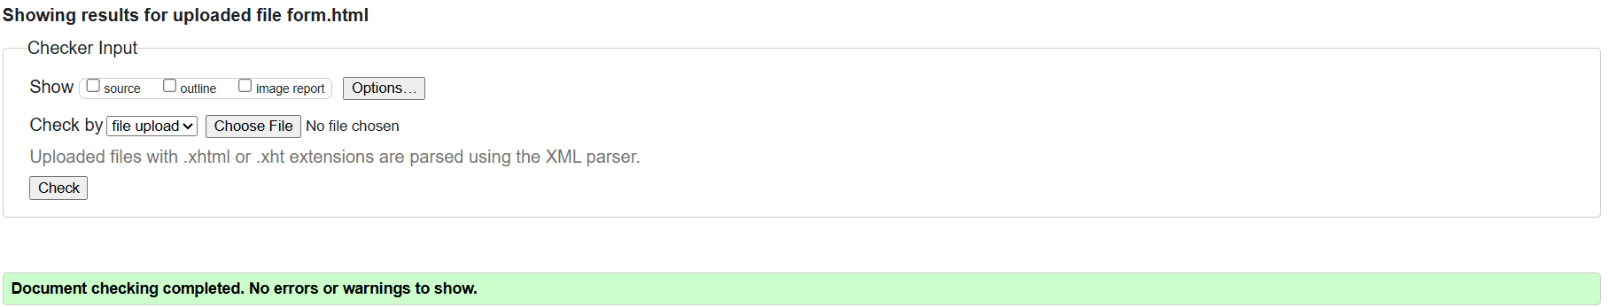

**Part 3B: Version control evidence:**

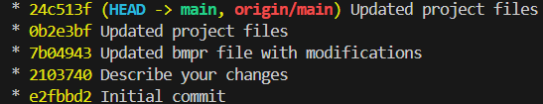

Committing the completed folder to the online EMA repository.

**Result:**

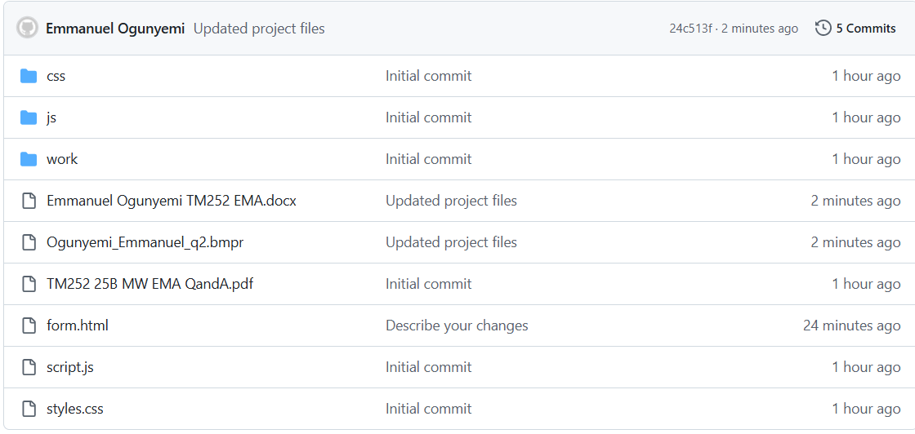

**Part 4A: Discussion:**

**Table:**

|  |  |
| --- | --- |
| **Question** | Do you want us to use a modern JavaScript front-end framework (like Vue, React, SolidJS), or keep using server- rendered approach? |
| **Answer 1** | “We would like to adopt a framework like Vue, since it has a large community.” |
| **Advice 1** | We recommend using Vue (or React) because its syntax is one of the more familiar across a large community. This way, it will be easier to find and hire developers who can seamlessly work together on the project as indicated by the Nielsen Norman Group: *“Their large ecosystems make it easier to find developers and third-party libraries, reducing long-term risk (Nielsen Norman Group, 2021)”*. There is also the added benefit that a framework like Vue, usually comes ready-made with its own libraries for forms, charts, and accessibility. |
| **Answer2** | “One of our members has worked with SolidJS before and is quite enthusiastic about using it for the project.” |
| **Advice 2** | SolidJS is extremely fast and innovative, however, it comes with the disadvantage of having a smaller community in comparison to other frameworks like Vue or React. Insisting on using it, would make hiring developers a bit more difficult. Most developers that you could hire here, might be in it just for training purposes. React/Vue has better long-term maintainability. |
| **Reasoning** | The choice for framework largely depends on team capacity, and long-term sustainability. React and Vue offer stability, documentation, and easier recruitment, while SolidJS offers innovation and a somewhat higher performance. However, Vue and react are more convenient to maintain long term. |

**Part 4B: Discussion:**

**Table:**

|  |  |
| --- | --- |
| **Question** | When hosting the server, do you intend to do so on your own dedicated server hardware, or use a cloud-based hosting plan? |
| **Answer 1** | “We want to buy our own hardware and host the server on that.” |
| **Advice 1** | Explain to them about how owning a server gives them full control, but as a trade-off, it usually comes with elevated costs (Maintainance, energy consumption e.t.c) |
| **Answer2** | |  | | --- | |  |  |  | | --- | | “We are considering using a virtual server or cloud hosting.” | |
| **Advice 2** | Explain how cloud hosting is advantageous for their endeavor because it offers scalability, it is usually lower cost than the alternative, and they wouldn’t have to maintain the hardware themselves. As explained by Gartner: *“cloud hosting (AWS, Azure, GCP, etc.) provides scalability, lower entry cost, and reduced maintenance overhead. (Gartner, 2023)”*. |
| **Reasoning** | To embark on any long-term project, me must think of sustainability. Will they be able to handle the operating costs of a decision long term, or will it be more feasible to switch to an alternative? It is best to guide them towards making the project functional and affordable long term. |

**(436 Words)**

**Reference list:**

Nielsen Norman Group (2021). ‘*Front-end frameworks UX: React, Angular, Vue*.’

Available at: https://www.nngroup.com/articles/frontend-frameworks/ (Accessed: 15 September 2025)

Gartner (2023). ‘*Cloud computing: Key initiative overview*.’ Available at: https://www.gartner.com/en/information-technology/glossary/cloud-computing (Accessed: 15 September 2025).

**Part 5 Reflection:**

For my career in web technologies, I would consider aiming web design/development. My reasoning is that besides it being very lucrative, I possess a high interest in this area. This interest is likely to inspire me to put in a high amount of effort during my practice if it has to do with web development. I thoroughly enjoyed working with the wireframes and seeing my rough outline come into shape. Though, the enthusiasm is a bit offset by the fact that I do not yet completely grasp the implementation stages, but that’s fine. I will simply channel more practice hours to this department.

As knowledge, I gained a higher understanding of the Python programming language, I also learned a bit of CSS and JavaScript. I also learned how to route with Flask. In this module, I have also gained better organization skills via the planning strategies. I have gained better studying habits and I am now able to focus on long term tasks better than before.

The knowledge and skills that I intend to develop in the future are; My programming skills (skills in Python, JavaScript, and CSS). They are the cornerstones of my future career, and I still need a lot of practice. I will work on come auxiliary projects that require them for a while. I am bound to improve if I persist continuously. I will also develop my project planning skills in the future. I will take up a few online and see if I can improve my professionalism. I will also try to improve my web development skills. I will review this module in combinations with some tutorials online, and I expect visible improvement after a period.

I would also like to develop Teamwork skills as it will be very important in the future. I will do this by taking on online projects that require the presence of more than one person. This was, I can not only achieve my aim, but I could also improve my communication skills, and we can all learn from each other.

**(341 Words)**