**Synopsis Report**

**on**

**Hand Gesture Controlled Car**

***Submitted in partial fulfillment of the***

***Requirements for the award of the degree***

***of***

BACHELORS OF ENGINEERING

in

MECHATRONICS ENGINEERING

**Submitted By: - Faculty Supervisor: -**

**NANDAN KUMAR ; 20BEM8010 Mr.Inderpreet Singh**

**SUNNY ; 19BEM1047**

**PARTHA PRABIR ; 20BEM8002**

**MOHAPATRA**

**FRANCK LEONEL ; 19BEM1058**

**FOTI HAMEKONG**



**UNIVERSITY INSTITUTE OF ENGINEERING**

**CHANDIGARH UNIVERSITY**

**GHARUAN, MOHALI, PUNJAB, INDIA-140413**

**2019**

**CONTENTS**

|  |  |  |
| --- | --- | --- |
| **Sr.No.** | **Content**  **Candidate Declaration 2**  **Acknowledgement 3** | **Page no.** |
| 1. | Introduction.............................................................................. | 4-5 |
| 2. | Literature Survey……………………………………… | 6 |
| 3.  4.  5.  6.  7. | Methodology…………………………………………...   1. Objective 2. Steps Involved   Block Diagram of System……………….......................   1. Description of Parts 2. Application and advantages of system   Approximate Cost and Total Cost……………………..  Workplan……………………………….,…………….  References…………………………………………….. | 7- 8  9-15  16  16  17 |
|  |  |  |
|  |  |  |
|  |  |  |
|  |  |  |
|  |  |  |

**CHANDIGARH UNIVERSITY, GHARUAN, MOHALI**

**CANDIDATE'S DECLARATION**

I “**SUNNY**” hereby declare that the work embodied in this synopsis entitled **“GESTURE CONTROL ROBOTIC CAR”** in partial fulfillment of requirements for the award of degree of B.E (MECHATRONICS ENGINEERING) at **CHANDIGARH UNIVERSITY GHARUAN, MOHALI.** The work which is being presented in this synopsis submitted to **Department of Mechatronics Engineering** is an authentic record of bonafied piece of work.

Signature

SUNNY

NANDAN KUMAR

FRANCK LEONEL

FOTI HAMEKONG

PARTHA PRABIR MOHAPATRA

Supervisor Signature

Mr.Inderpreet Singh

**ACKNOWLEDGEMENT**

It gives us proud privilege to complete this project work. This is the only page where I have the opportunity to express my emotions and gratitude from the core of my heart.

It is us great pleasure in expressing sincere and deep gratitude towards my guide for his valuable and firm suggestions, guidance and constant support throughout the completion of project named “**GESTURE CONTROL ROBOTIC CAR”.** I am thankful to Chandigarh University for providing me various resources infrastructure facilities.

I also offer my most sincere thanks to my team members and staff members of Mechatronics Department, University Institute of Engineering, Chandigarh University for cooperation provided by them in many ways.

**NAME :**

**: SUNNY**

**: NANDAN KUMAR**

**: FRANCK LEONEL**

**FOTI HAMEKONG**

**: PARTHA PRABIR**

**MOHAPATRA**

**(5th semester , Mechatronics Eng.)**

**INTRODUCTON**

In Modern World , automation in robots is increased on a high scale . Different types of technology are upcoming, modified in different categories in automation world. Generally , all this robots controlled by using some hardware equipments . Generation wants everything in fast mode , they want to wait for a long time, so also in this era, we have Technology support . Our Great Engineers invent many things , which help us to grow rapily in life . so , same in this technological era “I and My team members ” come with one more Project known as “**GESTURE CONTROL ROBOTIC CAR**”

So , a robot car controlled by a person’s body gestures is new technology upcoming in today’s world . All the movements of this automated car are controlled by different actions performs by user . car movements will be easily controlled . As human actions are involved in controlling movement , this car can be easily controlled .

Sensors are used to detect the gestures of hand and to transmit the data transmitter and receiver module is used . The exact movements are interpreted by Arduino UNO and Acceleromter. For , robot to turned efficiently , motors are connected in cross connection pattern to increase the turning efficiency of the automated car . Two different circuits namely Transmitter & Receiver Circuits namely to establish a proper and secured wireless connection between a person and automated car.

As the name itself suggests that , this is automated car controlled by hand gestures of person . For simple movements of car , if a person’s hand a tilted down then car moves forward direction , if tilted above then cars moves in backward direction , if tilted to right then car turns in left direction and if tilted the left direction , then car turned to right direction. First Acceleromter , gyroscope is used . The sensors has 3 axis x , y , z which detect position of a person;s hand and gives an output in range of serials . This data is received by Arduino UNO . Micro-controller of Arduino (ATMEGA328P) then computers and forwards data about direction to which car should move . This data is then sent to an ensure the safety . Then the data is forwarded to transmitter module . At a frequency of 433 MHz this data is sent in air in encoded format .

Now at receiver end , this encoded data is captured by receiver module and then data is sent to decoder IC . This decoded data is about which pin to set high so that motor of the automated car can run accordingly . A motor driver IC Board is used which runs the motor in desired direction given by User’s Hand Gestures . All this process is described in a block diagram part .

The Sensor works on power between 1.8V to 3.6V DC and typically consumes just 350microampere of current which become perfectly compatible for Arduino, It has 3 analog outputs for X , Y , Z axis measurements , 2 supply pins and self test pin . The analog outputs are Ratiometric , meaning 0g measurement output is generally equal to half of the 3.3V supply voltage .

Literature Survey

Hand Gesture based interface for navigating a robot. A Robot can be controlled by user using hand gestures. A axis accelerometer is adopted to record a user’s hand trajectories. The trajectory data is transmitted wirelessly via an RF module to an computer. The received trajectories will classified into 6 control commands for navigation.

Control strategy allows us to perform the dynamic walking gait of a virtual under-actuated robot even subjected to destabilizing the external disturbances. It based on two stages: the first stage in which we set programic elements which helps in walking of the robot & the second stage is we use neutal network to generate trajectories during the walking stage.

Next classification is Object tracking is the most important componentsis numerous applications of computer vision. There are many changes in the progress has been made in recent years with efforts on sharing code and datasets. It is important to develop a library and benchmark to gauge the state of the art. After reviewing recent advances of online object tracking , large scale experiments with various evolutions criteria to understand how algorithms perform can be carried out. By analyzing quantitive results, we identify effective approaches for rebust tracking & provide potential future research directions in this field.

Power Electronics , Components & elements are used to simulate for assessing the system. Co-simulation overcome by this by coupling sub;domain models that are described and solved within their native environments .

This article/survey discuss the state of an art and conceptually describes the main challenges for simulating intelligent power system, in this main parts we cover , Fundamental concepts & applications.

Methodology

1. Objective : Our Objective is to make this device simple as well as cheap so it can be produced and used for number of purposes. The objective of this project is to build a car that can be controlled by gesture wirelessly. In this project user is also able to control motions of the car by wearing controller glove and performing predefined gestures. This can be also used in many potential applications such as wireless controller car. Car using the accelerometer with the help of human hand tilting. Signals received and hand tilting . Robot movement depends upon the signal made by your hand and from a separation.
2. Steps to be involved : Working is divided into two parts :

Transmitter & Receiver Part

* In Transmitter circuit we have a arduino UNO with the accelerometer and with a encoder like our Bluetooth. First we have to recognize and detect the movements of hand by using Acceleromter MPU6050 and position of hand is identified by using x and y scale. The data is supplied to Arduino UNO. Arduno programmed using Arduino(IDE) Software.

Following algorithm is used to detect and analyse the gestures through the accelerometer and in which direction automated robot should move.

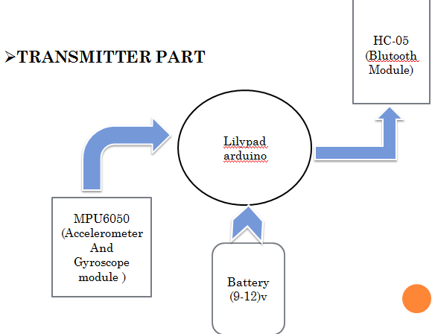

* In Receiver circuit generally , we used a arduino with a Bluetooth and the driver with the motoe and some programming to control the motor and its direction, then the transmitter gives the data in air then receiver circuit captured those data and used our bluetooth function as a decoder. It decodes the data and send 4 pin output of high or low digital signal to L298D motor driver board module.

Then the board runs the automated car in desired direction according to the gesture of the users hand.

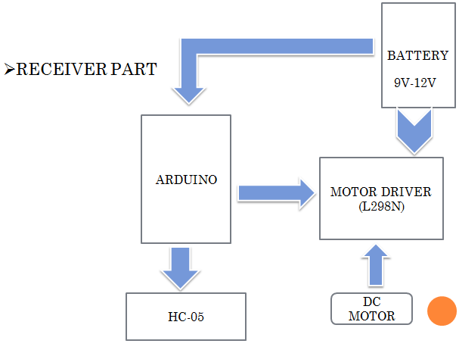

Block Diagram of System

1. Description of Parts :

* ARDUINO UNO : It is a microcontroller board based on ATmega328 which has 14 digital i/o and 6 analog pins. It has everything that is needed to support the microcontroller . It is connected with the computer with a USB Cable to get started with the Arduino Uno board. It is flexible , easy to use hardware and software. Arduino Uno can sense the environment byy receiving input from a variety of sensors and can affect its surroundings by contolling lights , measure and other actuators.

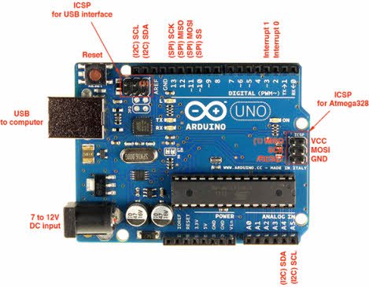

* ACCELEROMTER(MPU6050) : It is a devide that allows for measuring the changes in orientation that take place around in a reference axis, this provides information that allows a device to measure its orientation, maintain it or change it. Here we used 6 axis gyroscope then therefore a sensor with 6 degrees of freedom. Since it has three axis to measure the rate of turn and around three axis to measures the accelerometer. As you say it combines the 3 cartesian coordinate axis accelerometer and that takes gyroscopic measurements along these three axes pitch , roll , yaw.

* BLUETOOTH(HC-05) :This Bluetooth module is an easy to use Bluetooth SPP ( Serial Port Protocol ) module, designed for transparent wireless serial connection setup. Its communication is via serial communication which makes an easy way to interface with controller on PC. HC-05 Bluetooth modules provides switching mode between master and slave mode which means it able to use neither receiving nor transmitting data.

* BATTERY : A Battery is a device consisting of one or more electrochemical cells. It is a device that directly converts chemical energy to the electrical energy . The purpose of battery is to supply 9-12 volts to operate DC motors.
* DC MOTOR : It is used for the conversion of direct current into mechanical motion. The mechanicale principle motion could be rotary or linear. The operation of DC motor is based on that when a current carrying conductor is placed in a magnetic field, the conductor experiences a mechanical force. The speed of a Dc motor can be controlled by changing the voltage applied to armature or by changing the field current. DC motors can be used can be used for the movement of the robotic car.

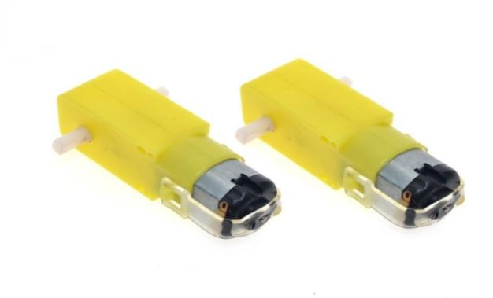

* MOTOR DRIVER: This l298n motor driver module is a highpower motor driver module for driving dc and stepper motors. L298N modules can control up to 4 dc motors , or 2 dc motors with directional and speed control. The L298n motor driver module consists of a motor driver IC 78M05 Voltage regulator , resistors, capacitor , power led , 5V jumper in a integrated circuit. M05 voltage regulator will be enabled only when the jumper is placed. At the heart of the module is the big , black chip with chuncky heat sink is an L298n a dual channel H-Bridge motor driver capable of driving a pair of DC motors.

* JUMPER WIRES: Jumper wires are used to connect two points in a circuit. All Electronics stocks jumper wire in a variety of lengths and assortments. Frequently used with breadboards and other prototyping tools in order to make it easy to change a circuit as needed. Male jumpers are designed to plug securely into the holes in a breadboard. Female jumpers are useful for connecting male header posts and pin terminals on components. Jumpers are available in female-female, male-male and male-female configurations.
* SOFTWARE DEVELOPMENT: ARDUINO (IDE )software has been used as the interface between software and hardware of this project. microcontroller needs a program to operate and execute the process associated with proposed design. It is easy to verify and compile after writing the code . Here, It connects to the ARDUINO hardware to upload programs. But before upload the program there is a need to select appropriate microcontroller like ARDUINO UNO and ARDUNO UNO from the Tool menu has been chosen. And for proper communication with computer and ARDUINO boards there is a need to select COM port from the tool menu .

1. Application and advantages of system :

Advantages:

* Simple ,fast and easy to implement and can be applied on real system .
* Speed and sufficient reliable for recognition system
* It is very much compact and user friendly
* It has low power consumption
* The system successfully recognized static and dynamic gestures

Applications :

* The use of gesture recognition, remote Control with the wave of a hand of various devices is possible such as gaming to make the game player’s experience more interactive and impressive
* Gesture controlling is very helpful for handicapped and physically disabled people to achieve certain tasks, such as driving a vehicle.
* Wireless controlled robots are very useful in many applications like remote surveillance, military , medical etc.
* Hand gesture controlled robot can be used by physically challenged in wheelchair
* Approximate Cost and Total Cost :

|  |  |  |
| --- | --- | --- |
| S.No | Approximate Cost | Total Cost |
| 1 | 3200 | 4000 |

* Work plan : We distribute whole work in team as NANDAN made Presentation for this project , SUNNY is doing synopsis report and manage working , FRANCK is doing research paper as well as PARTHA is doing Project Report .

All team members give full response during working and help each other to done this project . The most important part is Assembling , we decided to meet in University for one day, that day we made the assembling & other working.

References

[1] Yanan Chang, “Dynamic gesture recognition based on HMM,” MPhil. thesis, South China University of Technology, Guangzhou, GD, China 2012.

[2] Hang Zhao, “Motion control design of gesture recognition for mobile robot,” M.S. thesis, University of Electronic Science and Technology, Chengdu, SC, China, 2017.

[3] Chen Gao, “Research on the control of mobile robots based on dynamic and static gestures,” M.S. thesis, Beijing University of Chemical Technology, Nanjing, JS, China, 2017.

[4] Gould S J J, Brumby D P, Cox A L, et al., “Methods for Human Computer Interaction Research,” in The ACM Conference Extended.

ACM, 2015, pp. 2473-2474.

[5] Tianxing Wang, “Gesture-based remote-control technology for

unmanned platforms,” M.S. thesis, Nanjing University, JS, China, 2017.

[6] V. Bonato, A. K. Sanches, Fernandes M M, et al., “A Real Time Gesture Recognition System for Mobile Robots,” in Icinco 2004, Proceedings of the First International Conference on Informatics in Control, Automation and Robotics, Setubal, Portugal, August. DBLP, 2004, pp. 207-214.

[7] RM. Sanso, D. Thalmann, “A Hand Control and Automatic Grasping System for Synthetic Actors,” Computer Graphics Forum, vol. 13, no. 3, pp. 167-177, Aug. 1994.

[8] Robert Y. Wang, “Real-time hand-traking with a color glove,” in ACM SIGGRAPH.ACM, 2009, pp. 1-8.

[9] Poularakis S, Katsavounidis I, “Finger detection and hand posture recognition based on depth information,” in IEEE International Conference on Acoustics, Speech and Signal Processing. IEEE,2014, pp. 4329-4333.

[10] Yunde Zhang, “Research and application of gesture recognition technology,” M.S. thesis, Anhui University, Hefei, AH, China, 2013.

[11] Yuanxin Zhu, Guangyou Xu, “Appearance-based dynamic isolated gesture recognition,” Journal of Software, vol. 11, no.1, pp. 54-61, Jan.2000

[12] Xueping Zhao, Jianming Wang, Haiting Liu, et al., “Research on Recognition System of Indoor Robot Dynamic Gesture Command,” Computer Engineering and Applications, vol. 47, no. 33, pp. 209-212, Nov. 2011.