**Industrial Timer Controller Using PLC System**



**A PROJECT REPORT**

*Submitted by*

**Kurella Alekhya** **UID: 18BEM1020**

***In partial fulfillment for the award of the degree***

***of***

**BACHELOR OF ENGINEERING**

**in**

**MECHATRONICS ENGINEERING**

**Under the Guidance**

**Of**

**PARAMESH**

**University Institute of Engineering**

**CHANDIGARH UNIVERSITY**

# December – 2021

**CONTENT**

1. **Introduction**
2. **Relay**
3. **Introduction to PLC**
4. **Delta PLC**
5. **Procedure to Open WPL Software**
6. **PLC Wiring and Working of Components**
7. **PLC Wiring and Programming**
8. **Approximate Cost**
9. **Final Output**
10. **Future Scope**
11. **Reference**
12. **Links**

# INTRODUCTION

## Programmable logic controller [PLC]

### Definition of a PLC:

A programmable logic controller (PLC) is a specialized computer used to control machines and process. It uses a programmable memory to store instructions and specific functions that include On/Off control, timing, counting, sequencing, arithmetic, and data handling.

## The First Programmable Logic Controllers (PLCs):

* + - PLC was introduced in late 1960‘s
    - The First Commercial and successfully PLC was Design and developed by launched in 1969 by modicon as relay replacer for general motor
    - Earlier it was called acronym PC
    - Late 1970‘s it is greatly controlling device with microprocessor based equipment to control industrial equipment‘s.
    - Developed to offer the same functionality as the existing relay logic systems
    - Programmable, reusable and reliable

1. Could withstand a harsh industrial environment
2. They had no hard drive, they had battery backup
3. Could start in seconds
4. Used Ladder Logic for programming.
   * + Programmable logic controllers are used throughout industry to control and monitor a wide range of machines and other movable components and systems. PLC is used to monitor input signals from a variety of inputs (input sensors) which report events and conditions occurring in a controlled process. Programmable logic controllers are typically found in factory type settings. Typical programmable logic controller employs a backplane to serve as the communications bus interconnecting the plc processor with the array of individual input/output devices with which the processor interacts in terms of receiving input data for use in controlling the targeted objects. A PLC includes a rack into which plurality of input/output cards may be placed. a rack includes several slots into which a plurality of input/output cards are installed.

Each input/output card has a plurality of I/O points. The I/O modules are typically pluggable into respective slots located on a backplane board in the plc. An i/o bus couples the cards in the slots back to the processor of the programmable logic controller. the slots are coupled together by a main bus which couples any i/o modules plugged onto the slots to a central processing unit (CPU).

The CPU itself can be located on a card which is pluggable into dedicated slot on the backplane of the plc. The particular processor employed in a plc together with the particular choice of input and output cards installed in the plc rack are often referred to as the hardware configuration of the programmable logic controller. The hardware configuration also includes the particular address which the i/o cards. Each option module typically has a plurality of input/output points.

The option modules are coupled through an interface bus, for example via a backplane to a main controller having a microprocessor executing a user program. Option modules may also include a microprocessor and memory containing separate user programs and directed to a particular option of the PLC system. during the execution of a stored control program, the PLC ‘s read inputs from the controlled process and, per the logic of the control program, provide analog or binary voltages or―contacts‖ implemented by solid state switching devices to allow them to be easily reconfigured to meet the demands of particular process being controlled. The processor and i/o circuitry are normally constructed as separate modules that may be inserted in a chassis and connected together through a common backplane using permanent or releasable electrical connect.

## Need for PLCs:

* + - Hardwired panels were very time consuming to wire, debug and change.
    - The following requirements for computer controllers to replace hardwired panels.
    - Solid-state not mechanical
    - Easy to modify input and output devices
    - Easily programmed and maintained by plant electricians
    - Be able to function in an industrial environment
    - Used Ladder Logic for programming

## Advantages of PLC Control Systems:

* Flexible
* Faster response time
* Less and simpler wiring
* Solid-state - no moving parts
* Modular design - easy to repair and expand
* Handles much more complicated systems
* Sophisticated instruction sets available
* Allows for diagnostics ―easy to troubleshoot‖ Less expensive
* The program takes the place of much of the external wiring that would be required for control of a process**.**
* Since all the logic is contained in the PLC‘s memory, there is no chance of making a logic wiring error.
* It is easier to create and change a program in a PLC than to wire and rewire a circuit.
* End-users can modify the program in the field.
* They can be networked to perform such functions as: supervisory control, data gathering, monitoring devices and process parameters, and downloading and uploading of programs.
* Machines that process thousands of items per second and objects that spend only a fraction of a second in front of a sensor require the PLC ‘s quick response capability.

### PLC Architecture:

* + - An open architecture design allows the system to be connected easily to devices and programs made by other manufacturers.
    - A closed architecture or proprietary system is one whose design makes it more difficult to connect devices and programs made by other manufacturers.

**NOTE**: When working with PLC systems that are proprietary in nature you must be sure that any generic hardware or software you use is compatible with your particular PLC.



**Pushbuttons,**

**contacts,**

**limit switches, etc.**

**,**

**contactors, alarms**

**etc.**

**19**

**PROGRAMMING DEVICE**

**PROCESSOR**

**O M**

**U O**

**T D**

**P U**

**U L**

**T E**

**I M**

**N O**

**P D**

**U U**

**T L**

**E**

**POWER**

**SUPPLY**

Fig 1.5.1 Block diagram of PLC

## I/O Configurations:

### Fixed I/O:

* Is typical of small PLCs
* Comes in one package, with no separate removable units. The processor and I/O are packaged together but lacks flexibility.

### Modular I/O:

* Is divided by compartments into which separate modules can be plugged
* This feature greatly increases your options and the unit‘s flexibility. You can choose from all the modules available and mix them in any way you desire.
* It makes an electrical connection with a series of contacts - called the backplane. The backplane is located at the rear of the rack.

### Power Supply:

* Supplies DC power to other modules that plug into the rack.
* In large PLC systems, this power supply does not normally supply power to the field devices.
* In small and micro PLC systems, the power supply is also used to power field devices.

### Processor (CPU):

* Is the ―brain‖ of the PLC.
* Consists of a microprocessor for implementing the logic
* Designed so the desired circuit can be entered in relay ladder logic form.
* The processor accepts input data from various sensing devices, executes the stored user program, and sends appropriate output commands to control devices.

### I/O Section:

1. Input modules
2. Output modules.

I/O address format will differ, depending on the PLC manufacturer. You give each input and output device an address. This lets the PLC know where they are physically connected.

### Input module:

* Forms the interface by which input field devices are connected to the controller.
* The terms ―field‖ and ―real world ―are used to distinguish actual external devices that exist and must be physically wired into the system.

### Output Module:

* Forms the interface by which output field devices are connected to the controller.
* PLCs employ an optical isolator which uses light to electrically isolate the internal components from the input and output terminals.

### Programming Device:

* A personal computer (PC) is the most commonly used programming device
* The software allows users to create, edit, document, store and troubleshoot programs
* The personal computer communicates with the PLC processor via serial or parallel data communications link.
* Hand-held programming devices are sometimes used to program small PLCs. PLC Input Module Connections:
* The same input field devices are used.
* These devices are wired to the input module according to the manufacturer‘s labeling scheme
  + 1. **CPU**:
* This is heart of PLC.
* It is mainly Useful for up loading and down loading a Application program
* UPLOAD: The process of taking Program From PLC to our PC is Called Upl
* DOWNLOAD: The Process of Giving Program to PLC from our PC is Called down Load.
* Scan Time:

The Time Taken for One Scan Cycle is Called Scan Time.

* Scan Cycle:

The Process of Giving Input and Scan Total program and get the output from PLC is called one Cycle.

* CPU is Having Com Ports for communicate with PC and other devices
* It has indications on CPU Like: Run, Stop, Force ON, Force OFF, Error, System Fault, Break Down Fault Etc.….

For Processing Program, we have memory, and these memories are 3 types

* Load Memory: for Store a program
* System Memory: it has all programming files for write a program
* Work Memory: for execute a program
* Some CPU ‘s have inputs and Outputs also with PLC CPU
  1. **Introduction:**

# RELAY

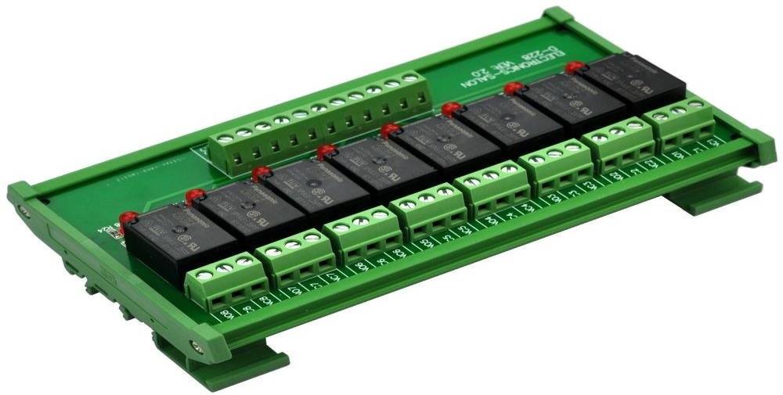A relay is an electromagnetic switch operated by a relatively small [electric](https://www.explainthatstuff.com/electricity.html) current that can turn on or off a much larger electric current. The heart of a relay is an electromagnet (a coil of wire that becomes a temporary [magnet](https://www.explainthatstuff.com/magnetism.html) when electricity flows through it). You can think of a relay as a kind of electric [lever](https://www.explainthatstuff.com/toolsmachines.html): switch it on with a tiny current and it switches on ("leverages") another appliance using a much bigger current. Why is that useful? As the name suggests, many sensors are incredibly sensitive pieces of [electronic](https://www.explainthatstuff.com/electronics.html) equipment and produce only small electric currents. But often we need them to drive bigger pieces of apparatus that use bigger currents. Relays bridge the gap, making it possible for small currents to activate larger ones. That means relays can work either as switches (turning things on and off) or as amplifiers (converting small currents into large currents).

Fig.2.1.1 Relay

A relay can be termed as different type of switch which can be operated electrically. Generally, relays are mechanically operated as switch using an electromagnet and these types of relays are termed as solid-state relays. There are [various types of relays](https://www.elprocus.com/different-types-of-relays-pdf/) and are classified based on various criteria such as based on operating voltage, based on operating technology, and so on. Various types of relays can be listed as latching relay, mercury relay, reed relay, Buchholz relay, vacuum relay, solid state relay, and so on. Before discussing in detail about types of relays, let us discuss how relay works.

## Designing of Relay:

There are only four main parts in a relay. They are:

* + - Electromagnet
    - Movable Armature
    - Switch point contacts
    - Spring

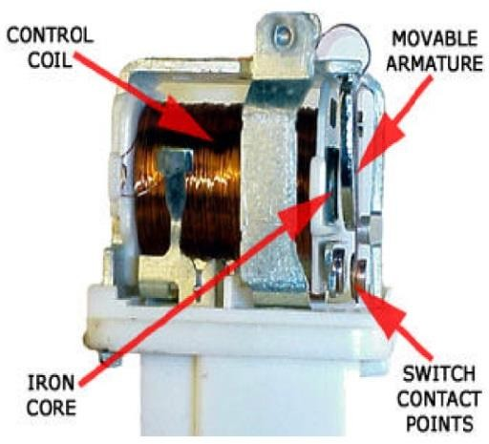

Fig.2.2.1 Design of Relay

It is an electro-magnetic relay with a wire coil, surrounded by an iron core. A path of very low reluctance for the magnetic flux is provided for the movable armature and also the switch point contacts. The movable armature is connected to the yoke which is mechanically connected to the switch point contacts.

* 1. **Working of Relay:**

The working of a relay can be better understood by explaining the following diagram given below.

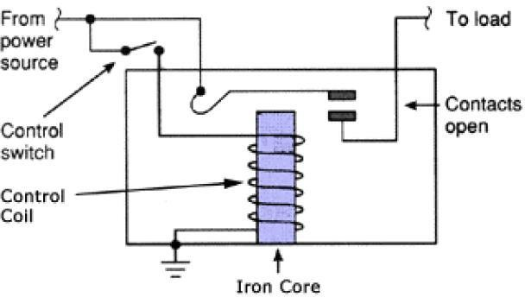

Fig.2.3.1 Working of relay

The diagram shows an inner section diagram of a relay. An iron core is surrounded by a control coil. As shown, the power source is given to the electromagnet through a control switch and through contacts to the load. When current starts flowing through the control coil, the electromagnet starts energizing and thus intensifies the magnetic field. Thus, the upper contact arm starts to be attracted to the lower fixed arm and thus closes the contacts causing a short circuit for the power to the load. On the other hand, if the relay was already de-energized when the contacts were closed, then the contact move oppositely and make an open circuit.

Relays are mainly made for two basic operations. One is low voltage application and the other is high voltage. For low voltage applications, more preference will be given to reduce the noise of the whole circuit. For high voltage applications, they are mainly designed to reduce a phenomenon called arcing.

* 1. **Types of Relay:**

There are two types of relay. They are:

1. Energized relay
2. De energized relay
3. **Energized Relay (ON):**

As shown in the circuit, the current flowing through the coils represented by pins 1 and 3 causes a magnetic field to be aroused. This magnetic field causes the closing of the pins 2 and 4. Thus the switch plays an important role in the relay working. As it is a part of1 the load circuit, it is used to control an electrical circuit that is connected to it. Thus, when the relay in energized the current flow will be through the pins 2 and 4.

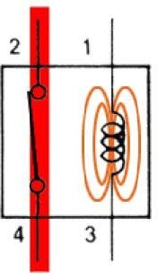

Fig. 2.4.1 Energized relay

1. **De – Energized Relay (OFF):**

As soon as the current flow stops through pins 1 and 3, the switch opens and thus the open circuit prevents the current flow through pins 2 and 4. Thus the relay becomes de- energized and thus in off position.

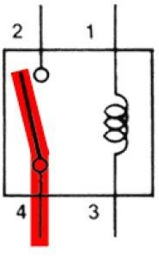

Fig.2.4.2 De energized relay

In simple, when a voltage is applied to pin 1, the electromagnet activates, causing a magnetic field to be developed, which goes on to close the pins 2 and 4 causing a closed circuit. When there is no voltage on pin 1, there will be no electromagnetic force and thus no magnetic field. Thus the switches remain open.

* 1. **Pole and Throw**

Relays have the exact working of a switch. So, the same concept is also applied. A relay is said to switch one or more poles. Each pole has contacts that can be thrown in mainly three ways. They are

* **Normally Open Contact (NO)** – NO contact is also called a make contact. It closes the circuit when the relay is activated. It disconnects the circuit when the relay is inactive.
* **Normally Closed Contact (NC)** – NC contact is also known as break contact. This is opposite to the NO contact. When the relay is activated, the circuit disconnects. When the relay is deactivated, the circuit connects.
* **Change-over (CO) / Double-throw (DT) Contacts** – This type of contacts are used to control two types of circuits. They are used to control a NO contact and also a NC contact with a common terminal. According to their type they are called by the names **break before make** and **make before break** contacts.
* **Single Pole Single Throw (SPST)** – This type of relay has a total of four terminals. Out of these two terminals can be connected or disconnected. The other two terminals are needed for the coil.
* **Single Pole Double Throw (SPDT)** – This type of a relay has a total of five terminals. Out f these two are the coil terminals. A common terminal is also included which connects to either of two others.
* **Double Pole Single Throw (DPST)** – This relay has a total of six terminals. These terminals are further divided into two pairs. Thus they can act as two SPST‘s which are actuated by a single coil. Out of the six terminals two of them are coil terminals.
* **Double Pole Double Throw (DPDT)** – This is the biggest of all. It has mainly eight relay terminals. Out of these two rows are designed to be change over terminals. They are designed to act as two SPDT relays which are actuated by a single coil.
  1. **Applications of relay:**

Relays are used to realize logic functions. They play a very important role in providing safety critical logic.

* + - Relays are used to provide time delay functions. They are used to time the delay open and delay close of contacts.
    - Relays are used to control high voltage circuits with the help of low voltage signals. Similarly they are used to control high current circuits with the help of low current signals.
    - They are also used as protective relays. By this function all the faults during transmission and reception can be detected and isolated
  1. **Selection of relay**

There are some factors while selecting a particular relay. They are

* + - Protection – Different protections like contact protection and coil protection must be noted. Contact protection helps in reducing arcing in circuits using inductors. Coil protection helps in reducing surge voltage produced during switching.
    - Look for a standard relay with all regulatory approvals.
    - Switching time – Ask for high speed switching relays if you want one.
    - Ratings – There are current as well as voltage ratings. The current ratings vary from a few amperes to about 3000 amperes. In case of voltage ratings, they vary from 300 Volt AC to 600 Volt AC. There are also high voltage relays of about 15,000 Volts.
    - Type of contact used – Whether it is a NC or NO or closed contact.
    - Select Make before Break or Break before Make contacts wisely.
    - Isolation between coil circuit and contact.

## CHANGE OVER RELAY OPERATION AND WIRING

A Relay is simply a device which can make its contacts change when the current flowing through its coil exceeds pick up value. A Relay may have NO and NC contact which can be used as per convenience. As far as changeover relay is concerned, suppose you use a relay having 1 NC and 1 NO contact. Also NC contact is used to extend power supply to meter (say) and the relay is energized. Now when the relay de- energies its NC contact will be NO and No will be NC and therefore the power will now be extended from other source to meter. So, the Relay works as Changeover Relay.

Relays have 2 contacts. In the normal state of the relay (when no current is passing through, a relay can be either closed or open (NO or NC).

The difference between a changeover relay and a conventional relay is that the conventional relay when open , it will prevent current from flowing ,but a changeover relay ,when open it will provide a connection to A , when closed it will provide a connection to B.

## Change over relay:

The most common changeover function relays are produced to switch a single feed line (usually positive - position 30) between two active functions in a circuit, the relay is switched manually via a toggle/push switch or remotely through the circuit. A simple 'single line changeover switch' is achieved by switching a single line input from

terminal position 30, at rest in the normally closed terminal position 87a (indicated by the 'thick set' black lines on the diagrams below), to the 87 position. When the coil is energized the line switches from terminal 87a to terminal 87, remaining in the second function until the power to the energized coil (via 85 and 86, which can be swapped in some applications) is switched off, returning the circuit to the normally closed (NC - 87a) position. A typical explanation of this function is to associate it with a headlight dipped beam, when momentary switching to full beam and then back to the dipped position (with both output positions 'by design' being active). In practice it would be correct to say that changeover relays have been used (sometimes by vehicle manufacturers) to achieve a normally open or normally closed make and break action, by leaving a line out position undesignated.

There are many configurations of a changeover relay used for automotive electrical circuit switching, each allowing a variation on the switch operation, versions include normally closed (NC or active circuit), latching and coil suppression. One of these, the latching relay allow a mechanical (or in some cases an electronic) function that retains the switched position even when power to the coil is cut, useful for conserving power, the line switch is reactivated (usually with a momentary push switch) only when the coil is energized again. Typical builds are:

Standard line changeover relay: as described, switching input 30 between 5 (NC) and 4 Changeover relays with diode: used for suppressing coil voltage spikes, 5 and 4 terminals become polarity sensitive; 4 must remain a positive designation if the diode tracks according to the diagram example below.

Changeover relays with resistor: used for a more reliable suppressing of coil voltage spikes, 5 and 4 can be swapped for coil energizing in some instances as the terminals do not become polarity sensitive.

Mechanical latching relay: allowing switching circuits and the position remains 'made' until

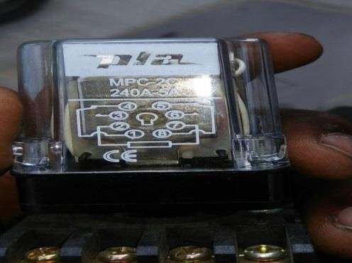

Fig 2.8.1 Change over relay

## Eight Channel relay:

Here we have 8 input coils and 8 output but here why we need relay because here we are using one pump motor and this pump motor is working on 230 v ac only for switching of this plug we are using relay and these is main important task

PLC output is interlinked with relay and these relay is enable the coil of relay and these coil is energies the plug of indication lamps for 230V AC lamps only we are using relay.

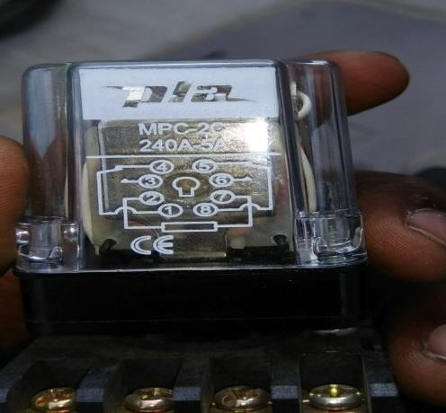

Fig 2.8.2 8 Channel relay

# INTRODUCTION TO PLC

## Programmable Logic Controller (PLC)

PLC is a device, which is used to control a machine or process as per the human control sequence. A PLC monitors inputs, makes decisions based on its program, and controls outputs to automate a process or machine.

### Advantages

* Smaller physical size than hard-wire solutions
* Easier and faster to make changes
* PLCs have integrated diagnostics and override functions
* Diagnostics are centrally available
* Applications can be immediately documented
* Applications can be duplicated faster and less expensive

## PLC-architecture

Fig 3.1.1 Architecture block diagram

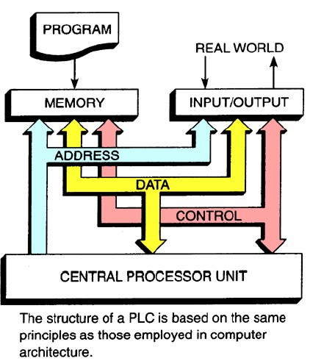

Fig.3.1.2 Architecture line diagram

### Processor memory organization

The memory of a PLC is organized by types. The memory space can be divided into two broad categories:

### Program and Data Memory:

Advanced ladder logic functions allow controllers to perform calculations, make decisions and do other complex tasks. Timers and counters are examples of ladder logic functions.

### Program files:

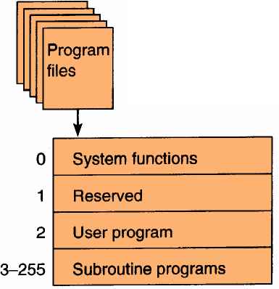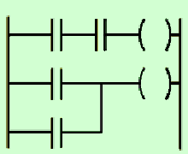

Fig.3.2.2 Program files

* + - * The user program will account for most of the memory of a PLC system.
      * Program files contain the logic controlling machine operation.
      * This logic consists of instructions that are programmed in a ladder logic format

### Data files:

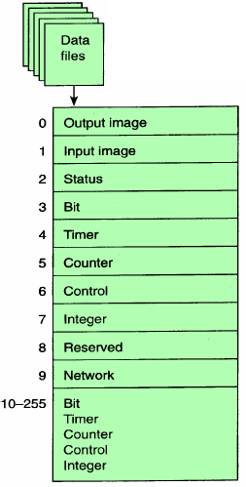

Fig.3.2.3 Data files

The data file portion of the memory stores input and output status, processor status, the status of various bits and numerical data.

## Input and output operation:

### Input table file operation:

Fig.3.3.1 Input table file operation

The Processor continually reads current input status and updates input image table file.

### Output table file operation:

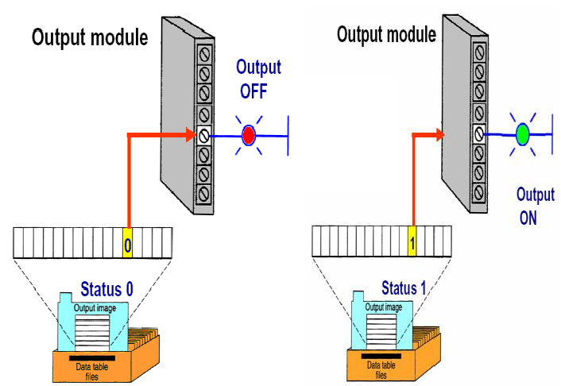

Fig. 3.3.2 Output table file operation

The Processor continually activates or deactivates output status according to output image table file status.

### Program scan:

During each operating cycle, the processor reads all inputs, takes these values, and energizes or de-energizes the outputs according to the user program. This process is known as a scan. Because the inputs can change at any time, the PLC must carry on this process continuously. I/O scan – records status data of input devices. Energizes output devices that have their associated status bits set to ON (1) Program scan – instruction are executed sequentially.

### Scan process:

The scan time indicates how fast the controller can react to changes in inputs. Scan times vary with computer model and program content, and length.

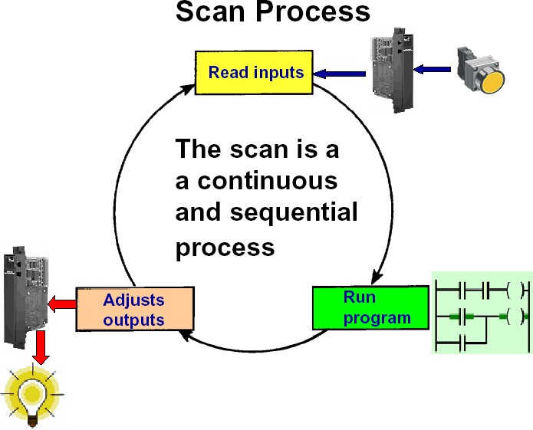

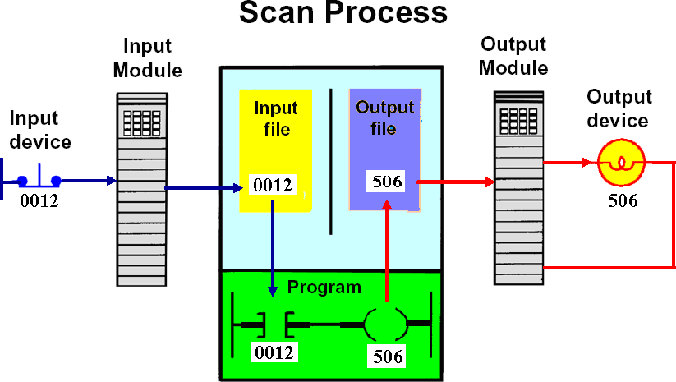

Fig 3.3.3 Scan process

* When the inputs are closed, the input module senses a voltage and an ON condition (1) is entered into the input table bit ‗0012‘.
* During the program scan the processor sets instructions ‗0012‘and ‗506‘to ON (1).
* The processor turns light output ‗506‘ON during the next I/O scale

## Automation

### Industrial automation:

Automation is the use of control systems such as computers to control industrial machinery and processes, replacing human operators. In the scope of industrialization, it is a step beyond mechanization. Whereas mechanization provided human operators with machinery to assist them with the physical requirements of work, automation greatly reduces the need for human sensory and mental requirements as well.

### Advantages of automation:

The purpose of automation has shifted from increasing productivity and reducing costs, to broader issues, such as increasing quality and flexibility in the manufacturing process.

Automation is now often applied primarily to increase quality in the manufacturing process, where automation can increase quality substantially.

Automobile and truck pistons used to be installed into engines manually. This is rapidly being transitioned to automated machine installation, because the error rate for manual instalment was around 1-1.5%, but has been reduced to 0.00001% with automation.

Hazardous operations, such as oil refining, the manufacturing of industrial chemicals, and all forms of metal working, were always early contenders for automation.

## Application of Automation:

* Power generation
* Transmission and distribution
* Oil and gas industries
* Process industries
* Building automation

## History of automation

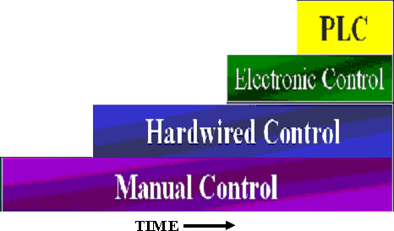

Fig 3.5History of automation

### Manual control:

Controls can be either be manual or automatic and since because lack of proper automatic tools the manual control are playing a vital role. Manual controls are applicable when judgement and discretion are required. Additionally, manual controls can be used in monitor automated controls.

### Hardwired control:

Prior to PLCs, many of these control tasks were solved with contactor or relay controls. This is often referred to as hard-wired control. Circuit diagrams had to be designed, electrical components specified and installed, and wiring lists created. Electricians would then wire the components necessary to perform a specific task. If an error was made the wires had to be reconnected correctly. A change in function or system expansion required extensive component changes and rewiring.

# DELTA PLC

## Product Details

## SS SERIES PLC:

* + - Offers powerful control features in an ultra-small package. It is ideally suited to smaller I/O applications where future expansion will not be required. In addition to the features already listed, the SS SERIES PLC also offers the following:
    - Choice of 10, 14, 20 and 30 fixed I/O sizes

85 applied instructions, 512 auxiliary relays, 64 timers, 32 counters, 256 data registers 2000 step EEPROM program memory (no backup battery required)

* + - The SS family of PLC's has a proven development lineage spanning more than 10 years. The three current models, the ES2 the EX2 and the EA2, offer a range of processing speeds, number of applied (complex) instructions and options from 10 I/O up to 256 I/O. See the following ranges for suitable digital, analogue and communication expansion modules and programming software.

The following features are common to all three types:

* + - All have 24Vdc inputs which can be configured as sink or source 27 basic instructions
    - Networking/communications ability using optional RS-232, RS-422 and RS-485 modules
    - 60kHz high speed counter
    - DIN rail or surface mount
    - Password security
    - Real time clock and Run/Stop switch built in
    - Choice of relay or transistor output models and we are using transistor output PLC
    - Relay outputs rated 240Vac or 30Vdc, up to 2A per point max.
    - Transistor outputs rated 5V to 30Vdc, up to 0.5A per point max.
    - Program using WPL soft version 2.49
    - Choice of ac or dc powered models (24v dc only)
    - ac type supply voltage 100-240Vac +10% -15%, 50/60Hz
    - dc type supply voltage 24Vdc +20% -1

## About PLC:

This type of PLC consists of 8 inputs and 8 outputs.

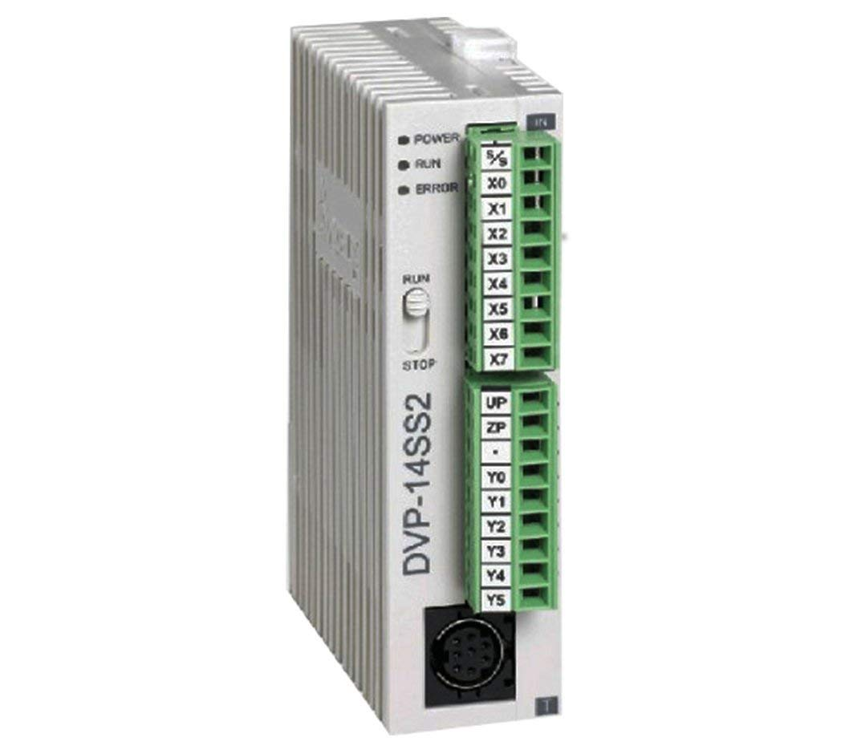

Fig 4.2 DELTA PLC

## 4.2.1 Specifications

Table 4.2.1 Specifications of plc

|  |  |
| --- | --- |
| **Attribute** | **Value** |
| For Use With | SS2 Series |
| Number of I/O | 14 |
| Manufacturer Series | DVP SS2 SERIES |
| Number of Inputs | 8 (Digital) |
| Input Type | Digital |
| Voltage Category | 24VDC |
| Output Type | TRANSISTER |
| Number of Outputs | 6 (Transister) |
| Communication Port Type | RS232 |
| Program Capacity | 1500 Steps |
| Programming Interface | Computer |
| Minimum Operating Temperature | 0°C |
| Mounting Type | DIN Rail |
| Output Current | 0.5 A |
| Length | 50mm |
| Programming Language Used | Ladder Logic |
| Number of Communication Ports | 1 |
| Width | 20mm |
| Depth | 40mm |
| Dimensions | 50x40x20mm |
| Maximum Operating Temperature | +55 |

## The advantages of DELTA PLC

* + - Although it is not as popular as the product Allen Bradley, simenens PLCs are still used by many users because it has many advantages, including the following
    - Reliable memory for storing input data and execution
    - One of advantages from Delta Modular PLC is having much more memory and has the ability to store a higher volume compared to products that have the same memory capacity with this PLC. This could speed up the process execution data.

### Having more numbers I/O modules that are profitable

Other types of PLC is usually have limited numbers I / O modules so that the choice of use Modular PLC is good decision because it has more number of I / O modules more so that it has the capacity to achieve more complex process.

### Easy in and operating a trouble shooting

Good controller must have the characteristics of easy to operate, and if a problem occurs, the PLC is easy to fix. Easy trouble shooting process is very beneficial because it lowers down time. For long-term use, the PLC is very advantageous because the production process will not be disturbed by the length of the process downtime and trouble shooting.

### Application of DELTA SS2 PLC

There are many applications of this PLC whether in industry or home appliance.

Several of them are as below:

### In The Home

* + - Residential air conditioners
    - Air conditioner for residential purposes of system usually requires only a simple control system, the manual switch combined with room thermostat and timer

switches to control the temperature of the room. Control equipment suitable for this application is Mitsubishi Modular PLC.

* + - Fridges
    - Home automation
    - Fans
    - Industrial Applications

### Commercial

* + - Commercial Air Conditioning
    - The control unit on Commercial Air Conditioning is regulated by a thermostat that will operate a relay or contactor. Relays or contactors will provide reinforcement to the compressors, fans, valves and pumps. Medium control unit
    - Large Screen Display
    - Jet Towel Commercial Hand Dryer
    - Ventilation

### Industrial

* + - Transportation
    - Automotive Equipment
    - Communication Systems
    - Industrial Automation
    - Semiconductors
    - Switchgear
    - TFT-LCD Modul

**PROCEDURE TO OPEN WPL SOFTWARE**

## How to perform programming without module:

* + 1. open WPLC SOFTWARE
    2. Go to project click on new window
    3. select CPU modelSS2 SERIES
    4. Next click on ok

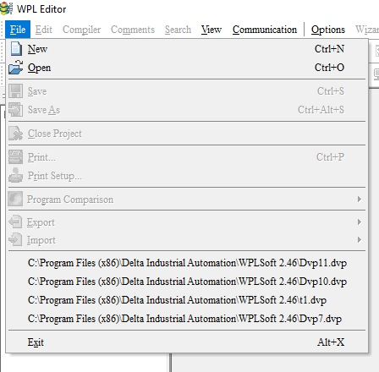

Fig 5.1.1 Opening the WPL

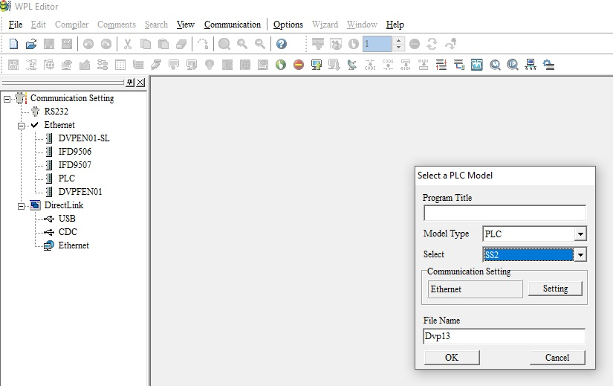

Fig 5.1.2 creating the new page

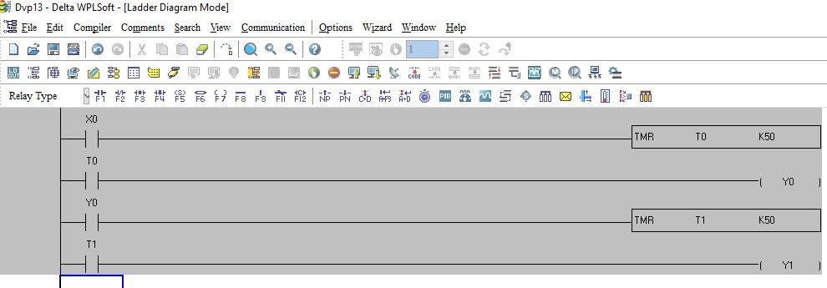

Fig 5.1.3 Creating the program

* + 1. Write a program according to given instructions
    2. Go to compiler and click ladder instructions options

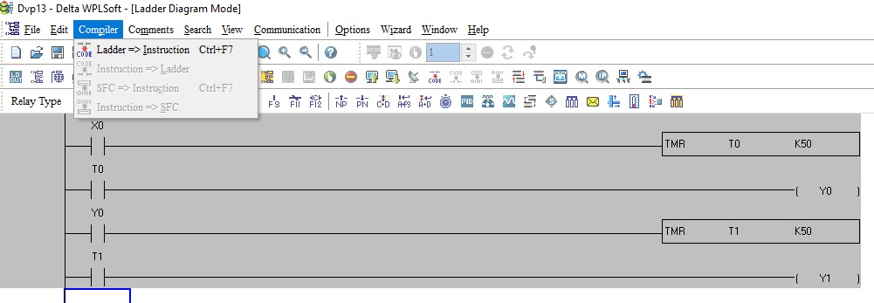

Fig 5.1.4 Converting the program

* + 1. Check the comport while going to options

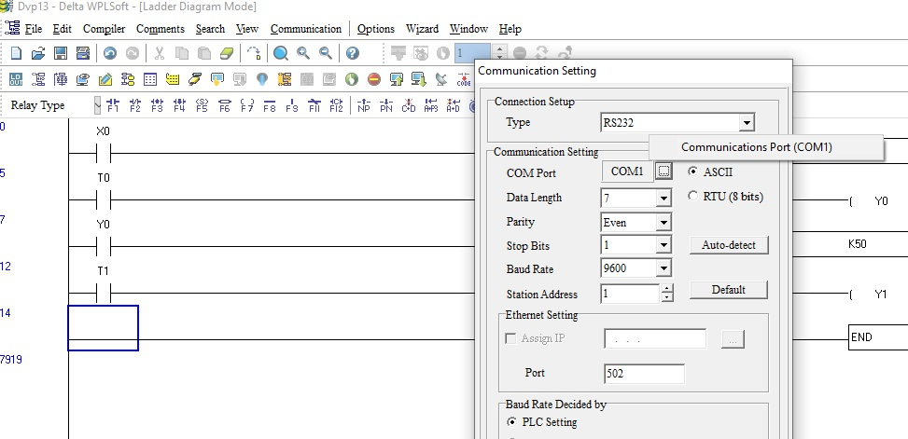

Fig. 5.1.5 Check the com port of PLC

* + 1. For downloading the program click communication

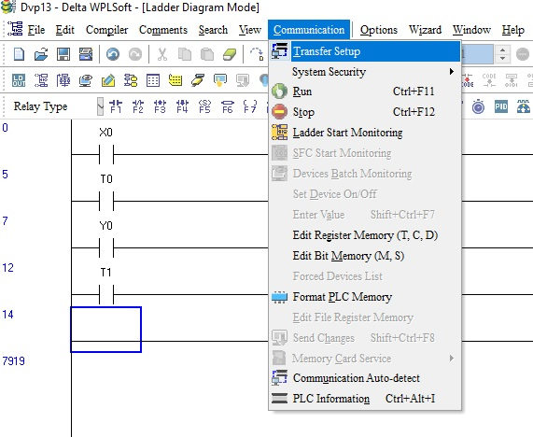

Fig 5.1.6 communication

* + 1. Select PC=>PLC

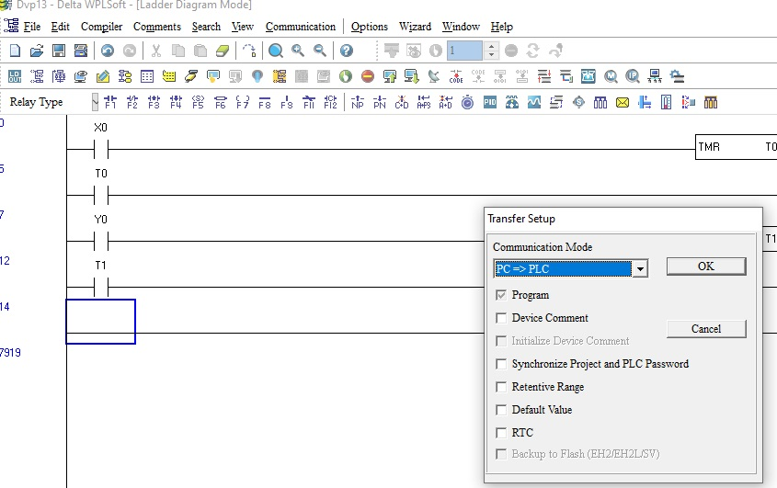

Fig 5.1.7 select download option

## How to perform programming with module:

* + 1. Open WPL software
    2. Go to project click on new window
    3. select cpu mode and select SS2 series
    4. Next click on ok



Fig.5.2.1 Opening the WPL SOFT

* + 1. Go to COMMUNICATION option and select PC <= PLC (program backup)

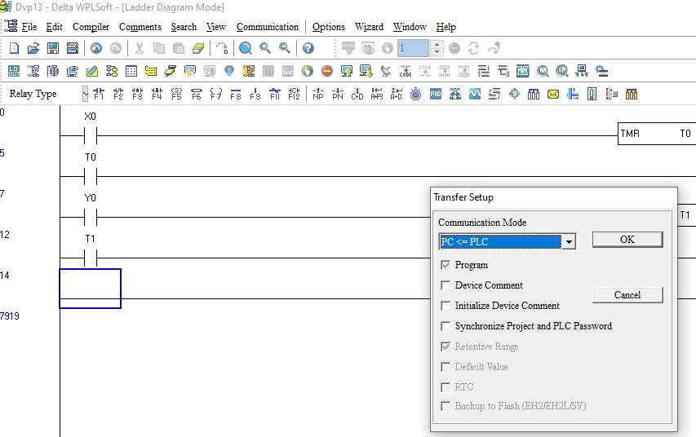

Fig 5.2.2 selection of backup PC <= PLC

* + 1. Click on online mode and check our program in online

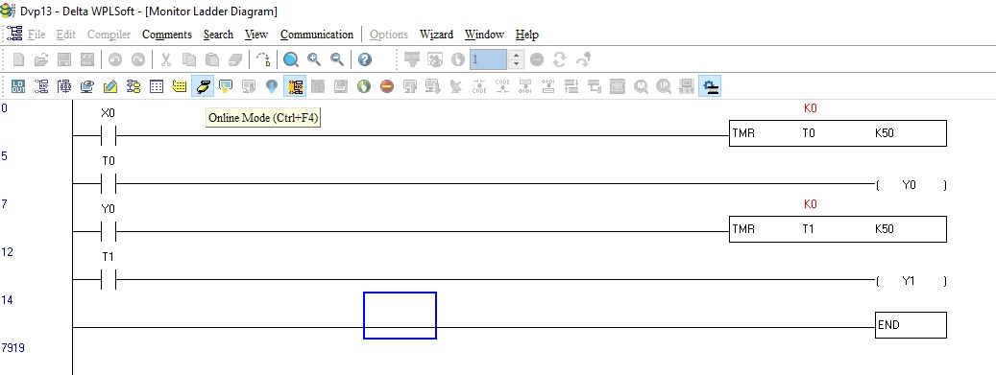

## Addressing in DELTA PLC

### INPUT ADDRESSING:-

(X0 X1---X7)

(X10 X11--X17) UP T0 (X370, X371, X372—X377)

### OUTPUT ADDRESSING:-

(Y0 Y1 ---Y7)

(Y10 Y11 ---Y17) UP TO (Y370, Y371---Y377)

### MEMORY ADDRESSING:

M0 M1 M2 M3 M4087

**INTEGER ADDRESSING:-**D0 D1 D2 D900

**CONSTANT VALUE:**-K30 K40 etc…

**PLC WIRING AND WORKING OF COMPONENTS**

## RELAY

Depending on the operating principle and structural features relays are of different types such as electromagnetic relays, thermal relays, power varied relays, multi-dimensional relays, and so on, with varied ratings, sizes and application

1. Electromagnetic relay
2. Solid state relay
3. Thermal relay
4. Static relay
5. Vaccum relay
6. Automatic reclosing relay
7. Protective and monitoring relay

**2.1 Electromagnetic Relays**

These relays are constructed with electrical, mechanical and magnetic components, and have operating coil and mechanical contacts. Therefore, when the coil gets activated by a supply system, these mechanical contacts gets opened or closed. The type of supply can be AC or DC.there electronic circuit is placed in the AC relay to provide magnetism in the zero current position. These relays can work with both AC and DC supply and attract a metal bar or a piece of metal when power is supplied to the coil. This can be a plunger being drawn towards the solenoid or an armature being attracted towards the poles of an electromagnet as shown in the figure. These relays don’t have any time delays so these are used for instantaneous operation. Induction Type Relays These are used as protective relays in AC systems alone and are usable with DC systems. The actuating force for contacts movement is developed by a moving conductor that may be a disc or a cup, through the interaction of electromagnetic fluxes due to fault currents. Induction Type Relays Induction Type Relays These are of several types like shaded pole, watt-hour and induction cup structures and are mostly used as directional relays in power-system protection and also for high-speed switching operation applications. Magnetic Latching Relays These relays use permanent magnet or parts with a high remittance to remain the armature at the same point as the coil is electrified when the coil power source is taken away.

**2.1.1 Attraction Type electromagnetic relays**

These relays can work with both AC and DC supply and attract a metal bar or a piece of metal when power is supplied to the coil. This can be a plunger being drawn towards the solenoid or an armature being attracted towards the poles of an electromagnet as shown in the figure. These relays don’t have any time delays so these are used for instantaneous operation. Induction Type Relays These are used as protective relays in AC systems alone and are usable with DC systems. The actuating force for contacts movement is developed by a moving conductor that may be a disc or a cup, through the interaction of electromagnetic fluxes due to fault currents. Induction Type Relays Induction Type Relays These are of several types like shaded pole, watt-hour and induction cup structures and are mostly used as directional relays in power-system protection and also for high-speed switching operation applications.

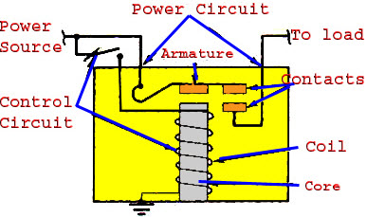

**Fig.2.0.**.Attraction type electromagnetic relay

A relay is an electrically operated switch. Many relays use an electromagnet to mechanically operate a switch, but other operating principles are also used, such as solid-state relays. Relays are used where it is necessary to control a circuit by a separate low-power signal, or where several circuits must be controlled by one signal. The first relays were used in long distance telegraph circuits as amplifiers: they repeated the signal coming in from one circuit and re-transmitted it on another circuit.

Relays were used extensively in telephone exchanges and early computers to perform logical operations. A type of relay that can handle the high power required to directly control an electric motor or other loads is called a contactor. Solid-state relays control power circuits with no moving parts, instead using a semiconductor device to perform switching. Relays with calibrated operating characteristics and sometimes multiple operating coils are used to protect electrical circuits from overload or faults; in modern electric power systems these functions are performed by digital instruments still called "protective relays". Magnetic latching relays require one pulse of coil power to move their contacts in one direction, and another, redirected pulse to move them back. Repeated pulses from the same input have no effect. Magnetic latching relays are useful in applications where interrupted power should not be able to transition the contacts. Magnetic latching relays can have either single or dual coils. On a single coil device, the relay will operate in one direction when power is applied with one polarity, and will reset when the polarity is reversed. On a dual coil device, when polarized voltage is applied to the reset coil the contacts will transition. AC controlled magnetic latch relays have single coils that

employ steering diodes to differentiate between operate and reset commands

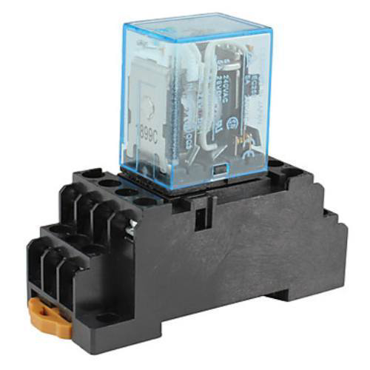

Fig.2.1.Electromagnetic relay

* Electromagnetic relay are those relay which operates on the principle of electromagnetic attraction
* It is a type of magnetic switch which uses the magnet for creating magnetic field
* The magnetic field than uses for opening and closing the switch and performing mechanical operation.

**Operation:**

Electromagnetic relays are those relays which are operated by electromagnetic action. Modern electrical protection relays are mainly microprocessor based, but still electromagnetic relay holds its place. It will take much longer time to replace all electromagnetic relays by microprocessor based static relays. So before going through detail of protection relay system we should review the various types of electromagnetic relays. Electromagnetic Relay Working Practically all the relaying device is based on either one or more of the following types of electromagnetic relays. Magnitude measurement, Comparison, Ratio measurement.\

* + SMPS

In case of SMPS with input supply drawn from the ac mains, the input voltage is first rectified and filtered using a capacitor at the rectifier output. The unregulated dc voltage across the capacitor is then fed to a high frequency dc-to-dc converter.

Most of the dc-to-dc converters used in SMPS circuits have an intermediate high frequency ac conversion stage to facilitate the use of a high frequency transformer for voltage scaling and isolation. In contrast, in linear power supplies with input voltage drawn from ac mains, the mains voltage is first stepped down (and isolated) to the desired magnitude using a mains frequency transformer, followed by rectification and filtering. The high frequency transformer used in a SMPS circuit is much smaller in size and weight compared to the low frequency transformer of the linear power supply circuit. The ‗Switched Mode Power Supply ‘owes its name to the dc-to-dc switching converter for conversion from unregulated dc input voltage to regulated dc output voltage.

The switch employed is turned ‗ON ‘and ‗OFF‘(referred as switching) at a high frequency. During ‗ON‘ mode the switch is in saturation mode with negligible voltage drop across the collector and emitter terminals of the switch where as in ‗OFF‘ mode the switch is in cut-off mode with negligible current through the collector and emitter terminals. On the contrary the voltage regulating switch, in a linear regulator circuit, always remains in the active region. Details of some popular SMPS circuits, with provisions for incorporating high frequency transformer for voltage scaling and isolation, have been discussed in next few lessons. In this lesson a simplified schematic switching arrangement is described that omits the transformer action. In fact there are several other switched mode dc-to-dc converter circuits that do not use a high frequency transformer. In such SMPS circuits the unregulated input dc voltage is fed to a high frequency voltage chopping circuit such that when the chopping circuit (often called dc to dc chopper) is in ON state, the unregulated voltage is applied to the output circuit that includes the load and some filtering circuit. When the chopper is in OFF state, zero magnitude of voltage is applied to the output side. The ON and OFF durations are suitably controlled such that the average voltage applied to the output circuit equals the desired magnitude of output voltage. The ratio of ON time to cycle time (ON + OFF time) is known as duty ratio of the chopper circuit. A high switching frequency (of the order of 100 KHz) and a fast control over the duty ratio results in application of the desired mean voltage along with ripple voltage of a very high frequency to the output side, consisting of a low pass filter circuit followed by the load.

The high Version 2 EE IIT, Kharagpur 6 frequency ripple in voltage is effectively filtered using small values of filter capacitors and inductors. A schematic chopper circuit along with the output filter is shown in Fig.21.3. Some other switched mode power supply circuits work in a slightly different manner than the dc-to-dc chopper circuit discussed above. Details of some of these circuits have been discussed in following lessons.

### SMPS versus linear power supply

As discussed above, in a linear regulator circuit the excess voltage from the unregulated dc input supply drops across a series element (and hence there is power loss in proportion to this voltage drop) whereas in switched mode circuit the unregulated portion of the voltage is removed by modulating the switch duty ratio. The switching losses in modern switches (like: MOSFETs) are much less compared to the loss in the linear element. In most of the switched mode power supplies it is possible to insert a high frequency transformer to isolate the output and to scale the output voltage magnitude.

In linear power supply the isolation and voltage-scaling transformer can be put only across the low frequency utility supply. The low frequency transformer is very heavy and bulky in comparison to the high frequency transformer of similar VA rating. Similarly the output voltage filtering circuit, in case of low frequency ripples is much bulkier than if the ripple is of high frequency. The switched mode circuit produces ripple of high frequency that can be filtered easily using smaller volume of filtering elements.

Linear power supply though more bulky and less efficient has some advantages too when compared with the switched mode power supply. Generally the control of the linear power supply circuit is much simple of SMPS circuit. Since there is no high frequency switching, the switching related electro-magnetic interference (EMI) is practically absent in linear power supplies but is of some concern in SMPS circuits. Also, as far as output voltage regulation is concerned the linear power supplies are superior to SMPS. One can more easily meet tighter specifications on output voltage ripples by using linear power supplies. Problem 3 Estimate and compare the size (window area X core area) of the following two transformers: (i) a 50 VA, 50Hz, 15V low frequency transformer and (ii) a 50 VA, 100 kHz, 15V high frequency transformer. Assume sinusoidal voltages.

Assume the peak flux density in low frequency transformer to be 1.5 tesla and in high frequency transformer to be 0.3 tesla. Take identical values for window utilization factor and copper current density. [Hint: VA rating for a single phase transformer = 2.22 f BmaxAC AW δ KW, where f is supply frequency, Bmax is the peak flux density, AC : core area, AW : window area, δ : current density in copper and KW is the window utilization factor.] Answer: Volume (size) of Low frequency transformer will be 400 times higher than that of high frequency transformer. Version 2 EE IIT, Kharagpur 7 21.5 Hybrid (SMPS followed by linear) power supply A comparison of linear and switched mode power supplies tells about the advantages and disadvantages of the two. Linear power supply is highly inefficient if it has to work over large variations in input voltage, is more bulky because of the use of low frequency transformer and filter elements (inductors and capacitors).

On the other hand linear power supplies give better output voltage regulation. It may sometimes be required to have output voltage regulation similar to the one provided by linear supplies and compactness and better efficiency of a switched mode supply. For this, the linear power supply may be put in tandem with a switched mode supply. Let us consider a case where one needs an isolated and well-regulated 5 volts output while input power is drawn from utility supply that has large voltage fluctuation. In such a situation one may generate an isolated 7.5 volts from an SMPS and follow it by a 5 volts linear power supply set to work with 7.5 volts input. The input to linear power supply

must be few volts more than the required output (for proper biasing of the switches) and hence SMPS tries to maintain around 7.5 volts input. It can be seen that the linear power supply now does not have large input voltage variation in spite of large variations in the utility rms voltage. The SMPS portion of the power supply efficiently performs the job of voltage isolation and conversion from widely varying utility voltage to fairly regulated 7.5 volts dc. Under the given condition it may not be difficult to see that the overall efficiency of this hybrid power supply will lie between that of a SMPS and a linear supply. The overall cost may or may not increase even though two supplies in tandem are used. It is to be kept in mind that to achieve the same output voltage specification by an SMPS circuit alone, the control and filtering circuit may become more costly and complex (than the one used in the hybrid power supply unit). Similarly if the linear supply has to be designed for larger fluctuation in input voltage the component ratings, including heat-sink ratings, will be higher and may cost as much as the hybrid unit.

### Multiple output SMPS

A single power supply unit may need to output several different voltages. The individual output voltages may have different ratings in terms of output current, voltage regulation and ripple voltages. These outputs may need isolation between them. Generally a common high frequency transformer links the input and output windings and in spite of output voltage feedback all the outputs can not have same regulation because of different loads connected to different outputs and hence different ohmic (resistive) drops in the output windings (loads are generally variable and user dependent). Also the coupling between the different secondary windings and the primary winding may not be same causing different voltage drops across the respective leakage inductances.

Barring this mismatch in the voltage drops across the resistances and leakage inductances of the secondary windings their output voltages feedback is used for SMPS switch control). The output that needs to have tighter voltage regulation may be used for output voltage feedback. In case another output needs to have similarly tight regulation then that particular output may be passed through an additional linear regulator circuit.

### Resonant Mode Power Supplies:

Resonant mode power supplies are a variation over SMPS circuits where the switching losses are significantly reduced by adapting zero-voltage or zero- current switching techniques. In non-resonant mode SMPS circuits the switches are subjected to hard switching (during hard switching, both the voltage and current in the switch are of considerable magnitude resulting in large instantaneous switching power loss). Efficiency of resonant mode power supplies is generally higher than non-resonant mode supplies.

Power supply specifications Power supplies may have several specifications to be met, including their voltage and current ratings. There may be short time ratings of higher magnitudes of current and continuous ratings of somewhat lower magnitudes.

One needs to specify the tolerable limits on the ripple voltages, short- circuit protection level of current (if any) and the nature of output volt-current curve during over-current or short circuit (the output voltage magnitude should reduce or fold back towards zero, gradually, depending on the severity of over- current). The fuse requirement (if any) on the input and the output side may need to be specified. One needs to specify the type of input supply (whether ac or dc) or whether the power supply can work both from ac or dc input voltages. Acceptable range of variation in input voltage magnitude, supply frequency (in case of ac input) are also to be specified. Efficiency, weight and volume are some other important specifications. Some applications require the electro- magnetic compatibility standards to be met. Output voltage isolation and it is specified in terms of isolation breakdown voltage. In case of multiple power supplies it needs to be specified whether all the outputs need to be isolated or not and what should be the acceptable ripple voltage range for each. In majority of the cases the available source of input power is the alternating type utility voltage of 50 or 60 Hz. The voltage levels commonly used are 115V (common in countries like, USA) and 230 volts (common in India and many of the European countries). Most utility (mains) power supplies are expected to have ± 10% voltage regulation but for additional precaution the SMPS circuits must work even if input voltages have ± 20% variation. Now-a-days universal power supplies that work satisfactorily and efficiently both on 115 V and 230 V input are quite popular.

These power supplies are very convenient for international travellers who can simply plug-on their equipment, like laptop computer and shaving machine, without having to pay much attention on the exact voltage and frequency levels of the utility supply. In contrast some of the other power supplies have a selector switch and the user is required to adjust the switch position to match the utility voltage. In case user forgets to keep the selector switch at correct position, the equipment attached may get damaged.

### Some common types of SMPS circuits

There are several different topologies for the switched mode power supply circuits. Some popular ones are: fly-back, forward, push-pull, C‘uk, Sepic, half bridge and H-bridge circuits. Some of these configurations will be discussed in the coming lessons. A particular topology may be more suitable than others on the basis of one or more performance criterions like cost, Version 2 EE IIT, Kharagpur 9 efficiency, overall weight and size, output power, output regulation, voltage ripple etc. All the topologies listed above are capable of providing isolated voltages by incorporating a high frequency transformer in the circuit. There are many commercially available power

**6.3 INDICATING LAMPS AND PUSH BUTTONS**

**.Indicating lamps:**

These indicating lamps consist of a light to indicate whether power is on or off

Indicating lamps available in different color to indicate different phases

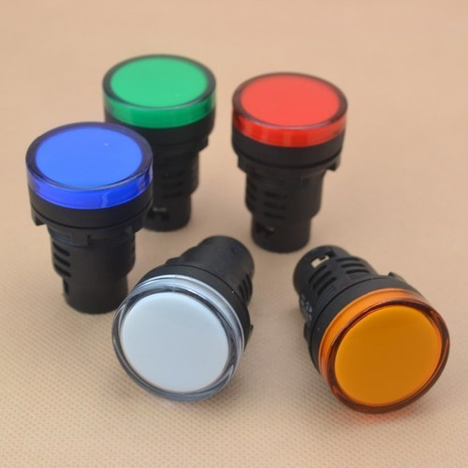

**Fig.4.1.Indicating lamp**

**4.2. Push button**

Two buttons are used just for on and off purpose. Red color indicates ‘stop’ and green color for to ‘start’



Fig.4.2.Push button

A push button is a momentary or non-[latching switch](https://en.wikipedia.org/wiki/Latching_switch) which causes a temporary change in the state of an [electrical circuit](https://en.wikipedia.org/wiki/Electrical_circuit) only while the switch is physically actuated. An automatic mechanism (i.e. a spring) returns the switch to its default position immediately afterwards, restoring the initial circuit condition. There are two types:

* **Push to make switch:** A **push to make** switch allows electricity to flow between its two contacts when held in. When the button is released, the circuit is broken. This type of switch is also known as a **Normally Open** (NO) Switch. (Examples: doorbell, computer case power switch, calculator buttons, individual keys on a keyboard)

[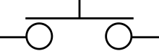](https://en.wikipedia.org/wiki/File:Push-to-make_switch_electronic_symbol.svg)

Push-to-make switch electronic symbol

Fig.4.3.make switch

* **Push to break switch:** A Push to break switch does the opposite, i.e., when the button is not pressed, electricity can flow, but when it is pressed the circuit is broken. This type of switch is also known as a Normally Closed (NC) Switch. (Examples: Fridge Light Switch, Alarm Switches in Fail-Safe circuits)

[https://upload.wikimedia.org/wikipedia/commons/thumb/5/53/Push-to-break_switch_electronic_symbol.svg/220px-Push-to-break_switch_electronic_symbol.svg.png](https://en.wikipedia.org/wiki/File:Push-to-break_switch_electronic_symbol.svg)

Push-to-break switch electronic symbol

Fig.4.4.Break switch

Many Push switches are designed to function as both push to make and push to break switches. For these switches, the wiring of the switch determines whether the switch functions as a push to make or as a push to break switch.

* + **ON DELAY TIMER**

## ****Time Delay Relay****

Some or all industrial control systems need timing operations. Timing devices are used to cut on or off pilot devices at a preset time. [Time delay relays](https://en.wikipedia.org/wiki/Relay#Time_delay_relay) and [solid-state timers](https://en.wikipedia.org/wiki/Solid-state_relay) similar and are used to provide the desired delay and timing functions.

Timers are constructed with dials, displays, or some type of operator interface used to set the time and contact state to normally open or normally closed on the device. Though there are many types of timers and different functions they can perform they all come from two basic types timing functions which are the **ON Delay Timer**and**OFF Delay Timer**.

## ****ON Delay Timer Working Principle****

The **on-delay relay timer** provides a change to the state of the contacts that are controlled by the energizing of the timer. The on-delay relay timer can be set or programmed to a predetermined time and this is called the preset time. **Preset time** can be as low as milliseconds to hours and even days but usually, in the industrial control system, it is set to seconds and minutes.

Once the coil of the timer is energized the timer starts to count from zero to the pre-set time, this count is known as the **accumulated time**. When the preset time and accumulated time are equal the contacts of the timer change their state; contacts that are normally open when the coil was not energized go closed and contacts that are normally closed will change to open. The contacts of the timer will stay in their changed state for the same amount of time the coil is energized. When the power is removed from the coil of the timer the accumulated time returns to zero and contacts return to their original state.

Timing diagrams are usually used to illustrate the operation of the timers’ function, so there will be a little learning curve to understanding the timers function.

* You May Also Read: [Solid State Timer | Solid State Relay Timer](https://electricalacademia.com/motor-control/solid-state-timer-solid-state-relay-timer/)

## ****On Delay Contact Symbol****

On-delay timers can easily be identified in ladder diagrams. On-delay timer coils are represented like all loads illustrated ladder diagrams except there is a label with the abbreviation of **TD** which stands for time delay and the contacts are drawn like a single pole switch with two legs coming out of the bottom as seen in figure 1.

The contact will be either a normally closed or a normally open contact. The normally open contact is termed**normally open time close (NOTC)**while the normally closed contact is termed**normally close timed open contact (NCTO)**.

On Delay contacts do not have a set of instantaneous contacts (which means the contacts will change state immediately when the coil of the timer is energized). Not having this operation means the timer cannot be activated by momentary control devices without the use of a control relay which is a pilot device with instantaneous contacts. When the momentary control device is activated the control relay can be used to seal in the circuit and keep the coil of the on-delay timer energized for the necessary time period.

[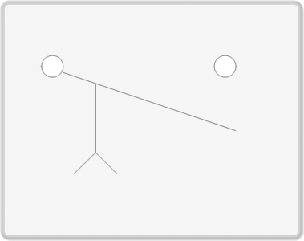](https://electricalacademia.com/wp-content/uploads/2017/08/NOTC.gif) 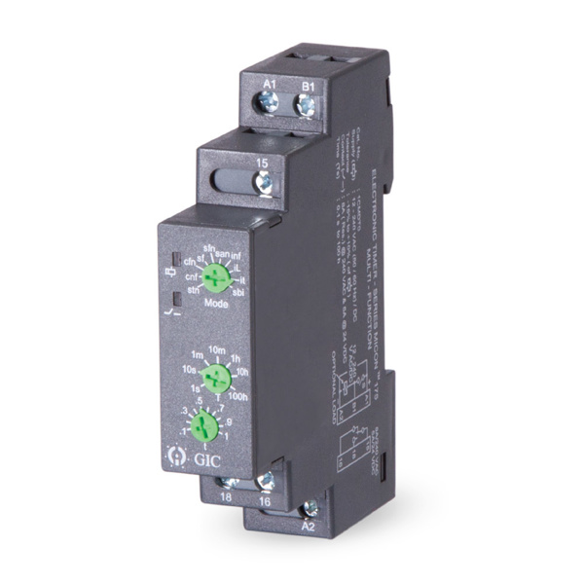

F: NOTC ON Delay Contact

## ****ON Delay Timer Timing Diagram****

A **timing diagram** is a graph that shows the status of the timer to the timing device in relation to the performance of the contact or output of the timer. **The diagram has two graphs, one is used to represent the input signal to the timing device; fowling graphic lines are used to represent the timing devices outputs or contacts.** The graphic lines in a timing diagram are drawn to show a false to true, on to off, or high to low. The lines are drawn at right angles to represent discrete values of the time cycle because there is no in between the values can only be off or on.

[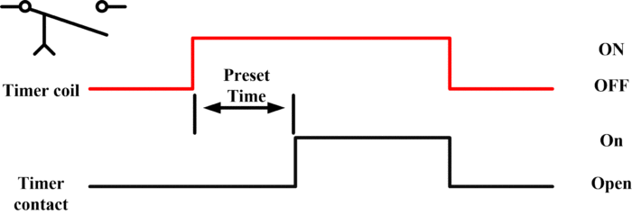](https://electricalacademia.com/wp-content/uploads/2017/08/figure-4.gif)

Fig.2: Normally Open Timed Closed (NOTC)

Figure 2 is the timing diagram used to represent a **normally open timed closed delay contact**. When the timer coil receives power the preset time starts to count. Once the accumulated time has equalled the preset time the timer contact will change from normally closed to open and will remain open until the timer coil has lost power. At this time the timer has been reset back to zero and the cycle can begin again.

[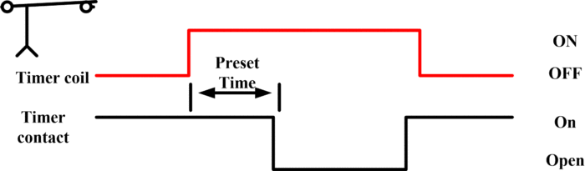](https://electricalacademia.com/wp-content/uploads/2017/08/figure-5.gif)

Fig.3: Normally Close Timed Open (NCTO)

Figure 3 timing diagram is used to represent the **normally closed timed open contact**. In this diagram, the load connected to the timer contact is on and will stay on after the timer coil has been energized and the preset time has become equal to the accumulated time. At that point of time, the contact will open causing the load to turn off and stay off until the timer coil has been de-energized. Once de-energized, the timer coil will return to zero and be ready to cycle again.

**PLC WIRING AND PROGRAMMING**

## Main objective of project:

Development of traffic control system using PLC (programmable logic controller) is the title of this project. This project is divided into two parts which are hardware and software. The hardware part for this project is a model of four way junction of a traffic light. Each lane has two sensors, three indicator lamps with different colours (Red, Yellow and Green) are installed at each lane for represents as traffic light signal. the sensors and indicator lamps are connected to MISTUBISHI PLC.

## Components:

* + - DELTA PLC system
    - Relay
    - ON DELAY TIMER
    - Indication lamps (24V DC)
    - SMPS
    - ON/OFF push buttons
    - Emergency push button

## TIMER Latching wiring diagram:

## C:\Users\ADMIN\Downloads\WhatsApp Image 2021-10-27 at 2.57.06 PM.jpeg

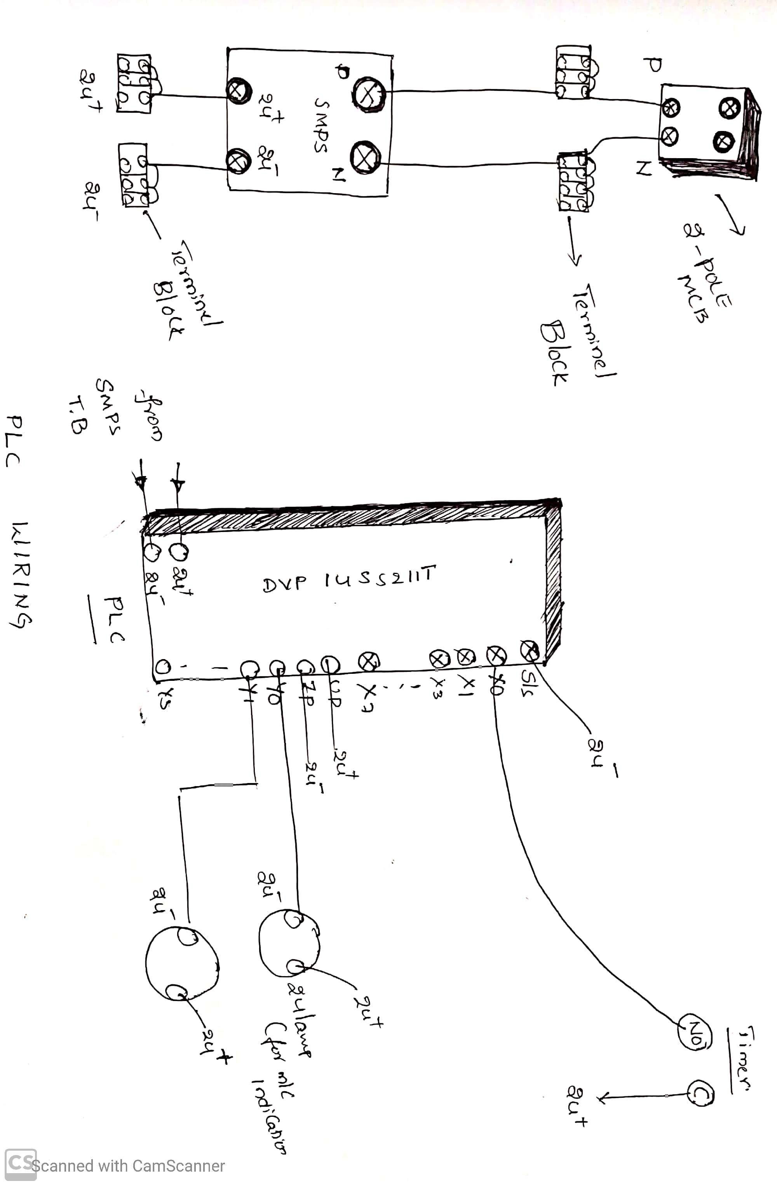

Fig 7.3 Wiring diagram

## PLC programming:

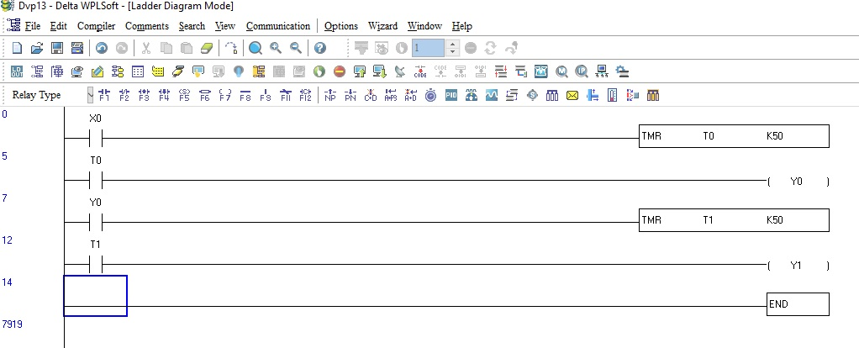

* 1. **Procedure for project:**
* Open PLC programming software WPL SOFTWARE and write a program and check your program in simulation whether it is running on our conditions
* If your program is ok then go for PLC panel wiring
* Give the connections according to latching circuit of Timer
* After given connection check the latch and unlatching circuit whether it is working or not
* Then connect the wiring of timer feedback to PLc for getting the signal
* After given connection to PLc check the Power supply whether it is coming or not from SMPs and give the connection to PLC
* After these input connection give the connections to output of PLC to lights
* In the place of machine we assumed two lights and turn on the supply
* After completion of all wiring and other programming analysis we have to give the wiring and dump the program in DELTA PLC and power ON the supply and check your conditions either it is running or not.

## Advantages:

* No need of man power
* This system is accurate and error free
* It consumes less power
* It reduces harms to motors also
* SOP will not Disturb
* Smooth Operation
* Troubleshooting of Connections is also easy
* Installation and commissioning is also easy

## Disadvantages:

* Installation cost is high
* Power backup is required

## Applications:

* It can be used at any type of motor controlling system
* All type of machines which can control in sequence wise

**Approximate Cost:**

|  |  |  |  |
| --- | --- | --- | --- |
| **Components** | **Cost** | **Components** | **Cost** |
| On Push Button | 200 | MCB Channel | 100 |
| Off Push Button | 200 | 2- Pole MCB | 800 |
| Emergency Push Button | 200 | PVC Channel | 100 |
| SMPS | 3500 | Indication Lamps | 400 |
| PLC (delta) | 7000 | Timer | 800 |
| 2 Change Over Relay | 300 | Wood | 200 |
| Terminals | 500 | Wiring Accessories | 400 |

**Final Output of Project:**

This project is developed on PLC. However, nowadays all the industries is based on relay wiring technology while using Relay logic they are facing so many problems like short circuits, less productions , raw material wastage To overcome this problem we have to change manual work to this latest technology and here in these project we need connect timer with latching circuit then we will get turn on feedback from Timer to PLC and in PLC we are writing a Program according Sequence requirement and according to these sequence we will turn on machines.

**CONCLUSION**

This project has developed on PLC. However, nowadays all the industries is based on relay wiring technology while using Relay logic they are facing so many problems like short circuits, less productions , raw material wastage To overcome this problem we have to change manual work to this latest technology and here in these project we need connect timer with latching circuit then we will get turn on feedback from Timer to PLC and in PLC we are writing a Program according Sequence requirement and according to these sequence we will turn on machines

# FUTURE SCOPE

* Instead of timer we can use any of other controlling device like HMI for entering the time and control many machineries
* Using SCADA, we can control these machines through Remote locations and through SCADA we can get Monitoring and controlling of total plant elements

# REFERENCE

1. Azura Che Soh/Lai Guan Rhung ―MATLAB Simulation of Fuzzy Traffic Controller for Multilane Isolated Intersection [www.enggjournals.com/ijcse/doc/IJCSE10-02-04-11.pdf](http://www.enggjournals.com/ijcse/doc/IJCSE10-02-04-11.pdf)
2. Monica Voines cu, Andreea Udrea, Simona Caramihal ―On Urban Traffic Modelling and Control‖ <http://www.ceai.srait.ro/index.php/ceai/article/view/307>
3. C. M. Mwangi, S. M. Kang ‘ethe and G. N. Nyakoe ―Design and simulation of a fuzzy logic traffic signal controller for a signalized intersection‖ elearning.jkuat.ac.ke/journals/ojs/index.php/jscp/article/view/699
4. Ovidiu TOMESCU, Ilona Madalina MOISE, Alina Elena STANCIU, Iulian BĂŢROŞ ―Adaptive Traffic Light Control System using AD HOC Vehicular CommunicationsNetwork‖[www.scientificbulletin.upb.ro/rev_docs_arhiva/full6a](http://www.scientificbulletin.upb.ro/rev_docs_arhiva/full6a) 2_686823.pdf

* Electrical utilization and automation by Dr. M Rama Krishna in the year 1977
* Plc and application by john w b 2001
* Plc principles and applications by Ronald A. reis
* Switch gear and protection by Dr. Sunil Rao 1972
* Protection devices and its applications by Arun ingolein 2018

**LINKS**

* <https://www.electrical4u.net/basic-accessories/on-delay-timer-off-delay-timer-working-principle/#:~:text=On%20delay%2C%20timers%20are%20the%20most%20used%20timer%20in%20electric%20circuit.&text=It%20means%20the%20timer%20does,output%20until%20the%20preset%20time.>
* <https://www.elprocus.com/understanding-a-programming-logic-controller/>
* <https://www.plcacademy.com/ladder-logic-tutorial/>