Intro to Arduino Uno R4: Beginner Lesson Plan

Lesson Overview
This lesson introduces students with no prior programming experience to Arduino programming using the Arduino Uno R4. Students will learn the basics of C/C++-style sketches, digital output, digital input, and how to upload programs.

Learning Objectives
• Understand what the Arduino Uno R4 is.
• Describe the structure of an Arduino sketch.
• Upload a sketch using the Arduino IDE.
• Control an LED using digital output.
• Use a button as digital input.
• Modify example programs to change behavior.

Materials Needed
• Arduino Uno R4 (WiFi or Minima)
• USB‑C cable
• Computer with Arduino IDE installed
• LED and 220–330 Ω resistor
• Pushbutton
• Breadboard and jumper wires

Section 1: What is Arduino?
Arduino is a small programmable microcontroller platform used to create interactive electronics. The Uno R4 can read sensors, control actuators, blink LEDs, and run code continuously.

Section 2: What Language Does Arduino Use?
Arduino uses a simplified version of the C/C++ language. Every Arduino sketch contains two required functions:
void setup() {
// Runs once when powered on
}
void loop() {
// Runs repeatedly
}
The setup() function initializes the board; loop() runs continuously for tasks like blinking LEDs or reading sensors.

Section 3: First Program – Blinking an LED
The Arduino Uno R4 includes a built‑in LED on pin 13. This is the perfect first project.
Enter the following code into the Arduino IDE:
void setup() {
pinMode(13, OUTPUT); // Set pin 13 as an output
}
void loop() {
digitalWrite(13, HIGH); // Turn LED on
delay(1000); // Wait 1 second
digitalWrite(13, LOW); // Turn LED off
delay(1000); // Wait 1 second
}
Upload the code. The LED should blink once per second.

Activity 1: Modify the Blink Pattern
• Change the LED to blink twice as fast.
• Create a long–short–long Morse‑style pattern.
• Blink three times quickly, pause, then repeat.

Section 4: Reading a Button Input
Students will wire a button to pin 2 and modify the sketch to turn the LED on when the button is pressed.
Example code:
int buttonPin = 2;
void setup() {
pinMode(13, OUTPUT);
pinMode(buttonPin, INPUT);
}
void loop() {
int state = digitalRead(buttonPin);
if (state == HIGH) {
digitalWrite(13, HIGH); // LED on
} else {
digitalWrite(13, LOW); // LED off
}
}

Something you may have noticed with the code above is that the input may flicker or stay high even though the button isn’t pressed. This is because it requires a pull-down resistor to make sure that the input is pulled to ground when there is no high or in this case 5v signal going to it. Go ahead and add a 10K resistor similar to the diagram layout below and note your results.
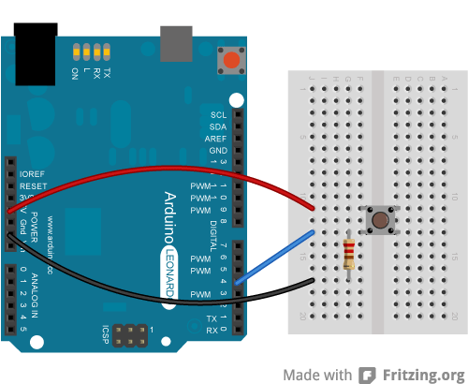

Activity 2: Button Challenges
• Make the LED turn on when the button is NOT pressed.
• Make the LED blink while the button is held.
• Blink faster the longer the button is held.
• Create a version where one press keeps the LED on for 3 seconds.

Check for Understanding
• What does pinMode() do?
• Explain the difference between setup() and loop().
• What does digitalWrite() do?
• What happens if delay() is removed from the blink program?

Next Steps for Students
• Using sensors (temperature, ultrasonic, light).
• Controlling servos or motors.
• Using analog input with analogRead().
• Building simple robots.
• Writing custom reusable functions.

