Documentation Structure

1. Cover Page
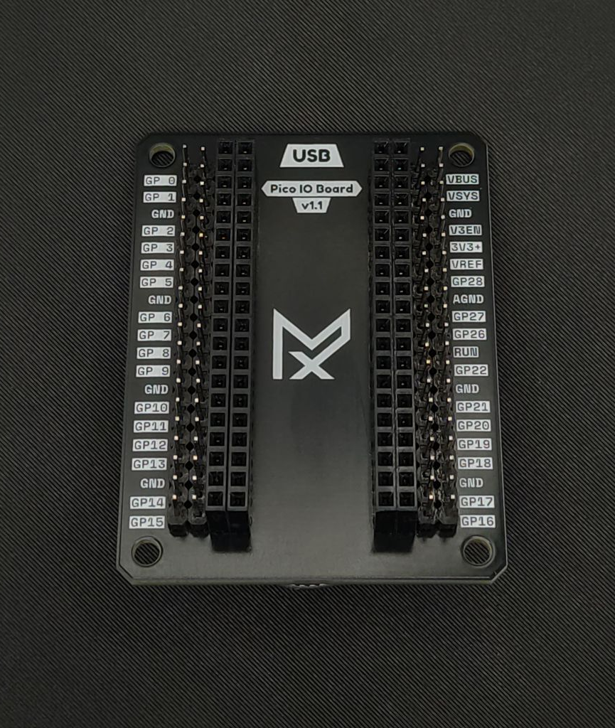
- Product name : Pico IO Board
- Revision/version v1.1
- Hero render
- Short description
The Mechaxil Pico IO Board expands the Raspberry Pi Pico pins so it's easier to use for prototyping.
Designed with usability, readability, and clean aesthetics in mind.
- Perfect for prototyping, education, embedded development, and quick testing setups.

- Status :Production
- License : CERN-Open Hardware License Version 2 – Weakly Reciprocal (CERN-OHL-W)
- Author/company : Attila Závoczki | Mechaxil
- Date 2026.05.10
- Certifications/logos (OSHWA etc.)
Example style:
- big render on white/light gray
- small metadata block on side
- subtle accent color only

2. Overview
Purpose of the board/product.
Should answer:
- What is it?
- Who is it for?
- What problem does it solve?
- Main capabilities
Include:
- short feature list
- block diagram
- product highlights

3. Hardware Specifications
Very STM/NXP style section.
Table format works best.
Example:
Parameter | Value
Input Voltage | 5V
MCU | RP2040
GPIO Count | 40
Logic Level | 3.3V
Dimensions | xx mm
Keep this extremely clean.

4. Board Layout & Identification
This section is SUPER important.
Include:
- top PCB render
- bottom PCB render
- labeled connectors
- dimensions
- mounting holes
- important component callouts
Should visually resemble datasheet-style diagrams.

5. Real Product Photos
You already identified this correctly.
Include:
- assembled photos
- angled shots
- closeups
- connector detail shots
- scale reference if useful
Important:
Use consistent lighting/background.
TI/ST style works because visuals feel "controlled".

6. Included Hardware / BOM
This is one of the biggest missing things in open hardware docs.
Should include:
- screws
- spacers
- inserts
- connectors
- optional parts
- tools required
Example:
Item | Quantity | Included
M3x8 Screw | 4 | Yes
Brass Insert | 4 | No
JST Cable | 1 | Yes
Could also split:
- Required
- Optional
- Recommended

7. CAD Files
You already nailed the important part.
VERY important section.
Should contain:
- Native CAD
- STEP
- STL (if relevant)
- Drawings
- PCB source
- Export formats
Explain WHY:
- native for editing
- STEP for compatibility
- STL for printing
I’d also include:
- software version used
- export revision
- unit system

8. Mechanical Assembly
Probably the most important section after specs.
Must contain:
- exploded view
- assembly order
- screw lengths
- torque notes if relevant
- cable routing
- alignment warnings
- tolerances if needed
Very visual section.
Think IKEA manual + industrial assembly guide hybrid.

9. Assembly Skill Level
This is actually genius and almost nobody does it.
Could be:
Skill Level | Meaning
Beginner | Basic screwdriver assembly
Intermediate | Requires soldering
Advanced | Requires calibration/rework
Then:
- soldering difficulty
- tools required
- estimated time
- safety warnings

10. Assembly Videos
This should be integrated directly inside docs.
For difficult operations:
- soldering connectors
- press fitting
- cable routing
- calibration
- firmware flashing
Add:
- QR code
- direct links
NXP/ST style docs usually lack this because they target professionals, but for open hardware this is HUGE.

11. Electrical Overview
Include:
- simplified schematic
- power tree
- IO explanation
- protection circuitry
- connector pinouts
Not full KiCad spaghetti directly.
Use simplified diagrams first.

12. Manufacturing Information
This makes the project feel serious instantly.
Include:
- PCB stackup
- thickness
- copper weight
- surface finish
- assembly notes
- recommended manufacturers
- critical tolerances

13. Firmware / Software
Include:
- flashing instructions
- dependencies
- supported platforms
- examples
- pin mappings
- debug interfaces

14. Validation & Testing
SUPER underrated.
Include:
- tested voltages
- stress tests
- thermal tests
- known limitations
- QA checklist
Makes project feel trustworthy.

15. Revision History
Very important for hardware.
Revision | Date | Changes
v1.0 | 2026-05-10 | Initial release

16. Licensing & Open Source
Include:
- hardware license
- software license
- documentation license
- attribution requirements

17. Support & Community
- GitHub
- Discord
- issue tracker
- contribution guidelines
