***Single wave model logistic growth model for COVID analysis***

Reference

1. M. Batista, (2020) “Estimation of the final size of the second phase of the coronavirus COVID 19 epidemic by the logistic model”, doi - <https://doi.org/10.1101/2020.03.11.20024901>
2. Haberman, Richard. (1998), “*Mathematical models mechanical vibrations, population dynamics, and traffic flow an introduction to applied mathematics*” Unabridged republication ed, Classics in applied mathematics. Philadelphia: SIAM.

The logistic growth model originates from population dynamics (Haberman 1998). The underlying assumption of the model is that the rate of change in the number of new cases per capita linearly decreases with the number of cases.

Hence, if C is the number of cases, and t is the time, then the model is expressed as

|  |  |
| --- | --- |
| $$\frac{dC}{dt}=rC\left(1 - \frac{C}{K}\right)$$ | (1) |

where r is infection rate, and K is the final epidemic size. [dC/dt] is the rate of change in number cases per unit of time. Here, unit of time can be daily or weekly and is incumbent upon what time base was used to track COVID cases.

If *C(0) = C0* is the initial number of cases, then solution of (1) is

|  |  |
| --- | --- |
| $$C=\frac{K}{1+A\exp\left(-rt\right)}$$ | (2) |

where, $A=\frac{K - C_{0}}{C_{0}}$

Eqn. 2 is a nonlinear equation with three design parameters (K, r, and A). These parameters are determined using nonlinear optimization techniques.

In practical sense, this is a numeric curve fitting problem which needs starting values for the three design parameters. This estimation is done using Eqn [3 – 6] as shown below

|  |  |
| --- | --- |
| $$t_{first}=t_{i}-2m=\frac{1}{r}ln\left(\frac{AC_{k-2m}}{{K - C}_{k-2m}}\right)$$ | (3a) |
| $$t_{second}=t_{i}-m=\frac{1}{r}ln\left(\frac{AC_{k-m}}{{K - C}_{k-m}}\right)$$ | (3b) |
| $$t_{third}=t_{i}=\frac{1}{r}ln\left(\frac{AC_{k}}{{K - C}_{k}}\right)$$ | (3c) |

|  |  |
| --- | --- |
|  | (4) |
| $$r_{int} = \frac{1}{m}ln\frac{C_{k}\left(C_{k-m}-C_{k-2m}\right)}{C_{k-2m}\left(C_{k}-C_{k-m}\right)}$$ | (5) |
| $$A_{int}=\frac{\left(C_{k}-C_{k-m}\right)\left(C_{k-m}-C_{k-2m}\right)}{\left(C_{k-m}^{2}-{C_{k}C}_{k-2m}\right)}{\left[\frac{C_{k}\left(C_{k-m}-C_{k-2m}\right)}{C_{k-2m}\left(C_{k}-C_{k-m}\right)}\right]}^{\frac{t_{i}-m}{m}}$$ | (6) |

Note, solutions to Eqns [4 - 6] are valid when value [K_int, r_int and A_int] are all positive, with [K_int, A_int] being integers. This is the case because the number of patients cannot be a fractional number.

Eqn 3(a – c) describes the three-point equidistant method, which for practical consideration, was implemented in the way of choosing the first, middle and last point of the dataset. During optimization, coefficient of determination and root mean squared error was used to fitness of the model

After determining the final three points dubbed Eqn 2 is solved using optimization techniques such as Levenberg-Marquardt, Trust Region Reflective Method and Nelder-Mead.

Using the determined model, we compute Prevalence (a.k.a cumulative number of cases) using Eqn 2 and Incidence (a.k.a rate of change in cases) using Eqn 1.

Epidemy phase of a fitted curve can be determined using the following ranges

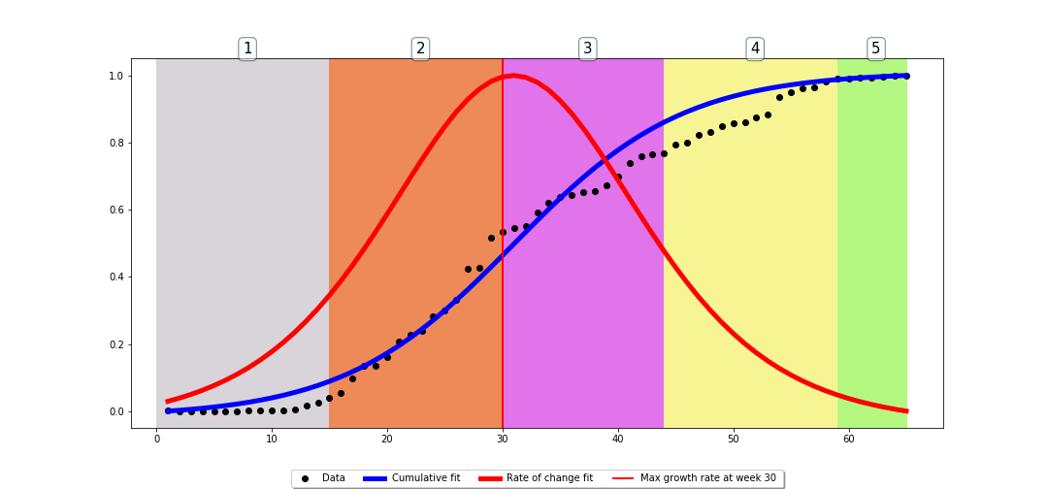

Figure 1 Epidemy phases as defined by Dr. Batista

1. Phase 1 – exponential growth $t<t_{p}-\frac{2}{r}$
2. Phase 2 – fast growth $t_{p}-\frac{2}{r}<t<t_{p}$
3. Phase 3 – fast growth to steady-state $t_{p}<t<t_{p}+\frac{2}{r}$
4. Phase 4 – steady-state $t_{p}+\frac{2}{r}<t<{2t}_{p}$
5. Phase 5 – ending phase $t>{2t}_{p}$

Here, *tp* is time peak of the wave i.e. $\frac{d^{2}C}{dt^{2}}=0$

The names of the phases are not standard and are arbitrarily chosen