

IT342-G2
System Integration and Architecture

System Design Document (SDD)

Project Title: Paluto
Prepared By: Auditor, Mechole Angelou M.

Version: 0.1
Date: February 23, 2026
Status: Final

REVISION HISTORY TABLE
Version | Date | Author | Changes Made | Status
0.1 | 2-23-2026 | Auditor, Mechole | Initial draft | Final
0.2 | [Date] | [Your Name] | Added API specifications | Review
0.3 | [Date] | [Your Name] | Updated database design | Review
0.4 | [Date] | [Your Name] | Added UI/UX designs | Review
0.5 | [Date] | [Your Name] | Incorporated feedback | Revised
0.6 | [Date] | [Your Name] | Final review and corrections | Final
1 | [Date] | [Your Name] | Baseline version for development | Approved

TABLE OF CONTENTS
Contents
EXECUTIVE SUMMARY 4
1.0 INTRODUCTION 5
2.0 FUNCTIONAL REQUIREMENTS SPECIFICATION 5
3.0 NON-FUNCTIONAL REQUIREMENTS 8
4.0 SYSTEM ARCHITECTURE 9
5.0 API CONTRACT & COMMUNICATION 10
Authentication Endpoints 11
User Registration 11
User Login 11
6.0 DATABASE DESIGN 13
7.0 UI/UX DESIGN 14
8.0 PLAN 17

EXECUTIVE SUMMARY
1.1 Project Overview
Paluto is a specialized booking platform designed to bridge the gap between professional home cooks and busy families or professionals. Unlike standard food delivery apps, this system facilitates on-site meal preparation services, allowing clients to have personalized meals cooked directly in their own kitchens. The system includes a Spring Boot backend API, React web application, and Android mobile app, all integrated to provide a seamless appointment booking across platforms.
1.2 Objectives
- Develop a fully functional Service-Booking platform with authentication, multi-user roles, cook portfolios, appointment booking scheduling, and service rating.
- Implement a three-tier architecture using Spring Boot (backend), React (web), and Android (mobile)
- Create RESTful APIs for communication between all system components
- Design a responsive user interface that works consistently across web and mobile platforms
- Deploy all system components to production-ready environments
1.3 Scope
Included Features:
- User registration and authentication (email/password)
- Google login integration
- Cook portfolio (add, remove, update certificates, menu, specialties, and rates)
- Transactional Appointment booking system
- Cook Service Rating System
- Payment Gateway Integration (sandbox)
- Email notification system
- In-app notifications
- Admin panel
- Native Android mobile application
- PostgreSQL database with relational schema
Excluded Features:
- Push notifications
- Advanced analytics dashboard

1.0 INTRODUCTION
1.1 Purpose
This document serves as the comprehensive design specification for the Paluto Booking system. It provides detailed requirements, architectural decisions, API contracts, database design, and implementation roadmap to guide development and ensure all components integrate seamlessly.

2.0 FUNCTIONAL REQUIREMENTS SPECIFICATION
2.1 Project Overview
Project Name: Paluto
Domain: Service-Booking platform
Primary Users:
- Clients
- Cooks
- Administrator

Problem Statement: Busy professionals and families struggle to maintain healthy eating habits due to lack of time, often relying on unhealthy fast food.
Solution: A specialized booking platform that connects these individuals with home cooks for on-site meal preparations.
2.2 Core User Journeys
Journey 1: First time client booking a service
- Clients opens the web or mobile application
- Clicks "Sign Up" and creates account
- Client logins with the registered account
- Browse cook portfolios to view specialty menus and hourly rates
- Selects a cook clicks “Book Appointment”
- Selects specific date, time, and menu for the home cooking
- Confirms the booking and provides the service address
- Receives a booking confirmation once the cook accepts booking
- After the service, the client rates the cook.
Journey 2: Cook accepts a booking
- Cook registers and completes their profile with certification/ specialties
- Sets hourly rate and uploads specialty menus
- Receives a notification for a new booking request
- Navigates to “My bookings” tab
- Click booking request and review details and confirm the schedule
- After the service, the cook marks the appointment as completed.

Journey 2: Admin manages users
- Admin logins into the web or mobile application
- Navigates to “users” section
- Click user details
- View user details
2.3 Feature List (MoSCoW)
MUST HAVE
- User authentication (register, login, logout)
- Role based access (client, cooks, admin)
- Cook portfolio (certification, menus rates)
- Appointment booking (date, time, menu, cook)
SHOULD HAVE
- Cook Service rating
- Booking history
- Google login integration
- Payment gateway integration
COULD HAVE
- Favorite Cooks
- Cook filtering
- Cook dashboard
- Email notification
- In app notification
- Responsive design for all screen sizes
WON'T HAVE
- Real payment processing
- Advanced analytics
- Multi-language support
- Real-time GPS tracking of the cook
2.4 Detailed Feature Specifications
Feature: User Authentication
- Screens: Client Registration, Client Login, Cook Registration, Cook Login, Forgot Password
- Fields: First name, Last name, address, phone number, Email, Password, Confirm Password
- Validation: Email format, password strength, uniqueness, phone number format,
- API Endpoints: POST /auth/register, POST /auth/login
- Security: JWT tokens, password hashing with bcrypt
Feature: Cook portfolio
- Screens: Portfolio View (Public), Portfolio edit (Cook)
- Display: Menu, rate, specialties, certification/s
- Functions: Add/edit menu, update rates, upload/ remove certifications.
- API Endpoints: GET /cook, GET /cook/{id}/ portfolio, GET /cook/portfolio/items, PUT /cook/portfolio/details
Feature: Appointment Booking
- Screens: Booking form, Appointment Summary, Booking History
- Functions: Select a cook, choose schedule (date & time), select menu, submit booking request, accept booking
- Data Collected: Service address, date/time, and menu.
- API Endpoints: POST /bookings, GET bookings/{id}, PUT /bookings/{id}/status
Feature: Service Rating
- Screens: Post-service Rating form, Cook profile rating section
- Fields: Star rating(1-5)
- Persistence: Ratings are linked to the cook’s profile and appointment.
- API Endpoints: POST /ratings, GET /ratings/cook/{cookdId}
2.5 Acceptance Criteria
AC-1: Successful User Registration
- Given I am a new user
- When I enter valid firstname, lastname, phonenumber, address, email and strong password
- And confirm password matches
- And click "Create Account"
- Then my account should be created
- And I should be redirected to login page
AC-2: Cook Portfolio Creation
- Given I am logged in as a cook
- When I navigate to my portfolio dashboard and add my specialty menus, hourly rates, and certifications.
- And I save the changes
- Then the updated information should be visible to Clients when they search for cooks
- And the certifications should be stored and available for Admin verification.

AC-3: Appointment Booking Flow
- Given I am logged in as a "Client"
- When I select a cook's profile and choose an available date and time slot.
- AndI provide the service location/address and confirm the booking request.
- Then the system should create a "Pending" appointment record.
- And the cook should see the new request in their management dashboard.

3.0 NON-FUNCTIONAL REQUIREMENTS
3.1 Performance Requirements
- API response time: ≤ 2 seconds for 95% of requests
- Web page load time: ≤ 3 seconds on broadband
- Mobile app cold start: ≤ 5 seconds
- Support 30 concurrent users
- Database queries complete within 500ms
3.2 Security Requirements
- HTTP for all communications
- JWT token authentication
- Password hashing with bcrypt
- Role based access control
- SQL injection prevention
- XSS protection
- Rate limiting: 100 requests/minute per IP
- Admin endpoints require role verification
3.3 Compatibility Requirements
- Web Browsers: Chrome, Firefox, Safari, Edge (latest 2 versions)
- Android: API Level 24+ (Android 7.0+)
- Screen Sizes: Mobile (360px+), Tablet (768px+), Desktop (1024px+)
3.4 Usability Requirements
- New users should be able to complete their first cook booking within 5 minutes.
- Consistent navigation across all pages
- Clear error messages with recovery options

4.0 SYSTEM ARCHITECTURE
4.1 Component Diagram
Note: This should be a component diagram
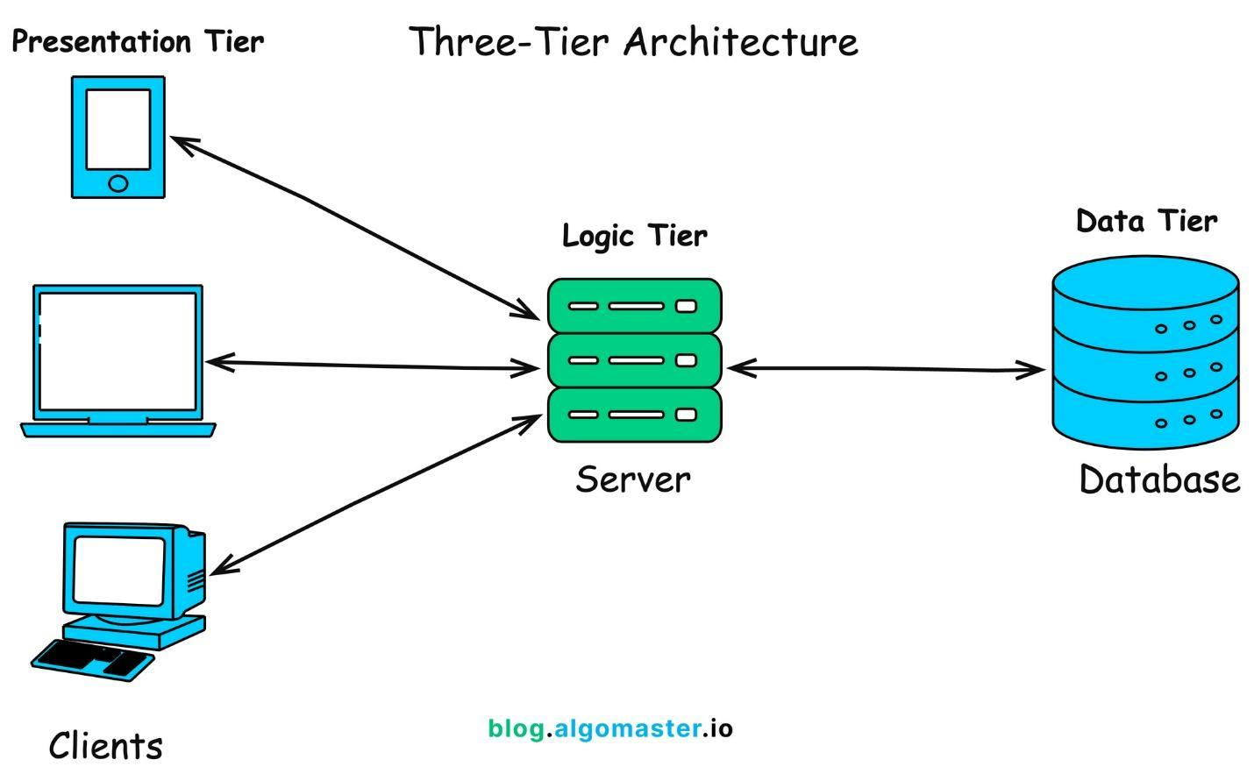
Technology Stack:
- Backend: Java 17, Spring Boot 3.x, Spring Security, Spring Data JPA
- Database: PostgreSQL 14+
- Web Frontend: React 18, TypeScript, Tailwind CSS, Axios
- Mobile: Kotlin, Jetpack Compose, Retrofit, Room
- Build Tools: Maven (Backend), npm/yarn (Web), Gradle (Android)
- Deployment: Railway/Heroku (Backend), Vercel/Netlify (Web), APK (Mobile)

5.0 API CONTRACT & COMMUNICATION
5.1 API Standards
Base URL | https://[server_hostname]:[port]/api/v1
Format | JSON for all requests/responses
Authentication | Bearer token (JWT) in Authorization header
Response Structure | {  "success": boolean,  "data": object|null,  "error": {  "code": string,  "message": string,  "details": object|null  },  "timestamp": string  }

5.2 Endpoint Specifications

Authentication Endpoints

User Registration
Description | User Registration
API URL | /auth/register
HTTP Request Method | POST
Format | JSON for all requests/responses
Authentication | None
Request Payload | {  “email”: <email>,  “password”: <password>,  “firstname”: <firstname>,  “lastname”: <lastname>,  }
Response Structure | {  "success": boolean,  "data": {  user {  “email”: <email>,  “firstname”: <firstname>,  “lastname”: <lastname>,  },  “accessToken”: <token>,  “refreshToken”: <token>,  },  "error": {  "code": string,  "message": string,  "details": object|null  },  "timestamp": string  }

User Login
Description | User Login
API URL | /auth/login
HTTP Method | POST
Format | JSON for all requests/responses
Authentication | None
Request Payload | {  “email”: <email>,  “password”: <password>,  }
Response Structure | {  "success": boolean,  "data": {  “user”: {  “email”: <email>,  “firstname”: <firstname>,  “lastname”: <lastname>,  “role”: <role>,  },  “accessToken”: <token>,  “refreshToken”: <token>,  },  "error": {  "code": string,  "message": string,  "details": object|null  },  "timestamp": string  }

5.3 Error Handling
HTTP Status Codes
- 200 OK - Successful request
- 201 Created - Resource created
- 400 Bad Request - Invalid input
- 401 Unauthorized - Authentication required/failed
- 403 Forbidden - Insufficient permissions
- 404 Not Found - Resource doesn't exist
- 409 Conflict - Duplicate resource
- 500 Internal Server Error - Server error
Error Code Examples

Example 1 | json  {  "success": false,  "data": null,  "error": {  "code": "AUTH-001",  "message": "Invalid credentials",  "details": "Email or password is incorrect"  },  "timestamp": "2024-01-28T10:30:00Z"  }
Example 2 | {  "success": false,  "data": null,  "error": {  "code": "VALID-001",  "message": "Validation failed",  "details": {  "email": "Email is required",  "password": "Must be at least 8 characters"  }  },  "timestamp": "2024-01-28T10:30:00Z"  }

Common Error Codes
- AUTH-001: Invalid credentials
- AUTH-002: Token expired
- AUTH-003: Insufficient permissions
- VALID-001: Validation failed
- DB-001: Resource not found
- DB-002: Duplicate entry
- BUSINESS-001: Insufficient stock
- SYSTEM-001: Internal server error

6.0 DATABASE DESIGN
6.1 Entity Relationship Diagram
Note: This should be an ERD (Database Schema)
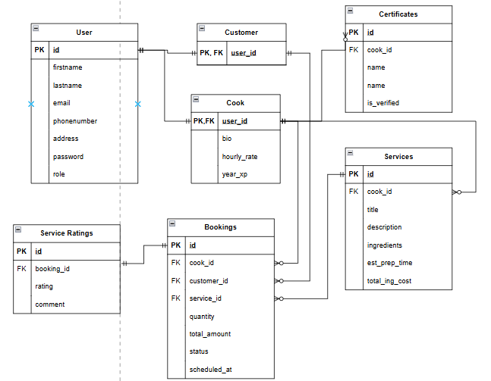
Detailed Relationships:
- One-to-One: User ↔ Cook (A cook is a user)
- One-to-One: User ↔ Customer (A customer is a user)
- One-to-Many: Cook → Service (A cook can offer multiple menu services)
- One-to-Many: Cook → Certificate (A cook can have multiple certificates)
- One-to-Many: Customer → Booking (A customer can have multiple bookings over time)
- One-to-Many: Cook → Booking (A cook can be assigned to multiple bookings)
- One-to-Many: Service → Booking (A specific service can be booked multiple times)
- One-to-One: Booking → Service Rating (A booking can only be rated one time)

Key Tables:
- users - User accounts, authentication, and baseclass for customer/ cook
- cooks - Extended profile for cooks
- customers - Extended profile for customers
- services - Specific offerings/ services of cooks (e.g., “Filipino breakfast”)
- certificates - Cook's personal certificates
- bookings - Booking transactions
- service_ratings - Rating of meal and service quality

Table Structure Summary:
- users: id, email, firstname, lastname, phonenumber, address, password, role(customer/cook)
- cooks: user_id, bio, hourly_rate, years_exp
- customers: user_id,
- services: id, cook_id, title, description, ingredients_ls, est_prep_time, ingredients_cost
- cook_certificates: id, cook_id, cert_name, is_verified, image
- bookings: id, customer_id, cook_id, service_id,quantity, total_cost, status, scheduled_at
- Service_ratings: rating_id, booking_id, rating, comment

7.0 UI/UX DESIGN
7.1 Web Application Wireframes
Note: This should be wireframes from Figma
Homepage (Product Listing)
Header: [Logo] [Search Bar] [Cart Icon] [User Menu]
Content: Product Grid (3 columns desktop)
Each Product Card: Image, Name, Price, "Add to Cart" button
Footer: Links, Copyright

Product Detail Page
Back Button
Product Image (large)
Product Name and Price
Description
Quantity Selector (1-10)
"Add to Cart" and "Buy Now" buttons
Product Specifications

Shopping Cart Page
Cart Title
List of Cart Items (Image, Name, Quantity, Price, Remove)
Order Summary: Subtotal, Shipping, Tax, Total
"Continue Shopping" and "Proceed to Checkout" buttons

Checkout Page
Shipping Address Form
Order Review (Items, Prices, Totals)
"Place Order" button
Terms and Conditions note

Admin Dashboard
Sidebar Navigation: Dashboard, Products, Orders, Users
Product Management: Add New button, Product list with Edit/Delete
Order Management: Order list with status filters

7.2 Mobile Application Wireframes
Note: This should be wireframes from Figma
Bottom Navigation
[🏠 Home] [🔍 Search] [🛒 Cart] [👤 Profile]
Home Screen
Search Bar
Product Grid (2 columns)
Swipe gestures for quick actions
Pull to refresh

Product Detail Screen
Back arrow
Product image (swipeable gallery)
Product info
Quantity selector
"Add to Cart" fixed bottom button

Cart Screen
Edit mode for quantity updates
Swipe to remove items
Order summary sticky bottom
Checkout button

Checkout Flow
Step indicator: Cart → Shipping → Payment → Confirm
Address form (auto-complete)
Order summary
Place order button
Mobile-Specific Features:
- Touch-optimized buttons (min 44x44px)
- Gesture support (swipe, pull-to-refresh)
- Offline caching for product images
- Bottom navigation for main actions
- Simplified forms for mobile input
Design System:
- Colors: Primary (#2563EB), Secondary (#7C3AED), Success (#10B981), Error (#EF4444)
- Typography: Inter font family, responsive sizing
- Spacing: 8px grid system
- Components: Consistent buttons, inputs, cards, modals
- Responsive: Mobile-first approach, breakpoints at 640px, 768px, 1024px

8.0 PLAN
8.1 Project Timeline
Phase 1: Planning & Design (Week 1-2)
Week 1: Requirements & Architecture
Day 1-2: Project setup and documentation
Day 3-4: Complete FRS and NFR
Day 5-7: System architecture design

Week 2: Detailed Design
Day 1-2: API specification
Day 3-4: Database design
Day 5-6: UI/UX wireframes
Day 7: Implementation plan finalization

Phase 2: Backend Development (Week 3-4)
Week 3: Foundation
Day 1: Spring Boot setup with dependencies
Day 2: Database configuration and entities
Day 3: JWT authentication implementation
Day 4: User management endpoints
Day 5: Product CRUD operations

Week 4: Core Features
Day 1: Cart functionality
Day 2: Order management
Day 3: Search and filtering
Day 4: Error handling and validation
Day 5: API documentation and testing

Phase 3: Web Application (Week 5-6)
Week 5: Frontend Foundation
Day 1: React setup with TypeScript
Day 2: Authentication pages (login, register)
Day 3: Product listing page
Day 4: Product detail page
Day 5: Shopping cart implementation

Week 6: Complete Web Features
Day 1: Checkout flow
Day 2: Order history and confirmation
Day 3: Admin dashboard
Day 4: Responsive design polish
Day 5: API integration and testing

Phase 4: Mobile Application (Week 7-8)
Week 7: Android Foundation
Day 1: Android Studio setup and project structure
Day 2: Authentication screens
Day 3: Product browsing
Day 4: Shopping cart
Day 5: API service layer

Week 8: Complete Mobile App
Day 1: Checkout flow
Day 2: Order management
Day 3: UI polish and animations
Day 4: Testing on emulator/device
Day 5: APK generation and documentation

Phase 5: Integration & Deployment (Week 9-10)
Week 9: Integration Testing
Day 1: End-to-end testing across platforms
Day 2: Bug fixes and optimization
Day 3: Security review
Day 4: Performance testing
Day 5: Documentation updates

Week 10: Deployment
Day 1: Backend deployment (Railway/Heroku)
Day 2: Web app deployment (Vercel/Netlify)
Day 3: Mobile APK distribution
Day 4: Final testing
Day 5: Project submission
Milestones:
- M1 (End Week 2): All design documents complete
- M2 (End Week 4): Backend API fully functional
- M3 (End Week 6): Web application complete
- M4 (End Week 8): Mobile application complete
- M5 (End Week 10): Full system deployed and integrated
Critical Path:
- Authentication system (Week 3)
- Product catalog API (Week 3-4)
- Shopping cart functionality (Week 4)
- Checkout process (Week 6)
- Cross-platform testing (Week 9)
Risk Mitigation:
- Start with simplest working version of each feature
- Test integration points early and often
- Keep backup of working versions
- Focus on core functionality before enhancements

