**CYPRUS INTERNATIONAL UNIVERSITY**

**CPE485 – Project I**

Year of Study: 2019-2020 SUMMER

Yunus Kahraman

Project Supervisor: Prof. Dr. Derviş Zihni DENİZ

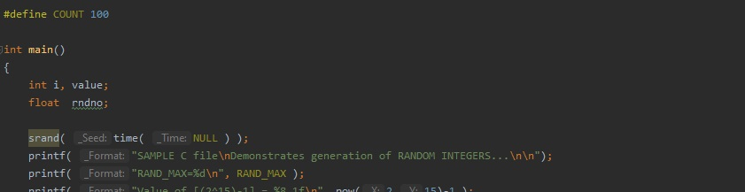

For taking values in the homework I assigned 1 integer value (value) and 1 floating value (rndno). I used “srand” function with “time” function for generate random integers in every run.

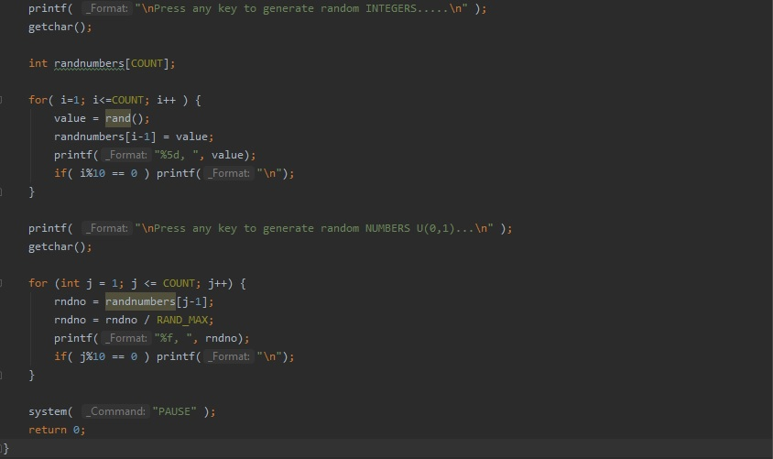

For keeping generated random values I assigned integer array (randnumbers). In first loop I generated random integers between 0-RAND_MAX value and I kept that numbers in “randnumbers” array. Because of aim of homework I divided generated random numbers with RAND_MAX value to get values between 0.0 and 1.0.

Output of the source code:

