Machine Learning
Spring 2026
Final Project / Competition
This Final Project, replacing the final exam, is the ML Competition, which has three major components:
- A Poster: due May 4st (Monday), 11:59pm, via Canvas
- Participation of the poster presentation: May 7th (Thursday), 4:00-8:00pm, The Commons Area, Engr. Building No. 1. You have a chance to win an award
- A Report (word format): due May 13th(Wed.), 11:59pm, via Canvas

Bolted flange looseness detection (classification)
From the early industrial age to modern times, bolted connections have been a reliable type of connection for structural components and widely used in many industries. For example, the offshore oil industry employs pipelines with flange connections to transport the oil from the seabed to the land. However, such connection still suffers from problems, such as bolt looseness, which may be resulting from chemical erosion, mechanical vibration, impact from foreign objects, and improper installation. That is, in the pipeline system, bolted connection represents a point of vulnerability and is prone to self-loosening due to uncertainties, which might lead to disastrous consequences, resulting in economic losses. Therefore, it is important to detect the bolt looseness of the subsea flange.

In this project/competition, You are required to use percussion method and build your ML/DL models (2 shallow learning models and 2 deep learning models) to identify the looseness/tightness level (0/25/50 ft-lbs) of bolted flanges. We will provide you with 4 percussion-induced audio datasets collected from 4 pairs of bolted flanges in a pipeline system (Fig. 1), respectively. These datasets were conducted by hitting the surface of flanges with a steel hammer and recorded by an iphone (48kHz sampling rate). Three looseness/tightness levels (0, 25, 50 ft-lbs) are considered, and the four bolts and nuts of a pair of flange are tightened in the same preload level. In Table 1, each dataset has 80 samples per class (0/25/50 ft-lbs), resulting in 240 samples in total. Within a batch of 80 (20x4) samples, every 20 samples are from an area (marked in Fig. 2).

Table1. Datasets Arrangement.
Flange ID | Dataset ID | Number of signal-hit percussion-induced audio signals in a preload level |  |  | Total number of samples in a set
 |  | 0 ft-lbs | 25 ft-lbs | 50 ft-lbs
1 | 1 | 80 | 80 | 80 | 240
2 | 2 | 80 | 80 | 80 | 240
3 | 3 | 80 | 80 | 80 | 240
4 | 4 | 80 | 80 | 80 | 240
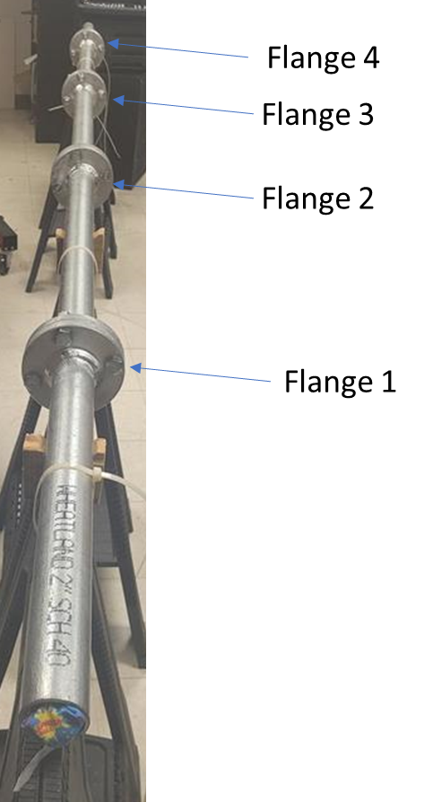
Fig. 1. A pipeline system with four bolted flanges

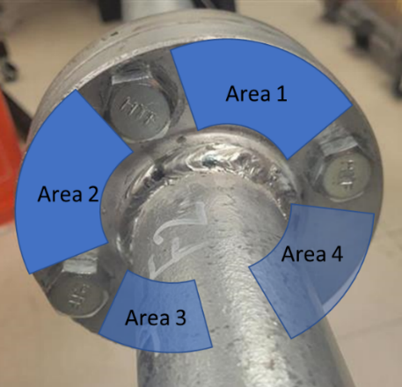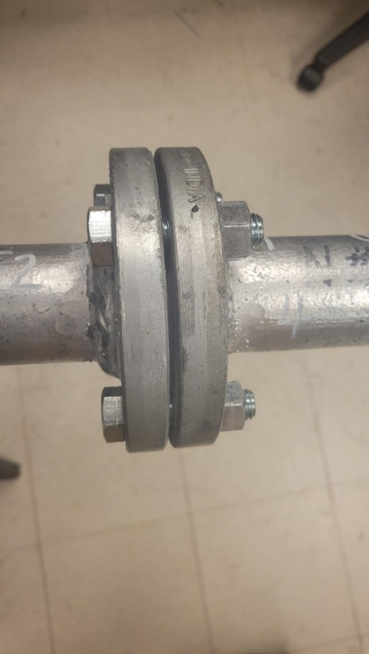
Fig. 2. A pair of bolted flange (front view and side view)

With the given 4 datasets, you are required to complete following task:

Mandatory Tasks:
1. Dependent Test: Combining these 4 datasets into a big dataset (240*4). Splitting the big dataset into training and test sets with a ratio of 7:3. Using the training set to train your model and using the test set to verify your model performance (present classification accuracy and confusion matrix).
2. Independent Test: Using the following arrangement (Table 2) to train and test your model. Presenting classification accuracy and confusion matrix of 4 test sets. Please include results of three-class and two-class (0 ft-lb vs 25-and-50 ft-lb) classification.

Table 2. Training and test sets arrangement.
Training set | Test set
Datasets 2,3,4 | Dataset 1
Datasets 1,3,4 | Dataset 2
Datasets 1,2,4 | Dataset 3
Datasets 1,2,3 | Dataset 4

3. Experimental Test – Determine the looseness/tightness levels of the flanges: We will tighten these four pairs of bolted flanges under different preload levels, each pair of flange will be tightened with a specific torque value (0/25/50 ft-lbs) uniformly. Please come to lab and collect four independent test sets from these four pairs of bolted flanges, respectively. Using your models to identify their looseness/tightness levels. Please presenting your classification results in following formats and we will announce the true label of these four pairs of bolted flanges in the competition.

Table 3. An example of the format of your classification result.
 | Flange 1 | Flange 2 | Flange 3 | Flange 4
Classification res | 25 ft-lbs | 50 ft-lbs | 0 ft-lbs | 50 ft-lbs

Bonus Tasks:
1) Make an app to automate the entire project, including a live demonstration function to make a prediction/classification of the flange tightness of testing data.
2) Please feel free to demonstrate your creativities by addressing challenging problems, such as clustering and finding better features

