S6 ProBE: a temporal benchmarking framework for protein function prediction
ProBE (Protein Benchmark Evaluator, https://github.com/ggradara/ProBE) is an open-source benchmarking framework developed to construct temporally defined benchmark datasets and provide a standardized evaluation pipeline for automated protein function prediction (AFP) methods. ProBE compares experimentally supported Gene Ontology (GO) annotations across successive Gene Ontology Annotation (GOA) releases to identify proteins that acquire new functional information over time. Redundancy-aware identifier harmonization and annotation consolidation are applied to reduce hidden knowledge leakage before benchmarking. An overview of the complete ProBE workflow is provided in Figure S10.
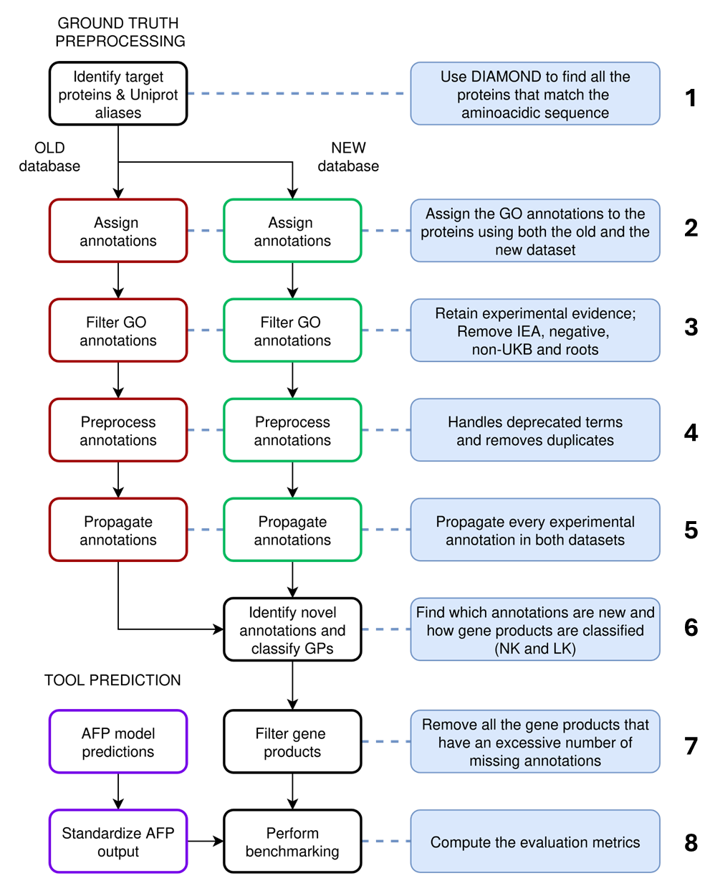
Figure S10. Workflow of the ProBE benchmarking framework. ProBE constructs temporally defined benchmark datasets by comparing successive GOA releases and provides a standardized evaluation pipeline for automated protein function prediction methods. Each box corresponds to a methodological stage described in the Supplementary Information.

S6.1. Benchmark generation
Benchmark generation was initiated from the complete CAFA5 target protein space. ProBE constructs benchmark datasets by following the temporal evolution of Gene Ontology annotations associated with these target proteins across successive GOA releases.
Protein identifiers are subsequently harmonized (Figure S10, Box 1) through exact sequence matching against UniProtKB using DIAMOND. This procedure retrieves all identical UniProt entries associated with each representative protein, allowing experimentally supported annotations distributed across equivalent identifiers to be consolidated before temporal comparison.
Experimentally supported GO annotations are retrieved independently from the 2023 and 2025 GOA releases (Figure S10, Box 2). Non-experimental and root GO terms are removed (Figure S10, Box 3), followed by preprocessing of deprecated terms and redundant annotations (Figure S10, Box 4). The remaining annotations are then propagated along the Gene Ontology directed acyclic graph according to CAFA evaluation rules (Figure S10, Box 5).
Temporal comparison between the propagated annotation sets allows proteins to be classified according to the acquisition of new experimental knowledge (Figure S10, Box 6). Proteins receiving their first experimentally supported annotation are assigned to the New Knowledge (NK) category, whereas proteins acquiring additional experimentally supported annotations despite previous experimental characterization are classified as Limited Knowledge (LK). Together, NK and LK constitute the complete ProBE benchmark.
Finally, proteins exhibiting substantial annotation loss between successive GOA releases are excluded (Figure S10, Box 7). The resulting benchmark datasets are exported together with standardized metadata required for downstream benchmarking.

S6.2 Prediction preprocessing and benchmarking
Predictions generated by automated protein function prediction (AFP) methods are standardized before evaluation (Figure S10, Box 8). This preprocessing includes score normalization to the $\left[0 , 1\right]$interval and, when required, propagation of predicted Gene Ontology annotations along the Gene Ontology directed acyclic graph according to the CAFA evaluation protocol.
The standardized prediction sets are subsequently compared with the temporally defined benchmark datasets generated by ProBE. Evaluation is performed over a continuous range of score thresholds, allowing optimal operating points to be identified for each prediction method.
The benchmarking module produces both conventional classification metrics and information-content–aware semantic evaluation metrics, enabling comprehensive comparison of automated protein function prediction methods across Gene Ontology domains and knowledge categories.

S6.3 Benchmark statistics
The complete ProBE benchmark contains 34,323 representative proteins, corresponding to 156,380 protein records after identifier harmonization. The benchmark is partitioned into 7,959 New Knowledge (NK) proteins and 26,364 Limited Knowledge (LK) proteins, which together constitute the complete benchmark dataset.
Across the three Gene Ontology domains, the benchmark comprises 5,579, 2,355, and 16,868 unique GO terms for Molecular Function, Cellular Component and Biological Process, respectively. In the General dataset, total GO annotation counts refer to the complete annotation sets associated with benchmark proteins, whereas the NK and LK subsets report the newly acquired annotations identified by temporal comparison between the 2023 and 2025 releases. Complete benchmark statistics are summarized in Table S1. For the component-level analysis reported in Section 3.4 and Figure 5 of the main manuscript, a deliberately stringent subset of approximately 2,500 benchmark proteins was selected according to the sequence similarity of database hits retrieved by DIAMOND. Only target proteins for which no retrieved hit exceeded 60% sequence similarity were retained. This filtering reduced the availability of readily transferable sequence-similarity–based functional information and therefore provided a more challenging setting for Argot3-KB. This subset was used only for the component-level analysis, whereas the complete ProBE benchmark described above was used for the main predictor comparisons.

Dataset | Representative proteins | UniProt records | MF GO (total / unique) | CC GO (total / unique) | BP GO (total / unique)
General | 34,323 | 156,380 | 346,545 / 5,579 | 510,725 / 2,355 | 1,592,093 / 16,868
NK | 7,959 | 47,414 | 44,449 / 2,328 | 60,353 / 1,058 | 114,133 / 5,860
LK | 26,364 | 108,966 | 112,258 / 4,197 | 147,576 / 1,808 | 424,979 / 12,164
Table S1. Summary statistics of the ProBE benchmark datasets. Overview of the benchmark datasets generated by ProBE through temporal comparison of Gene Ontology annotations between the 2023 and 2025 GOA releases. The General benchmark corresponds to the complete set of representative proteins retained after quality control, whereas the New Knowledge (NK) and Limited Knowledge (LK) datasets constitute mutually exclusive subsets defined according to the acquisition of new experimentally supported annotations. For each dataset, the table reports the number of representative proteins and the total number of associated UniProt records after identifier harmonization. For the General benchmark, total GO annotation counts refer to the complete annotation sets associated with the benchmark proteins, whereas totals reported for NK and LK refer only to annotations newly acquired between the two releases. Unique GO-term counts describe the functional diversity represented in each dataset.

S6.4 Performance metrics
Performance evaluation was performed using the per-protein evaluation setting, in which the complete set of predicted Gene Ontology (GO) annotations is compared with the propagated reference annotations associated with each target protein. Before metric computation, both predicted and ground-truth annotations were propagated according to the CAFA evaluation protocol, ensuring hierarchical consistency between prediction and reference annotation sets.
To provide a comprehensive evaluation of automated protein function prediction (AFP) methods, ProBE implements three complementary groups of performance metrics: conventional classification metrics, information-content–weighted classification metrics, and semantic distance metrics.
The complete mathematical definitions of all evaluation metrics adopted by ProBE, including classification, information-content–weighted and semantic distance measures, are reported in Appendix A.
Together, these complementary metrics quantify prediction accuracy, functional specificity and semantic consistency, providing a comprehensive evaluation framework for automated protein function prediction methods.

Appendix A

Mathematical definition of the ProBE evaluation metrics
ProBE evaluates automated protein function prediction (AFP) methods using the per-protein evaluation setting, in which the complete set of predicted Gene Ontology (GO) annotations associated with each target protein is compared with the corresponding propagated reference annotations. Prior to metric computation, both predicted and ground-truth annotation sets are propagated according to the CAFA evaluation protocol, ensuring hierarchical consistency throughout the Gene Ontology directed acyclic graph (DAG).
To provide a comprehensive characterization of prediction performance, ProBE implements three complementary groups of evaluation metrics: conventional classification metrics, information-content–weighted classification metrics, and semantic distance metrics.

A.1 Classification metrics
For each GO term $g$, True Positives $TP\left(τ\right)\left(g\right)$, False Negatives $FN\left(τ\right)\left(g\right)$ and False Positives $FP\left(τ\right)\left(g\right)$ ratios are calculated:
$$TP\left(τ\right)\left(g\right)=\left(g∈P\left(τ\right)∩g∈T\right)$$
$$FN\left(τ\right)\left(g\right)=\left(g∉P\left(τ\right)∩g∈T\right)$$
$$FP\left(τ\right)\left(g\right)=\left(g∈P\left(τ\right)∩g∉T\right)$$
Where $τ$ is the value of the mobile threshold at which the ratios are calculated, $P\left(τ\right)$ the set of predicted terms above the threshold value and $T$ the set of terms present in the groundtruth.
From this, precision $pr\left(τ\right)$, recall $rc\left(τ\right)$ and their harmonic mean$F_{max}$ are calculated, where $1$ () is an indicator function that returns either 1 or 0 if its conditions are met, namely if the term g is a TP, FN or FP:
$$pr\left(τ\right)=\frac{\sum_{g}{1\left(TP\left(τ\right)\left(g\right)\right)}}{\sum_{g}{\left(1\left(TP\left(τ\right)\left(g\right)\right)+1\left(FP\left(τ\right)\left(g\right)\right)\right)}}$$
$$rc\left(τ\right)=\frac{\sum_{g}{1\left(TP\left(τ\right)\left(g\right)\right)}}{\sum_{g}{\left(1\left(TP\left(τ\right)\left(g\right)\right)+1\left(FN\left(τ\right)\left(g\right)\right)\right)}}$$
$$F_{max}=\max_{τ}\left(2∙\frac{pr\left(τ\right)∙rc\left(τ\right)}{pr\left(τ\right)+rc\left(τ\right)}\right)$$
$F_{max}$ represents the principal classification metric used throughout the study.

A.2 Information-content–weighted metrics
Because Gene Ontology terms differ substantially in biological specificity, ProBE additionally computes information-content–weighted versions of the classification metrics. Information content, $ic\left(g\right)$, is calculated according to the cumulative frequency of each GO term within its corresponding ontology.
$$ic\left(g\right)=-log \frac{f_{c}\left(g\right)}{f_{c}\left(root\right)}$$
where $f_{c}\left(g\right)$ stands for the cumulative frequency of the term, calculated over its descendants, and $f_{c}\left(root\right)$ that of the corresponding root ontology term.
From this, the weighted precision $wpr\left(τ\right)$, recall $wrc\left(τ\right)$ and $wF_{max}$ are calculated:
$$wpr\left(τ\right)=\frac{\sum_{g}{ic\left(g\right)∙1\left(TP\left(τ\right)\left(g\right)\right)}}{\sum_{g}{ic\left(g\right)∙\left(1\left(TP\left(τ\right)\left(g\right)\right)+1\left(FP\left(τ\right)\left(g\right)\right)\right)}}$$
$$wrc\left(τ\right)=\frac{\sum_{g}{ic\left(g\right)∙1\left(TP\left(τ\right)\left(g\right)\right)}}{\sum_{g}{ic\left(g\right)∙\left(1\left(TP\left(τ\right)\left(g\right)\right)+1\left(FN\left(τ\right)\left(g\right)\right)\right)}}$$
$$wF_{max}=\max_{τ}\left(2∙\frac{wpr\left(τ\right)∙wrc\left(τ\right)}{wpr\left(τ\right)+wrc\left(τ\right)}\right)$$

A.3 Semantic distance metrics
Prediction quality is additionally evaluated using semantic distance measures derived from Gene Ontology information content.
Remaining uncertainty $ru\left(τ\right)$ quantifies the information content associated with experimentally supported GO terms that were not predicted, whereas misinformation $mi\left(τ\right)$ quantifies the information content associated with incorrectly predicted GO terms.
$$mi\left(τ\right)=\sum_{g}{ic\left(g\right)∙ 1\left(FP\left(τ\right)\left(g\right)\right)}$$
$$ru\left(τ\right)=\sum_{g}{ic\left(g\right)∙ 1\left(FN\left(τ\right)\left(g\right)\right)}$$
The minimum semantic distance $S_{min}$ is then computed as:
$$S_{min}=\min_{τ}\left(\sqrt{{mi\left(τ\right)}^{2}+{ru\left(τ\right)}^{2}}\right)$$
Unlike classification-based measures, semantic distance metrics explicitly quantify the biological relevance of prediction errors by weighting both missing and incorrect annotations according to their information content.
Together, these complementary metrics provide a comprehensive evaluation framework that jointly measures prediction accuracy, functional specificity and semantic consistency.

REFERENCES
Hagberg AA, Schult DA, Swart PJ. Exploring Network Structure, Dynamics, and Function using NetworkX. Python in Science Conference published online 6 May 2008. https://doi.org/10.25080/TCWV9851.

